EXPLORATORY DATA ANALYSIS · PUBLIC DATA
Maldives Crime Statistics
A Three-Year Exploratory Analysis, 2024–2026
Reported cases from the Maldives Police Service · 2026 data to October · 29 October 2026

−4.2%  Total reported cases, 2025 vs 2024 (12,641 → 12,113) |  | +23.7%  Drug cases, 2025 vs 2024 (1,670 → 2,066) |  | 10 months  of 2026 data (to October): not directly comparable with full years

Summary
Reported cases fell 4.2% between 2024 and 2025, from 12,641 to 12,113. The 2026 figures cover only about ten months, so the raw 2026 total of 10,205 cannot be compared with a full year. Underneath the overall movement, two categories behave very differently from the rest.
- Drugs is the one consistent increase. Cases rose from 1,670 to 2,066 to 2,128 (2026 to October). That is about 139, 172 and 213 cases a month, and drugs grew from 13.2% to 20.9% of all reported cases.
- Traffic accidents peaked in 2025, but modestly. 3,079 cases was the highest of the three years, 6.8% above 2024. Whether 2026 is lower depends on the cut-off month of the 2026 data.
- Most other categories fell. All ten other categories fell from 2024 to 2025. Sexual offences, robbery and counterfeit and forgery kept falling in 2026 under either cut-off.
- These are recorded cases, not proof that crime itself changed. The data cannot show whether either of the two laws discussed in this report affected the counts.

Data and approach
The analysis uses annual counts of cases for twelve categories from the Maldives Police Service crime statistics, for 2024, 2025 and 2026 (to October). The three yearly totals match the sum of the twelve categories, and no values are missing.
Because 2026 is not a full year, the analysis compares the two full years (2024 and 2025) directly and converts 2026 to cases per month (January–October divided by ten). The exact last month of the 2026 data is not recorded, so every 2026 comparison is also tested against a nine-month cut-off. Where the two readings disagree, the report says the direction is not settled. No significance tests are used: the figures are complete tallies rather than a sample.
Two categories, traffic accidents and lost items, are incident or service reports rather than crimes. Together they make up 33.6% of 2025 cases, so the total should be read as “recorded cases”.

Results by category
Category | 2024 | 2025 | 2026 (Jan–Oct) | 2025 vs 2024 | Cases per month, 2024 → 2025 → 2026
Theft | 3,762 | 3,480 | 2,814 | −7.5% | 313.5 → 290.0 → 281.4
Traffic Accidents | 2,882 | 3,079 | 2,452 | +6.8% | 240.2 → 256.6 → 245.2
Drugs | 1,670 | 2,066 | 2,128 | +23.7% | 139.2 → 172.2 → 212.8
Lost Items | 1,036 | 993 | 819 | −4.2% | 86.3 → 82.8 → 81.9
Vandalism | 714 | 603 | 558 | −15.5% | 59.5 → 50.2 → 55.8
Assault | 662 | 596 | 540 | −10.0% | 55.2 → 49.7 → 54.0
Domestic Violence | 657 | 356 | 269 | −45.8% | 54.8 → 29.7 → 26.9
Sexual Offences | 506 | 323 | 225 | −36.2% | 42.2 → 26.9 → 22.5
Embezzlement | 321 | 272 | 223 | −15.3% | 26.8 → 22.7 → 22.3
Robbery | 257 | 232 | 122 | −9.7% | 21.4 → 19.3 → 12.2
Counterfeit and Forgery | 167 | 107 | 53 | −35.9% | 13.9 → 8.9 → 5.3
Cheque Bounce | 7 | 6 | 2 | −14.3% | 0.6 → 0.5 → 0.2
Total | 12,641 | 12,113 | 10,205 | −4.2% | 1,053.4 → 1,009.4 → 1,020.5
Shaded cells: orange = increase, blue = decrease. Percentage changes for cheque bounce (7, 6 and 2 cases) are not meaningful. 2026 monthly rates assume ten months of data.
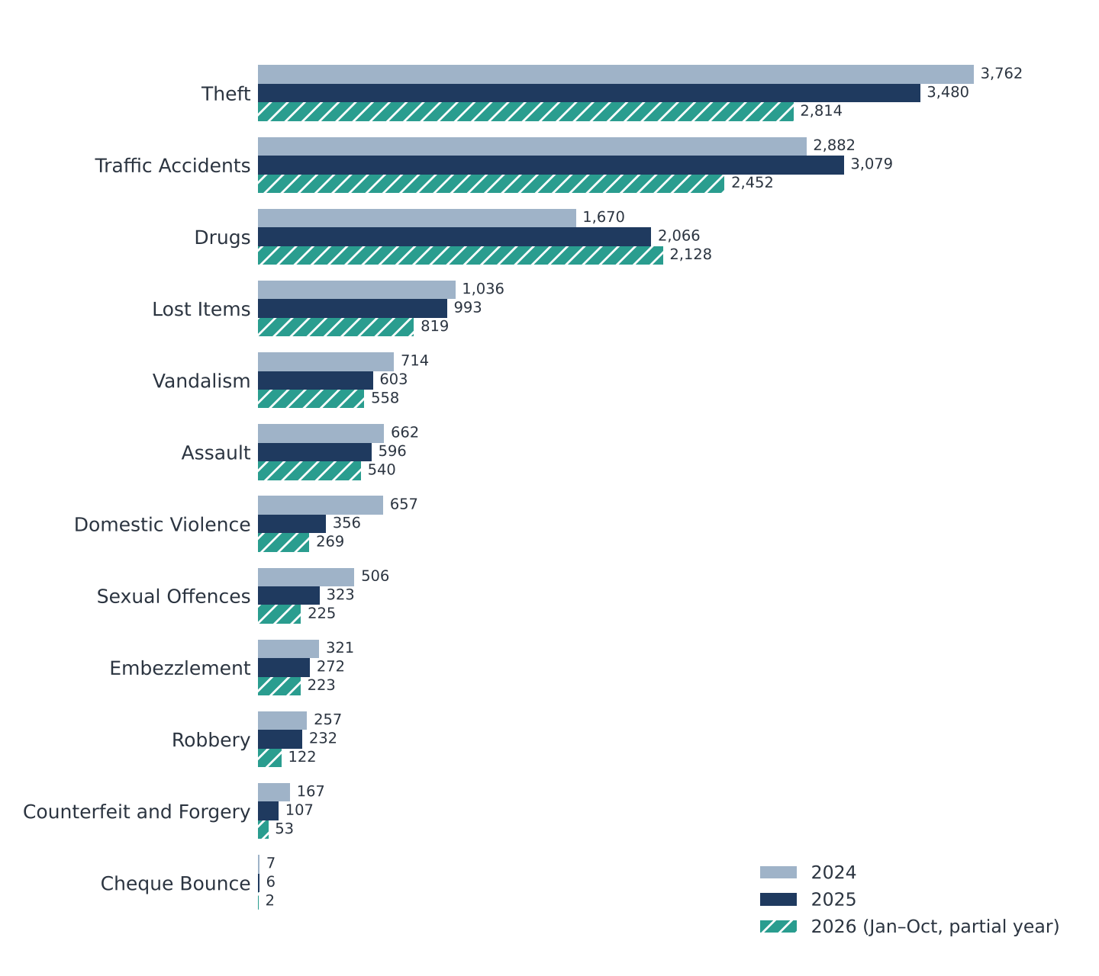
Figure 1. Reported cases by category. 2026 (hatched) covers January to October only.

Key findings

1. Drugs: the one consistent increase
Observation Cases rose from 1,670 to 2,066 (+396, +23.7%, the largest absolute rise of any category) and reached 2,128 in about ten months of 2026. Monthly cases went from 139 to 172 to 213. The rise holds under both 2026 cut-offs.
Interpretation More drug cases were recorded. That could reflect more drug activity, more detection and enforcement (drug cases are usually found by police rather than reported by victims), or changed recording. The data cannot separate these.

What the data cannot show
There is no split by offence type (use, possession, trafficking) and no enforcement data. The continued rise after the Gang Act was ratified in May 2025 does not show the Act failed or succeeded.

2. Traffic accidents: a modest peak in 2025
Observation Cases were 2,882, 3,079 and 2,452 (to October 2026). The 2025 monthly rate of 257 is the highest of the three years (240 and 245). The 2025 increase is 197 cases, or 6.8%.
Interpretation 2025 was higher, but the gap is within the range of year-to-year movement in other categories. For 2026, the monthly rate is 4.4% lower than 2025 on a ten-month basis and 6.2% higher on a nine-month basis, so the direction is not settled.
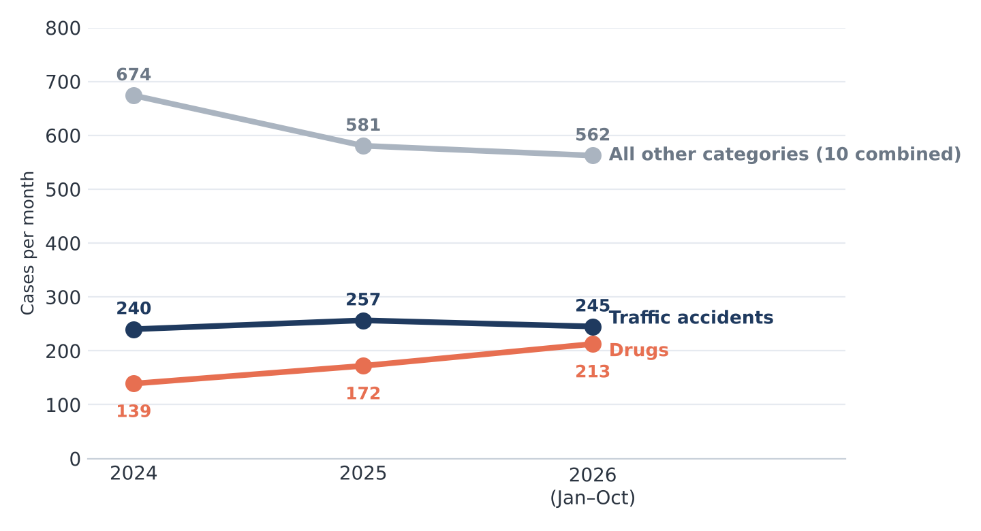
Figure 2. Cases per month: drugs closes in on traffic accidents while the other ten categories combined decline.
What the data cannot show
The counts say nothing about severity or casualties. The Land Transport Act was ratified on 31 August 2026 and takes effect about 30 days after gazetting, so it cannot explain these counts.

3. Categories that declined
Observation From 2024 to 2025, every category other than drugs and traffic accidents fell. The largest absolute falls were domestic violence (−301), theft (−282) and sexual offences (−183). In 2026, the monthly rates of sexual offences, robbery and counterfeit and forgery kept falling under either cut-off. Domestic violence halved in 2025 (55 → 30 a month) and stayed near that level (27).
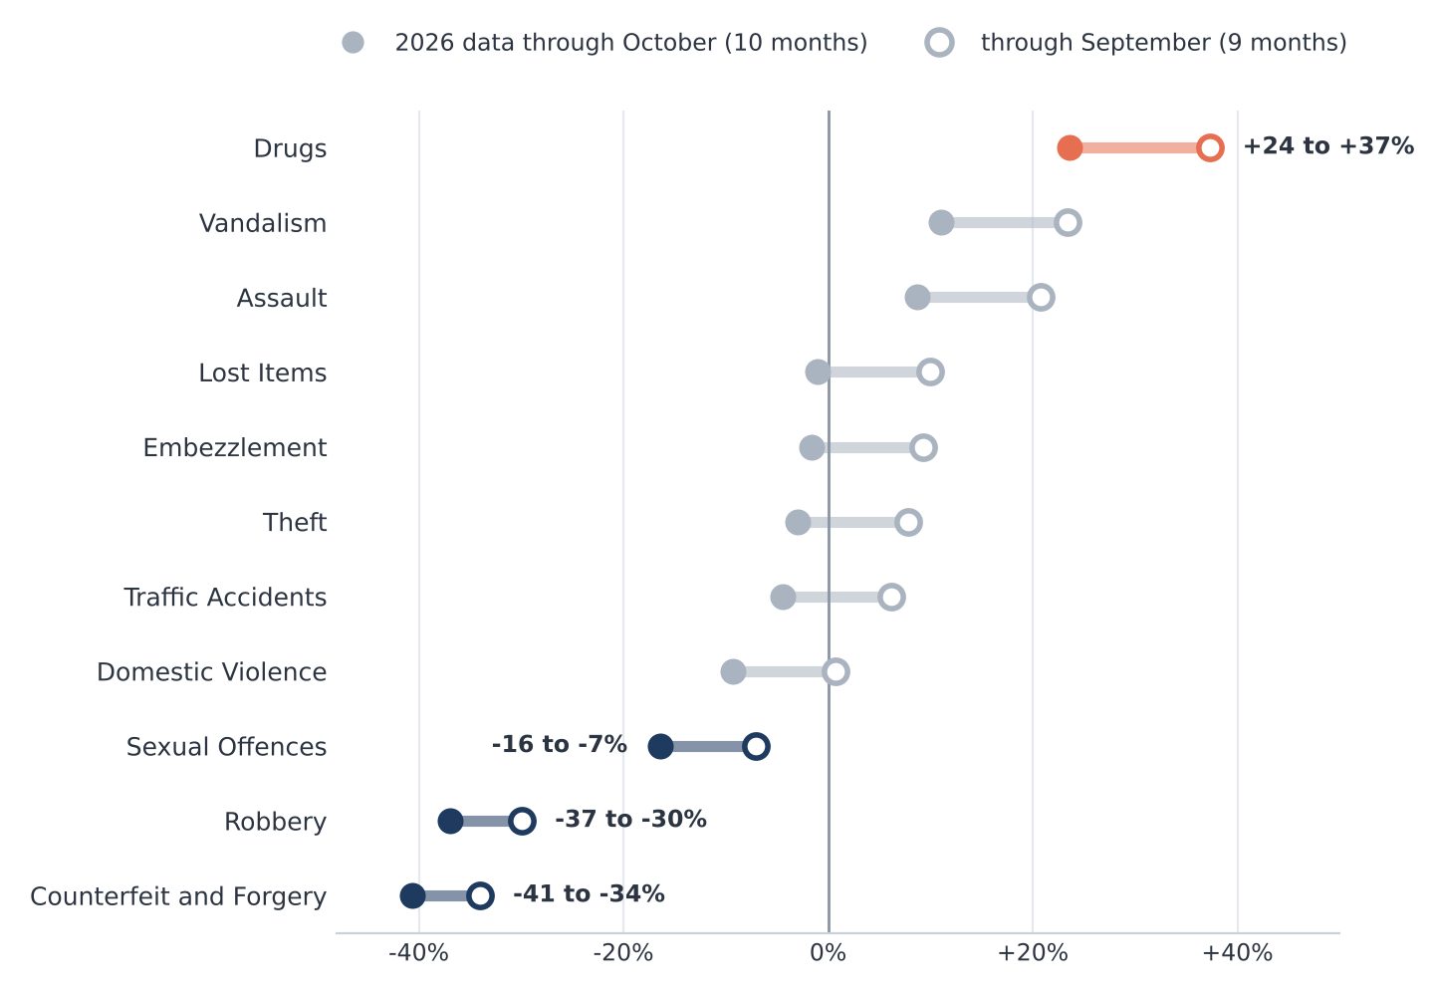
Figure 3. Change in monthly case rate, 2026 vs 2025, under both possible cut-offs. A range that crosses zero cannot be read as a rise or a fall.
Interpretation Only drugs rose, and only sexual offences, robbery and counterfeit and forgery fell, under both cut-offs. For theft, lost items, embezzlement, vandalism and assault the 2025 decline is real, but 2026 cannot be called up or down.

What the data cannot show
A fall in recorded cases does not establish improved safety. Domestic violence and sexual offences are often under-reported, so a fall can reflect changes in reporting, classification or recording as well as fewer incidents. Nothing in the supplied evidence links any reform to these categories.

4. The overall picture
Observation Drugs and traffic accidents together added 593 cases in 2025 while the other ten categories lost 1,121. Excluding those two, cases fell from 8,089 to 6,968 (−13.9%). For all categories, the 2026 monthly rate is +1.1% against 2025 on ten months and +12.3% on nine.
Interpretation “Crime fell” is too strong a summary. The mix is shifting toward drug cases, and the total combines crimes with accidents and lost-property reports. The overall direction in 2026 depends on the cut-off date.

Legislative and news context
The supplied evidence gives useful context, but none of it can test whether a law changed the counts, because the statistics are annual and the evidence items are single events.
Item | What it establishes | What it cannot establish
Prevention of Gang and Other Serious Offences Act (7/2025) | Passed by the Majlis on 15 May 2025; presidency release dated 25 May 2025; in legal effect after gazetting. | Any effect on case counts. 2025 mixes pre- and post-Act months, and 2026 is only partly recorded.
Land Transport Act | Ratified 31 August 2026; takes effect 30 days after gazetting and replaces Act No. 5/2009. | Any effect on 2024–2026 traffic counts, as it takes effect at the very end of the data window.
News items (a drug arrest, a motorbike crash, a hacking theft, all 2026) | That such cases occur and are reported. | A trend. Each is a single case.

Explaining a change needs counts dated finely enough to fall before and after an event. What this evidence supports is a set of hypotheses to test, not explanations.

Limitations and next steps
- Only 36 values exist (12 categories × 3 years), one per category per year, with a partial final year.
- The measure is not defined (reported crimes versus cases attended), and categories mix crimes with accidents and lost property.
- There are no population, visitor, regional or monthly figures, so no rates per head and no seasonality.
- How the police compile or classify the figures could not be verified.

Suggested next steps
- Confirm the exact end date of the 2026 data and state it in every chart and table.
- Check whether the police page offers monthly or quarterly counts, and rebuild the analysis on them.
- Record each category’s definition and separate crimes from accident and lost-property reports.
- Add population and visitor figures to compute rates per 100,000 residents.
- Test specific hypotheses with dated data, for example monthly drug cases before and after May 2025.

Sources
- Case counts: Maldives Police Service crime statistics (police.gov.mv/crime-statistics), as supplied in MALDIVES_CRIMESTATS_2426.xlsx; stats are up to October 2026.
- Presidency of the Maldives, press release on the Prevention of Gang and Other Serious Offences Act: presidency.gov.mv/Press/Article/33786
- Presidency of the Maldives, press release on the Land Transport Act, 31 August 2026: presidency.gov.mv/Press/Article/37273

