FINAL ASSIGNMENT
Full-stack E-Commerce Website — Project Report
WEB DEVELOPMENT AND DATABASES
Hussain Azzam Ibrahim
UWE ID: 26031831 | S2102626

CONTENTS
01 Introduction
02 Planning and Design
03 Main Features
04 AI Declaration
05 Conclusion
06 Appendix — Image Directory
07 Setup and Installation Guide

INTRODUCTION
Duckyvibes is a full-stack e-commerce website which focuses on gaming and technology products. The website provides a modern shopping experience with features such as Cart, Wishlist and separate customer and admin login interfaces. The project integrates both frontend and backend architecture as instructed, providing users with an interactive and functional e-commerce platform.

PLANNING AND DESIGN

1. Homepage
Header with logo, search, cart, Wishlist, and login; category navigation bar; product card grids per category (Laptops, Headsets, and additional categories); footer with contact details.
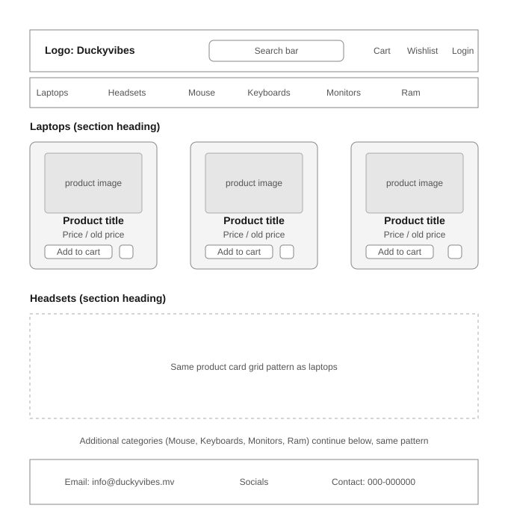
Figure 1. Homepage wireframe shows header, category navigation, and product card grid.

2. Product Page
Sole product view with header, product image, title, price, specifications list, add-to-cart and Wishlist actions, leading into the related products section. Product detail view includes the related products row directly below it. Footer intentionally omitted this page with the latest revision.

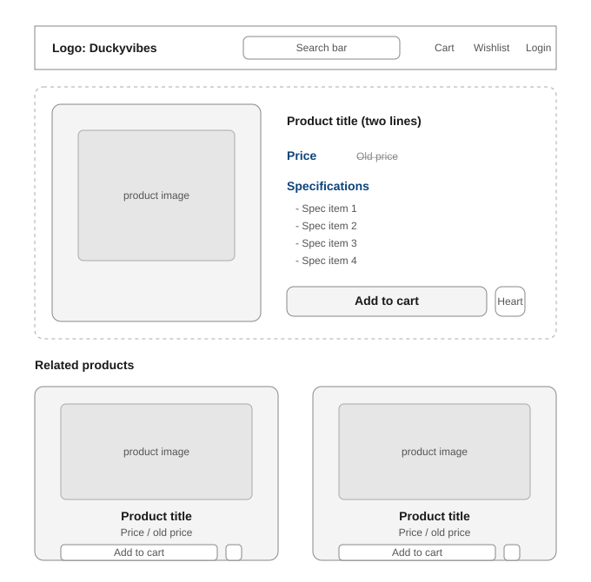
Figure 2. Product page wireframe with specifications, actions, and related products.

3. Filtered Pages
Filtered sets of products are viewed with header, product image, title, price, specifications list, add-to-cart and Wishlist actions leading to product page when items below are clicked.

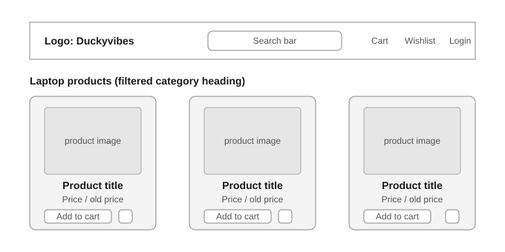
Figure 3. Filtered product listing wireframe.

MAIN FEATURES

Frontend
1. Product Catalogue
Products can be dynamically displayed and organized into categories through the category section allowing customers to view separate products groups which can be accessed through the list of categories given. This allows users to filter out products based on the type such as laptop, mouse or RAM.
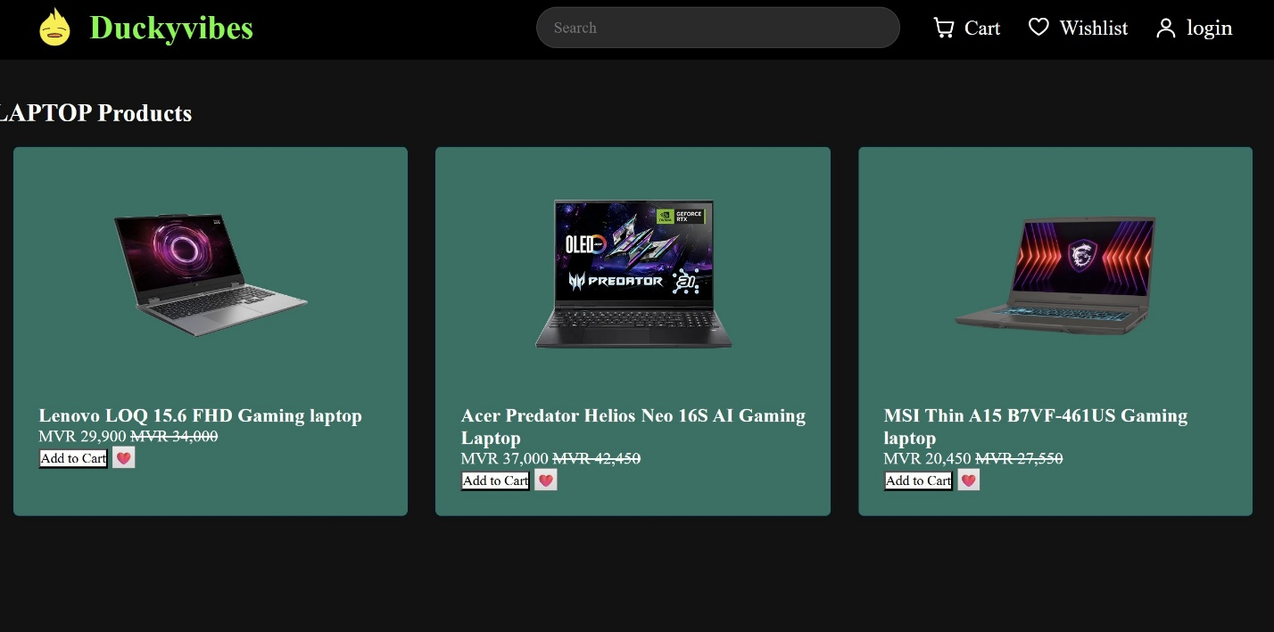
Figure 4. Product catalogue view organized by category.

2. Search & Filtering
Users can search for products in real time and filter products by category. For instance, if customer A searches for laptop, then the drop-down search menu will show laptops and if a specific product is mentioned then Customer A will be directed to the product page allocated for that product.
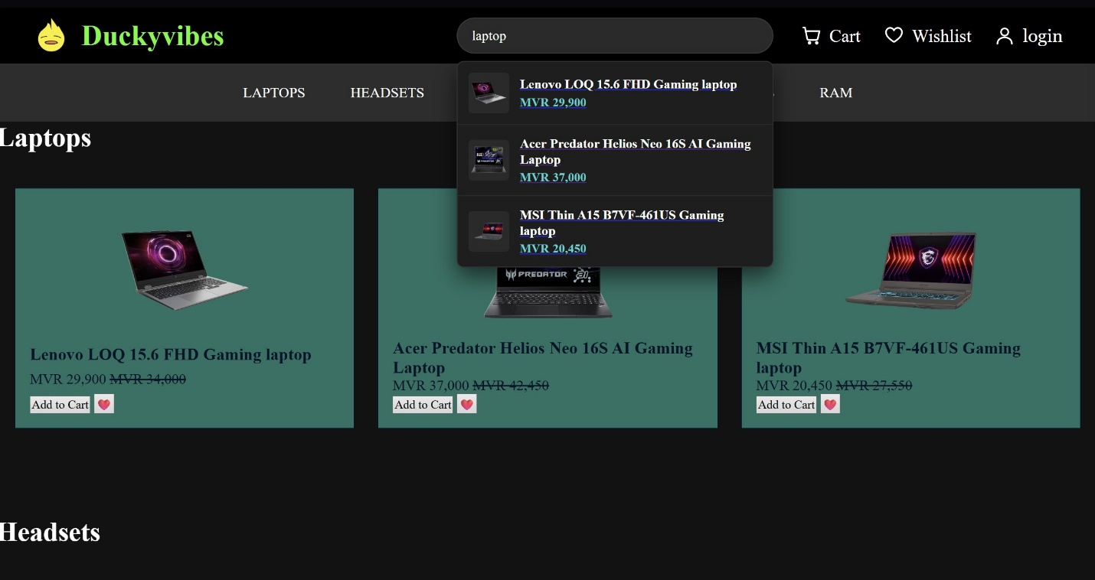
Figure 5. Real-time search and filtering interface.

3. Product Details
As mentioned above, each product has its own allocated product page which contains, Price, old price for marketing purposes, specifications and a short description of the product. Moreover, this website was designed with gamers as a focal point, so I made it so that the specifications were transparent and placed simultaneous interest to it as description since most gamers buy technological products based on specifications.
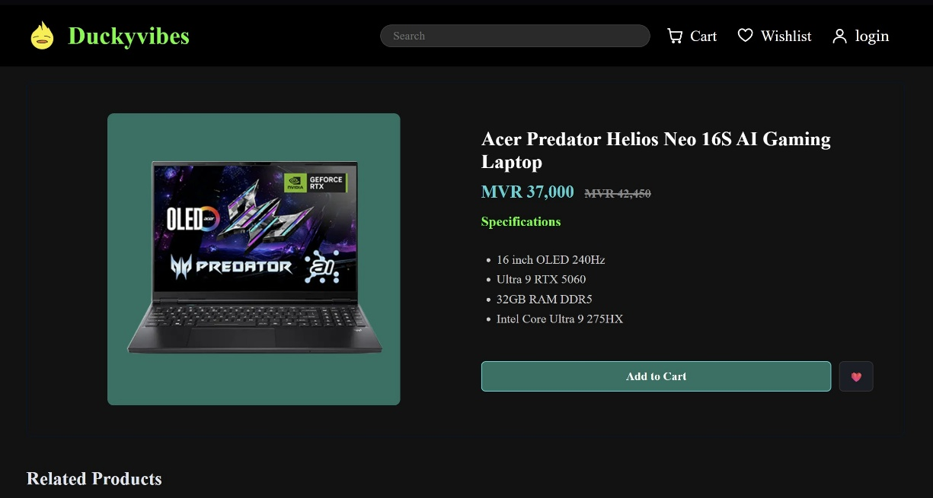
Figure 6. Product detail page with pricing and specifications.

4. Shopping Cart
Users can add products, change quantities, remove products and view the total which has an inbuilt calculation mechanism where the amount varies based on original price of the product and quantities purchased by the user. The checkout button is only there for design which I was unable to enable to functionality due to time constraints.
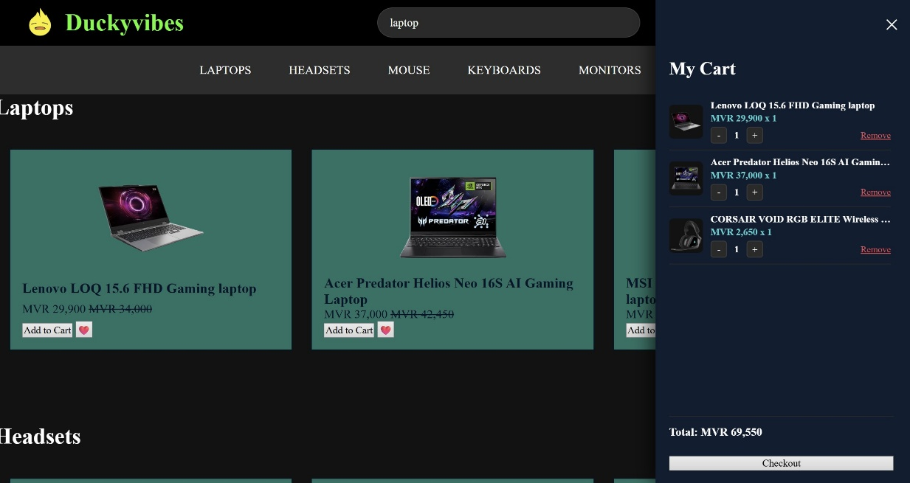
Figure 7. Shopping cart with quantity controls and live total.

5. Wishlist
This is a feature that is generic among similar websites as Duckyvibes. Users can save products and move them to the cart later. This was included through personal experience of the desire to purchase a product and saving that purchase for a different date when all requirements were met.
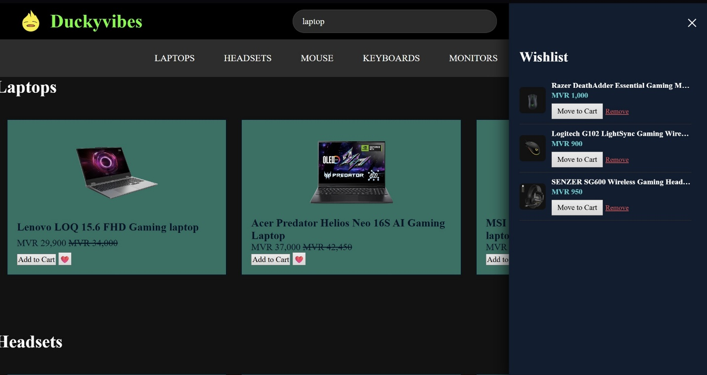
Figure 8. Wishlist page for saved products.
6. User Authentication
Login information is sent to the Django backend for authentication and allowing the user to be labelled either as customer or admin. Customers can view the default website with products and Wishlist items. On the other hand, individuals with administrative access can use crud functions and view various orders which were not made available due to time constraints.
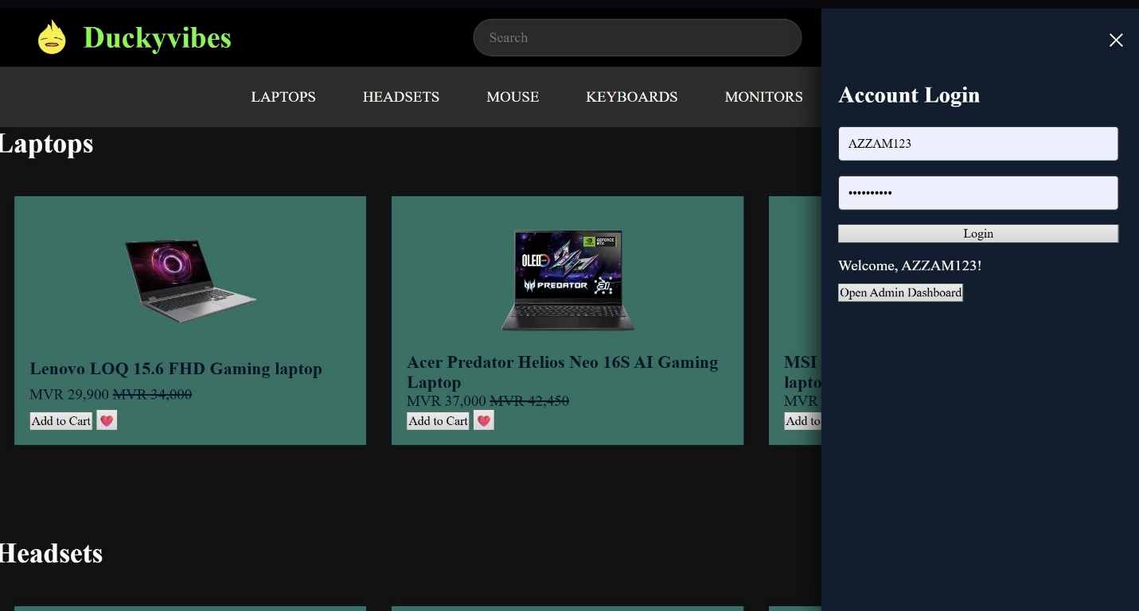
Figure 9. User authentication and login flow.

7. Admin Management
As mentioned above, admin management involves authorized users to view, add, delete and edit products. This feature was inspired by my time in a shop as a salesclerk where I had to use crud functions for retail items and only, I had access to username + password as roles were assigned to each of the staff.
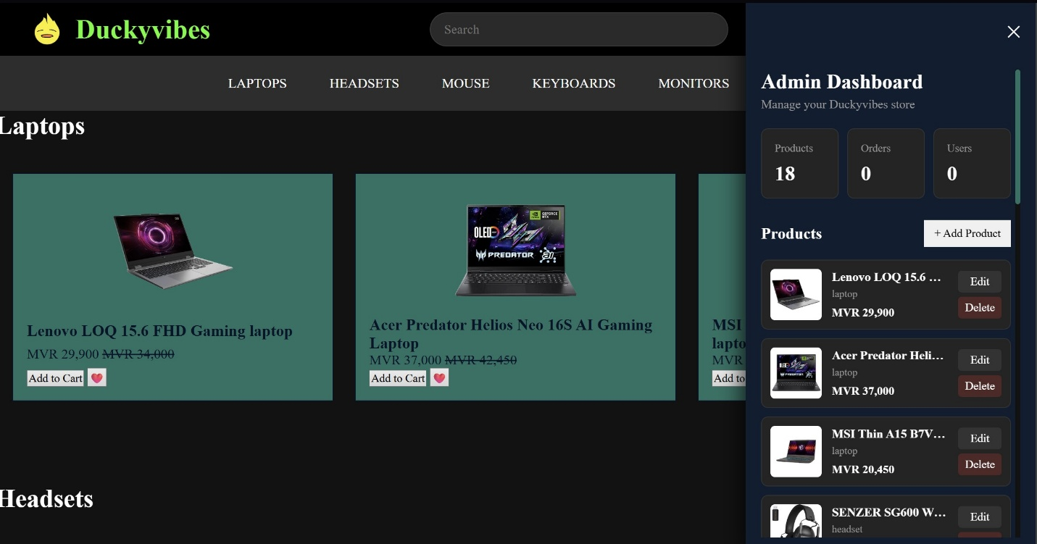
Figure 10. Admin management dashboard for product CRUD operations.
8. Backend Integration & Fallback System
Currently, Products are loaded from Django and to load them the Django server must be online. So, I made a fallback dataset to counter a scenario where Django server fails to be online within a grace period of 3 seconds and to allow the developers to see whether the server is connected and online, I included a banner that mentions either live mode or demo mode.
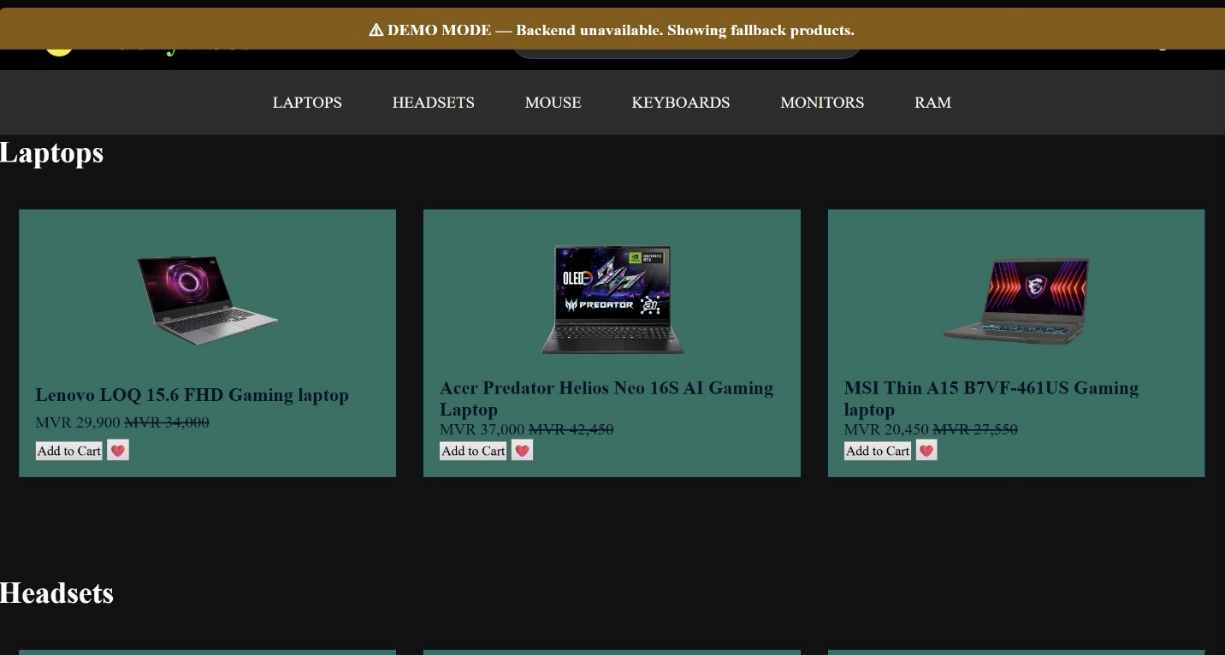
Figure 11. Live/Demo mode banner for backend connectivity fallback.

9. Error Handling
The JavaScript includes error handling for backend operations. For instance, for example if Admin username and password is incorrect or role is not given then the frontend displays a message which allows the web page stay active rather than leaving the user with a broken interface.
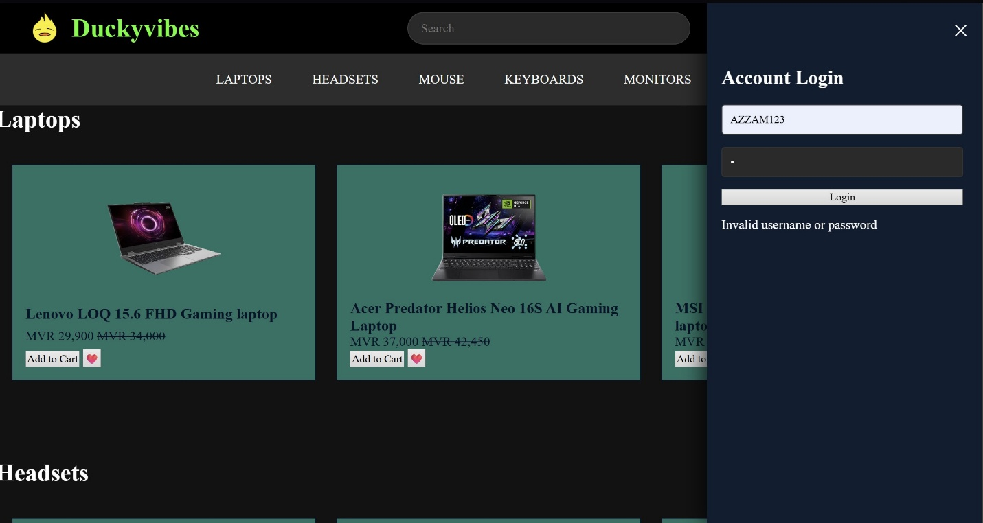
Figure 12. Error handling message displayed to the admin user.
10. Product Database
This is the foundation of the website which stores items in a SQLite Database which can be accessed through the JSON file. After that, when the frontend requests for the product Django retrieves them from the database. This feature created the boundary between a static website and a full-stack application.
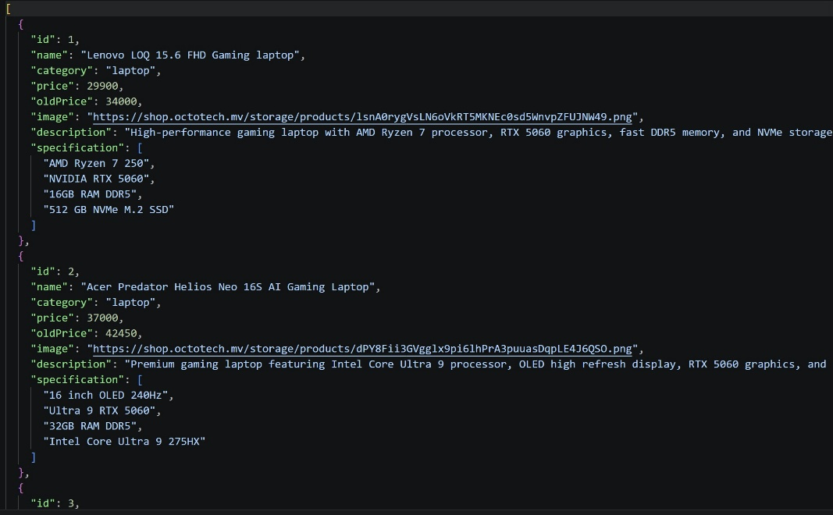
Figure 13. Product database structure accessed via Django.

AI DECLARATION
During the development of this website, I have used AI tools to optimize my learning and implementation process. I used Gemini to discuss the architecture and steps of building a full-stack e-commerce website, debug errors and better understand the development process. I found some AI-generated JavaScript code useful examples useful, which I then reviewed, modified, and integrated and evaluated before I included them into the project. I used ChatGPT to create the setup and installation guide due to constraints which I checked and implemented after reading and amending certain points I found to be important. Moreover, ChatGPT was used to explain the fundamentals of backend development and an assistance tool to discuss setting up of Django framework. I also used Claude for creating wireframes provided above, which were compared, reviewed and amended accordingly before being included in the documentation. Moreover, Claude was used as a design assistant for the report and a discussion partner for implementation of my ideas. Moreover, I also used to create the appendix which was examined and checked before being integrated into the report.
I remain responsible for the overall design, implementation, testing and final submission of the report and website.

CONCLUSION
Upon completion of the website, I learnt the architectural structure of a full-stack website and worked together with AI tools as a developer discussing technical issues of a project with more experienced developers to reduce any inconsistencies. I also discovered that I have retained the skill of identifying whether a specific website uses backend or only frontend just from the UI. For future websites, I will include a product selection and payment process more functional and include mobile responsiveness since a major demographic of gamers use mobiles to purchase products. Due to time constraints and to avoid losing functionality, I did not implement these known limitations before submission.

APPENDIX — IMAGE DIRECTORY
This appendix lists every figure referenced in the report, labelled in the order they appear, alongside the section they belong to and a brief description of each image.

Label | File | Section | Description
Figure 1 | image1.png | Planning & Design | Homepage wireframe
Figure 2 | image2.png | Planning & Design | Product page wireframe
Figure 3 | image3.png | Planning & Design | Filtered product listing wireframe
Figure 4 | image4.jpeg | Main Features | Product catalogue view
Figure 5 | image5.jpeg | Main Features | Search & filtering interface
Figure 6 | image6.jpeg | Main Features | Product detail page
Figure 7 | image7.jpeg | Main Features | Shopping cart
Figure 8 | image8.jpeg | Main Features | Wishlist page
Figure 9 | image9.jpeg | Main Features | User authentication / login
Figure 10 | image10.jpeg | Main Features | Admin management dashboard
Figure 11 | image11.jpeg | Main Features | Backend fallback banner (Live/Demo mode)
Figure 12 | image12.jpeg | Main Features | Error handling message
Figure 13 | image13.jpeg | Main Features | Product database structure

SETUP AND INSTALLATION GUIDE
1. Introduction
Duckyvibes is a full-stack e-commerce website developed using HTML, CSS, JavaScript, and Django. The frontend provides the user interface for browsing products and interacting with the website, while the Django backend manages server-side functionality.
The project was developed using Visual Studio Code (VS Code) and Git Bash. A Python virtual environment (venv) is used to manage the project's Python dependencies.
2. Technologies Used
- Visual Studio Code — Code editor used for development.
- HTML — Website structure.
- CSS — Website styling and layout.
- JavaScript — Frontend interactivity and functionality.
- Python — Backend programming language.
- Django — Python web framework used for the backend.
- Git Bash — Terminal used to run commands and manage the project.
- Git/GitHub — Version control and project repository.
- Live Server — VS Code extension is used to preview frontend files in a web browser.
3. Project Structure
The project contains the frontend and Django backend components.

Duckyvibes/
│
├── venv/
│ └── Python virtual environment
│
├── backend/
│ ├── manage.py
│ ├── config/
│ └── shop/
│
├── frontend/
│ ├── HTML files
│ ├── CSS files
│ ├── JavaScript files
│ └── assets/
│
└── README.md

The exact folder names may vary depending on the final project structure.
4. Requirements
Before running the project, make sure the following software is installed:
- Visual Studio Code
- Python
- Git Bash
- A modern web browser such as Google Chrome
- Required VS Code extensions, such as Live Server
Python can be verified by running:
Python version 3.14.3

Git can be verified using:
git version 2.53.0.windows.1
5. Opening the Project
Open Git Bash and navigate to the Duckyvibes project directory.
cd ~/Villa_web_dev/Duckyvibes

Alternatively, the project can be opened directly in Visual Studio Code.
code.

This opens the Duckyvibes project folder in VS Code.
6. Activating the Virtual Environment
The project uses a Python virtual environment called venv. From the Duckyvibes project directory, activate the environment using:
source venv/Scripts/activate

After successful activation, the terminal should display something similar to:
(venv) user@computer ~/Villa_web_dev/Duckyvibes

The virtual environment ensures that the Python packages required by Duckyvibes are isolated from other Python projects on the computer.
7. Navigate to the Django Backend
After activating the virtual environment, navigate to the directory containing manage.py.
cd backend

The manage.py file is the main command-line utility used to interact with the Django project.
8. Install Required Dependencies
If the project contains a requirements.txt file, install the required Python packages using:
pip install -r requirements.txt

This should be done after activating the virtual environment. If Django needs to be installed manually, use:
pip install django
9. Run Database Migrations
Before starting the Django server for the first time, apply the database migrations:
python manage.py migrate

Django uses migrations to create and update the database structure required by the application.
10. Start the Django Development Server
Once the virtual environment is activated and the terminal is inside the backend directory, start the Django development server:
python manage.py runserver

If successful, Django will display a message similar to:
Starting development server at http://127.0.0.1:8000/

The backend can then be accessed through:
http://127.0.0.1:8000/

The Django development server should remain running while testing the backend functionality.
11. Running the Frontend
The frontend can be previewed using the Live Server extension in Visual Studio Code.
Steps:
- Open the frontend HTML file in VS Code.
- Right-click the HTML file.
- Select Open with Live Server.
- The website will open automatically in the default browser.
Live Server provides a convenient way to preview frontend changes in an external browser.
12. Running Frontend and Backend Together
For the complete Duckyvibes website, both the frontend and backend may need to be running.
Terminal 1 — Django Backend
cd ~/Villa_web_dev/Duckyvibes
source venv/Scripts/activate
cd backend
python manage.py runserver

Browser
The Django server will normally be available at:
http://127.0.0.1:8000/

Frontend
If the frontend is being served independently, use the Live Server extension from VS Code to open the frontend in the browser.
13. Creating a Django Superuser
If the project uses Django's administration system, a superuser can be created using:
python manage.py createsuperuser

Django will ask for the required username and password. The Django administration panel can then normally be accessed at:
http://127.0.0.1:8000/admin/
14. Stopping the Server
To stop the Django development server, return to the Git Bash terminal where the server is running and press:
CTRL + C

This will terminate the development server.
15. Complete Setup Command Sequence
For future use, the basic setup process can be summarized as:
cd ~/Villa_web_dev/Duckyvibes
source venv/Scripts/activate
cd backend
pip install -r requirements.txt
python manage.py migrate
python manage.py runserver

After running the server, open the address displayed in the terminal, normally:
http://127.0.0.1:8000/
16. Troubleshooting
Django command not found
Make sure the virtual environment is activated:
source venv/Scripts/activate

Then check Django:
python -m django --version

Cannot find manage.py
Make sure you are inside the backend directory:
cd ~/Villa_web_dev/Duckyvibes/backend

Then check the files:
ls

manage.py should appear in the directory.
Port 8000 is already in use
Django can be started on another port:
python manage.py runserver 8080

The website will then normally be available at:
http://127.0.0.1:8080/
17. Development Workflow
The general development workflow used for Duckyvibes is:

Open Project
↓
Activate Virtual Environment
↓
Open Backend Directory
↓
Run Django Server
↓
Run / Preview Frontend
↓
Open Website in Browser
↓
Test Features
↓
Modify HTML / CSS / JavaScript / Django
↓
Refresh Browser
↓
Commit Changes to Git

This setup allows the frontend and Django backend to be developed and assessed locally before deployment.

18. Summary
Duckyvibes can be started locally by activating the Python virtual environment, navigating to the Django backend directory, and running the Django development server.
The essential commands are:
cd ~/Villa_web_dev/Duckyvibes
source venv/Scripts/activate
cd backend
python manage.py runserver

The frontend can be previewed through VS Code's Live Server extension, while Django's development server oversees the backend functionality.
This setup provides a local development environment where the Duckyvibes e-commerce website can be developed, tested, and demonstrated before deployment.

