Instructions to run product-service (myretail):
Clone and import the maven projects from Git hub in to the IDE (preferred STS)
Build maven projects (mvn clean install)
Install mysql version 8 and create user with the following credentials
User name : root and password : admin
Create schema product
CREATE DATABASE `product` /*!40100 DEFAULT CHARACTER SET utf8mb4 COLLATE utf8mb4_0900_ai_ci */;
Run “registry “service as spring boot application (runs on port 8761).
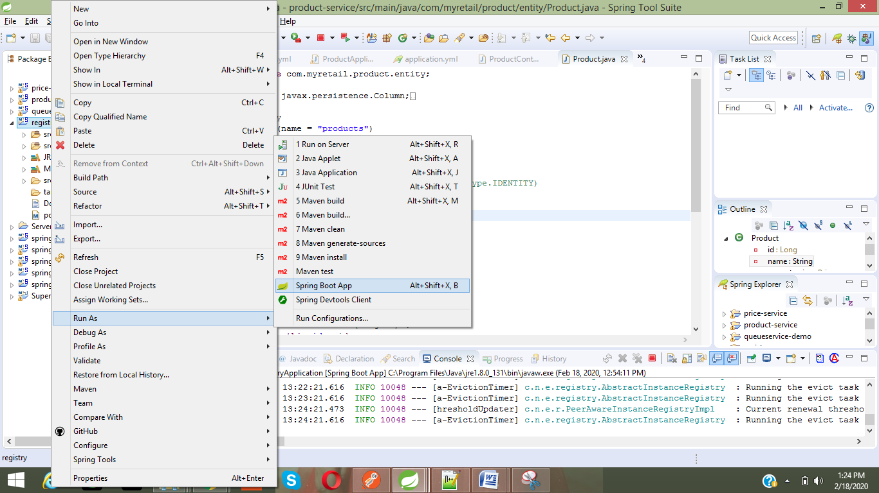

Run price-service as spring boot application (runs on port 8081).
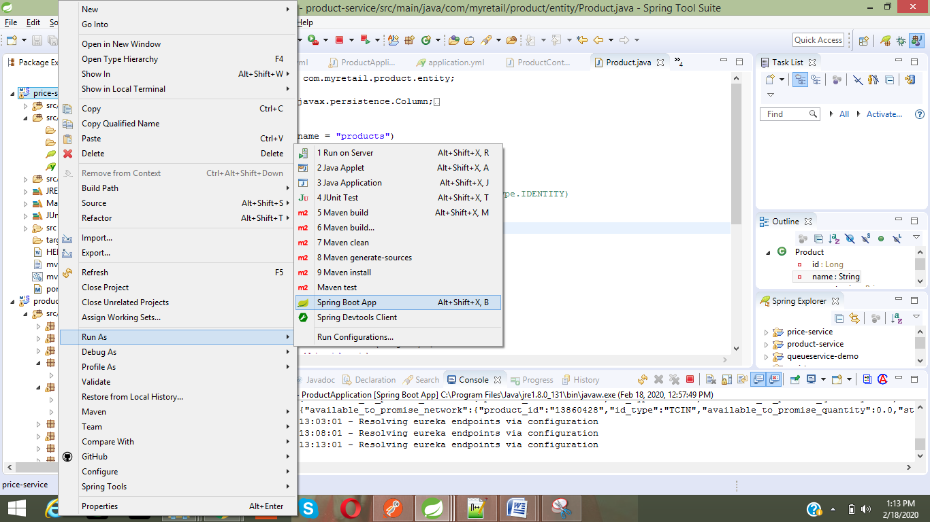
To run another instance of price-service, for scalability
Run as →runconfigurations
Override the server.port property.
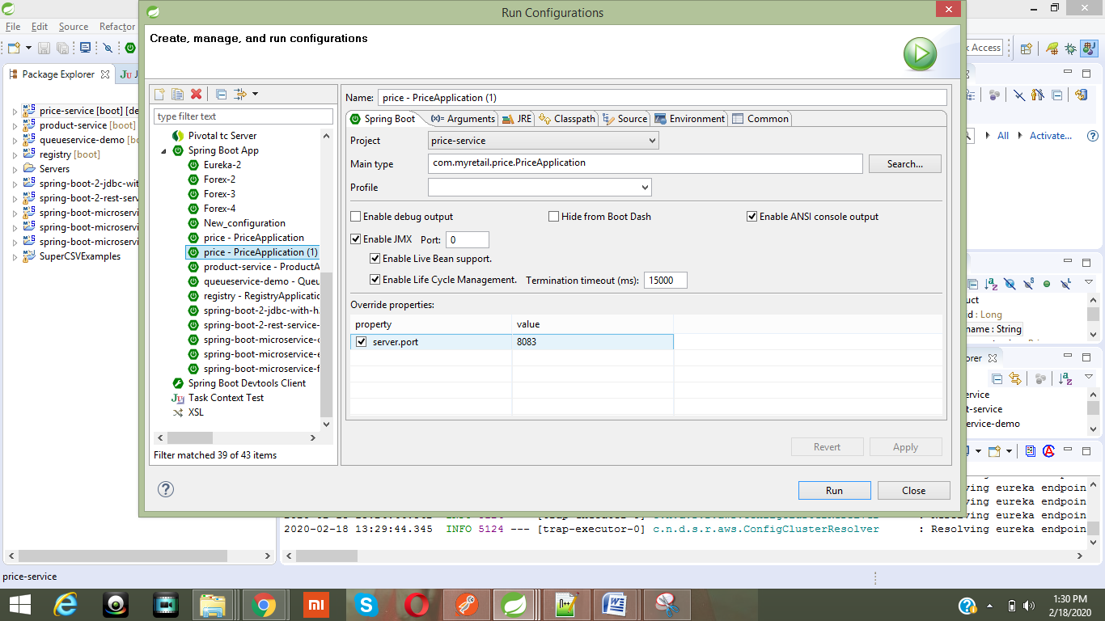

Run product-service as spring boot application (runs on port 8080).
Add an environment variable PDP_URL
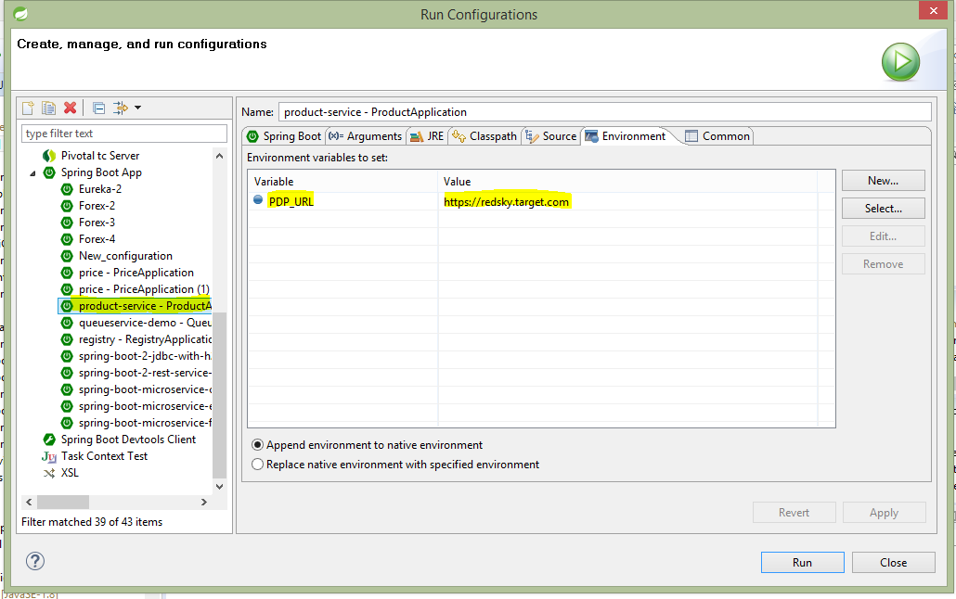
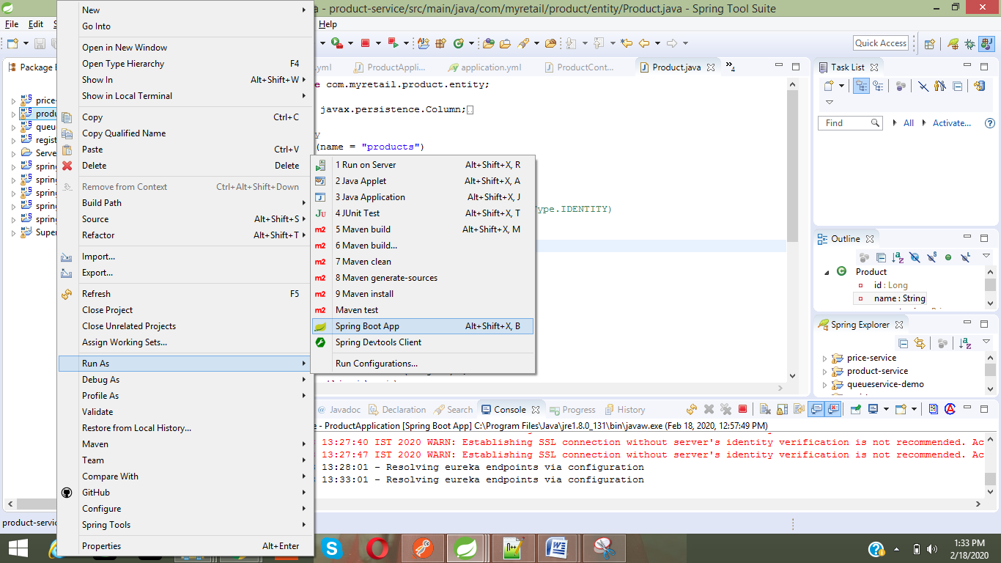

All the services get register with discovery server (Netflix Eureka).
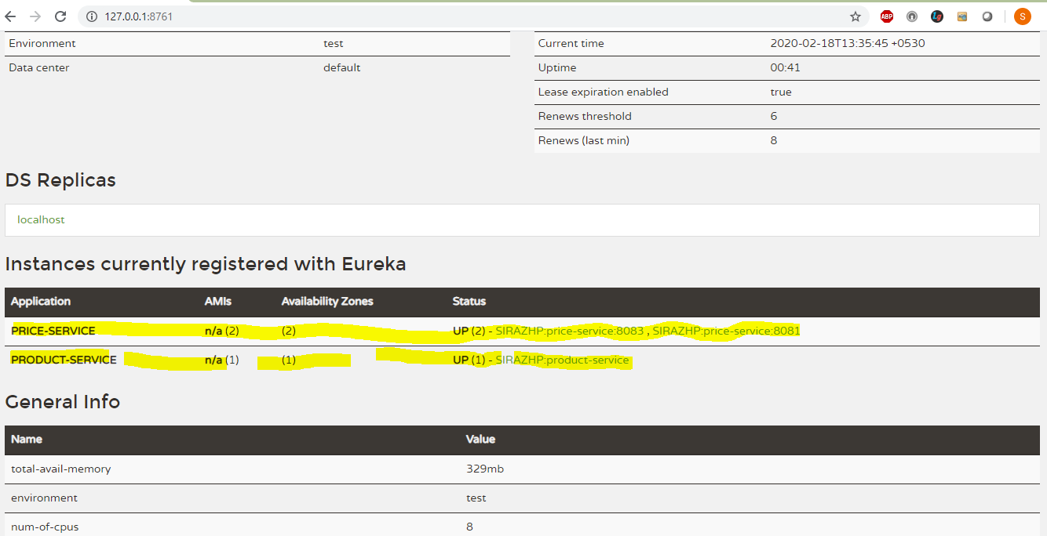

Service URLs:
Registry URL: http://127.0.0.1:8761/
Price-service URLs: http://127.0.0.1:8081/
http://127.0.0.1:8083/
product-service URL: http://127.0.0.1:8080/
Service implementation details
Price-service is a spring boot micro service, which expose a GET URI http://localhost:8083/price/{productId}
For example: http://localhost:8083/price/13860428
Price-service will return mocked price details for a given product Id. On start-up this will register with Eureka discovery server. This can be implemented using data store.
Sample price-service json response.
{
"value": 3.22,
"currency_Code": "USD"
}

Product-service also a spring boot micro service acts as an aggregate service which respond to a GET URI
http://localhost:8080/v1/myretail/products/{productId} and combines response into single json response from the below two services
This service gets the product name for a given productId from the below service URL
https://redsky.target.com/v2/pdp/tcin/13860428?excludes=taxonomy,price,promotion,bulk_ship,rating_and_review_reviews,rating_and_review_statistics,question_answer_statstics
And also gets the price details from the price-service (URI http://localhost:8083/price/{productId})
http://localhost:8083/price/13860428

Example: http://localhost:8080/v1/myretail/products/13860428
Json response:
{
"id": 13860428,
"name": "The Big Lebowski (Blu-ray)",
"current_price": {
"value": 3.22,
"currency_Code": "USD"
}
}

Product –service uses a feign client and eureka service registry (client side hystrix (circuit breaker) and Ribbon (client side load balancer)) to access the external services.

Swagger UI fro product-service can be accessible at http://localhost:8080/swagger-ui.html#/

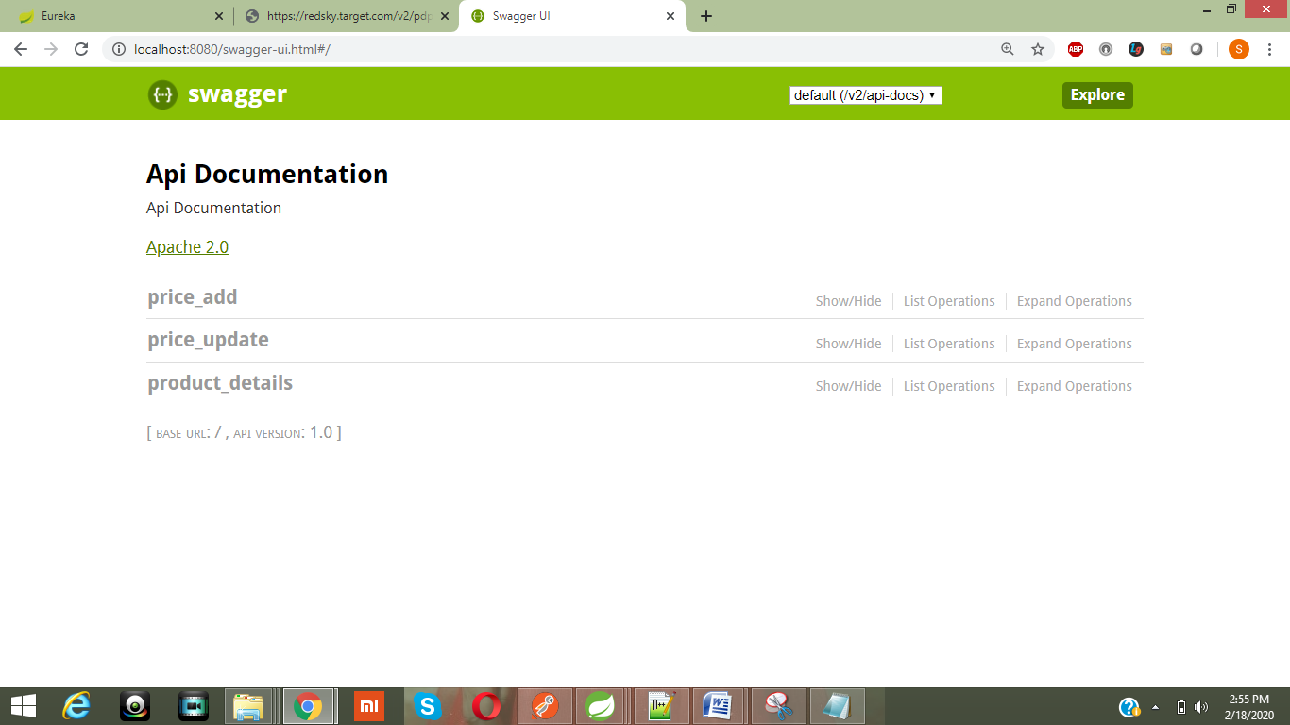

Swagger UI fro price-service can be accessible at http://localhost:8081/swagger-ui.html#/

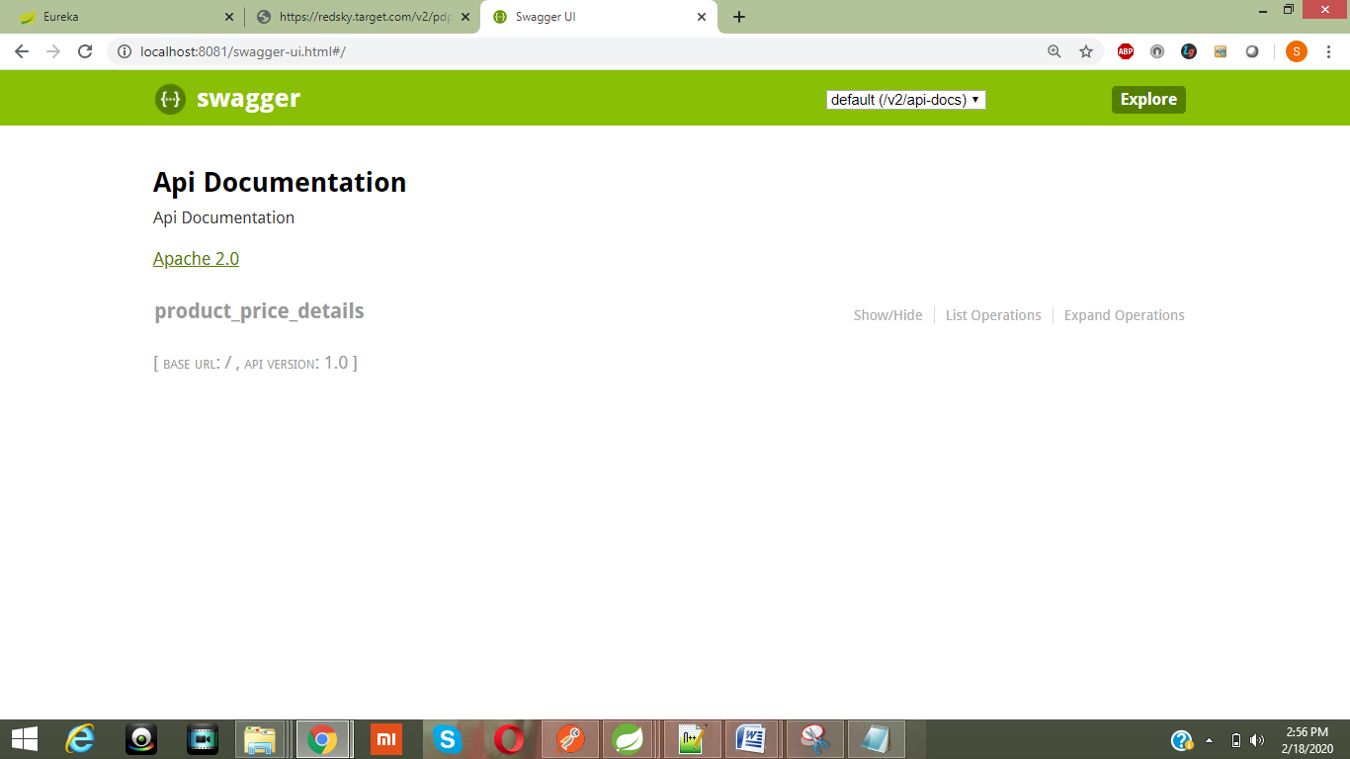

Test results:

Sample mocked price available for the below productIds

public void loadProductPriceData() {
map.put(13860428l, new Price(3.22f, "USD"));
map.put(13860421l, new Price(4.22f, "USD"));
map.put(13860422l, new Price(5.22f, "USD"));
}

1). ProductId13860428 exists in both services.
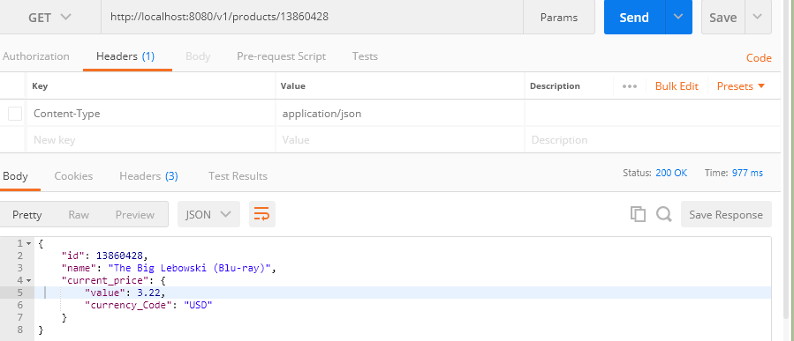

2). ProductId13860421 exists in both services.
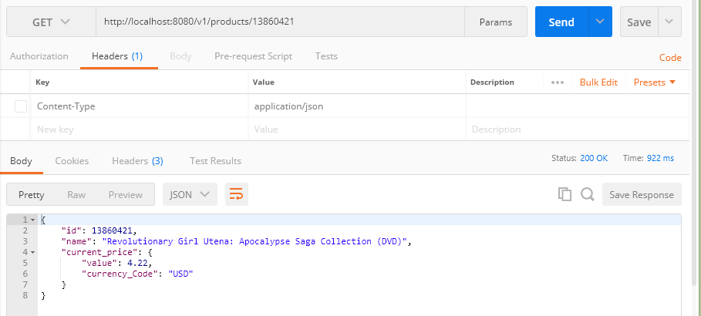

3). ProductId13860422 exists in “price-service” but no product in the https://redsky.target.com/v2/pdp/tcin/13860422?excludes=taxonomy,price,promotion,bulk_ship,rating_and_review_reviews,rating_and_review_statistics,question_answer_statstics
As product don’t exixts, we should not display the price also.

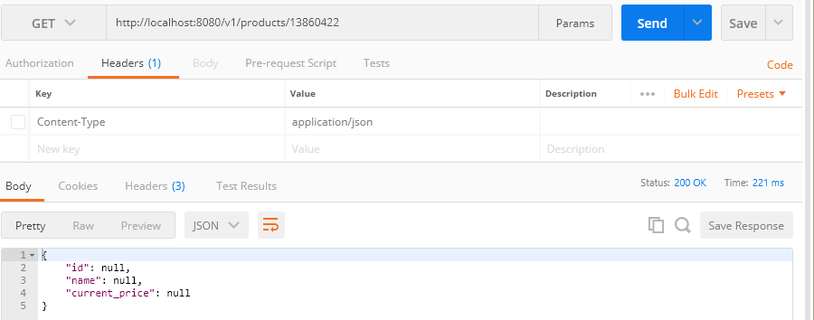

4). ProductId 13860423 exists in https://redsky.target.com/v2/pdp/tcin/13860423?excludes=taxonomy,price,promotion,bulk_ship,rating_and_review_reviews,rating_and_review_statistics,question_answer_statstics.
Price not exists for 13860423 in “price-service”.

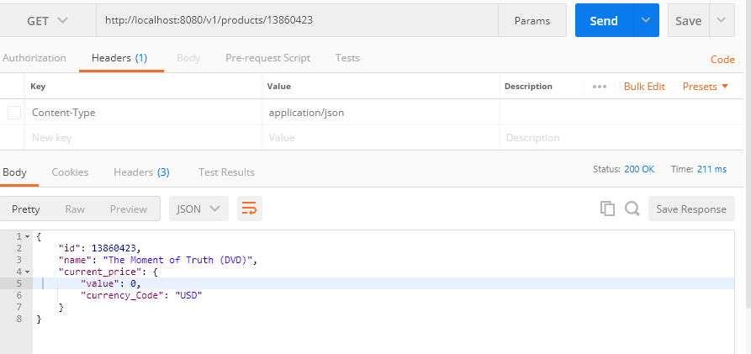

5). Service https://redsky.target.com/v2/pdp/tcin/13860428?excludes=taxonomy,price,promotion,bulk_ship,rating_and_review_reviews,rating_and_review_statistics,question_answer_statstics not reachable or not available
In this case hystrix breaks the circuit to avoid cascade failure and returns the default product details using the fallback method.
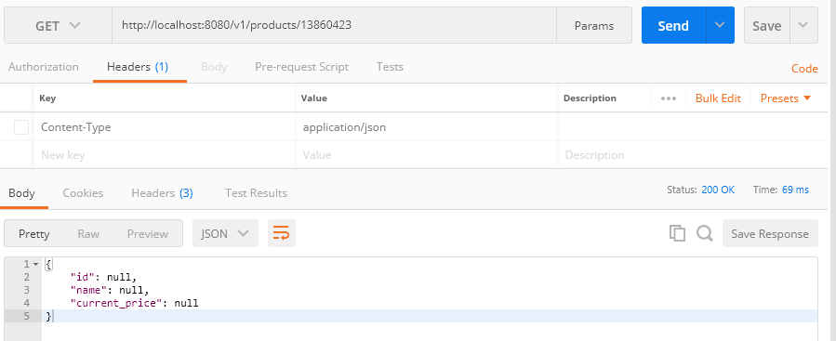

6). If “price-service” not reachable or not available, but product exists in https://redsky.target.com/v2/pdp/tcin/13860428?excludes=taxonomy,price,promotion,bulk_ship,rating_and_review_reviews,rating_and_review_statistics,question_answer_statstics
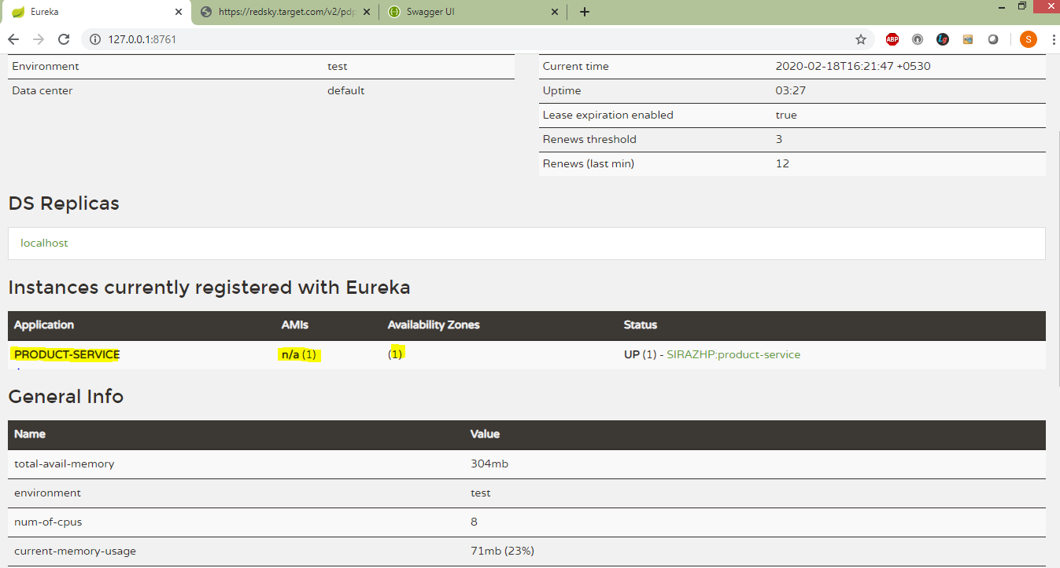
So hystrix returns default price

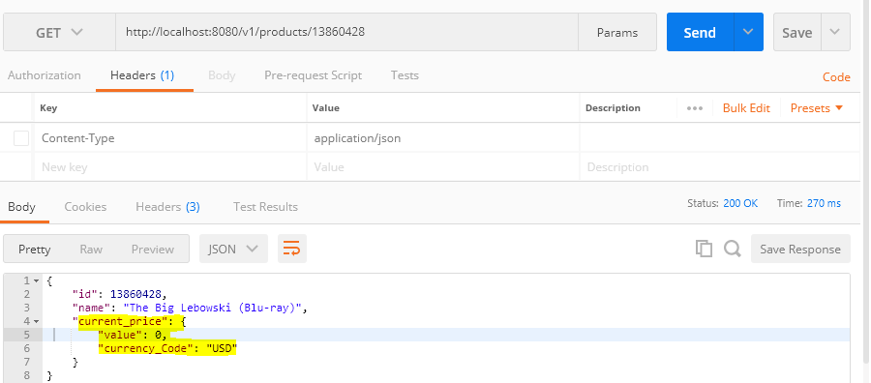

7). Save price to product-service DB.

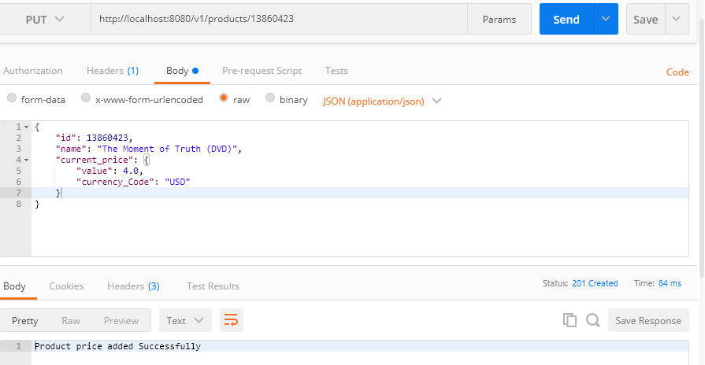
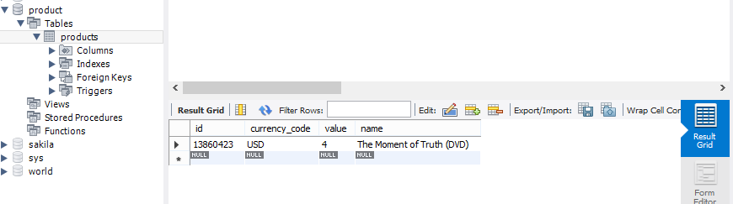
8). Update price using http POST.

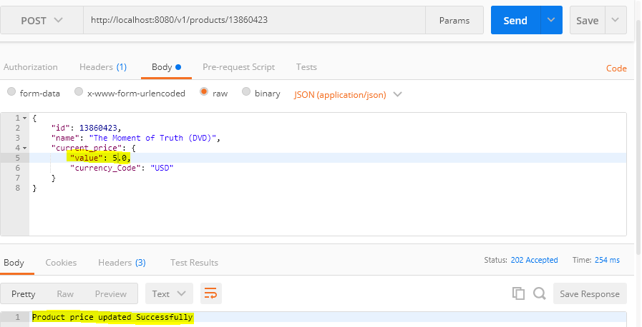

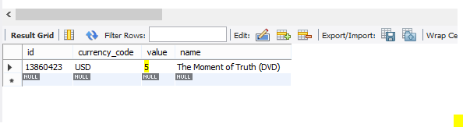
Note:
To make above solution production ready we can consider following things
Proper exception handling with error codes.
Implementation of Logging.
Implementing unit test cases using powermock, mokito , restassured and testing.
Implementation of ssl (https), TLS, OWASP recommendations.

Implementing the micro services patterns like
Config server (spring cloud config server)
API gateway (Zuul)
Authorization thru Oauth server / using JWT / SAML
Centralized Logging using ELK /kafka / fluentd
Distributed tracing using spring cloud sleuth, zipkin
Monitoring using spring boot admin / prometheus

The above micro services patterns can be implemented uisng service mesh like Istio.

The implementation of micro services should be followed by using Devops tool chain.

The micro service can be shipped as a docker image and can run in Kubernates clustor to manage the micro services using pods and can take advantage of Kubernates features like scaling, resiliency, to do blue green, kenary deployments etc.

