A

Project Report

ON

” Online Fee Structure”



**Session: 2015-2019**

Department of Computer Science

**IES COLLEGE OF TECHNOLOGY, BHOPAL**

**KALKHEDA, RATIBAD, BHOPAL**

**RGPV University Madhya** **Pradesh**



**SUBMITED BY:**

**ABU INTAKHAB (0177CS151008)**

**MD SADDAM HUSSAIN (0177CS151087)**

**HARIS SERWER (0177CS151056)**

**MD SAIFULLAH (0177CS151088)**

**Submitted To:-**

**PROF. ANSHUL SARAWAGI PROF. AISHWARYA MISHRA DR. S. KUMAR**

**(PROJECT GUIDE) (H.O.D.) (PRINCIPAL)**

## Department of Computer Science



## IES College of Technology Bhopal(MP)

# **DECLARATION**

I hereby declare that the work, which is being presented in the Project Report, entitled **“Online Fee Structure”** in partial fulfillment for the award of Degree of **“Bachelor of Engineering” Submitted to the Department of Computer Science, IES College of Technology & Management, Bhopal** RGPV Technical University is a record of my own investigations carried under the Guidance of **Prof. Anshul Sarawagi** Department of Computer Science, IES College of Technology & Management, Bhopal. I have not submitted the matter presented in this Project Report anywhere for the award of any other Degree.

**Supervisor**

**(ANSHUL SARAWAGI**)

IES College of Technology Bhopal.

Kalkheda Ratibad, Bhopal(MP)

## Department of Computer Science

IES College of Technology, Bhopal



# **TO WHOM IT MAY CONCERN**

This is to certify that Mr. /Miss/Mrs. **ABU INTAKHAB, MD SADDAM HUSSAIN, HARIS SERWER, MD SAIFULLAH** University Examination Roll No.0177CS151008, 0177CS151087, 0177CS151056, 0177CS151088 of the Course of **BE 6th** Semester (third year) has completed this assignment and project work satisfactory. He/She has performed this project work entitle “**Online Fee Structure**” under my supervision. I am satisfied with his /her work and wish for his/her further success.

### Internal Examiner External Examiner

### Name: Anshul Sarawagi Name: _________________

**Signature: _____________ Signature: ______________**

**CONTENTS**

|  |  |  |  |  |
| --- | --- | --- | --- | --- |
| **Acknowledgement** | | | |  |
|  | | | |  |
| **Abstract** | | | | **1** |
|  | | | |  |
| **List of Figures** | | | | **2** |
|  | | | |  |
| **List of Tables** | | | | **3** |
|  | | | |  |
| **1** | **Introduction** | | | **4** |
|  | |  |
| 2 | Objective | | | 5 |
|  |  | | |  |
|  |  | | |  |
| **3** | **System Analysis** | | | **6** |
|  | 3.1 Definition | | | 6 |
|  | 3.2 Description of present system | | | **6** |
|  | 3.3 Limitation of present system | | | 6 |
|  |  | | |  |
| **4** | **Feasibility Study** | | | **8** |
|  | 4.1 Technical Feasibility | | | 8 |
|  | 4.2 Economic Feasibility | | | 9 |
|  | 4.3 Behavioral Feasibility | | | 9 |
|  |  | | |  |
|  |  | | |  |
| **5** | **Software Engineering Paradigm Applied** | | | **10** |
|  | 5.1 Life Cycle Models | | | 10 |
|  | 5.1.1 Waterfall Model | | | 11 |
|  |  | | |  |
|  |  | | |  |
| **6** | **System Specification** | | | **13** |
|  | 6.1 Hardware description | | | 13 |
|  | 6.2 Software description | | | 13 |
| **7** | **Introduction Of PHP** | | | **14** |
|  |  | | |  |
| **8** | **System Design** | | | **16** |
|  | 8.1 Definition | | | 16 |
|  | 8.2 Output Design | | | 16 |
|  | 8.3 Input Design | | | 17 |
|  | 8.4 Logical Design | | | 17 |
|  | 8.5 Modules | | | 17 |
|  | 8.6 Diagram | | | 20 |
|  | 8.6.1 Data Flow Diagram | | | 20 |
|  | 8.6.2 ER Diagram  8.6.3 Use Case Diagram  8.7 UML Diagram  8.8Architecture Design  8.9 Flow Chart | | | 21  22  23  24  25 |
|  | 8.10ER Diagram | | | 26 |
|  |  | | |  |
|  |  | | |  |
|  |  | | |  |
|  |  | | |  |
| **9** | **Tables** | | | **30** |
|  |  | | |  |
| **10** | **Form Layout** | | | **34** |
|  |  | | |  |
| **11** | **Testing** | | | **42** |
|  |  | | |  |
| **12** | **System implementation & Evaluation** | | | **46** |

**13 Feature and uniqueness of the Project 47**

**14 Conclusion 48**

**15 Bibliography 49**

|  |  |  |
| --- | --- | --- |
|  |  |  |

**ACKNOWLEDGEMENT**

I wish to express my deep sense of gratitude and sincere thanks towards my guide **Mr. Anshul Sarawagi** (Head, Department of Computer Science, IES College of Technology & Management, Bhopal) for his guidance and encouraging support which were invaluable for the completion of this work.

.

I would like to express my special thanks to my friends and those who helped my directly and indirectly in completion of this project.

Finally, yet importantly, I would like to express my heartfelt thanks to my beloved parents for their help, and support in all the circumstances and kept my moral always high.

**ABSTRACT**

The Project entitled "Online Fee Structure" is a web application. Software developed in PHP LANGUAGE using **HTML/CSS** as front-end and **MYSQL** as back-end on Windows Operating System. The Online Fee Structure web application is intended to provide complete solutions for student as well as college through a single get way using the internet as the sole medium.

It will enable student to setup online fee, student to browse through the website and pay online fee without having to visit the account section physically.

The proposed system is a web application. It can be accessed by anywhere in the world. The proposed system builds a direct communication between the student and intitution. With this both have an understanding and maintain their fee and fine directly on website.

|  |  |  |
| --- | --- | --- |
|  |  |  |
|  |  |  |

### List of Figures

|  |  |  |
| --- | --- | --- |
| **SNO.** | **Name of Figure** | **Page No.** |
| 1 | DFD Level-0 for User | 11 |
| 2 | DFD Level-1 for User | 11 |
| 3 | Architecture | 24 |
| 4 | Flowchart | 25 |
| 5 | ER Diagram | 26 |
| 7 | Screenshot of Home Page | 34 |
| 8 | Screenshot of Registration Page | 35 |
| 9 | Screenshot of Student Profile Page | 35 |
| 10 | Screenshot of Result Page | 36 |
| 11 | Screenshot of attendance | 36 |

**List of Tables**

|  |  |  |
| --- | --- | --- |
| **SNO.** | **Name of Table** | **Page No.** |
| 1 | Home Page | 30 |
| 2 | Category | 30 |
| 3 | Slider | 31 |
| 4 | Register | 32 |
| 5 | Transaction | 32 |

**INTRODUCTION**

**Project Title: “Online Fee Structure”**

Over View of Project**:**

The proposed system is a web application. It can be accessed by anywhere in the world. The proposed system has to overcome the hassle in the account section. The proposed system builds a direct communication between the student and management. With this both have an understanding and maintain their fee and fine directly without visiting account section.

**OBJECTIVE**

Online Fee structure is aimed towards the student who want to pay online fee to the college. This project envisages bridging the gap between the student and management . Online fee submitiion should be student-friendly, ‘Quick to learn’ and reliable software for the above purpose. It should run on both UNIX and Windows based platform.

**SYSTEM ANALYSIS**

**Definition:-**

System Analysis is the detailed study of the various operations performed by the system and their relationships within and outside the system. Analysis is the process of breaking something into its parts so that the whole may be understood. System analysis is concerned with becoming aware of the problem, identifying the relevant and most decisional variables, analyzing and synthesizing the various factors and determining an optimal or at least a satisfactory solution. During this a problem is identified, alternate system solutions are studied and recommendations are made about committing the resources used to design the system.

**Description of Present System:-**

The existing system is the manual system. The manual system is prone to error. It is time consuming. It is very difficult for a person to produce the report. There are chances for changing the scheme report and do malpractice. This system involves a lot of manual entries with the applications to perform the desired task. Usage of papers in the payment process leads to less efficiency, less accuracy and less productivity.

**Limitations of Present System:-**

* Increasing expenditure for papers shuffling and storage.
* Increasing labors and hence errors.
* Less control of Amounts.
* Time delay between the payment and its receipt.
* Persons who are present in different part of the world cannot transact efficiently.

**Proposed System:-**

The proposed system is designed to eliminate the drawbacks of the existing system. It is designed by keeping to eliminate the drawbacks of the present system in order to provide a permanent solution to the problems. The primary aim of the new system is to speedup transactions. The report is prepared for the schemes and implemented by the concerned officials.

**FEASIBILTY STUDY**

A feasibility analysis usually involves a thorough assessment of the operational (need), financial and technical aspects of a proposal. Feasibility study is the test of the system proposal made to identify whether the user needs may be satisfied using the current software and hardware technologies, whether the system will be cost effective from a business point of view and whether it can be developed with the given budgetary constraints. A feasibility study should be relatively cheap and done at the earliest possible time. Depending on the study, the decision is made whether to go ahead with a more detailed analysis.

When a new project is proposed, it normally goes through feasibility assessment. Feasibility study is carried out to determine whether the proposed system is possible to develop with available resources and what should be the cost consideration. Facts considered in the feasibility analysis were.

* Technical Feasibility
* Economic Feasibility
* Behavioral Feasibility

**Technical Feasibility:-**

Technical Feasibility deals with the hardware as well as software requirements. Technology is not a constraint to type system development. We have to find out whether the necessary technology, the proposed equipment’s have the capacity to hold the data, which is used in the project, should be checked to carry out this technical feasibility.

The technical feasibility issues usually raised during the feasibility stage of investigation includes these

* This software is running in windows 2000 Operating System, which can be easily installed.
* The hardware required is Pentium based server.
* The system can be expanded.

**Economical Feasibility:-**

This feasibility study present tangible and intangible benefits from the prefect by comparing the development and operational cost. The technique of cost benefit analysis is often used as a basis for assessing economic feasibility. This system needs some more initial investment than the existing system, but it can be justifiable that it will improve quality of service.

Thus feasibility study should center along the following points:

* Improvement over the existing method in terms of accuracy, timeliness.
* Cost comparison
* Estimate on the life expectancy of the hardware
* objective

Our project is economically feasible. It does not require much cost to be involved in the overall process. The overall objectives are in easing out the requirement processes.

**Behavioral/ Operational Feasibility:-**

This analysis involves how it will work when it is installed and the assessment of political and managerial environment in which it is implemented. People are inherently resistant to change and computers have been known to facilitate change. The new proposed system is very much useful to the useful to the student and there for it will accept online payment.

**SOFTWARE ENGINEERING PARADIGM APPLIED**

The establishment and use of sound engineering principles in order to obtain economically developed software that is reliable and works efficiently on real machines is called software engineering.

Software engineering is the discipline whose aim is:

* Production of quality software
* Software that is delivered on time
* Cost within the budget
* Satisfies all requirements.

Software process is the way in which we produce the software. Apart from hiring smart, knowledgeable engineers and buying the latest development tools, effective software development process is also needed, so that engineers can systematically use the best technical and managerial practices to successfully complete their projects.

A software life cycle is the series of identifiable stages that a software product undergoes during its lifetime .A software lifecycle model is a descriptive and diagrammatic representation of the software life cycle .A life cycle model represents all the activities required to make a software product transit through its lifecycle phases .It also captures the order in which these activities are to be taken .

**SYSTEM SPECIFICATION**

**Hardware Description:-**

The selection of hardware is very important in the existence and proper working of any software. When selecting hardware, the size and requirements are also important.

**Minimum Requirements:-**

Processor : Pentium IV class, 450MHz

RAM : 512MB

Hard Disk Drive : 3GB

Video : 800X600, 256 colors

CD-ROM : Required

**Software Description**

Operating System : Windows 10

Front- End : HTML.CSS,PHP

Back- End : MYSQL,WAMP

**INTRODUCTION OF PHP**

PHP is the recursive acronym for "PHP: Hypertext Pre-processor". PHP is a powerful server-side scripting language for creating dynamic and interactive websites.

PHP is the widely-used, free, and efficient alternative to competitors such as Microsoft's ASP. PHP is perfectly suited for Web development and can be embedded directly into the HTML code.

The PHP syntax is very similar to Perl and C. PHP is often used together with Apache (web server) on various operating systems. It also supports ISAPI and can be used with Microsoft's IIS on Windows.

What distinguishes PHP from something like client-side JavaScript is that the code is executed on the server. The PHP code is enclosed in special start and end tags that allow you to jump into and out of "PHP mode".

The major advantages of PHP include-

* PHP can be used on all major operating systems, including Linux, many UNIX variants, Microsoft Windows, Mac OS X, and probably others.
* PHP has also support for most of the web servers today. This includes Apache, Microsoft Internet Information Server, Personal Web Server, Netscape and I Planet servers, and many others.
* With PHP you are not limited to output HTML. PHP's abilities includes outputting images, PDF files and even Flash movies.
* One of the strongest and most significant features in PHP is its support for a wide range of databases, like MySQL, Oracle, Solid, PostgreSQL, Generic ODBC etc.

**PHP Syntax**

You cannot view the PHP source code by selecting "View source" in the browser - you will only see the output from the PHP file, which is plain HTML. This is because the scripts are executed on the server before the result is sent back to the browser.

A PHP scripting block always starts with <?php and ends with ?>. A PHP scripting block can be placed anywhere in the document.

|  |
| --- |
| <?php  ?> |

A PHP file normally contains HTML tags, just like an HTML file, and some PHP scripting code.

Below, we have an example of a simple PHP script which sends the text "Hello World" to the browser:

|  |
| --- |
| <html>  <body>  <?php  echo "Hello World";  ?>  </body>  </html> |

**SYSTEM DESIGN**

**Definition:-**

The most creative and challenging face of the system development is System Design. It provides the understanding and procedural details necessary for implementing the system recommended in the feasibility study. Design goes through the logical and physical stages of development.

In designing a new system, the system analyst must have a clear understanding of the objectives, which the design is aiming to fulfill. The first step is to determine how the output is to be produced and in what format. Second, input data and master files have to be designed to meet the requirements of the proposed output. The operational phases are handled through program construction and testing.

**Output Design:-**

In the output design, the emphasis is on producing a hard copy of the information requested or displaying the output on the CRT screen in a predetermined format. Two of the most output media today are printers and the screen. Most users now access their reports from a hard copy or screen display. Computer’s output is the most important and direct source of information to the user, efficient, logical, output design should improve the systems relations with the user and help in decision-making.

As the outputs are the most important source of information to the user, better design should improve the system’s relation and also should help in decision-making. The output device’s capability, print capability, print capability, response time requirements etc should also be considered form design elaborates the way output is presented and layout available for capturing information. It’s very helpful to produce the clear, accurate and speedy information for end users.

**Input Design:-**

In the input design, user-oriented inputs are converted into a computer based system format. It also includes determining the record media, method of input, speed of capture and entry on to the screen. Online data entry accepts commands and data through a keyboard. The major approach to input design is the menu and the prompt design. In each alternative, the user’s options are predefined. The data flow diagram indicates logical data flow, data stores, source and destination. Input data are collected and organized into a group of similar data. Once identified input media are selected for processing.

**Logical Design:-**

Logical data design is about the logically implied data. Each and every data in the form can be designed in such a manner to understand the meaning. Logical data designing should give a clear understanding and idea about the related data used to construct a form.

**Modules:-**

A module is a bounded contiguous group of statements having a single name and that can be treated as a unit. In other words, a single block in a pile of blocks.

##### Guidelines for Modularity

* Make sure modules perform a single task, have a single entry point, and have a single exit point.
* Isolate input-output (I-O) routines into a small number of standard modules that can be shared system-wide.
* Isolate system-dependent functions (e.g., getting date or time) in the application to ease possible future conversions to other computer platforms or to accommodate future operating system revisions.

**Module Description**

**Administrator:**

* **Database Management:** Control the database and keep track of all records of student details.
* **Contact and Giving Permission to Student:** Contact with the Student and give permission to conduct exam under the site after testing quality.
* **View all details:** View the details of all students and control the whole site.

**Student:**

* **Login:** Student must have a valid login id to enter into the site.
* **Registration:** New Student can sign up by creating new ID
* **View and edit Own Details:** Can view/edit his personal details.
* **Fee Structure:** Can see and pay the fee and fine online.
* **Logout:** Student must logout the site after completion.

**Visitors:**

* **Visiting the Site:** Can only visit the site without registration.
* **Register:** Registration Process.

**DIAGARM**

**E-R Diagram:-**

An entity-relationship model (ERM) is an abstract and conceptual representation of data. Entity-relationship modeling is a database modeling method, used to produce a type of conceptual schema or semantic data model of a system, often a relational database, and its requirements in a top-down fashion. Diagrams created by this process are called entity-relationship diagrams, ER diagrams, or ERDs.

**The building blocks: entities, relationships, and attributes:-**

An entity-relationship (ER) diagram is a specialized graphic that illustrates the interrelationships between entities in a database. ER diagrams often use symbols to represent three different types of information. Boxes are commonly used to represent entities. Diamonds are normally used to represent relationships and ovals are used to represent attributes.

Also Known As: ER Diagram, E-R Diagram, entity-relationship model

There are three types of relationships between entities:

* One-to-one: one instance of an entity (A) is associated with one other instance of another entity (B). For example, in a database of employees, each employee name (A) is associated with only one social security number (B).
* One-to-many: one instance of an entity (A) is associated with zero, one or many instances of another entity (B), but for one instance of entity B there is only one instance of entity A. For example, for a company with all employees working in one building, the building name (A) is associated with many different employees (B), but those employees all share the same singular association with entity A.
* Many-to-many: one instance of an entity (A) is associated with one, zero or many instances of another entity (B), and one instance of entity B is associated with one, zero or many instances of entity A. For example, for a company in which all of its employees work on multiple projects, each instance of an employee (A) is associated with many instances of a project (B), and at the same time, each instance of a project (B) has multiple employees (A) associated with it.

**Data Flow Diagram (0 and 1 level):-**

A Data Flow Diagram (DFD) is a diagram that describes the flow of data and the processes that change data throughout a system. It’s a structured analysis and design tool that can be used for flowcharting in place of or in association with information. Oriented and process oriented system flowcharts. When analysts prepare the Data Flow Diagram, they specify the user needs at a level of detail that virtually determines the information flow into and out of the system and the required data resources. This network is constructed by using a set of symbols that do not imply physical implementations. The Data Flow Diagram reviews the current physical system, prepares input and output specification, specifies the implementation plan etc.

**Data Flow Diagram Symbols:-**

* **Source or Destination of data**
* **Data Flow**
* **Process**
* **Storage**

**UML DIAGRAMS**

**DFD Level 0-User:-**

View Details

View Details

Manage

View Details

User Details

Management

Fee Structure

Student

Fig.2 DFD Level-0 for User

**DFD Level 1-User**

Updating

Add Details

User Details

Details

Confirmation

Validation

Enrollment

Password

Management

Registration

Login

Database

Fig.3 DFD Level-1 for User

**Flow Chart:-**

Mangement

Student

Helpline

Our Services

Login

Database Management

Fig.5 Flowchart for services

**ER Diagram:-**

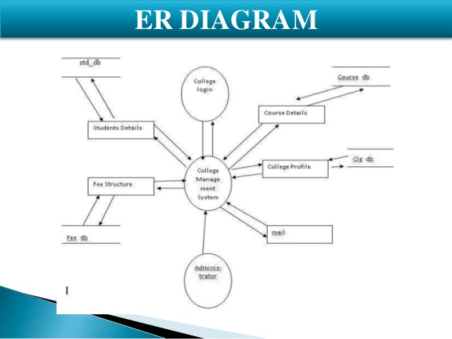

Fig.7 ER Diagram for Fee structure

**TABLES**

**Admin Login**

|  |  |  |  |
| --- | --- | --- | --- |
| **Field Name** | **Data Type** | **Null** | **Constraints** |
| Id | int(11) | Not Null |  |
| Enrollment | Varchar(10) | Not Null | Primary Key |
| Password | Varchar(255) | Not null |  |

Table 1:-Homepage Table

**Register Table**

|  |  |  |  |
| --- | --- | --- | --- |
| **Field Name** | **Data Type** | **Null** | **Constraints** |
| Enrollment no | Varchar(20) | Not Null | Primary Key |
| Name | Varchar(20) | Not Null |  |
| Email | Varchar(20) | Not Null |  |
| Password | Varchar(20) | Not Null |  |
| Mobile | Varchar(20) | Not Null |  |
| Branch | Varchar(20) | Not Null |  |

Table 2:-Register Table

**Form Layout**

**Home Page Form**

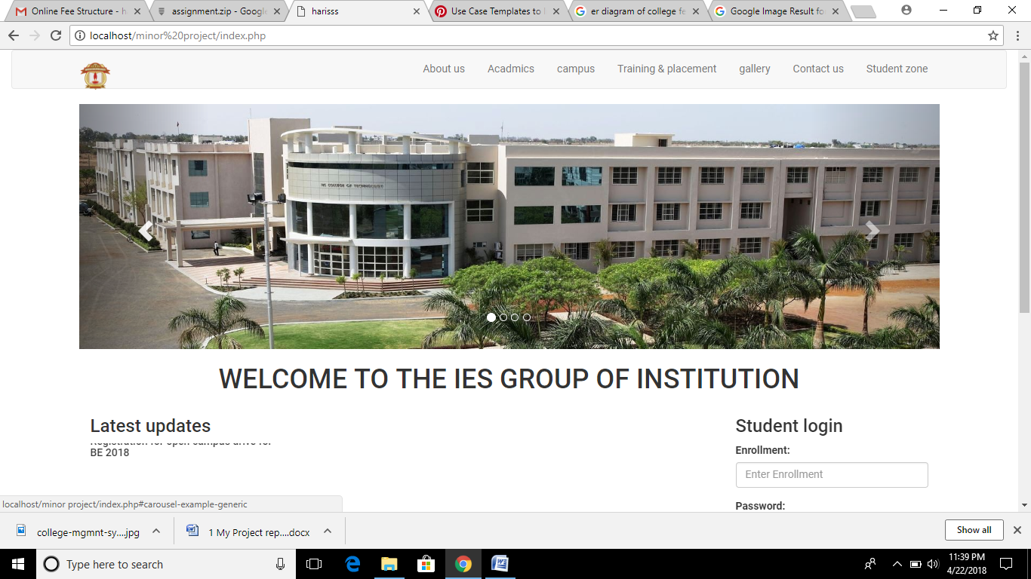

Fig 10: screenshot of Home page

**Stuudent Login page**

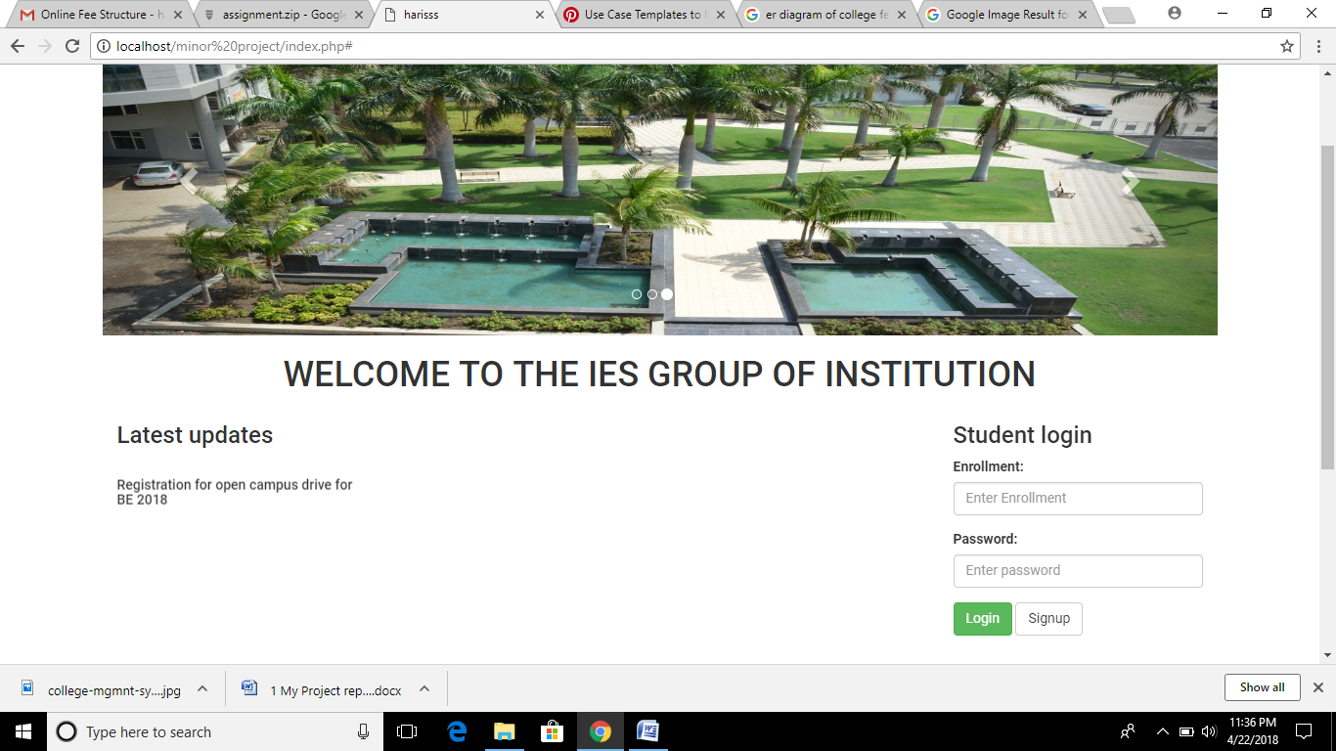

Fig 11: screenshot of Student login page

**Registration Page**

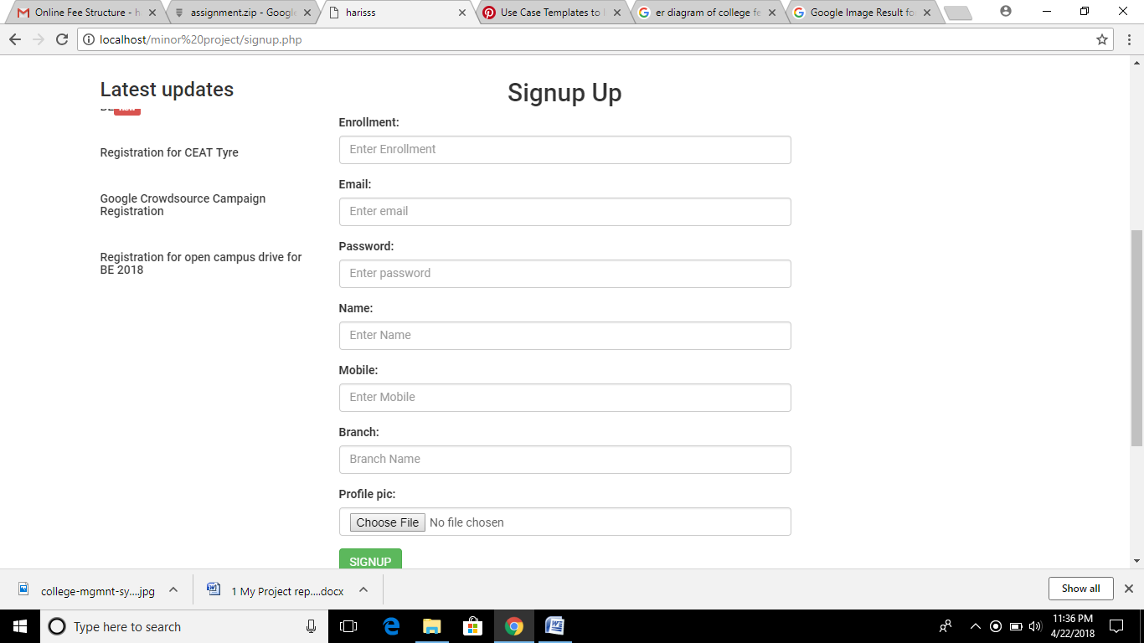

Fig 12: screenshot of Registration page

**Student Profile Page**

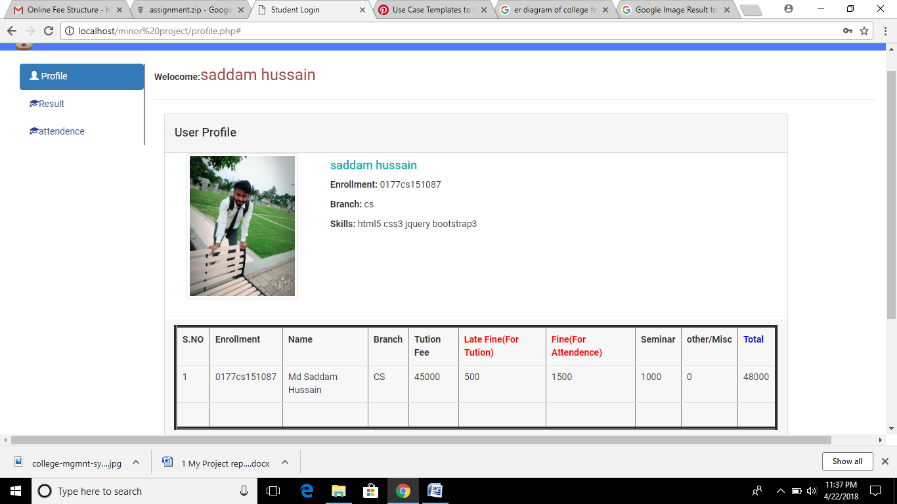

Fig 13: screenshot of student profile page

**payment Page**

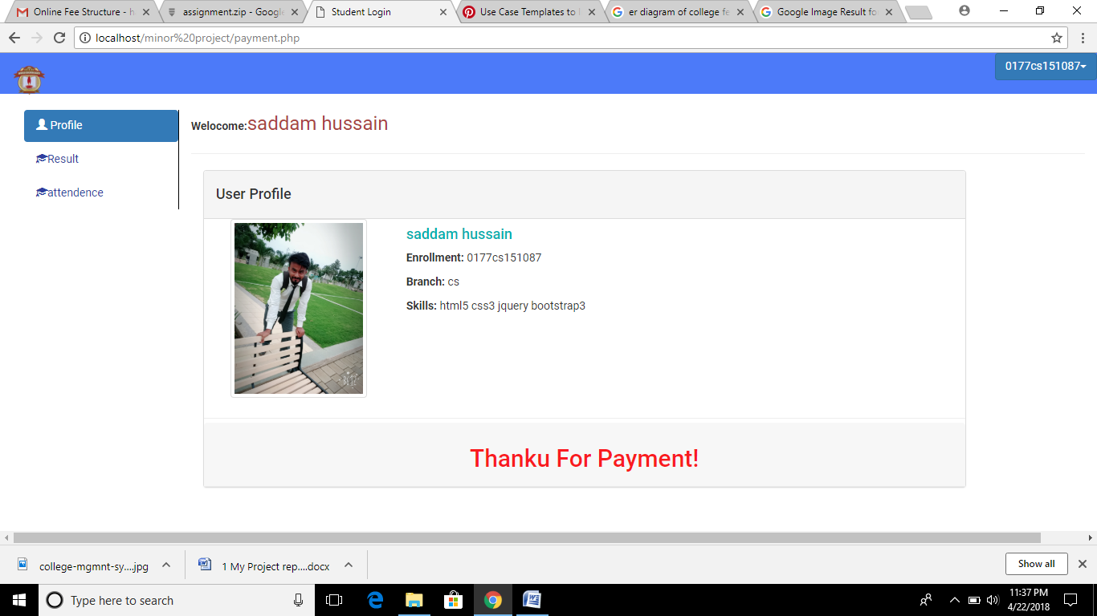

Fig 14: screenshot of payment page

**Student Result Page**

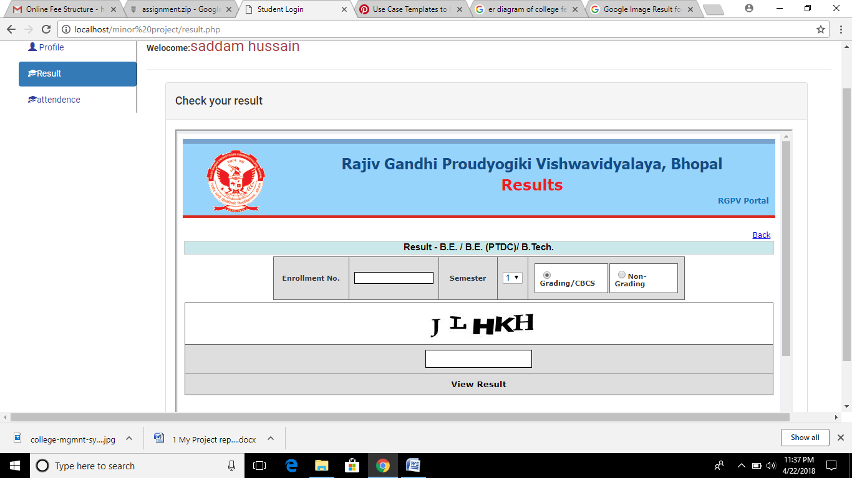

Fig 15: screenshot of Student Result page

**Student attendance Page**

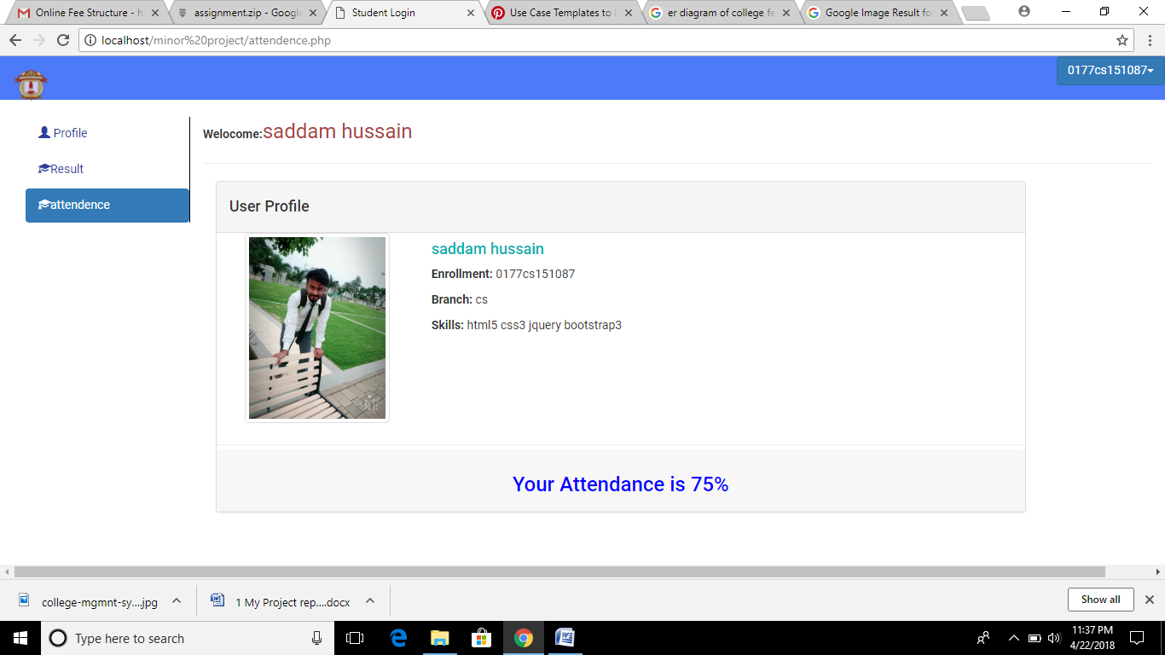

Fig 16: screenshot of Student attendance page

**TESTING**

**Introduction:-**

Testing is major quality control measure used during software development. Its basic functions are to detect errors in the software. The goal of testing is to uncover requirements, design in coding in the program.

**Objective of Testing:-**

Testing is a process of executing a program with the intention of finding error. A good test case is one that has a probability of finding an undiscovered error.

**Essential of Software Testing Process:-**

* The quality of the test process determines the quality of the effort.
* Prevents defect migration by using early life-cycle testing techniques.
* Cultivates a positive attitude of creative disruption.

**Importance:-**

Every time the program is executed, a customer tests it.Therefore, we have to execute the program before it gets to the customer with specific intent of finding and removing all errors. In order to find the higher possible number of errors, test must be conducted systematically and test cases must be designed using discipline techniques.

**Methodology Used For Testing:-**

* **Testing Methodology**

During requirement analysis and design, the output is a document that is usually textual and non-executable. After the coding phase, computer programs are available that can be executed for testing purposes. This implies that testing not only has to uncover errors introduced during the previous phases.

Consequently, different levels of testing are used. After the system is put together, system testing is performed, here, system is tested against the system requirements to see if all requirements are met and if the system performed to demonstrate to the client on the real life data of the client, the operation of the system

* **The Testing Process**

The testing process should therefore proceed in stages where testing is carried out incrementally in conjunction with system implementation.

The most widely used testing process consists of five stages as shown below:

**Acceptance testing**

**System Testing**

**Sub-system Testing**

**Module Testing**

**Unit Testing**

Fig 18: Stages Testing

**Test Process Stages:-**

* **Unit Testing**

Individual components are tested to ensure that they operate correctly. The starting point of testing is unit testing. In this, module is tested separately and is often performed by the coder himself simultaneously along with the coding of the module. The purpose is to exercise the different parts of module of the cod to detect coding errors.

* **Module Testing**

Module is a collection of dependent components such as an object class, abstract data type or some looser collection of procedures or functions. A module encapsulates related components so can be tested with ought system module.

* **Sub System Testing**

This phase involves testing collections of modules which have been integrated into sub system. Sub system may be independently designed and implemented.

* **System Testing**

The sub system is integrated to make up the entire system. The test process id connected with finding errors which result from unanticipated interactions between subsystems and system components.

* **Acceptance Testing**

This is the final stage in the testing process before the system is acceptance for operational use.

**Testing Techniques:-**

* **Black Box Testing**

Aim to test a given program is behavior against its specification of component without making any reference to internal structures of the program or the algorithms used. Therefore, the source code is not needed. We study the system by examining its input and related outputs. The key is to divide inputs that have a higher likelihood of causing outputs that reveals the presence of defect. Black box testing is rarely exhaustive, fails to reveal the corruption defects caused by weird combination of inputs.

* **White Box Testing**

Used as an important primary testing approach. Code is tested using code’s scripts, drivers, stubs, and etc., which are implied directly, interface with it and drive the code. The tester can analyze the code and use knowledge.

**Report:-**

The criteria needed for the software to pass the testing process are that all the modules communication properly and pass the variable from one module to another.

**Test Cases:-**

**Test Cases 1:** Login Empty

Login, password field is empty.

The appropriate message is displayed.

**Test Cases 2:** Login incorrect

Login, password if entered incorrect.

The user is again redirected to login to fill correct entries.

**Cases 3:** Correct Registration

Correct entries are inserted in the database.

Verification done before inserting new entries in the database.

**Test Cases 4:** Correct Deletion

Entries are deleted from database after verification.

**SYSTEM IMPLIMENTATION &EVALUATION**

**System Implementation:-**

This phase encompasses all the organizational technical aspects of successful implementation form the end user acceptance to data access system implementation is primary concern with user training. These following activities are undertaken in the implementation phase:

* Training to the user.
* System changes over.
* Test data supplied to the user for hands on exposure to the system.
* Helping and guiding user until the implementation is satisfactory and the user develop confidence in the system.

**System Evaluation:-**

Evaluation of the system is performed to identify its strength & weaknesses. The actual evaluation can occur along any of the following dimensions.

**Operational evaluation:**

Identifications & measurement of benefits to the organization in such areas as financial concerns, operational efficiency & competitive impact.

**User management assessment:**

Evaluation of the attitude of senior & user managers within the organization as well as end users

**Development Performance:**

Overall development time, efforts, conformance to benefits & standards & project management criteria

### FEATURE AND UNIQNESS OF THE PROJECT

* Online Fee Submition
* It avoids a lot of rush in account section.
* It provides simple way to pay the fee and fine..
* It saves a lot of time of student.
* Student can easily access the system without much experience.
* Provide Hardware and software securities.
* Portable and flexible for further extension

**CONCLUSION**

We conclude that from the intriguing journey of the project development we gained an insight of various aspects of software development. It was most inspiring to be guided by the software developer and the project manager who were enthusiastic and willing to share their career experiences. It was a thought-provoking experience in learning about the various web-technologies available in PHP to develop online applications. The intellectually stimulating teaching and guidance gave us a unique opportunity to observe for ourselves the practical aspects of software engineering.

We would like to thank all those who were directly or indirectly involved in this training period.

**System Features:**

System satisfies all the requirements for which the company developed the system. System has strong security. System is fully GUI based. It is easy to operate and user-friendly. Platform includes the inbuilt back-up and recovery facility.

Working on the project was a good experience. Working together in teams helped us to communicate better. We understand the importance of planning and designing as a part of software development.

The concept of peer-reviews helped to rectify the problems as and when they occurred and also helped us to get some valuable suggestions that were incorporated by us. Developing the project has helped us to gain some experience on real time development procedures.

**Suggestion for further development:**

System required sufficient RAM and faster server to run the application properly.

**BIBLIOGRAPHY**

**Websites:-**

* http://www.bootstrap.com
* <http://google.com>
* <http://w3school.com>
* http://www.dynamicdrive.com
* http://www.bootsnipp.com
* http://www.stackoverflow.com
* <http://www.wikipdia.org>

**Books:-**

* PHP Unleashed Stephen Walther
* SQL Server Essential Reference Sharon Dooley