DESIGN/USAGE DOCUMENT

My custom web app is a phonebook application that lets users store their contact information online. But for this task I haven’t connected the app to a database but instead push the data into a Jason file. There are some pre inserted contacts in the file that display when the app opens up. With the current code the data added by the user is lost if they refresh the page since it’s not connected to a database.

The app has a navigation bar with a number of elements. A search bar lets the user search though their contacts based on name, number, email or city. The user can also add their contacts using the *dropdown form* from the navigation bar by clicking Add contacts. The form is completely validated presenting error messages in case information with some wrong pattern is added in the input. The contact can only be added once all the input fields are validated.

All the contacts are added into a table which is paginated. The user can sort the contacts based on the newest ones added, alphabetically or according to their residence. The app allows the user to remove/edit a contact directly from the table itself. Routing was also implemented. By clicking on a contact name the whole contact information is displayed on top of the table in a box. This is useful when opening the app on mobile devices. This is because to fit the table and avoid horizontal scrolling the table is shrunk to just the contact’s name and an option to remove them.

WIREFRAMES

# C:\Users\hussain\Desktop\eee.PNG

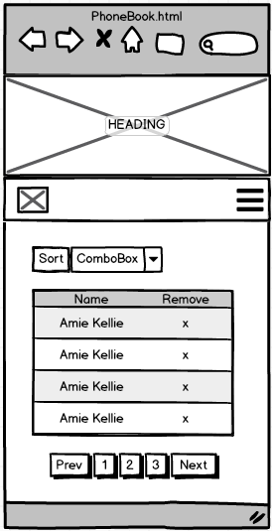

The figure above shows the wireframe design for desktop and tablet devices. All the elements of the app are fully displayed on a single page and can be accessed within a single click. The table contents are also fully displayed and paginated.it shows the heading and the subheading being scaled according to the screen width

The image on the left is the wireframe for a standard mobile device. It should be noted that the there is no subheading. The navigation bar is collapsed. Clicking on the 3 bar button displays a drop down menu with search bar and the add contacts options. Since horizontal scrolling is discouraged on mobile devices the most of the table contents were removed. Routing was added when the user clicked on the contact name which then displays the contacts full information in a box like windows.