1. -- ITCS285 Database Management Systems - Lab #3
2. -- Student ID: 202405120
3. -- Student Name: hussain ali h. ali
4. -- MySQL queries for the Lab #3 bank database.

1. USE itcs285_lab1;
2.
3. -- 1. For each client, find his accounts with their branches.
4.
5. SELECT
6. c.ClientID,
7. c.FirstName,
8. c.LastName,
9. a.AccountID,
10. a.Balance,
11. br.BranchID,
12. br.BranchName,
13. br.BranchAddress,
14. b.BankName
15. FROM Client c
16. LEFT JOIN Account a ON c.ClientID = a.ClientID
17. LEFT JOIN Branch br ON a.BranchID = br.BranchID
18. LEFT JOIN Bank b ON br.BankID = b.BankID
19. ORDER BY
20. c.ClientID,
21. a.AccountID;
22.
23. -- 2. Find clients who have only BBK accounts.
24.
25. SELECT
26. c.ClientID,
27. c.FirstName,
28. c.LastName,
29. c.Phone,
30. c.Address,
31. c.Profession
32. FROM Client c
33. WHERE EXISTS (
34. SELECT 1
35. FROM Account a
36. JOIN Branch br ON a.BranchID = br.BranchID
37. JOIN Bank b ON br.BankID = b.BankID
38. WHERE a.ClientID = c.ClientID
39. AND b.BankName = 'BBK'
40. )
41. AND NOT EXISTS (
42. SELECT 1
43. FROM Account a
44. JOIN Branch br ON a.BranchID = br.BranchID
45. JOIN Bank b ON br.BankID = b.BankID
46. WHERE a.ClientID = c.ClientID
47. AND b.BankName <> 'BBK'
48. );
49.
50. -- 3. Find clients who have at least two accounts in different banks.
51.
52. SELECT
53. c.ClientID,
54. c.FirstName,
55. c.LastName,
56. c.Phone,
57. c.Address,
58. c.Profession,
59. COUNT(DISTINCT a.AccountID) AS AccountCount,
60. COUNT(DISTINCT b.BankID) AS BankCount
61. FROM Client c
62. JOIN Account a ON c.ClientID = a.ClientID
63. JOIN Branch br ON a.BranchID = br.BranchID
64. JOIN Bank b ON br.BankID = b.BankID
65. GROUP BY
66. c.ClientID,
67. c.FirstName,
68. c.LastName,
69. c.Phone,
70. c.Address,
71. c.Profession
72. HAVING COUNT(DISTINCT a.AccountID) >= 2
73. AND COUNT(DISTINCT b.BankID) >= 2;
74.
75. -- 4. For each account, find details of clients with the highest salary.
76. -- The bank schema has no Salary column, so Balance is used as the amount.
77.
78. SELECT
79. a.AccountID,
80. a.BranchID,
81. a.Balance,
82. c.ClientID,
83. c.FirstName,
84. c.LastName,
85. c.Phone,
86. c.Address,
87. c.Profession
88. FROM Account a
89. JOIN Client c ON a.ClientID = c.ClientID
90. WHERE a.Balance = (
91. SELECT MAX(Balance)
92. FROM Account
93. );
94.
95. -- 5. Find details of clients who do not have BBK nor CITI accounts.
96.
97. SELECT
98. c.ClientID,
99. c.FirstName,
100. c.LastName,
101. c.Phone,
102. c.Address,
103. c.Profession
104. FROM Client c
105. WHERE NOT EXISTS (
106. SELECT 1
107. FROM Account a
108. JOIN Branch br ON a.BranchID = br.BranchID
109. JOIN Bank b ON br.BankID = b.BankID
110. WHERE a.ClientID = c.ClientID
111. AND b.BankName IN ('BBK', 'CITI')
112. );
113.

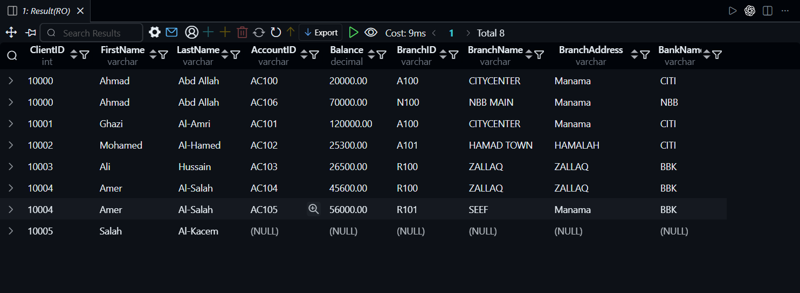 1. SELECT
2. c.ClientID,
3. c.FirstName,
4. c.LastName,
5. a.AccountID,
6. a.Balance,
7. br.BranchID,
8. br.BranchName,
9. br.BranchAddress,
10. b.BankName
11. FROM Client c
12. LEFT JOIN Account a ON c.ClientID = a.ClientID
13. LEFT JOIN Branch br ON a.BranchID = br.BranchID
14. LEFT JOIN Bank b ON br.BankID = b.BankID
15. ORDER BY
16. c.ClientID,
17. a.AccountID;
18.

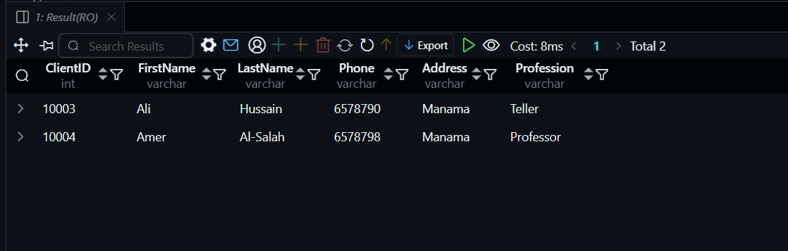
1. SELECT
2. c.ClientID,
3. c.FirstName,
4. c.LastName,
5. c.Phone,
6. c.Address,
7. c.Profession
8. FROM Client c
9. WHERE EXISTS (
10. SELECT 1
11. FROM Account a
12. JOIN Branch br ON a.BranchID = br.BranchID
13. JOIN Bank b ON br.BankID = b.BankID
14. WHERE a.ClientID = c.ClientID
15. AND b.BankName = 'BBK'
16. )
17. AND NOT EXISTS (
18. SELECT 1
19. FROM Account a
20. JOIN Branch br ON a.BranchID = br.BranchID
21. JOIN Bank b ON br.BankID = b.BankID
22. WHERE a.ClientID = c.ClientID
23. AND b.BankName <> 'BBK'
24. );
25.



1. SELECT
2. a.AccountID,
3. a.BranchID,
4. a.Balance,
5. c.ClientID,
6. c.FirstName,
7. c.LastName,
8. c.Phone,
9. c.Address,
10. c.Profession
11. FROM Account a
12. JOIN Client c ON a.ClientID = c.ClientID
13. WHERE a.Balance = (
14. SELECT MAX(Balance)
15. FROM Account
16. );
17.

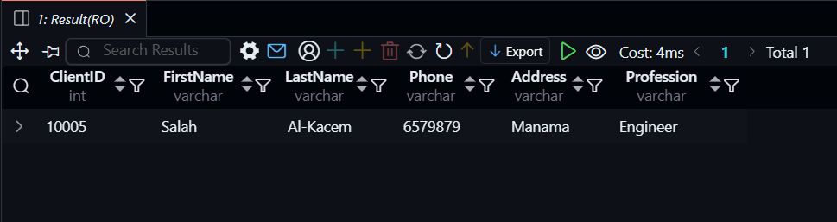

1. SELECT
2. c.ClientID,
3. c.FirstName,
4. c.LastName,
5. c.Phone,
6. c.Address,
7. c.Profession
8. FROM Client c
9. WHERE NOT EXISTS (
10. SELECT 1
11. FROM Account a
12. JOIN Branch br ON a.BranchID = br.BranchID
13. JOIN Bank b ON br.BankID = b.BankID
14. WHERE a.ClientID = c.ClientID
15. AND b.BankName IN ('BBK', 'CITI')
16. );
17.
18.

