Need to Update
Point – 1 – General Changes – Background color for full website to be update as natural white or light colors with gradient – refer below sample photo. Please note the background color should be always light with dark color text also the des logo should be always presented with a light background you may use gradient colors which you start from slightly dark and move towards light colors gradually and the logo is always on the light color side as shown in below photograph
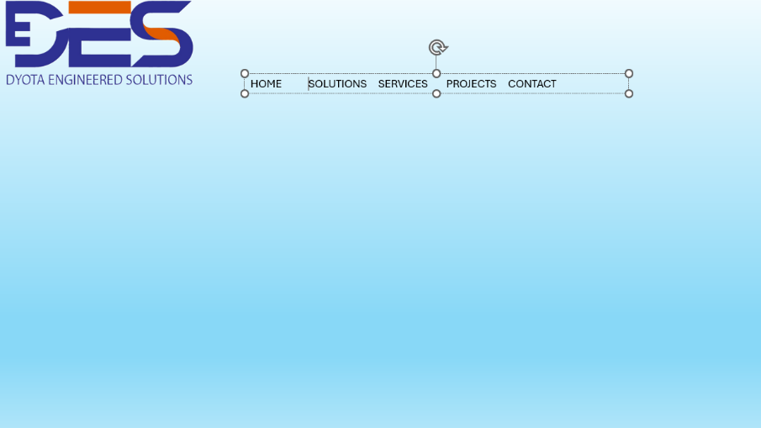
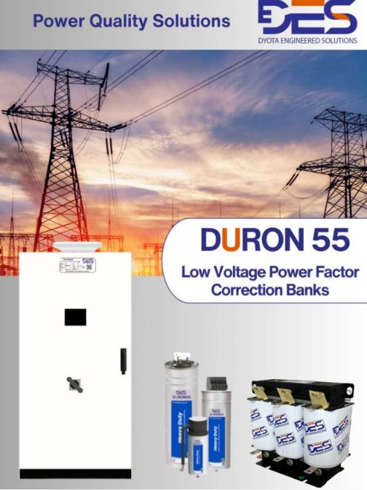

Point - 2
TEXT CORRECTION-Experts in Harmonics Study & Analysis, Power Quality Audits, UAE‑based manufacturing of Power quality solution, Harmonic Filters, and Delta‑T HVAC Control Solutions.

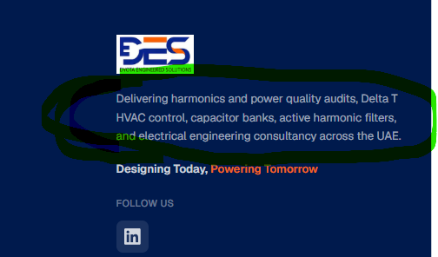
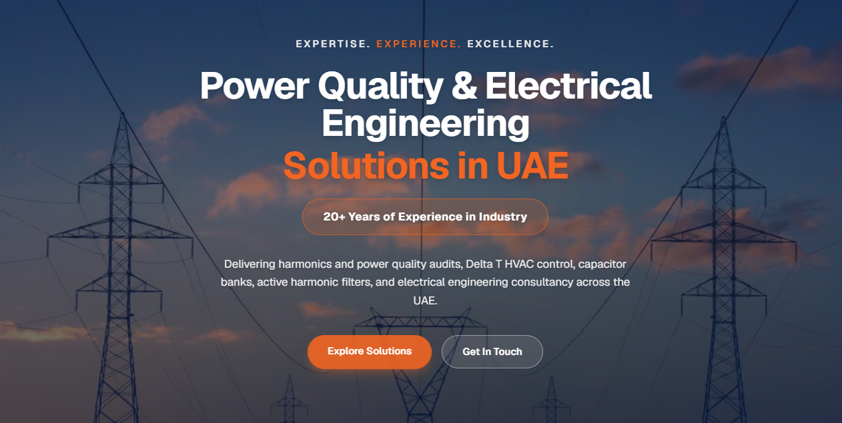

Point - 3
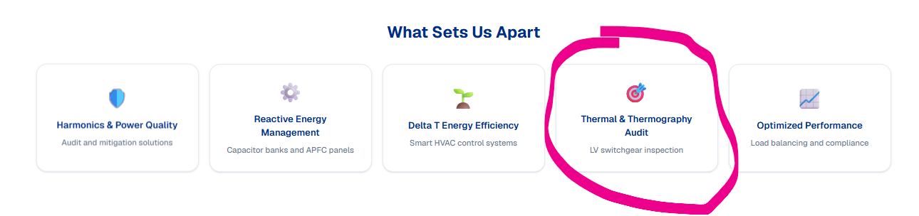
Add LV Switchgear and Power Busbar troubleshoot.
Electrical Network performance optimization.

Point - 3
Pls Remove from every where – Electrical Engineering Consultantcy – This is not to be promoted 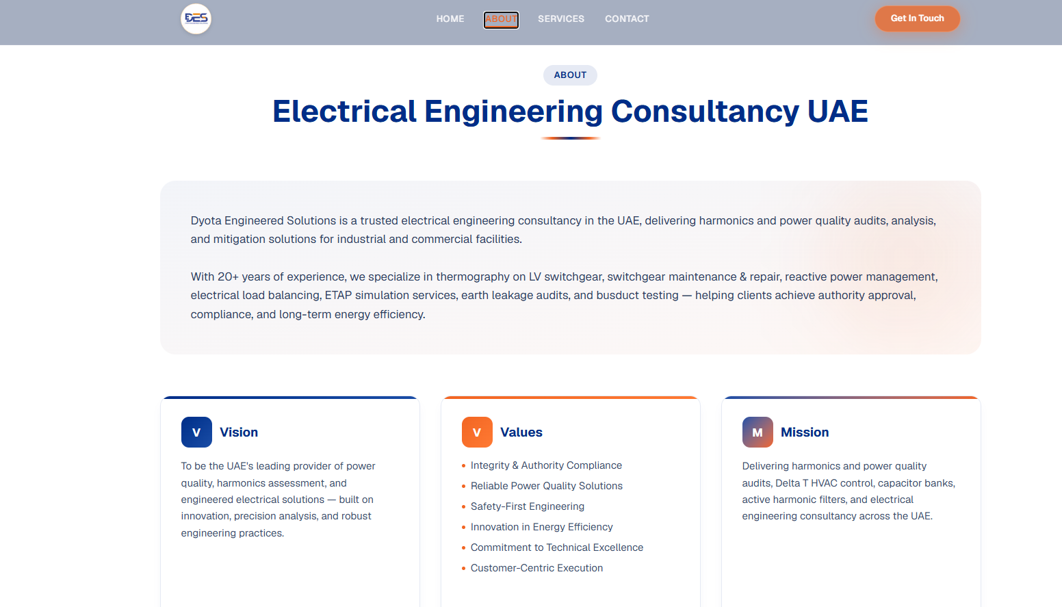
ABOUT
Welcome to DES, with 20+ years of experience your trusted partner in Power Quality Solutions for Electrical Network, Energy Audit Energy Savings, and Network Testing and Troubleshooting with specialized solutions.
At DES, we are committed to providing comprehensive and innovative solutions to enhance the efficiency and reliability of your energy systems. Our expertise spans across various domains ensure your business operates at its best, minimizing downtime and maximizing savings.
• Power Quality Audit and Solutions
• Energy Audit and Chilled Water System Optimization
• Testing and Troubleshooting Network
VISION
“To optimize the electrical industry by delivering cutting-edge solutions that enhance the health and reliability of electrical networks, ensuring sustainable energy for generations to come.”

VALUES
- Engineering Excellence – Precision-built products designed for performance and durability.
- Innovation in Power Quality – Advanced harmonic mitigation technologies
- Customer-Centric Delivery – Fast turnaround, reliable support, and tailored solutions
- Safety & Reliability – Products engineered for stable, long-term operation.
- UAE Manufacturing Commitment – Made in UAE with precision quality Solutions and faster delivery.
MISSION
To manufacture high-quality Capacitors, Reactors, and Active Harmonic Filter Panels, and deliver advanced Harmonics Study & Analysis, Power Quality Audits, Reactive Energy Management, and Delta-T HVAC Control Solutions across the UAE — enabling clients to achieve compliance, efficiency, and electrical stability.

Point - 4
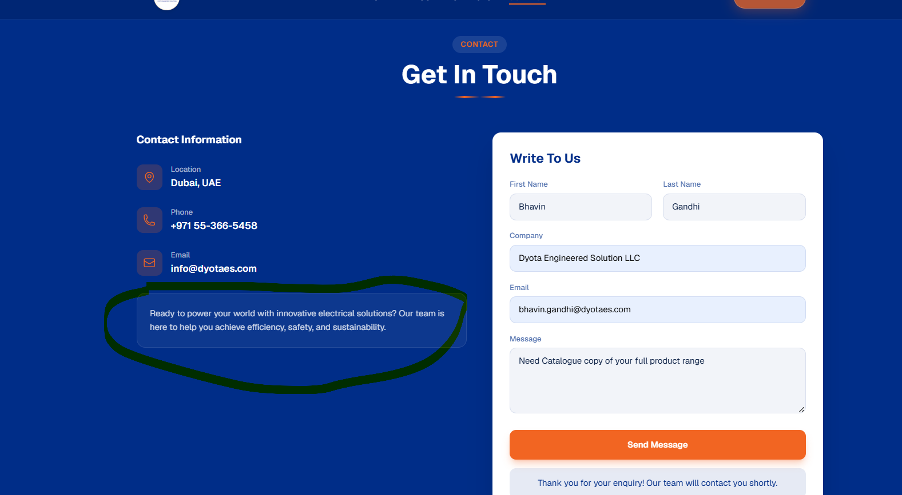

Ready to elevate your electrical infrastructure with precision-engineered power-quality products? Our UAE-based manufacturing team delivers advanced Capacitors, Reactors, and Active Harmonic Filters to support your journey toward efficiency, safety, and sustainable performance.

Point - 5
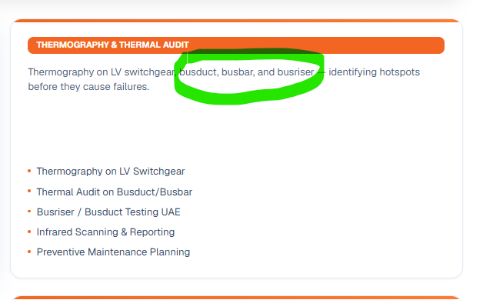
TEXT CHANGE- Providing detailed thermography services in line with NFP and IC standards to ensure reliable operations of the network along with forecasting future risks and providing mitigation solutions

Point - 6
Need to change this page with Our solutions and Our Services (2 separate Page) as per below lists.
Solutions  Capacitors  ✓ Reactors  ✓ Auto-PFC Controller  ✓ Harmonic’s Filters  ✓ Customize Filters  ✓ Low Voltage Capacitors, Reactors and Controllers  ✓ Capacitor Banks and Compact APFC Panels  ✓ Hybrid Systems | Services  Thermal Testing  ✓ Dark-Hour Test  ✓ Capacitor bank Test  ✓ UPS Load / Unload Test ✓ Battey Test  ✓ Switchgear Test  ✓ Earth Testing  ✓ Loop Impedance Test ✓ LV Test  ✓ Earth Leakage Test  ✓ Network Imbalance Test✓ Harmonics and Power Quality Audits ✓ Harmonics’ Assessment  ✓ Mathematical Modeling C Simulation  ✓ Design calculation for Harmonic Mitigation, Sag/Swell correction, Unbalance,  ✓ Reactive Energy Management  ✓ Transient’s Calculations/simulation ✓ Load Un-balance calculation  ✓ Earth Leakage current calculation/simulation  ✓ Reactive Energy calculation/simulation

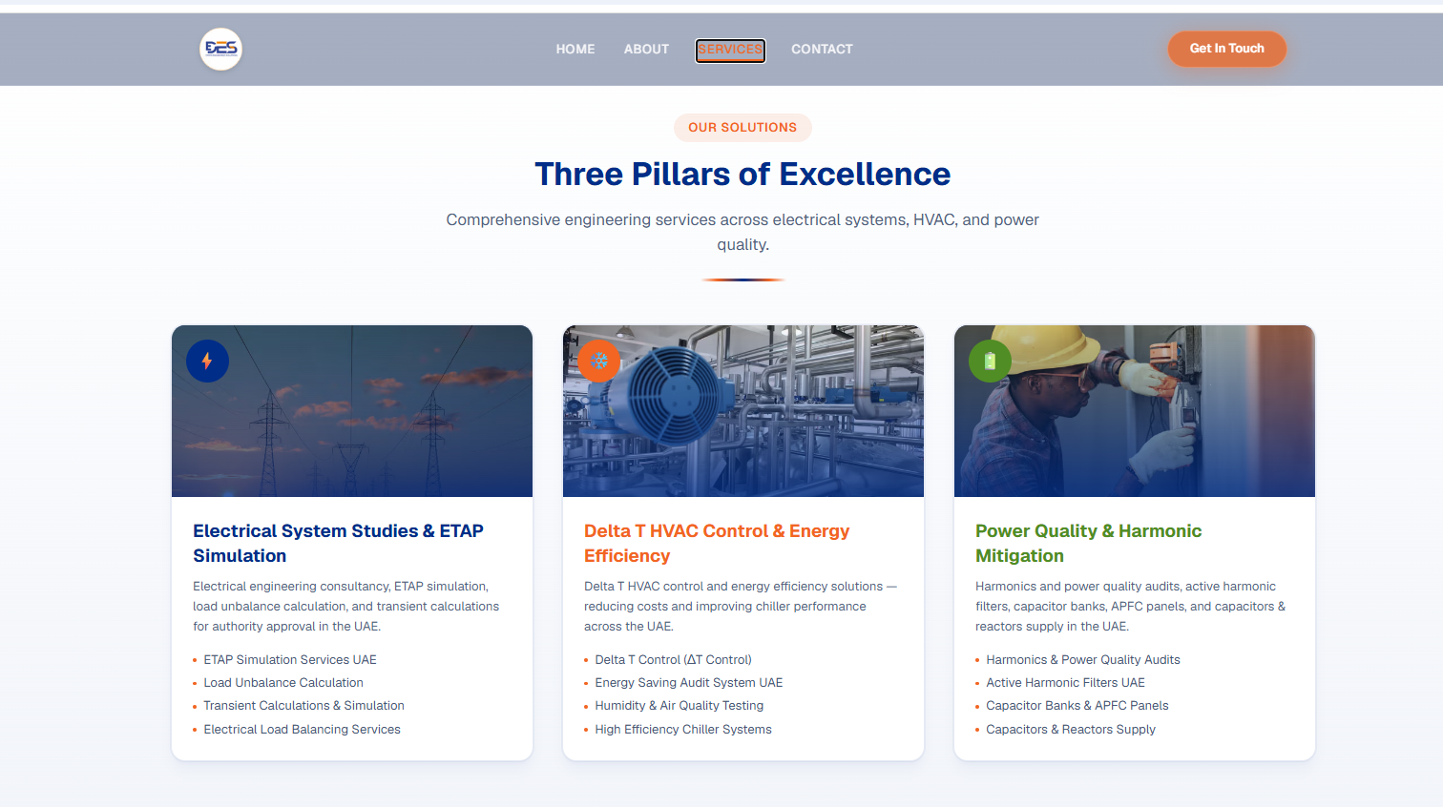

Meeting Points to discuss
- also please share me the Google business profile management access
- and please add customer review on google business profile and if and images in it
- Domin for google review.

