**Informatics Institute of technology**

http://www.coursenet.lk/Content/institutes/logos/1052/549625820121228.jpg

**Coursework 1** – Guess the Word Game

**Name: -** Hussain Mustafa

**IIT Student ID: -** 2014278

**UoW ID: -** 15830638

**Course: -** BSc [Hons] Computer Science

**Module Code: -** ECSC410

**Module Name: -** Software Development Principles 1

# Flowchart



# Pseudocodes

SDP1_GuessWordCW

1. initialize correctGuessCount = 0
2. initialize incorrectGuessCount = 0
3. initialize i = 0
4. Read word.txt file
5. Ramdomize the word
6. Get Input
7. if i < word
8. if input equals to eachCharacter
9. Replace label with eachCharacter
10. correctGuessCount++
11. If correctGuessCount equals to word length
12. Display "Congratzz you have won. Game over."
13. Else
14. incorrectGuessCount++
15. Update btn_img
16. If incorrectGuessCount equals to 6
17. Display "You did not win. Game over."
18. END

# Source Codes

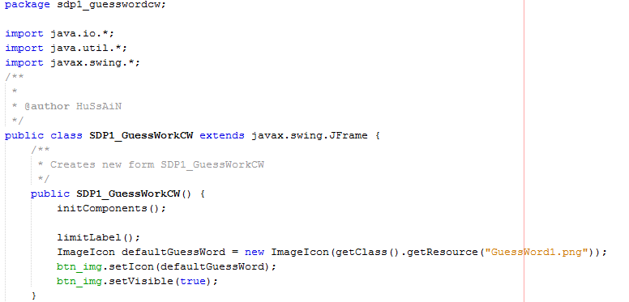

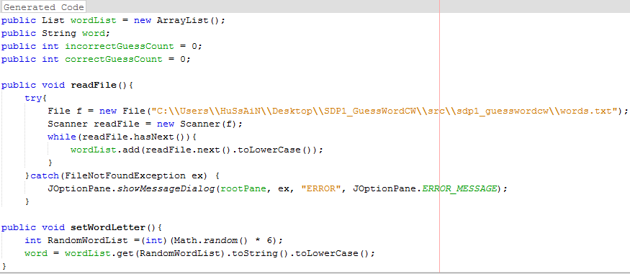

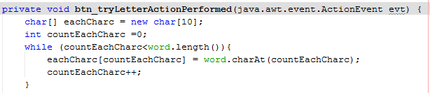

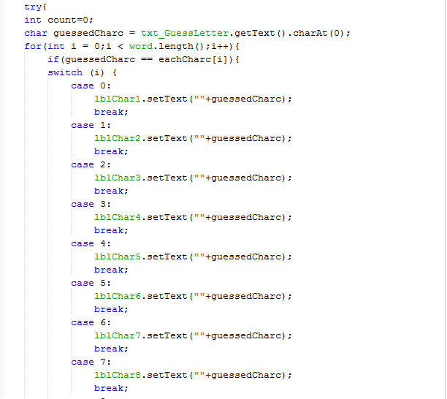 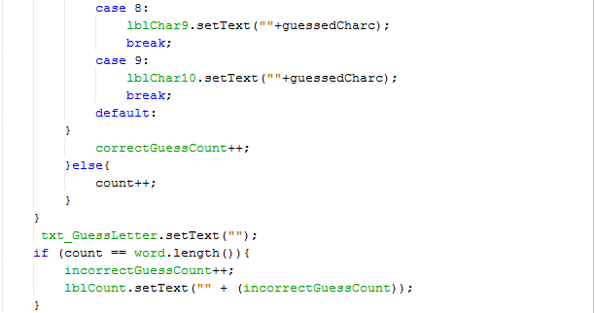

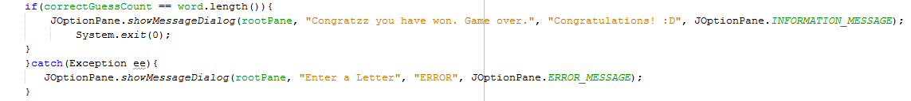

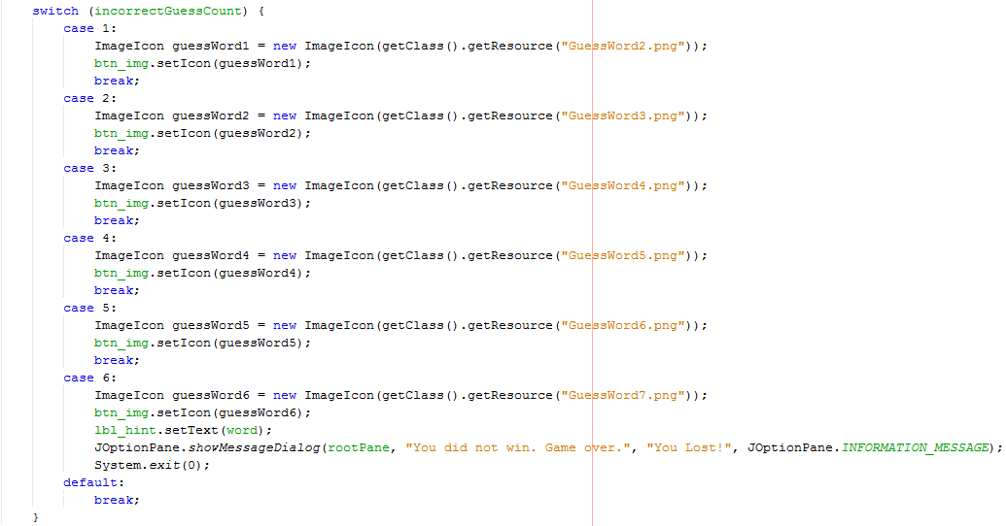

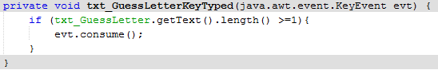

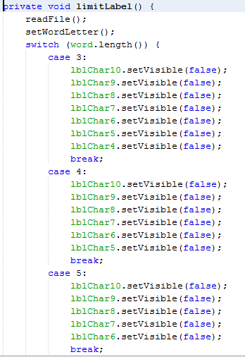

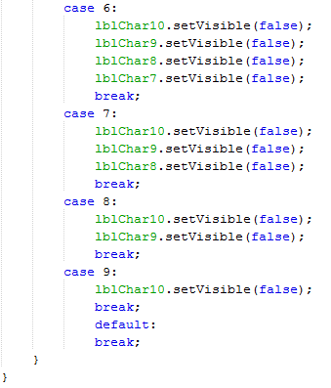

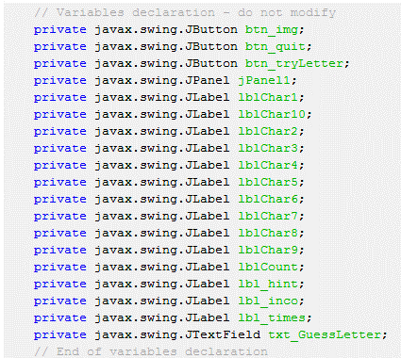

## Designing

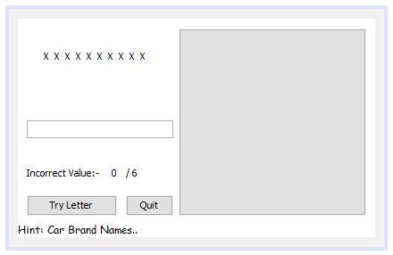

## Testing

