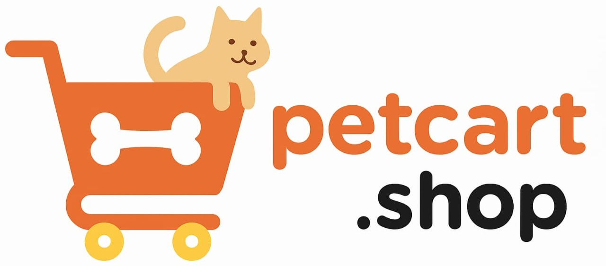 | FAQ’s : Orders, Refunds & Returns

Contents
- Placing & Managing Orders
- Order Issues
- Returns & Exchanges
- Refunds & Store Credit
- Cancellations & Issues

🛒 Placing & Managing Orders
Q1: How do I place an order on PetCart?
A: To place an order, simply browse our products, select the ones you like, and click “Add to Cart.” Once done, proceed to checkout, enter your delivery details, and choose a payment method. After payment confirmation, your order will be successfully placed.
Q2: Do I need an account to order?
A: No, you can checkout as a guest without creating an account. However, creating an account lets you save addresses, track orders easily, and manage returns and refunds faster. It also gives you access to exclusive offers.
Q3: Can I save items for later?
A: Yes, you can add products to your wishlist and purchase them later. This way, you don’t have to search again for your favorite items. Wishlisted products also help you keep track of price drops or restocks.
Q4: How do I know if my order is confirmed?
A: You’ll receive an order confirmation email and SMS immediately after checkout. It includes your order ID, payment status, and product details. If you don’t receive it within 10 minutes, please reach out to our support team.
Q5: Can I modify my order after checkout?
A: Yes, you can modify your order within 1 hour of placing it by contacting our customer support. Once the order is shipped, modifications cannot be made. We always recommend reviewing items before confirming checkout.
Q6: Can I order in bulk for shelters?
A: Yes, we support bulk orders for animal shelters, NGOs, and pet stores. Bulk discounts may apply depending on the order size. Please contact our sales team for assistance with such orders.
Q7: Can I add a gift note to my order?
A: Yes, you can include a personalized gift note at checkout. The note will be printed and included with the package. We also offer discreet billing so prices won’t be shown if it’s a gift.
Q8: Can I repeat a past order?
A: Yes, you can go to “My Orders” in your account and click “Reorder.” This automatically adds all the same items to your cart. You can still adjust quantities or remove items before checkout.
Q9: Will I get an invoice for my order?
A: Yes, invoices are automatically generated and emailed once your order is placed. You can also download invoices anytime from your account dashboard. They include product details, taxes, and payment information.
Q10: What if I don’t receive a confirmation?
A: If you don’t see a confirmation email, check your spam or promotions folder. Sometimes, network delays can also cause a delay of up to 30 minutes. If you still don’t receive it, contact our support team to verify your order.

⚠️ Order Issues
Q11: What if I receive the wrong product?
A: If you receive the wrong item, report it within 48 hours of delivery. We’ll arrange a free pickup of the incorrect item and send the correct product at no extra charge.
Q12: What if my order arrives incomplete?
A: Sometimes items in one order ship separately. Check your tracking details first. If items are truly missing, contact our support team within 48 hours for a resolution.
Q13: What if my order is damaged on arrival?
A: Please take clear photos of the damaged product and packaging. Send them to support, and we’ll arrange a free replacement or refund depending on your choice.
Q14: Can I report a missing product?
A: Yes, if you notice a missing product in your delivery, notify us within 48 hours. We’ll verify the shipment and either reship the missing item or issue a refund.
Q15: What if I get a defective toy or accessory?
A: Report defective items with photos. Depending on availability, we’ll replace them with a new one or offer a refund. Quality issues are handled on priority.
Q16: What if I receive an expired pet food item?
A: Expired products should never reach customers, but if it happens, report it immediately. We’ll send a fresh replacement free of cost and collect the expired product.
Q17: Can I request a replacement for a faulty product?
A: Yes, replacements are always offered first. If the product is unavailable, we’ll process a refund or issue store credit.
Q18: Do I need photos to prove product issues?
A: Yes, photos help us speed up verification. For damages, defects, or wrong products, clear photos ensure a quicker resolution.
Q19: How long do I have to report a problem?
A: Please report any order issues within 48 hours of delivery. This helps us process your claim quickly and arrange replacements if needed.
Q20: Will I get compensation for repeated issues?
A: If you face repeated problems, our team will investigate and may offer vouchers, store credits, or priority service as compensation.

🔄 Returns & Exchanges
Q21: Do you accept returns?
A: Yes, returns are accepted within 7 days of delivery for most products. Items should be unused, unopened, and in original packaging.
Q22: Which products are non-returnable?
A: Opened food packets, perishable items, and personalized goods cannot be returned. This is to ensure hygiene and safety for all pets.
Q23: How do I request a return?
A: Go to “My Orders” in your account, select the product, and click “Request Return.” Our courier will arrange a pickup from your address.
Q24: Do I need the original packaging?
A: Yes, returns must be packed in the original box and include the invoice. Without original packaging, returns may be rejected.
Q25: Is return shipping free?
A: Yes, we provide free return shipping for eligible items. The pickup is arranged at your doorstep for convenience.
Q26: Can I exchange instead of returning?
A: Yes, you can choose an exchange instead of a refund. Exchanges are available for size, color, or variant mismatches.
Q27: What if the product I want is out of stock?
A: If your preferred item is out of stock, you may opt for a refund or store credit. Store credit can be used later once the item is back.
Q28: Can I return toys if my pet doesn’t like them?
A: Yes, unused toys in original packaging can be returned. However, used or damaged toys cannot be accepted.
Q29: Are grooming products returnable?
A: Grooming products like shampoos, brushes, and clippers can only be returned if unused and unopened. Used products are not accepted for hygiene reasons.
Q30: How do I know if my return is approved?
A: Once your return is inspected, we’ll send you an approval email. If the item meets our conditions, a refund or exchange will be processed.

💳 Refunds & Store Credit
Q31: When will I get my refund?
A: Refunds are usually processed within 5–7 business days after your returned product is approved. Bank timelines may add an extra 2–3 days.
Q32: How will refunds be processed?
A: Refunds are sent back to your original payment method. For COD orders, we issue bank transfers or store credits.
Q33: Can I opt for store credit instead of refund?
A: Yes, you can choose store credit, which is added to your PetCart wallet. Credits can be used instantly for your next order.
Q34: How are refunds issued for COD orders?
A: Since COD is cash-based, refunds are processed through bank transfer or added as store credit to your account.
Q35: Do you refund original shipping fees?
A: Shipping fees are only refunded if the return is due to our mistake, like wrong or defective products.
Q36: What if my refund is delayed?
A: Refunds may sometimes be delayed due to bank processing. If you don’t see it within 10 business days, contact our support for resolution.
Q37: Can I split a refund into cash + credit?
A: Yes, on request we can partially refund to your payment method and issue the balance as store credit.
Q38: Do you offer instant refunds?
A: Instant refunds are not available yet. All refunds follow the standard 5–7 business day cycle.
Q39: Can I track my refund status?
A: Yes, under “My Orders” in your account you’ll see the return/refund status. You’ll also get email updates at each step.
Q40: Are discounted items refundable?
A: Yes, unless marked as “Final Sale” or “Non-Returnable.” Always check the product’s return policy before purchase.

❌ Cancellations
Q41: How do I cancel my order?
A: Log into your account, go to “My Orders,” and click “Cancel.” You can also call support within 1 hour of placing your order.
Q42: Can I cancel part of an order?
A: Yes, partial cancellations are possible before the order is shipped. You can cancel selected items while keeping the rest.
Q43: How long do I have to cancel?
A: Orders can be canceled within 1 hour of placing them. After that, the order is locked for processing.
Q44: Can I cancel after shipping?
A: Once shipped, cancellations are not allowed. You’ll need to request a return after delivery instead.
Q45: Do I get a full refund on cancellation?
A: Yes, if canceled within the allowed time, you’ll get a full refund including product cost and any discounts used.
Q46: Are cancellations free?
A: Yes, there are no cancellation charges. You’ll be refunded in full if canceled before shipping.
Q47: Can I cancel COD orders?
A: Yes, COD orders can be canceled within the same 1-hour window. If shipped, you can refuse delivery.
Q48: Can I cancel a return request?
A: Yes, if your return hasn’t been processed yet, contact support to cancel it.
Q49: Can you refuse cancellation in some cases?
A: Yes, if an order is already shipped or marked for delivery, cancellation may be declined. In such cases, returns are the option.
Q50: What if I face multiple cancellations on my account?
A: Frequent cancellations may affect your eligibility for COD orders or promotional offers. Please place orders carefully to avoid restrictions.

