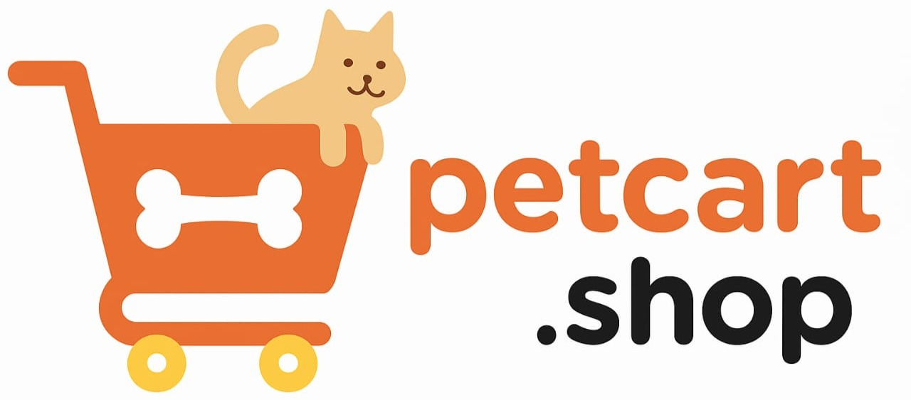 | FAQ’s : Products & Specifications

Contents
- Product Information
- Size, Fit & Variants
- Ingredients & Nutrition (for pet food)
- Safety & Quality Standards
- Availability & Stock

📦 Product Information
Q1: How do I know if a product is suitable for my pet?
A: Each product page includes detailed descriptions such as recommended pet type, age group, and usage instructions. If unsure, check customer reviews or consult your vet before purchase.
Q2: Do you provide product manuals or guides?
A: Yes, for items like grooming kits, feeders, or training devices, we provide manuals either inside the package or downloadable from the product page.
Q3: Are product images on the website accurate?
A: We strive to show real, high-quality product photos. Colors may vary slightly due to lighting or screen differences, but product specifications remain accurate.
Q4: Can I check product expiry dates before buying?
A: Yes, all consumable products such as pet food and treats display manufacturing and expiry dates on the package. For online shoppers, expiry details are listed in the description.
Q5: How can I be sure the products are original?
A: We source all items directly from trusted brands and distributors. Every product is 100% genuine and undergoes quality checks before shipping.
Q6: Do you sell used or refurbished items?
A: No, we only sell brand-new, unused products. Any item marked “open box” will be clearly stated with details of its condition.
Q7: What if the product description is unclear?
A: If you need more details, you can contact our support team. We’ll provide additional information, usage guidelines, or even brand recommendations.
Q8: Do you list customer reviews for products?
A: Yes, verified buyers can leave reviews and ratings. This helps you make informed decisions based on real experiences from other pet parents.
Q9: Are there size charts available for accessories?
A: Yes, collars, harnesses, and clothing items include detailed size charts. Measuring guides are also provided to ensure you pick the right size.
Q10: Can I request a demo for complex products?
A: For certain high-value products like automatic feeders, we provide demo videos on the product page. Live demos are not available.

📏 Size, Fit & Variants
Q11: How do I choose the right size for pet accessories?
A: Each product includes a size chart with measurements in inches or cm. Use a measuring tape on your pet’s neck, chest, or paw depending on the product.
Q12: What if the size I order doesn’t fit my pet?
A: You can return or exchange unused products for a different size. Just ensure they’re in original condition with tags attached.
Q13: Do products come in multiple variants?
A: Yes, many products are available in different colors, sizes, or flavors. Variants can be selected from the dropdown menu on the product page.
Q14: Do you provide recommendations based on pet breed?
A: Yes, our team often lists breed-specific suggestions in product descriptions. You can also filter products by pet type and breed on our site.
Q15: Are there adjustable accessories available?
A: Yes, most collars, harnesses, and leashes are adjustable. Adjustable designs ensure a better fit as your pet grows.
Q16: Can I request a custom-sized product?
A: Custom sizes are available only for selected items. Contact our team to check availability and lead times before placing an order.
Q17: Do food products come in different pack sizes?
A: Yes, pet foods are usually available in small trial packs, medium bags, and larger bulk packs. Choose based on your pet’s consumption needs.
Q18: How do I measure my pet for clothing?
A: Measure the length from neck to tail, chest girth, and neck circumference. Compare these with our size chart before placing an order.
Q19: What if the color I want is unavailable?
A: If a particular color is out of stock, you may opt for another variant or subscribe to “Notify Me” for restock alerts.
Q20: Can I exchange accessories if my pet outgrows them?
A: Exchanges are allowed only within the return window. For long-term growth, we recommend adjustable or larger sizes.

🥩 Ingredients & Nutrition (Pet Food)
Q21: Do you display full ingredients for pet food?
A: Yes, every food product has an ingredient list on the packaging and on our website. This ensures you know exactly what your pet is eating.
Q22: How do I know if food is safe for my pet?
A: All foods sold meet safety standards and are sourced from trusted brands. Always check the feeding guide for pet type, age, and health conditions.
Q23: Do you sell prescription diets?
A: Yes, prescription foods are available but should only be purchased after a vet’s recommendation. We strongly discourage self-prescription.
Q24: Do food products have nutritional information?
A: Yes, packaging and product pages include details like protein, fat, and fiber content. This helps you compare and pick the right diet.
Q25: Can I get grain-free or organic food options?
A: Yes, we stock grain-free, organic, and hypoallergenic food options for sensitive pets. You can filter by category while browsing.
Q26: Are feeding instructions provided?
A: Yes, feeding guidelines based on weight, age, and breed are printed on the package. Following these helps avoid overfeeding.
Q27: How do I know if food is fresh?
A: Always check the manufacturing and expiry date on the packaging. We ensure all food shipped has a long shelf life.
Q28: Do you provide samples for new pet foods?
A: From time to time, brands include free samples with certain orders. Availability depends on ongoing promotions.
Q29: Can I request vet-recommended food brands?
A: Yes, if a specific brand is missing, let us know. We constantly update our stock based on customer requests and veterinary trends.
Q30: What should I do if my pet reacts badly to food?
A: Stop feeding immediately and consult your vet. You can report the issue to us for assistance with returns or refunds.

✅ Safety & Quality Standards
Q31: How do you ensure product safety?
A: All products go through strict quality checks before shipping. We work only with trusted brands that comply with safety standards.
Q32: Are grooming products safe for all pets?
A: Most grooming items are species-specific. Always check labels for “dog safe” or “cat safe” before purchasing. If in doubt, contact support.
Q33: Are toys tested for safety?
A: Yes, toys are made from non-toxic, pet-safe materials. However, supervision is always recommended while pets play.
Q34: Do you sell eco-friendly or sustainable products?
A: Yes, we stock eco-friendly items such as biodegradable waste bags and sustainably sourced toys. Look for the eco-label on product pages.
Q35: Are your medicines and supplements safe?
A: Yes, we only sell vet-approved and certified products. Always consult your vet before administering supplements.
Q36: How do I know if accessories are durable?
A: We provide detailed material descriptions and customer reviews. Heavy-duty products are labeled for extra durability.
Q37: Are pet clothes washable?
A: Yes, most clothes are machine-washable. Washing instructions are provided on the product tag or page.
Q38: Do you check expiry dates before dispatching?
A: Yes, consumables like food and supplements are checked for validity. We never dispatch expired or near-expiry items.
Q39: Can I report a quality issue?
A: Absolutely. Contact support with photos or details. We’ll investigate with the brand and arrange replacement or refund if necessary.
Q40: Do you provide warranty on products?
A: Some products come with brand warranties. Warranty details are mentioned on the product page if applicable.

📊 Availability & Stock
Q41: How do I know if a product is in stock?
A: If the product is available, you’ll see the “Add to Cart” button active. Out-of-stock items will display “Notify Me” instead.
Q42: Can I get notified when a product is restocked?
A: Yes, click “Notify Me” on the product page and enter your email. We’ll alert you as soon as it’s back.
Q43: Why are some products frequently out of stock?
A: High-demand or imported items may run out quickly. We try to restock regularly but supply chain delays can affect availability.
Q44: Can I pre-order out-of-stock items?
A: Currently, we don’t accept pre-orders. However, you can sign up for restock alerts or contact support for timelines.
Q45: Do you sell limited-edition products?
A: Yes, we occasionally offer special collections or seasonal items. These are usually limited in stock, so act fast when they appear.
Q46: What if my order includes an out-of-stock item?
A: In rare cases of stock mismatch, we’ll inform you and provide alternatives, store credit, or a refund for that item.
Q47: Do you import products directly from abroad?
A: Yes, some premium brands are imported, but they are still stocked in our warehouse to ensure faster shipping.
Q48: Can I check stock before ordering?
A: Yes, product availability is always updated in real-time on our website. If it shows “Available,” it is in stock.
Q49: What if stock runs out after I place my order?
A: If inventory error occurs, we’ll notify you and issue a refund or provide alternatives. Your money is always safe.
Q50: Do you guarantee availability for subscriptions?
A: Yes, subscribed products are prioritized in stock allocation. This ensures your pet’s essentials are never missed.

