

IT8416 - DATA MINING
Group Project

Loan Default Prediction
Using Classification and Ensemble Models

Done By:

Ebrahim Bakhsh - 202304139

Jaafar Alhayki - 202301759

Husain Idrees - 202306335

Meqdad Muhana - 202306213

Abdulla Alasbool - 202303022

Table of Contents
Table of Contents 2
Task 1 — Problem Statement Formulation and Definition 4
1.1 Background 4
1.2 Motivation 4
1.3 Objectives 4
1.4 Problem Statement 4
1.5 Expected Result 5
Task 2 — Selection of an Appropriate Dataset 6
2.1 Dataset Source 6
2.2 Reason for Choosing the Dataset 6
2.3 Dataset Overview 6
2.4 Target Variable 7
2.5 Types of Attributes 7
2.6 Missing Data 8
2.7 Redundant Attributes 8
2.8 Initial Data Visualisation 8
2.9 Comment on Data Distribution 9
Task 3 — Data Preparation and Preprocessing 10
3.1 KDD Preprocessing Workflow 10
3.2 Handling Redundant Attributes 11
3.3 Handling Missing Values 12
3.4 Encoding Categorical Attributes 14
3.5 Data Normalization 15
3.6 Outlier Detection and Data Distribution 16
3.7 Dimensionality Reduction — PCA 17
3.8 Before and After Preprocessing Comparison 18
3.9 Conclusion of Preprocessing Stage 19
Task 4 — Building Data Mining Models 20
4.1 Train/Test Data Split 20
4.2 Model 1 — Decision Tree 21
4.3 Model 2 — Naive Bayes 22
4.4 Ensemble Model — Random Forest 23
Task 5 — Evaluating Data Mining Models 25
5.1 Model 1 — Decision Tree Evaluation 25
The Decision Tree performed with 76.12% accuracy, 478 true defaults were correctly predicted for the default class, the recall was 4.31% and the F1-Score was 8.24%. 26
5.2 Model 2 — Naive Bayes Evaluation 26
Naive Bayes had an accuracy of 84.46%, a recall of 67.08% and an F1-Score of 68.22%, where it correctly classified 7,445 of the actual defaults among 11,099. 27
5.3 Ensemble Model - Random Forest Evaluation 28
5.4 Model Comparison Summary 29
Task 6 — Inferences, Recommendations and Reflection 31
6.1 Model Comparison and Inferences 31
6.2 Impact on the Business Problem 31
6.3 Recommendations 31
6.4 Reflection 32

Task 1 — Problem Statement Formulation and Definition

1.1 Background
In the economic world today, the loan lending by banks and other lenders for their clients is based on financial and demographic information of the borrower. However, not all borrowers are able to repay their loans on time, this amounts to loan default. Financial institutions incur major losses due to loan defaults, and it can affect the operational stability and profitability of the financial institutions. With defaults on the rise, it is imperative that banks move towards proactive and data-driven loan applications evaluations.

1.2 Motivation
As the number of loan defaults has been growing, it is becoming crucial for financial institutions to implement smart solutions to spot the risky customers before giving them loans. The traditional approaches to credit evaluation are largely manual, using a relatively few financial metrics and they do not often capture the complex patterns related to the risk of default. Data mining and machine learning techniques enable banks to develop predictive models, which means they analyse vast quantities of customer information to make the decisions about lending they need to make, help minimize financial risks, and optimize operational performance.

1.3 Objectives
Objective No. | Objective
Objective 1 | To analyse and preprocess customer (financial and demographic) data so that the data would be in good quality for an accurate prediction.
Objective 2 | To develop models that can identify if a customer is likely to pay back a loan or not.
Objective 3 | To compare the different data mining classification models and choose the best and most reliable one.
Objective 4 | To offer viable information that can be utilized to curtail default risk for the financial institutions.

1.4 Problem Statement
This project focuses on creating a predictive data mining model used to detect if a customer will default on a loan or not, by using the financial and personal attributes that they provide. The data is fed through the KDD process, which involves data preprocessing, feature engineering, and classification algorithms, to extract meaningful insights for the financial service industry and come up with conclusions regarding the real-world loan data set.

1.5 Expected Result
The outcome expected from this project is to deliver an accurate binary classification model which can predict the status of a loan whether it is defaulted or not and help banks make informed decisions for loans, flag the loan applicants early-on who are at risk and help reduce financial losses in banks. Objectives of the project also include determining most important attributes that affect loan defaulting risk.

Task 2 — Selection of an Appropriate Dataset

2.1 Dataset Source
The dataset that has been used in this project is the Loan Default Dataset, obtained from Kaggle:
https://www.kaggle.com/datasets/yasserh/loan-default-dataset

2.2 Reason for Choosing the Dataset
The financial domain is of particular interest and contains data on a large variety of customer financial and demographic data that are relevant to loan default prediction. It contains both quantitative and qualitative variables and can therefore be used to apply a number of classification methods. Moreover, the dataset is large enough, more than 148,000 data firmly, providing it with enough size and hierarchy for effective use of data mining techniques and obtaining meaningful and reliable information.

2.3 Dataset Overview
Item | Value
Dataset name | Loan Default Dataset
Source | Kaggle
Number of instances | 148,670
Number of attributes | 34
Target variable | Status (0 = No Default, 1 = Default)
Problem type | Binary Classification
Attribute types | Hybrid (Quantitative + Qualitative)

The dataset meets all project requirements: 250+ instances and 8+ attributes.

2.4 Target Variable
The target variable is ‘Status’ representing the defaulted status of a customer (1 for defaulted, and 0 for not defaulted) on a loan. The distribution of the target variable is visualized below.
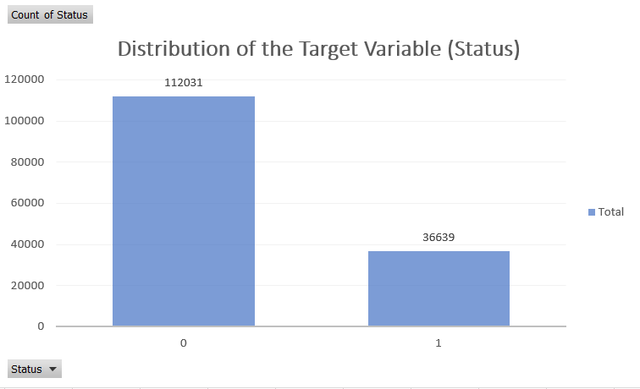
Figure 1: Distribution of the target variable (Status). Non-default cases (112,031) significantly outnumber default cases (36,639), indicating class imbalance.

2.5 Types of Attributes
The data has both qualitative (categorical) and quantitative (numerical) attributes , as shown in the table listed below.
Attribute | Type | Sub-Type
loan_amount | Quantitative | Continuous
income | Quantitative | Continuous
property_value | Quantitative | Continuous
Credit_Score | Quantitative | Continuous
LTV | Quantitative | Continuous
rate_of_interest | Quantitative | Continuous
Region | Qualitative | Nominal
Gender | Qualitative | Nominal
loan_type | Qualitative | Nominal
loan_limit | Qualitative | Nominal
Status | Qualitative | Binary (Target)

A mix of numerical and categorical attributes enables the thorough examination of customer financial profiles and loan-related behavior.

2.6 Missing Data
Initial inspection of the dataset revealed the presence of missing values in several important financial attributes, as shown in the table below. In the Preprocessing stage, these missing values must be dealt with.
Attribute | Missing Values | Missing %
Upfront_charges | 39,642 | 26.66%
Interest_rate_spread | 36,639 | 24.64%
rate_of_interest | 36,439 | 24.51%
dtir1 | 24,121 | 16.22%
property_value | 15,098 | 10.16%
LTV | 15,098 | 10.16%
income | 9,150 | 6.15%

The distribution of missing data was mostly in certain financial variables, indicating a need for attention when assigning the missing values, prior to modeling.

2.7 Redundant Attributes
The attribute ID is identified at the initial inspection phase as a non-predictive identifier which does not contribute meaningful information for predicting loan default. This attribute was marked for deletion during pre-processing. Other attributes have been kept since they have financial, demographic or loan related information that could be useful.

2.8 Initial Data Visualisation
First of all, the initial visualisations served as an understanding of the distribution of the key numerical and qualitative variables, as well as looking for skewness and imbalance in the data set.
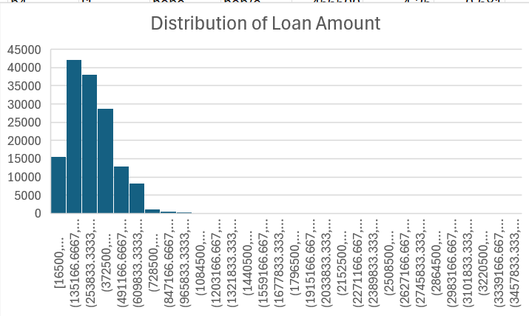
Figure 2: Distribution of loan amount. Right-skewed distribution indicating most loans are concentrated in lower ranges with a long tail of high-value loans.
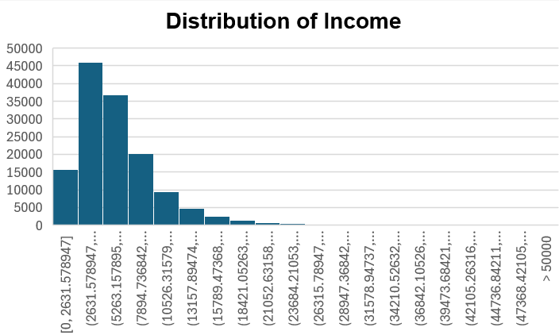
Figure 3: Distribution of income. Highly right-skewed with most customers in lower income ranges and a small number of very high-income outliers.
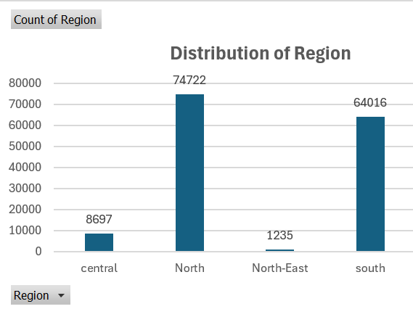
Figure 4: Distribution of region. North and South regions contain the majority of borrowers; Central and North-East are underrepresented.

2.9 Comment on Data Distribution
The data set includes quantitative and qualitative attributes of different distributions. These quantitative variables (e.g., loan amount, income) display some skewness to the right; most of the cases are near the bottom of the range, whereas a few are higher. Customers are unevenly distributed on the qualitative variable Region with the majority located in the North and South Regions. The target variable is not equally distributed (default cases vs. non-default cases) with the non-default being about three times more than the default cases. The missing values in several important financial variables also signifies that extensive preprocessing of the data is necessary before getting started with modelling.

Task 3 — Data Preparation and Preprocessing
One of the most important stages in KDD (knowledge discovery in Database) process is data preprocessing because raw datasets often contain missing values, inconsistent formats, redundant attributes, and uneven data distributions that can negatively affect model performance before building the classification models, the loan default dataset was cleaned and transformed using RapidMiner AI Studio to improve data quality, reduce noise, and prepare the dataset for predictive analysis.
The preprocessing stage included several important steps:
Step No. | Preprocessing Step
Step 1 | Removing the redundant attributes and setting the target
Step 2 | Handling the missing values using imputation techniques
Step 3 | Converting the categorical attributes into numerical
Step 4 | Normalizing numerical variables
Step 5 | Inspecting outliers and data distribution
Step 6 | Apply PCA (principal component analysis) for dimensionality reduction

3.1 KDD Preprocessing Workflow
The preprocessing stage followed the KDD methodology to systematically clean, transform, and reduce the dataset before model building. The whole workflow was implemented in RapidMiner AI Studio.
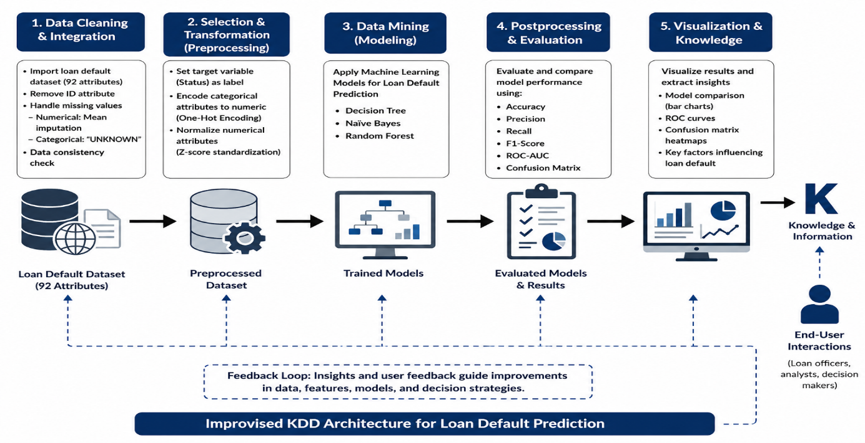Figure 5: Complete KDD preprocessing pipeline in RapidMiner AI Studio
The preprocessing pipeline followed these steps in sequence:
Step No. | Preprocessing Pipeline Step
Step 1 | Importing the loan default dataset into RapidMiner
Step 2 | Setting the target variable (status) as the label attribute
Step 3 | Removing the non-predictive (ID) column
Step 4 | Replacing missing values in numerical attributes using mean imputation
Step 5 | Replace missing categorical values with “UNKNOWN”
Step 6 | Converting categorical attributes into numerical format
Step 7 | Normalizing numerical attributes using Z score standardization
Step 8 | Applying PCA to reduce dimensionality from 92 attributes to 20 principal components

3.2 Handling Redundant Attributes
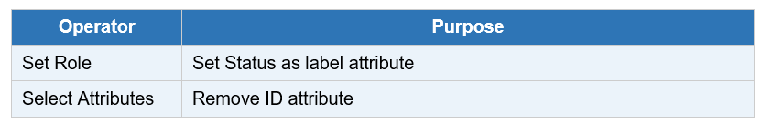
The ID attribute was removed because it acts only as a unique identifier and does not contribute to loan default prediction.

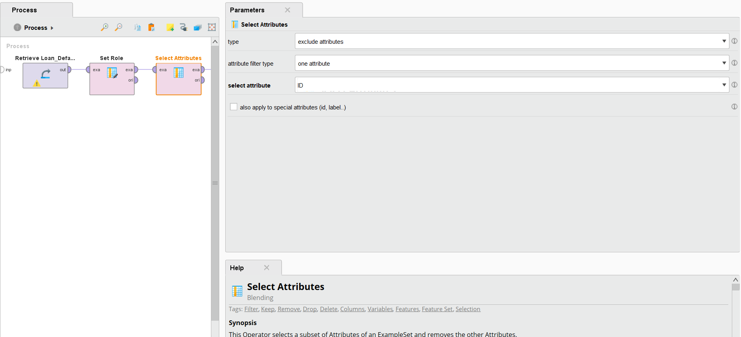
Figure 6: Select Attributes operator configured to exclude irrelevant attributes .
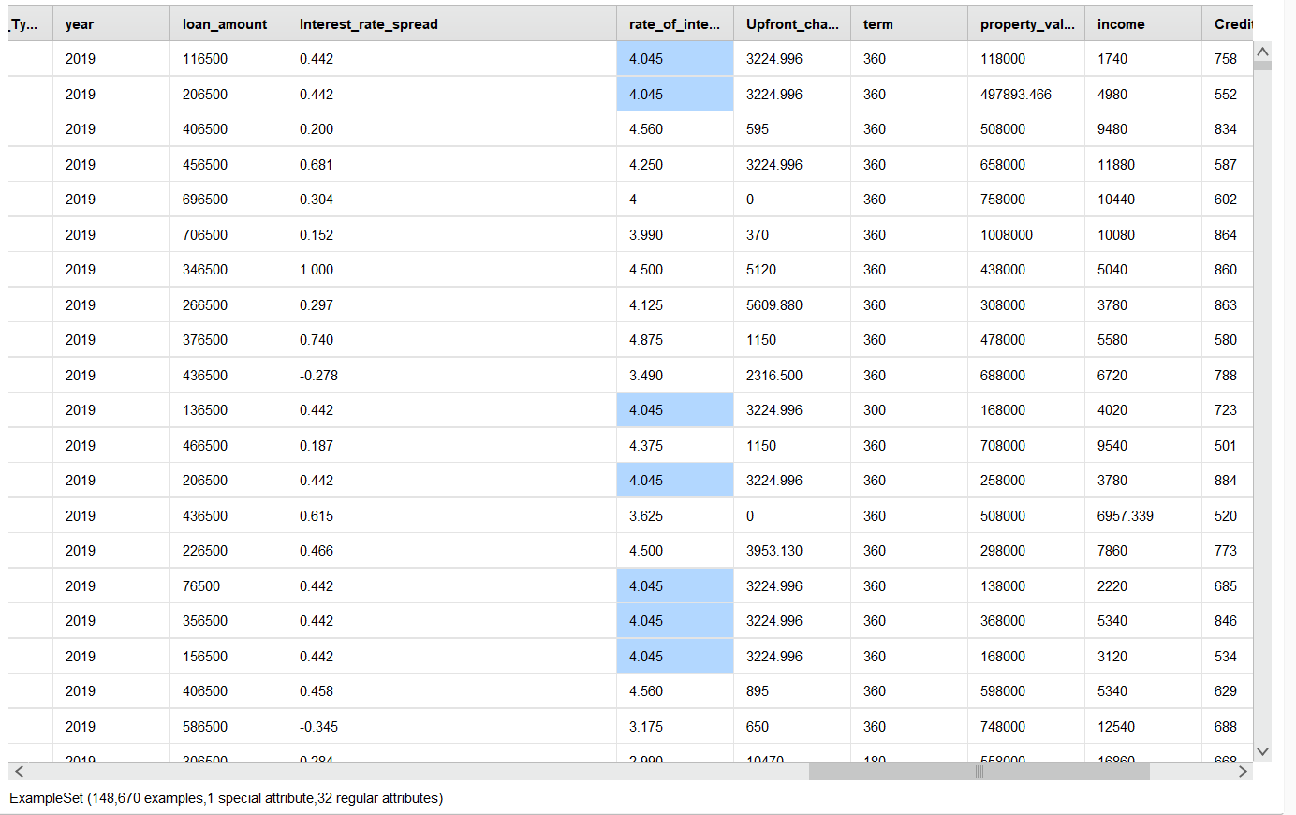
Figure 7: Dataset after removing the ID attribute and setting Status as the label — 148,670 examples, 1 special attribute (label), 32 regular attributes.

3.3 Handling Missing Values
Missing values were handled using imputation to preserve dataset size and consistency.
Attribute | Missing Value Handling
Upfront Charges | Mean Imputation
Interest rate spread | Mean Imputation
Rate of interest | Mean Imputation
Income | Mean Imputation
Property value | Mean Imputation
LTV | Mean Imputation
Dtir1 | Mean Imputation

Imputation was used to preserve dataset size and improve data consistency. Using the following:
Attribute Type | Imputation Method
Numerical attributes | Mean (average)
Categorical attributes | UNKNOWN

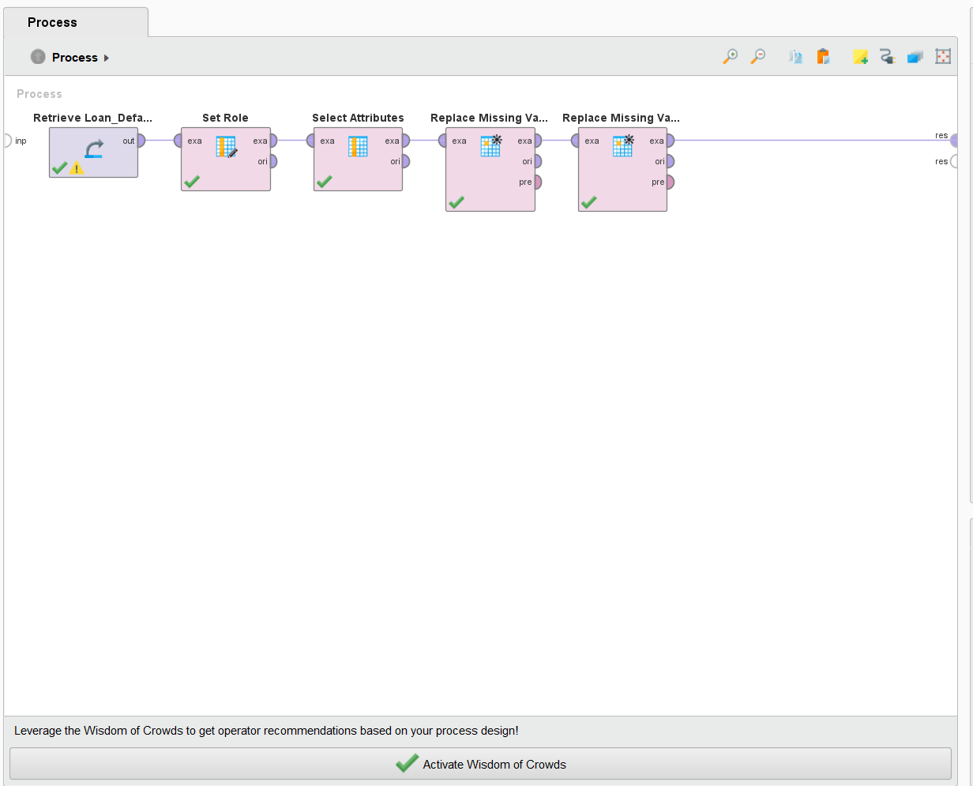
Figure 8: RapidMiner process showing the two Replace Missing Values operators added to the pipeline.

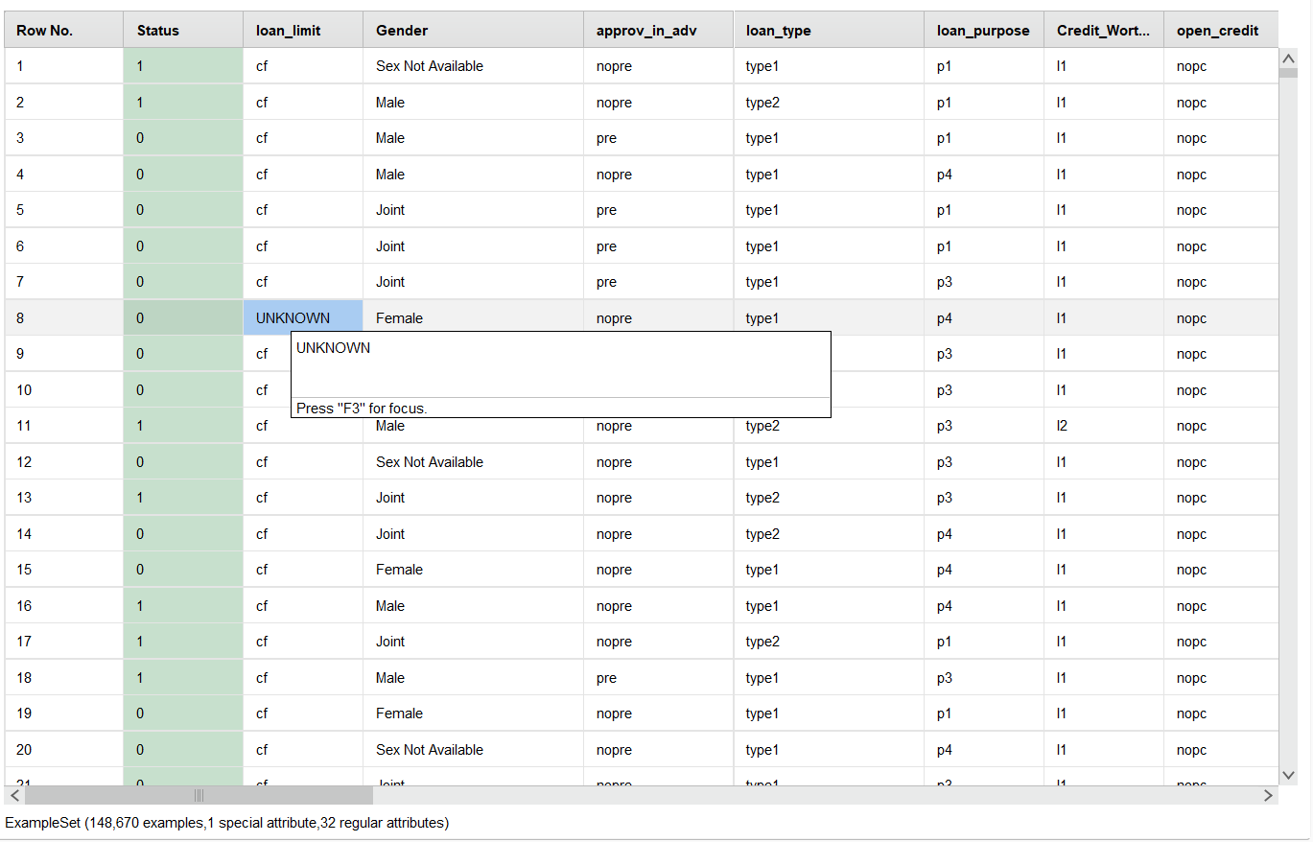
Figure 9: Dataset view showing categorical attribute values (including the UNKNOWN replacement for loan_limit)

3.4 Encoding Categorical Attributes
Categorical Attributes Encoded
Gender
Region
loan_type
loan_limit
occupancy_type
approv_in_adv
business_or_commercial

Nominal to Numerical with one-hot encoding was applied.
One-hot encoding resulted in the 32 attributes being increased to 92 regular attributes.
By converting the dataset, the preservation of information from the original categorical attributes enabled effective use of the data by classification algorithms.

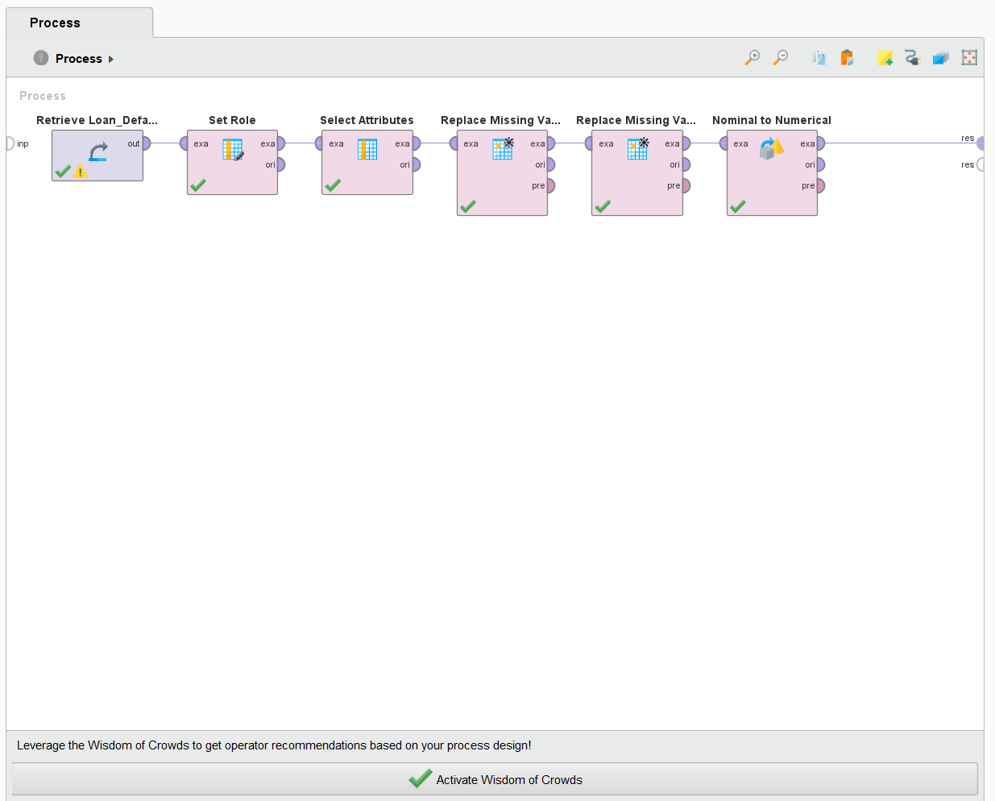
Figure 10: AI Studio process showing the Nominal to Numerical operator added to the pipeline.
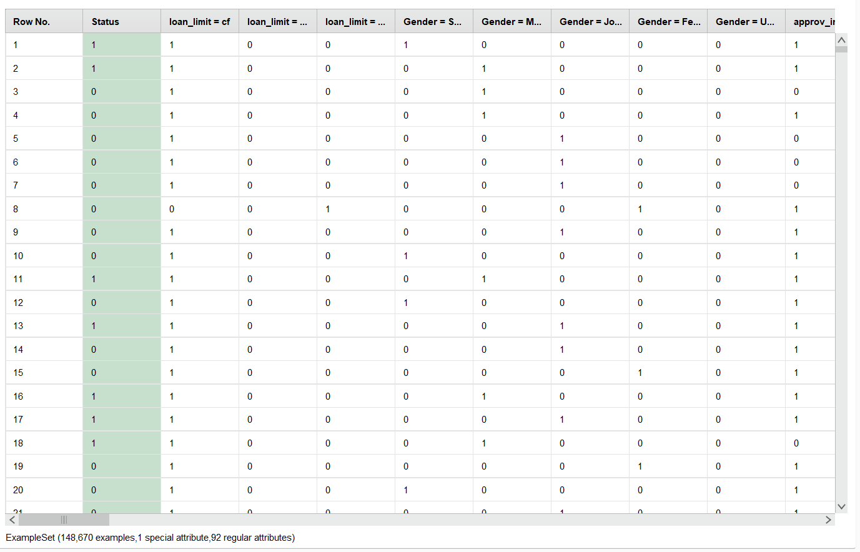
Figure 11: Dataset after one-hot encoding — 148,670 examples, 92 regular attributes. Categorical columns are now represented as binary dummy variables (e.g., Gender = Male, Gender = Female, etc.).

3.5 Data Normalization
Normalization was applied to ensure equal contribution of numerical attributes during model training.
Technique | Method
Normalization | Z-Score Standardization
Mean After Scaling | 0
Standard Deviation After Scaling | 1

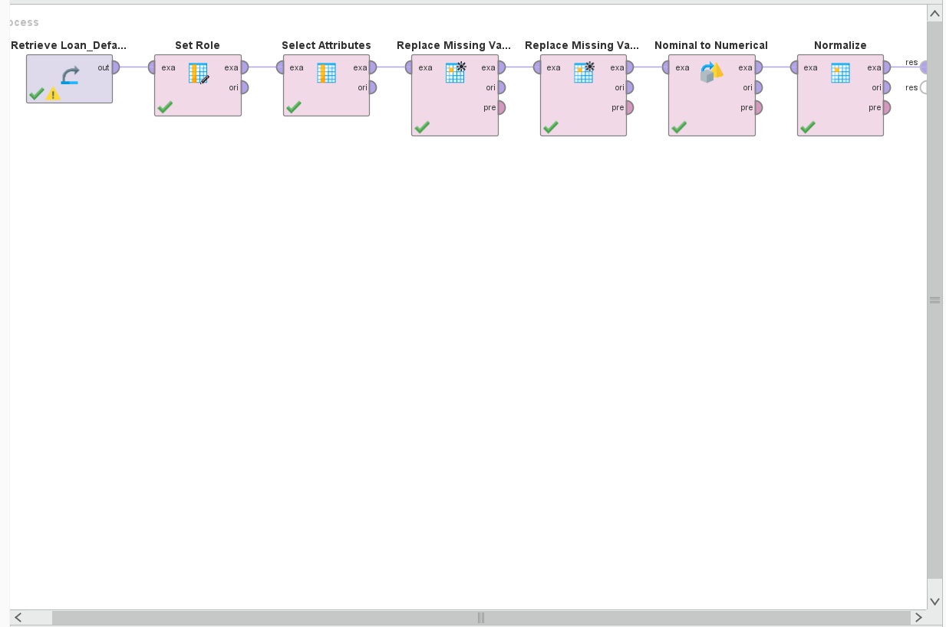
Figure 12: : AI Studio process showing the Normalize operator added to the pipeline.
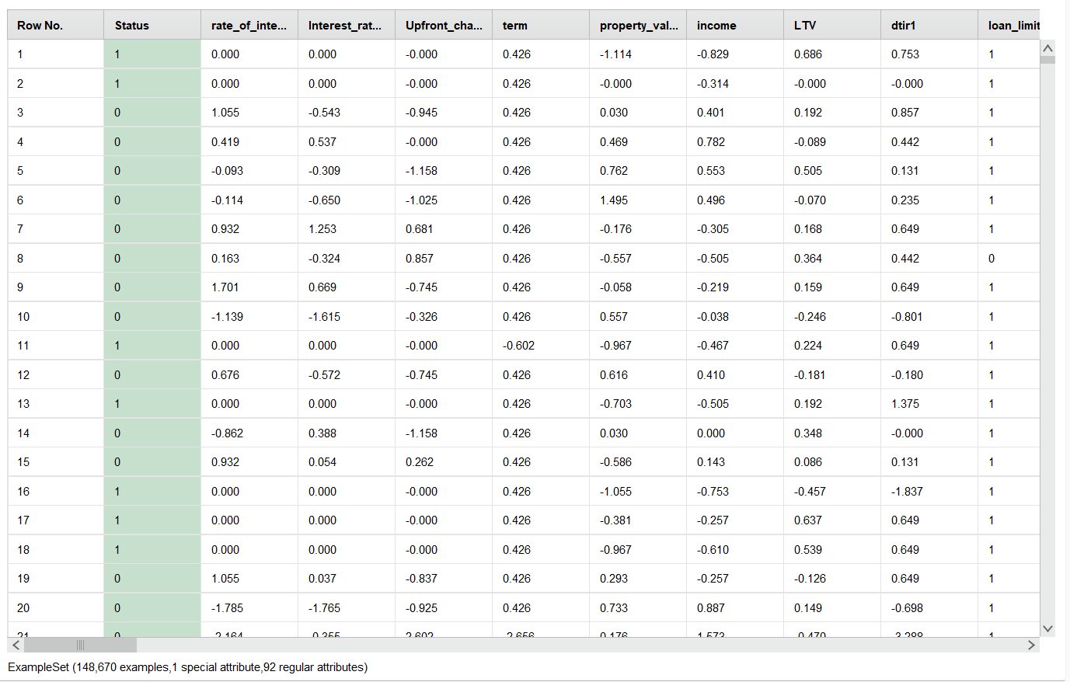
Figure 13: Dataset after z-score normalisation — values are now standardised (centred around 0), as seen in the rate_of_interest, income, and property_value columns.

3.6 Outlier Detection and Data Distribution
Since the data collected is too large to be 148,670, the outlier analysis was done on a representative stratified sample of 5,000 records. This method can be used to efficiently check the distribution of the data and maintains the distribution's representativeness of the overall data set. The box plot analysis revealed that there are outliers in some of the financial attributes: There were extreme values in the “property_value” column with values up to about 5,800,000. “loan_amount” had outliers up to 2,500,000.There were outliers in the data set loan_amount that were approaching 2,500,000. The distribution of `income` was reasonably compact, with a few outliers of high income The distributions of `Credit_Score` and `LTV` were relatively stable with few extreme values. Extreme values were detected, but the outliers were not removed as this would indicate that the cases were indeed high value loans. Removing them could result in the loss of important financial patterns related to loan default prediction
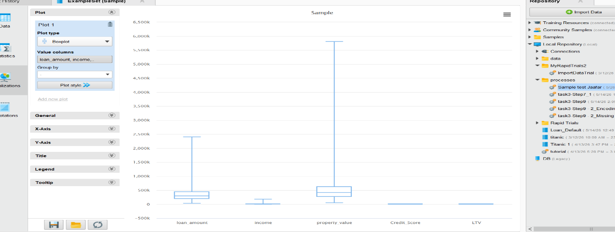

3.7 Dimensionality Reduction — PCA
PCA was applied after one-hot encoding to reduce dimensionality while preserving important variance.
PCA Configuration | Value
Attributes Before PCA | 92
Principal Components Retained | 20
Attributes After PCA | 20

PCA Benefit
Reduced complexity
Reduced overfitting
Improved efficiency
Simplified dataset

This reduction helped in:
- simplifying the dataset structure and reduce model complexity.
- Use a smaller data set without overfitting.
- Enhance computational efficiency in training the model

The PCA transformed dataset consisted of:
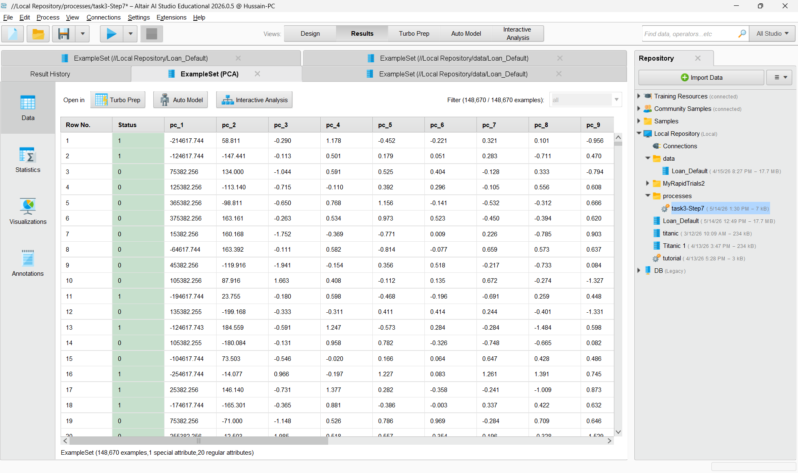
Figure 15: PCA output dataset showing principal components PC1 through PC20 — 148,670 examples, 1 label attribute (Status), 20 regular attributes (principal components).
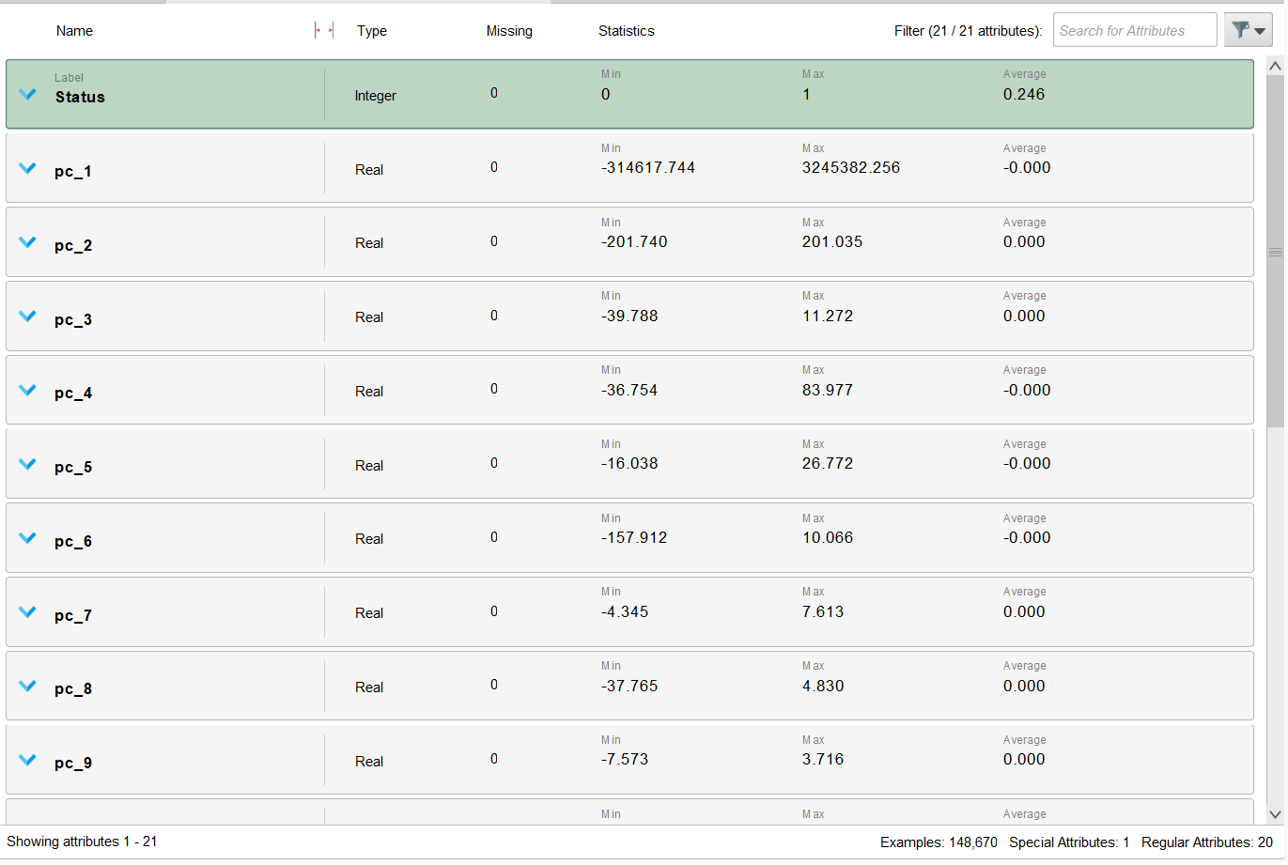
Figure 16: Statistics view after PCA — all 21 attributes (Status + PC1 to PC20) show 0 missing values, confirming the preprocessing pipeline has produced a clean dataset.

3.8 Before and After Preprocessing Comparison
The preprocessing stage played a pivotal role in increasing the quality and organization of the dataset. Data was handled for missing values, categorical variables were converted into
- 148,670
- 20 principal components attributes
- 1 label attribute (Status)
- 0 missing value
Numerical, unnecessary attributes were eliminated, and dimensionality reduction was done using PCA.

Stage | Action | Result
Original Dataset | — | 148,670 records, 34 attributes
Set Role | Status set as label | 1 special attribute, 33 regular attributes
Select Attributes | ID column removed | 1 special attribute, 32 regular attributes
Replace Missing Values | Mean for numerical; UNKNOWN for categorical | No missing values in imputed columns
Nominal to Numerical | One-hot encoding applied | 92 regular attributes (expanded from 32)
Normalize | Z-score standardisation | All numerical values centred around 0
Outlier Inspection | Box plot analysis on sample | Outliers identified and retained
PCA | 20 principal components retained | 20 regular attributes, 0 missing values
Final Dataset | — | 148,670 records, 20 PC attributes + label

3.9 Conclusion of Preprocessing Stage
The preprocessing stage was successful in converting the raw Loan Default Dataset into a clean, structured, and dimensionally reduced dataset for predictive modelling. Systematic application of key preprocessing techniques such as missing value treatment, categorical encoding, z score normalisation, outlier inspection, and PCA were used in RapidMiner AI Studio. The final data set is now completely ready to be used to create and test classification models for the prediction of defaulting customers.

Task 4 — Building Data Mining Models
Since the aim of the project was the prediction of the loan default status, supervised classification techniques were used. Its target variable Status is binary (0 or 1 as no default or default) and hence, binary classification is the most suitable data mining approach for solving the problem. Three models were created and evaluated: Decision Tree model, Naive Bayes model, and Random Forest (ensemble model).

4.1 Train/Test Data Split
Firstly, the preprocessed data set was split into training and test partitions with the help of the Split Data operator in RapidMiner. The ratio was divided as 70:30 where the number of records used in training is ~104,069 and the number of records used for testing is ~44,601. This ratio was chosen to be in accordance with the commonly used industry practice for binary classification problems: to provide enough data for training, and enough data for unbiased model evaluation. It was split using linear sampling because the data was ordered.
Partition | Ratio | Approximate Records
Training Set | 70% | ~104,069
Testing Set | 30% | ~44,601
Total | 100% | 148,670

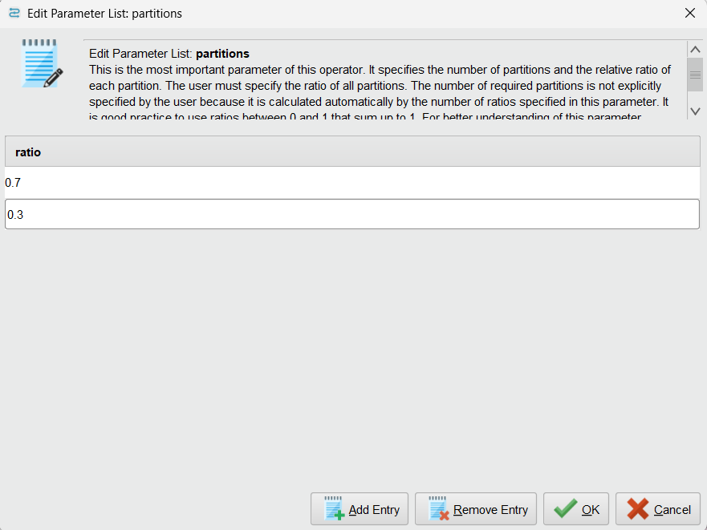
Figure 17: Split Data operator (70/30 ratio) in AI Studio

4.2 Model 1 — Decision Tree
The Decision Tree was selected as the first classification model because it is highly interpretable, does not require feature scaling, and naturally handles both numerical and categorical data. Decision Trees work by recursively partitioning the dataset based on the attribute that maximises information gain or gain ratio at each node, building a tree-like structure that can be visually inspected and understood.

The Decision Tree model was configured with the following parameters in RapidMiner:

Parameter | Setting | Justification
Criterion | Gain Ratio | Rather than information gain, it was preferred for dealing with attributes with many values without bias.
Maximal Depth | 10 | Reduces size of trees (to avoid overfitting) but not so small as to lose complexity
Minimal Gain | 0.01 | Puts in extra effort to avoid unjustified splits
Minimal Leaf Size | 2 | Provides at least 2 examples, to avoid overfitting, in each leaf
Apply Pruning | Yes | Removes branches that provide little predictive power

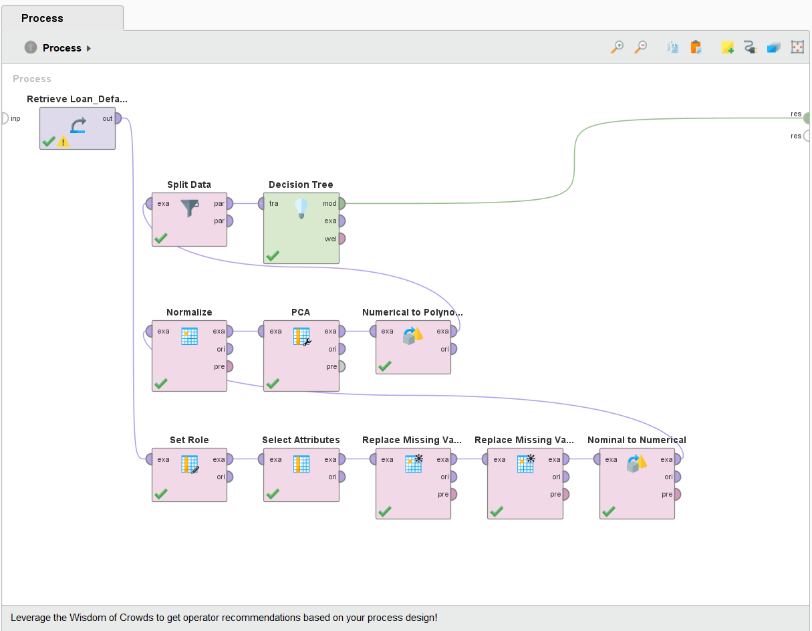
Figure 18: Decision Tree pipeline in AI Studio

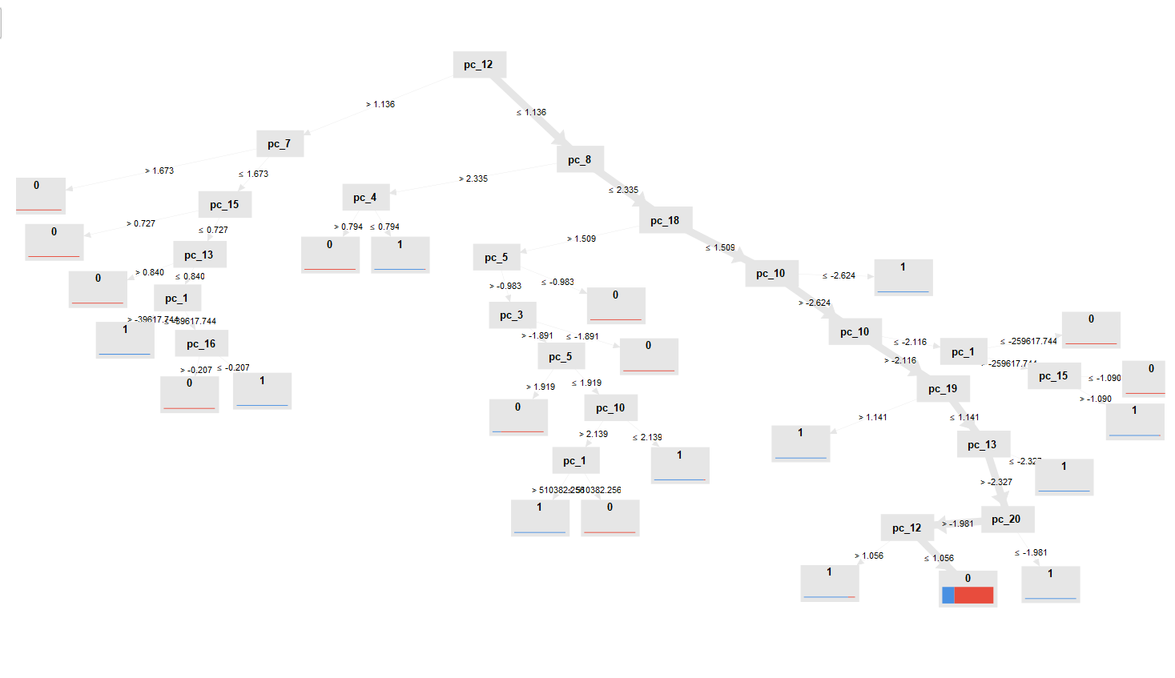
Figure 19: Decision Tree structure output

4.3 Model 2 — Naive Bayes
Second classification model was Naive Bayes, low cost, simple and has good baseline performance in binary classification. It applies Bayes' theorem by assuming the attributes are independent and the probabilities for each class (default vs. no default) are given for specific values of attribute(s) for a given individual customer. Despite the simplifying independence assumption Naive Bayes has been demonstrated to be effective on financial data.
Parameter | Setting | Justification
Laplace Correction | Enabled | Prevents zero probability issues for unseen attribute values
Distribution Model | Normal | Suitable for continuous numerical attributes

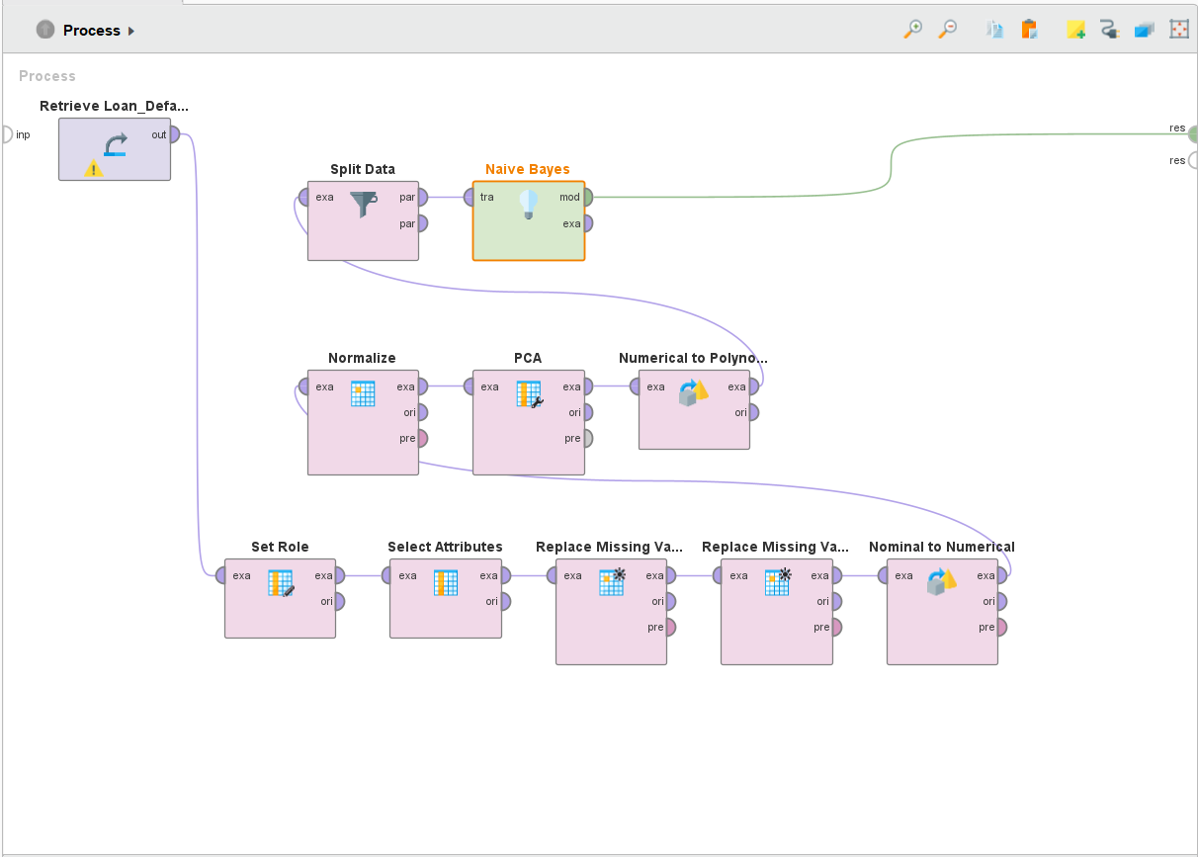
Figure 20: Naive Bayes pipeline in AI Studio
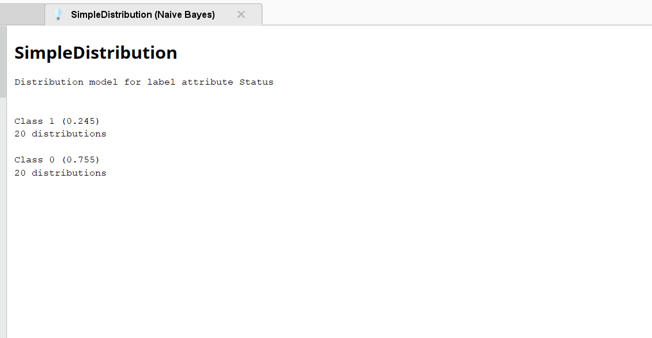
Figure 21: Naive Bayes Simple Distribution output (24.5% / 75.5%)

4.4 Ensemble Model — Random Forest
The model of the ensemble was chosen as Random Forest due to the very important limitation of Decision Tree - overfitting. Random Forest generates trees, random subsets of the training data and uses a majority voting approach (for classification). This ensemble approach minimizes the variance, generalizes better and often yields better results on real-world dataset like loan default prediction, as opposed to individual models.
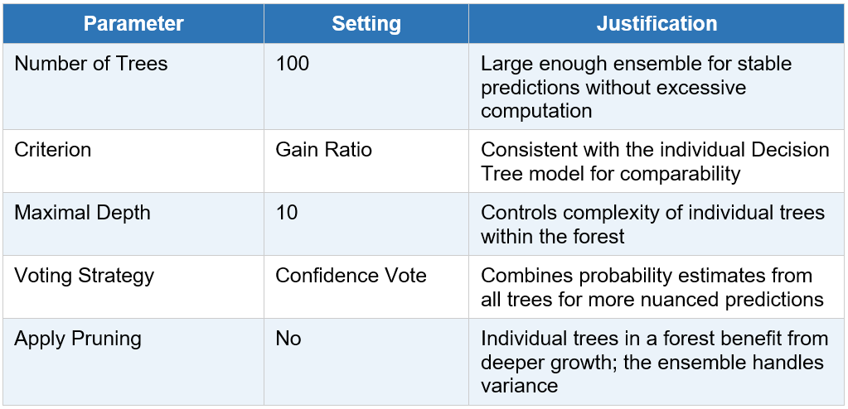

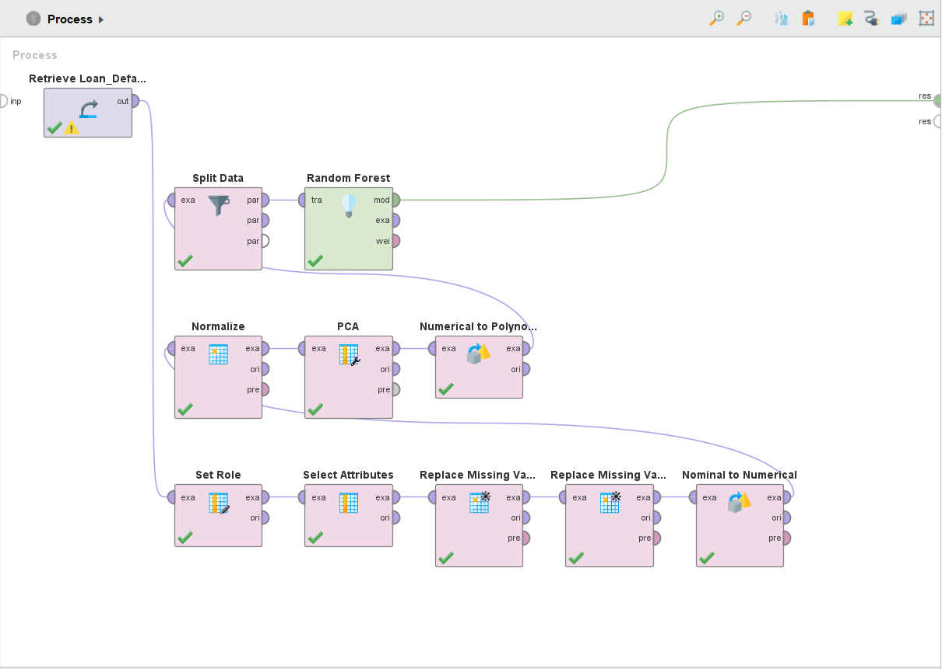
Figure 22: Random Forest pipeline in AI Studio

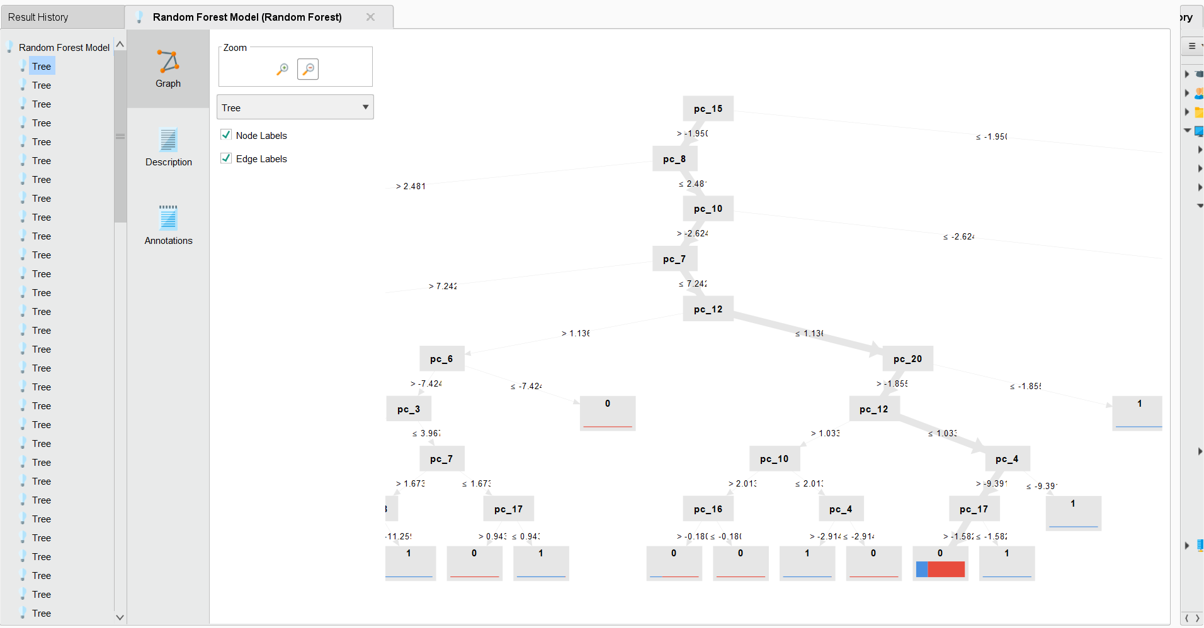
Figure 23: Random Forest trees output

Task 5 — Evaluating Data Mining Models
(Decision Tree, Naive Bayes, and Random Forest) all these Classification models were compared using the same set of performance measures. These were the metrics chosen to be evaluated:
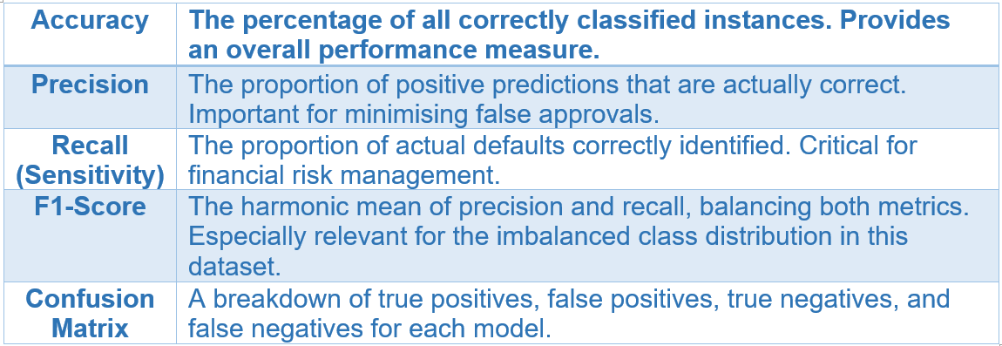

These measures were selected because the data is class-imbalanced (comprising significantly more non-defaults than defaults). In other instances, however, accuracy may be deceptive; a model that predicts that no default will occur for any of their records could have a high accuracy rate but be of no use in practice. For the default class Recall and F1-Score give a more full picture of the effectiveness of the model.

5.1 Model 1 — Decision Tree Evaluation
The following model's results were generated by the Performance operator using the Execution of Decision Tree model that was created on the 30% test partition.

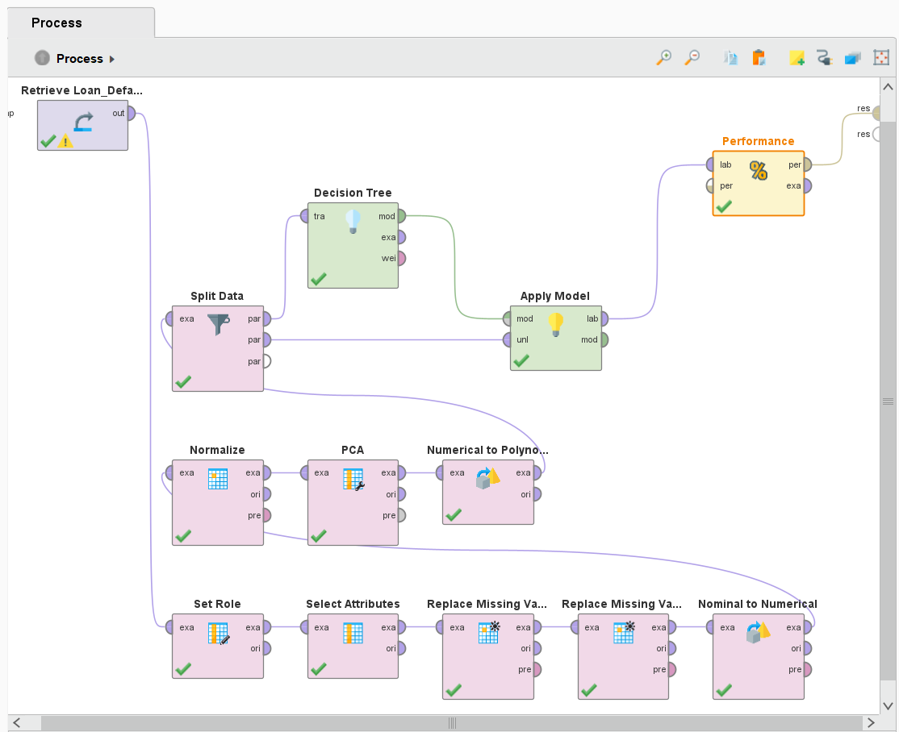
Figure 24: Decision Tree Performance Evaluation Pipeline in AI Studio

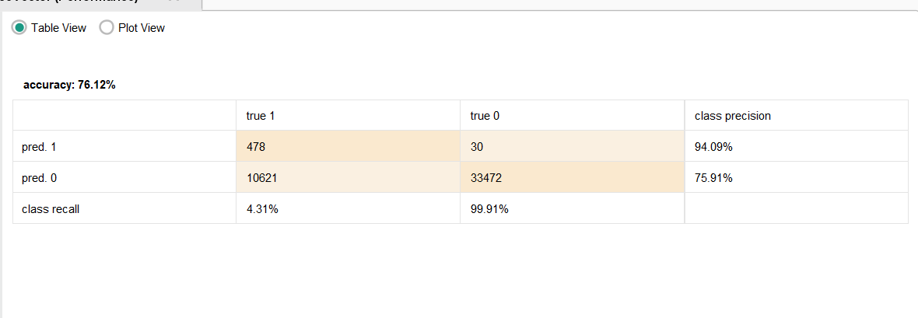
Figure 25: Decision Tree Confusion matrix result (76.12% accuracy, 4.31% recall)

Metric | Value
Accuracy | 76.12%
Precision (Default class) | 94.09%
Recall (Default class) | 4.31%
F1-Score | 8.24%
True Positives | 478
False Positives | 30
True Negatives | 33,472
False Negatives | 10,621

The Decision Tree performed with 76.12% accuracy, 478 true defaults were correctly predicted for the default class, the recall was 4.31% and the F1-Score was 8.24%.

5.2 Model 2 — Naive Bayes Evaluation
Then, running the Naive Bayes model on the same 30% test partition, we get the following performance results.
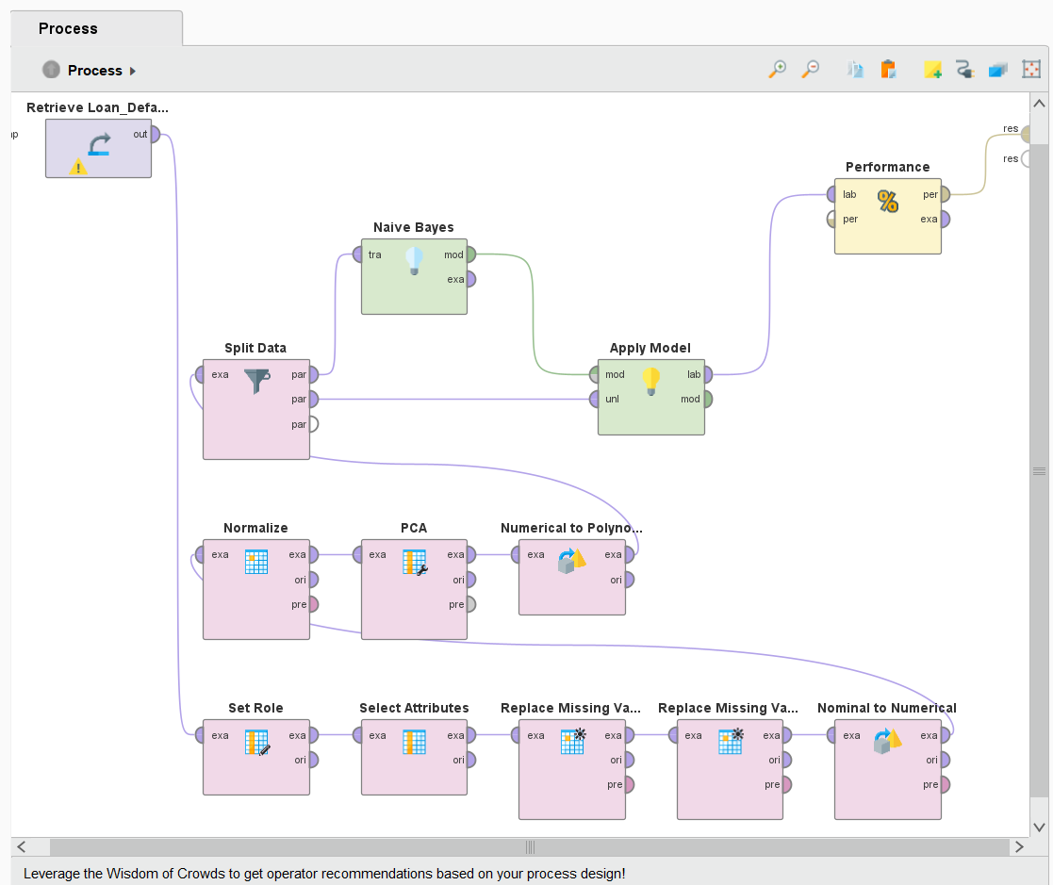
Figure 26: Naïve Bayes Performance Evaluation Pipeline in AI Studio

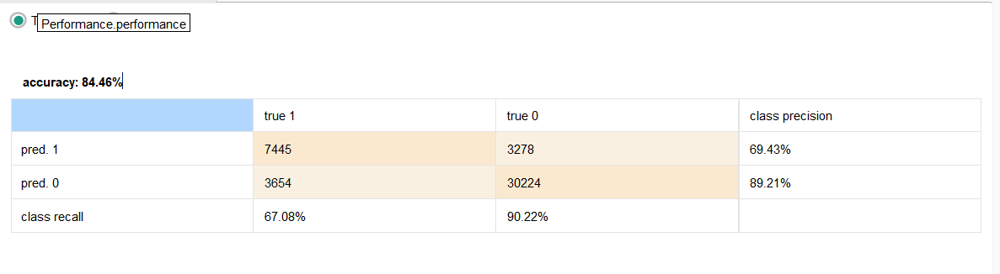
Figure 27: Naive Bayes confusion matrix result (84.46% accuracy, 67.08% recall)

Metric | Value
Accuracy | 84.46%
Precision (Default class) | 69.43%
Recall (Default class) | 67.08%
F1-Score | 68.22%
True Positives | 7445
False Positives | 3278
True Negatives | 30,224
False Negatives | 3654

Naive Bayes had an accuracy of 84.46%, a recall of 67.08% and an F1-Score of 68.22%, where it correctly classified 7,445 of the actual defaults among 11,099.

5.3 Ensemble Model - Random Forest Evaluation
The random forest ensemble model was evaluated using the same 30 percentage testing dataset. Since random forest merges multiple decision tree it was expected to provide more accurate and stable predictions compared to a single decision tree model.
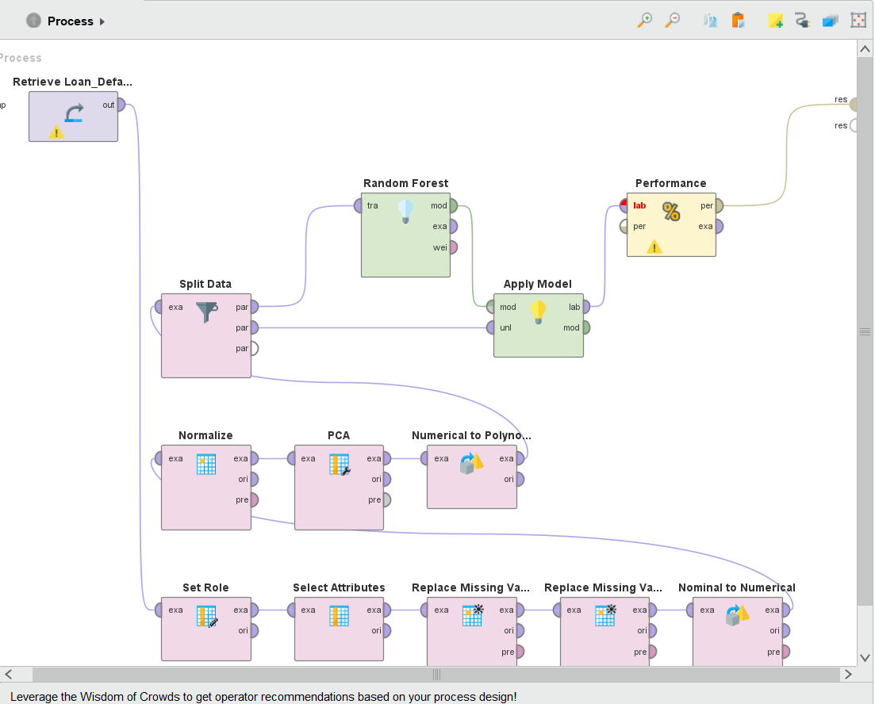
Figure 28: Random Forest Performance Evaluation Pipeline in AI Studio

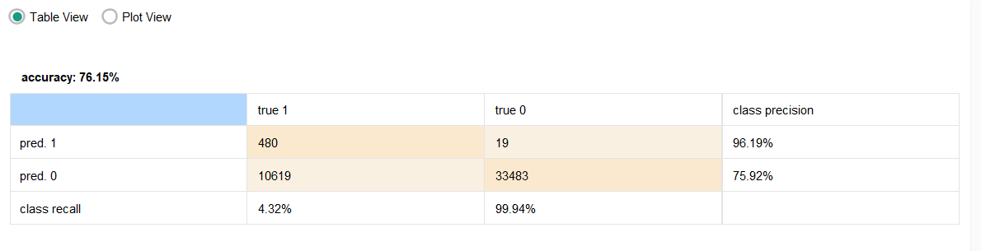
Figure 29: Random Forest confusion matrix result (76.15% accuracy, 4.32% recall)

Metric | Value
Accuracy | 76.15%
Precision (Default class) | 96.19%
Recall (Default class) | 4.32%
F1-Score | 8.27%
True Positives | 480
False Positives | 19
True Negatives | 33,483
False Negatives | 10,619

The accuracy of the Random Forest ensemble was 76.15% with a recall of 4.32 % for the default class (correctly identified 480/11,099 actual defaults) and F1-Score of 8.27 %.

5.4 Model Comparison Summary
A summary of all three models is given in the table below for all the evaluation metrics. It is observed that the best model is Naive Bayes with an accuracy of 84.46%, a recall of 67.08%, an F1-Score of 68.22% and an AUC of 0.885, which means that it correctly classifies a defaulter or a non-defaulter 88.5% of the time.
Metric | Decision Tree | Naive Bayes | Random Forest (Ensemble)
Accuracy | 76.12% | 84.46% | 76.15%
Precision | 94.09% | 69.43% | 96.19%
Recall | 4.31% | 67.08% | 4.32%
F1-Score | 8.24% | 68.22% | 8.27%
Best Model? | - | Yes | -

The class imbalance problem dominated both models with a mere 4.3% recall of defaults, irrespective of the ensemble effect of the Random Forest model. Naive Bayes, on the other hand, managed to deal with the imbalance well with the use of probabilities. Recall is the most important measure in the banking arena a missed default is much more expensive than a false alarm. The ROC curve below demonstrates a good discriminatory ability of the Naive Bayes model.

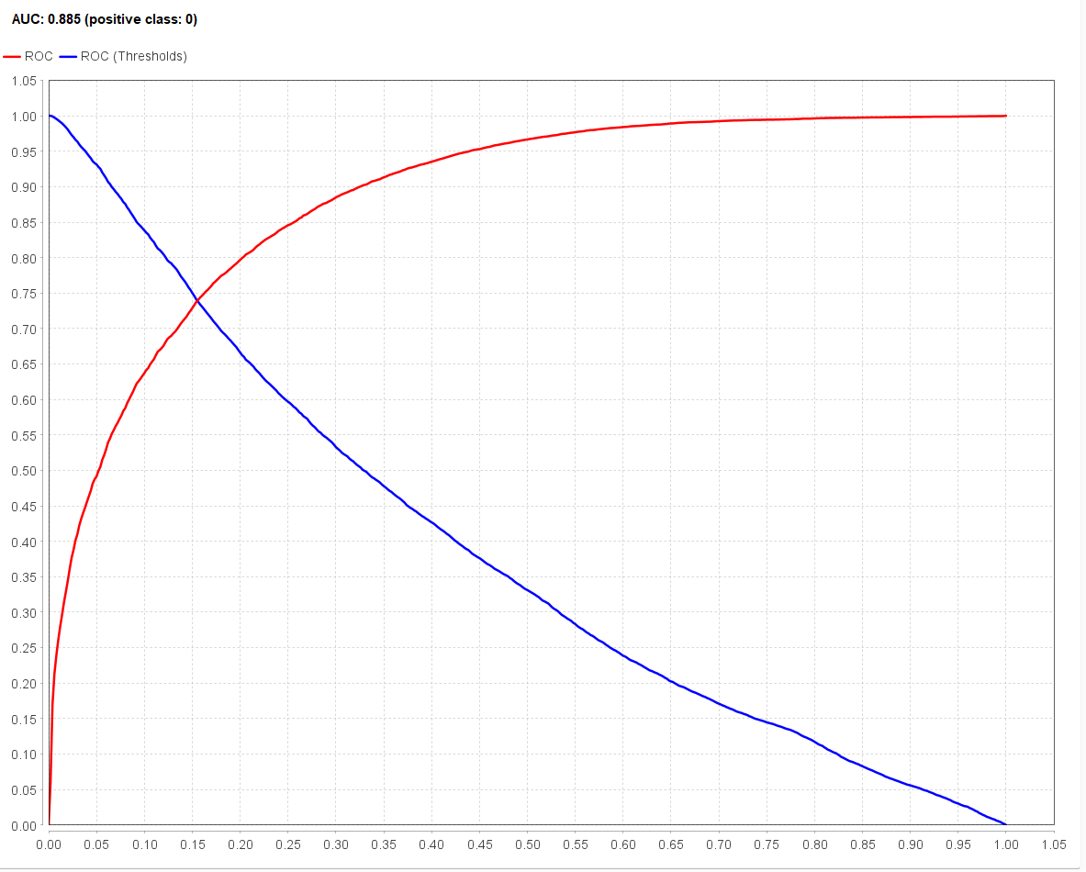
Figure 30: Final model comparison summary

Task 6 — Inferences, Recommendations and Reflection

6.1 Model Comparison and Inferences
Naive Bayes achieved the best, accuracy = 84.46%, AUC value = 0.885, recall = 67.08%, which is 0.882 greater than that of default class accuracy of the tree-based models. However, both Decision Tree and Random Forest had incredibly low value for recall (around 4.3%) because of class imbalance and this shows that alone ensemble methods are not able to compensate for an imbalance ratio of 3:1 without other strategies.
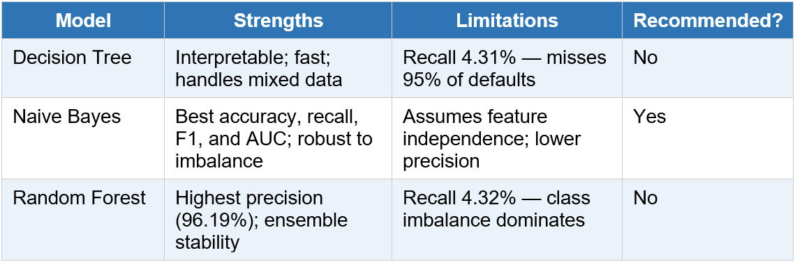

6.2 Impact on the Business Problem
In real time, a deployed Naive Bayes model can help identify loan applications which are high risk, which in turn helps to lower the amount of non-performing loans. The key predictors identified in the analysis (Credit_Score, income, LTV, loan amount) can be used to determine the minimum terms of the loans and the lending policy. Prioritising recall over precision is critical — an undetected default costs far more than a declined safe application.

6.3 Recommendations
- Apply SMOTE oversampling to generate synthetic default cases and improve detection of minority class customer.
- Explore additional models such as SVM and neural networks to expand the comparison more than the current project scope
- Implement cross validation to obtain more efficient, reliable and less biased performance estimate.
- Use feature importance from the random forest model to improve feature selection and reduce unnecessary attributes.
- Retrain the model regularly using updated data to maintain the prediction accuracy over time.

6.4 Reflection
One of the hardest and most challenging parts of the project was selecting a suitable dataset and understanding why the expected best performing model, random forest, was outperformed by naive bayes due to the class imbalance issue. Preprocessing was also more complex than expected because the date set contained 34 attribute, multiple types of missing values and required dimensionality reduction using PCA.
The group learned that evaluation of metrics such as recall and F1 score are more important than the accuracy alone when working with imbalanced data set. The project also highlighted how strongly data quality affects the model's performance. Given more time, the group would test additional classification modes and implement cross validation to improve the prediction reliability in real banking environments.

