Time Series Analysis of Gold ETF Prices Data

Name: Hussain Nathani

Introduction
Gold is a crucial asset in the financial market, often used as a hedge against inflation and economic uncertainty. Understanding the behaviour of gold prices is essential for investors, policymakers, and analysts. This analysis explores the underlying patterns in the Gold ETF price movements and assesses their predictability using time series modelling techniques. By identifying trends and seasonality in the data, this study aims to provide insights that can enhance market forecasting strategies.

Dataset and Variables
Kaggle Link: “www.kaggle.com/Gold_Data”
The dataset chosen for this study consists of historical financial data, including key indices and commodity prices, with the following selected variables:
- S&P 500 ETF Close Price
- NASDAQ QQQ ETF Close Price
- Consumer Price Index (CPI)
- Gross Domestic Product (GDP)
- Silver ETF Close Price
- Oil USO ETF Close Price
- Platinum ETF Close Price
- Palladium ETF Close Price
- Gold ETF Open Price
- Gold ETF Low Price
- Gold ETF Close Price (Forecast Variable)
- Gold ETF Volume
This dataset is ideal for time series analysis as it is multivariate, contains continuous numerical features, includes many observations, and exhibits non-stationary behaviour. The dataset’s public availability and relevance to financial market analysis make it a strong candidate for forecasting gold prices and analysing market trends.

Time Series Analysis
Non-Stationarity Assessment
A time series plot of the Gold Close Price against time demonstrates an upward trend, indicating potential non-stationarity.

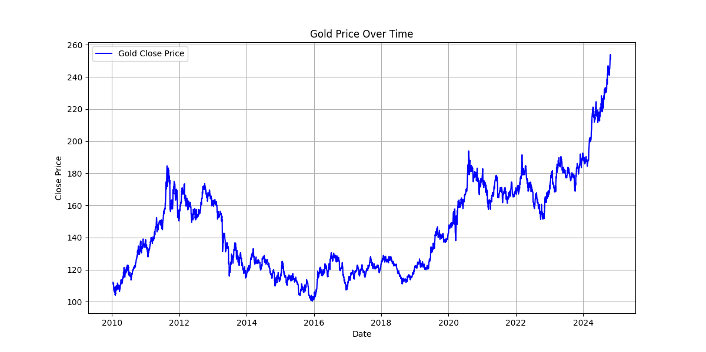

This is further validated through:
- Rolling Mean and Variance: The rolling mean follows the general trend of the original series closely, indicating underlying trends in the data. The rolling variance shows significant fluctuations, particularly in times of economic turbulence.

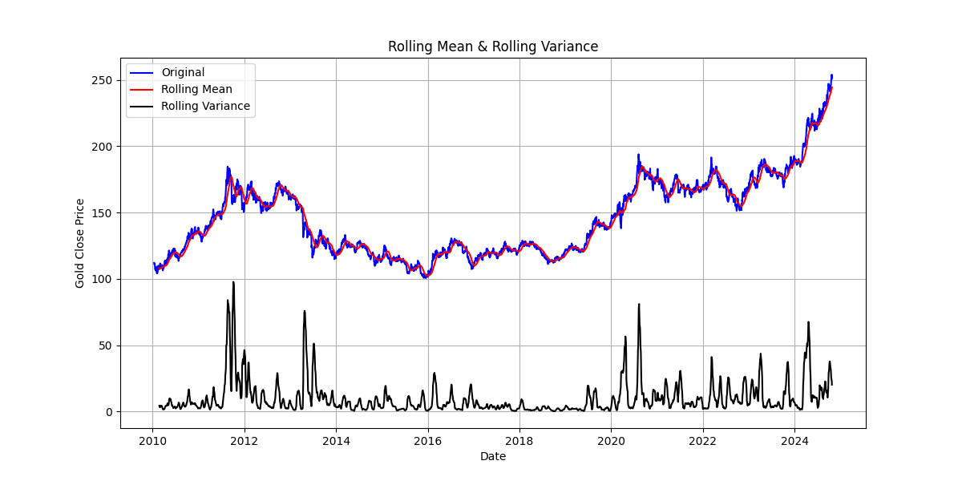
- Augmented Dickey-Fuller (ADF) Test: The test returned a statistic of 0.3768 with a p-value of 0.9806. Since the p-value is significantly higher than 0.05, it fails to reject the null hypothesis, confirming the non-stationary nature of the dataset.

Trend and Seasonality Analysis
Non-stationarity in this dataset arises from both trend and seasonality:
- Trend: The decomposition reveals an upward trajectory over recent times. The strength of the trend is 0.9694, indicating that the dataset is heavily trend driven.
- Seasonality: The seasonal component shows recurring fluctuations. However, the strength of seasonality is 0.3309, suggesting that while seasonality exists, it has a relatively weaker influence compared to the trend.

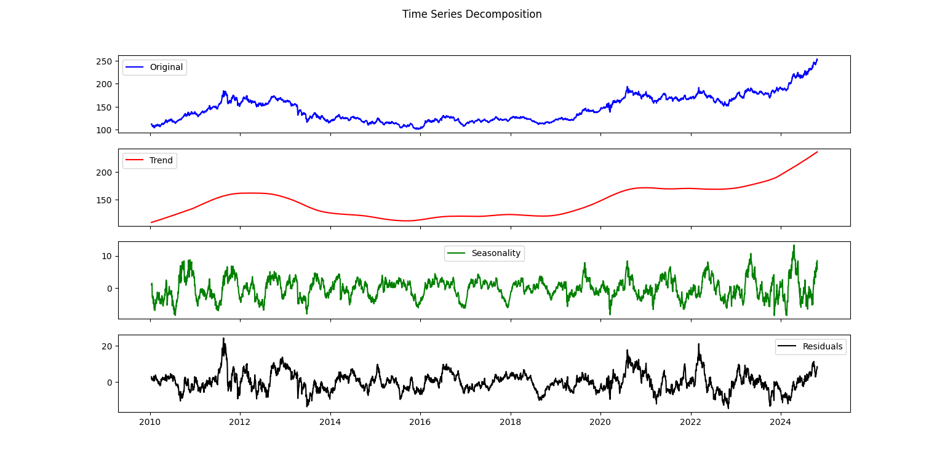

Autocorrelation Analysis
The Autocorrelation Function (ACF) plot of the Gold Close Price shows high autocorrelation across all time lags, with values sticking close to 1 and a minor decline. This means there’s a steady and strong link between past and future values, making the data highly non-stationary. In simple terms, the closing price depends heavily on its previous values.

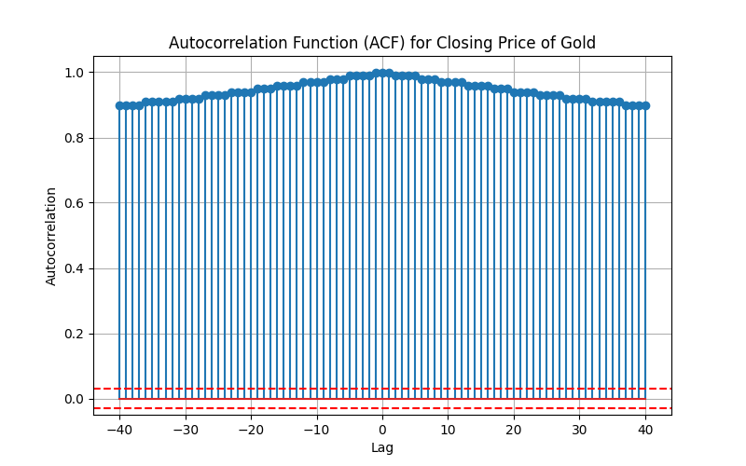

Since the autocorrelation doesn’t gradually decrease, it points to a strong trend in the data. To make this data stationary, differencing would be necessary. Because of these patterns, forecasting models that handle non-stationary data and autocorrelation are ideal. The ARIMA (Auto Regressive Integrated Moving Average) model fits well here because it’s built to deal with such trends. If there’s a seasonal pattern in the data, SARIMA (Seasonal ARIMA) would be a better pick, as it adds seasonal components on top of ARIMA’s features.

Conclusion
This dataset presents an excellent opportunity for in-depth time series analysis. The presence of both trend and seasonality makes it suitable for predictive modelling.
Further steps in this study will involve feature engineering, model selection, and evaluation to optimize forecasting accuracy. Ultimately, this analysis aims to provide valuable insights into Gold ETF price movements, equipping investors with data-driven predictive analytics for informed decision-making.

