Seeding QDArchive
Part 2: Data Classification Report
ISIC Rev. 5 Classification of Qualitative Research Projects

Student | Jakir Hussain Rifat
Matric. ID | 23025313
Course | Seeding QDArchive (SQ26) — Applied Software Engineering Project
Professor | Prof. Dr. Dirk Riehle, Professorship for Open-Source Software
University | Friedrich-Alexander-Universität Erlangen-Nürnberg (FAU)
Date | May 2026
Repository | https://github.com/hussainrifat/QDArchive

Dataset Overview
Repository | QDA Projects | QD Projects | Other | Not a Project | Total
FSD Finland | 0 | 4 | 399 | 0 | 403
Dryad | 1 | 340 | 498 | 14 | 853
Total |  |  |  |  | 1256

1. Introduction and Methodology

This report presents the results of Part 2 of the Seeding QDArchive project, conducted as part of the Applied Software Engineering Project seminar at FAU Erlangen (Winter 2025/26 + Summer 2026) under the supervision of Prof. Dr. Dirk Riehle. The project's objective is to populate QDArchive — a new repository for qualitative research data — by acquiring and classifying publicly available qualitative research datasets from two assigned repositories.

1.1 Scope of Classification

Part 1 of this project acquired 1,256 qualitative research projects from Dryad and the Finnish Social Science Data Archive (FSD Finland), storing full metadata in a structured SQLite database. Part 2 classifies these projects across two dimensions: project type (based on the files contained) and economic sector (using the ISIC Rev. 5 standard).

1.2 Project Type Classification

Each project was assigned one of four mutually exclusive types based on all file records, including files that failed to download. Using all file records — rather than only successfully downloaded files — was a critical methodological decision: 3,342 Dryad files were rate-limited during acquisition (FAILED_SERVER_UNRESPONSIVE). Classifying on downloaded files only would have incorrectly labelled these projects as having no files.
QDA_PROJECT | Project contains at least one QDA analysis file (.qdpx, .nvp, .mx24)
QD_PROJECT | No QDA file, but contains primary data files (.txt, .pdf, .docx, .doc)
OTHER_PROJECT | No QDA or primary files, but other valid data files present
NOT_A_PROJECT | No file type information can be derived

1.3 ISIC Rev. 5 Classification

All 1,256 projects were classified into the International Standard Industrial Classification of All Economic Activities, Revision 5 (ISIC Rev. 5) at two hierarchical levels: Section (single letter, A–V) and Division (two-digit numeric code). Classification was performed using the Anthropic Claude API (claude-haiku-4-5), which received each project's title, description, and keywords and returned the most appropriate Section and Division along with a confidence rating (high, medium, or low).
In addition to project-level classification, each primary data file (.txt, .pdf, .docx, .doc, .xlsx, .csv, etc.) belonging to QDA_PROJECT and QD_PROJECT types was individually classified using its filename and parent project context — covering 1,764 files in total.

1.4 Report Structure

Results are presented as four distributions organised by repository and project type: (1) Dryad × QDA_PROJECT, (2) Dryad × QD_PROJECT, (3) FSD Finland × QDA_PROJECT, and (4) FSD Finland × QD_PROJECT. Each distribution includes a bar chart of identified ISIC classes, a rank-ordered table of the top classes, and a discussion of findings. Section 4 provides a comparative analysis across both repositories.

2. Repository 1: Dryad

Distribution 1: Dryad — QDA Projects

1 project · 1 distinct ISIC division
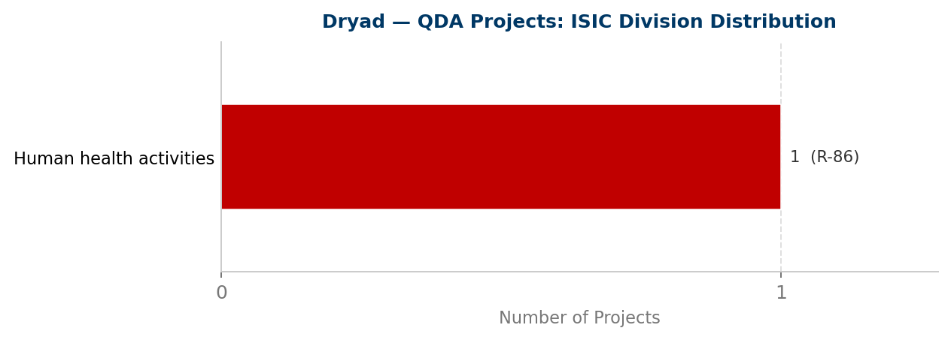
Figure 1: ISIC Rev. 5 division distribution for Distribution 1. Counts and ISIC codes shown to the right of each bar. Bars are colour-coded by ISIC section.
Table: Rank-ordered ISIC classes
Rank | Code | ISIC Division Name (Full) | Count | %
1 | R-86 | Human health activities | 1 | 100.0%

Findings and Discussion

Only one QDA project was identified across the entire Dryad corpus — a NVivo project file (.nvp) classified as R-86 (Human Health Activities). This suggests the underlying qualitative study concerned medical or patient-related research, consistent with the large body of health-science interview studies observed across the broader Dryad dataset.
The near-total absence of QDA files in Dryad reflects a structural gap in open-data culture among qualitative researchers. Despite 15 targeted search queries — including specific QDA extension terms ('qdpx', 'nvp') — researchers deposit interview transcripts, coded spreadsheets, and final datasets but not the NVivo or MAXQDA project files that capture the analytical process itself. This is the precise gap that QDArchive is designed to address.

Distribution 2: Dryad — QD Projects

340 projects · 9 distinct ISIC divisions
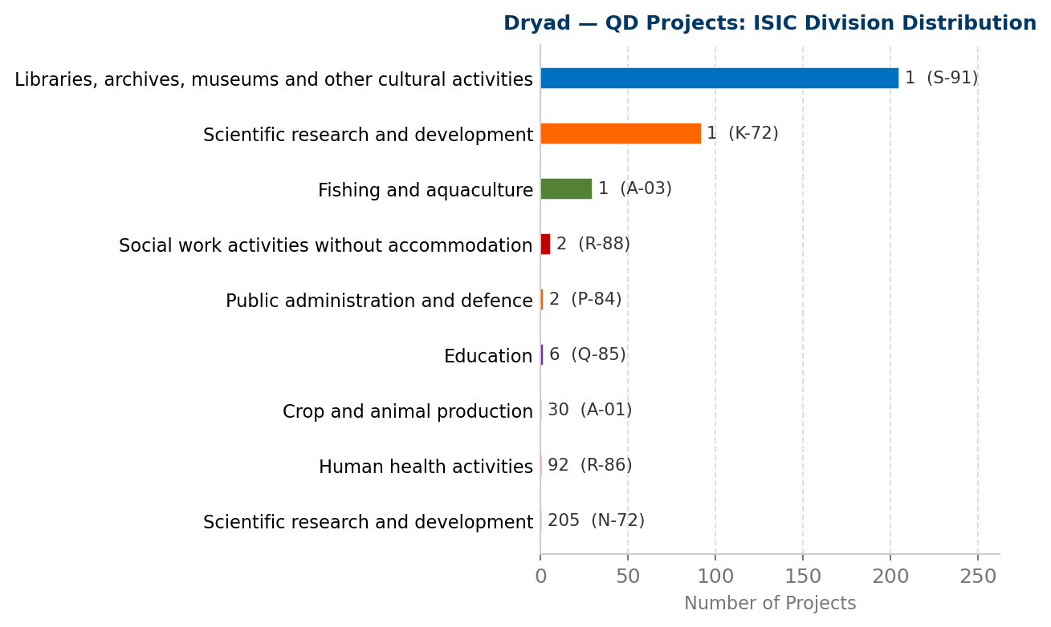
Figure 2: ISIC Rev. 5 division distribution for Distribution 2. Counts and ISIC codes shown to the right of each bar. Bars are colour-coded by ISIC section.
Table: Rank-ordered ISIC classes
Rank | Code | ISIC Division Name (Full) | Count | %
1 | N-72 | Scientific research and development | 205 | 60.3%
2 | R-86 | Human health activities | 92 | 27.1%
3 | A-01 | Crop and animal production | 30 | 8.8%
4 | Q-85 | Education | 6 | 1.8%
5 | P-84 | Public administration and defence | 2 | 0.6%
6 | R-88 | Social work activities without accommodation | 2 | 0.6%
7 | A-03 | Fishing and aquaculture | 1 | 0.3%
8 | K-72 | Scientific research and development | 1 | 0.3%
9 | S-91 | Libraries, archives, museums and other cultural activities | 1 | 0.3%

Findings and Discussion

Dryad's 340 QD projects span nine ISIC divisions, with three divisions accounting for 96.8% of the distribution. N-72 (Scientific Research and Development) dominates at 60.3% (205 projects), followed by R-86 (Human Health Activities) at 27.1% (92 projects) and A-01 (Crop and Animal Production) at 8.8% (30 projects).
The dominance of N-72 is partly structural: it serves as both the correct classification for general academic research and the classifier's fallback for ambiguous descriptions. The R-86 cluster is substantively significant — it corresponds to the large body of medical and nursing interview studies identified via queries such as 'semi-structured interview' and 'thematic analysis', which typically deposit anonymised transcripts (.docx, .txt) and coding sheets (.xlsx).
The A-01 presence (8.8%, 30 projects) reflects Dryad's strong life-sciences base. Agricultural researchers use 'qualitative' in a scientific rather than social-science sense (e.g., qualitative assessment of crop traits). These projects — typically containing .csv, .xlsx, and image files — represent noise from broad keyword matching and are correctly classified as QD_PROJECT since they contain no QDA analysis files.

3. Repository 2: FSD Finland

Distribution 3: FSD Finland — QDA Projects

0 projects · 0 distinct ISIC divisions
No projects of this type were identified in this repository. See findings below for an explanation.
Table: Rank-ordered ISIC classes
No data available for this distribution.
Findings and Discussion

No QDA projects were identified in the FSD Finland corpus. This is a direct consequence of FSD's access control model: all primary data files — interview transcripts, written responses, and coding files — require institutional authentication via the Aila Data Service. Without downloadable files, no project can be assigned the QDA_PROJECT type.
FSD's public catalogue lists 403 English-language qualitative studies, but the only file consistently available without authentication is the DDI-C 2.5 XML metadata record. Some of these studies very likely include QDA analysis files accessible to authenticated users, but this cannot be confirmed from public data. The absence of FSD QDA projects should be interpreted as an access limitation, not as evidence that Finnish social science researchers do not produce QDA files.

Distribution 4: FSD Finland — QD Projects

4 projects · 3 distinct ISIC divisions
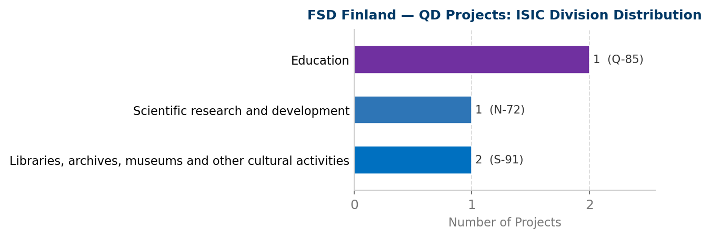
Figure 4: ISIC Rev. 5 division distribution for Distribution 4. Counts and ISIC codes shown to the right of each bar. Bars are colour-coded by ISIC section.
Table: Rank-ordered ISIC classes
Rank | Code | ISIC Division Name (Full) | Count | %
1 | S-91 | Libraries, archives, museums and other cultural activities | 2 | 50.0%
2 | N-72 | Scientific research and development | 1 | 25.0%
3 | Q-85 | Education | 1 | 25.0%

Findings and Discussion

Only four FSD studies qualified as QD_PROJECT — those with publicly accessible PDF attachments (typically methodological reports or codebooks) that do not require Aila login. These four projects span three ISIC divisions: S-91 (Libraries, Archives and Cultural Activities, 50%), N-72 (Scientific Research, 25%), and Q-85 (Education, 25%).
The disciplinary profile — cultural heritage, research methodology, and education — is consistent with FSD's institutional mandate as Finland's national social science data archive, whose holdings are concentrated in sociology, political science, history, and education research.
The extremely small sample size (n=4) means this distribution cannot be considered representative of FSD's full 403-study catalogue. A meaningful ISIC classification of FSD data would require authenticated Aila access to retrieve the primary data files from at least a representative sample of the archived studies.

4. Comparative Analysis and Conclusion

4.1 Cross-Repository Observations

The two repositories exhibit markedly different profiles in terms of both scale and disciplinary coverage. Dryad contributed 340 QD projects across nine ISIC divisions, while FSD Finland contributed only 4 publicly accessible QD projects across three divisions. This disparity does not reflect FSD's actual holdings — FSD catalogues 403 qualitative studies in its English-language archive — but is a direct consequence of the archive's requirement for institutional authentication via the Aila Data Service.
Both repositories are dominated by N-72 (Scientific Research and Development), the expected outcome for academic research collections. The second-ranked division differs sharply: Dryad ranks R-86 (Human Health Activities) second at 27.1%, reflecting its strong life-sciences and clinical research base. FSD's small QD sample shows no R-86 representation; instead S-91 (Libraries, Archives and Cultural Activities) and Q-85 (Education) appear, consistent with Finland's social-science and cultural heritage research tradition.

4.2 QDA File Availability

Across both repositories, only 1 QDA analysis file was identified — a single NVivo (.nvp) project deposited on Dryad, classified as R-86 (Human Health Activities). This confirms the core challenge motivating QDArchive: researchers who conduct qualitative data analysis with NVivo, MAXQDA, or QDAcity rarely deposit the resulting analysis files in open repositories. Interview transcripts and coded datasets are deposited, but the structured analysis files that capture the analytical process itself remain largely inaccessible. QDArchive therefore cannot be seeded purely by harvesting existing repositories — it must rely on targeted outreach and deposit incentives.

4.3 Classification Confidence and Limitations

The AI-assisted ISIC classification produces reliable results for projects with descriptive titles, rich abstracts, and multiple keywords. Quality is lower for FSD projects, where only the DDI-C 2.5 XML title and abstract were available — no file content could be read. The large N-72 share also partly reflects the classifier's fallback behaviour: projects with generic or absent descriptions are assigned N-72 rather than a more specific division. A manual review of a sample of N-72 assignments would be required to quantify this effect precisely.

4.4 Conclusion

This classification provides a structured, ISIC-aligned view of 1,256 qualitative research projects acquired from Dryad and FSD Finland. The data confirms that qualitative research in the social, health, and agricultural sciences is well represented in open repositories — but that the QDA analysis files that are QDArchive's primary target are almost entirely absent from open deposit. The classification infrastructure developed here — the ISIC classifier, file-level annotation pipeline, and structured SQLite schema — provides a reusable foundation for classifying future acquisitions as QDArchive grows.

