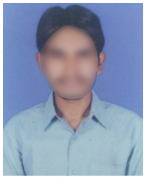**Konuru Srinivas**

**Address:** D No: 123-1, Pandeypur,

Paharia, Varanasi,  
Uttar Pradesh 221007.

**Email:** [srinuknrxx@gmail.com](mailto:srinuknrxx@gmail.com)

**Mobile**: 9395XXXX20.

**Career Objective**

* To start a career in a challenging and growth oriented organization to effectively use skills and excel as a professional to achieve greater heights and recognition in career.

**Educational Qualification**

|  |  |  |  |
| --- | --- | --- | --- |
| **Qualification** | **Institution** | **Year of Passing** | **GPA** |
| B. Tech (CSE) | Amity University | 2022 | 8 |
| Intermediate | Montfort Inter College | 2018 | 8.5 |
| 10th Class | City Montessori School | 2016 | 8.4 |

**Technical Skills**

* Programming languages: Core Java,
* Web technologies: HTML, CSS
* Web Servers: Apache tomcat.
* Database: Oracle, MYSQL
* Operating Systems: Windows 10, Linux

**Achievements**

* Won awards in painting competitions
* Won several awards in technical paper presentation.
* NCC head during graduation.

**Declaration**

I do hereby declare that all the above furnished information is true to the best of my knowledge and belief.

Place:

Date: Srinivas K.