––––

**Cairo University**  
**Faculty of Computers and Information**  
**Computer Science Department**

––

**Graduation project 2017/2018**

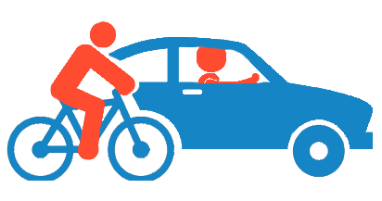

**Transportation Rental Services**

**Dr. Abeer El-Korani**

|  |  |  |
| --- | --- | --- |
| ID | Name | Dept. |
| 20140146 | Sayed Ashraf Sayed | CS |
| 20140108 | Khaled Mohamed Ibrahim | CS |
| 20140185 | Omar Adel Mohamed Ramzy | CS |
| 20140099 | Hossam Khaled El-Hwary | CS |

**Abstract**

Nowadays when any family or organization want to move to a new apartment or move their old location they will face a major problem which is having a secure and a reliable way of transportation to transport their furniture.

Regards the accidents in Egypt, our application provides a winch for these cases.

Also, when a foreigner comes to Egypt and he doesn’t want a taxi but needs to rent a car for a certain amount of time, he won’t find many reliable companies that could offer him a good car for him to rent.

This problem isn’t for car and transportation only, it’s about renting a bicycle.

We can notice also that many young people go to riding a bicycle to their university or school instead of riding a car and anyone who cannot afford buying a bicycle will have the same problem.

So our application will provide all of these solutions for the mentioned above problems to facilitate people’s life in that matter.

Our application aims to make people life more comfortable and easy in two main parts:

* Being able to rent a car or bicycle at any moment of time
* Solving the transportation problem for home or building’s furniture and any other related equipment

The main aim for any customer who wants either to rent a car, bicycle or even a truck for transporting what he needs is being able to rent it at any time and from any place.

Our application will solve that problem as for renting a car or bicycle the customer will have to go to the company’s place to take the car or the bicycle, but for the truck the application will know the location of the customer and send the truck to that location.

This application will help people who are in need of renting a bicycle for their daily routine or even for a certain moment of time.

Some will need this application for reserving a truck which will save time for them to search for one.

In addition the application will locate their place immediately in a more efficient and reliable way without facing any issues in having the wrong address.

Work Plan