By Hussein Esmail

January 8, 2019

Submaster page: 1

Submasters at a glance:

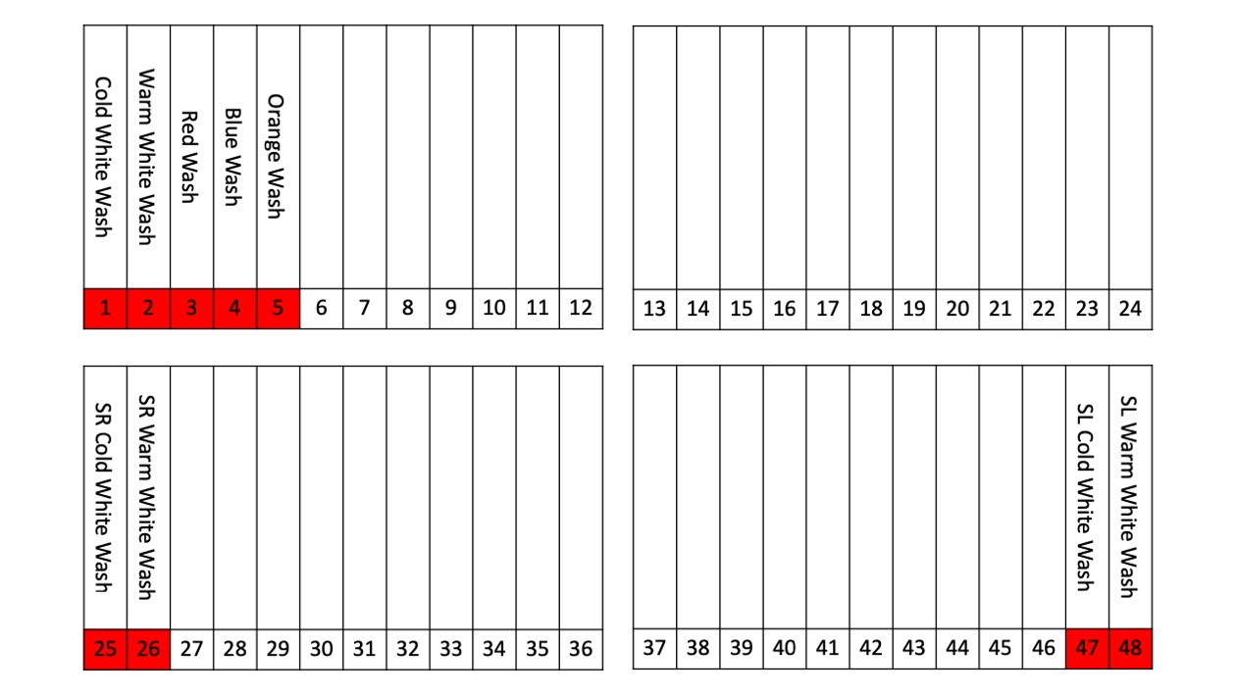

|  |  |  |
| --- | --- | --- |
| Sub Number | Description | Exact Lighting  Percentages |
| 1 | Cold white wash | Light 1: 1@40%, 2-5@100%  Light 4: 19-23@100%  Light 6: 31-35@100% |
| 2 | Warm white wash | Light 1: 1@40%, 2@100%, 3@50%, 4@30%, 5@60%  Light 4: 19-21@100%, 22@30%, 23@60%  Light 6: 31-33@100%, 34@30%, 35@60% |
| 3 | Red wash | Light 3: 13-14@100%  Light 5: 25-26@100% |
| 4 | Blue wash | Light 3: 13, 16@100%  Light 5: 25, 28@100% |
| 5 | Orange wash*  Looks best when SUB1 and SUB2 are off | Light 3: 13-14@100%, 17@15%  Light 5: 25-26@100%, 29@15% |
| 25 | SR cold white spot | Light 2: 7-11@100% |
| 26 | SR warm white spot | Light 2: 7-9@100%, 10@30%, 11@60% |
| 47 | SL cold white spot | Light 7: 37-41@100% |
| 48 | SL warm white spot | Light 7: 37-39@100%, 40@30%, 41@60% |

How to change submaster pages:

Hold down the submaster button, then press the number button of the desired page (the ones on all the faders).

Notes from January 8, 2019

Some information may be inaccurate, specifically the lighting map

