How to Make Proper Lighting Charts

By Hussein Esmail

October 3, 2018

Version 1

# Why is this important?

You might be asking why this is important? During practices or dress rehearsals, we make and modify our own lighting charts. This is not entirely necessary, but it is easier to keep track of things if we write them down. This is simply the format on how to do so. Don’t think that you must follow this if another format works better for you. Just make sure that other people can also understand it if they have to use your charts.

# Formatting

## Lx

Usually when people have a list of items, they are numbered in the order they appear. Well theatre has something similar too. It is referred to as the ‘cue’ but written as “Lx”. This means that whenever we write our lighting cues, they must have the following at the beginning:

**Lx: 1**

## Cue

This would only be completely accurate if this was the first cue in the performance. At the moment, there is no indication when to change lights. Most of the time, lights change between lines unless specified otherwise. We can add our own indication between the lights when to change. It would be two lines with a symbol in between, and you would change the lights when you reach the symbol. This symbol shouldn’t be very complex, because you want to see the lines beside it easily. Personally, when I make my lighting charts, I use “🡪”. This can be done in Microsoft Word by typing “-” twice, then the “>” symbol. This line would look something like this:

**Lx: 1**

**Cue: [line before cue] 🡪 [line after cue]**

## BASIC

Now is where you would write what lights need to change. There are 2 ways of approaching this: The first way is noting only the changes. This is beneficial because only the important information is listed when going to the next cue, so you are ready to perform the change. The bad part about this, is if someone wants to go right to that cue, not all the lights on will be listed in that cue. An example could be: if we have light 3 on for the first 5 cues, and at cue 2 lights 4, 5, and 6 turn on, this is what cue 2 would look like:

**Lx: 2**

**Cue: “I’m the line before the cue” 🡪 “I’m the line after cue”**

**BASIC: 4, 5, 6@100%**

|  |  |  |
| --- | --- | --- |
|  | Only writing changes | Writing all instructions on all cues |
| Benefit | Faster to read during performances. | Easier for switching directly to a certain scene. |
| Downside | Worse to switch directly to a certain scene. | Slower to read during performances because there will also be cues that are already on. |

This is the point where you would actually write down what to change. If there are only changes with the LEDs, you don’t want to take the time to check if the BASIC lights need any changing if there aren’t any. 9 times out of 10 there are BASIC light changes, so it is easier to write if there are BASIC changes.

Note that if you are using specific light numbers, they only work if you are at the same theatre. A solution to this would be to write stage locations, but we will go into that later on. If you are using submasters on the lighting board, you can simply write **SUB 1**. If you are using multiple submasters at the same time, it would look a little like this:

**BASIC: SUB1@100%, SUB2@50%**

I recommend refraining from using multiple submasters during individual cues, because that would defeat the use of them; which is to have all the lights you need in one fader. The goal is to make it something like this:

**BASIC: SUB1@100%**

## When there are no changes

If there are no changes in something but you still need a new lighting cue, you would write “[NONE]” in the spaces where no change occurs. For the BASIC lights, it would look something like this:

**BASIC: [NONE]**

## LEDs

I mentioned before that you don’t want to be checking if there are LED changes when there are only BASIC changes. Well this is where the chart tells you if there are LED changes. With setting LEDs, the positions are too complex to change on the spot, so I advise that you always use Sequences (the LED equivalent to Submasters). When making the Sequences, you want the first one to be off (when the SHUTTER is CLOSED), and the same for the last one. The reason is if you are turning on the LEDs for its first cue, then there are changes right after, you don’t have to press the SHUTTER button then look for the “>” button to go to the next sequence. It is easier to store the off cue into the Sequence. Writing the LEDs on the lighting charts is the simplest of them all:

**LED: Next cue** /or/ **LED: [NONE]**

If there is something that is constant the entire time, it is easier to just state it at the top of the first page, or not put it at all if it never gets turned on. The most common thing that would occur is “LED: [NONE]”. This doesn’t really need any instruction, so there would be no point of putting this. If there is one LED throughout the entire performance, I recommend putting it on all sections. If you don’t, you may have forgotten that there needs to be LEDs and suddenly you see “LED: …” on Lx 11 (random number somewhere in the middle of a performance) and you start to panic. This way, you only have to look at Lx 1 when setting up because it will tell you which things you need.

## Stage Locations/Other Theatres

If you are making lighting charts that you know will only be performed at your own theatre, then this section isn’t as necessary. Some examples of this scenario can be the school talent show, and the winter and spring showcases.

However, if there is even a possibility there will be performances at a different theatre, I recommend that you write this section. This section is used to make submasters at new theatres. I won’t go into why, but please, if there is one thing you need to know out of this entire document, MAKE SURE YOU WRITE DOWN STAGE LOCATIONS FOR LIGHTS FOR EACH CUE!

This section refers to the stage map made by Aaron Wood, which is also shown below:

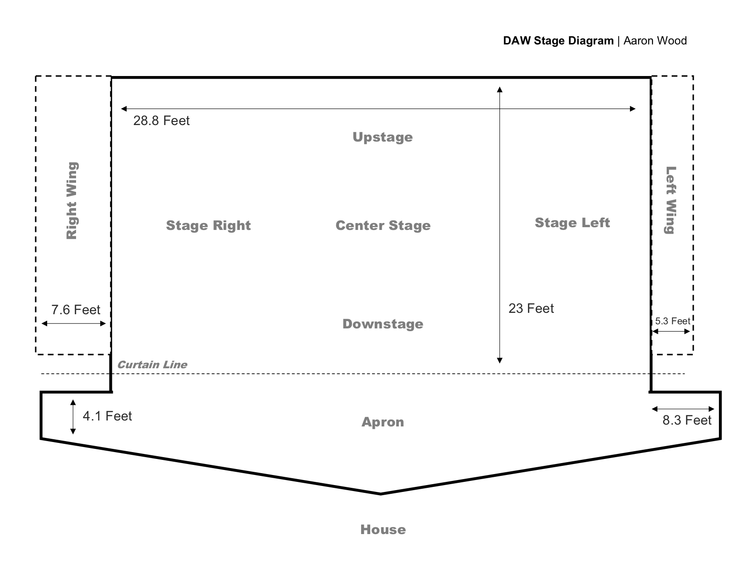

Since words like “Downstage” or “Stage Right” take up a lot of space, we use abbreviated terms.

|  |  |
| --- | --- |
| Term | Name |
| USR | Upstage Right |
| USC | Upstage Centre |
| USL | Upstage Left |
| SR | Stage Right |
| CS | Centre Stage |
| SL | Stage Left |
| DSR | Downstage Right |
| AL | Apron Left |
| AC | Apron Centre |
| AR | Apron Right |

An example of Stage Positions on the lighting charts would look something like this:

**Lx: 2**

**Cue: “I’m the line before the cue” 🡪 “I’m the line after cue”**

**BASIC: 4, 5, 6@100%**

**LED: [NONE]**

**STAGE: DSC@100%**

If you do decide to add the Stage Positions, and some are empty, add some indication that there should be a value there, because if it is blank, you may think there aren’t any during that cue. Something like this would match the format:

**STAGE: [UNKNOWN]**

# One of my previous lighting charts

Performance Name: Test Chart

Hussein Esmail

Date: October 4, 2018

Lx: 1

Cue: [No line] 🡪 “Welcome to Donald A. Wilson.”

BASIC: 7-9@100%, 18@75%

LED: [NONE]

STAGE: AR@100%, SR@75%

Lx: 2

Cue: [When the video starts]

BASIC: ALL OFF

LED: [NONE]

STAGE: ALL OFF

Notes: Put the screen down

Lx: 3

Cue: [Video finishes]

BASIC: 7-9@100%, 18@75%

LED: Next Cue

STAGE: AR@100%, SR@75%