Lighting and Sound Manual V3

By Hussein Esmail

May 30, 2018 – October 22, 2018

# Introduction

In this manual, I will mainly be talking about the Strand 200 Plus Lighting board, and the Graham sound board, as well as the Marin LightJockey 1.0 software and whatever other sound systems that the school (Donald A. Wilson) has.

Sound equipment that the school has in the booth:

* Graham GB4 console

# LIGHTS:

Lighting equipment that the school has in the booth:

* Strand 200 Plus Lighting Console

## Setting up the Lighting Board:

First you have to make sure that the 5-Pin XLR cable is plugged into the DMX 512 input on the back of the lighting board, the optional VGA cable to the monitor, and that the 5V DC power cable is plugged in.

The DMX port that connects to the wall in the lighting booth is near the projector systems, around some outlet plugs. There is also a port backstage, near the floor to the left of the speaker system.

When all the wires are plugged in, turn on the power switch, and it should light up. Now the board is ready for use. But for the school settings, make sure of the following:

* Make sure Grand Master is set to 100%
* Preset A is set to 100%
* Preset B is set to 100% (It is supposed to be at the bottom → it’s weird like that for some reason)
* And finally, it is set to Single Scene Mode

## Submasters

A submaster is basically a series of lights programmed into one fader. An example would be if you wanted to turn on light 12, 14, and 15 at the same time and at the same rate. You would set all of them to 100% and record the submaster. If you wanted light 15 dimmer than the other two, you would set it how you want it, then record it when it is exactly how you want it during the performance.

There are many submaster pages. A submaster page is a group of submasters (quantity is determined by how many faders there are. In this case, 48), regardless if it has a function or if it is empty. An easy way to tell if it has a function, is to look at the bottom left corner of the monitor, and if the respective fader number is white, it does not have one, and if it is red, then it has one. This also applies to the light-up buttons below each fader (the ones indicating the fader number). If it is red, it has a function, and if it does not light up, it has no function. To switch between submaster pages, you hold down the “submaster” button, and press one of the fader number buttons (1 for page 1, 2 for page 2, etc.), then let go of the submaster button. The LCD screen in the top right corner should indicate which submaster page you are in, as well as the title portion of the submaster list on the monitor (should say “Submaster Page: 01”, or whatever page is selected). If you are going to record submasters, make sure the proper submaster page is selected beforehand, because if you record onto a submaster that already has a function, it will erase what it was previously.

While making the submaster, you must make sure that it always meets these conditions:

1. The Grand Master is always at 100%
2. The Step Rate is **not** “Manual”. It can be anything else. If it is a number, then no matter how fast you turn the fader on to 100, it will take that long to slowly and gradually turn on and off. If you want to control the time it takes (actually manual) to fully turn on, then you need to set the Step Rate to “--”.
3. Ensure that any other specifications are met from the start-up procedure of the lighting board, such as the scene mode, and pre-sets A and B.

To set the submaster after you have everything as you like it, you have to press the “record” button, then press the corresponding number button (below the faders).

For more information about the Strand 200 Lighting board, please visit: <http://www.theatrecrafts.com/archive/documents/200series_console_manual.pdf>

## Martin LightJockey 1.0

This software is used to control the 2 moving LEDs mounted on the ceiling of the cafeteria.

When researching more about this software, make sure you are looking at version 1.0, because that is the version that the school laptop has, and version 2.0 is very different.

When you open this software, you will see a blank panel with two (or four) items, on the panel, depending on if the Basic lights are connected to the computer.

First, you want to select the first two, that looks like the LEDs. Then press the blue rectangular button that should be on the 4th row of the button rows. This brings up many windows that do different things, which you will be needing.

If you want to alter one LED at a time, deselect the LED you don’t want to use, so that the one you do want to alter is the only one selected. When doing Cues, it will work regardless if both LEDs are selected or not.

This list will describe the appearance of each window and the functions of each of them.

1. **Position 16 bit window**: This has a blue grid on it, along with buttons on the right side including what looks like a D-Pad. On the diagram included, shows how the LED positioning works, as it is not simple to operate.
2. **Intensity window**: This window is for the brightness of the LEDs. It has 3 rows and is a fairly small window. The first row will consist of a button that is white and says; “Shutter open” or a black button that says; “Shutter closed”. The next two rows will say “Strobe” and “Intensity”. 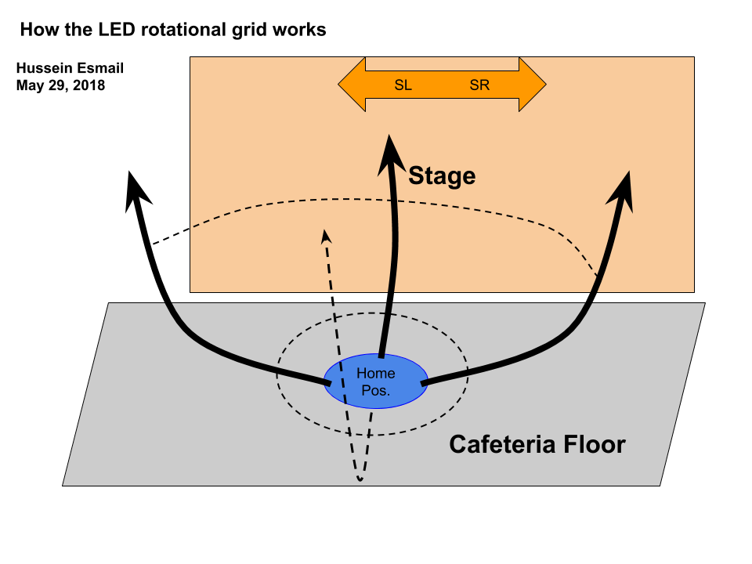
3. **Beam window**: To clarify, “Beam” refers to the focus/zoom of the light. If it has a low zoom number, the light will be very wide and not as intense in one area, but more a general intensity. If it has a high zoom number, it is very focused, to roughly 1m2. This has only one slider on the window, and the size of the window is fairly similar to the brightness window.
4. **Colors window**: Here is where the colours of the LEDs can be altered. There are a few options to changing colour.
   1. The first is the top 3 sliders which can alter the RGB (Red Green Blue) values and show them as percentages.
   2. The 4th to 6th slider which show the visual colours. I do not recommend using this as a main source of changing the colours, because this is dependent to the computer monitor’s colour scale for which colours you see on the screen. The first slider of this section is to alter the colour, the second is for the white levels, and the third the blacks.
   3. The 7th to 10th (4 sliders) are in general. See the list for more info.
      1. Row 7: Colour slider, similar to the 4th slider showing the colour spectrum, but this time returns a numerical value, the maximum being 255.
      2. Row 8: This is the Scroll slider, which is used for displaying random colours at a certain speed. The slider controls how fast the randomization is.
      3. Row 9: This is the White levels, similar to row 5.
      4. Row 10: This is the CTC slider. To be honest, I have no idea what this means. The only use I have gotten out of this slider, is if you want a good shade of red, choose the 4th box on the 4th row of the preset boxes below (which will be discussed upon in point d.) and set the CTC to 255 (100%). There is no other case where you would need this, so I recommend leaving it at 0 in any other case (unless I’m wrong…).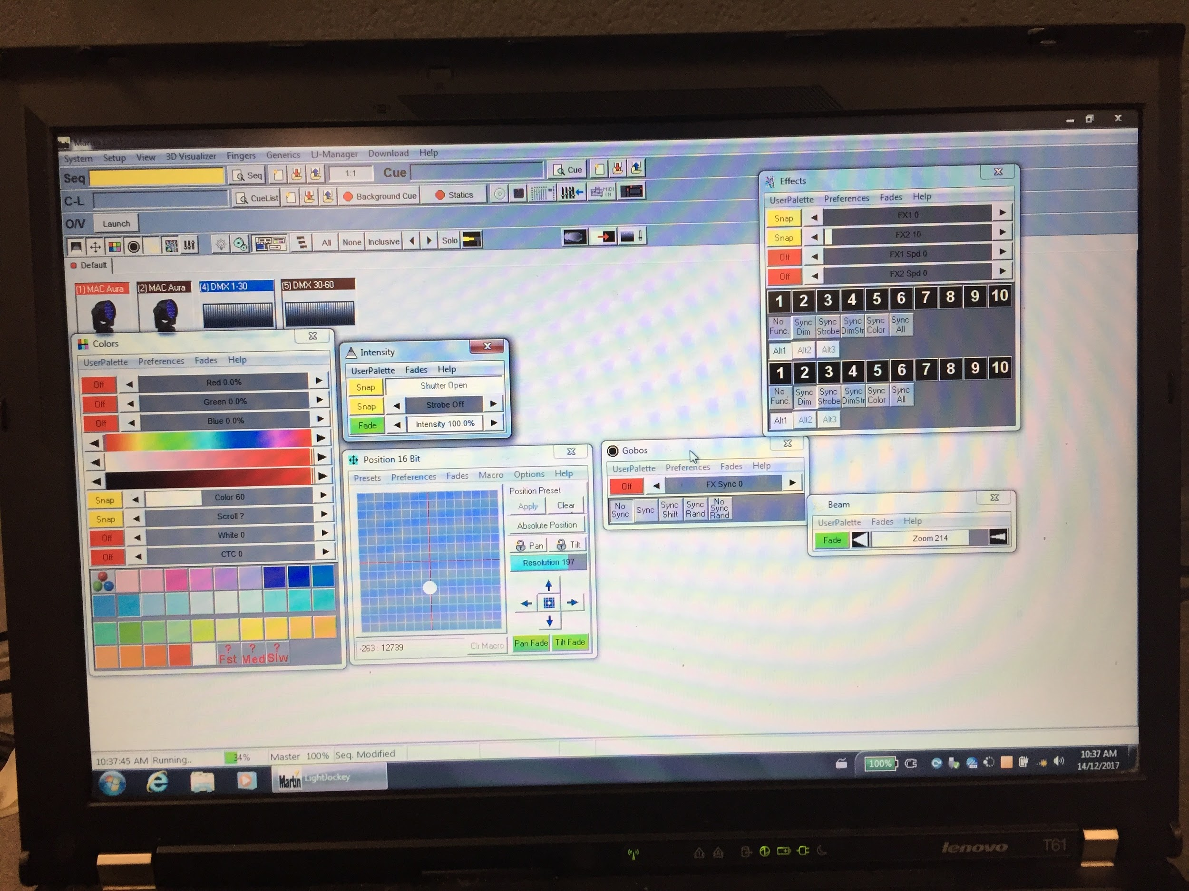
   4. The boxes at the very bottom are preset colours you can click, and the LEDs will immediately go to that colour. I don’t know if these presets will change over time, so I’ll refer to them as they are at the moment (see snapshot included). The first row of these are mainly pinks, purples, and dark blues. The second is an unnecessary number of shades of light blues. The third are greens and yellows, while the last are the reds along with a regular white (the white level will need to be at full to *actually* get a proper white). At the moment, I have no idea what the 1st box on the 1st row does, nor the last 3 boxes on the last row. This would be a good subject of investigation for future students learning to operate this lighting.
5. **Gobos window**: At the moment, I have no idea what this does, but there has not been a need for it so far, so this is another good topic of investigation.
6. **Effects window**: Another irrelevant window because you have to set your own effects, but at the moment, there are none. Wow look at that! Another good investigation topic!

# LIGHTS IN OTHER THEATRES:

## What boards other locations have:

**Oshawa Little Theatre (OLT) (62 Russett Ave, Oshawa, ON L1G 3R5)** (http://oshawalittletheatre.com)

* ITC Element (60 channel) Lighting Board

**Cornwall**

* Canto 1200msd/msr MK2 Spotlight [www.ldr.it/docs_download.php?file=canto_1200th_mk2_engl.pdf](http://www.ldr.it/docs_download.php?file=canto_1200th_mk2_engl.pdf)



**J. Clarke Richardson Collegiate (1355 Harwood Ave N, Ajax, ON L1T 4G8)**

The lights at this school are as follows in the diagram. Each circle represents one light where they are positioned as of March 1, 2018. In downstage right, there is absolutely no light, so it is recommended that you alter planned blocking accordingly before the tech set up day.

At other theatres, they use more updated boards, which almost always include the use of monitors (sometimes more than one).

# SOUND:

## Sound board in the Lighting booth

To power up the sound system in the lighting booth, you first need to power on the sound board. You do this by pressing a small black button on the back of the board slightly to the right from the middle. After you have confirmed that the board is on, you can now turn on the Carver Pro Xi2600 speaker system that is backstage on Stage Right, on the side closer to the hallway. To do that, there are a few steps:

1. There are 3 power switches:
   1. The top right corner, there is a push button
   2. The left side, there is a switch
   3. And finally, the bottom right switch
2. There are 2 circular dials in the lower left side of the console. Make sure that both of them are facing 3 o’clock.

The systems are now ready to perform audio tasks.

Please note: When plugging in/removing a microphone from a channel, make sure that the respective channel is muted, or else there will be a power surge, which can be identified by a loud “pop” sound on the speakers (and annoyed reactions from the audience/anyone in the cafeteria)

When turning off the speaker and sound board, the speaker must be turned off first, or else there will be a power surge (see note above). To turn off the speaker, do the following:

1. There are 3 power switches. Make sure all these are off:
   1. The top right corner, there is a push button.
   2. The left side, there is a switch
   3. And finally, the bottom right switch
2. There are 2 circular dials in the lower left side of the console. Make sure that both of them are to the left as much as possible.

These don’t need to be done in any particular order.

To turn off the sound board, first make sure all channels are muted. Then, on the very right side of the board, make sure the Center, Left, and Right faders are all off. Then press the power button on the back of the board.

### Playing music from an external device to the Cafeteria sound system

To play music from an external device, you would need the proper wire that converts AUX to XLR or ¼” stereo. But luckily, the way the projector sound goes to the sound board, is that it is run through an Ethernet cable, then converted by AUX (in the converter), to ¼” stereo. What that means is that you can unplug it straight from the converter (the tiny converter called Kramer Tools XGA/Audio Line Receiver TP-122) and use the AUX directly from your device.

Please note, that if this is unplugged, the projector sound will not work, because it is originally run through this cord as well.

For playing video to the projector from the booth, please see ***Playing video from an external device to the Cafeteria projector.***

## Sound in the Gym

Before setting up the sound system in the gym, make sure you acquire the proper components that are not already there (microphones, extension cords for the portable sound system, and as many XLR 3-pin cords you can find, trust me, they’ll feel short in the gym). Make sure you also check with the Comtech Room (Room 120) and the Music Room for any extra XLR cords.

To play sound in the **large** gym, there is a portable sound system in the equipment room (the one located more to the right). Once you have gotten that, connect the speaker output to the XLR input in the wall located in the left corner of the gym, near the door to the small gym. While doing this, make sure the power to the speakers in the gym are off, to ensure that there will be no power surges.

Sound in the gym is mainly used to host the Junior Awards ceremony and the Commencement ceremony for the grade 12s who have already graduated. While setting up for these two, please be courteous to the custodians if they are setting up chairs and/or the black platform that the principal/vice principals will be standing on to hand out the certificates.

## Sound in other theatres

If you are playing sound in other theatres/schools, make sure that you follow instructions given by the supervisor from that school (there isn’t much info in this section, basically don’t do anything stupid).

## Intercom Systems

In full-scale theatres, there are also intercom systems so that people don’t have to be too loud when talking to people. They can simply talk into their own microphone and the people also wearing those headsets will hear them. Since this is not broadcasted on the speaker system, the sound board is not needed (meaning it works even if the sound board is off).

### Connecting the Intercom

On the back of the intercom receiver, are 3 ports (1 XLR Male, 1 4-Pin XLR Male, and an XLR Female). The input for the channel goes into the male XLR input (the wire should be XLR female). The headset goes in the middle port, which is the 4-Pin XLR. The last port is for output which is not necessary. When connecting intercoms, they don’t all need to be connected 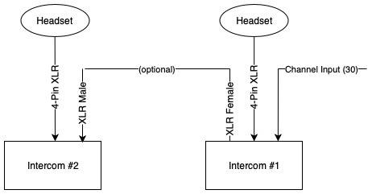directly to the channel. By this I mean an intercom can be connected to another intercom which is connected to the channel. This would be ideal for use in the lighting booth, so that the lighting technician and sound technician each get an intercom.

### Where to find the intercom inputs

The wire to plug it in is Channel 30 as an XLR.

* Booth input: The booth input is simply a wire, which connects to the intercom receiver directly. It should be labeled “INTERCOM” on masking tape or “30” (because of the channel number).
* Backstage input: This input is at the bottom of the speaker system, on the left side.
* Drama Room input: When you walk into the Drama Room, the port is in the middle of the wall that the entrance door is also on.

# Other

## Playing video from an external device to the Cafeteria projector

To play video from the booth to the projector in the cafeteria, you must have a device that can connect to a VGA video output.

In the booth, the video normally comes from the stage through Ethernet, then to the Kramer Presentation Switcher Scaler HQV VP-728 then to the Magenta console (which had a “Video to Projector” label on it), then goes back out the wall through Ethernet to the Projector. The audio comes from the wall directly into the “Video to Projector” console. This is how it normally should be for the projector input by the speaker to work.

To play video from the booth, you need to take the input cord from the Kramer Presentation Switcher/Scaler HQV VP-728 and put another VGA cord from the computer into it.

**Please note:** You must put these cords back the proper way to ensure the functionality of the stage video input.

**Future improvement:** In the future, it might be possible to have just one system that goes like this: Input from downstairs to [unnamed console] to Projector, where the audio would also go into the [unnamed console].

## Links for further reading

* For instruction manuals for any of the Strand Lighting products, you can visit <http://www.strandlighting.com/support-documents/> and specify the model.
* Martin LightJockey 1.0 Software Manual: <http://www.martin.com/Admin/Public/Download.aspx?file=%2ffiles%2ffiles%2fproductdocuments%2f11_MANUALS%2f999%2fUM_LJ_EN_d.pdf&ForceDownload=true>
* Setting Submasters for ETC lighting consoles: <https://www.reddit.com/r/techtheatre/comments/7qsf7d/etc_express_programming/?st=JCXGJGZI&sh=654a9e9b>

# Video Tutorials for Lighting

* Setting Submasters for the Strand 200 Lighting board: <https://m.youtube.com/watch?v=PftZWxb1ETA>
* Making proper lighting charts with Submasters: <https://m.youtube.com/watch?v=jzFnM5nUZvY>