COVID19 TRACKER

Name: Hussein A Motiwala

Roll no: 1911031

Batch: A2

INTRODUCTION

*Coronavirus disease (COVID-19) is an infectious disease caused by a newly discovered coronavirus.*

*Most people who fall sick with COVID-19 will experience mild to moderate symptoms and recover without special treatment.*

*The virus that causes COVID-19 is mainly transmitted through droplets generated when an infected person coughs, sneezes, or exhales. These droplets are too heavy to hang in the air, and quickly fall on floors or surfaces.*

*You can be infected by breathing in the virus if you are within close proximity of someone who has COVID-19, or by touching a contaminated surface and then your eyes, nose or mouth.*

*This covid situation has worsened and has caused a chaos around globe. And therefore, taking precaution is very important.*

*This project may not help directly in contributing to curb the coronavirus but may help in tracking the cases around the world to give a rough estimate as to where most help is needed. This proposed covid19 tracker uses the covid19 India api and web scraping from popular and trustworthy sites that have legit covid data which is updated on a regular basis.*

TECHNOLOGIES USED

*For the purpose of this project to be user friendly and operational by a non-coder I have created a GUI which is completely based on python’s popular GUI library* ***tkinter.*** *For a using a python library its necessary to have python installed on your local machine and also the project should be majorly a* ***python*** *project.*

*Now for data collection I have used* ***api calls*** *and* ***web scraping*.**

FEATURES

*This project provides the following features regarding tracking covid data,*

* *Check the overall covid case across the globe with the total deaths, total recovered and 3 more sections.*
* *View the total cases, total deaths and total recovered cases for a particular country.*
* *Plot a graph for cases vs days or death vs days for the last 5 days*
* *For India specifically we can get the total cases and deaths at a given date.*
* *Plot a graph for cases and deaths over the past ‘n’ days.*
* *Get covid cases for a particular state and city within India by entering the correct name.*

IMPLEMENTATION DETAILS

*The project is mainly divided into 5 modules*

1. *Environment setup and installing libraries: - Firstly I installed required software for coding the project. I used PyCharm for the complete project. Then I installed the required libraries for the project listed below*

* *tkinter*
* *requests*
* *Beautiful Soup*
* *Json*
* *tkcalender*
* *matplotlib*

1. *Creating Design: - For the application to be usable by non-programmer we need to add GUI (Graphical User Interface). For this purpose we use tkinter a popular python library which is used for the exact same reason. We cannot finalize on the design without completely knowing what functionalities we are going to implement. So we also try and finalize on the functionalities which our application is going to have.*
2. *Data Collection: - Our complete application revolves around data which we will be showing the user, so gathering the correct data is very important. For this purpose we use the official covid19 India api* [*https://www.covid19india.org/*](https://www.covid19india.org/) *and scrape data from worldometer corona’s official website* [*https://www.worldometers.info/coronavirus/*](https://www.worldometers.info/coronavirus/)*.*
3. *Merging design and implementation: - Merging the created design with the implementation, example creating buttons for respective function calls adding data to respective text fields for display purpose etc.*
4. *Refining: - Check working of all the functionalities, tweak application to get exact desired output.*

SCREENSHOTS

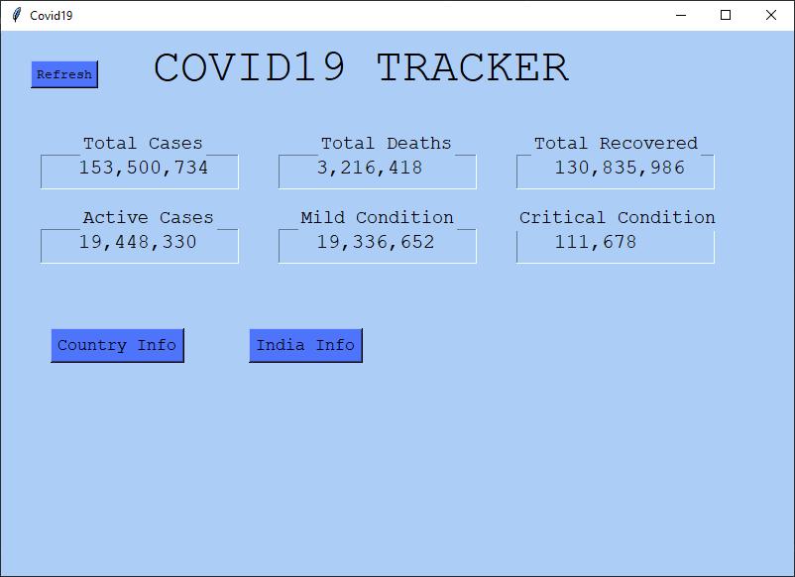

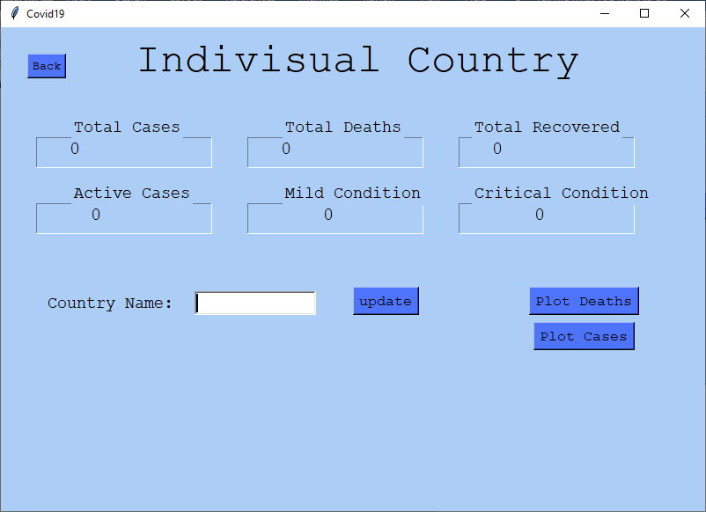

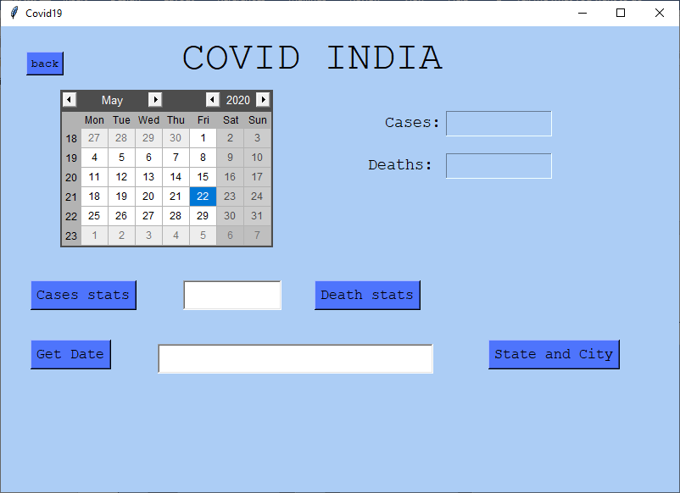

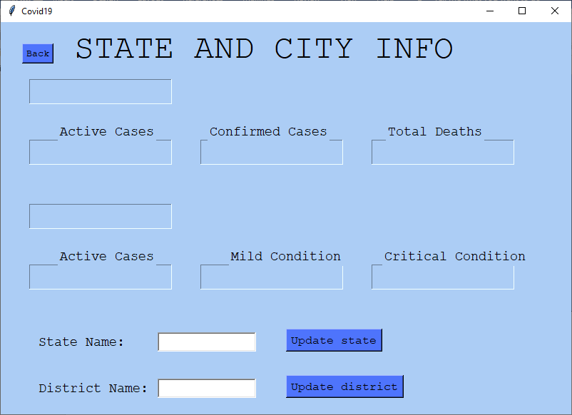

CONCLUSION

*A covid tracker can be useful in giving insights on the current covid situation in different countries, states and cities in India. This can help people get help where the cases are increasing sharply. Although this application won’t predict future cases but tracking those cases can be helpful.*