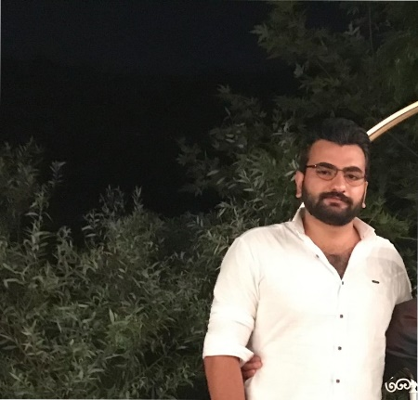

About

Motivated programmer and Computer Science student with excellent knowledge in Java, Python, Databases, and Android Development.

Hussein Khodor Khalil

Address: South Lebanon, Tyre District, Bedias – Main Road

Email: [husseinkhalil420@gmail.com](mailto:husseinkhalil420@gmail.com)

Phone: +961 76 067 804