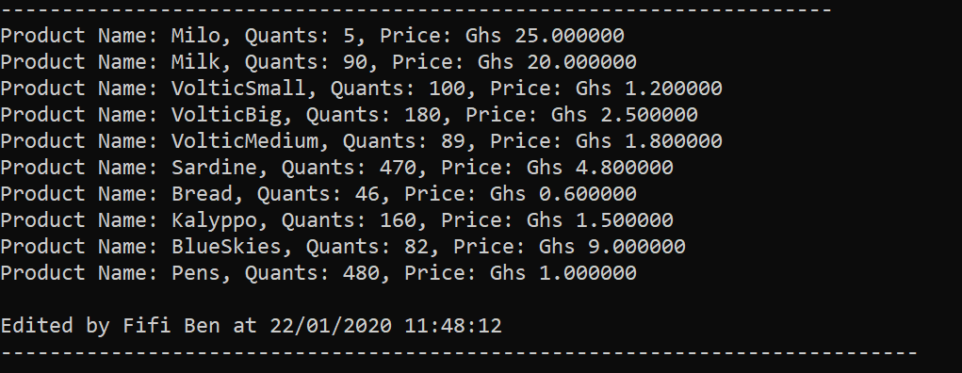UML of Phase 1

Output of Code

Stock

* Name -> String
* Price -> int
* Quantity -> int

+ setName

+ setPrice

+ setQuantity

Vendor

* Name -> String
* Gender -> String
* Age -> int

+ setName

+ setGender

+ setAge

+ getName

Shop

* Shop name
* Vendor -> Object
* Stock/Item -> ArrayList

+ setShopName

+ setVendor

+ addStock

+ getVendor

+ getStock

Name - String