|  |  |  |
| --- | --- | --- |
| **Credit Hours System**  **ELCN446**  **Advanced Topics in Communications I**  **Spring 2020** |  | **Cairo University**  **Faculty of Engineering** |

Project-1

|  |  |
| --- | --- |
| Team Members | ID |
| Hussein Ahmed Ibrahim | 1180594 |
| Omar Tarek Ahmed | 1180004 |

# GUI

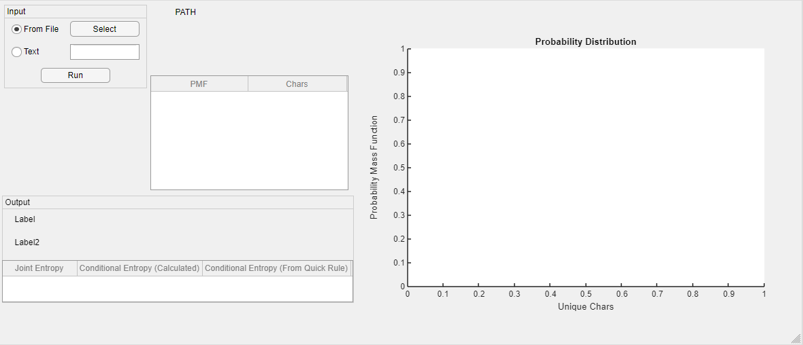

# Allow the user **enter the path of a text file** (.txt), in which the text is written in English letters.

1. • Read the .txt file • Extract characters from the file

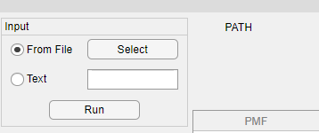We gave the user 2 options, to select the path of the text file and read it before running the program or choosing the second option text option to write the text. We used the function unique to extract the unique chars in the file or in the text box. If you choose the file, the path of the file will appear beside it.

• Find the PMF of the characters

We Count the number of occurrences of each char and divide it by the total number of chars not the unique chars to get the probability mass function and plot the output in the following table.

• Display a plot of the probability distribution of the characters in file.

After calculating the PMF, Plot on the graph and the unique chars on the labels.

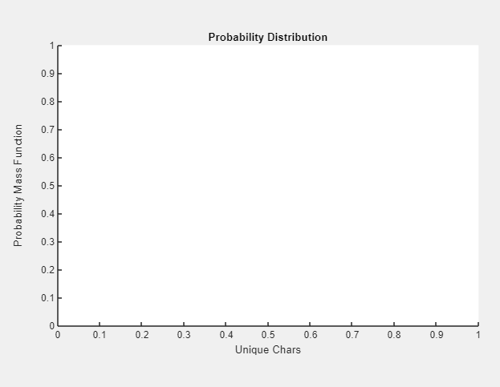

• Display the Entropy of the characters. • Display the Relative Entropy

From the PMF calculated, we calculate the entropy from its expression and also the relative entropy which is relative to the uniform distribution of unique chars in the text or file. They appear in the output section in label 1 as entropy and label 2 as relative entropy.

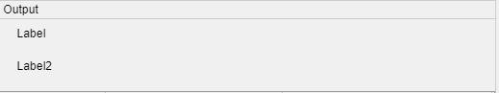

1. Assume that the characters, *X*, are coded, each using 6 bits. If the bit sequence representing the file is denoted by *Xcoded*, assume it is sent over a binary symmetric channel with *p* = 5%. Let the received bit sequence be denoted by *Ydecoded*. Decode the sequence *Ydecoded* back to text characters *Y* . *i.e. X* – coded to *Xcoded* – received as *Ydecoded* – decoded to *Y* Now, it is required to **calculate and display**:  
   *•* The joint entropy, *H*(*X; Y* ).  
   *•* The conditional entropy, *H*(*Y jX*).  
   *•* Verify if *H*(*X; Y* ) = *H*(*X*) + *H*(*Y jX*).

# Test Cases

Test Case Sample 1:

Input: 

Output is

Comment:

Test Case Sample 2:

Input: 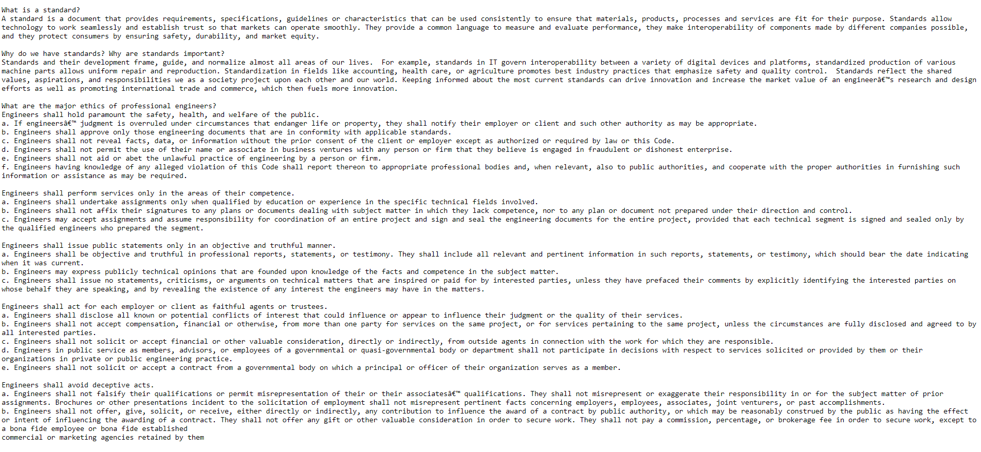

Output is

Comment:

# Appendix