**Problem 1**

**Data preparation**

* Latitude and longitude were shifted 90 so the boxcox would not get affected, it doesn’t matter if we do so from the start for all the problem.
* Data was split into 80/20 for the whole problem

**Part A**

The latitude model had an R-Squared in the training data equal to 0.32, and in the testing data equal to 0.29, while mean square error over the testing data was 269.79.

While the longitude had an R-Squared in the training data equal to 0.37, and in the testing data equal to 0.36, while mean square error over the testing data was 1619.16.

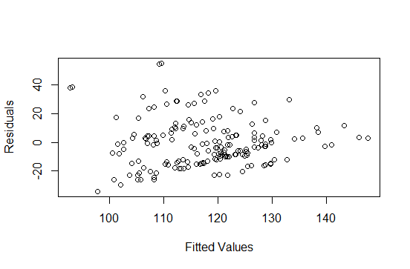

Residuals against values for latitude regression

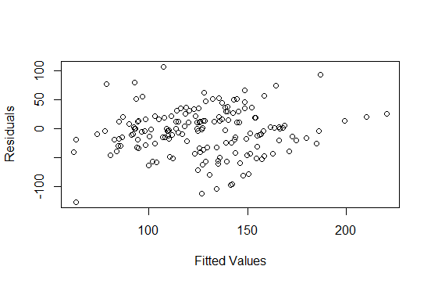

Residuals against values for longtitude regression

**Part B**

For the BoxCox Lambda selection over the latitude, I applied the boxcox function and it gave me best lambda equal to 2 as follows :

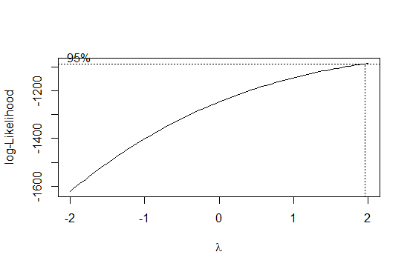

I then applied the transformation over the data and built a regression model over the transformed data, then converted the data back to calculate the R-Squared for training which was 0.29. As for testing data, R-Squared was 0.25 after reconstructing the data. MSE over the testing data was 273.

As for longitude regression, best lambda was 1 as shown in the figure below, so it doesn’t make since to try it as there’s no actual transformation for the data, just shifting.

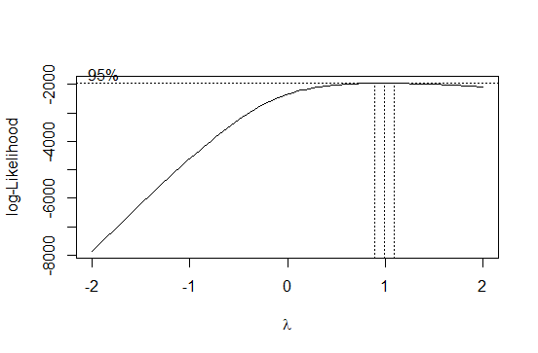

Decision is not to use BoxCox furthermore since it hasn’t add value in neither the R-Squared nor the MSE.

**Part C.1 (Ridge regularization)**

For the case of latitude regression with a ridge regularization, min lambda was 4.94 (deducted from the below figure), and it resulted in R-Squared over the training equal to 0.21, and over the testing equal to 0.08, and MSE equal to 313.97

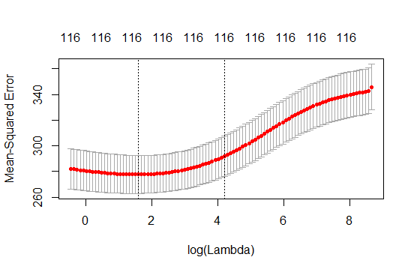

Lambda selection and MSE over training data for Ridge Latitude regression

For the case of longitude regression with a ridge regularization, min lambda was 7.69 (deducted from the below figure), and it resulted in R-Squared over the training equal to 0.28, and over the testing equal to 0.12, and MSE equal to 1875.2.

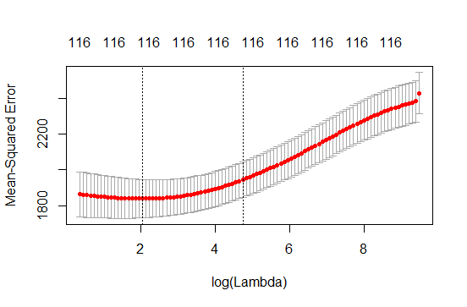

Lambda selection and MSE over training data for Ridge Longtitude regression

Conclusion is that regularization is not better than the original regression in neither latitude nor longitude for the different tried metrics.

**Part C.2(Lasso regularization)**

For the case of latitude regression with a lasso regularization, min lambda was 0.18 (deducted from the below figure), and it resulted in R-Squared over the training equal to 0.26, and over the testing equal to 0.06, and MSE equal to 314.5 and number of non zero coefficients for minimum lambda is 46

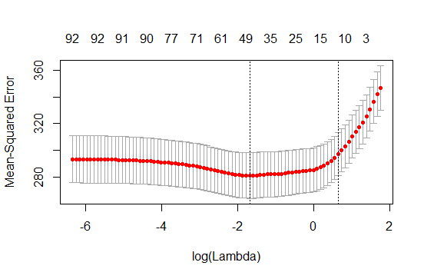

Lambda selection and MSE over training data for Lasso Latitude regression

For the case of longitude regression with a lasso regularization, min lambda was 0.28 (deducted from the below figure), and it resulted in R-Squared over the training equal to 0.33, and over the testing equal to 0.12, and MSE equal to 1835.1 and number of non-zero coefficients for minimum lambda is 80

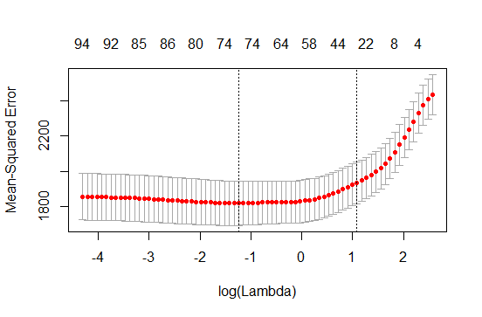

Conclusion is that regularization is not better than the original regression in neither latitude nor longitude for the different tried metrics.

**Parc C.3**

**Here are the table that represents different numbers for Elastic net regularization against different alpha values.**

|  |  |  |  |  |
| --- | --- | --- | --- | --- |
| **Regression Task** | **R-Squared Training** | **R-Squared Testing** | **MSE Over Testing** | **# of Coefficients** |
| **Latitude** | 0.24 | 0.06 | 313 | 74 |
| **Longitude** | 0.31 | 0.15 | 1765 | 102 |

Metrics for Elastic net regularization with alpha equal to 0.25

|  |  |  |  |  |
| --- | --- | --- | --- | --- |
| **Regression Task** | **R-Squared Training** | **R-Squared Testing** | **MSE Over Testing** | **# of Coefficients** |
| **Latitude** | 0.26 | 0.05 | 316 | 70 |
| **Longitude** | 0.31 | 0.12 | 1828 | 94 |

Metrics for Elastic net regularization with alpha equal to 0.5

|  |  |  |  |  |
| --- | --- | --- | --- | --- |
| **Regression Task** | **R-Squared Training** | **R-Squared Testing** | **MSE Over Testing** | **# of Coefficients** |
| **Latitude** | 0.24 | 0.06 | 312 | 56 |
| **Longitude** | 0.26 | 0.11 | 1853 | 73 |

Metrics for Elastic net regularization with alpha equal to 0.75

Conclusion is that regularization is not better than the original regression in neither latitude nor longitude for the different tried metrics.