**WEBAPACK**

**Npm install webpack webpack-cli webpack-dev-server faker html-webpack-plugin**

**WEBPACK : Combines many js Files into one single file**

* **Implementation**

1. **Create Main File ( index.js )**
2. **In Scripts Object Write start : “ webpack”**
3. **Create index.html File in public directory**
4. **Install html webpack plugin**
5. **Inside module.exports object add array of plugins and use new htmlwebpackPlugin and give it the path name of the root html file**

**Html webpack plugin : this plugin will gonna take a look at files that are coming out of webpack and automatically update html file to add script tags**

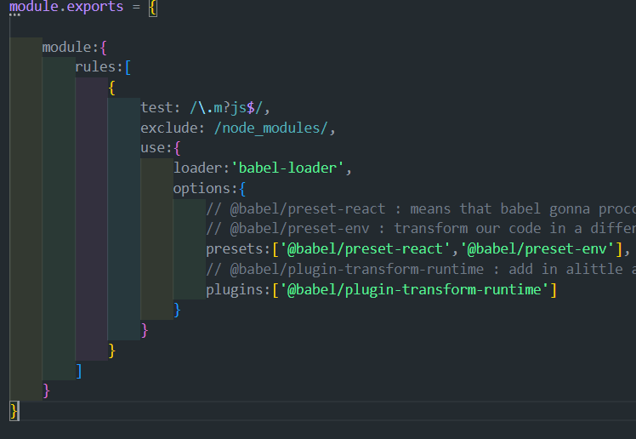

**Inside rules array we are going to define whats called a loader**

**The goal of a loader : is to tell webpack to process some different files as we start to import them into our project**

**First rule is Babel**

**Babel : in charge of processing all of our code from es 15,16 ,17 ,18, etc.. and turn it into regular ES five code that can be easily executed inside of a typical browser**



**Whenever we import a file that ends with extension js or mjs we want it to be processed by babel**



**Do not run babel on any file in node_modules directrory**

@babel/preset-react : means that babel gonna proccess all jsx tags  ( related to react)

@babel/preset-env : transform our code in a different ways take all es15 16  17 convert it down to es5

@babel/plugin-transform-runtime : add in alittle additional code to enable some different features of our project  insdide browser like ( async , await syntax )

**References :**

[Microfrontend with Webpack Module Federation | by Senura Vihan Jayadeva | Medium](https://senuravihanjayadeva.medium.com/microfrontend-with-webpack-module-federation-cd5e37625fb9)

[Best way to create Microfrontend react apps using webpack module federation | by Gopesh Jangid | Medium](https://medium.com/@gopesh.jangid/best-way-to-create-microfrontend-react-apps-using-webpack-module-federation-7763950f7fba)