**Machine Learning Project Report: Food Vision**

**Zeinab Hijazi (202211601)**

**Hussein Hassan (202210194)**

**Loading Dataset:**

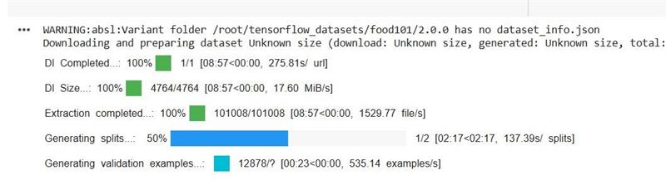

**Without Fine Tuning:**

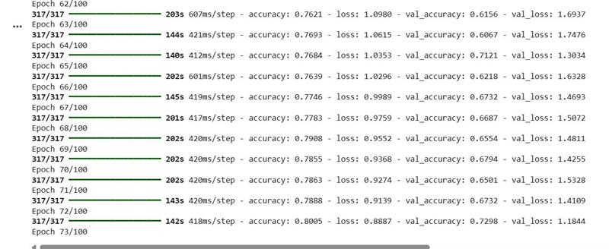

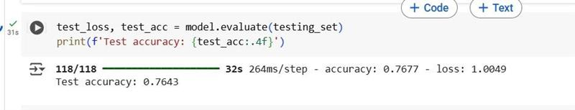

**Classification Report:**

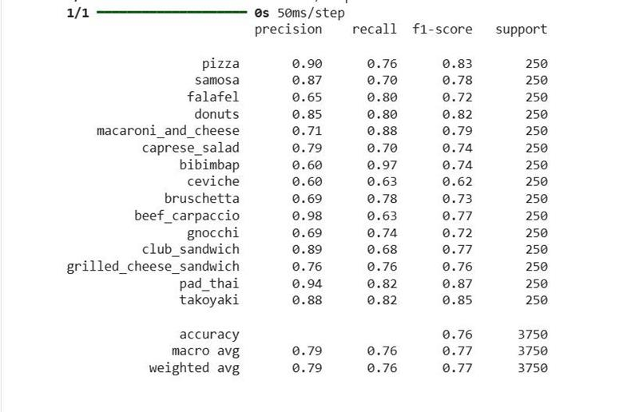

**Confusion Matrix:**

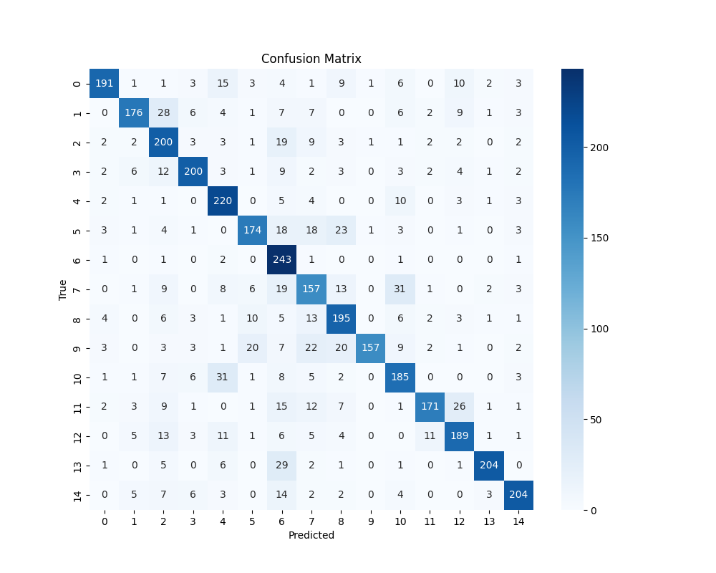

**With Fine tuning:**

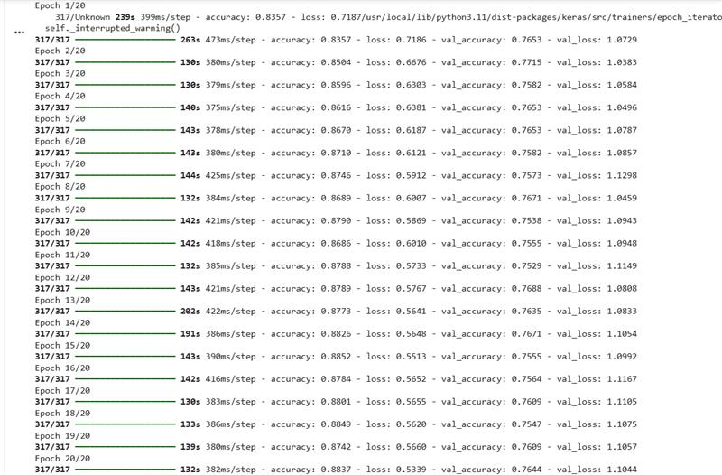

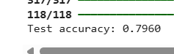

**Classification Report:**

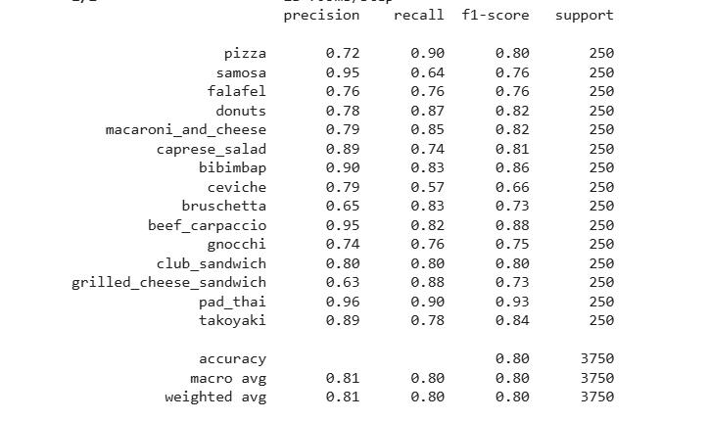

**Confusion Matrix:**

