|  |  |  |
| --- | --- | --- |
| **Vaststellen beslispunten en in en uitgaande paden** | **IN** | **OUT** |
| Switch direction | 1 | 2,3,4,5,6,7 |
| !(stuk instanceof Muur) | 14 | 15 |
| !(stuk == null) | 15 | 16 |
| Stuk instanceof Valsspeler | 18 | 19 |
| Stuk instanceof Bazooka | 20 | 21 |
| Stuk instanceof Helper | 22 | 23 |
| Stuk instanceof Vriend | 24 | 25 |
| Result == 0 | 26 | 27 |
| Stuk instanceof Muur | 28 | 29 |

**Testmaat2: Vaststellen van de feitelijke testsituaties**

1-2; 1-3; 1-4; 1-5; 1-6; 1-7

**Logische gevallen:**

1,2, 8, [14,15,16,17,18,19,20,21,22,23,24,25,26,27,28,29]

1,3,9, [14,15,16,17,18,19,20,21,22,23,24,25,26,27,28,29]

1,4,10, [14,15,16,17,18,19,20,21,22,23,24,25,26,27,28,29]

1,5,11, [14,15,16,17,18,19,20,21,22,23,24,25,26,27,28,29]

1,6,12, [14,15,16,17,18,19,20,21,22,23,24,25,26,27,28,29]

1,7, [14,15,16,17,18,19,20,21,22,23,24,25,26,27,28,29]

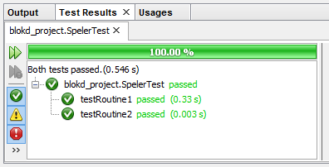

Wat en hoe

|  |  |  |
| --- | --- | --- |
| Logisch testgevallen | Ammo > 0 |  |
| A | 0 | 0 |
| B | 1 | 1 |

|  |  |  |  |
| --- | --- | --- | --- |
| Fysieke testgevallen | Ammo > 0 | Verwacht | Daadwerkelijk |
| A | “0” | Mag niet schieten | Mag niet schieten |
| B | “1” | Mag schieten | Mag schieten |