|  |  |  |  |  |
| --- | --- | --- | --- | --- |
|  |  |  | Construction Barricade with solid fill |  |
| Electric car with solid fill | Construction Barricade with solid fill |  |  |  |
|  |  |  | Construction Barricade with solid fill |  |
| Construction Barricade with solid fill |  |  | Electric car with solid fill |  |
|  |  | Construction Barricade with solid fill |  |  |

|  |  |  |  |  |  |  |  |  |  |
| --- | --- | --- | --- | --- | --- | --- | --- | --- | --- |
|  |  |  |  |  |  | Construction Barricade with solid fill |  |  |  |
|  | Electric car with solid fill |  | Construction Barricade with solid fill |  |  |  |  |  |  |
|  |  |  |  |  |  |  | Electric car with solid fill |  |  |
|  |  |  |  | Construction Barricade with solid fill |  |  |  |  |  |
|  | Construction Barricade with solid fill |  |  |  |  |  | Construction Barricade with solid fill |  |  |
|  |  |  |  |  |  |  |  |  |  |
|  |  | Electric car with solid fill |  |  | Construction Barricade with solid fill |  |  |  | Construction Barricade with solid fill |
|  |  |  |  |  |  |  |  |  |  |
|  |  | Construction Barricade with solid fill |  |  |  |  |  | Electric car with solid fill |  |
|  |  |  |  |  |  | Construction Barricade with solid fill |  |  |  |

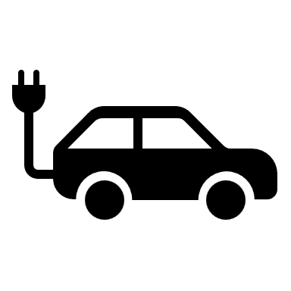

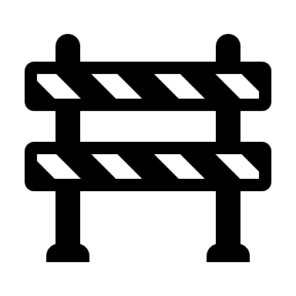Charging Station

Obstacle