Poll Shows Wide Open Race in proposed VA-6; Rasoul in Strong Position to Win Progressive District
A recent survey of likely Democratic primary voters shows a wide open race for the newly proposed and drawn VA-6. The survey, conducted February 18-22 by Community Pulse, a division of Molitico, surveyed 1,031 likely Democratic primary voters with a margin of error of 3%. While former Congressman Tom Perriello holds an early lead, the plurality of voters are undecided, and progressive Delegate Sam Rasoul is in a strong position to win.
Rasoul begins with strong name ID: nearly 60% of voters in the district are familiar with him and he has an impressive +47% net favorability.
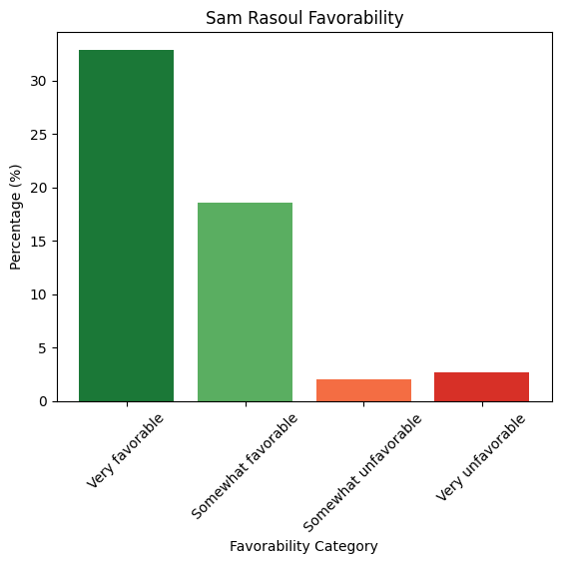
The plurality of voters on the initial, uninformed ballot are undecided, indicating a wide open race. As voters learn more about Rasoul, he gains the most among the three candidates tested, putting him within striking distance of Perriello with 20% of voters remaining undecided. Given the percentage of undecided voters and the fact that the test included no negative communication against Perriello, Rasoul is in a strong position to win the race.
Candidate | Initial Ballot | Post-Info Ballot | Shift
Tom Perriello | 34.38% | 37.40% | +3.02 pts
Sam Rasoul | 15.47% | 27.77% | +12.30 pts
Beth Macy | 12.59% | 12.89% | +0.30 pts
Undecided/Don't Know | 35.38% | 19.98% | −15.40 pts
Rasoul’s growth makes sense given his progressive bio and track record. Nearly 50% of Democratic primary voters prefer a progressive candidate.
Candidate Type Preference | Weighted %
A proud progressive with a proven track record, who will hold big corporations and special interests accountable | 48.38%
An experienced leader with an understanding of how to get things done in Washington | 39.29%
A political outsider with a fresh perspective | 12.33%
Similarly, voters hold overwhelmingly positive views of prominent national progressives such as Sen. Bernie Sanders, Sen. Elizabeth Warren, and Rep. Alexandria Ocasio-Cortez.
Individual | Very Favorable | Smwt. Favorable | Total Fav.
Elizabeth Warren | 54.74% | 29.33% | 84.07%
Bernie Sanders | 52.76% | 29.99% | 82.75%
Alexandria Ocasio-Cortez | 52.30% | 26.58% | 78.88%

METHODOLOGY
This poll was conducted from February 18–22, 2026, among 1,031 likely Democratic primary voters in Virginia's newly proposed 6th Congressional District. The margin of error is ±3 %. Results were weighted to reflect the demographic composition of the VA-6 Democratic primary electorate using the following targets:
Gender: Female 60% | Male 40%
Race/Ethnicity: White 80% | Black 8.5% | Hispanic 2.5% | Asian 2% | Other 7%
Age: 18–19: 0.7% 20–24: 3.1% 25–29: 3.9% 30–34: 4.9% 35–39: 5.9% 40–44: 5.9% 45–49: 5.4% 50–54: 5.1% 55–64: 14.6% 65 and over: 50.7%
Geographic weighting was applied based on county/city share of the VA-6 electorate, with Albemarle County (24.9%), Charlottesville City (15.4%), and Roanoke City (12.2%) representing the three largest jurisdictions in the district.

