Name Hussnain Ahmad
Class BSCSeve-V-C
Roll No 242816
Task-02
Agent Idea: Smart Irrigation Agent (a robot/system that waters plants on its own)

What is this agent?
I chose a smart irrigation (watering) agent. It is a system used in a field or garden that decides on its own when and how much to water the plants, instead of a person turning the tap on and off manually.

P — Performance Measure (how we know the agent is doing a good job)
- Plants stay healthy, not too dry and not overwatered
- Uses as little water as possible (no wastage)
- Uses as little electricity as possible (pump should not run extra)
- No plants die because of wrong watering
- Does not water when it is already raining

E — Environment (the world the agent works in)
- A field or garden, divided into small areas/zones
- Soil in each zone (some soil holds water longer than others)
- Weather conditions: rain, heat, humidity, sunlight
- A water supply/tank that has a limited amount of water
- Plants that need different amounts of water depending on their growth stage (a young plant needs less water than a fully grown one)

A — Actuators (the parts the agent uses to actually do something)
- Water valves that open and close for each zone
- A water pump motor that turns on/off
- Sprinklers or drip pipes that control how much water comes out
- A notification system that sends an alert to the farmer's phone
- A logger that saves a record of when watering happened

S — Sensors (the parts the agent uses to observe the world)
- Soil moisture sensor (tells how wet or dry the soil is)
- Temperature and humidity sensor
- Rain sensor, plus a weather app/API to check the forecast
- Water flow sensor (to check if a pipe is leaking or blocked)
- Light sensor and a clock (to know the time of day)

Bonus: Which agent type does this best match?
I think this agent is closest to a Utility-Based Agent.
Reason (in simple words):
- A simple reflex agent can't work here because it needs to remember things, like when it last watered a zone, so it needs memory. That already rules out "simple reflex."
- A goal-based agent just checks yes/no: "is the soil wet enough?" But this agent has more than one goal at the same time, and they can clash with each other — save water, save electricity, keep plants healthy, don't water at the wrong time. It has to pick the option that gives the best overall result, not just any option that meets one goal. That "best overall result" idea is what a utility-based agent does.
- Also, the weather is not 100% certain (forecast might be wrong), so the agent has to guess the better choice under uncertainty, e.g. "80% chance of rain soon, so better skip watering now." That is also a utility-based way of thinking.

Task-01
Output:
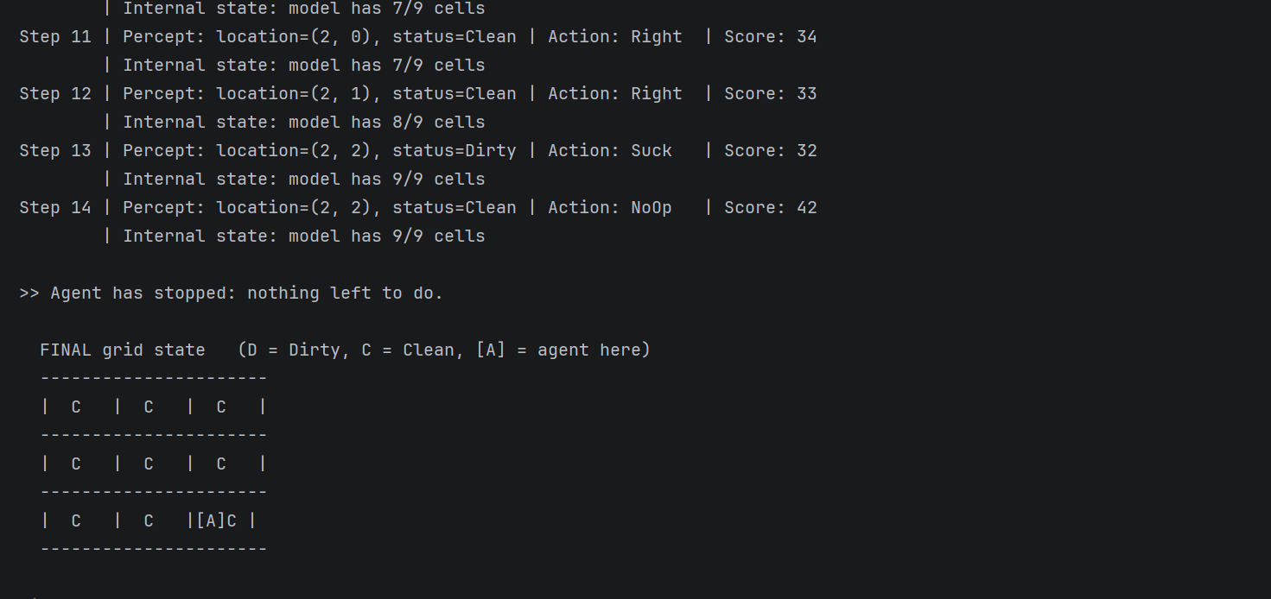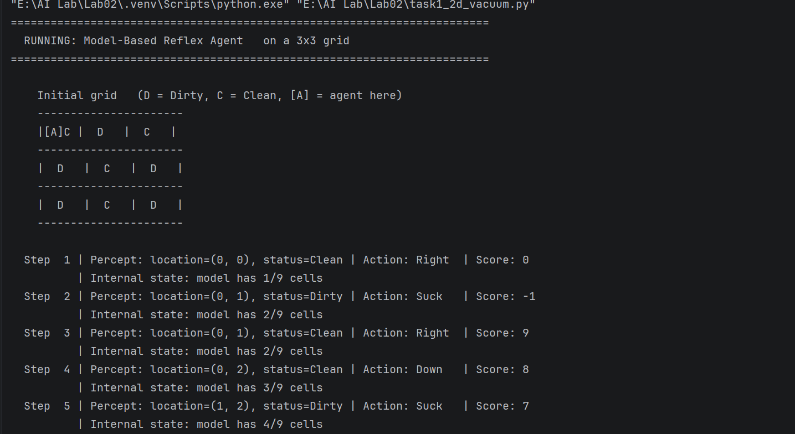

Code:
from collections import deque
ROWS = 3
COLS = 3
MOVES = {
'Up': (-1, 0),
'Down': ( 1, 0),
'Left': ( 0, -1),
'Right': ( 0, 1),
}
# -----------------------------------------------------------------------------
# STEP 1: THE ENVIRONMENT
# -----------------------------------------------------------------------------
class VacuumEnvironment2D:
"""A rows x cols room. Every cell is either 'Dirty' or 'Clean'."""
def __init__(self, rows=ROWS, cols=COLS, dirty_cells=None, agent_start=(0, 0)):
self.rows = rows
self.cols = cols
dirty_cells = set(dirty_cells or [])
self.grid = {
(r, c): ('Dirty' if (r, c) in dirty_cells else 'Clean')
for r in range(rows) for c in range(cols)
}
self.agent_location = agent_start
self.performance = 0 # +10 per dirt removed, -1 per move
def percept(self):
return (self.agent_location, self.grid[self.agent_location])
def in_bounds(self, r, c):
return 0 <= r < self.rows and 0 <= c < self.cols
def execute_action(self, action):
if action == 'Suck':
if self.grid[self.agent_location] == 'Dirty':
self.grid[self.agent_location] = 'Clean'
self.performance += 10
elif action in MOVES:
dr, dc = MOVES[action]
r, c = self.agent_location
nr, nc = r + dr, c + dc
self.performance -= 1
if self.in_bounds(nr, nc):
self.agent_location = (nr, nc)
else:
print(" (bumped into a wall - stayed in place)")
# 'NoOp' -> do nothing, no cost
def is_clean(self):
return all(v == 'Clean' for v in self.grid.values())
def display(self, title="Grid state"):
print(f"\n {title} (D = Dirty, C = Clean, [A] = agent here)")
print(" " + "-" * (self.cols * 7 + 1))
for r in range(self.rows):
row_cells = []
for c in range(self.cols):
mark = 'D' if self.grid[(r, c)] == 'Dirty' else 'C'
if (r, c) == self.agent_location:
row_cells.append(f"[A]{mark} ")
else:
row_cells.append(f" {mark} ")
print(" |" + "|".join(row_cells) + "|")
print(" " + "-" * (self.cols * 7 + 1))
# -----------------------------------------------------------------------------
# STEP 2: MODEL-BASED REFLEX AGENT (4-directional)
# -----------------------------------------------------------------------------
class ModelBasedReflexAgent2D:
"""
Keeps an INTERNAL MODEL of the room:
self.model -> what it learned about each visited cell
self.visited -> which cells it has already been to
Rules:
1. current cell Dirty -> Suck
2. else move to next unvisited cell of a fixed snake sweep
3. whole sweep visited -> NoOp (stop)
"""
name = "Model-Based Reflex Agent"
def __init__(self, rows=ROWS, cols=COLS):
self.rows = rows
self.cols = cols
self.model = {}
self.visited = set()
self.sweep = self._snake_path()
self.index = 0
def _snake_path(self):
"""Row 0 left->right, row 1 right->left, ... so consecutive cells touch."""
path = []
for r in range(self.rows):
cols = range(self.cols) if r % 2 == 0 else range(self.cols - 1, -1, -1)
for c in cols:
path.append((r, c))
return path
@staticmethod
def _step_towards(loc, target):
(r, c), (tr, tc) = loc, target
if tr < r:
return 'Up'
if tr > r:
return 'Down'
if tc < c:
return 'Left'
if tc > c:
return 'Right'
return 'NoOp'
def program(self, percept):
location, status = percept
self.model[location] = status # update internal state
self.visited.add(location)
if status == 'Dirty': # Rule 1
return 'Suck'
while self.index < len(self.sweep) and self.sweep[self.index] in self.visited:
self.index += 1 # Rule 2
if self.index >= len(self.sweep): # Rule 3
return 'NoOp'
return self._step_towards(location, self.sweep[self.index])
def describe_state(self):
return f"model has {len(self.model)}/{self.rows * self.cols} cells"
# -----------------------------------------------------------------------------
# STEP 3: GOAL-BASED AGENT (4-directional, plans with BFS)
# -----------------------------------------------------------------------------
class GoalBasedAgent2D:
"""
GOAL: every cell is known AND Clean.
1. update model from percept
2. goal test -> NoOp if satisfied
3. Dirty here -> Suck (discard old plan)
4. else BFS to nearest unknown/dirty cell, execute plan one step at a time
"""
name = "Goal-Based Agent"
def __init__(self, rows=ROWS, cols=COLS):
self.rows = rows
self.cols = cols
self.model = {}
self.plan = []
def _goal_reached(self):
return (len(self.model) == self.rows * self.cols
and all(v == 'Clean' for v in self.model.values()))
def _is_interesting(self, cell):
return cell not in self.model or self.model[cell] == 'Dirty'
def _bfs_plan(self, start):
"""Breadth-first search -> shortest action list to nearest goal cell."""
frontier = deque([(start, [])])
explored = {start}
while frontier:
cell, actions = frontier.popleft()
if cell != start and self._is_interesting(cell):
return actions
r, c = cell
for action, (dr, dc) in MOVES.items():
nxt = (r + dr, c + dc)
if (0 <= nxt[0] < self.rows and 0 <= nxt[1] < self.cols
and nxt not in explored):
explored.add(nxt)
frontier.append((nxt, actions + [action]))
return []
def program(self, percept):
location, status = percept
self.model[location] = status # 1
if self._goal_reached(): # 2
return 'NoOp'
if status == 'Dirty': # 3
self.plan = []
return 'Suck'
if not self.plan: # 4
self.plan = self._bfs_plan(location)
return self.plan.pop(0) if self.plan else 'NoOp'
def describe_state(self):
plan_txt = "->".join(self.plan) if self.plan else "(none)"
return f"model has {len(self.model)}/{self.rows * self.cols} cells, plan: {plan_txt}"
# -----------------------------------------------------------------------------
# STEP 4: SIMULATION DRIVER
# -----------------------------------------------------------------------------
def run_agent(agent, environment, max_steps=60):
print("=" * 72)
print(f" RUNNING: {agent.name} on a {environment.rows}x{environment.cols} grid")
print("=" * 72)
environment.display("Initial grid")
print()
for step in range(1, max_steps + 1):
percept = environment.percept()
action = agent.program(percept)
print(f" Step {step:>2} | Percept: location={percept[0]}, status={percept[1]:<5}"
f" | Action: {action:<6} | Score: {environment.performance}")
print(f" | Internal state: {agent.describe_state()}")
if action == 'NoOp':
print("\n >> Agent has stopped: nothing left to do.")
break
environment.execute_action(action)
else:
print("\n >> Step limit reached.")
environment.display("FINAL grid state")
print(f"\n Final performance score : {environment.performance}")
print(f" Room completely clean? : {environment.is_clean()}")
print()
return environment.performance
# -----------------------------------------------------------------------------
# STEP 5: MAIN
# -----------------------------------------------------------------------------
if __name__ == "__main__":
DIRTY = [(0, 1), (1, 0), (1, 2), (2, 0), (2, 2)]
START = (0, 0)
env_a = VacuumEnvironment2D(ROWS, COLS, DIRTY, START)
score_a = run_agent(ModelBasedReflexAgent2D(ROWS, COLS), env_a)
env_b = VacuumEnvironment2D(ROWS, COLS, DIRTY, START)
score_b = run_agent(GoalBasedAgent2D(ROWS, COLS), env_b)
print("=" * 72)
print(" COMPARISON")
print("=" * 72)
print(f" Model-Based Reflex Agent : score = {score_a}")
print(f" Goal-Based Agent : score = {score_b}")
print("""
Both agents score the same here, and that is expected: the room is only
PARTIALLY OBSERVABLE, so even the goal-based agent has to physically visit
all 9 cells before it can prove its goal is satisfied.
""")

