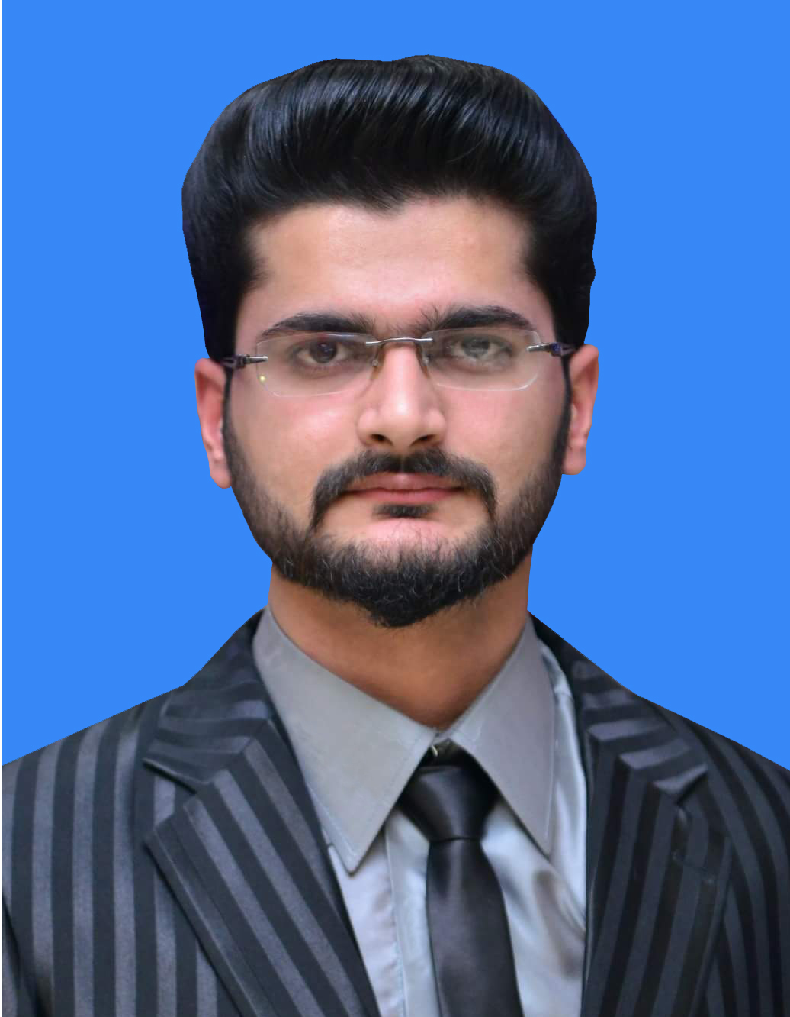
HUSSNAIN JAVED
Email: hussnain.jav3d@gmail.com
Mobile: +92-306-9200-201
Address: Street Mehr Boota, House No. 156/26, Mahallah Tootianwala, Gujranwala.

Career Objective
- To make sound position in corporate world and work enthusiastically in team to achieve goal of the organization with devotion and hard work.
- To pursue highly rewarding career, seeking for a job in challenging and healthy work environment where I can utilize my skills and knowledge efficiently for organizational growth.
- Also to be a astute learner and best performer in your organization. So, I can build an innovative career in your esteemed Organization by using my skills and other significant talents.

Personal Profile
- Father’s Name: Muhammad Javed
- Date of Birth: Mar-25-1994
- Nationality: Pakistani
- Domicile: Gujranwala, Pakistan
- Gender: Male
- Marital Status: Single
- NIC #: 34101-6267928-1
- City: Gujranwala

Educational Background
Year | Qualification | Institute | Division
2016 | BSCS | University of Gujrat | 1st
2012 | F.Sc (Pre-Eng) | B.I.S.E Gujranwala. | 1st
2010 | Matric (Science) | B.I.S.E Gujranwala. | 1st

Work Experience
- 1 Year Experience as Virtual Assistant at TEC PVT. Lt.
- 2 Year experience as teacher in own Academy.

Competencies
- I’m a competent and adaptable person.
- Attention to Communication
- Managing Performance
- Fostering Team Work
- Motivational Support
- Delegation and Commitment

Computer Skills
- Word Press
- HTML, CSS
- PHP, JavaScript
- MS Office

Language Skills
- Urdu, English.

Interests and Hobbies
- Web Exploring
- Reading
- Tourism
- Cricket
- Badminton
REFERENCES
References
- References will be provided on demand.

