# SOULMUSIC

Submitted in partial fulfillment of the requirements of the degree

**BACHELOR OF ENGINEERING**

**IN** **INFORMATION TECHNOLOGY**

By

|  |  |
| --- | --- |
| **Hussain Rampurawala** | **19101A0026** |
| **Shahid Afridi Mandal** | **19101A0050** |
| **Rahul Sakhalkar** | **19101A0060** |
| **Mudassir Ansari** | **19101A0066** |

Supervisor

**Dr. Vipul Dalal**



**Department of Information Technology**

**Vidyalankar Institute of Technology**

**Vidyalankar Educational Campus,**

**Wadala(E), Mumbai - 400 037**

**University of Mumbai**

**(AY 2021-22)**

# CERTIFICATE

This is to certify that the Mini Project entitled “**SOULMUSIC”** is a bonafide work of **Hussain Rampurawala (19101A0026), Shahid Afridi Mandal (19101A0050), Rahul Sakhalkar (19101A0060), Mudassir Ansari (19101A0066)** submitted to the University of Mumbai in partial fulfillment of the requirement for the award of the degree of **“Bachelor of Engineering”** in **“Information Technology”.**

### Dr. Vipul Dalal

Supervisor

### Dr. Vipul Dalal Dr. S. A. Patekar

Head of Department Principal

# Mini Project Approval

This Mini Project entitled **“SOULMUSIC”** by **Hussain Rampurawala (19101A0026), Shahid Afridi Mandal (19101A0050), Rahul Sakhalkar (19101A0060), Mudassir Ansari (19101A0066)** is approved for the degree of **Bachelor of Engineering** in **Information Technology.**

## Examiners

**1………………………………………**

(Internal Examiner Name & Sign)

### 2…………………………………………

(External Examiner name & Sign)

Date: Place:

# Contents

### Abstract i

### Acknowledgments ii

### List of Figures iii

### Introduction 1

* 1. Introduction
  2. Motivation
  3. Problem Statement & Objectives
  4. Organization of the Report

### Literature Survey 4

* 1. Survey of Existing/Similar System
  2. Limitation Existing/Similar system or research gap
  3. Mini Project Contribution

### Proposed System (eg New Approach of Data Summarization) 8

* 1. Introduction
  2. Architecture/ Framework
  3. Algorithm and Process Design
  4. Details of Hardware & Software
  5. Experiment and Results
  6. Conclusion and Future work

### 4 References 20

### i ABSTRACT

We have built an application that will detect users' mood and suggest him/her relevant songs based on a single chat input. Our model first predicts the user's mood whether he/she is Angry, Happy, Feeling loved or Sad. Then based on the mood detected our AI recommend the user Spotify links to songs that match the user's mood.

### ii ACKNOWLEDGEMENTS:

### With immense gratitude, we the students Hussain Rampurawala, Shahid Afridi Mandal, Mudassir Ansari, Rahul Sakhalkar of Vidyalankar Institute Of Technology, present to you our mini project, titled ‘SOULMUSIC’ as part of the curriculum of Third Year Engineering. We wish to thank all our teachers who gave us unending support.

### We express our profound thanks to, Dr. Vipul Dalal, our project guide and mentor and all those who have directly, as well as, indirectly guided and helped us throughout.

### 1) Hussain Rampurawala - 19101A0026

### 2) Shahid Afridi Mandal - 19101A0050

### 3) Rahul Sakhalkar - 19101A0060

### 4) Mudassir Ansari - 19101A0066

### iii LIST OF FIGURES:

|  |  |  |
| --- | --- | --- |
| Sr no | Figure Name | Page no |
| 1 | Architecture | 9 |
| 2 | Flowchart | 10 |
| 3 | Mood Detection | 11 |
| 4 | Song Suggestion | 11 |
| 5 | Process Design | 13 |
| 6 | App UI | 15 |
| 7 | Know More & Features | 16 |
| 8 | About Us | 17 |
| 9 | Mood Detection and Song Suggestion | 18 |

**Chapter 1**

### INTRODUCTION

### INTRODUCTION

### While music genre plays an enormous role in building and displaying social identity, the emotional expression of a song and — even more importantly — its emotional impression on the listener is often underestimated in the domain of music preferences.

### Only a few decades back, choosing music by genre and/or artist was effectively the only option. This has changed dramatically since millennials now a day's select music based on their mood, they listen to pop when sad, love song's when they feel happy.

1

### Motivation

We have built this project keeping in mind that millennials spend a lot of time in their leisure to listen to various songs. We feel this sector consisting of song recommendation is the next big thing & is fairly under noticed in this growing world of AI. Many new technologies can be combined to ease out the process of recommending music.

* 1. **Problem Statement and Objectives**

Only a few decades back, choosing music by genre and/or artist was effectively the only option. This has changed dramatically since millennials now a day's select music based on their mood. To provide a solution we propose **SoulMusic – Music for Every Mood,** A full-fledged website exclusively for music enthusiasts where users will be able to listen to songs based on their mood without searching for it.

### Objectives:

* To implement an AI based mood detection system named Emotion-BERT from scratch using transformers.
* To use AI techniques to sort music based on features like danceability, energy, loudness, tempo, audio valence, instrumentalness.
* To combine the above-mentioned features i.e. to detect mood and suggest a song from the sorted list.

2

* 1. **Organization of Report**

Chapter 1 gives introduction about the Mini Project and highlights the motivation behind choice of this Mini Project.

Chapter 2 gives us idea about Existing/Similar systems their limitations and the contribution of this Mini Project to the Society.

Chapter 3 tells us the architecture and framework of the project; it also tells us about the algorithm and the Result of the project and what can we add to it in the future.

### 3

**Chapter 2**

**LITERATURE SURVEY**

**2.1** **Survey of Existing/Similar System**

### We went through a few different research papers and understood all the previous work done on the project that we have undertaken. We have understood the following inferences.

### Paper Name: BERT: Pre-training of Deep Bidirectional Transformers for Language Understanding

### Link: <https://arxiv.org/abs/1810.04805>

### We studied about the BERT model which is the State-of-the-Art model for a wide range of tasks, such as question answering and language inference, without substantial task-specific architecture modifications. It obtained new state-of-the-art results on eleven natural language processing tasks, including pushing the GLUE score to 80.5% (7.7%-point absolute improvement), MultiNLI accuracy to 86.7% (4.6% absolute improvement), SQuAD v1.1 question answering Test F1 to 93.2 (1.5 point absolute improvement) and SQuAD v2.0 Test F1 to 83.1 (5.1 point absolute improvement).

### Paper Name: CARER: Contextualized Affect Representations for Emotion Recognition

### Link: <https://aclanthology.org/D18-1404/>

### dataset link: <https://huggingface.co/datasets/emotion>

### For recognizing different emotions, we took a dataset from the paper CARER:

### 4

### Contextualized Affect Representations for Emotion Recognition. Emotions are expressed in nuanced ways, which varies by collective or individual experiences, knowledge, and beliefs. Therefore, to understand emotion, as conveyed through text, a robust mechanism capable of capturing and modelling different linguistic nuances and phenomena is needed. The Emotion Dataset is a dataset of English Twitter messages with six basic emotions: anger, fear, joy, love, sadness, and surprise. For more detailed information please refer to the paper. We have used four emotions anger, joy, love, sadness.

### Paper Name: Music Mood Classification

### Link <https://shorturl.ae/7W6tS>

### For Classifying the songs into different genres, we studied and took inspiration

### from the article from Eesenior Design Handbook (2015). It broke down a song into quantifiable musical components such as rhythm, harmony, and timbre can allow for the matching of songs to specific categories based upon expected data for each type of mood. A group of engineers at the BNM Institute of Technology in Bangalore, India. The group used an algorithm identifying amounts of intensity, timbre, pitch, and rhythm in a few songs across moods. Once these audio features were extracted, they were compared against pre-determined threshold amounts found for each mood to make the classification decision (Bhar et al). The most successfully identified moods were energetic, calm, and happy, respectively. The percent accuracy for these – each above 90%.

### 

### 5

### 

**2.2 Limitation Existing/Similar system or research gap**

### EMO Player: Emo player (an emotion-based music player) is a novel approach that helps the user to automatically play songs based on the emotions of the user.

### SoundTree: Sound Tree is a music recommendation system which can be integrated to an external web application and deployed as a web service. It uses people-to-people correlation based on the user's past behaviour such as previously listened, downloaded songs.

### lucyd: lucyd is a music recommendation tool developed by four graduate students in UC Berkeley's Master of Information and Data Science (MIDS) program. lucyd lets the user ask for music recommendations using whichever terms they want.

### Reel Time.AI: This system works by having the user subscribe to them. The user

### can then upload images of large gatherings such as shopping malls, movie theatres and restaurants. The system then identifies the moods happy and sad. It recognizes which faces portray happy emotion and which faces portray sad emotion and gives the verdict of the situation from the faces of the people present.

### Music.AI: It uses the list of moods as input for mood of the user and suggests songs based on the selected mood. It is a combination of Collaborative filtering based and Content based filtering models. Emotion, time, ambience and learning history are the features considered for music recommendation.

### 6

**2.3 Mini Project Contribution**

This project is useful in many fronts since we have successfully implemented two grave functionalities i.e., mood detection based on input and fetching of songs based on a particular input.

The above-mentioned functions have vast range of uses as separate functions. We have combined the use cases of both the functions and have made listening to songs based on mood very easy

7

**Chapter 3**

**PROPOSED SYSTEM (NEW APPROACH OF DATA SUMMARIZATION)**

**3.1 INTRODUCTION**

### While music genre plays an enormous role in building and displaying social identity, the emotional expression of a song and — even more importantly — its emotional impression on the listener is often underestimated in the domain of music preferences.

### Only a few decades back, choosing music by genre and/or artist was effectively the only option. This has changed dramatically since millenials now a day's select music based on their mood, they listen to pop when sad, love song's when they feel happy.

### 8

**3.2 ARCHITECTURE/FRAMEWORK**

Following figure shows the Architecture for the implemented system.

### 

Figure 1: Architecture

9

**3.3 ALGORITHM AND PROCESS DESIGN**

### Following is database for the implemented system.

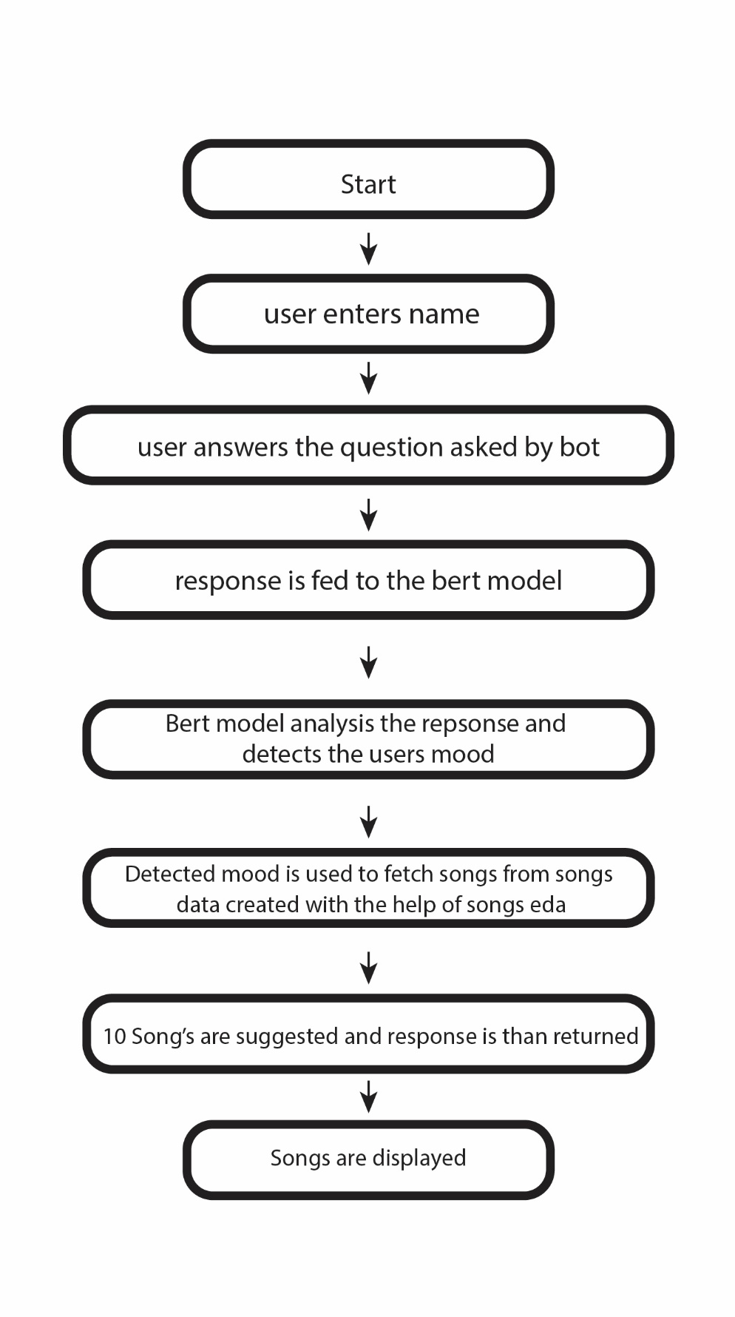

Figure 2: Flowchart.

### 10

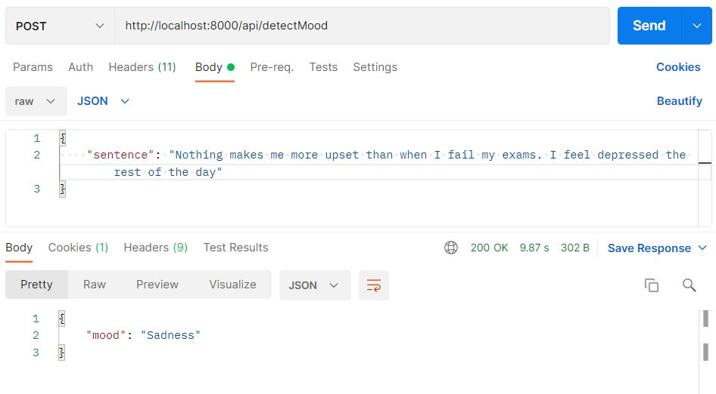

Figure 3: Mood Detection.

### 

Figure 4: Songs Suggestion

11

**PROCESS DESIGN:**

There are three distinct components.

1. Client application-

This is the front end where the bot makes small talk with the user by asking questions like “what is your name”, “how was your day” etc.

1. ML Model-

* The Raw text is entered by the User, that text is tokenized using AutoTokenizer which uses 'bert-base-uncased' tokenizer. The tokenizer generates input_ids and attention_mask of the raw text.
* In input_ids each word is allocated a index number along with some BERT specific tokens like [CLS], [SEP], etc. The attention_mask is used for masking unused space of our array of text. These two are fed to BERT pretrained model it's our transformers layer.
* The Output from the transformer layer is fed to the Attention Head layer, the attention head layer generates a context_vector which aggregates information of the alignment vectors from the previous step and it remembers long sequences.
* After all that is done, we need to pass it into a classifier to predict a mood. The output from attention head layer is passed onto a Dropout layer to prevent over fitting. And the last layer is our Dense layer with SoftMax activation which gives us the Mood.

1. Api-

The model has been converted into a rest api framework (restful) and all the communication between the client side and the model is achieved by virtue of API (get & pull requests)

12

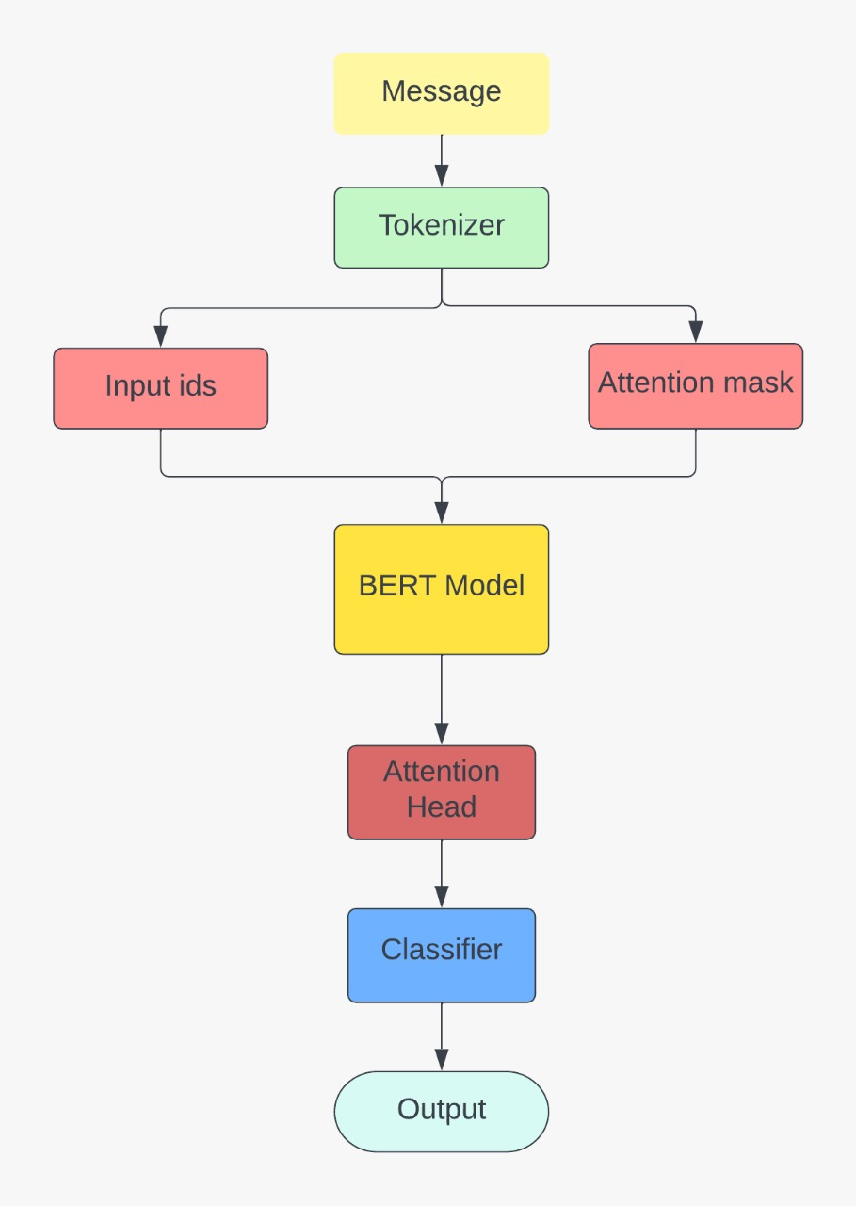

Figure 5: Process design

13

* 1. **DETAILS OF HARDWARE AND SOFTWARE**

Developing the system environment calls for the requirement of hardware and software. The hardware and software requirements in our project are-

Hardware requirements-

* Basic computer system with 8gb minimum ram
* Minimum processor : Ryzen 3 minimum
* OS : Windows 10
* Graphics : Basic integrated graphics
* Storage : 10gb

Software requirements-

* Next.js to develop the page UI
* Tailwind Css to style the UI
* Python to create the Model
* Kaggle for development of model
* Visual studio code to develop the UI
* Transformer library to create Emotion-BERT
* Scikit Learn
* Pandas
* NumPy
* Rest Api with Django to deploy the model
* NodeJS to run the project locally
* Microsoft Excel to save the dataset as csv
* Adobe XD to create UI wireframe
* Onnx for making deployment model

14

* 1. **EXPERIMENT AND RESULTS**

We tried making two models of the project, one would be for mood detection and other is the songs EDA. Our main focus was to link both the models together to suggest songs through the users moods.

At the end the linking of both models was done successfully and desired output was achieved.

### Screenshots:

Figure 6: App UI

### 15

### 

Figure 7: Know More & Features

16

### Figure 8: 10 About Us Page

17

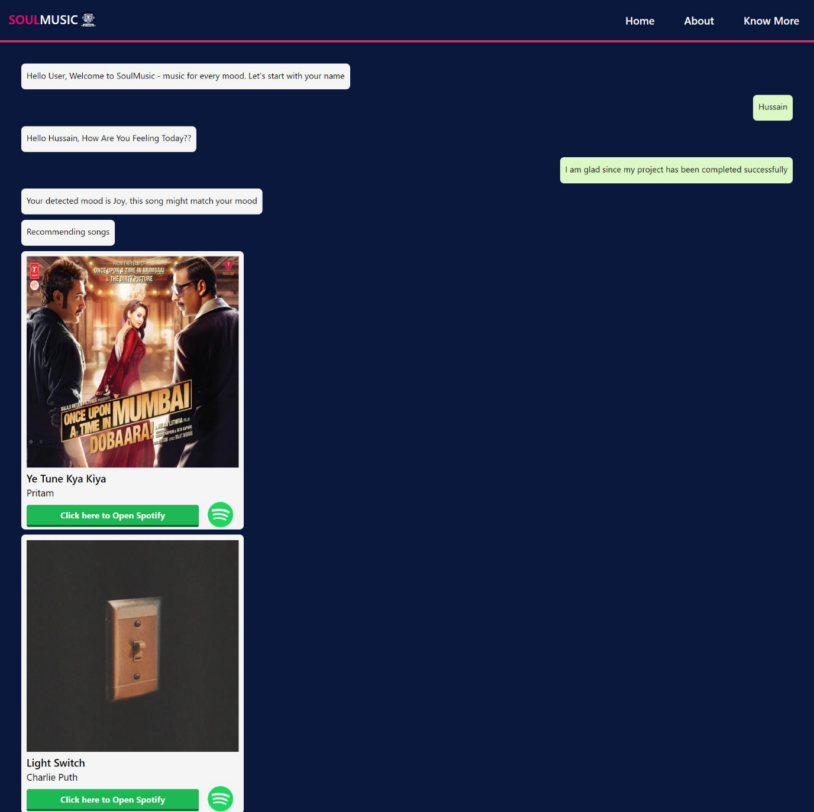

Figure 9: Mood detection and songs suggestion.

18

### CONCLUSION AND FUTUREWORK

The project abstract proposes a full-fledged application that will detect users mood and suggest him/her relevant songs based on a single chat input. In the Final Implementation all of the above-mentioned proposal has been achieved successfully.

As a future implementation we could add YouTube links so the user could listen to the songs on YouTube, and we could also add an inbuilt audio player so the user won’t have to leave the site to listen to songs.

### 19

**REFERENCES**

### <https://www.python.org/>

### <https://developer.mozilla.org/en-US/docs/Learn/Server-side/Django/Introduction>

### <https://www.w3schools.com/>

### <https://nextjs.org/docs>

### <https://nodejs.org/en/>

### <https://tailwindcss.com/docs/>

### <https://pypi.org/>

### <https://www.django-rest-framework.org/>

### <https://www.geeksforgeeks.org/how-to-create-a-basic-api-using-django-rest-framework/>

### <https://medium.com/@humble_bee/django-basics-for-a-beginner-5d864e6aa084>

### <https://onnxruntime.ai/docs/get-started/with-python.html>

### <https://www.kaggle.com/code/shahidmandal/emotion-bert/edit/run/91658948>

### 20