Dealing with High Workloads at University using ML

EECE 490 Milestone 4

Vincent Nakhle, Awon Alnsour, Hussein Haidar, Andrew Ghafary, Farid Boulos, Kareem Halablab, Hasan Ramadan

***Abstract-*** There is no question that high levels of stress are the most inhibiting obstacles faced by students all over the world! [12] This stress leads to dissatisfaction, low productivity and, by extension, lower grades in even the brightest students. The goal of our proposed system is to help students choose courses in a way that minimizes their stress levels. This was achieved by creating an application that allows users to input the courses they are taking in any semester and measure the stress and workload levels of any combination of courses entered. A recommender system then suggests possible changes to the schedule to reduce said workload. This solution therefore tries to help users make better choices for their courses, their semester and their education as a whole by reducing the amount of stress they are exposed to and in the process maximize their learning experience. The different course recommendations consist of the various courses that Computer and Communication as well as Electrical and Computer Engineering students have to take. This project will be implemented using Machine Learning.

1. **Empathize Phase with Human centered Surveys**

The COVID-19 pandemic compounded with the current economic crisis has had an undeniable effect on every aspect of society all over the world. It has changed the way we live, socialize and work. This, like any sudden change, has turned into a series of never ending hurdles for professional and student lives especially in Less Developed Countries like Lebanon. The Lebanese people now suffer from a lack of access to the Internet and to the tools needed for remote working and education. They are also susceptible to fake news about the coronavirus itself and the newly launched vaccines. Finally, they are subject to the mental stress that comes with confinement, especially with the absence of any real financial help for low income communities. The aim of this project is to help people and students in particular reduce their levels of stress especially in these extraordinary circumstances

We discussed these issues with people from different age groups and backgrounds and got some really interesting feedback as to the problems they are facing and their corresponding mental state. All the interviewees reported problems related to the pandemic or the current economic situation. Although, most issues were tied to the pandemic or the economic situation, they were also really diverse ranging from university workloads to the vaccination campaign. We quickly realized that if our goal was to reduce stress levels in people, our stakeholders would be the whole of the Lebanese population as most of the Lebanese citizens are struggling in some way or another due to these cumulative crises.

Due to the multiple lockdowns and the time constraints, we were only able to conduct six interviews.

Below is a summary of the three most insightful interviews we conducted.

|  |  |  |  |  |  |
| --- | --- | --- | --- | --- | --- |
| **Name** | **Age** | **Profession** | **Gender** | **Length of interview** | **Interviewer** |
| Elie | 22 | Student | Male | 18 min | Andrew Ghafary |
| Hadi | 20 | Student | Male | 22 min | Andrew Ghafary |
| Mahmoud | 62 | Professor | Male | 22 min | Kareem Halablab |
| Tamara | 20 | Student | Female | 18 min | Hasan Ramadan |
| Fadia | 50 | Professor | Female | 25 min | Hussein Haydar |
| Jad | 20 | Student | Male | 22 min | Andrew Ghafary |

Table 1. Interviews Table

The first person we interviewed was Hadi Hamoud, a 20 years old Computer and Communication Engineer at AUB. He enlightened us on multiple issues faced as a student in Lebanon during the pandemic. The most prominent issue he mentioned is the mental health effect of the lockdown on him and on his studies. He argues that social media has made it harder for him to stay at home as some people were going out and posting about their different activities. He also blamed fake news on social media for his decline in mental state as it blurs the line between what is real and what is not.

He recommends being more transparent with the vaccination campaign as well as better enforcement of the lockdown measures to enable a better fight against the virus. He also advises the use of reliable sources of information to keep up to date.

We would like to assist Hadi in having a better academic experience as well as an easier lockdown experience by removing some of the stress factors affecting him.

The second person we interviewed was Dr. Mahmoud Halablab, a 62 years old professor in Microbiology.

In this interview Dr. Mahmoud narrates his experience with online teaching during the pandemic. He discussed several issues such as the difficulties he faced while turning lab material into a digital version. Dr. Mahmoud also emphasizes the challenges in communicating with students, especially virtually

Dr. Mahmoud also expresses his surprise with the current medical developments. He is particularly marveled with the worldwide vaccination campaign that was able to deliver such a huge number of effective vaccines in a very short period of time. He is, however, still skeptical about the Lebanese vaccination campaign as it is surprisingly slow and might not catch up to new strains of the virus.

We would like to help Dr. Mahmoud have a better teaching experience and provide him with additional tools to communicate course content with his students.

The third person we interviewed was Tamara Haydar, a 20 years old Computer and Communication Engineer at AUB. She mentioned the difficulties she has been facing trying to cope with online learning. She expresses her dismay and frustration with the huge workload professors assign to the different courses due to them being online.

She argues that, although online learning provides more resources and better access to course material, the mental aspect of studying in quarantine proves to be the most challenging. Tamara clearly portrays this when comparing studying with her colleagues at the AUB library versus studying alone in her room.

She recommends that professors should communicate with each other in order to unify the workload among different courses, change policies, and be more lenient on deadlines and exams.

We would like to provide Tamara with a better educational experience and keep a positive outlook throughout university.

II. **Define Phase**

After discussing with our interviewees and concluding our first investigation, we clearly saw people struggling to manage anxiety, massive workloads, fake news and the slow vaccination campaign. The Covid-19 Pandemic as well as the steps taken by universities and our incompetent government have only added to the overall stress levels in Lebanese citizens. We decided that we cannot tackle the vaccination campaign as a problem since we do not have enough data on the subject. In addition, the government is already working on a fact-checking platform in accordance with the ministry of public health. We also did not want to tackle the problem of fake news as there are already many implemented models. We finally settled on university related issued that came to being due to the pandemic like communication between peers or between teachers and students. Other ideas include helping students choose better schedules by minimizing their workloads. We quickly discovered that different course combinations have different effects on our interviewees’ state of mind and well-being. We additionally found out that these combinations have various implications in terms of workload. As a group, we chose to utilize our insight in Machine Learning to help our stakeholders figure out how to facilitate the process of choosing the right set of courses in order to lessen the impact of induced workload and their implication on mental health. We would then assist them in discovering customized, explicit, and powerful strategies to manage those inclinations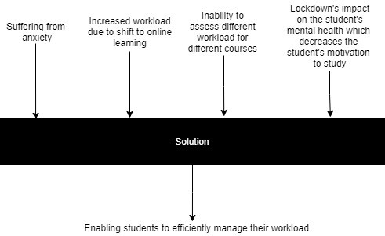

Figure 2. Brainstorming Ideas

Figure 1. Black Box Diagram

III- **Ideation & Low-resolution Prototypes**

1. *Brain Storming*

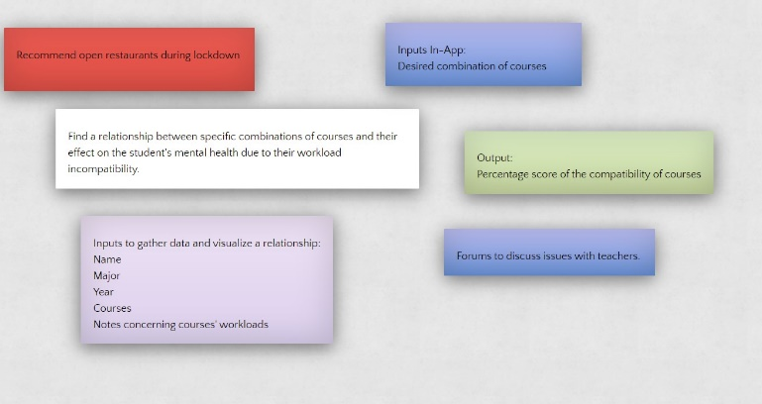

The first step we took to uncover answers to our concerns in the characterize stage was to sit and conceptualize as a group. During our zoom meetings, we made a common page where we wrote down a wide range of ideas and thoughts that may answer our concerns. We understood that despite the craziness of some ideas, it was their center reason that made a difference. We attempted to discover methods of interpreting that reason in a more pragmatic manner. The first step in our problem was to identify the courses that students are taking in addition to how they are feeling throughout key weeks in the semester. Moreover, we thought of having a student-input assessment that would evaluate your daily mood. The next step was to analyze how different combinations of courses and especially those that have incompatible workloads will make any semester a living hell and induce tremendous mental health effect on students. We then found out that we needed a long-term solution to help people even after Covid-19. We therefore brainstormed some ideas and came up with a course combination calculator and a happiness optimizer. We now had our key parts, how might we convey them to our client? We bantered between having a site or an application. We wound up settling on an application to augment the common sense of our framework. The examination likewise showed the benefits of making an application. For example, availability because of ceaseless network or simplicity of route. We now had a fairly reasonable thought of our sources of info and yields. Our inputs would be the individual’s profile, major, university, courses he’s taking and an overall score for the workload during this semester. After gathering data and creating a relationship between certain combinations of courses and respective scores, a student will then input his desired courses for the upcoming semester and will get an as output an expected overall score describing the load he should be anticipating, unfolding the overall happiness by this selection.

*B. Related work*

Numerous plans have been constructed that attempt to answer comparative issues as our own. Here are some striking ones (All works are referred to in References – in Appendix):

**1. Course Enrollment Recommender System**

The framework and the system provided fundamentally assists with understudies' enlistment choices. Explicitly, it gives proposal of particular courses as for understudies' abilities, information, interests and extra energy spaces in their schedules. The framework likewise cautions understudies against troublesome courses and ones with heavy workload, and reminds them obligatory examination obligations.

**2. A Collaborative Filtering Based Approach for**

**Recommending Elective Courses**

In this paper they extended the concept of collaborative filtering approach to develop a course recommendation system. The proposed approach provides student an accurate prediction of the grade they may get if they choose a particular course, by evaluating the workload and effort required by this course and previous grades from students, which will be helpful when they decide on selecting elective courses, as grade is an important parameter for a student while deciding on an elective course. They experimentally evaluated the collaborative filtering approach on a real life data set and show that the proposed system is effective in terms of accuracy.

**3. Implementation of Course Recommender System for Virtual University of Pakistan.**

This article examines the necessity of a recommender system to assist students in choosing relatively “easy” elective courses to maximize their GPA, since the selection of courses can have a huge impact in determining final score of a student during his academic career. In addition to that, this paper provides key information regarding distance-learning since it is about a virtual university where all lectures are delivered through Internet, which is a common point with our current situation right now.

**4. An Automated Recommender System for Course**

**Selection**

This paper presents a shared recommender framework that prescribes college elective courses to understudies by misusing courses that other comparable understudies had taken. The proposed framework utilizes an affiliation rules mining calculation as a fundamental strategy to find designs between courses.

Tests were directed with genuine datasets to evaluate the general exhibition of the proposed approach.

**5. Developing an Intelligent Recommendation System**

**for Course Selection by Students for Graduate**

**Courses**

This paper proposes doable expectations for

graduate course determination dependent on their imprints and decision of occupation interest. Grouping procedure is utilized to discover structures what's more, relationship inside the information. This paper additionally uncovers the exploration cycle of readiness of such a recommender framework.

|  |  |  |  |  |  |
| --- | --- | --- | --- | --- | --- |
|  | 1 | 2 | 3 | 4 | 5 |
| Personalized | ✓ | ✓ | ✓ | ✓ | ✓ |
| Mood Evaluation | ✖ | ✖ | ✖ | ✖ | ✖ |
| Expected Grade | ✖ | ✓ | ✓ | ✖ | ✖ |
| Online Learning | ✖ | ✖ | ✓ | ✖ | ✖ |
| Undergraduate(✓), Graduate(✖) | ✓ | ✓ | ✓ | ✓ | ✖ |
| Recommender system- Based on emotion | ✖ | ✖ | ✖ | ✖ | ✖ |
| Recommender system- Based on grades | ✓ | ✓ | ✓ | ✓ | ✓ |
| Ratings for effectiveness | ✖ | ✖ | ✖ | ✖ | ✖ |
| Elective courses only(✓), All courses(✖) | ✖ | ✓ | ✓ | ✖ | ✖ |

Table 2. Comparison Table

Based on this comparison table, we noticed that not much

work has been done that is as complete as ours. We took into consideration many features that allow the system to get to

know the user’s feeling during a specified semester. Our model is more personalized than others, notably due to the fact that we have several recommendation options based on emotions as well as workload and taking into account the mental health of the students during the semester not only notifying them with the expected grade of a certain course. This is an advantage since emotions and mental health of students are significant factors affecting their feeling toward a given amount of workload during a specific semester, and therefore a system that incorporates both the grades and emotional aspect of courses would be more complete and offer a more credible recommendation that would more accurately highlight students’ past experience with different sets of courses

IV**. Testing of Low Resolution Prototype**

*A. Prototype Ideas*

The prototyping phase was not an easy one. It was really stressful because we wanted to deliver the most helpful solution to our users, especially since this application would also benefit us as Computer and Communication students that have made a lot of mistakes when it comes to scheduling courses.

We had a discussion of possible project ideas which included creating a personalized chatting messenger app for students and for students and teachers to lessen the workload in some courses, or providing people with open restaurants during lockdown, even though this might go against government guidelines. We also discussed the matter of workload which is distributed among different courses, and that taking some courses together might be exhausting for students as they might necessitate a huge amount of effort. We discussed the feasibility and the innovation of these ideas to select the best one. Before deciding on our prototype, we talked about the forum between students, and students-instructors, and realized that this is really not innovation nor efficient as such tools already exist in Outlook, Moodle forums and AUB’s counseling center. Concerning open restaurants, the main issue that we noticed was

the legal aspect of it.

During lockdown, businesses are meant to shut down to prevent the spread of Covid-19. We cannot therefore, report these restaurants that are open and recommend them to people because it undermines the point of the lockdown and basically is an illegal act even if it might help some students to co-study. We finally talked about how different course combination can really make a difference in a student’s semester. We reflected a little bit deeper into the idea and realized how new students can take advantage of past students’ mistakes and remarks when designing their schedules. This drove us to put things into perspective; How can we really help students in organizing their schedule in a way that will reduce their respective workloads? This in turn led us to the idea of a Machine Learning recommender system that takes as input previous students’ semester as well as the amount of work they had to do and the stress level they felt and creates a certain relationship between combinations of courses and expected stress and work levels. To make things more concrete, we started with a base prototype for this raw idea, to later on introduce it to our stakeholders and get their feedback which will be necessary for us to build the final output.

1. *Prototype Output*

To tackle the problem at hand, we designed a prototype application consisting of the Machine Learning solution as well as other interesting features (Prototype included in Appendix). The application starts with a setup for the user profile, asking for essential features such as the name, age, class, major, and courses taken. After a successful sign up, users enter the main page, where many options are available to explore. We have buttons that take you to settings and profile. We can divide the implementation of this prototype into two main functions: First we can get an old evaluation of old students’ semesters by taking into account courses taken in terms of workload to create a certain formula between some courses or a combination of them, and what is the expected output of these courses as a grade. In addition, after generating enough data, we can go on to the next phase of the app which is generating a new evaluation. Here a student will have to put desired combination of courses he is planning to take during the upcoming semester and will get a percentage score notifying him with the expected workload that he will have to endure and therefore he can adjust his schedule to get an optimized one, hence the name: Sched-Best.

We will implement a content-based recommendation system which is a system that gives personalized outputs based on the provided data from a user regarding specific courses. In other words, the system captures patterns to predict a score based on the inputs mentioned above to facilitate a student’s responsibility of creating a schedule that fits him best.

Planning this application took a great deal of time and exertion. We initially had a few troubles in every step, sorting out some way to imagine it to offer it to our stakeholders. Eventually, we found a site called proto.io where we had the option to plan it, its aesthetics and interactions. Subsequent to drawing each segment, we had the option to make a series of screens that contain every one of the highlights we wanted. This part of the project really incited us to make the best experience possible for our stakeholders, in terms of having enough data in order to predict a precise and accurate score.

We presented this template to users to get feedback to make further adjustments.

1. *Feedback*

Now that the prototype has been designed, we went around and asked people to test it and give us their opinions. Since we realized in our first round of interviews that older generations don’t suffer from problems related to schedule optimization, this time around we mainly asked young students who have difficulties doing so and are usually very familiar with technology. We conducted interviews where we present and explain each of our prototype features. A total of five interviews were conducted.

The majority of our interviewees were dazzled with our plan and urged us to continue with the execution. They noticed how simple and stylishly satisfying the layout was, yet they additionally noticed how reasonable the thought behind it was.

Abed, an interviewee, exclaimed that “[He] would see myself every semester using this”. Most believed that it serves its purpose of recommending specific course combinations to facilitate the registration process and remove the burden of having too much workload or stress during the semester in an innovative way traditional “Advisors” do not follow since most do not go as in depth in personalizing a student’s schedule. In fact, we got complimented over and over about how much people appreciated that this app allows people to take matters into their own hand by allowing them to evaluate different combinations of courses and facilitate the registration process.

Nonetheless, there is always room for improvement. Here are some of the major concerns we would like to tackle based on the reviews.

Marc, a 20-year old CCE student, gave us a lot of helpful ideas to improve our design. To start on a positive note, he exclaimed how impressed he was with the easy way you could evaluate a certain schedule by using a slider which goes on a scale from 0 to 100. However, he raised a concern when he wanted to view previous evaluations-where we didn’t include an option to view history of previously generated evaluations. From here, we wanted to explore ways to fix this issue in order to make it easier for people to view recent evaluations or schedules. A second interview with 32-year-old Zein shed a light on another problem that can lead to somehow and incomplete evaluations. Similar to Abed, he noticed that there are some inputs missing notably when it comes to adding a new schedule. He explained that if more features are taken into consideration, that will greatly change the output of the evaluation system. For instance, he mentions that people with a huge brain capacity may not get as stressed for the same workload as an average student. He also brought up the fact that the application does not let you save different sets/schedules which can be really helpful If the user wants to refer to it after a while. We wondered what slight changes could make Zein’s and other people’s experience more suitable to their availabilities and disadvantages. Finally, we interviewed Lucie who is a 20-year-old Arts student. Like others, she exclaims that she loves how personal the application is as it tackles a lot of details some other services might ignore. She likes the range of different features we offer. However, she suggested the addition of a gender field in the sign-up which increases the features of the data we have. Thus, we would like to generate precise and accurate evaluations with more features to be added. Based on the interviews conducted, we came up with several adjustments to our design that answers people’s requests. With the help of Zein and Abed, we came up with a plan of adding the ability to view previous evaluations and to save them and also the “stress” input which was coupled with the existing “workload” input. On the other hand, Lucie mentioned that we should add a field for the user to input his/her gender in order to account for all variables. All of this was prototyped using proto.io and the interfaces can be seen down below.

|  |  |  |  |  |
| --- | --- | --- | --- | --- |
| Name | Age | Length | Feedback Summary | Interviewer |
| Lucie | 20 | 15 min | -Addition of gender field in sign up stage | Hasan Ramadan |
| Abed | 20 | 12 min | -Add feature to view recent evaluations  -Add input of stress as a slider near the workload slider | Andrew Ghafary |
| Zein | 32 | 19 min | -Addition of ability to save preferred schedules | Hasan Ramadan |
| Elio | 24 | 19 min | -Really loved the features and the smooth interface | Andrew Ghafary |
| Jacob | 19 | 9 min | -Emphasized on how much it was important to him as a first year student | Hassan Ramadan |

Table 3. Feedback Summary

V**. Ideation and Final Solution**

1. *Brain storming*

As outlined in the previous two milestones, we have decided to implement a regression to compute the level of stress and workload associated with a particular schedule and a recommender system to recommend a change in schedule to reduce workload in the case of a hard semester. We looked up the different possible recommender systems that use Machine Learning. We found the Content Based and the Collaborative filtering recommender systems. A Content Based Recommended System uses item features to recommend other items similar to what the user likes, based on their previous actions or explicit feedback [13]. This is done using a utility matrix that describes the relationship between an item and the user. As for the Collaborative Filtering Recommender System, it uses similarities between users and items simultaneously to provide recommendations. This allows the collaborative filtering models to recommend an item to user A based on the interests of a similar user B [14]. We noticed that a Collaborative Filtering System would be the best choice for our project to recommend similar courses. We also looked at the different options we had regarding the regression. We originally started with a linear regression model to determine the relation between courses and the different stress and workload levels experienced by students. We then iterated through several different methods like Ridge regression (regularized linear regression), decision trees, extra trees, and neural networks. However, we finally settled on XGBoost which stands for e**X**treme **G**radient **B**oosting, an implementation of gradient boosted decision trees designed for speed and performance [15].

Our inputs for the models are the different combination of courses that the user would take. The corresponding output would be the workload and stress levels experienced for the inputted courses as well as recommendations for which courses can be substituted for which other courses. The model also shows the levels of workload and stress achieved by this substitution as a percentage.

1. *Literary Reviews Update (and rewrite)*

We have done some additional research since Milestone 2 where we covered articles related to our project. We found a couple more articles that are relevant to our project. First of all, in “A Collaborative Filtering Based Approach for Recommending Elective Courses” [11] and “Recommender Systems for university elective course recommendation” [16], both researches use Collaborative Filtering methods, like us, to determine which courses to recommend to students. They, and all other articles we examined do not use workload and stress levels as a measure of fit for new recommendations but the grades of previous students. This allows Students to make decisions that maximizes their grades. Another article we uncovered was “Content-Based Course Recommender System for Liberal Arts Education” [17] which uses a Content Based recommender system instead of the Collaborative Filtering that we used. It showed us that we should use Collaborative and not Content based filtering for our project. Another paper we found really useful was “xgboost: e**X**treme **G**radient **B**oosting” [18] which provided us with more insights about xgboost and its functionality.

Our project seems to be quite unique as we did not find an instance of a recommender system that uses workload and stress as the main driver for recommending courses to the user. All these papers can be classified as *Related Work.*

1. *Concept Product*

We will use the same layout and logic from our low resolution prototype. The user will first be able to login to his profile, he will then be able to evaluate different set of courses and receive recommendations on which course he can substitute to reduce stress and workload. The user will also be able to add sets of previous semesters that he already took in order to increase our dataset for better future predictions. So the more the application gets used, the more accurate it will become.

1. *Data Set*

After thorough searches on the internet and careful consideration we decided that the only way to have a reliable and relevant dataset was to create it ourselves. This is due to the fact that our application works on AUB courses dataset that cannot be found online. We created a google sheet that we shared with our peers at AUB and especially to CCE and ECE students of all ages. The sheet consisted of 68 columns with 66 columns used for courses, 1 for stress levels and 1 for workload. The respondents were tasked with filling out which courses they took each semester and the corresponding stress and workload levels experienced. We were able to get about 550 responses in our sheets, i.e. 550 semesters. Therefore, to avoid the under fitting bias, we filled the rest of the data sheet with dummy samples that provided more samples for our models. The final number of samples was around 1090.

Our dataset had originally included courses from the whole AUB curriculum, not just limited to ECE and CCE, but these were dropped due to added complexity as well as the lack of available data to train a model with that many features (A model with a 100 features cannot be trained with a dataset with 550 instances!)

We had also added which semester users where filling out as a feature (Fall E1, Spring E2…) but this was also dropped to decrease complexity.

We would have loved to work on the whole of AUB curriculum but we just could not get enough data to do it.

VI**. Initial Implementation**

We started our experiment with the dataset we gathered ourselves. As for pre-processing, we performed a transformation on the columns to represent each semester in a way that can be interpreted by python. Instead of having 5 columns (courses 1 to 5) containing strings of each course taken, we included each course as its own column and for each row a “1” was assigned to the courses that were taken by that specific student, and a “0” for the courses which weren’t taken. We didn’t need to look for missing values since the dataset was ours and not externally brought in, and also due to data scarcity we couldn’t afford to drop many rows anyway. No further columns were dropped as the courses were essential to provide the best possible prediction on the target variables which were the workload and stress columns.

VII**. Comprehensiveness of experiment**

We went through multiple iterations before settling on the most convenient model. We considered linear regression / ridge regression, decision trees, extra trees, neural networks, and finally XGB regressor. The main factor pushing us to look for different models was optimization of the accuracy and minimization of the errors. Our first linear regression model didn’t score well on the R2 and MSE (mean-squared-error) metrics because of its simple approach to the problem. Next, we tried to add a regularization term and optimize for it, but still the best results we got were nowhere near what we wanted. So we tried implementing basic decision trees that scored well on both metrics but not for both Workload and Stress which meant it wasn’t as consistent as we thought it would be in the first place. Given that our decision tree wasn’t completely useless, we said why not try a better implementation of decision trees. So upon further research, we found a model called Extra trees. Extra trees work very similarly to random forests. However, it ironically adds more randomness while keeping the same level of optimization of random forests. Surprisingly, the results we got from the extra trees model were nothing but a slight improvement from decision trees. So, we decided to use neural networks as our last resort. First, we initialized an input layer with 66 inputs, 3 hidden layers each with 256 nodes and a “ReLu” activation function which was ideal for our case, and finally an output layer with a linear activation function. The neural network model was compiled and fit to the data and the results were a huge improvement on all previous models where it scored relatively high in the average case. However, just when we thought that NN was the perfect solution, we stumbled across a decision-tree based model called extreme gradient boosting. Extreme gradient boosting is basically gradient boosting on steroids. As for gradient boosting, it is a special case of boosting where errors are minimized using the gradient descent algorithm. So extreme gradient boosting is a perfect combination of software and hardware optimization techniques to yield superior results using less computing resources in the shortest amount of time. For the recommender system, we first considered building a collaborative model which would take as input a single course and output similar courses, but we found that wasn’t ideal and didn’t align with the overall goal of our project. The main concern was that we were looking to build a more complex recommender system that would take an array of strings of courses or classes together as input and offer recommendations that take into consideration the complexity, workload, and stress induced by them by recommending a single course to be replaced by one that would decrease the overall workload and stress by certain amounts. Therefore, we built a function that would take a list of strings of all taken courses by a student and used the XGB Boost model to predict its workload and stress. After that, our recommender system would recommend a certain course to be replaced by a similar one, which would prompt the function to recompute the workload and stress again with the hope of decreasing them both. This would be done in an iterative manner with different courses in order to look for the highest decrease in the target variable percentages.

VIII**. Complexity of Solution**

For the technical part, we decided to opt for the item-based recommendation system. First, we created a CSV file with indexes of our different courses and their corresponding names along with the course description. We then decided to use the course description as our similarity criteria. So we created a function that given a course and an integer “n”, gives “n” similar courses to the input course along with their description. We then decided to change the shape of the output of the system while preserving its functionality.

Initially, our main function would score a given set of courses based on their workload and stress levels. So, we made a function that for a list of courses gives us another list of “lists of courses” where each “list of courses” contains 3 similar courses to the courses in the original list. The function would then proceed to substitute each course from the “list of courses” with its corresponding course in the original list of courses and give this new list a score based on the workload and stress levels it would result in. After finishing all iterations, the function would return a list of easier alternatives to the input course list and the optimal alternative which we decided to call the “Sched-Best” alternative. At first the execution of the code was taking a lot of time to yield an output. Upon further inspection, we were able to reduce the time of the execution significantly where it only needs around 0.66 seconds to run now. We got rid of many unnecessary steps to save time. For example, we noticed that sometimes two courses in the original list will have each other as similar courses for each other, so a list with two of the same courses wouldn’t be of any use to score and waste time on. Other than that we tried to minimize the levels of nested loops our code had. We also got rid of another useless case where the function would substitute a 3 credit course with a Lab. To prevent this from happening we first thought of creating a dictionary that includes the courses and their corresponding number of credits, however, even though this was a very efficient solution but we found a more efficient one. Instead of creating this dictionary, we added a comparison which wouldn’t let two courses of different lengths take each other’s places. For now, this implementation seems as a reasonable solution, but in the case where more courses are added, we might need to resort for the dictionary approach.

We added below different snapshots of the code showing the recommender system and the structure of the main “predict” function and a sample output.

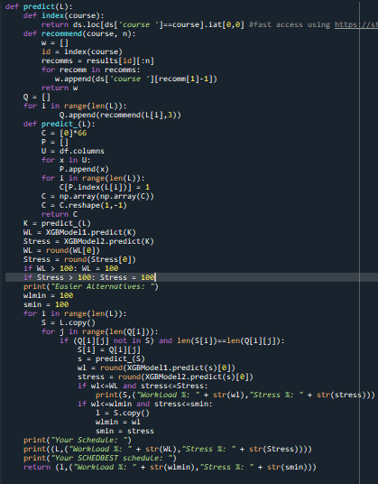

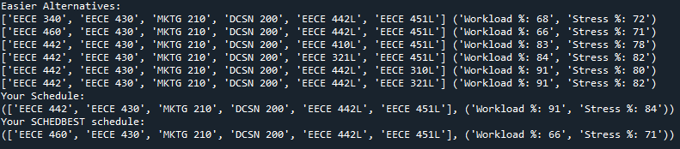

IX**. Performance Results**

Concerning the results of the project, we were satisfied with the performance of our combined prediction / recommendation system with regard to error and coherence. We felt that it aligned well with the goals we set for our project in previous milestones and with the overall motivation toward building a system that would be beneficial to students both academically and mentally. We feel as though collecting a bigger amount of data of students’ previous semesters would significantly improve the system’s ability to spot patterns and offer more accurate recommendations. As users go through more semester and assess their impact on mental health and the overall workload, the system will become more refined and learn more combinations which would give more satisfying results.

Below you can see the different performance results for the different approaches we used in building the final model. As you can see the linear model didn’t score well on both target variables (workload and stress), where it yielded a 0.7 and 0.48 R2 score respectively. Also we must note that the MSE for our case was relatively high. Next, the DT and extra trees model gave similar results on both metrics for both target variables which weren’t accurate enough. The neural model then showed a huge improvement on the average case (even though it scored lower on one of the targets, it was more consistent on different runs). And finally you can see the XGB model that scored the highest on both metrics for both targets consistently which made us implement it when creating the final model.

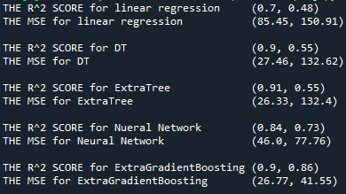

X**. Insights and Discussions from experiment**

The main hurdle was choosing the most efficient algorithm to perform the specific task of predicting workload and stress. Factors that were considered while going through the decision process were accuracy, speed and reliability. For the first task, we first considered linear regression but we encountered a low r-squared score and a high MSE. After implementing ridge regression, the errors slightly improved, but not enough. Because of data scarcity and to avoid under-fitting, we then tried to implement cross validations, which further improved the scores. After that, we attempted a decision tree regressor followed by a random forest regressor which used information gain and took the mean of different combined decision trees increasing the scores significantly. Our next model was a neural network with three hidden layers with 256 nodes each. This pushed our r-squared score up to 0.84 and 0.73 for workload and stress respectively, however because our dataset was not too large we decided to conduct further research to ensure it is correctly used. This made us settle for XGB regressor which pushed our errors down significantly and showed a big improvement given that it implements cross-validation, and uses gradient descent to optimize for the best hyper parameters to use for the model fitting.



XI**. Testing of ML solution under real-world data**

In order to test our ML solution under real-world conditions, we conducted several interviews in which we let our interviewees test the model with their own input and rating different schedules, simulating the actual app. We have targeted our questions in a way where we want to understand the user experience.

Maya is the first person we interviewed, a 20-year-old ECE major. After explaining the basic concept of the project, and showing the interviewee the “interface”, she had a very positive reaction. She really liked the concept and found that the model/project effectively fills its purpose; help the student find the perfect schedule which minimizes workload and stress levels for him while still being able to complete his required courses, she also loved how the recommendations became more accurate after every use, and stated that they do in fact come in line with reasonable workload and stress scores.

Another person we interviewed was Walid, a 4th year CCE student. Walid was very supportive of the idea, given that he suffered a lot during his earlier years. He also mentioned something about using previously generated schedules to create perfect 4-year schedule for ECE students. However, we told him that our app was still in very early stages and that we didn’t have enough data to add more courses to the available ones. We think that once we have more data, we can start to add more available courses, we can also add more majors to the app making it open to non-ECE students. Moreover, more interesting features such as including instructors of the course as a variable can be thought of at later stages when more samples are collected from different students.

To conclude our project report, we believe that we have met and exceeded our own expectations for our model and its performance. In fact, by following the HCD process and through great teamwork, we have created a prototype that met our stakeholders’ needs by providing an effective and reliable recommender system that helps them find easier, effective alternatives to their schedules.

**Appendix:**

**I. Contribution of members:**

|  |  |  |  |  |  |
| --- | --- | --- | --- | --- | --- |
| Team  Members | Interviews | Report | Lit Review | Brain-Storming | Prototype  And Interface |
| Hassan  Ramadan | √ | √ | √ | √ | √ |
| Andrew  Ghafary | √ | √ | √ | √ | √ |
| Kareem  Halablab | √ |  | √ | √ |  |
| Farid  Boulos | √ | √ | √ |  |  |
| Awon El  Nsour | √ |  | √ | √ |  |
| Hussein  Haydar | √ |  | √ | √ |  |
| Vincent Nakhle | √ | √ | √ |  |  |

Who read each Paper:

*1.* **Course Enrollment Recommender System**

*Farid Boulos – Awon El Nsour*

*2.* **A Collaborative Filtering Based Approach for**

**Recommending Elective Courses**

*Hassan Ramadan – Hussein Haydar*

*3.* **Implementation of Course Recommender System for Virtual University of Pakistan.**

*Andrew Ghafary – Vincent Nakhle*

*4.* **An Automated Recommender System for Course**

**Selection**

*Kareem Halablab*

*5.* **Developing an Intelligent Recommendation System for Course Selection by Students for Graduate Courses**

*Andrew Ghafary – Hassan Ramadan*

**Final** **Prototype** **Design-** **Sched-Best** **using proto.io** **Preview** **Prototype:**

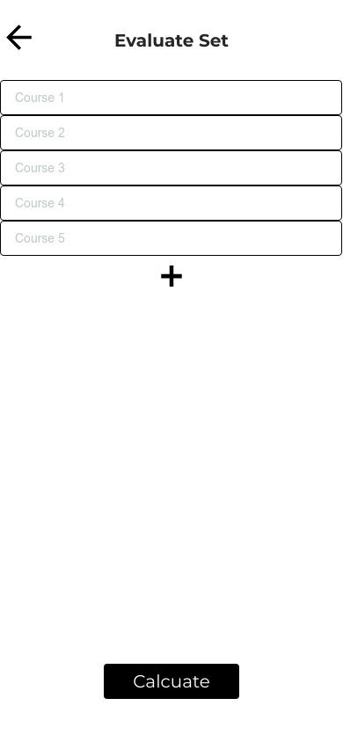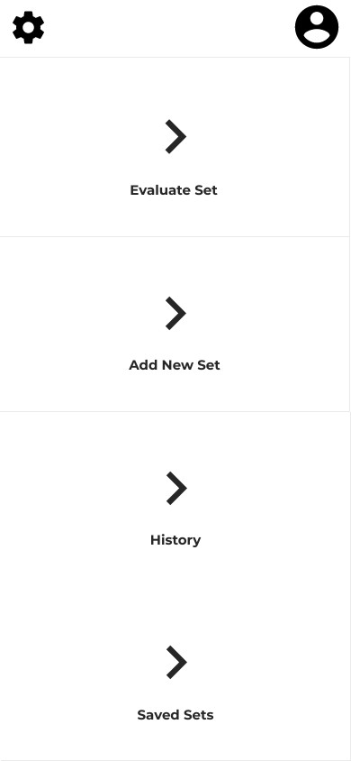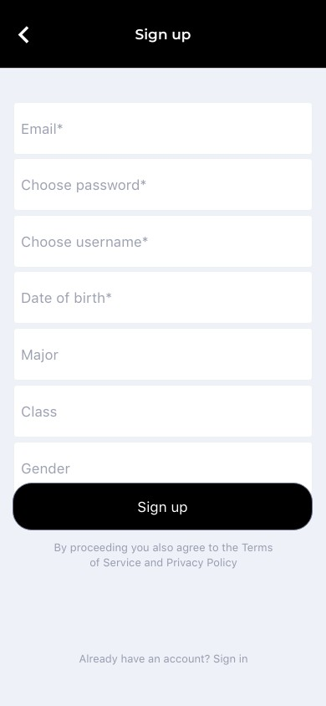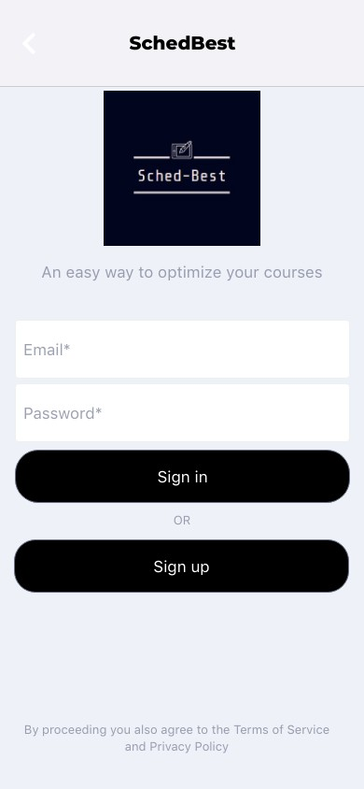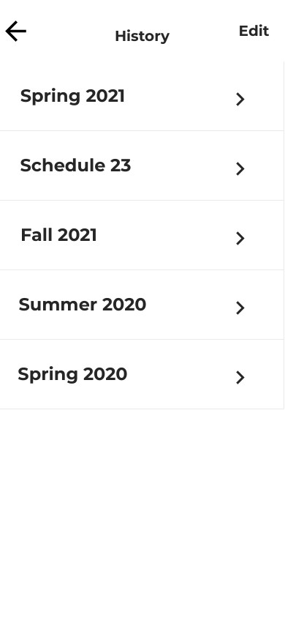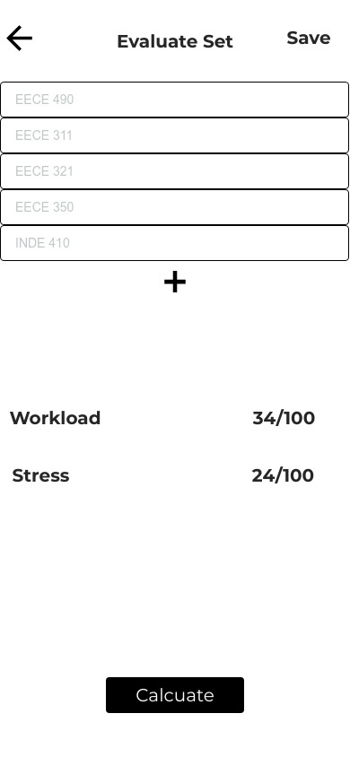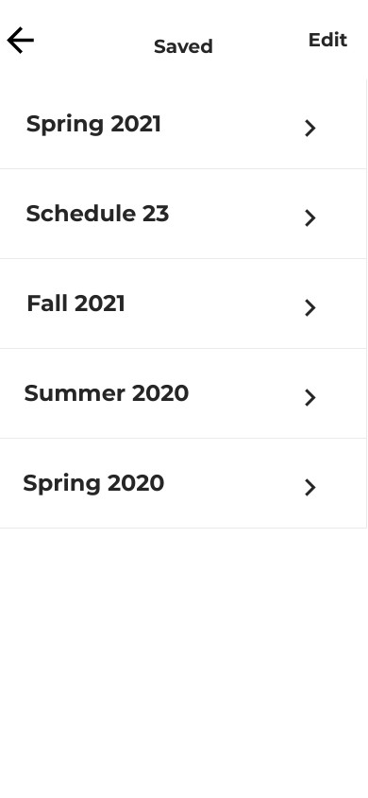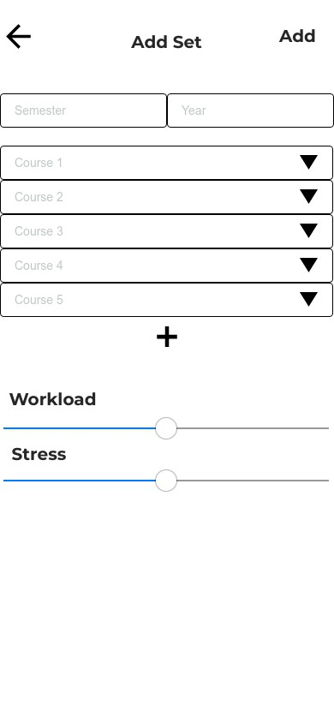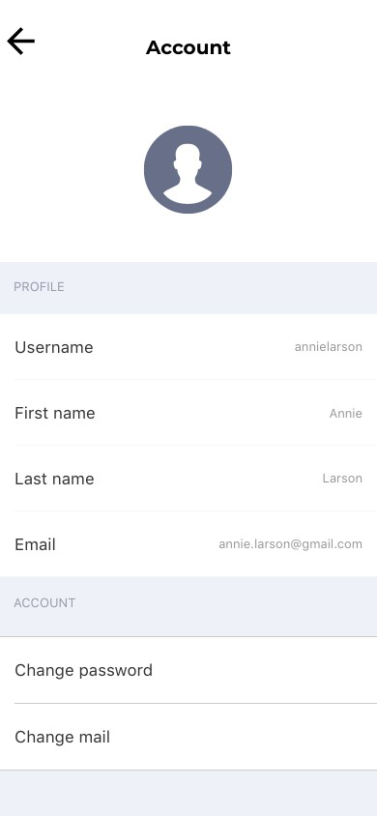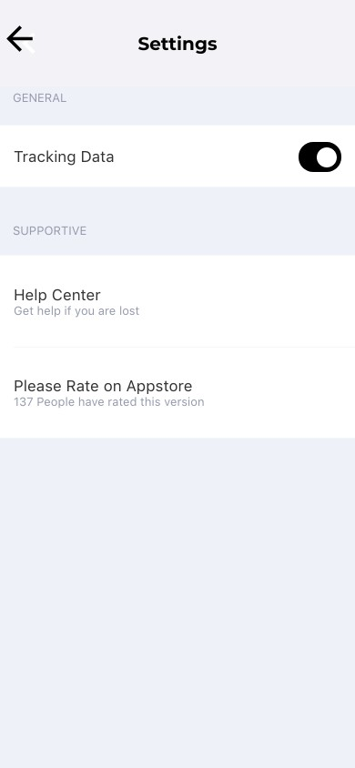

**Interview Information:**

**Interviewer Kareem Andrew Hasan Vincent** Interviewee Mahmoud Elie Tamara Elio

Duration 22 mins 18 mins 18mins 28 mins

**Interviewer Andrew Hussein Andrew** Interviewee Jad Fadia Hadi

Duration 20 mins 25 mins 22 mins

**II. Interviews**:

1st Interview: **Interviewer: Andrew Ghafary** Interviewee: Elie Ghafary

**Q: Please introduce yourself**

A: Hello my name is Elie Ghafary I am 22 years old and I've been a volunteer in the Red Cross for the past 18 months.

**Q: Could you tell me the main issues that you are facing in the red cross?**

A: The main issue that we are facing right now in the red cross is actually the coronavirus and the vaccination campaign in Lebanon. Actually we do not have a lot of people that are really encouraged to do it right now because there are a lot of false news all over social media. in addition to that the vaccine that we have right now in Lebanon is the Pfizer vaccine which is the hardest one in terms of logistics, storage, temperature and handling etc. it's a new type of vaccine and so it requires training for the nurses and healthcare workers that are going to vaccinate people. Because of the false news regarding the Pfizer vaccine lot of people that are registered to take it, when the day of vaccination is set they do not show up and therefore we are sometimes forced to jeopardize one or two doses of the vaccine or giving it to people that are not in the phase one just so we do not throw the dose away. And all this process is going to make the situation harder and make it longer for us to be able to be back to our normal lives.

Q**: Could you tell me other challenges that are not technical.** A: Yes of course, the lockdown really affected the people's mental health in a way that they sometimes exaggerate their own symptoms just because they are not stable emotionally. And another challenge is that we do not have a clear database on the empty beds that we have in the ERs and the COVID-19 rooms in different hospitals so we sometimes take the patient around 1,2 or even three hospitals before securing an empty bed.

**Q: I'd love for you to focus on the emotional side more if you can please.**

A: Regarding the emotional side, the economic crisis in Lebanon is already affecting their mental health enough and on top of that we have the coronavirus right now and it's all taking a toll on them in a way that they are really stressed out and anxious concerning the vaccine the coronavirus. People are dying and we know we don't have enough beds and in the hospital to take care of all the patients etc. so all this all that this does is it makes people exaggerate their own symptoms and

make the effect of false news harder on them and make them a little bit undecided regarding taking the vaccine or not which will delay the “herd immunity” phase in Lebanon.

**Q: thank you a lot for this amazing interview and the useful information that you gave me I'm sure that will be in contact throughout the semester so you can provide me with even more. Just before we're done I want you to give me like a small recommendation or a small solution that might help with everything that you said.**

A: The best recommendation that I could give is that we should enforce fact-checking on all COVID-19-related posts. We should educate people more about the efficiency of the vaccine and the benefits it holds so that we ensure a big percentage of people showing up on their vaccination date.

2nd Interview:

**Interviewer: Andrew Ghafary**

Interviewee: Jad Nahas

**Q: Please introduce yourself first.**

A: My name is Jad, I am 20 years old student and I’m currently studying economics.

**Q: As a student right now what are the main challenges that you face academically?**

A: I am actually living alone in a studio, so I really can’t move nor socialize, I am forced to stay in my 20m apt all day long, but the main thing that is bugging me is I can’t co-study with my friends which was my main motivation when I was physically going to university last year. I actually have developed a fear of missing out, FOMO as people would call it, and I don’t want to waste my early 20s living alone w doing nothing. In addition to that, I really miss socializing with my friends, going to bars and enjoying my time, I do believe that in doing so I can get the right motivation to study once I get back and right now I cannot do that because of Covid which is actually showing in my grades. And because of that I get even more frustrated and the cycle goes on.

**Q: How would you impose measures that will balance between keeping the community safe, sustaining the economy and providing assistance with everything that has to do with mental instabilities.**

A: I am actually against lockdown measures, I think every rational man is able to assess his own situation and decide whether he can go out or not, for example if he is living with his grandparents or he has a chronic illness. One of best policies in my opinion is the Swedish one where they let the people decide for themselves to get to the herd immunity. In that case people can still lead normal lives, the economy will remain strong and we can ensure a better mental state for a lot of people. In addition to that I find that imposing measures without financial support to businesses and people in the poor class is really stupid because people will always find a way around the system so they can open their shops and make a bit of money, especially in these tough times.

**Q: Are you looking forward to go back to university?**

A: In a way, yes. But I don’t know if my answer is based on my feelings, like missing my friends, or just because I find physical learning better. In fact, I do believe that we have to go through a big transition phase to go back to our normal lives just like we had to teach people to take precautions, it is a matter of habit,

and a lot of people are now used to staying and not going out except for special occasions. In addition to that, I think that masks will remain prevalent, just because people are now aware of the germs around us, and how disease can be transmitted in mid-air, and a lot of people including myself developed a small “OCD” when it comes to cleaning and sanitizing products. But in order to go back to normal we have to take the vaccine which is our only option right now, we should spread awareness of its importance and its necessity and try to limit these talks for professional experienced doctors, we can’t just let social media celebrities have a saying on this, especially since people get more convinced when their favorite singer says that the vaccine contains a micro-chip rather than the doctor talking for 4 hours straight about the effectiveness of the vaccine.

**Q: What do you recommend doing in fighting this pandemic.**

A: I think that we have to be really transparent with the people when it comes to the vaccination campaign and the vaccines that are coming to Lebanon and we have to impose the same measures for all people we cannot afford staying at home and watching stories all over Instagram of people coming out and enjoying the snow because it really affects people’s mental health and just to fact check everything that is said on TVs and on social media platforms because they really have a huge impact on the mindset of the people regarding the vaccine. And one more thing if they wish to impose strict lockdown measures and force people to close their businesses I believe that they have to compensate in a way that they should give them a small allowance just so they can survive and so they cannot have “the economic argument” as an excuse every time they open their business illegally and secretly.

3rd Interview:

**Interviewer: Andrew Ghafary**

Interviewee: Hadi Hammoud

**Q: Introduce yourself first please.**

A: Hadi hammoud, 3rd year CCE student at AUB, 20 y.o.

**Q: What do you think are the main issues that you are**

**facing right now in your daily life?**

A: The most important issue that I am facing right now is definitely Covid, and everything related to covid, economically, socially, academically.

**Q: How do you think govt is handling covid?**

A: When talking about covid, everyone has a role, you cannot enforce 6 million people to stay at home, we don’t have the facilities to do that. But the government definitely has a big share of the responsibility, and should enforce stricter lockdown measures and penalties, be more transparent when it comes to the vaccination campaign and giving people alternatives to make sure they stay home, like a monthly stipend or something like that. Because when it comes to the lockdown in Lebanon, we have tried every technique and still people are bending rules and going out and even posting on social media, and no one is here to enforce the law. The lockdown is not only beginning to seem ineffective, but is also having negative effect on the people staying at home.

**Q: How do you think the lockdown affected you academically?**

A: The effect of COVID-19 academically is a result of its effect on the mental health. In the first few weeks of the lockdown, I tried to stay positive as much as I can just like everyone, but then my motivation dropped because while I am quarantined I see a lot of people having fun on social media and not caring about the virus, but I keep reminding myself that I am doing this for my family first, and that I can have fun later once COVID-19 is done. Another thing that is affecting my mood is the immense amount of news concerning COVID-19 and the vaccine that are being distributed all over social media with no real and reliable source. You get a post saying that the vaccine can cause cancer in 5 years then you get a post saying that hospitalization dropped among vaccinated communities. A lot of people shouldn’t have a saying concerning the vaccine because these so called “influencers “don’t really have medical background and should be banned from stating their opinion especially during this pandemic.

**Q: How do you think life will be after COVID-19?**

A: I really don’t think life will be back to normal fast, people will still be cautious and avoid social meetings, especially after getting used to staying home on weekdays and weekends. People could still be using sanitizers because we became aware of the bacteria’s presence all around us. But I really do think that once COVID-19 is over, if I have the option to still study online I would definitely do so, in this way I can save a lot of time in traffic especially in Lebanon, I can take advantage of recorded lectures, to work or to adjust my schedule and on the other hand I can still go out which will enhance my performance at university.

**Q: What are your recommendation when it comes to this whole pandemic?**

A: Stay at home, for yourself first and your family, avoid fake news, get a reliable source and follow it, take the vaccine, spread positivity, the more we work together the faster we can overcome this and the happier we will be. I would recommend the govt to be more transparent, putting a platform for COVID-

19 and vaccines facts, organizing a Q/A where we address people’s concern, and implementing stronger lockdown measures to ensure the safety of our community.

4th Interview:

**Interviewer: Hasan Ramadan**

Interviewee: Tamara Haydar

**Q: Please tell me about yourself.**

A: My name is Tamara; I am a 3rd year CCE student at AUB.

**Q: Can you take me through a normal day in your life?**

A: I'm usually up early, then I have breakfast and attend my

online classes. If I finish early I study and read, and if I still have enough time I go out with friends or watch some series on Netflix.

**Q: What do you think about studying from your home?**

A: I think it is the most tiring and unproductive thing that can be done because most instructors think that we have more time to study since we are at home. They will proceed to give us more work while neglecting our mental state in such times

which is a really crucial factor. So we end up with so much workload but not enough time or motivation which worsens the situation.

**Q: What was the hardest part you had to adapt to when it comes to online learning?**

A: I think when it comes to studying, the way we are given the

information is much easier and makes information more accessible because of the recordings that are exclusive to online learning. We also have the chance and ability to do better. However, even though this is the positive part of it, the hardest thing to do is to deal with all of this amount of workload while being surrounded by walls alone in your room. I think other people's support which we lack now is a crucial part of the learning process; so you would be studying in the library around your friends in a healthy environment which I think is crucial for your mental state, and when you return home you can review the material. Also, if you get overwhelmed on a sunny day, you can go outside the library and have a glimpse of the sun and then continue. On the other hand, you would easily be frustrated and bored at home after barely studying anything even though you have access to more resources.

**Q: So you think it is more of a mental challenge than a technical one?**

A: Well yes, professors now think that the material is as easy as "a,b,c" just because it is available all the time contrary to the limitations we had on-campus where a lecture couldn't be viewed another time but students were taking detailed notes instead.

**Q: What is the course of action you take to cope with these**

**changes?**

A: Personally, I try to put myself and my mental state first and I make sure that I remain healthy and in a good place mentally. I also like to maintain a very positive attitude in spite of everything happening around me. In addition to that I try to push myself to meet the new standards they set for us even though they are too much but I believe all of this will come to an end and things will be in my favor.

**Q: Do you have any recommendations regarding the situation we're in?**

A: I feel that instructors should communicate more with each other even if they have different ways of communicating their ideas in lectures. This communication should yield what I like to call a "common standard for online learning" which should help students at overcoming problems related to workload and will give everyone a better shot at performing well during the semester. Instructors should agree to an upper limit for workload across all courses of the same level and exams should be of same difficulty in the same course even if the instructor is different. Also I must add that the communication between

students and teachers should be bolstered and teachers should

be more lenient in their policies regarding submission and monitoring online exams.

5th Interview:

**Interviewer: Kareem Halablab**

Interviewee: Dr. Mahmoud Halablab

**Q: Good morning.**

A: Good morning to you.

**Q: Tell me more about yourself first.**

A: I’m a professor in Medical Microbiology, I graduated with a PHD from King’s College, University of London, and MSC holder from London School of Hygiene and Tropical Medicine, University of London. I am currently a full time professor at Rafik Hariri University.

**Q: The Medical Microbiology field is a wide subject. What are your main interests in this area?**

A: My main interests are infectious diseases, food poisoning, and antibiotic resistance.

**Q: Let’s focus on infectious diseases, specifically on the current Covid-19 pandemic. How did your journey start with this infectious disease?**

A: I followed up this novel virus since it originated in Wuhan in China. I had to keep myself scientifically updated ever since then, and until this current moment. This is crucial for me, both professionally, and to provide continuous interviews on more than 16 international TV channels and radios with whom I had the opportunity to disseminate as much facts and information about this virus as possible. Thankfully so far, I had the privilege to appear on more than 300 interviews on international media. I am also active on social media to inform non-scientific communities about this virus using scientifically friendly languages. In particular, to encourage people to enroll on the vaccination platform to increase awareness about the importance of Covid-19 vaccines.

**Q: That it is very interesting, can you please inform us more**

**about the vaccines available against the Covid-19 disease.** A: There is no hint of doubt that the development of effective and safe vaccines in less than a year is considered a magnificent scientific achievement. To be able to produce billions of doses of the vaccine in a record time is also a scientific and technological revolution. Since this is the only weapon we have to enable us to come out of the economical lockdown which resulted in the loss of at least thirteen trillion dollars in the world economy. The ultimate challenge at the moment is to deliver the vaccine to at least 80% of the world population to achieve herd immunity to control the disease. However, another major obstacle is to vaccinate enough people in less developed countries due to two main difficulties. One, the lack of appropriate infrastructure to keep the vaccines effective, and secondly, the financial costs involved. Although, the Covax platform (headed by the World Health Organization) will be providing the countries with two billion doses this year. But, this will not be enough to achieve herd immunity.

**Q: How are you coping with the challenges that have arisen due to the pandemic, with regards to teaching?**

A: To start with, at the beginning it was a completely new experience to teach online, and I had to familiarize myself with new technology to be able to communicate “virtually” with our students. Another challenge is the adaptation to delivering the message remotely, rather than face to face. For example, I had to obtain access to virtual labs for instance in order to allow students to experience practical work as much as possible.

**Q: Before we end our interview, do you envisage that we are going to come out of this pandemic soon?**

A: This is a very difficult question; my personal opinion is that the problem won’t be completely solved for at least 2 years.

This is because of the worryingly low pace at which the vaccination campaign is going. I am extremely worried that the virus may mutate significantly rendering these vaccines less effective. However, the pandemic will end, but the virus will remain. Microbiologically speaking, of all the microbes that we know about, only the small pox virus has been eradicated.

**Q: Thank you very much for this enlightening interview and**

**I hope we get all back to our normal life very soon.**

A: Thank you for giving me the opportunity to be part of this interview.

6th Interview:

**Interviewer: Hussein Haydar**

Interviewee: Fadia Kesserwani

**Q: Could you introduce yourself please?**

A: Yes, my name is Fadia Kisserwan, I am 50 years old, a full

time teacher and mother of 3 beautiful children.

**Q: Could you tell me more about your typical day?**

A: My typical day includes working online, conducting online sessions and house chores. In addition to that I do 1 hour of walking. In my free time I love to watch TV series.

**Q: How do you feel about working from home?**

A: it doesn’t seem healthy to me honestly. There is no connection between the students and the teacher ad it is really different than face to face learning. I really miss going by taxi to work every morning and meeting my co-workers as well.

**Q: Could you tell me more about the transition and**

**challenges in work:**

A: It was actually really rough there was no proper training for using online software: Zoom, WebEx… We had to put double the work in order to prepare the session. Student are not motivated and not participating as they should. One day a student of mine was away from his device and I tried calling his name with no reply you can’t really know who is with you or not. Moreover, I feel like I am not in control of the environment due to connection issues and other technical difficulties.

**Q: What did you do to face these challenges:**

A: Personally I started to walk for at least one hour a day because it helps me so much to release some pressure. And I registered in an online course for AutoCAD because it helped me improve my skills and provide better learning experience for my students. When it comes to work I try as much as I can to make my students participate by asking them to rephrase what I say in their own words and asking a lot of question: she said” it is very challenging to keep the student motivated “and she is constantly trying to familiarize herself with this new software.

**Q: How would you describe the students’ and teachers’**

**mental health in this situation?**

A: For student it is mixed, some of them are really enjoying

online learning. These people are the ones that are not attending or people that are comfortable with online learning even some of them are still in their beds or even having breakfast while attending, and the other ones are struggling because of the Wi- Fi and they are not capable of handling online lectures. For teachers it is really hard for those who aren’t familiar with technology and software. some of my friend don’t even know how to turn on their laptops.

**Q: Thank you for the lovely interview, I am sure that we will be in contact throughout the semester.**

A: No worries, it is my pleasure to help you with your project.

7th Interview:

**Interviewer: Vincent Nakhle**

Interviewee: Elio Sweidy

**Q: What problems are you facing the most during your academic years?**

A: To be honest, one of the most frustrating things in university is course registration. I always end up taking very material- heavy courses during the same semester without knowing the effects, and end up getting overwhelmed during the term.

**Q: Could you give an example of one of your experiences with this issue?**

A: Sure, I once took both Math 201, Chem 201 and Stat 230 at the same time and I was definitely not able to focus enough and dedicate enough time studying for all three courses.

**Q: Do you know anyone else facing the same problem?**

A: Of course, this is a problem that all my friends faced at some point, and the issue is that there’s no way to evaluate how compatible or manageable two or more courses are, unless you know other people who already took the courses together.

**Q: Can you think of any possible solution?**

A: Some kind of recommendation system or algorithm that knows all courses, their characteristics, and student reviews, that tells you which courses it’s preferable not to pursue in the same semester would definitely be helpful.

***References*:**

1.“COVID-19 Disrupting Mental Health Services in Most Countries, WHO Survey.” *World Health Organization*, World Health Organization, [www.who.int/news/item/05-10-2020-covid-19-](http://www.who.int/news/item/05-10-2020-covid-19-) disrupting-mental-health-services-in-most-countries- who-survey.

2. “The Socioeconomic Impact of COVID-19 on Lebanon: A Crisis Within Crises: EuroMeSCo – Euro- Mediterranean Research, Dialogue, Advocacy.” *EuroMeSCo*, 1 June 2020, [www.euromesco.net/publication/the-socioeconomic- impact-of-covid-19-on-lebanon-a-crisis-within- crises/](http://www.euromesco.net/publication/the-socioeconomic-%20impact-of-covid-19-on-lebanon-a-crisis-within-%20crises/).

3. Wellness and mental health in 2020 online learning. (n.d.). Retrieved March 10, 2021, from https://www.insidehighered.com/digital- learning/blogs/online-trending-now/wellness-and- mental-health-2020-online-learning

4. Lischer, S., Safi, N., & Dickson, C. (2021, January 5).

Remote learning and students' mental health during the Covid-19 pandemic: A Mixed-method enquiry. Retrieved March 10, 2021, from https://www.ncbi.nlm.nih.gov/pmc/articles/PMC7784

617/

5. Lischer, S., Safi, N., & Dickson, C. (2021, January 5).

Remote learning and students' mental health during the Covid-19 pandemic: A Mixed-method enquiry. Retrieved March 10, 2021, from https:/[/www.ncbi.nlm.nih.gov/pmc/articles/PMC7784](http://www.ncbi.nlm.nih.gov/pmc/articles/PMC7784)

617/

6. Ray, S., & Sharma, A. (2011). A collaborative filtering based approach for recommending elective courses. *Information Intelligence, Systems, Technology and Management,* 330-339. doi:10.1007/978-3-642-

19423-8_34

7. Al-Badarenah, A., & Alsakran, J. (2016). An automated recommender system for course selection. *International Journal of Advanced Computer Science and Applications, 7*(3). doi:10.14569/ijacsa.2016.070323

8. Choudhary, S., Ismail, A., & Hanif, R. (2017).

Individual compassion leading To Employees’ PERFORMANCE: An empirical study from Pakistan. *Journal of Management and Research, 4*(1), 114-148. doi:10.29145/jmr/41/040106

9. Anuvareepong, S., Phooim, S., Charoenprasoplarp, N., & Vimonratana, S. (2017). Course recommender system for student enrollment using augmented reality. *2017 6th IIAI International Congress on Advanced Applied Informatics (IIAI-AAI)*. doi:10.1109/iiai-aai.2017.174

10. DS, G., & K, K. (2015). Developing an intelligent recommendation system for course selection by students for graduate courses. *Business and Economics Journal, 7*(2). doi:10.4172/2151-

6219.1000209

11. Bhumichitr, K., Channarukul, S., Saejiem, N., Jiamthapthaksin, R., & Nongpong, K. (2017). Recommender systems for University elective COURSE RECOMMENDATION. *2017 14th International Joint Conference on Computer Science and Software Engineering (JCSSE)*. doi:10.1109/jcsse.2017.8025933

12. Cotton, S.J., Dollard, M.F. & de Jonge, J. Stress and Student Job Design: Satisfaction, Well-Being, and Performance in University Students. *International Journal of Stress Management* **9,**147–162 (2002). <https://doi.org/10.1023/A:1015515714410>

13. “Content-based Filtering Recommendation Systems” *Google Developers*, Google Developers. https://developers.google.com/machine-learning/recommendation/content-based/basics

14. “Content-based Filtering Recommendation Systems” *Google Developers*, Google Developers. https://developers.google.com/machine-learning/recommendation/collaborative/basics

15. “A Gentle Introduction to XGBoost for Applied Machine Learning” *Jason Brownlee*, Machine Learning

<https://machinelearningmastery.com/gentle-introduction-xgboost-applied-machine-learning/Mastery.mmdie>

16. “ K. Bhumichitr, S. Channarukul, N. Saejiem, R. Jiamthapthaksin and K. Nongpong, "Recommender Systems for university elective course recommendation," 2017 14th International Joint Conference on Computer Science and Software Engineering (JCSSE), 2017, pp. 1-5, doi: 10.1109/JCSSE.2017.8025933.

17. Morsomme, Raphael; Alferez, Sofia Vazquez, “Content-Based Course Recommender System for Liberal Arts Education” International Educational Data Mining Society, Paper presented at the International Conference on Educational Data Mining

<https://eric.ed.gov/?id=ED599195>

18. Tianqi Chen and Carlos Guestrin. 2016. XGBoost: A Scalable Tree Boosting System. In <i>Proceedings of the 22nd ACM SIGKDD International Conference on Knowledge Discovery and Data Mining</i> (<i>KDD '16</i>). Association for Computing Machinery, New York, NY , USA, 785–794

DOI:https://doi.org/10.1145/2939672.293978

**III. Mural Map:**

We have used the Mural app that we were introduced to in the HCD sessions to organize and brainstorm problems that were addressed in the interviews for further milestones.

