

**PIMS TOURISM**

**PRE-TRAVEL TIPS**

**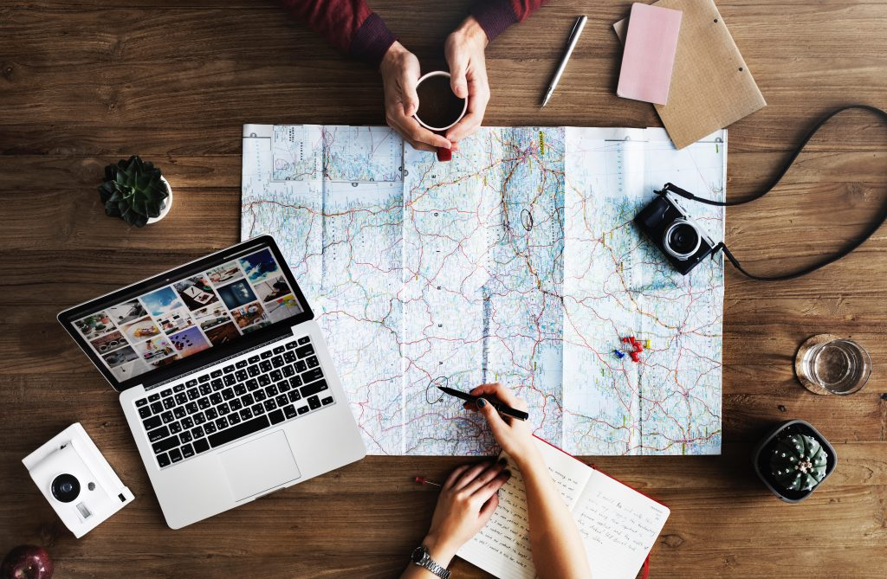**

**Important things you must do before International travel**

One of the best and exciting moment of life is international trip, it can be full of fun, history, and culture as well also be very stressful in the weeks and days leading up to your departure. From the big things like booking your flights and buying travel insurance, to all of the little things like calling your tour operator, bank and checking the weather forecast, there is a lot to cover.



If you don’t have a pre-travel checklist to reference, you might totally forget to do something important before you take off, which will mean more stress and less fun while you’re traveling. Nobody wants that!

This pre-travel checklist will help ensure that you’re totally ready to go when your departure date arrives. In this pre-travel checklist, you will find important things you must do before you travel out of the country!

**1. Buy travel insurance**

The most important and most overlooked thing you must do before you travel is purchase [travel insurance](http://www.travelalphas.com/WorldNomads)! The truth is, it can be hard to spend money on something you may not need after all. But in the event that something does happen, you will be so thankful that you have it.

While traveling, anything can go wrong — and if you travel enough, you can bet that something will. From unexpected cancellations or injuries, to stolen belongings and lost luggage, anything can happen.

To be blunt, it’s foolish not to invest in [travel insurance](http://www.travelalphas.com/WorldNomads) when it’s so affordable and easy to purchase. We highly recommend purchasing your travel insurance through [World Nomads](http://www.travelalphas.com/WorldNomads) because they offer great coverage, a quick and easy process, and come highly recommended by the likes of National Geographic and Lonely Planet.

**2. Apply for any necessary documentation**

Depending on the country you’re visiting, you may need to apply for a visa or some other special permission. Start researching this as soon as possible, since it could take weeks to finish the application process and obtain the proper documentation.

**3. Keep documents and money save**

Keep all the documents including visas, passports, travel insurance and money etc. safely in your luggage to avoid getting it stolen.

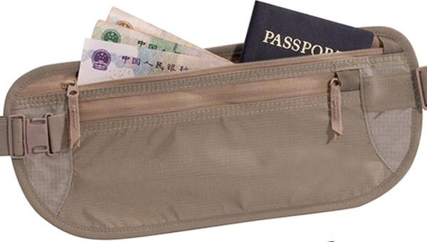

**Make copies of your passport**: If your passport gets stolen or lost, you will be thankful to have a couple of printed copies of your passport. This will make the process of getting a new passport much easier.

You should keep a copy in your carry-on, and a copy in your checked bag. It’s also a good idea to scan a copy of your passport and either email it to yourself or save it in your Google Drive.

Register with your embassy, if there’s a problem in the country, this will make it easier for your government to contact you and get you to safety.

**4. Call your doctor**

If you’re traveling to a faraway land, you may require vaccines and/or medications. Call your doctor or go in for an appointment to see if you’re good to go!

**5. Score a cheap flight**

Roughly three to six months before your trip, you should be on the lookout for flights, and ready to pounce when the price is right. We highly recommend searching on www.pimstourism.com for flights, as well as contact with other travel companies/agents or searching on online flights search engines.

**6. Book your accommodations**

A few months before you depart, you should also book your accommodations. We always find that the sooner you book, the cheaper and better they are! We always recommend tourism companies/travel agencies because Travel agencies provide the best and competitive price to the tourist. Travel agencies negotiate with suppliers of tourism product such as hotels and provide the best possible price to the tourist…Tourism companies provide best travel experience during a tour and having the best deals and options.

**7. Money**

1. **Make sure your credit card will work in the country you're visiting, Asian/**European banks have switched almost completely to the more secure chip-and-PIN technology, and fewer businesses abroad are accepting the outdated magnetic-strip cards.
2. **Always have local cash:** Not every place takes credit cards. Especially important places like trains or buses, museums etc.
3. **Get cash out:** When you travel, you should *always* have some emergency cash on you — whether in your currency or the local one.

You can’t predict when you’ll find yourself in a pinch, but you can bet that if you don’t have any cash, the situation could become much worse.

**8. Learn a few key phrases in the local language**

When you travel to another country, it’s always a good and courteous idea to learn some simple words for example,

**Pakistan National Language Urdu Glossary**

|  |  |  |
| --- | --- | --- |
| **English** |  | **Urdu Pronunciation** |
| Greeting (Peace be with you) | » | Salaam alay kum |
| Reply to Greeting (With you also be peace) | » | Waalay kum as salaam |
| How are you? | » | Aapka (or Tumhara) kya hal heyh? |
| I am well. | » | Theekh heyh or Theek thak. |
| What is your name? | » | Aapka (or Tumhara) naam kya heyh? |
| Do you speak English? | » | Kya aap angrezi boltay heyn? |
| I am Chinese | » | Meyn Chinese hun. |
| Which way to Lahore? | » | Lahore kiss taraf heyh? |
| How much is this/that? | » | Yeyh/Voh kitne ky heyh? |
| Thank you | » | Shukria. |
| Good Bye | » | Khoodha Haafiz. |
| Yes | » | Ji haan, haanji or haan |
| No | » | Naheen (na’en) |
| Okay/Good | » | Achhaa |
| When? | » | Kub? |
| Three O’clock | » | Teen bajay |
| Morning | » | Subha |
| Evening | » | Shaam |
| Go/going | » | Jao/Jaana |
| Near | » | Nazdeek |
| Far | » | Dur |
| Food | » | Khana |
| To eat food | » | Khana khana |
| To drink | » | Peena |
| Meat | » | Gosht |
| Beef | » | Gai ka gosht |
| Goat meat | » | Bakri ka gosht |
| Chicken | » | Murghi |
| Fish | » | Machii/machhlii |
| Egg | » | Anda |
| Vegetable | » | Subzi |
| Potato | » | Aalu |
| Spinach | » | Palak |
| Lentils | » | Daal |
| Rice | » | Chavel |
| Bread | » | Roti, naan, chapati |
| Baked bread | » | Double roti |
| Yoghurt | » | Dahi |
| Water | » | Pani |
| Tea | » | Chai |
| Salt | » | Namak |
| Sugar | » | Cheeni |
| Home/house | » | Ghar/makaan |
| Bed | » | Palang, charpai |
| Blanket | » | Kambal |
| Pillow | » | Takya |
| Sheet | » | Chader |
| Fan | » | Pankha |
| Candle | » | Mombutti |
| Hot | » | Garam |
| Cold | » | Thanda (m)/thandi (f) |
| Small | » | Chhota (m)/chhoti (f) |
| Big | » | Burha (m)/burhi (f) |
| Clean | » | Saaf |
| Expensive | » | Mehenga |

Most often, local people will appreciate your efforts to speak their language, even if you only know how to say a few words!

**9. Read up on the local customs & etiquette**

Before you visit somewhere new and especially somewhere very different than your country you should do plenty of research on the local customs and etiquette.

You should always research things like how to dress, how to greet people, the dining and drinking etiquette, In case you are visiting though Tourism Company, you must learn all “local customs & etiquette of the country where you are visiting.

**10. Get an international driver’s license**

If you plan to rent a car, scooter, and other motorized vehicle while you’re abroad, you may need to get an international driver’s license.

Requirements vary from country to country, so make sure to do your research well in advance or ask the roles and regulations of the country from your travel agency.

**11. Plan a rough itinerary**

When planning a trip, the last thing you want to do is schedule your vacation time down to the minutes. For example at 10:00 AM we eat breakfast, at 10:30 AM we go shopping, at 11:30 AM we take a walking tour. But on the other side of the spectrum, you also don’t want to go in blind, without any sort of plan at all.

Before your trip, do some research on what you’d like to do in each place, and then make a rough itinerary? That way, you’ll leave room for serendipity, while also including all of the important, can’t-miss bits.

If you are going through expert travel agencies than just enjoy your trip they will responsible for your trip and planning, they will better facilitate you.

**12. Research events going on while you’re there**

This will help you make sure that you’re not missing the best events going on in the city -- fun things like festivals, ceremonies and natural events. Also be sure to research as a few national dishes to try. You don’t want to leave the country without experiencing what its known for.

**13. Do restaurant research**

As you all know, food is one of our main reasons for traveling, so of course we do tons of restaurant research before we go! If you are traveling through travel agency than no need of tension otherwise we recommend combination of travel blogs, Yelp, Foursquare, Google Reviews, and [TripAdvisor](http://www.travelalphas.com/TripAdvisorHomepage" \t "_blank) to find potential restaurants and cross-check them.

**14. Let someone know that you’re traveling**

**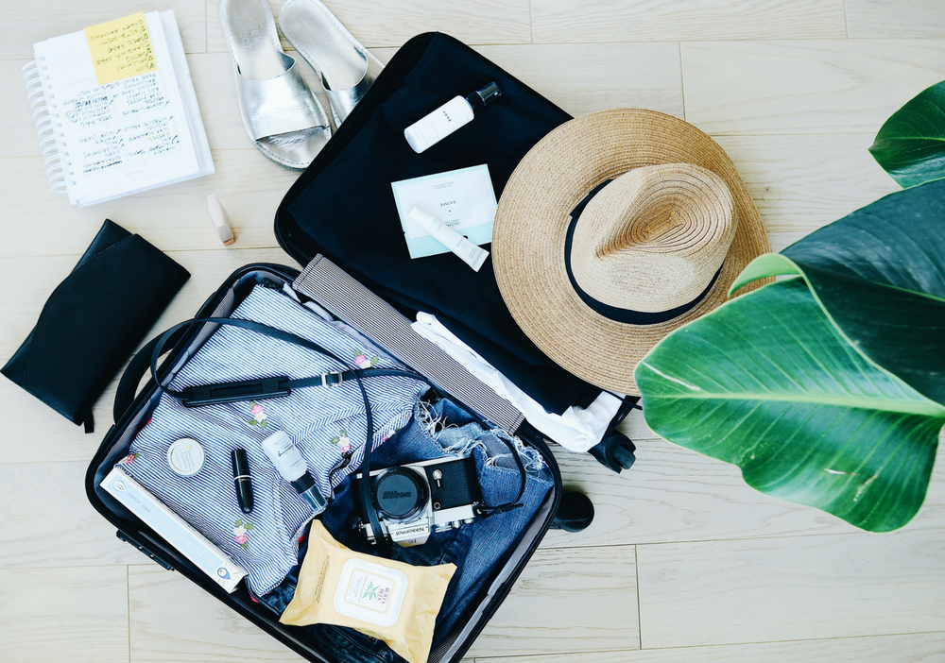**

Before you go, you should tell someone you trust about your plans, and if possible, give them a copy of your entire itinerary.

That way, in case of any emergency, you can be accounted for much easier.

**15. Gather up all of your confirmations**

Whether you prefer to print out all of your flight itineraries, accommodation confirmations, transportation tickets, etc. or to keep them in a file online, it’s important to get organized.

You should have all of your confirmations in one easily accessible place. You never know when you will need to reference them, or when a government official might demand to see them!

**16. Check the weather forecast**

Before you start packing for your trip, make sure you check the weather forecast. Just because somewhere — like Pakistan, for example — has pretty consistent weather, it does not mean it can’t change.

If you rely on what you think you know about a place’s climate and weather patterns, you could be caught by surprise.

**17. Get an adapter & a converter**

1. **Bring a charger adapter.** Countries have different size plugs and voltage. Throughout the world, there are all different shapes of wall outlets, which means you need [an adapter](http://rstyle.me/n/ctbnz2b2r67) with the properly configured prongs to then plug your devices into.
2. **Check the voltage of your electronics.** As our experience, nothing is worse than having an adapter and still not being able to use a blow-dryer or a straightener because the voltage isn’t high enough for that country.
3. **Activate your phone’s global capabilities.** There's usually a charge for doing this, but it is much less than the roaming charges you’ll get if you don’t.

**18. Figure out your transportation to & from the airport**

Will you call or cab or use a ride-hail app? Will a friend or family member take and pick you up?

At least a few days before your departure, you should have a plan for getting to and from the airport to make sure your trip starts off smoothly. Travel Agency can also provide transport service for your whole trip or just pick and drop from airport another, option of pick and drop from airport is your hotel where you will be stay, most of the hotels have pick and drop facility.

**19. Plan your transportation to your accommodation**

There’s nothing worse than arriving in a foreign place where you don’t speak the language, exhausted from hours and hours of traveling, and not knowing where to go.

Before you depart, do research on where exactly your accommodation is, and what the easiest (or cheapest) way to get there is. Depending on where you’re going, you should look into trains, shuttles, buses, ride-hail apps, taxis, and even boats. That way, you’ll have everything figured out when you finally arrive.

We will recommend tourism companies for local transpiration they will give better support.

**20. Star places on Google Maps**

Out of the thousands of travel apps out there, I think the most useful one is [Google Maps](https://itunes.apple.com/us/app/google-maps-gps-navigation/id585027354?mt=8). Before you go anywhere, you can open up the app, and star (save) all of the places you know you can go, your hotels, restaurants, tour meeting points, etc.

These stars (and your exact current location) always show up in the app, whether you have service/wifi or not. This makes navigation an absolute breeze.

**21. Get your house ready for your departure**

Before you leave, you don’t want to forget the little things like taking out the trash, throwing out perishable food, and locking everything up.

**22. Join the Smart Traveler Enrollment Program (STEP)**

For American citizens STEP is a free service for American citizens and nationals which provides important alerts and warnings about the safety conditions in your destination(s). STEP also helps the US Embassy, friends, and family contact you in case of an emergency.

Many other countries also offer these services. If you’re not from the US, check your government’s travel-related website to see if you can register your trip, too or contact your travel agency for guidance.

**23. Luggage & packing**

1. **To check a bag or not to check bag.**Each airline has its own set of guidelines as to how many bags can be checked or carried on for free. Make sure to look up what your airline’s rules are to avoid any incremental fees. And, if you are connecting during your trip, know the luggage rules/fees for those airlines as well -- especially for regional or low-cost carriers.
2. **Bring snacks.** Traveling abroad is fun, but eating in a foreign country can sometimes become a task. Bring small snacks that will tide you over until you find that perfect restaurant or food cart.

**24. Role of Tourism Companies/Travel Agencies**

1. **Key role:** Last but very import “Role of Tourism Companies/Travel Agencies”, for informative and historical trip we will recommend tour with tourism companies/travel agencies because tourism companies/travel agencies play a key role in the tourism sector. Travel agencies create tourist product, sold them with best services.
2. **Best and competitive price to the tourist:** Travel agencies provide the best and competitive price to the tourist. Tour operators negotiate with suppliers of tourism product such as hotels, airlines and provide the best possible price to the tourist. Tour operators buy tourist product in bulk and get huge discounts from suppliers. So that they provide tourist products at cheap price.
3. **Tour operators save tourist’s times and money:** Tour operators organized a tour in the best way. They personalize and make sure each and every component of the tour is well-taken care. Tour operators provide best travel experience during a tour. Tour operators save tourist’s times and money.
4. **Immediate and best support system to tourists at host country:** Travel agencies provide immediate support system at host country as well as foreign land. When tourists travel to a foreign land and things get uncertain, maybe it’s a health or loss of documents and need to return back or change of travel plan. A qualified travel agencies takes care of all these unseen events with efficiency.

In simple words tourism companies/travel agencies caters to the needs of tourists on the based on their taste of travel and provides all the best available option according to tourist needs and demands.

