**C:\Users\Gull\Desktop\LOGO1_tnr_g.png**

**Transportation Facility**

**Transportation** is an integral part of the **tourism industry**. It is largely due to the improvement of **transportation** that **tourism** has expanded. **Transportation** links the various destinations and ferries people, goods, and services. **Tourism** is all about travel; and the **role of transportation** in its operation is vital So, We have a fleet of vehicles including various chauffeur driven cars, Hi-roof, coasters and coaches/Buses to cater to the varied needs of different tourists. You may hire from among a large variety of luxurious and economic Cars, Hi-roof, Coasters etc,. All of these are well maintained to give you a comfortable ride. If your group is a large one, we can arrange coaches. The coaches that seat various number of persons. There are air-conditioned and non-air-conditioned vehicles to suit various needs and budgets. All the services are looked after by our experienced staff and you will experience the best in hospitality.

We seek to deliver a better tomorrow as a trusted partner to our clients.

**We offer series of the following Transept facility:**

1. **Car**
2. **HI-roof Toyota (12 Seater)**
3. **Coaster Saloon (22 Seater)**
4. **Land Cruiser**
5. **APV (For family 7 Seater)**
6. **BR-V (6 Seater)**
7. **Jeep Safari**

|  |  |  |  |  |  |
| --- | --- | --- | --- | --- | --- |
| **We have Car / Coach Rental in Following Cities** | | | | | |
| **KP** | **PUNJAB** | **Sindh** | **Balochistan** | **AJK** | **Gilgit Baltistan** |
| Peshawar | Islamabad | [Karachi](https://en.wikipedia.org/wiki/Karachi_Division) | [Quetta](https://en.wikipedia.org/wiki/Quetta_Division) | [Mirpur](https://en.wikipedia.org/wiki/Mirpur_Division) | [Gilgit](https://en.wikipedia.org/wiki/Gilgit_Division) |
| Swat | Lahore | [Hyderabad](https://en.wikipedia.org/wiki/Hyderabad_Division) | [Kalat](https://en.wikipedia.org/wiki/Kalat_Division) | [Muzaffarabad](https://en.wikipedia.org/wiki/Muzaffarabad_Division) | Skardu |
| Chitral | Multan | [Sukkur](https://en.wikipedia.org/wiki/Sukkur_Division) | [Makran](https://en.wikipedia.org/wiki/Makran_Division) | [Poonch](https://en.wikipedia.org/wiki/Poonch_Division) | Hunza |
| Abbottabad | Faisalabad | [Larkana](https://en.wikipedia.org/wiki/Larkana_Division) | [Naseerabad](https://en.wikipedia.org/wiki/Nasirabad_Division) | [Rawalakot](https://en.wikipedia.org/wiki/Rawalakot) |  |
| Mansehra | Bahawalpur | [Mirpur Khas](https://en.wikipedia.org/wiki/Mirpur_Khas_Division) | [Sibi](https://en.wikipedia.org/wiki/Sibi_Division) |  |  |
| Haripur | [Sahiwal](https://en.wikipedia.org/wiki/Sahiwal_Division) | [Shaheed Benazirabad](https://en.wikipedia.org/wiki/Shaheed_Benazirabad_Division) | [Zhob](https://en.wikipedia.org/wiki/Zhob_Division) |  |  |

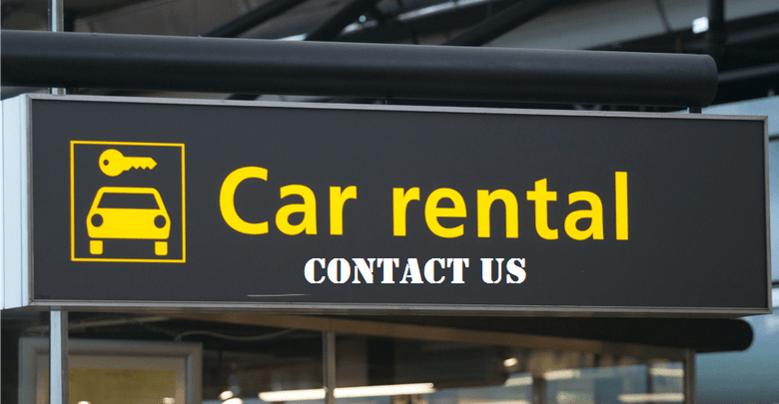

**Email id:** [**car.booking@pimstourism.com**](mailto:car.booking@pimstourism.com)

**Contact No**. +923469092937/+923018142726