**Cyber Combat 3 D**

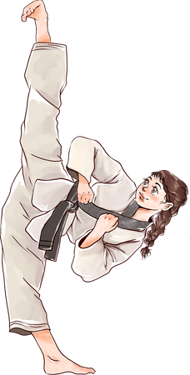

**Certificate of MMA**

T H E F O L L O W I N G A W A R D I S G I V E N T O

{Name Surname}

This certificate is awarded for outstanding dedication and exceptional achievement in the art of [Martial Art Style], showcasing unparalleled discipline, skill, and perseverance.



**Expert Trainer**