Final Solution

Contents

Introduction 1

Javascript 1

React Native Core Components 5

React Navigation 9

Fire store 10

# Introduction

Q1 : Write a drawback of mobile application.

* Many Apps invade the privacy of people when requesting access to the person's location and their photos.
* Depending on the characteristics of your Hardware you will have certain restrictions.
* Depending on the type of development you want to make these applications can be expensive.

Q.2: Differentiate between native and hybrid apps

Native apps are developed specifically for a particular platform, such as iOS or Android, using the platform's native programming languages and tools. They have full access to all of the device's features and can take advantage of the latest platform-specific capabilities. They are usually faster and more responsive than hybrid apps.

Hybrid apps, on the other hand, are developed using web technologies such as HTML, CSS, and JavaScript and are wrapped inside a native container. They are essentially a combination of a web app and a native app. They can be run on multiple platforms with one codebase, which makes them more cost-effective and easier to maintain than native apps.

# Javascript

Question: Create a javascript class Person with attributes: id, name, age.

* Derive two classes from person, named Student and Teacher. The extra attributes of Student are cgpa, currently enrolled semester (e.g., FA22 or SP22, etc), admission date. The extra attributes of Teacher are salary, designation (Lecturer, Assistant Professor, Professor, etc), department, and joining date.
* Populate at least 3 records in each class use class objects.
* A user should be able to search a student or teacher with the provided ID. To manage that you should store objects of Teacher and Student in an array.

class Person {

    constructor(*id*, *name*, *age*) {

        this.id = *id*;

        this.name = *name*;

        this.age = *age*;

    }

}

class Student extends Person {

    constructor(*id*, *name*, *age*, *cgpa*, *semester*, *admissionDate*) {

*super*(*id*, *name*, *age*);

        this.cgpa = *cgpa*;

        this.semester = *semester*;

        this.admissionDate = *admissionDate*;

    }

}

class Teacher extends Person {

    constructor(*id*, *name*, *age*, *salary*, *designation*, *department*, *joiningDate*) {

*super*(*id*, *name*, *age*);

        this.salary = *salary*;

        this.designation = *designation*;

        this.department = *department*;

        this.joiningDate = *joiningDate*;

    }

}

const allPersons = [];

const student1 = new Student(1, "John Smith", 22, 3.8, "FA22", "01/01/2022");

const student2 = new Student(2, "Jane Doe", 21, 3.5, "SP22", "01/08/2021");

const student3 = new Student(3, "Bob Smith", 20, 3.2, "FA21", "01/01/2021");

allPersons.push(student1, student2, student3);

const teacher1 = new Teacher(4, "Dr. Michael", 45, 75000, "Assistant Professor", "Computer Science", "01/01/2010");

const teacher2 = new Teacher(5, "Dr. Sarah", 40, 80000, "Professor", "Math", "01/01/2015");

const teacher3 = new Teacher(6, "Dr. David", 35, 65000, "Lecturer", "Physics", "01/01/2020");

function searchPerson(*id*) {

    for (let person of allPersons) {

        if (person.id === *id*) {

            return person;

        }

    }

    return "No Person Found";

}

console.log(searchPerson(2)); *//Will return student2 object*

console.log(searchPerson(5)); *//Will return teacher2 object*

Write arrow functions for the following equations:

𝐴 = 𝑥 ^2 + 2𝑥𝑦 + 𝑃. 𝑧

𝐴 = 𝑛 ^2 + 𝑞𝑛 + 1

Z = x ^2 + 4y^2 – 8y + 2x

const A = (*p*,*x*, *y*, *z*) => (*x*\*\*2)+2\**x*\**y*+(*p*\**z*)

const A = (*n*, *q*) => *n*\*\*2+ *q*\**n* + 1;

const Z = (*x*, *y*) => *x*\*\*2+ 4*(*y*\*\*2) - 8\**y* + 2\**x*;

Suppose the equation is:

Z = x^2 + 4y^2 – 8N + 2x Where N

is represented by a separate equation:

N = p^2z + rq^2 + s

Solve ‘Z’ with arrow function. Note, here you are calling an arrow function within an arrow function.

const Z = (*x*, *y*, *p*, *q*, *r*, *s*) => {

    const N = (*p*, *q*, *r*, *s*) => *p*\*\*2*z + *r*\**q*\*\*2 + *s*;

    return *x*\*\*2 + 4\**y*\*\*2 - 8*N(*p*, *q*, *r*, *s*) + 2\**x*;

  }

Question

Suppose you have the following array of objects, var myarray: [ {‘name‘: ‘ali’, ‘age’:’45’}, {‘name’:’noman’, ‘age’:’34’}] Display the values of array using map function.

var myarray = [{'name': 'ali', 'age': '45'}, {'name': 'noman', 'age': '34'}];

myarray.map((*obj*) => console.log(*obj*.name, *obj*.age));

Question Suppose we have an object const myObject1 = { name: 'Devin', hairColor: 'brown' } Write code to change value of hairColor using spread syntax (…) three dots.

const myObject1 = { name: 'Devin', hairColor: 'brown' };

const newObject = { ...myObject1, hairColor: 'black' };

console.log(newObject); *// Outputs: { name: 'Devin', hairColor: 'black' }*



Write an example of defining an arrow function within another arrow function.

const outerFunction = (*num1*) => {

    const innerFunction = (*num2*) => {

        return *num1* + *num2*;

    }

    return innerFunction;

}

let result = outerFunction(5);

console.log(result(10)); *//15*

# React Native Core Components

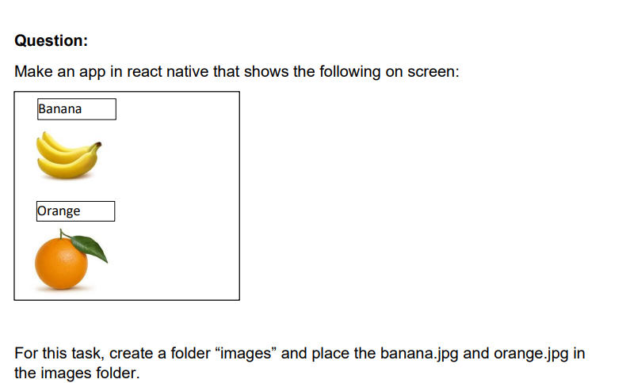

<https://snack.expo.dev/@armohsin_dev/c35d3e>

Write a function component to show grade of a student for the given marks. The marks are provided to a javascript arrow function as argument, e.g., calculateGrade(marks) which is called in the of function component. Here is the grade distribution:

< 50 --- F

>= 50 and < 60 --- E

>= 60 and < 70 --- D

>= 70 and < 80 --- C

>= 80 and < 90 --- B

>= 90 --- A

https://snack.expo.dev/@armohsin_dev/f46423

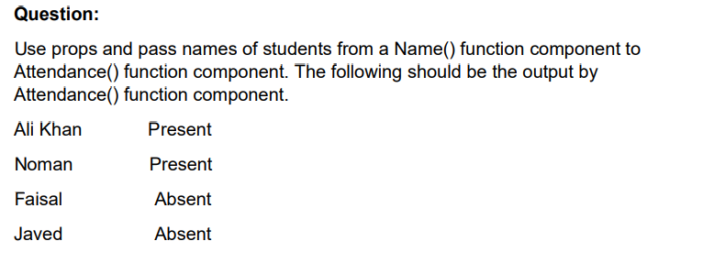

<https://snack.expo.dev/@armohsin_dev/q>

Write code to add a button in React Native. The text showing in the button should be Click Here. When the button is clicked, an alert dialog should be shown with message “hello world”.

<https://snack.expo.dev/@armohsin_dev/biased-raisins>

Write the code of App function. When a user enters any text in the TextInput, it is also automatically written in another TextInput.

<https://snack.expo.dev/@armohsin_dev/spunky-churros>

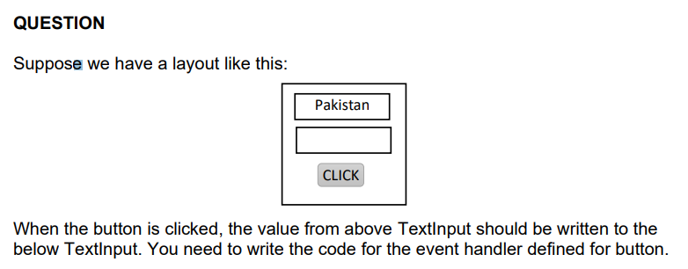

https://snack.expo.dev/@armohsin_dev/graceful-churros

When the button is clicked, the message in the TextInput should display in a dialog. Write code for event handler of button.

<https://snack.expo.dev/@armohsin_dev/amused-cashew>

Create a simple registration page in react native asking for users username, email, name, and cell number. When the user click on register button, the information should be shown using elements. However, if any input is missing, message should be shown about the missing element.

<https://snack.expo.dev/@armohsin_dev/juicy-cookie>

Use the class component to do the following: Create a simple registration page in react native asking for users username, email, name, and cell number. When the user click on register button, the information should be shown using elements. However, if any input is missing, message should be shown about the missing element.

YET TO SOLVE

Suppose that you have a string defined in strings.js. The name of the string is country_name and value is “Pakistan”. Write a program that shows the value of string in your app function. (You need to import the string from strings.js)

<https://snack.expo.dev/@armohsin_dev/groaning-ice-cream>

Suppose you have two TextInputs, each containing a number, and a button to add the values of the two TextInputs. When the button is clicked, the values of the TextInputs are added and result should be shown in console.

<https://snack.expo.dev/@armohsin_dev/calm-pretzel>

The following layout has three number buttons, a plus and equal operator, and a TextInput initialized with a zero “0”. The user should be able to enter a string of numbers like 12232213. The user need to enter a number, click on + operator, and then input another number. When user click on equal, the result of sum should display in TextInput (Hint: Check eval method of javascript).

https://snack.expo.dev/@armohsin_dev/9f176d

Suppose we have a predefined function that has following prototype: function GetComputerChoice().When this function is called in a button click event, it returns either “fire”, “wood”, or “water”. In the same button click event, a random number is generated from 1 to 3, such that if 1 is generated, this means, the user gets “fire”, if 2 is generated, the user gets “wood”, and if 3 is generated, the user gets “water”. You need to check against the button click event that which of the computer or user has WON. Show name of winner in alert. NOTE: Wood > Water; Water > Fire; Fire > Wood

YET TO SOLVE

Suppose you want to build a game in which a user either can press fire or wood, and then a random choice is generated for computer. The player that gets fire is the winner. Write the code of the program. In case both user and computer get same value, it will be a draw.

https://snack.expo.dev/@armohsin_dev/1d027c

Suppose we have data in this format:

v

Write code to show the above array of objects in a flatlist

<https://snack.expo.dev/@armohsin_dev/5c8314>

You have a layout as given in the following. You need to write a “single method” for all the three buttons. The prototype of method is: function button_Click(). In this method, you need to get the text of the button clicked. If the text is matching with the string “ISLAMABAD”, the should be assigned value ISLAMABAD, otherwise it remains blank

Yet to solve

# React Navigation

Write code that launches a screen Display from Home screen. Send two numbers from Home to Display, where they should be shown in .

https://snack.expo.dev/@armohsin_dev/318a50

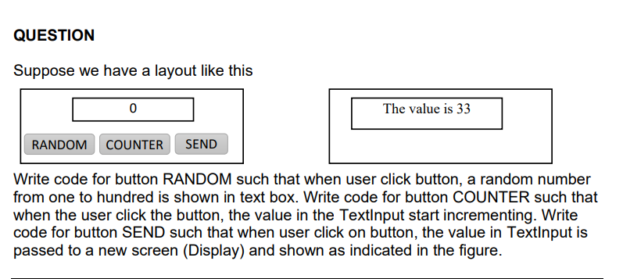

<https://snack.expo.dev/@armohsin_dev/lonely-waffle>

When the user click on button in Home screen, the both strings in TextInputs should be passed separately to the Display screen where they are shown as concatenated string in display function of Display screen.

<https://snack.expo.dev/@armohsin_dev/laughing-cheese>

Pass a number from 1 to 3 from the Home screen to the Display screen. In the Display screen, check which of the number is received, and then write the number words. For example, you passed 3 from Home screen, and in Display screen, you will print “three” as shown below

<https://snack.expo.dev/@armohsin_dev/95b271>

# Fire store

const deleteDocument = (*id*) => {

*// Get a reference to the document by ID*

    const docRef = db.collection("collection").doc(*id*);

*// Delete the document*

    docRef.delete()

}

import { doc, setDoc } from "firebase/firestore";

*// Add a new document in collection "persons"*

await setDoc(doc(db, "persons", "20"), {

  name: "Ali",

  address: "Supply Pakistan"

});

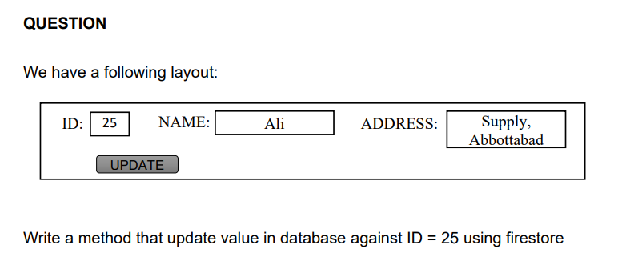

import { doc, setDoc } from "firebase/firestore";

*// Updating a document in collection "persons"*

await updateDoc(doc(db, "persons", "25"), {

  name: "Ali",

  address: "Supply Pakistan"

});

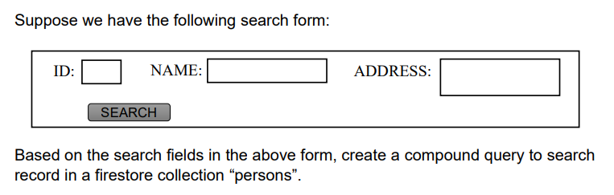

NOT YET SOLVED

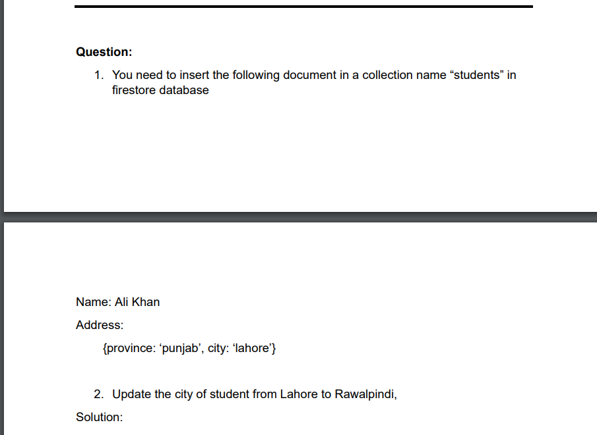

import { doc, setDoc } from "firebase/firestore";

await setDoc(doc(db, "students"), {

  name: "Ali Khan",

  address: {province: 'punjab', city: 'lahore'}

});

await updateDoc(doc(doc,"students"),{

    "address.city":"Rawalpindi"

})

You have a cities collection in firestore database. You need to select cities using compound query such that state of city is ABC, country is PQR, and population is greater than 1000. You need to fetch record from 100th row and select the next 50 records

Not solved yet

# ASYNCHRONOUS

Write a program to store the following object using AsyncStorage. The name of key is @data, and the object is {‘name’:’Ali’, ‘Age’:’45}

import { AsyncStorage } from 'react-native';

const saveData = async () => {

  try {

    await AsyncStorage.setItem('@data', JSON.stringify({ name: 'Ali', age: '45' }));

  } catch (error) {

    console.log(error);

  }

};

Suppose you have used Context API in your code to maintain global storage. Give an example, how you will retrieve the values stored in context variable in some screen, e.g., you want to retrieve values of name, age, city. Show the code

Here's an example of how you can retrieve values stored in a context variable using the useContext hook in a screen:

First, create a new file named context.js and define your context in it.

Copy code

import { createContext } from 'react';

export const Context = createContext({

name: '',

age: '',

city: ''

});

In the root component, you will wrap your entire application in the Context.Provider component and set the values of the context.

Copy code

import { Context } from './context';

const App = () => {

const contextValue = { name: 'John', age: '30', city: 'New York' };

return (

<Context.Provider value={contextValue}>

{/* Your app components go here */}

</Context.Provider>

);

};

In the screen where you want to retrieve the values, you can use the useContext hook to access the values.

Copy code

import { Context } from './context';

const DisplayScreen = () => {

const { name, age, city } = useContext(Context);

return (

<View>

<Text>Name: {name}</Text>

<Text>Age: {age}</Text>

<Text>City: {city}</Text>

</View>

);

};

This way, you can access the values of name, age and city stored in the context variable in any component that is wrapped in the provider.

Please note that, context is a feature that allows you to share values like these between components without having to explicitly pass a prop through every level of the component tree.

**Suppose you have a users table in mysql database. Write a react native function to retrieve all records from the users table using PHP. (You don’t need to write the PHP part).**

import axios from 'axios';

const retrieveUsers = async () => {

try {

const response = await axios.get('http://your-server-url/retrieve-users.php');

const users = response.data;

console.log(users);

} catch (error) {

console.log(error);

}

};

In this example, the retrieveUsers function makes a GET request to a PHP script named retrieve-users.php using the axios library. The PHP script should be responsible for querying the MySQL database to retrieve all records from the users table. The response data containing the users will be logged in the console.

You can call this function whenever you want to retrieve the data.

It's important to note that this code assumes that you have a PHP script setup on a server that can handle this request and also has the necessary connection to the MySQL database and the correct query to retrieve data from the users table. It also assumes that you have the correct url of the server and the correct endpoint where the PHP script is located.

Also, keep in mind that you should take care of the security of your server and the data that is being sent and received. It is highly recommended to use HTTPS and encrypt sensitive data.