**NMEA0183输出协议列表:**

|  |  |  |  |
| --- | --- | --- | --- |
| **序号** | **命令** | **说明** | **备注** |
| 1 | $GPGGA | 全球定位数据 | 标准NMEA0183 |
| 2 | $GPGSA | 卫星PRN数据 | 标准NMEA0183 |
| 3 | $GPGSV | 卫星状态信息 | 标准NMEA0183 |
| 4 | $GPRMC | 运输定位数据 | 标准NMEA0183 |

1. **GGA 定位结果**

|  |
| --- |
| Example: |
| $GPGGA,135324.00,5106.9791988,N,11402.3002127,W,2,09,1.0,1047.606,M,,,04,AAAA*1C |

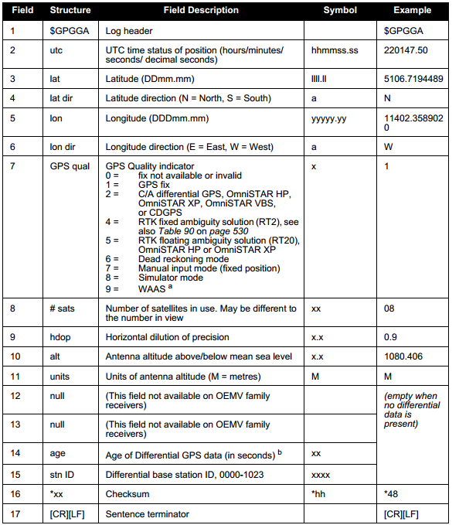

GPS状态模式

|  |  |
| --- | --- |
| GPS状态模式 | 描述 |
| 0 | 无效解 |
| 1 | 单点定位解 |
| 2 | 伪距差分解 |
| 4 | RTK 固定解 |
| 5 | RTK 浮点解 |
| 6 | 航迹推算模式 |
| 7 | 用户设定位置（Fixed Position） |
| 8 | 模拟器模式 |
| 9 | WAAS |

1. **GSA卫星PRN数据**

|  |
| --- |
| Example: |
| $GPGSA,M,3,17,02,30,04,05,10,09,06,31,12,,,1.2,0.8,0.9*35 |

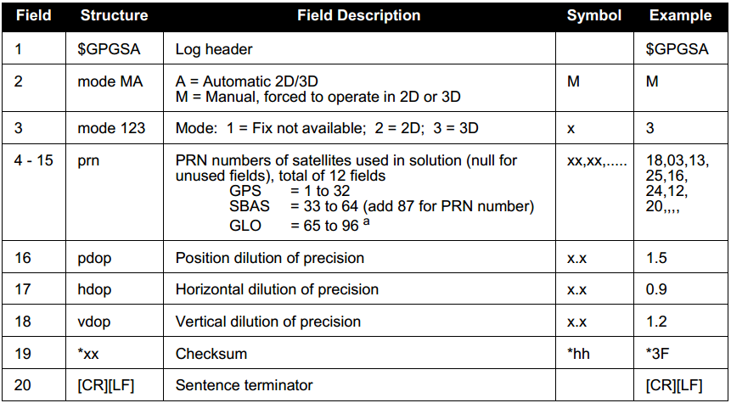

1. **GSV卫星状态数据**

|  |
| --- |
| Example: |
| $GPGSV,3,1,8,18,87,050,48,22,56,250,49,21,55,122,49,03,40,284,47*78  $GPGSV,3,2,11,19,25,314,42,26,24,044,42,24,16,118,43,29,15,039,42*7E |

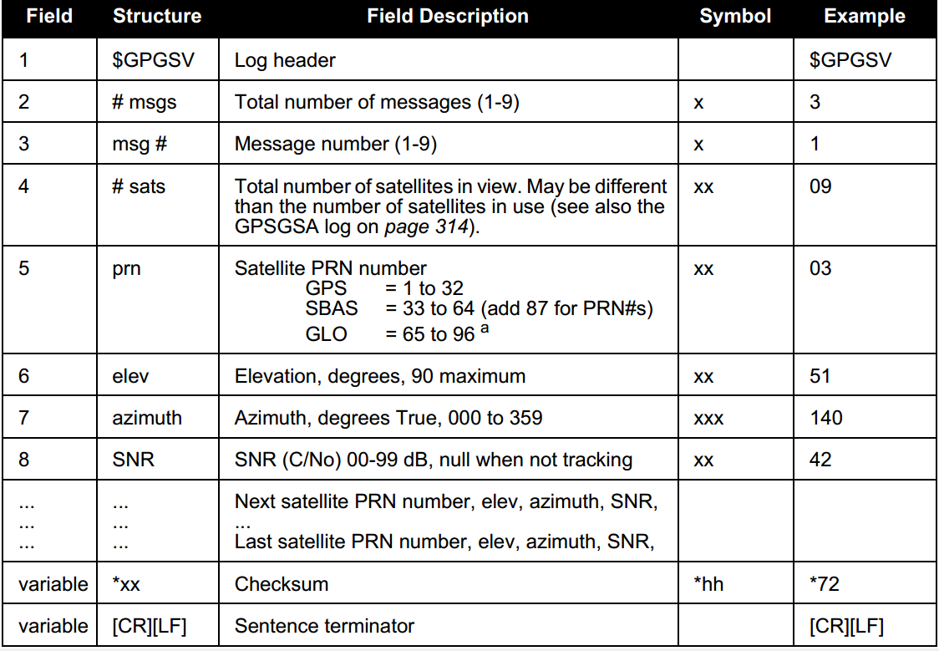

1. **RMC运输定位数据**

|  |
| --- |
| Example: |
| $GPRMC,144326.00,A,5107.0017737,N,11402.3291611,W,0.080,323.3,210307,0.0,E,A*20 |

