3dRNAscore: a distance and torsion angle dependent evaluation function of three-dimensional RNA structures
Jian Wang*, Yunjie Zhao*, Chunyan Zhu and Yi Xiao†

Biomolecular Physics and Modeling Group, Department of Physics and Key Laboratory of Molecular Biophysics of the Ministry of Education,

Huazhong University of Science and Technology, Wuhan 430074, Hubei, China

*These authors made equal contributions.
†Corresponding author (email: yxiao@hust.edu.cn).

Abstract
Model evaluation is a necessary step for better prediction and design of three-dimensional RNA structures. For proteins, this has been widely studied and the knowledge-based statistical potential has been proved to be one of effective ways to solve this problem. Currently, a few knowledge-based statistical potentials have also been proposed to evaluate predicted models of RNA tertiary structures. The benchmark tests showed that they can identify the native structures effectively but further improvements are needed to identify near-native structures and those with non-canonical base pairs. Here we present a novel knowledge-based potential, 3dRNAscore, which combines distance-dependent and dihedral-dependent energies. The benchmarks on different testing datasets all show that 3dRNAscore are more efficient than existing evaluation methods in recognizing native state from a pool of near-native states of RNAs as well as in ranking near-native states of RNA models.

AVAILABILITY: http://biophy.hust.edu.cn/download.html

Introduction
RNA molecules play different biological roles besides messengers between DNA and protein (1,2), e.g., regulatory functions (3). Like proteins, the three-dimensional structural information is needed for better understanding of the functions of RNAs. Since the number of available RNA experimental structures is very limited at present, several computational methods have been proposed for structural modeling or RNA tertiary structures prediction (4-13). These methods usually generate a large set of candidates that need to be evaluated.
Knowledge-based statistical potential has been proved to be a powerful approach for evaluating models of protein tertiary structures (14-16). Currently, some knowledge-based potentials have also been proposed to evaluate models of RNA tertiary structures (17-21). For examples, the Ribonucleic Acids Statistical Potential (RASP) developed by Capriotti et al. (17,19) and the coarse-grained and all-atom RNA KB potentials by Bernauer et al. (18). The all-atom version of RASP, RASP-ALL, is a distance-dependent statistical potential with 23 clustered atom types and is trained on a non-redundant training set (randstr) generated by MODELLER (22). The RNA KB potentials are also distance-dependent statistical potentials. In the coarse-grained version of RNA KB potential, five atoms (P, C4’ in backbone, and C2, C4, C6 in base) are selected to represent the nucleotide. In the all-atom version of RNA KB potential, unlike RASP in which the atom types are clustered, the atom types in different nucleotides are considered to be different, so totally 85 atom types are considered rather than 23 atom types used in RASP-ALL. Furthermore, The RNA KB potentials used a Dirichlet process mixture model to obtain the distance distributions instead of bin counting (23). The fully differentiable feature also makes it possible for molecular dynamics simulations. The benchmark tests showed that the RASP and KB potentials could identify the native state structures effectively (17,18). However, further improvements are needed to rank near-native structures and pick out the structure closest to the native state from near-native structures including those with non-canonical base pairs, which is important in the prediction of RNA tertiary structures. Besides, there are other statistical potentials for evaluating RNA tertiary structures embedded in the RNA tertiary structure prediction programs and they have been compared in the ref. (17). For example, a full atom RNA potential (FARFAR, fragment assembly of RNA with full-atom refinement) available within the ROSETTA suite was successfully used for the de novo prediction and design of non-canonical RNA 3D structures (6,11). This full-atom potential contains weak carbon hydrogen bonding and solvation terms, as well as a complete description for potential hydrogen bonds between bases and backbone oxygen atoms.
In this work, we introduce a novel all-heavy-atom knowledge-based statistical potential, 3dRNAscore, to evaluate the 3D structure of RNA. Unlike the aforementioned two knowledge-based potentials that utilize the distances between atoms, a new energy contribution based on backbone torsion angle (dihedral) is involved in 3dRNAscore. The dihedral-based energy can describe the flexibility of RNA molecules more efficiently (24,25). Furthermore, we also consider the RNA stacking interactions in adjacent bases in the calculation of the distance-based energy of 3dRNAscore. It turns out that 3dRNAscore performs better than RASP and KB potentials in identifying RNA native structures from a pool of structural decoys as well as ranking a tremendous amount of near-native RNA tertiary structures.

Methods
The steps for building 3dRNAscore (Figure 1) are as follows. Firstly, we design the functional form of 3dRNAscore from Boltzmann distribution, which contains two energy terms: the distance-dependent energy and the backbone dihedral-dependent energy. Secondly, in order to train the parameters in the scoring function, we select a training set of non-redundant RNA tertiary structures in which the structures having high similarity and those having similar sub-motifs with the structures in the test sets are removed. Using the training set, we determine the parameters in the scoring function. Thirdly, we use the test sets to test the performance of 3dRNAscore. Here, we select three existing test sets. We use different metrics to compare the performance of 3dRNAscore with other scoring methods. The detail of each building step of 3dRNAscore is described in the following.

Distance-dependent energy
Our knowledge-based potential 3dRNAscore is composed of two parts: the first part is based on distance between any two non-bonded heavy atoms located at different residues in the molecule, and the second part is based on the backbone torsion angles. Among them, the distance-dependent part is constructed as a mean force potential (26) derived from Boltzmann distribution.
Samudrala (27) pointed out that three assumptions underlie the mean force potential scoring method. The first assumption is that the total free energy of a molecule relative to some reference state, 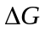, can be expressed as a sum of the relative free energy 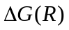 of a number of individual contributions, where R represents the value of a “reaction coordinate”. The reaction coordinate may be any convenient measure of properties of the molecule. When using the distance d between atoms i and j of types a and b as the reaction coordinate, the assumption can be expressed as:
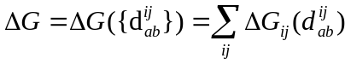
The second assumption is that the relative free energy can be deduced from the inverse of Boltzmann’s law:
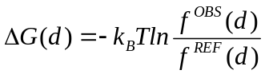
Substituting equation into equation , we have:
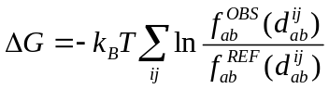
where T is the absolute temperature and is set to 298K, 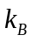is the Boltzmann’s constant, 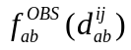 is the observed probability of the distance of 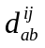 between two atoms of types a and b in native RNA structures and 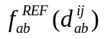 is the probability of the distance between two atoms of a and b in reference state structures.
The third assumption is the thermodynamic hypothesis (28): the lowest free energy conformation represents the native state. The equation thus is useful for addressing the issue of ranking near-native structures.
The probability could be evaluated with the number of occurrence observed in experimental structures:
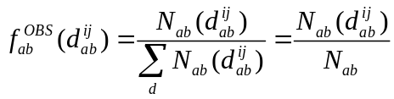
The probability could not be compiled from experimental structures directly. It relies on which reference state we choose. The RASP (17) and KB (18) potentials used averaged (RAPDF) (27) and quasi-chemical (KBP) (29) approximation reference states, respectively (30). These reference states consider covalent-bond constraints between atoms when counting the number of atom pair distances and usually need larger datasets of experimental RNA structures to obtain accurate potentials. In the average reference state, is evaluated by ignoring the type of atoms:
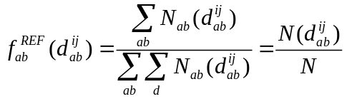
Equation could then be expanded by substituting equation and to it:
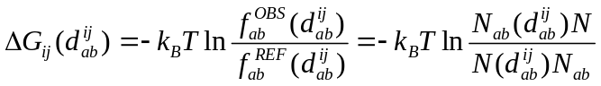
where 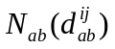 is the counts of the occurrence of the distance of d between two atoms of types a and b. N is the total counts. 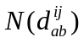 is the counts of the occurrence of the distance d regardless of atom types. 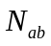 is the counts of the occurrence of atom pairs of types a and b in whole distance region.
In general, the atom pair in which the two atoms belong to two adjacent nucleotides along the sequence would not be considered. This is because that there may be bonding interactions between two atoms in adjacent nucleotides. The distance-dependent statistical potential just considers non-bonding interactions. However, atoms in adjacent bases do not have bonding interactions, and there exist base stacking interactions between them. Therefore, unlike other statistical potentials, the atom pair in two adjacent bases are considered in 3dRNAscore. Furthermore, the maximum value of the distance d in the process of statistics, namely the cutoff, is taken as 20Å in 3dRNAsocre like other scoring methods.
Our all-heavy-atom distance-dependent potential utilizes all the 85 atom types (Table 1) in the four nucleotides: adenine (A), cytosine (C), guanine (G) and uracil (U). We number these 85 atom types from 1 to 85. For each atom-pair from 1-1 to 85-85, we count the distance distribution in a discrete space with a bin width of 0.15 Å. We use a matrix to represent the distance distribution information that each row denotes an atom-pair type and each column the counts of occurrences of the distance in the corresponding bin. So the data in the ith row and jth column of the matrix represents the counts of occurrences that the ith atom-pair has appeared at a distance of j in native RNA structure. Finally, we deposit the matrix into a parameter file that will be used in the scoring process.

Selection of the bin width
The probability 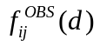 and 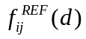 are stored for discrete bins with a fixed width of 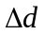. The size of the bin has a great influence on the probability distribution. Once the bin width is oversized, the probability and stored would be truly rough. When the bin width is undersized, there may be none or little samples located in certain bins, leading to an inappropriate and artificial discontinuity of the probability distribution. The size of the bin width should be compatible with the total counts of the samples, namely the N. With the increase of the number of the samples, the size of the bin should be as small as possible, the samples located in the bins should be sufficient, and the samples of the bins should be quite a very small part of the total samples.
Sippl (26) used a bin width of 1Å, Samudrala (27) used a bin width of 1Å and then carry out spline fitting, Capriotti (RASP) also used a bin width of 1Å, Bernauer (KB) didn’t used a Dirichlet process mixture model which leads to analytically differentiable potential functions rather than fixed binning and spline fitting. 3dRNAscore also uses a fixed bin width. Due to the large amount of samples in training set, the bin width could be assigned to a considerable small value. To decide the appropriate value of bin width , tests have been done for bin width of 0.1Å, 0.15Å, 0.2Å, 0.25Å, 0.3Å, 0.35Å, …, 0.95Å, 1.0Å, respectively. It will be further discussed in the results section below.

The problem of sparse data
In mathematical statistics, a larger size of samples yields a more accurate population distribution. A too small size of samples is likely to result in severe uncertainty for population distribution. The accuracy of the distance distribution of a specific pair of atom types thus heavily dependent on the size of the total observations on this pair of atom types. That is to say, the 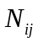 in equation should not be far too small.
In 1990, Sippl developed a method to address the problem of small data sets (26). He approximated the genuine frequency 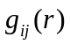 by the sum of the total densities 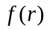 and the statistical frequencies 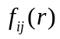:
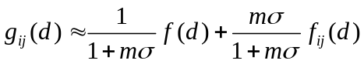
where m is actually , represents a custom constant. In the limit , 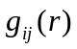 converges to . In the limit 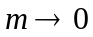, converges to . Equation ensures that the genuine frequency distribution resembles the total distribution when encountering the situation of sparse data.
In order to avoid the error caused by sparse data (small size of observations on certain pair of atom types), N_{ab}, the numbers of counts between two atoms of type a and b in 3dRNAscore regardless of distances, compiled from experimental structures have all been checked. The results show that even the smallest N_{ab} is large enough (39030) to evaluate an accurate population distribution, which results from the huge amounts of experimental structures used to compile the parameters. This shows that 3dRNAscore has no need of the method proposed by Sippl to address the issue of sparse data.

Dihedral-dependent energy
We used not only distance-dependent potential, but also a dihedral-dependent potential, involving seven RNA dihedral angles (α, β, γ, δ, ε, ζ for the nucleotide backbone, and χ for the base). Firstly, we calculated their statistical distribution over the training set (Figure 2).
Once we get their statistical distributions, just like the distance-dependent potential, it can be assumed that all of these angles obey Boltzmann statistical distribution, and once again the mean force potential (26) is used:

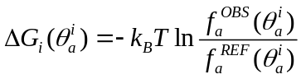
where T is the absolute temperature that is set to 298K, is the Boltzmann’s constant, 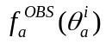 is the observed probability of angle i (one of α, β, γ, δ, ε, ζ and χ) of θ degree (0~360) and type a in the database of experimental RNA structures and 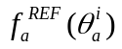 is the expected probability of arbitrary angle i of θ degree and type a in reference state.
Then, we could also get a total score 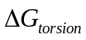 in the same way as the distance-dependent potential energy:
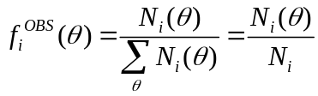
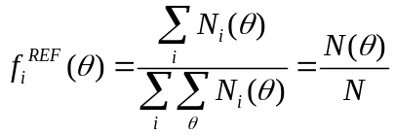
Just like the distance-dependent energy, we also use a matrix to store all the dihedral distribution information. Each row denotes a dihedral-pair type and each column the counts of occurrences of the dihedral value in the corresponding bin with a bin width of 1 degree. So the matrix has 7 * 7 rows and 360 columns.

Combination of the two energy terms
In 3dRNAscore the two energy terms we are combined together to get the final total energy:
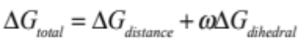
where 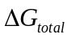 is the total energy, 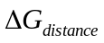 is the distance-dependent energy, 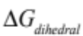 is the dihedral-dependent energy, and is the weight.
The dihedral-dependent energy concerns itself with interactions among four consecutive atoms along the backbone. The distance-dependent energy concerns about intermolecular atom-pair interactions. It doesn’t consider atom-pairs located in two adjacent residues along the backbone. In this sense, the dihedral-dependent energy and the distance-dependent energy have no overlap. Accordingly, the weight of the dihedral-dependent energy term ω should be 1.
From another perspective, the weight would still be proved to be 1. Samudrala and coworkers have argued cogently that equation (1) could be deduced by the Bayesian conditional probability theory (27). They evaluated 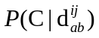, the probability that a structure is native state, given it contains the distances 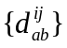. The is expressed as
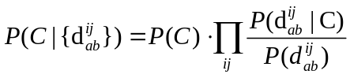
where 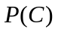 is the probability that any structure picked at random is a native state, 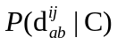 is the probability of observing a distance d between two atoms i and j of types a and b in native state.
An assertion underlies equation (4) that all distances are independent of one another, that is to say:
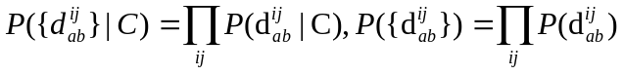
In the same way, 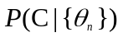, the probability that a structure is native fold, given that it contains the backbone dihedrals 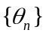, is expressed as
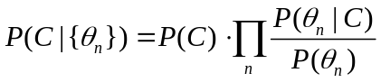
where is still the probability that any structure picked at random is a native state, 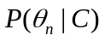 is the probability of observing a dihedral of type n in native states.
It is also assumed that all dihedrals are independent of one another:
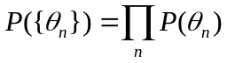
The atoms participated in the calculation of dihedrals are not considered when calculating the interatomic distances because the distances don’t involve those in adjacent residues. Hence, it is reasonably assumed that all distances are independent of all dihedrals. Then 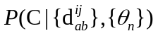, the probability that a structure is native fold, given that it contains the distances and the backbone dihedrals 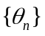, could be expressed as:
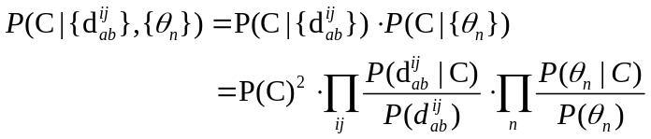
We use a scoring function to represent the negative logarithmic form of the probability :
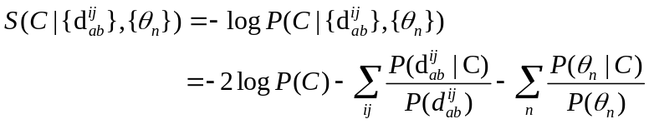
is a constant independent of conformation for a given sequence. The second term 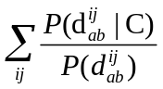 corresponds to the distance-dependent energy, and the third term 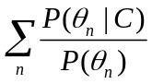 corresponds to the dihedral-dependent energy. It is obvious that the weight of the dihedral term should be 1.

Training set
We have trained 3dRNAscore over the RNA 3D Hub non-redundant RNA set. RNA 3D Hub hosts non-redundant set of RNA-containing 3D structures extracted from experimental RNA structures according to the methodology described in Chapter 13 in ref. (31). Leontis’ group summarized two categories of structural redundancy existed in PDB/NDB database (32,33), which are redundancy within a given PDB file and redundancy in PDB/NDB database. They figured out ways to get rid of these redundancies, and then clustered all structures into 749 classes (Release 1.32, 2013-10-12) based on redundancies between structures. About how they get rid of these redundancies, please see Chapter 13 in ref. (31). For each class, they chose a structure to represent it and assigned a unique and stable id to it. The dataset can be accessed at http://rna.bgsu.edu/nrlist/oldsite.html.
To construct the training set, we first gathered all the representative structures of 749 classes of RNA 3D Hub non-redundant RNA set. RNA 3D Hub ensured that sequence identity between any two sequences is less than 95%. By the way, RASP also used a sequence identity of 95% and the coverage of 80% to reduce redundancy in training set. RNA KB potential used a lower sequence identity of 80% to delete homologies in training set. We then used the blastn (34) program to discard all the RNAs with sequence identity greater than 80% and coverage greater than 80%. After that, we carried out 3D structure alignment by the ARTS program (35) to discard all the RNAs where the coverage of aligned part was greater than 80%. However, there exist recurrent motifs, e.g., the sarcin motifs and the GNRA motifs, in RNA 3D structures, and they often have quite different sequences and are hardly found by sequence alignment. These recurrent motifs may also affect the training of a scoring function and should remove this kind of redundancy. Based on RNA 3D Motif Atlas (36), which is a collection of RNA 3D motifs, we can find out the motifs contained in each structure in the training set. Then, RNAs having the motifs also contained in other RNAs in training set or in test sets were removed from the training set. These steps ensure that structures in the training set and test sets have no sequence and structural overlap. Finally, structures having low quality (Resolution > 3.5Å) are removed. Thus, there are 317 structures remained in the training set, which do not share any structures or motifs that are homologous to those in the test sets and have high structure quality (Resolution < 3.5Å).

Test sets
We tested our knowledge-based potential using three different decoy sets available at present. Test set I is a randstr decoy set (17), which is generated by MODELLER (37) with a set of Gaussian restraints for dihedral angles and atom distances from 85 native structures. This is the largest decoy dataset in the benchmark. It can be downloaded from http://melolab.org/supmat.html.
Test set II consists of the decoys built by Bernauer group (18) and FARNA decoys (11). The former is generated by position restrained dynamics, REMD simulation and normal-mode perturbation method (38,39). In the REMD simulation, 1ns REMD simulations are performed for each RNA structures. The temperature is roughly distributed from 285K to 592K for 50 different temperatures. In the normal-mode perturbation approach, the structures possess stereochemically correct bond lengths and angles but without correct contacts (40). These methods can generate decoy sets with RMSD ranging from 0 to 10Å. It can be downloaded from http://csb.stanford.edu/rna. The FARNA decoys used in this study consist of lots of near-native tertiary models (11).
Test set III is the FARFAR decoy set which was generated by RNA modelling with ROSETTA-3.1 (6,11). The FARFAR decoy dataset consists of five lowest energy clusters of tertiary structures with non-canonical base pairs for each of 32 motifs. The FARNA and FARFAR decoys can be downloaded from http://www.stanford.edu/~rhiju/data.html.

Metrics of measuring RNA structures
To compare any two RNA structures quantitatively, we should make use of some metrics to assess their tertiary structures. The most commonly used metric is RMSD (Root Mean Square Deviation). RMSD depicts the global geometry differences between two RNA 3D structures but it is usually difficult to describe the hydrogen bond networks of RNA molecules. Hence, some metrics accounting for hydrogen-bonding networks intramolecular in RNA have been proposed to assess RNA structures. One of the commonly used metrics specifically devised for RNA is DI (Deformation Index) proposed by Parisien (41). The DI is defined as
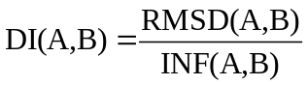
where RMSD reflects the geometry discrepancy and INF reflects the topology discrepancy. INF(A,B) is the interaction network fidelity between two structures A and B. Base-pairing and base-stacking are the two major interactions in RNA. These two interactions constitute the interaction network of RNA. Suppose 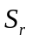 is the set of interactions in reference structure and 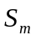 is the set of interactions in modeled structure, then the true positives TP is defined as 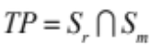, the false positives FP is defined as 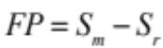, and the false negatives FN is defined as 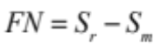. INF is defined as MCC, that is to say
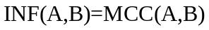
The Matthews correlation coefficient (MCC) is estimated by (42,43)

where 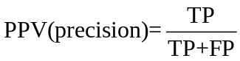 and 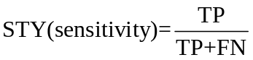.
In this work, we use both RMSD and DI to measure how well a RNA model recapitulates the corresponding experimental structure in the benchmark of the performance of 3dRNAscore and other scoring functions.

Results

Ability of identifying native structure
An important function of scoring methods is to identify the native-like tertiary structure of target RNA in a pool of structural decoys correctly. To compare such ability of 3dRNAscore with three existing RNA knowledge-based potentials: RASP (17), KB (18) and Rosetta (FARFAR) (6), for the sake of fairness, we use all-heavy-atom representation for all the potentials and evaluate them over the same decoy sets.
Two tests are done on test set I and test set II, respectively (see Figure 3). When using 3dRNAscore, 84 out of 85 native structures are identified in test set I, and 36 out of 39 in test set II. For RASP, 79 out of 85 in test set I and 34 out of 39 in test set II. KB potentials could identify 80 out of 85 native structures in test set I, and 33 out of 39 in test set II. For Rosetta, the former is 53 out of 85 and the latter is 26 out of 39. These results show that 3dRNAscore has a better performance than other three methods on identifying native RNA structures.
It is noted that Capriotti’s group has verified that RASP has a better performance than NAST (44) and the molecular force field energy function: AMBER pseudo-energies (45).

Ability of ranking near-native RNAs
Another significant function of scoring function is to rank near-native structures reasonably. In the RNA structure prediction, a natural question is how to affirm that a predicted structure is closer than others to the native state. For RNA, a structure could be geometrically and topologically close to another structure. Hence, both RMSD and DI are used in this work to evaluate structure discrepancy. Mentioned earlier, RMSD measures similarity of two RNA structures from the aspect of geometry and DI is from both geometry and topology. Once we could determine that a near-native structure is closer than another one to the native-state, we could say that a scoring method ranks near-native structures more appropriately than another one.
To describe the performance of a scoring function, the ES (Enrichment Score (18,46)) is employed here and it is defined as
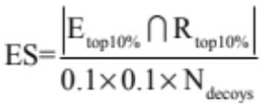
where 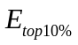 is the number of structures with energies (scores given by scoring function) in the lowest 10% of the energy range, 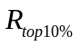 is the number of structures with RMSD/DI in the lowest 10% of the RMSD/DI range, and  is the intersection of and . If the relationship between the scores and RMSD/DI value is completely linear, then the ES is equal to 10. If the relationship is random, the ES is equal to 1, so
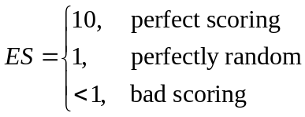
We have benchmarked the performance of 3dRNAscore, RASP, KB and Rosetta in ranking near-native structures on test set II, using both RMSD and DI metrics. Table 2 shows that when using ES calculated by DI, 3dRNAscore (ES=4.5) outperforms other three scoring methods (RASP(ES=3.8), KB(ES=3.7) and Rosetta(ES=2.7)) on the overall average level. It also outperforms them on the REMD decoys, normal mode decoys and FARNA decoys of test set II. The result is the same when the test set II is divided into two parts: NMR and X-Ray. When using ES calculated by RMSD, the result is similar. These results suggest that 3dRNAscore is better than other methods when it’s used to rank near-native structures.

Selecting correct structure containing non-canonical base pairs.
Non-canonical base pairs occur frequently in RNA tertiary folds and functional motifs (47-49). The selection of near-native conformations containing non-canonical base pairs is an inevitable and intractable problem in current RNA 3D structure prediction (6). Test set III is used to test the ability of 3dRNAscore in selecting correct structures containing non-canonical base pairs. Test set III (the FARFAR decoy set) consists of five lowest energy clusters of tertiary structures with non-canonical base pairs for each of 32 motifs. We calculated the energy score with RASP, KB, ROSETTAmin and 3dRNAscore, respectively. The lowest energy models according to each potential are then selected and compared with the lowest DI models. The results are presented in Table 3. 3dRNAscore, RASP, KB and Rosetta are able to identify the lowest DI models of 10, 9, 8 and 2 out of the 32 RNA motifs from the FARFAR decoy set, respectively (see Figure 4 (A)). 3dRNAscore can pick out models with lower DI than those by RASP, KB and Rosetta for 8, 12 and 21 out of 32 motifs and models with DI identical to those by RASP, KB and Rosetta for 22, 16 and 1 out of 32 motifs, respectively (see Figure 4 (B). Moreover, 3dRNA can pick out models with DI greater than those by RASP, KB and Rosetta for 2, 4 and 10 out of 32 motifs, respectively.

Comparison of different bin widths
As mentioned before, tests have been done for different sizes of bin width to select a most appropriate bin width for 3dRNAscore. Benefiting from the large amount of samples in the training set, the bin width could be small enough to yield a fairly accurate probability distribution. Figure 4 shows the total averaged ES scores of test set II at different bin width. It indicates that the bin width of 0.15Å leads to the best performance of 3dRNAscore. Figure 4 shows that with the increase of the bin width, the ability of ranking near-native structures decreases.

Contribution of the dihedral-dependent potential
Most statistical potentials for RNA structures are based on distance distribution of intermolecular atom pairs or residue pairs. 3dRNAscore incorporated an additional energy contribution based on the distribution of backbone dihedrals (torsion angles) in the light of molecular force field. This will be discussed in the discussion section. The contribution of the dihedral-dependent energy can be shown by seeing the ability of ranking near-native structures using single distance-dependent energy, single dihedral-dependent energy and the combined one of these two, respectively.
When using RMSD-based ES and evaluating over test set II, the average ES of single distance-dependent energy is 4.48. The average ES of single dihedral-dependent energy is 2.1. When these two energy terms are combined, the average ES is 4.57. Thus the dihedral-dependent energy can further promote the performance of distance-dependent energy.

Relationship between 3dRNAscore and physical interactions in RNA
Capriotti and coworkers have found that all-atom version of RASP, RASP-ALL, could well capture base-pairing and base-stacking interactions in RNA. We observed the same phenomenon using 3dRNAscore. It seems that base-pairing and base-stacking interactions are implicitly contained in all-atom distance-dependent statistical potential. For example, Figure 5 depicts the distance distribution of the atom pair between N9 of adenine and N1 of uracil. Three apparent peaks appear on the distance distribution. The first peak is at the distance of 4.65Å, and it stems from the base-stacking interaction between adjacent residues along the nucleotide residues chain. The second peak is at the distance of 7.05Å, and it’s from the indirect interaction between the ith residue and the (i + 2)th residue. The third peak is at the distance of 8.7Å, and it results from the base-pairing interaction between adenine and uracil.

Choosing a structure model in a robust way
Evaluation function is used to select proper structure models. Here, we give an example of how we choose a structure model in a robust way during RNA tertiary structure prediction (Table 4). We firstly use the RNA 3D structure building program 3dRNA (12) to predict 500 models for a duplex RNA (PDB id: 1FQZ). The 500 models are then divided into 15 groups based on the base pairing and base stacking interactions discrepancies calculated by INF. We score all the group centers by 3dRNAscore. It finds that the center of Group-II has a lowest energy score, which suggests that Group-II is more likely than other groups to host the most native-like structure model. All of the models in Group-II are then scored and the lowest energy score is then chosen as the candidate structure. Table 4 shows the 5 largest groups. It shows that the DI of the model with the lowest energy score evaluated by 3dRNAscore is just the minimum DI.

Discussions
The native structure tends to have the lowest free energy according to the thermodynamic hypothesis proposed by Anfinsen (28). So precisely to say, we need to use free energy to evaluate a structure. For classical molecular force fields, it is easy to calculate the enthalpy of a structure but it is very time consuming to calculate its entropy. In contrast to force fields, statistical potentials extracted from experimental data of known RNA structures include both enthalpy and entropy information. Although they are not directly equal to free energy, they in principle correlate with the latter. Furthermore, the calculation is easy and fast. So, statistical potentials are more often used for RNA and protein structure scoring than molecular force fields.
A main difference of 3dRNAscore from existing RNA statistical potentials is combining the conventional distance-dependent energy with a dihedral-dependent energy. The results above indicate better performance of this combined potential. It is known that molecular force fields are the basis of molecular dynamics simulation to study conformations of biomolecules. Many force fields in use today are composed of four components: bond stretching, angle bending, the rotation of bonds and non-bonded interactions. The distance-dependent statistical potential corresponds to non-bonded interactions part of a force field while the dihedral-dependent potential corresponds to bond rotation part. The latter can efficiently describe the flexibility of RNA molecules, which is one of the major features of RNA structures that are different from that of protein structures. Originally, we planned to design four different statistical potentials corresponding to the four components of a force field. However, we found that the potentials corresponding to bond stretching and angle bending have no significant effect because all of the decoy sets don’t involve any variation of bond length and bond angle in the process of their generations.
RNA backbone is rotameric (50,51), and this may help recognize native-like models. Murray and coworkers (50) processed the backbone torsion angle distributions of an 8,636-residues RNA database with quality-filtering techniques like resolution, crystallographic B factor and all-atom steric clashes. With noise levels greatly reduced, clear signal appears for the underlying angle preferences. It suggests that native-like models have obvious preference for certain specific backbone torsion angle distribution. The dihedral-dependent energy of 3dRNAscore utilizes this preference to identify the native-like model from decoys where the dihedral distributions of RNA structures deviate from the normal dihedral distributions.
The Rosetta RNA scoring function (FARFAR) (6) is more detailed and precise than most other RNA knowledge-based potentials. The RNA energy function used in FARFAR includes a term weakly favoring compactness (proportional to radius-of-gyration), a term to penalize steric clashes within molecules and other terms that are specially designed for RNA interactions (6,11). On account of these precise energy terms contained in FARFAR, its scoring performance depends largely on the quality of the decoy sets. The less good scoring performance of FARFAR than that of other three scoring methods in the test above may be attributed to its unfitness to these decoys sets.
Test set I is generated by Gaussians on distances and torsions and Test set II is generated by molecular dynamics in a relative short period of time, hence decoys in these two datasets have low diversity and are distributed around a local minimum free energy state (in these two sets, the local minimum free energy state is just the native state) in the sense of free energy landscape. Results in these two sets show that 3dRNAscore is quite qualified for identifying local minimum free energy state and ranking structures around the local minimum. Test set III is a more real-world decoy set which is generated by RNA modelling with FARFAR (6), so decoys in test set III have a very high diversity, which is owed to the Monte Carlo algorithm adopted by FARFAR. Results in test set III show that 3dRNAscore’s performance in ranking structures widely distributed in free energy landscape is not so good, but still better than other existing statistical potentials.
Other limitations exist for knowledge-based statistical potentials at present. The limited number of RNA tertiary structures of the training set is still the major problem for developing knowledge-based potentials (52-54). Almost all the knowledge-based potentials face the possibility of over-training problem because the parameters depend on the limited number of structures in training datasets (55). We have tried to use a non-redundant RNA tertiary structure set as the training set and then remove all the structures that are similar to certain structures in test sets. More non-redundant structures would improve the accuracy of knowledge-based potentials (56,57). Furthermore, RNAs are very sensitive to electrostatic interactions because of the negative charges in the phosphate groups of the backbone (58-60). RNA may be unable to form the functional folds in the absence of positive ions. The knowledge-based potentials only implicitly consider this effect by counting the experimental structures. We will study these problems in future.

Conclusion
In this paper, we have developed a novel RNA knowledge-based potential for identifying native RNA structures and ranking predicted structures and functional structural motifs with non-canonical base pairs. We used a non-redundant RNA training set to train the parameters by combining the distances of paired atoms and torsion angles to construct our statistical potential. The benchmark tests show that our method could identify not only appropriate tertiary folds, but also tertiary motifs with the non-canonical base pairs. Although some limitations, 3dRNAscore performs consistently better than existing methods in both two cases.

Acknowledgements
This work is supported by the National High Technology Research and Development Program of China under Grant No. 2012AA020402 and the NSFC under Grant No. 11374113. Computations presented in this paper were carried out using the High Performance Computing Center experimental testbed in SCTS/CGCL.

References:
1. Guttman, M. and Rinn, J.L. (2012) Modular regulatory principles of large non-coding RNAs. Nature, 482, 339-346.
2. Montange, R.K. and Batey, R.T. (2008) Riboswitches: emerging themes in RNA structure and function. Annu. Rev. Biophys., 37, 117-133.
3. Dethoff, E.A., Chugh, J., Mustoe, A.M. and Al-Hashimi, H.M. (2012) Functional complexity and regulation through RNA dynamics. Nature, 482, 322-330.
4. Laing, C. and Schlick, T. (2011) Computational approaches to RNA structure prediction, analysis, and design. Curr Opin Struct Biol, 21, 306-318.
5. Cao, S. and Chen, S.J. (2011) Physics-based de novo prediction of RNA 3D structures. J Phys Chem B, 115, 4216-4226.
6. Das, R., Karanicolas, J. and Baker, D. (2010) Atomic accuracy in predicting and designing noncanonical RNA structure. Nature Methods, 7, 291-294.
7. Frellsen, J., Moltke, I., Thiim, M., Mardia, K.V., Ferkinghoff-Borg, J. and Hamelryck, T. (2009) A probabilistic model of RNA conformational space. PLoS computational biology, 5, e1000406.
8. Sharma, S., Ding, F. and Dokholyan, N.V. (2008) iFoldRNA: three-dimensional RNA structure prediction and folding. Bioinformatics, 24, 1951-1952.
9. Parisien, M. and Major, F. (2008) The MC-Fold and MC-Sym pipeline infers RNA structure from sequence data. Nature, 452, 51-55.
10. Martinez, H.M., Jr. Maizel, J.V. and Shapiro, B.A. (2008) RNA2D3D: a program for generating, viewing, and comparing 3-dimensional models of RNA. J Biomol Struct Dyn, 25, 669-683.
11. Das, R. and Baker, D. (2007) Automated de novo prediction of native-like RNA tertiary structures. Proc Natl Acad Sci U S A, 104, 14664-14669.
12. Zhao, Y., Huang, Y., Gong, Z., Wang, Y., Man, J. and Xiao, Y. (2012) Automated and fast building of three-dimensional RNA structures. Sci Rep, 2, 734.
13. Zhao, Y., Gong, Z. and Xiao, Y. (2011) Improvements of the hierarchical approach for predicting RNA tertiary structure. J Biomol Struct Dyn, 28, 815-826.
14. Zhang, Y. (2008) Progress and challenges in protein structure prediction. Curr Opin Struc Biol, 18, 342-348.
15. Zhou, H. and Skolnick, J. (2011) GOAP: a generalized orientation-dependent, all-atom statistical potential for protein structure prediction. Biophys J, 101, 2043-2052.
16. Adhikari, A.N., Freed, K.F. and Sosnick, T.R. (2013) Simplified protein models: Predicting folding pathways and structure using amino acid sequences. Phys Rev Lett, 111, 28103.
17. Capriotti, E., Norambuena, T., Marti-Renom, M.A. and Melo, F. (2011) All-atom knowledge-based potential for RNA structure prediction and assessment. Bioinformatics, 27, 1086-1093.
18. Bernauer, J., Huang, X., Sim, A.Y. and Levitt, M. (2011) Fully differentiable coarse-grained and all-atom knowledge-based potentials for RNA structure evaluation. Rna, 17, 1066-1075.
19. Norambuena, T., Cares, J.F., Capriotti, E. and Melo, F. (2013) WebRASP: a server for computing energy scores to assess the accuracy and stability of RNA 3D structures. Bioinformatics, 29, 2649-2650.
20. Sim, A.Y., Schwander, O., Levitt, M. and Bernauer, J. (2012) Evaluating mixture models for building RNA knowledge-based potentials. J Bioinform Comput Biol, 10, 1241010.
21. Olechnovi V C, K. and Venclovas, V.C.E. (2014) The use of interatomic contact areas to quantify discrepancies between RNA 3D models and reference structures. Nucleic Acids Res, u191.
22. Melo, F., S A Nchez, R. and Sali, A. (2002) Statistical potentials for fold assessment. Protein Sci, 11, 430-448.
23. Neal, R.M. (2000) Markov chain sampling methods for Dirichlet process mixture models. J Comput Graph Stat, 9, 249-265.
24. Holbrook, S.R. (2008) Structural Principles From Large RNAs*. Annu. Rev. Biophys., 37, 445-464.
25. Reiter, N.J., Chan, C.W. and Mondrag O N, A. (2011) Emerging structural themes in large RNA molecules. Curr Opin Struc Biol, 21, 319-326.
26. Sippl, M.J. (1990) Calculation of conformational ensembles from potentials of mena force: an approach to the knowledge-based prediction of local structures in globular proteins. J Mol Biol, 213, 859-883.
27. Samudrala, R. and Moult, J. (1998) An all-atom distance-dependent conditional probability discriminatory function for protein structure prediction. J Mol Biol, 275, 895-916.
28. Anfinsen, C.B. (1973) Principles that govern the folding of protein chains. Science, 181, 223-230.
29. Lu, H. and Skolnick, J. (2001) A distance-dependent atomic knowledge-based potential for improved protein structure selection. Proteins: Structure, Function, and Bioinformatics, 44, 223-232.
30. Rykunov, D. and Fiser, A.A.S. (2007) Effects of amino acid composition, finite size of proteins, and sparse statistics on distance-dependent statistical pair potentials. Proteins: Structure, Function, and Bioinformatics, 67, 559-568.
31. Leontis, N.B.Z.C. (2012) Nonredundant 3D Structure Datasets for RNA Knowledge Extraction and Benchmarking. Springer Berlin Heidelberg, Vol. 27, 281-298.
32. Berman, H.M., Westbrook, J., Feng, Z., Gilliland, G., Bhat, T.N., Weissig, H., Shindyalov, I.N. and Bourne, P.E. (2000) The Protein Data Bank. Nucleic Acids Res, 28, 235-242.
33. Berman, H.M., Olson, W.K., Beveridge, D.L., Westbrook, J., Gelbin, A., Demeny, T., Hsieh, S., Srinivasan, A.R. and Schneider, B. (1992) The nucleic acid database. A comprehensive relational database of three-dimensional structures of nucleic acids. Biophys J, 63, 751.
34. Altschul, S.F., Gish, W., Miller, W., Myers, E.W. and Lipman, D.J. (1990) Basic local alignment search tool. J Mol Biol, 215, 403-410.
35. O, D., R, N. and H, W. (2005) ARTS: alignment of RNA tertiary structures. Bioinformatics, 21, i47-i53.
36. Petrov, A.I., Zirbel, C.L. and Leontis, N.B. (2013) Automated classification of RNA 3D motifs and the RNA 3D Motif Atlas. Rna, 19, 1327-1340.
37. V S Ali, A. and Blundell, T.L. (1993) Comparative protein modelling by satisfaction of spatial restraints. J Mol Biol, 234, 779-815.
38. Huang, E.S., Subbiah, S., Tsai, J. and Levitt, M. (1996) Using a hydrophobic contact potential to evaluate native and near-native folds generated by molecular dynamics simulations. J Mol Biol, 257, 716-725.
39. Hansmann, U.H. and Okamoto, Y. (1999) New Monte Carlo algorithms for protein folding. Curr Opin Struc Biol, 9, 177-183.
40. Summa, C.M. and Levitt, M. (2007) Near-native structure refinement using in vacuo energy minimization. Proceedings of the National Academy of Sciences, 104, 3177-3182.
41. Parisien, M., Cruz, J.A., Westhof, E. and Major, F. (2009) New metrics for comparing and assessing discrepancies between RNA 3D structures and models. Rna, 15, 1875-1885.
42. Gorodkin, J., Stricklin, S.L. and Stormo, G.D. (2001) Discovering common stem--loop motifs in unaligned RNA sequences. Nucleic Acids Res, 29, 2135-2144.
43. Matthews, B.W. (1975) Comparison of the predicted and observed secondary structure of T4 phage lysozyme. Biochimica et Biophysica Acta (BBA)-Protein Structure, 405, 442-451.
44. Jonikas, M.A., Radmer, R.J., Laederach, A., Das, R., Pearlman, S., Herschlag, D. and Altman, R.B. (2009) Coarse-grained modeling of large RNA molecules with knowledge-based potentials and structural filters. Rna, 15, 189-199.
45. Wang, J., Cieplak, P. and Kollman, P.A. (2000) How well does a restrained electrostatic potential (RESP) model perform in calculating conformational energies of organic and biological molecules? J Comput Chem, 21, 1049-1074.
46. Tsai, J., Bonneau, R., Morozov, A.V., Kuhlman, B., Rohl, C.A. and Baker, D. (2003) An improved protein decoy set for testing energy functions for protein structure prediction. Proteins: Structure, Function, and Bioinformatics, 53, 76-87.
47. He, S., Hickman, A.B., Dyda, F., Johnson, N.P., Chandler, M. and Ton-Hoang, B. (2011) Reconstitution of a functional IS608 single-strand transpososome: role of non-canonical base pairing. Nucleic Acids Res, 39, 8503-8512.
48. Orioli, A., Pascali, C., Quartararo, J., Diebel, K.W., Praz, V., Romascano, D., Percudani, R., van Dyk, L.F., Hernandez, N. and Teichmann, M. et al.. (2011) Widespread occurrence of non-canonical transcription termination by human RNA polymerase III. Nucleic Acids Res, 39, 5499-5512.
49. Betel, D., Koppal, A., Agius, P., Sander, C. and Leslie, C. (2010) Comprehensive modeling of microRNA targets predicts functional non-conserved and non-canonical sites. Genome biology, 11, R90.
50. Murray, L.J., Arendall, W.R., Richardson, D.C. and Richardson, J.S. (2003) RNA backbone is rotameric. Proc Natl Acad Sci U S A, 100, 13904-13909.
51. Humphris-Narayanan, E. and Pyle, A.M. (2012) Discrete RNA libraries from pseudo-torsional space. J Mol Biol, 421, 6-26.
52. Ngan, S., Hung, L., Liu, T. and Samudrala, R. (2008), Protein Structure Prediction. Springer, pp. 243-281.
53. Berman, H.M., Bhat, T.N., Bourne, P.E., Feng, Z., Gilliland, G., Weissig, H. and Westbrook, J. (2000) The Protein Data Bank and the challenge of structural genomics. Nature Structural \& Molecular Biology, 7, 957-959.
54. Westbrook, J., Feng, Z., Chen, L., Yang, H. and Berman, H.M. (2003) The protein data bank and structural genomics. Nucleic Acids Res, 31, 489-491.
55. Zheng, S., Robertson, T.A. and Varani, G. (2007) A knowledge-based potential function predicts the specificity and relative binding energy of RNA-binding proteins. FEBS journal, 274, 6378-6391.
56. Handl, J., Knowles, J. and Lovell, S.C. (2009) Artefacts and biases affecting the evaluation of scoring functions on decoy sets for protein structure prediction. Bioinformatics, 25, 1271-1279.
57. Li, Y., Rata, I. and Jakobsson, E. (2011) Sampling multiple scoring functions can improve protein loop structure prediction accuracy. Journal of chemical information and modeling, 51, 1656-1666.
58. Chen, S. (2008) RNA folding: conformational statistics, folding kinetics, and ion electrostatics. Annual review of biophysics, 37, 197.
59. Chin, K., Sharp, K.A., Honig, B. and Pyle, A.M. (1999) Calculating the electrostatic properties of RNA provides new insights into molecular interactions and function. Nature Structural \& Molecular Biology, 6, 1055-1061.
60. Draper, D.E. (2013) Folding of RNA tertiary structure: Linkages between backbone phosphates, ions, and water. Biopolymers, 99, 1105-1113.

Table and Figure Captions
Table 1 Atom types in 3dRNAscore
Table 2 The near-native structures ranking results of 3dRNAscore, KB potential, and Rosetta methods.
Table 3 The ranking results of Rosetta, RASP-ALL, KB, and 3dRNAscore methods on the FARFAR decoy set.
Table 4 Five largest groups divided from the 500 models predicted by 3dRNA for 1FQZ.
Figure 1 Flow charts of the building steps of 3dRNAscore.
Figure 2 The frequency distributions of seven RNA torsion angles (α, β, γ, δ, ε, ζ for the nucleotide backbone, and χ for the base).
Figure 3 Counts of native states identified correctly from Test set I and Test set II by 3dRNAscore, RASP, KB and Rosetta, respectively.
Figure 4 Results on test III. (A) The counts of models having the lowest energy selected by 3dRNAscore, RASP, RNA KB and Rosetta, respectively. (B) The red part represents the counts of models that are worse than those selected by 3dRNAscore. Blue represents the counts of models are that better than those selected by 3dRNAscore. Gray represents the counts of models that are the same as those selected by 3dRNAscore.
Figure 5 ES of 3dRNAscore versus bin width over test set II
Figure 6 (A) Counts distribution of the distance between N9 of adenine and N1 of uracil. (B) Diagram of the three representative distance between N9 of adenine and N1 of uracil.

Table 1 Atom types in 3dRNAscore potential
A | P OP1 OP2 O5’ C5’ C4’ O4’ C3’ O3’ C2’ O2’ C1’  N9 C8 N7 C5 C6 N6 N1 C2 N3 C4
U | P OP1 OP2 O5’ C5’ C4’ O4’ C3’ O3’ C2’ O2’ C1’  N1 C2 O2 N3 C4 O4 C5 C6
C | P OP1 OP2 O5’ C5’ C4’ O4’ C3’ O3’ C2’ O2’ C1’  N1 C2 O2 N3 C4 N4 C5 C6
G | P OP1 OP2 O5’ C5’ C4’ O4’ C3’ O3’ C2’ O2’ C1’  N9 C8 N7 C5 C6 O6 N1 C2 N2 N3 C4

Table 2 The near-native structures ranking results of 3dRNAscore, KB potential, and Rosetta methods.
 |  |  |  | Enrichment Score (RMSD) |  |  |  | Enrichment Score (DI)
Decoy | RNA | Length | Method | 3dRNAscore | KB | RASP | Rosetta | 3dRNAscore | KB | RASP | Rosetta
Position restrained dynamics and REMD (A) | 1duq | 26 | X-ray | 8.5 | 7.6 | 7.6 | 7.1 | 8.4 | 7.5 | 7.6 | 7.0
Position restrained dynamics and REMD (A) | 1f27 | 30 | X-ray | 8.3 | 7.9 | 6.6 | 6.2 | 8.2 | 7.8 | 6.6 | 6.2
Position restrained dynamics and REMD (A) | 1msy | 27 | X-ray | 7.5 | 5.7 | 5.7 | 3.6 | 7.4 | 6.0 | 5.6 | 3.5
Position restrained dynamics and REMD (A) | 1nuj | 24 | X-ray | 7.7 | 7.3 | 5.2 | 6.9 | 7.7 | 7.2 | 5.2 | 6.7
Position restrained dynamics and REMD (A) | 434d | 14 | X-ray | 8.0 | 7.7 | 7.0 | 6.8 | 7.9 | 7.7 | 6.9 | 6.8
Normal modes (B) | 1duq | 26 | X-ray | 7.5 | 7.0 | 5.7 | 3.8 | 6.3 | 7.0 | 5.7 | 3.5
Normal modes (B) | 1esy | 19 | NMR | 4.9 | 5.4 | 4.5 | 5.6 | 6.3 | 5.5 | 4.7 | 5.7
Normal modes (B) | 1f27 | 30 | X-ray | 5.9 | 5.8 | 3.7 | 2.6 | 6.1 | 5.8 | 3.7 | 2.5
Normal modes (B) | 1i9v | 76 | X-ray | 6.1 | 2.6 | 5.3 | 3 | 5.9 | 2.7 | 5.1 | 3.0
Normal modes (B) | 1kka | 17 | NMR | 5.7 | 4.6 | 4.1 | 4.6 | 6.5 | 4.3 | 4.1 | 4.8
Normal modes (B) | 1msy | 27 | X-ray | 5.9 | 5.6 | 2.2 | 4.6 | 6.3 | 5.4 | 2.7 | 4.5
Normal modes (B) | 1nuj | 24 | X-ray | 7.1 | 7.4 | 5.9 | 2.4 | 4.5 | 7.0 | 5.9 | 2.2
Normal modes (B) | 1qwa | 21 | NMR | 3.5 | 3.2 | 2.0 | 3.8 | 3.5 | 3.3 | 2.2 | 3.9
Normal modes (B) | 1x9k | 62 | X-ray | 6.7 | 1.6 | 5.2 | 3 | 2.5 | 1.9 | 5.2 | 2.8
Normal modes (B) | 1xjr | 46 | X-ray | 7.7 | 5.4 | 7.9 | 2.2 | 6.0 | 5.0 | 7.9 | 2.5
Normal modes (B) | 1ykq | 19 | X-ray | 4.6 | 3.4 | 3.5 | 2.8 | 4.8 | 3.3 | 3.8 | 2.5
Normal modes (B) | 1zih | 12 | NMR | 7.7 | 5.4 | 5.7 | 6.6 | 7.5 | 5.3 | 5.7 | 6.5
Normal modes (B) | 28sp | 28 | NMR | 5.7 | 4 | 6.5 | 1.8 | 5.7 | 4.5 | 6.7 | 2.9
Normal modes (B) | 2f88 | 34 | NMR | 6.8 | 5.4 | 4.9 | 4.4 | 4.3 | 5.4 | 4.7 | 4.2
Normal modes (B) | 434d | 14 | X-ray | 7.7 | 7.4 | 7.4 | 5.2 | 6.9 | 7.4 | 7.6 | 5.2
FARNA (C) | 1a4d | 41 | NMR | 2.4 | 3.8 | 2.0 | 0.8 | 2.4 | 4.0 | 2 | 0.7
FARNA (C) | 1csl | 28 | X-ray | 2.0 | 1.5 | 1.6 | 1.3 | 2.6 | 1.4 | 1.6 | 1.4
FARNA (C) | 1dqf | 19 | X-ray | 4.2 | 1.8 | 2.8 | 1 | 4.4 | 2.0 | 3.2 | 1.0
FARNA (C) | 1esy | 19 | NMR | 3.2 | 3.7 | 4.8 | 1.2 | 3.6 | 3.5 | 4.2 | 1.1
FARNA (C) | 1i9x | 26 | X-ray | 3.4 | 1.3 | 2.2 | 1.5 | 4.4 | 1.5 | 3.6 | 1.6
FARNA (C) | 1j6s | 24 | X-ray | 0.2 | 1.4 | 0.2 | 0.6 | 0.2 | 1.7 | 0.8 | 0.5
FARNA (C) | 1kd5 | 22 | X-ray | 3.2 | 0.3 | 0.8 | 0.2 | 3.0 | 0.5 | 1.6 | 0.3
FARNA (C) | 1kka | 17 | NMR | 1.4 | 1.2 | 0.6 | 0.6 | 1.8 | 0.8 | 0.8 | 0.6
FARNA (C) | 1l2x | 27 | X-ray | 0.6 | 3.2 | 1.0 | 1.8 | 0.8 | 3.2 | 1.2 | 1.8
FARNA (C) | 1mhk | 32 | X-ray | 1.6 | 1.2 | 1.6 | 1 | 1.8 | 1.2 | 1.4 | 1.2
FARNA (C) | 1q9a | 27 | X-ray | 2.6 | 0.5 | 0.8 | 0.8 | 3.6 | 0.5 | 1.2 | 0.8
FARNA (C) | 1qwa | 21 | NMR | 2.2 | 1.2 | 0.4 | 1 | 1.8 | 1.3 | 0.6 | 1.0
FARNA (C) | 1xjr | 46 | X-ray | 2.4 | 2 | 2.4 | 1.2 | 2.8 | 1.9 | 3.4 | 1.0
FARNA (C) | 1zih | 12 | NMR | 4.8 | 5 | 4.8 | 2 | 6.8 | 5.5 | 7.2 | 1.9
FARNA (C) | 255d | 24 | X-ray | 2.4 | 0.7 | 0.6 | 1.3 | 2.6 | 0.7 | 0.6 | 1.1
FARNA (C) | 283d | 24 | X-ray | 1.4 | 0.8 | 0.8 | 0.7 | 3.8 | 0.8 | 1 | 0.7
FARNA (C) | 28sp | 28 | NMR | 2.8 | 1.5 | 3.0 | 1.7 | 3.8 | 1.2 | 4.2 | 1.8
FARNA (C) | 2a43 | 26 | X-ray | 2.2 | 2 | 1.4 | 0.6 | 2.4 | 1.8 | 2 | 0.6
FARNA (C) | 2f88 | 34 | NMR | 3.2 | 1.3 | 2.2 | 1.3 | 3.6 | 1.3 | 1.6 | 1.2
AVERAGE VALUES | (A) |  |  | 8.0 | 7.2 | 6.4 | 6.1 | 7.9 | 7.2 | 6.4 | 6.0
AVERAGE VALUES | (B) |  |  | 6.2 | 4.9 | 5.0 | 3.8 | 5.5 | 4.9 | 5.0 | 3.8
AVERAGE VALUES | (C) |  |  | 2.3 | 1.8 | 1.8 | 1.1 | 2.8 | 1.8 | 2.2 | 1.1
AVERAGE VALUES | X-Ray |  |  | 4.8 | 3.8 | 3.7 | 2.8 | 4.7 | 3.8 | 3.9 | 2.7
AVERAGE VALUES | NMR |  |  | 4.2 | 3.5 | 3.5 | 2.7 | 4.4 | 3.5 | 3.7 | 2.8
AVERAGE VALUES | All |  |  | 4.5 | 3.7 | 3.6 | 2.7 | 4.5 | 3.7 | 3.8 | 2.7
Table 3 The ranking results of Rosetta, RASP-ALL, KB, and 3dRNAscore methods on the FARFAR decoy set.
Motif name | DI of the Lowest Energy Model |  |  |  | Minimum DI  Model
Motif name | ROSETTAmin | RASP-ALL | RNA KB | 3dRNAscore | Minimum DI  Model
G-A base pair | 4.026 | 1.408 | 2.455 | 1.408 | 1.408
Fragment with G/G and G/A pairs, SRP helix VI | 13.910 | 6.073 | 6.073 | 6.073 | 5.267
Helix with A/C base pairs | 2.414 | 3.262 | 5.410 | 5.866 | 2.414
Four-way junction, HCV IRES | 21.236 | 21.236 | 21.526 | 20.067 | 15.040
Loop 8, A-type Ribonuclease P | 8.421 | 4.290 | 4.290 | 4.290 | 1.615
Helix with U/C base pairs | 6.012 | 3.136 | 3.136 | 3.136 | 3.136
Curved helix with G/A and A/A base pairs | 1.062 | 1.929 | 3.565 | 1.929 | 0.998
Pre-catalytic conformation, hammerhead ribozyme | 30.097 | 12.830 | 12.830 | 12.830 | 12.830
Loop E motif, 5S RNA | 2.404 | 2.561 | 2.561 | 2.561 | 1.986
UUCG tetraloop | 1.284 | 1.278 | 1.403 | 1.278 | 1.278
Rev response element high affinity site | 7.802 | 5.826 | 4.227 | 5.826 | 4.227
Fragment with A/C pairs, SRP helix VI | 3.930 | 2.424 | 2.424 | 2.424 | 2.424
Signal recognition particle Domain IV | 5.516 | 3.224 | 3.224 | 3.224 | 1.338
Bulged G motif, sarcin/ricin loop | 1.902 | 7.066 | 7.838 | 7.066 | 1.588
Tertiary interaction, hammerhead ribozyme | 25.215 | 24.647 | 24.647 | 24.647 | 19.453
GAGA tetraloop from sarcin/ricin loop | 1.075 | 0.956 | 0.956 | 0.956 | 0.956
Pentaloop from conserved region of SARS genome | 4.147 | 4.145 | 4.147 | 4.145 | 1.068
L2/L3 tertiary interaction, purine riboswitch | 16.371 | 19.160 | 19.160 | 19.160 | 16.371
L3, thiamine pyrophosphate riboswitch | 6.076 | 2.262 | 2.262 | 2.262 | 2.262
Kink-turn motif from SAM-I riboswitch | 1.592 | 13.086 | 12.107 | 12.107 | 1.454
Active site, hammerhead ribozyme | 20.394 | 23.413 | 22.927 | 22.927 | 17.947
P1/L3, SAM-II riboswitch | 14.885 | 18.103 | 10.478 | 18.174 | 10.478
J4/5 from P4-P6 domain, Tetrahymena ribozyme | 2.504 | 2.919 | 2.919 | 2.919 | 2.199
Stem C internal loop, L1 ligase | 3.479 | 3.479 | 3.226 | 3.479 | 3.226
J5/5a hinge, P4-P6 domain, Tetr. ribozyme | 25.063 | 23.920 | 28.689 | 23.920 | 20.910
Three-way junction, purine riboswitch | 13.693 | 13.734 | 10.616 | 10.616 | 10.387
J4a/4b region, metal-sensing riboswitch | 6.237 | 5.012 | 6.549 | 5.012 | 5.012
Kink-turn motif | 15.0735 | 23.997 | 28.729 | 16.805 | 11.695
Tetraloop/helix interaction, L1 ligase crystal | 1.398 | 0.948 | 1.398 | 0.948 | 0.948
Hook-turn motif | 7.598 | 16.240 | 15.354 | 1.985 | 1.985
Tetraloop/receptor, P4-P6 domain, Tetr. ribozyme | 16.803 | 11.112 | 4.477 | 4.477 | 3.818
Pseudoknot, domain III, CPV IRES | 10.097 | 7.063 | 7.771 | 4.377 | 4.274

Table 4 Five largest groups divided from the 500 models predicted by 3dRNA for 1FQZ.
 | Group I | Group II | Group III | Group IV | Group V
Size | 190 | 168 | 56 | 23 | 19
Center DI | 4.636 | 3.153 | 5.621 | 5.055 | 10.183
Minimum DI | 4.116 | 1.429 | 5.355 | 4.373 | 9.758
Minimum score DI | 5.129 | 1.429 | 5.930 | 5.048 | 10.307

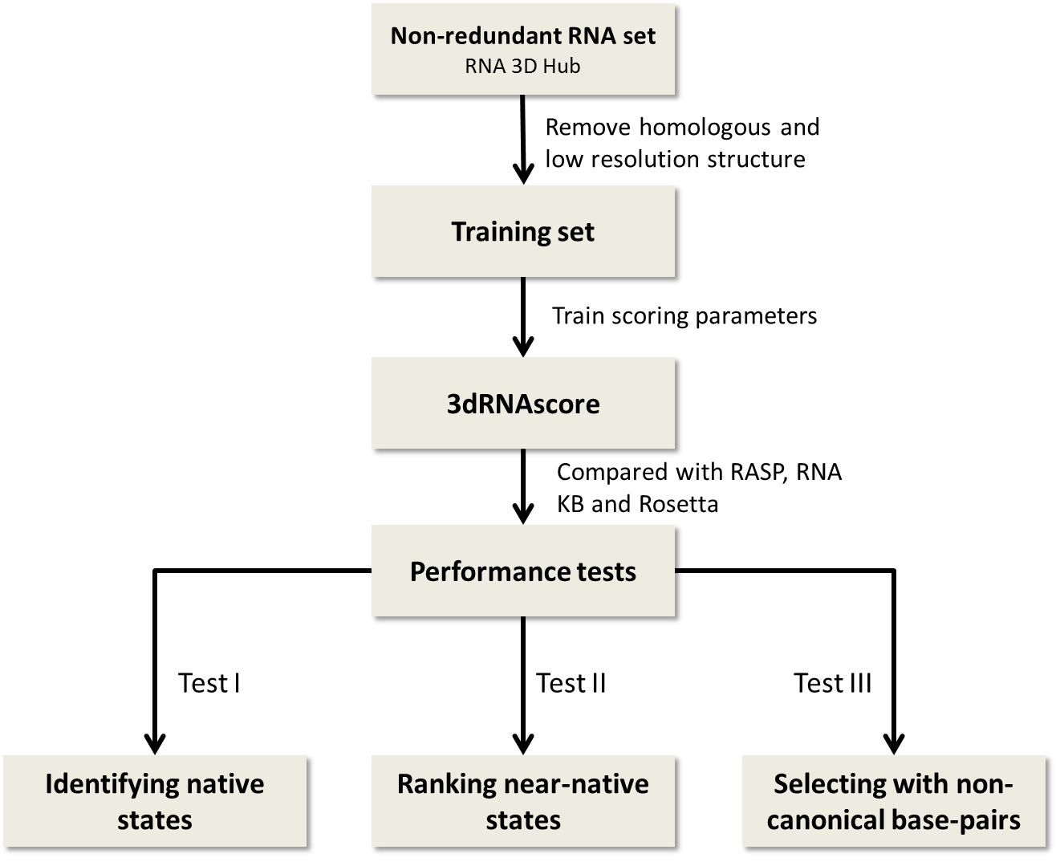

Figure 1 Flow charts of the building steps of 3dRNAscore.

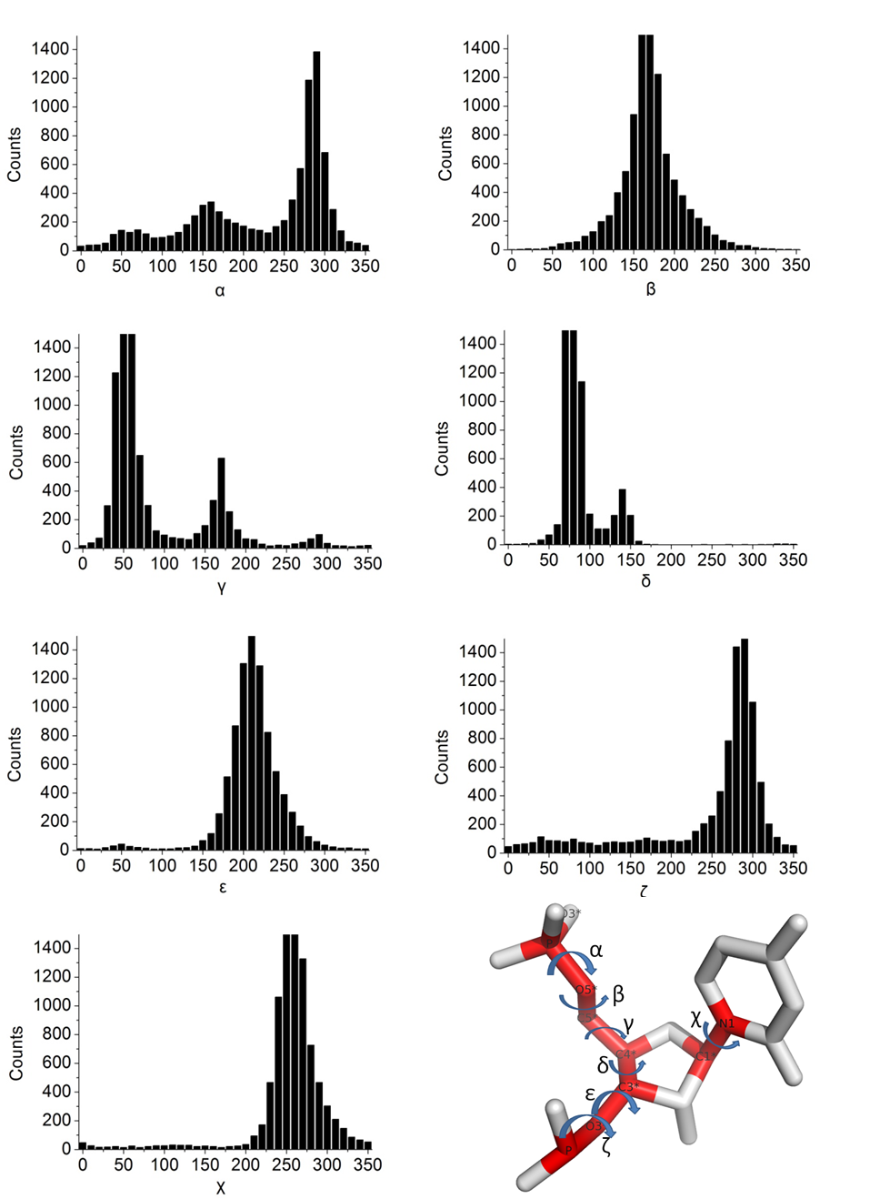
Figure 2 The frequency distributions of seven RNA torsion angles (α, β, γ, δ, ε, ζ for the nucleotide backbone, and χ for the base).

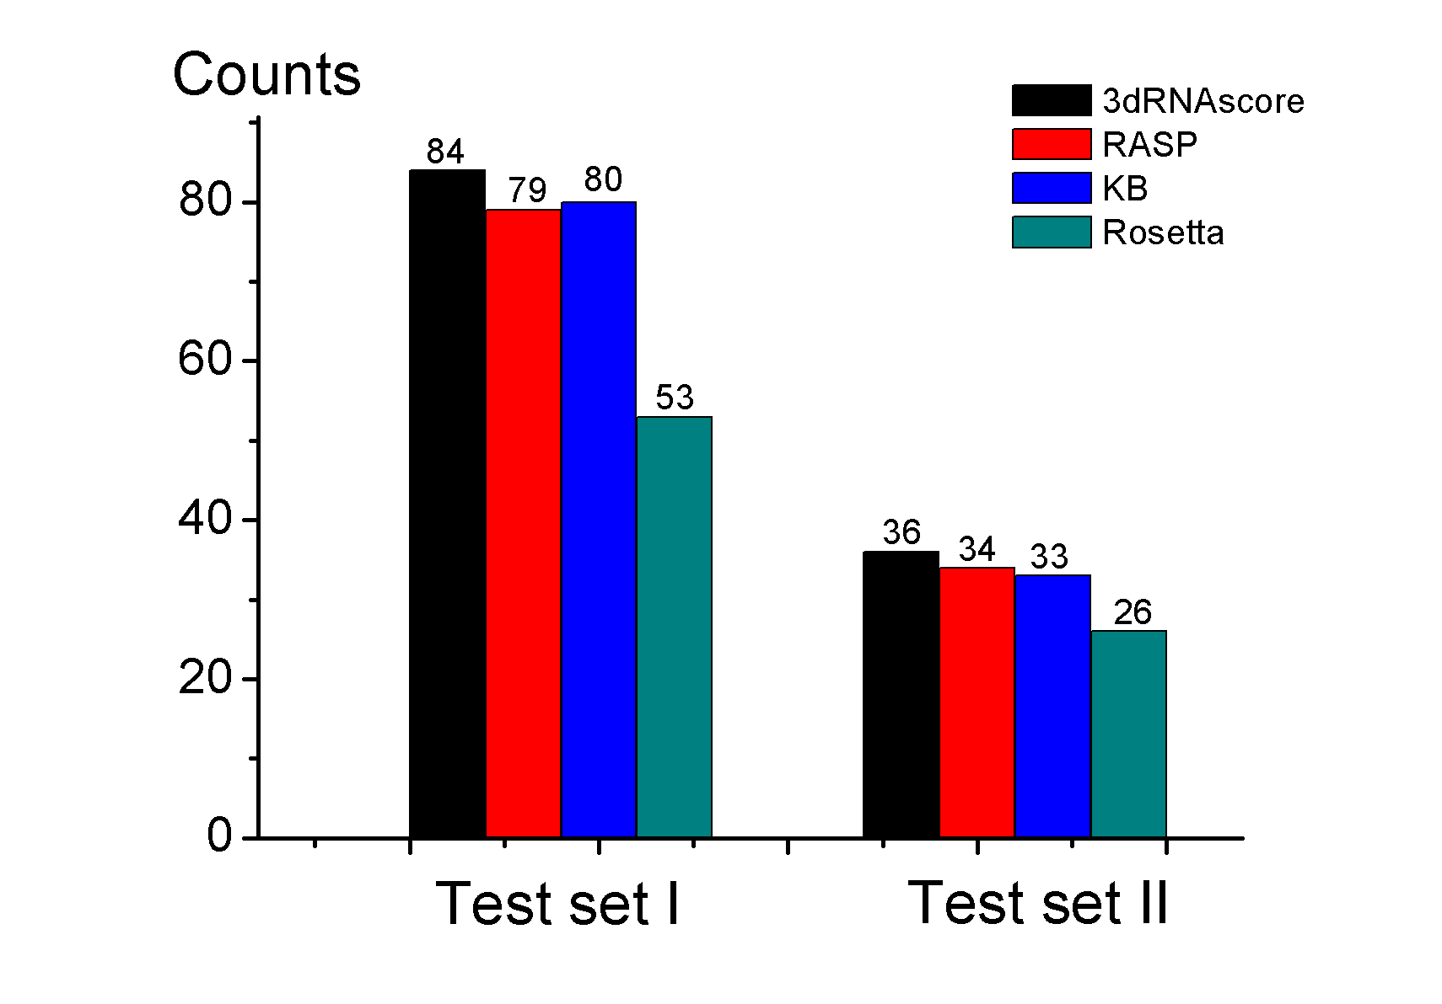
Figure 3 Counts of native states identified correctly from Test set I and Test set II by 3dRNAscore, RASP, KB and Rosetta, respectively.

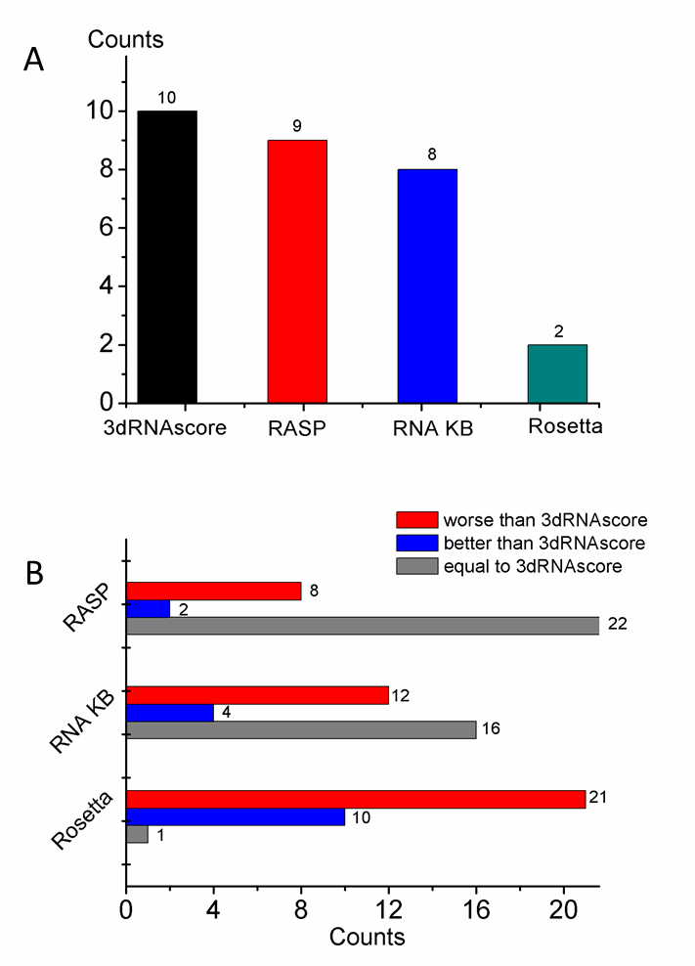
Figure 4 Results on test III. (A) The counts of models having the lowest energy selected by 3dRNAscore, RASP, RNA KB and Rosetta, respectively. (B) The red part represents the counts of models that are worse than those selected by 3dRNAscore. Blue represents the counts of models are that better than those selected by 3dRNAscore. Gray represents the counts of models that are the same as those selected by 3dRNAscore.

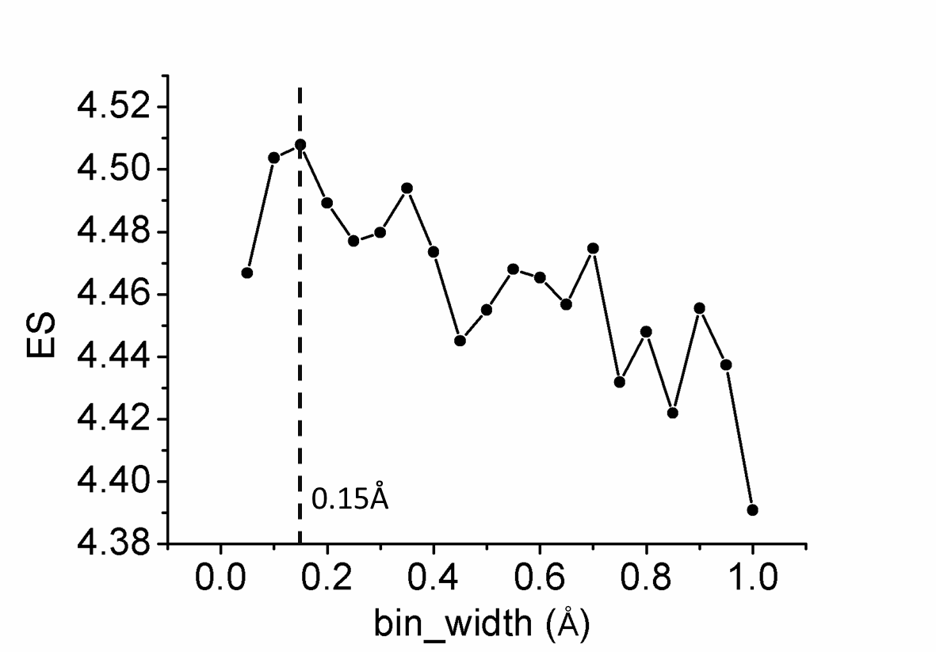
Figure 5 ES of 3dRNAscore versus bin width over test set II

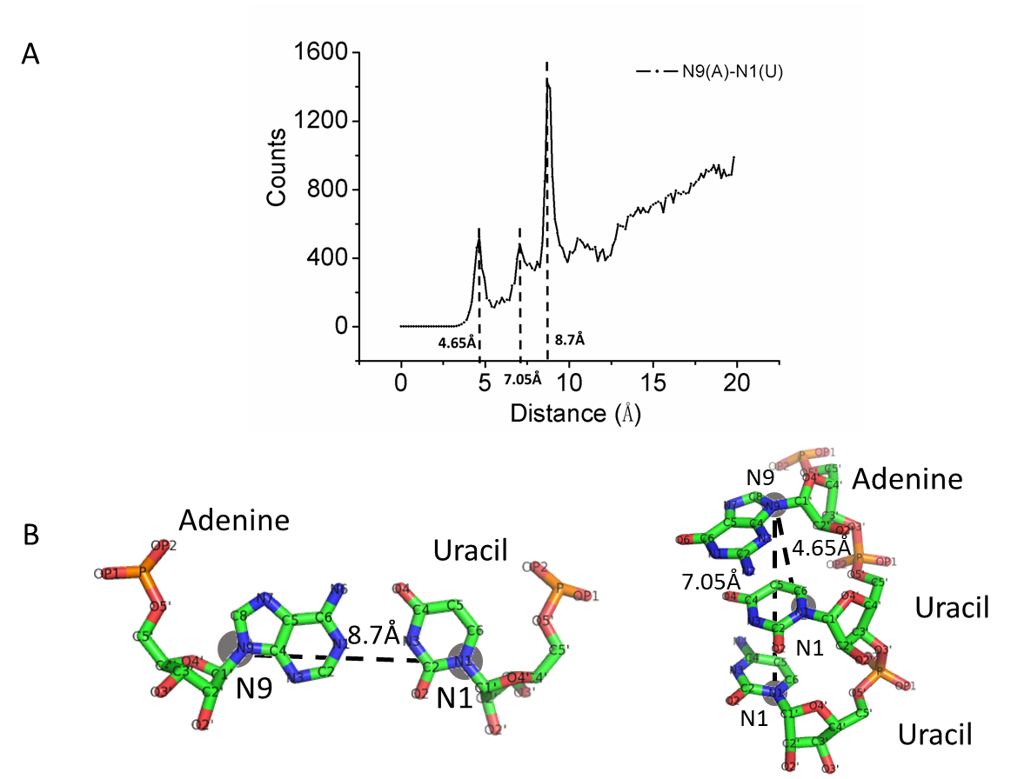
Figure 6 (A) Counts distribution of the distance between N9 of adenine and N1 of uracil. (B) Diagram of the three representative distance between N9 of adenine and N1 of uracil.

校对报告

当前使用的样式是 [Nucleic Acids Res]
当前文档包含的题录共95条
有0条题录存在必填字段内容缺失的问题
所有题录的数据正常

