3dRNA-2.0…
Jian Wang … Yi Xiao†
Biomolecular Physics and Modeling Group, Department of Physics and Key Laboratory of Molecular Biophysics of the Ministry of Education,
Huazhong University of Science and Technology, Wuhan 430074, Hubei, China

†Corresponding author (email: yxiao@hust.edu.cn).

ABSTRCT
Besides experimental methods, automated RNA 3D structure prediction in computer is also of important significance in comprehending various RNA biological functions. For proteins, this has been widely studied and all kinds of matured methods have been devised. Recently, a few automated and accurate methods have also been proposed to predict models of RNA 3D structures. These methods together promote the development of RNA 3D structure prediction. We’ve also developed an automated and fast RNA 3D structure building method, 3dRNA . The benchmark tests showed that it can predict the native-like structures effectively and fast. In this work, we are committed to promote the function of 3dRNA including the prediction accuracy and complex RNA topology supporting, and develop new function such as sampling and RNA 3D structure evaluation.

INTRODUCTION
In recent decades, non-coding RNA (ncRNA) molecules are found to play significant roles in numerous biological process, such as catalytic and regulatory roles. To perform these functions, they need to form special tertiary structures. Just like proteins, 3D structure is elementary for better understanding of the functions of RNA. Since the number of solved RNA tertiary structures are very limited, more and more computational methods have been proposed for RNA 3D structure prediction.
Before 2008, most of these methods are not automated and need manual manipulations, such as MANIP , BARNACLE , ASSEMBLE . After several years of development, more and more automated and accurate methods have been proposed. We’ve also developed an automated and fast RNA 3D structure building method, 3dRNA.
All of these automated RNA 3D structure prediction methods can be roughly categorized into 3 group: The first group of methods is based on fragment assembly. The most representative method is MC-Sym , which builds full-atomic models of RNA structures using nucleotide cyclic motifs (NCM). Other methods include: Vfold which is based on three-vector virtual bond-based RNA folding model; RNAComposer which is founded on a machine translation system; Enrwin which predicts RNA 3D structure using a coarse-grain helix-centered model; RNAnbds/SMC method which uses a nucleobase discrete-state model; and so on.
The second group of methods are based on coarse-grained MD or MC simulation, such as NAST and iFoldRNA. NAST uses an RNA-specific knowledge-based potential in a coarse-grained molecular dynamics engine to generate plausible 3D structures. iFoldRNA is based on DMD . Other methods include: RNA2D3D, SimRNA, oxRNA, and Shi’s method which is able to consider salt effect, etc.
Another important method FARNA/FARFAR is a fragment assembly based method using MC simulation. It has an amazing performance in RNA Puzzles , which is a CASP-like evaluation of RNA three-dimensional structure prediction.
The third group is based on homology modelling. Mode RNA can model post-transcriptional modifications. RLoom allows the insertion and replacement of loop structures of a desired sequence into an existing RNA structure. .
Liang and Schlick evaluated the performance of these methods and found that most predictions have RMSD values larger than 6Å from experimental structures and for RNA molecules of larger size (50–130 nucleotides) the mean RMSD value is about 20 Å. Furthermore, most of these methods are not automated and need manual manipulations.
Sim reviewed the general computational approaches developed to model nucleic acid systems. They focused on four key areas of nucleic acid modeling: molecular representation, potential energy function, degrees of freedom and sampling algorithm. They found that appropriate choices in each of these key areas in nucleic acid modeling can effectively combine to aid interpretation of experimental data and facilitate prediction of nucleic acid structure.
3dRNA is a fast and automated method of building RNA tertiary structure based on secondary structure. Since the organization of RNA structure is largely defined by topological constraints encoded at secondary structural level and tertiary contacts , the whole RNA tertiary structure is building from the smallest secondary elements (SSEs) by using a two-step procedure. It first assemble the SSEs into hairpins or duplexes and then into complete structure since the tertiary structures of hairpins and duplexes usually can be built with a high accuracy. In 3dRNA the SSEs are defined as base pair, hairpin loop, internal loop, bulge loop, pseudo-knot loop and junction loop.
3dRNA has several deficiencies to be solved. First, it can only predict one model for one RNA. This cannot always meet the needs of biology research. Furthermore, if we improved the function of 3dRNA so that it could sample a large set of models, we would need an elaborated RNA 3D structure scoring method to evaluate these models. Second, it is not able to handle with too much complicated RNA, such as RNA with long chain or with several multi-branch loops. Therefore, we improved the function of 3dRNA from several aspects including higher accuracy, efficient sampling, structure evaluating, supporting arbitrary complex and long RNA, etc. The new version, 3dRNA-2.0, is now provided on web (http://biophy.hust.edu.cn/3dRNA). For the convenience of comparison, we would refer to the old version of 3dRNA as 3dRNA-1.0 in the below contents.

METHODS
The steps for RNA 3D structure prediction in 3dRNA-2.0 are as follows (Figure 1). First, we develop a new method to represent RNA 2D structure by tree form. Second, we construct a templates library which is composed of the templates of different type of SSEs. We then construct a 2D structure tree for the given sequence and its corresponding 2D structure. The detail of each building step of 3dRNAscore is described in below. After that, the overall structure is split into different SSEs. For each SSE, we searched the templates library for appropriate templates. Then we assemble these templates iteratively into a large set of integrate structures. In the last, we use our new devised RNA 3D structure evaluation method to pick out the final candidate models.

New RNA 2D structure representation
Both 3dRNA-1.0 and other methods like RNAComposer , Vfold and Ernwin utilized a tree-like structure to represent the topology of the 2D structure of RNA. Generally, each node in the tree represent a secondary structure element (SSE) . The specific representation in each method differs a little. With the tree structure, one can have an intuitive impression on the topology of the 2D structure of RNA. Furthermore, with the tree representation the total structure of RNA can be decomposed easily into individual SSEs, the structure of which is more conservative relative to the their sequences .
Unfortunately, it is impossible to represent the 2D structure of RNA with pseudo-knots by the tree representation. A pseudo-knot in the 2D structure can lead to a ring in the tree, which turn the tree to a graph. We don’t expect a graph to depict the 2D topology of RNA because graph is difficult to be utilized to assemble individual SSEs to a complete structure seamlessly. It is based on this consideration that we developed the tree representation to adapt to RNA with pseudo-knots (Figure 2). We first merged each ring in the tree to a single node. Then we reconstruct the total topology of the tree to generate a new tree. Each node in the new tree represent an extend SSE which includes pseudo-knots now.

SSE 3D Templates library
In the development of 3dRNA-1.0, we constructed a database of 3D conformations of the SSEs with non-redundant sequences. We’ve now expanded database by importing templates from more RNA. We downloaded all the mono-RNA 3D structures from Protein Database (PDB, http://www.rcsb.org) and Nucleic Acid Database (NDB, http://ndbserver.rutgers.edu) . All the 2D structures of these RNAs are then extracted by RNAView . In the next, we construct the tree representation for each 2D structure of these RNAs. The integral 3D structure of each RNA can then be divided into individual SSE templates. We then import all of these templates into the templates library.
The templates library is divided into three major sub-library: helix library, loop library and pseudo-knots library. The helix library includes all kinds of helices with different length and different sequences. Moreover, even the helix with same length and same sequence, it can have several different templates. This ensure the diversity of the templates. The loop library consist of different type of loops including hairpin loops, bulge loops, internal loops and multi-branch loops. The hairpin loops, bulge loops, internal loops involves all kinds of types and sequences. The multi-branched loops contains 3-way junction, 4-way junction, 5-way junction… and so on. The pseudo-knots library includes pseudo-knots.
There are 6122 helices, 2612 hairpins, 2728 bulge loops and internal loops, 551 pseudo-knots, 313 3-way junctions, 98 4-way junctions, 38 5-way junctions and other 22 templates in the library.

Searching for appropriate templates
For each SSE in the tree, we searched the whole templates library for several or more appropriate 3D templates, the number of which depends on the number of models expected. We selected appropriate templates on the basis of secondary structure identity and sequence similarity. Specifically, for a given SSE with sequence and 2D structure, we first search the whole templates library for those with exactly the same 2D structure with the SSE. Usually this procedure would result in a set of candidate templates. We then ranked these templates according to the similarity of the sequence of the templates with respect to the sequence of SSE. Templates with higher sequence similarity would be ranked in the front; vice versa. Then we picked up the first n templates as candidate templates, where n is determined by the total number expected.

Ab initio templates building
Some SSEs are so complicated that there are little or no appropriate templates deposited in the library. So we have to build templates ab initio under this situation. RNAComposer utilized CYANA package to create the templates, Vfold searched exhaustively on a diamond grid model. Molecular dynamics (MD) and Monte Carlo (MC) methods can also be used to build templates, but all of these methods take times. We proposed a new method here based on the Distance Geometry (DG) theory (Figure 3).
DG can solve the coordinates of a set of points based on all or a part of the distances between these points. It was often applied for solving instances of the problem in which the data come from NMR experiments.
We first get statistics about the parameters of distances between atoms intra-nucleotide, atoms in adjacent nucleotides and atoms in paired nucleotides and stacked nucleotides. Then we construct a distance bounds matrix by applying the distance statistics and the 2D structure. Each coefficient with index (i, j) in the matrix represents the upper limit of the distance between atom i and atom j if i < j, otherwise it’s the lower limit. We then construct the distance matrix in which each coefficient is less than the upper limit and greater than the lower limit in the bound matrix. According to the DG algorithm, we then construct a metric matrix based on the distance matrix. After that, the 3D coordinates can be deduced from the metric matrix. In the last, we did conjugate gradient refining to make the coordinates satisfy the bound matrix.

Assembling
To get an integral 3D structure, we must assemble the templates of all the SSEs orderly. This procedure can be completed with-in the traversal of the 2D tree in a pre-order. In each step, we merge two individual templates to a single integral templates by superpose the common nucleotides of these two templates. The superpose method adopted the Kabsch’s method , which is first proposed to calculate RMSD between two molecules.

Sampling
3dRNA-1.0 can only produce one structure for one RNA. So we devised a fast and effective sampling method for it.
The searching of appropriate templates for a specific SSE usually results in hundreds of candidate templates. We then sample the conformation space of the integral 3D structure by iterating each SSE’s structure over its candidate templates set.
This method can generate a great deal of models in a very short time because of the scale in SSE level but not in atom or nucleotide level. It is effective because of the conservation of the 3D structure of SSE, which will be dug in the discussion.

All-atom knowledge-based RNA statistical potential -- 3dRNAscore
To evaluate all of the structures predicted by 3dRNA-2.0, we’ve developed a novel knowledge-based potential, 3dRNAscore , which combines distance-dependent and dihedral-dependent energies.
3dRNAscore is composed of two parts: the first part is based on distance between any two non-bonded heavy atoms located at different residues in the molecule, and the second part is based on the backbone torsion angles. The distance-dependent part is constructed as a mean force potential derived from Boltzmann distribution. The dihedral-dependent potential involves seven RNA dihedral angles (α, β, γ, δ, ε, ζ for the nucleotide backbone, and χ for the base). It also comes from the mean force potential.
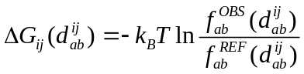
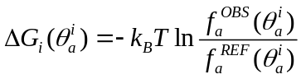
We used a non-redundant RNA training set to train the parameters by combining the distances of paired atoms and torsion angles to construct our statistical potential. The benchmark tests show that our method could identify not only appropriate tertiary folds, but also tertiary motifs with the non-canonical base pairs.

Secondary and tertiary structure analysis.
The RNAView program is used to analyze and compare the base pairs of the native and the predicted tertiary structures. The tertiary structure visualization and figures are generated using PyMOL (http://www.pymol.org/). RMSD (Root Mean Squared Deviation) and INF (Interaction Network Fidelity) against experimental structures are calculated to measure the prediction accuracy.
INF(A,B) is the interaction network fidelity between two structures A and B. Base-pairing and base-stacking are the two major interactions in RNA. These two interactions constitute the interaction network of RNA. In Parisien’s paper , INF is defined as MCC, that is to say
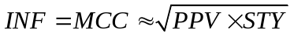
where MCC is the Matthews correlation coefficient, 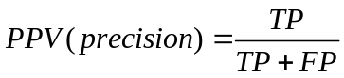 and 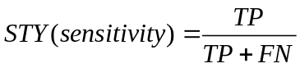. TP is the true positives, FP is the false positives and FN is the false negatives.

RESULTS

Higher accuracy with the aid of sampling
For simple hairpins and duplexes, 3dRNA-1.0 can give high prediction accuracy. We’ve took two representative RNAs as examples: 28SP and 1I9X. The hairpin 28SP (28 nt) contains a large internal loop. 3dRNA gave the predicted model with the interaction network fidelity (INF) of 0.89 and RMSD of 2.99 Å, while the promoted new version 3dRNA-2.0 increased the INF to 0.93 and decreased the RMSD to 2.05 Å; the duplex 1I9X (26nt) contains two bulge loops and the structure predicted by 3dRNA has an INF of 1.00 and RMSD of 2.73 Å. 3dRNA-2.0 could predict it with INF of 1 and RMSD of 1.89 Å.
In last work, we’ve compared the performance of 3dRNA-1.0 with several methods including iFoldRNA, RNA2D3D and MC-sym in a dataset consisting of 185 RNAs. These RNAs includes duplexes (12–56 nt), hairpins (10–63 nt) and molecules (26–101 nt) with complex topology containing pseudo-knots or junctions. It turns out that 3dRNA-1.0 performs better than the other methods in this dataset. In this work, we’ve tested the prediction performance of 3dRNA-2.0 with respect to 3dRNA-1.0 in the same dataset. Supplementary Table 2 shows that the overall average RMSD of the 185 RNA structures predicted by 3dRNA-2.0 is 3.81 Å which is smaller than 3.99 Å of 3dRNA-1.0. Figure n shows the RMSD distribution of predictions of 185 RNA molecules. All these suggest that there is a slightly promotion in the prediction accuracy from 3dRNA-1.0 to 3dRNA-2.0.
For RNA, RMSD is not enough to reflect the difference between two molecule 3D structures. RMSD is calculated by superposing two molecule structures. It can perfectly designates how far the geometrical coordinates of two molecules differ from each other. But RMSD is not able to reflect the difference of the base interaction network between two RNA molecules. In this sense, INF is preferable. So we further test if 3dRNA-2.0 can recapitulate the whole base interaction network in native state. As we’ve done in last work, we use the 32 representatives of 185 RNA structures to further test the performance of 3dRNA-2.0. To get the 32 representative structures, we clustered the 185 RNA structures into 32 classes with the sequence identity between any two of them being less than 50%. One representative for each class is then selected for comparison. These representatives include simple hairpins such as 1ZIH and complex junctions such as typical L-shaped tRNA with four-way junction.
Supplementary Table 1 shows that the overall average RMSD of predictions of the 32 RNA molecules with 3dRNA-2.0 is 3.91 Å which is also slightly better than 3.95 Å of 3dRNA-1.0, while the INF is 0.87 which is slightly worse than 0.88 of 3dRNA-1.0. Furthermore, the average RMSD decreased to 3.60 Å and the INF increased to 0.89 if we sampled 1000 models. The RMSD and INF is calculated for the center structure of the cluster with lowest energy in all the clusters from the 1000 models. Once we sampled 10000 models, the RMSD decreased further to 3.13 Å and INF increased to 0.90. These result verified the effectiveness of the sampling procedure.

Short running time
A prominent feature of 3dRNA-2.0 is that it can predict even a large set of long non-coding RNAs in a very short time. We picked out 14 RNA molecules with the length from 10 nt to 168 nt. Figure 4 (a) shows all the time elapsed for the prediction of the 14 RNA molecules. It suggests a weak relationship between the time and the length of RNA. The length longer, the time elapsed more. We also delved into the relationship between the time and the complexity of the 2D topology of RNA. We use the number of loops to represent the complexity of the 2D topology. For example, there are 3 loops in the 2D structure in Figure 2 (a). Figure 5 (b) shows a stronger relationship between the time and the number of loops than that between the time and the length. For all of these RNA molecules, the running time are less than 3 seconds.
To dig into the time consumed for the sampling procedure, we’ve predict from 1, 2, 4, … , to 2¹⁴ number of models for RNA 1KXK with the length of 70 nt. Figure 5 (c) suggests a perfect linear relationship between the time and the sampling number. It is worth noting that even for 2¹⁴ (16384) number of predictions, the running time is only 346.6 seconds.

non-Watson–Crick base pair recapitulation
FARFAR can predict accurate RNA 3D structures with low RMSD, while recapitulating non-Watson–Crick base pairs seen in the native structures . Here we also tested if 3dRNA-2.0 can recapitulate non-Watson-Crick base pairs. For the convenience of comparison, we select the FARFAR models which is composed of 32 RNA motifs as the test set. Supplementary table 3 shows that the average RMSD of the cluster center of the models predicted by 3dRNA-2.0 is 3.81 Å, and the average RMSD of the cluster center of the models predicted by FARFAR is 3.84 Å. The two are almost equal. Nevertheless, the average RMSD of the lowest energy cluster member of the models predicted by 3dRNA-2.0 is 3.83 Å, which is smaller than 4.01 Å by FARFAR. This suggests that 3dRNAscore which is plugged in 3dRNA-2.0 is able to pick out the structure more close to the native. Within the total 92 non-Watson–Crick base pairs, 3dRNA-2.0 can recapitulate 41 from the cluster centers and 45 from the lowest energy cluster members. FARFAR can recapitulate 37 from the cluster centers and 42 from the lowest energy cluster members. This suggests that 3dRNA-2.0 performs better in the ability of recapitulating non-Watson-Crick base pairs.

Supporting more complex RNA
3dRNA-1.0 is not limited to predict RNA 3D structures with simple topology and small size. It can also give reliable accuracy (5.7 Å on average) for RNA molecules with complex topology and larger size such as pseudo-knot and multi-branch junction. With 3dRNA-1.0, the topology of pseudo-knot couldn’t be too complicated and the number of pseudo-knot or multi-branch junction in one structure should only be one. We’ve solved this problem in 3dRNA-2.0 with the help of the new tree representation of RNA 2D structure and distance geometry. For example, 3ZEX is an rRNA of 4199 nt. Figure 6 (a) shows the extremely complicated 2D structure plotted by VARNA . Figure 6 (b) is the native 3D structure of 3ZEX. Figure 6 (c) shows the predicted 3D structure of 3ZEX with 3dRNA-2.0. The total running time is only 8.4 seconds, while the all-atom RMSD is 81.55 Å. This suggests that it need a promotion to predict large RNA with more accuracy.

DISCUSSION

Assumption
In the last work, we illustrated that in different molecules the 3D conformations of the loops of a given type and length (e.g., 4 nt hairpin loop) are close to each other if they have the same sequence. Even their sequences are different the backbone conformations are still similar. In this work, we found that for long loops having same sequence, the conformations of them are close in most cases. But there still existed circumstances that the conformations are far away from each other. Longer the loops, the more the case that conformations of loops having same sequence are far away from each other. Therefore, just like FARNA , in 3dRNA-2.0 we also took the assumption that the distribution of conformations observed in known RNA structures with same sequence provides a reasonable approximation to the conformations of a specific SSE with the same sequence.

Sample procedure
In most other methods, the sampling procedure is done on the level of atoms or residues. For instance, iFoldRNA utilized a simplified three-bead per nucleotide model of RNA to do replica-exchange DMD simulation. NAST does Monte Carlo simulation with the model that each residue is replaced by one atom. The sampling is done on residue level. For FARFAR, it also does a Monte Carlo simulation on the three residue fragments. All of these methods need a large time to generate a large set of models. For 3dRNA-2.0, the sampling procedure is almost a moment for small RNA. The short time benefits from the sampling on the level of SSEs. The number of residues in one SSE varies from several to dozens. Hence the sampling is very fast. On the other hand, the substitution templates for SSE are all extracted from experimental structures according to the assumption above. So the final structure can recapitulate a lot of non-Waston-Crick base pairs.

Large RNA problem
Also 3dRNA-2.0 can generate models for arbitrary long and complex sequence and its corresponding 2D structure, the accuracy is very bad for RNA the size of which reaches thousands of nucleotides long. The bad accuracy comes from two aspects. First, the long sequence accumulates the inaccuracy for short sequence. For locally short sequence fragments, even the precision of the predicted model is very high such as less than 1 Å, the total precision may become very low after a large number of assembly of these high accuracy fragments. That is to say that the inaccuracy accumulates. Second, the given 2D structure is not able to provide so much information about the tertiary interaction in RNA. The tertiary interactions have a great influence on the space arrangement of the SSE templates. Nevertheless, the 2D structure can provide with only the base-pair information. So much tertiary interactions especially in large RNA are omitted. Therefore, to solve the problem of large RNA 3D structure prediction problem, we may move along these two directions.

RNA Puzzles
We’ve evaluated 3dRNA-1.0 by ourselves in the problem 1-3 of the RNA-Puzzles. RNA-Puzzles is a CASP-like contest for blind RNA three-dimensional structure prediction. This time, we’ve took participate in the problem 5 of the RNA-Puzzles. The target is the lariat-capping ribozyme of 188-nt long. It catalyzes a distinct reaction involving formation of a 3-nt 2’, 5’ lariat. It’s a disappointment that the two models we’ve submitted gained a bad results. The RMSD of the two are 32.53 Å and 36.54 Å, respectively. We’ve analyzed the results and found that the large RMSD is due to the large difference between the 2D structure we used and that of the experimental structure. Once we used the experimental structure to predict the structure, the RMSD decreased rapidly to 12.37 Å. Another result also supports the conclusion that the INF taking into account only non-Watson–Crick interactions of our two models rank the third and the fourth, respectively. This suggests that the local structure of our models are verisimilar to the native structure. And it’s because that the decomposition of the total structure into individual SSEs can result in locally accuracy of each SSEs. The main deviation comes from the space arrangement of these SSEs, which largely depends on the 2D structure. Another worth noting result is that the clash score of our two models rank the first and the fourth. And it’s due to the delicate assembly of the SSE templates which are extracted directly from the experimental structures.

CONCLUSION
In this work, we are committed to improve the function of 3dRNA-1.0. The results suggest that the new version 3dRNA-2.0 performs better in several aspects including higher accuracy, supporting arbitrary large and complex RNA, etc. We also developed new function for 3dRNA, including sampling and precise RNA 3D structure evaluation. In addition, we’ve illustrated that 3dRNA-2.0 also performs well in the ability of recapitulating non-Waston-Crick base pairs.

AVAILABILITY
http://biophy.hust.edu.cn/3dRNA

ACKNOWLEDGEMENT

TABLE AND FIGURES LEGENDS
Figure 1 Schematic diagram of the predicting process in 3dRNA-2.0
Figure 2 Tree representation of RNA 2D structure.
Figure 3 Schematic diagram of loop building using distance geometry.
Figure 4 The RMSD distribution of the predictions in the 185 RNA datasets with 3dRNA-1.0 and 3dRNA-2.0, respectively.
Figure 5 (a) The time elapsed for the prediction of several different RNA molecules with different number of nucleotides. (b) The time elapsed for the prediction of RNA molecules with the topology of different complexity. (c) The time elapsed for different number of predictions of RNA 1KXK.
Figure 6 (a) The 2D structure of 3ZEX of 4199 nt. It is generated by VARNA (reference). (b) The native 3D structure of 3ZEX. (c) The predicted 3D structure of 3ZEX with 3dRNA-2.0.
Supplementary Table 1 Comparison of predictions of 32 RNA tertiary structures by 3dRNA-1.0 and 3dRNA-2.0.
Supplementary Table 2 Comparison of predictions (the heavy-atom RMSD values) of 185 RNA tertiary structures by 3dRNA-1.0 and 3dRNA-2.0.
Supplementary Table 3 Comparison of predictions of 32 FARFAR models between 3dRNA-2.0 and FARFAR

REFERENCES
1. V S Ali, A. and Blundell, T.L. (1993) Comparative protein modelling by satisfaction of spatial restraints. Journal of molecular biology, 234, 779--815.
2. Chopra, G., Summa, C.M., Levitt, M., Moult, J., Hubbard, T., Fidelis, K. and Pedersen, J.T. (2008) Solvent dramatically affects protein structure refinement
Critical assessment of methods of protein structure prediction (CASP): round III. Proceedings of the National Academy of Sciences, 105, 20239--20244.
3. Lee, J., Wu, S. and Zhang, Y. (2009), From protein structure to function with bioinformatics. Springer, pp. 3--25.
4. Zhao, Y., Huang, Y., Gong, Z., Wang, Y., Man, J. and Xiao, Y. (2012) Automated and fast building of three-dimensional RNA structures. Scientific Reports, 2, 734.
5. Ding, F., Sharma, S., Chalasani, P., Demidov, V.V., Broude, N.E. and Dokholyan, N.V. (2008) Ab initio RNA folding by discrete molecular dynamics: from structure prediction to folding mechanisms. RNA, 14, 1164-1173.
6. Tanaka, I., Nakagawa, A., Hosaka, H., Wakatsuki, S., Mueller, F. and Brimacombe, R. (1998) Matching the crystallographic structure of ribosomal protein S7 to a three-dimensional model of the 16S ribosomal RNA. RNA, 4, 542-550.
7. Kerpedjiev, P., Zu Siederdissen, C.H. and Hofacker, I.L. (2015) Predicting RNA 3D structure using a coarse-grain helix-centered model. RNA, 21, 1110-1121.
8. Das, R., Karanicolas, J. and Baker, D. (2010) Atomic accuracy in predicting and designing noncanonical RNA structure. Nature Methods, 7, 291-294.
9. Das, R. and Baker, D. (2007) Automated de novo prediction of native-like RNA tertiary structures. Proc Natl Acad Sci U S A, 104, 14664-14669.
10. Sharma, S., Ding, F. and Dokholyan, N.V. (2008) iFoldRNA: three-dimensional RNA structure prediction and folding. Bioinformatics, 24, 1951-1952.
11. Gherghe, C.M., Leonard, C.W., Ding, F., Dokholyan, N.V. and Weeks, K.M. (2009) Native-like RNA tertiary structures using a sequence-encoded cleavage agent and refinement by discrete molecular dynamics. J Am Chem Soc, 131, 2541-2546.
12. Massire, C. and Westhof, E. (1998) MANIP: an interactive tool for modelling RNA. J Mol Graph Model, 16, 197-205, 255-197.
13. Parisien, M. and Major, F. (2008) The MC-Fold and MC-Sym pipeline infers RNA structure from sequence data. Nature, 452, 51-55.
14. Hyeon, C., Thirumalai, D., Berne, B.J., Flores, S.C., Wan, Y., Russell, R. and Altman, R.B. (2005) Mechanical Unfolding of RNA Hairpins
Predicting RNA structure by multiple template homology modeling. Proceedings of the National Academy of Sciences of the United States of America, 102, 6789 - 6794.
15. Rother, M., Rother, K., Puton, T. and Bujnicki, J.M. (2011) ModeRNA: a tool for comparative modeling of RNA 3D structure. Nucleic Acids Res, 39, 4007-4022.
16. Jonikas, M.A., Radmer, R.J., Laederach, A., Das, R., Pearlman, S., Herschlag, D. and Altman, R.B. (2009) Coarse-grained modeling of large RNA molecules with knowledge-based potentials and structural filters. RNA, 15, 189-199.
17. Ulc, P., Romano, F., Ouldridge, T.E., Doye, J.P.K. and Louis, A.A. (2014) A nucleotide-level coarse-grained model of RNA. The Journal of chemical physics, 140, 235102.
18. Sim, A.Y., Minary, P. and Levitt, M. (2012) Modeling nucleic acids. Current opinion in structural biology, 22, 273--278.
19. Schudoma, C., May, P. and Walther, D. (2010) Modeling RNA loops using sequence homology and geometric constraints. Bioinformatics, 26, 1671-1672.
20. Martinez, H.M., Jr. Maizel, J.V. and Shapiro, B.A. (2008) RNA2D3D: a program for generating, viewing, and comparing 3-dimensional models of RNA. J Biomol Struct Dyn, 25, 669-683.
21. Popenda, M., Szachniuk, M., Antczak, M., Purzycka, K.J., Lukasiak, P., Bartol, N., Blazewicz, J. and Adamiak, R.W. (2012) Automated 3D structure composition for large RNAs. Nucleic Acids Res, 40, e112.
22. Cruz, J.A., Blanchet, M.F., Boniecki, M., Bujnicki, J.M., Chen, S.J., Cao, S., Das, R., Ding, F., Dokholyan, N.V., Flores, S.C. et al. (2012) RNA-Puzzles: a CASP-like evaluation of RNA three-dimensional structure prediction. RNA, 18, 610-625.
23. Miao, Z., Adamiak, R.W., Blanchet, M.-F., Boniecki, M., Bujnicki, J.M., Chen, S.-J., Cheng, C., Chojnowski, G., Chou, F.-C., Cordero, P. et al. (2015) RNA-Puzzles Round II: assessment of RNA structure prediction programs applied to three large RNA structures. RNA.
24. Jossinet, F. and Westhof, E. (2005) Sequence to Structure (S2S): display, manipulate and interconnect RNA data from sequence to structure. Bioinformatics, 21, 3320-3321.
25. Rother, K., Rother, M., Boniecki, M.L., Puton, T., Tomala, K., L Ukasz, P.L. and Bujnicki, J.M. (2012) Template-based and template-free modeling of RNA 3D structure: Inspirations from protein structure modeling. 67--90.
26. Cao, S. and Chen, S.-J. (2011) Physics-Based De Novo Prediction of RNA 3D Structures. The Journal of Physical Chemistry B, 115, 4216-4226.
27. Xu, X.J., Zhao, P.N. and Chen, S.J. (2014) Vfold: A Web Server for RNA Structure and Folding Thermodynamics Prediction. Plos One, 9.
28. Zhang, J., Bian, Y., Lin, H. and Wang, W. (2012) RNA fragment modeling with a nucleobase discrete-state model. Phys Rev E Stat Nonlin Soft Matter Phys, 85, 021909.
29. Malhotra, A., Tan, R.K. and Harvey, S.C. (1994) Modeling large RNAs and ribonucleoprotein particles using molecular mechanics techniques. Biophys J, 66, 1777-1795.
30. Tan, R.K.Z., Petrov, A.S. and Harvey, S.C. (2006) YUP:? A Molecular Simulation Program for Coarse-Grained and Multiscaled Models. Journal of Chemical Theory and Computation, 2, 529 - 540.
31. Shi, Y.Z., Wang, F.H., Wu, Y.Y. and Tan, Z.J. (2014) A coarse-grained model with implicit salt for RNAs: predicting 3D structure, stability and salt effect. J Chem Phys, 141, 105102.
32. Frellsen, J., Moltke, I., Thiim, M., Mardia, K.V., Ferkinghoff-Borg, J. and Hamelryck, T. (2009) A probabilistic model of RNA conformational space. PLoS Comput Biol, 5, e1000406-e1000406.
33. Jossinet, F., Ludwig, T.E. and Westhof, E. (2010) Assemble: an interactive graphical tool to analyze and build RNA architectures at the 2D and 3D levels. Bioinformatics, 26, 2057-2059.
34. Laing, C. and Schlick, T. (2011) Computational approaches to RNA structure prediction, analysis, and design. Curr Opin Struct Biol, 21, 306-318.
35. Bailor, M.H., Sun, X. and Al-Hashimi, H.M. (2010) Topology links RNA secondary structure with global conformation, dynamics, and adaptation. Science, 327, 202-206.
36. Wang, J., Zhao, Y., Zhu, C. and Xiao, Y. (2015) 3dRNAscore: a distance and torsion angle dependent evaluation function of 3D RNA structures. Nucleic Acids Res, 43, e63.
37. Berman, H.M., Westbrook, J., Feng, Z., Gilliland, G., Bhat, T.N., Weissig, H., Shindyalov, I.N. and Bourne, P.E. (2000) The Protein Data Bank. Nucleic Acids Res, 28, 235-242.
38. Berman, H.M., Olson, W.K., Beveridge, D.L., Westbrook, J., Gelbin, A., Demeny, T., Hsieh, S.-H., Srinivasan, A.R. and Schneider, B. (1992) The nucleic acid database. A comprehensive relational database of three-dimensional structures of nucleic acids. Biophysical journal, 63, 751.
39. Yang, H., Jossinet, F., Leontis, N., Chen, L., Westbrook, J., Berman, H. and Westhof, E. (2003) Tools for the automatic identification and classification of RNA base pairs. Nucleic Acids Res, 31, 3450-3460.
40. Stein, E.G., Rice, L.M. and Brunger, A.T. (1997) Torsion-angle molecular dynamics as a new efficient tool for NMR structure calculation. J Magn Reson, 124, 154-164.
41. Hubbard, J.M.Œ.H. (1991) Computer modeling 16 S ribosomal RNA. Journal of molecular biology, 221, 889.
42. Havel, T.F. (1998) Distance geometry: Theory, algorithms, and chemical applications. Encyclopedia of Computational Chemistry, 120.
43. Kabsch, W. (1978) A discussion of the solution for the best rotation to relate two sets of vectors. Acta Crystallographica Section A: Crystal Physics, Diffraction, Theoretical and General Crystallography, 34, 827--828.
44. Sippl, M.J. (1990) Calculation of conformational ensembles from potentials of mena force: an approach to the knowledge-based prediction of local structures in globular proteins. Journal of molecular biology, 213, 859--883.
45. DeLano, W.L., Ultsch, M.H. and Wells, J.A. (2000) Convergent solutions to binding at a protein-protein interface. Science, 287, 1279-1283.
46. Parisien, M., Cruz, J.A., Westhof, E. and Major, F. (2009) New metrics for comparing and assessing discrepancies between RNA 3D structures and models. RNA, 15, 1875-1885.
47. Darty, K., Denise, A. and Ponty, Y. (2009) VARNA: Interactive drawing and editing of the RNA secondary structure. Bioinformatics, 25, 1974.

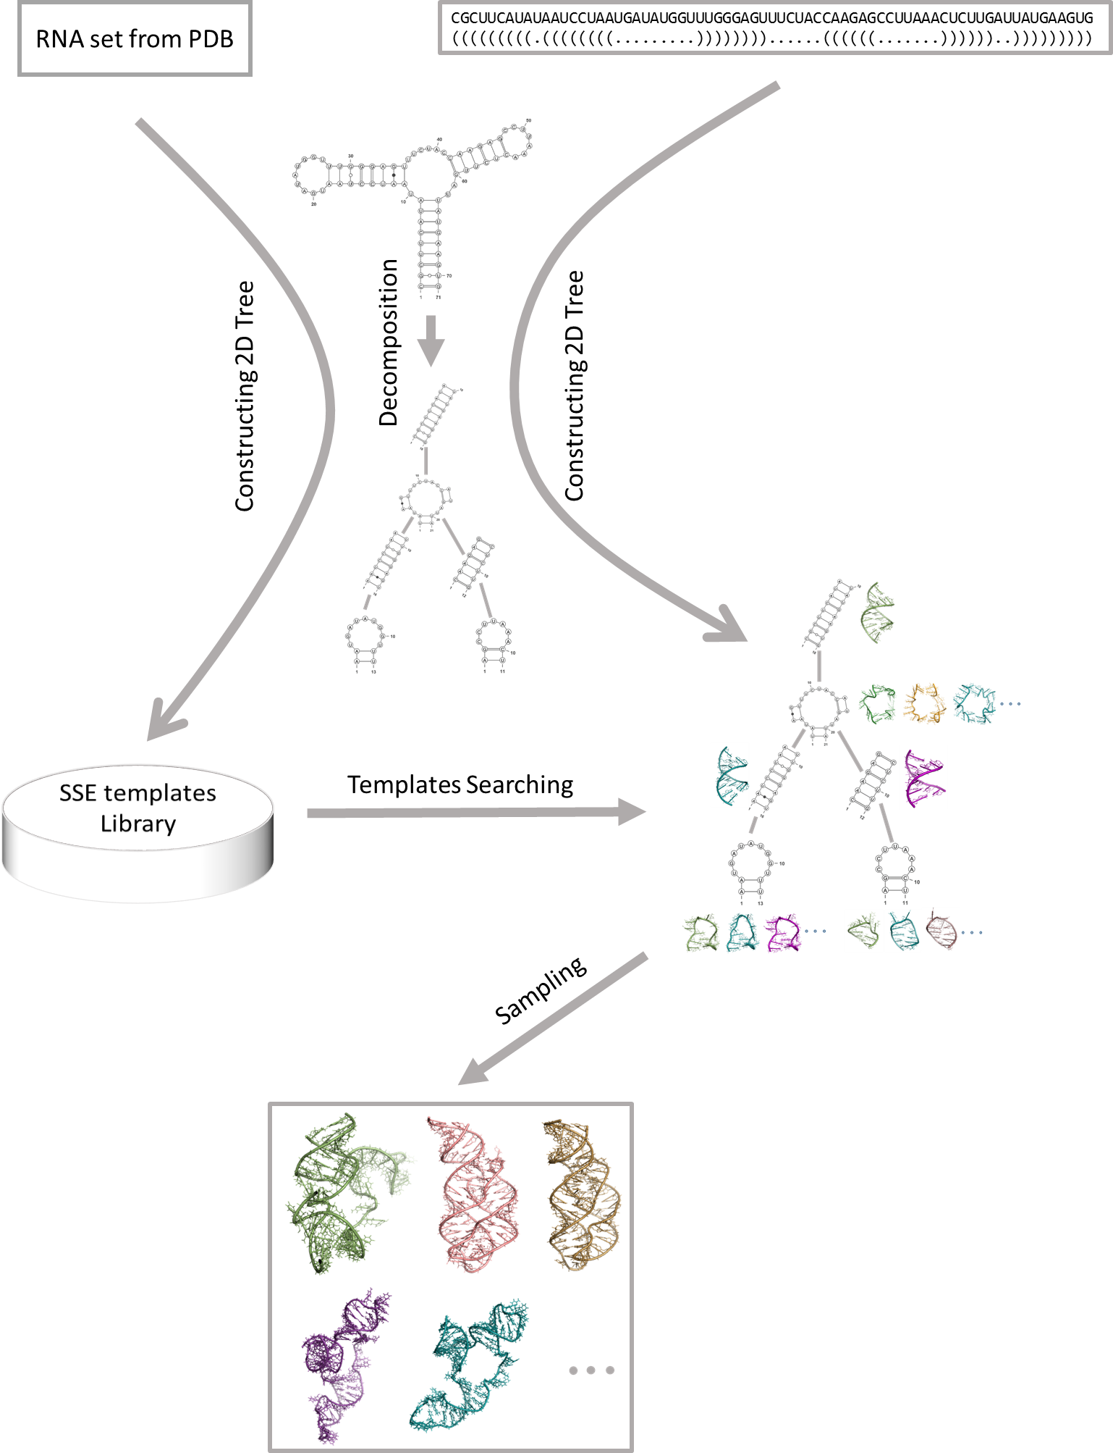

Figure 1 Schematic diagram of the predicting process in 3dRNA-2.0

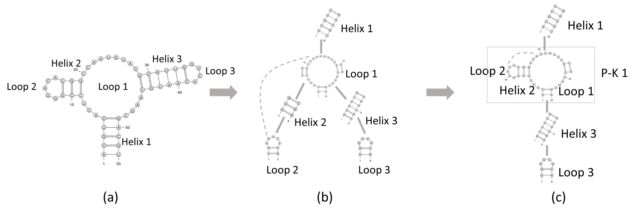

Figure 2 Tree representation of RNA 2D structure. The sequence is “ACGUCACUCCGGGACACGGCCAAUGUACGCAUUGGUCACAAUGCAAGCGACGU” and the dot-bracket form of 2D structure is “(((((...(((.....))).........((((((....))))))....)))))”. The dashed in (a) means that there is pseudo-knot interaction between loop 1 and loop 2.

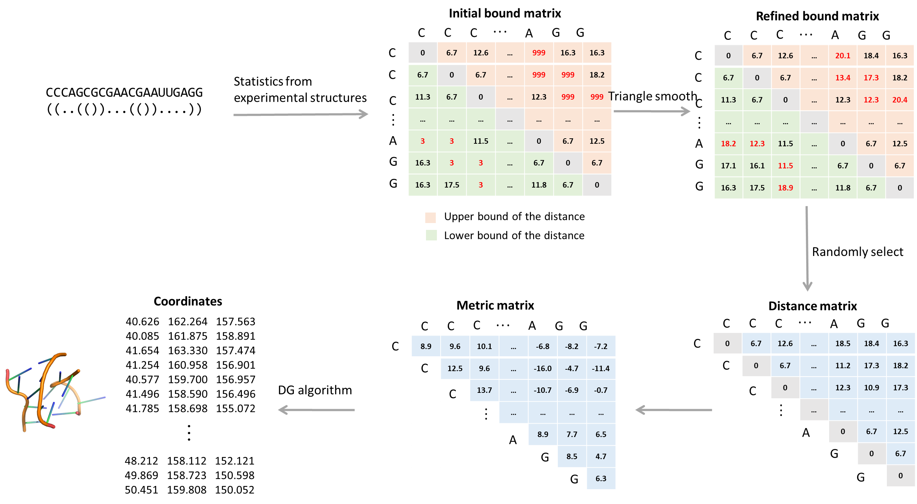

Figure 3 Schematic diagram of loop building using distance geometry.

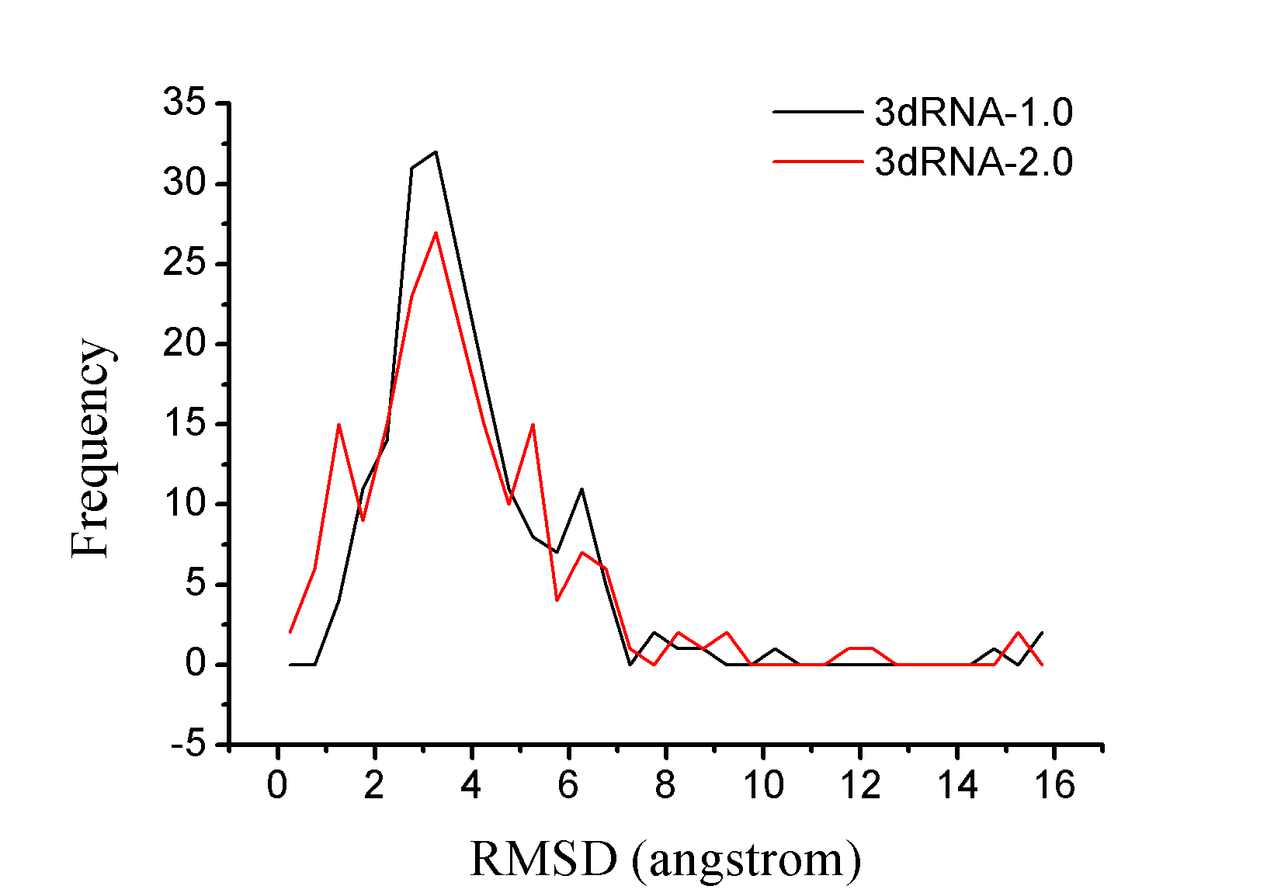

Figure 4 The RMSD distribution of the predictions in the 185 RNA datasets with 3dRNA-1.0 and 3dRNA-2.0, respectively.

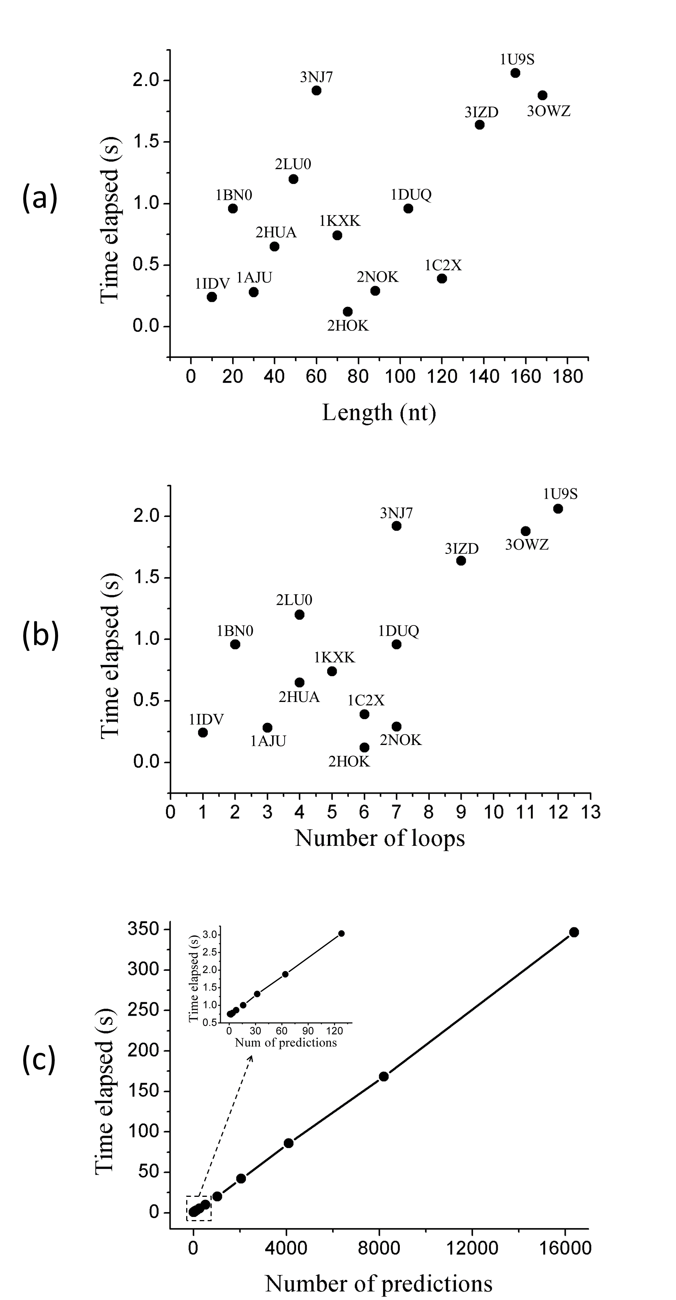

Figure 5 (a) The time elapsed for the prediction of several different RNA molecules with different number of nucleotides. (b) The time elapsed for the prediction of RNA molecules with the topology of different complexity. (c) The time elapsed for different number of predictions of RNA 1KXK.
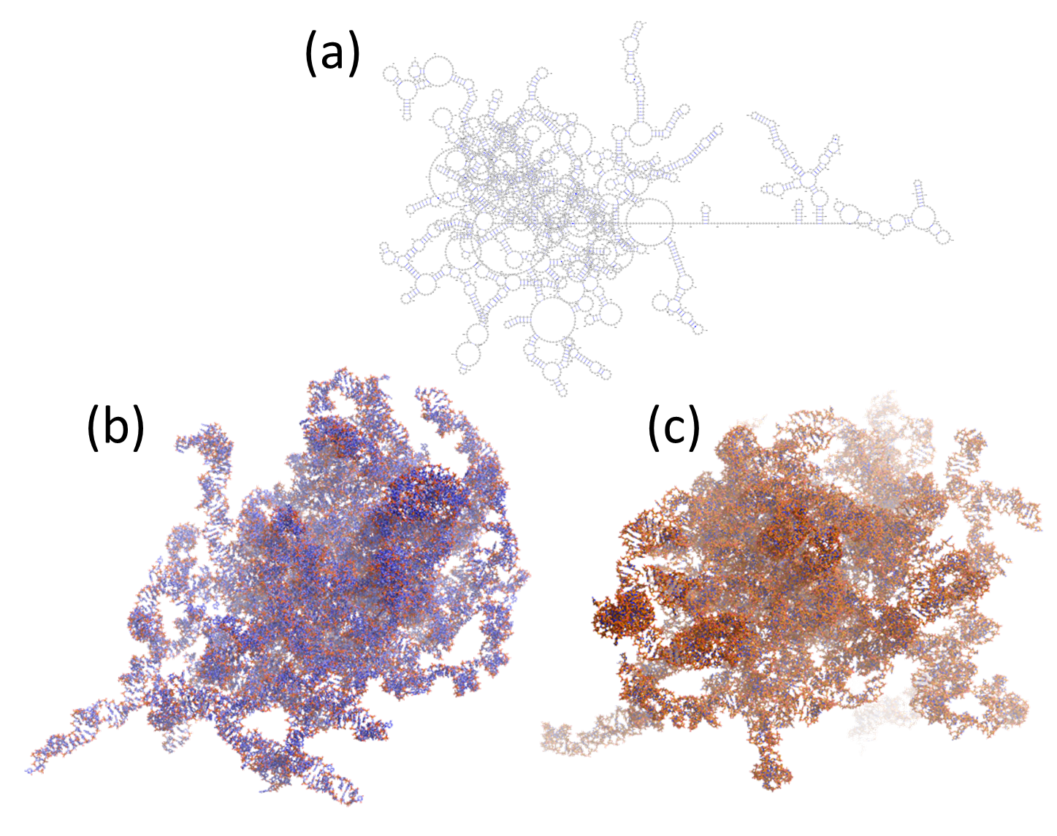

Figure 6 (a) The 2D structure of 3ZEX of 4199 nt. It is generated by VARNA (reference). (b) The native 3D structure of 3ZEX. (c) The predicted 3D structure of 3ZEX with 3dRNA-2.0.

