**Steady State Analysis of Rural Feeder concerning permissible PV-DG**

Distribution Engineering Term Project – Final Report

**Abstract**

This paper provides a summary of an initial steady state analysis of a radial 23kV feeder determining the optimal locations of Photovoltaic –Distributed Generation (PV-DG). As the PV-DG penetration level increases, there can be impacts on the distribution system’s power flow magnitude and direction, line losses, and voltage regulator action. A unique challenge arises on this system due to Duke Energy Progress implementing a distribution system demand response (DSDR) program in which multiple line voltage regulators were installed to achieve a 2 volt profile. Describing the methodology in concluding the optimum PV-DG locations on this feeder will be discussed in further detail keeping in mind that this does not include the dynamic nature of Solar irradiance but only selectively the steady state characteristics.

1. **Introduction**

The original system was provided Duke Energy in CYMEDIST, a commercial steady state power flow tool. This system has 990 spot loads modeled with total connected capacity of 36.02MVA. This feeder had approximately a 7 mile long three-phase backbone and its furthest point being 13 miles from PCC to the furthest single phase load. It also had three 1,200kVAR capacitor banks, three 3- line voltage regulators (VREGs), and one 2- VREG. The topology of this feeder is shown in Appendix A, figure 1 with the backbone conductor being 477CMIL Historical telemetered data was provided at the point of common coupling (PCC), on 7/2/2014 and 4/17/2014. On the summer day at 4:45 there was a daily peak of 9.737MVA which was assumed to be the feeder’s peak. When conducting a permissibility study of PV-DG injection levels, the peak condition is not as pertinent as the maximum ratio condition of load to PV output. The early spring typically has these conditions having relatively clear, cooler days with minimum HVAC loading. Thus, the 4/17/2014 was selected to be used as the loading condition with it having a daily peak three phase power measurement of 6.04MVA. Since we are planning for the future, a 1.25 load increase factor was applied yielding 7.55 MVA. Table I presents the real and reactive power per phase and the future estimate was selected to be testing condition for further PV-DG impact studies.

**Table I** – Unbalanced Loading Conditions

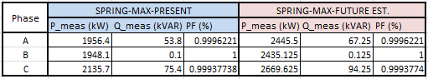

Initial work was focused on developing a simplified system for conceptualizing feeder design. The majority of laterals were condensed to spot loads unless their lengths were considerable. The system was divided into 36 conductor sections depending on if a voltage regulator was present, the locations of capacitor banks, phase conductor gauge, pole configuration, overall length of section, multi-junction nodes, and major lateral branches. All the spot load’s connected capacities were aggregated and an equivalent spot load was modeled at the apparent load center. A 3.3% error was developed with this conversion process, with total connected load of each phase in the actual and equivalent feeder shown in below in Table II.

**Table II** – Connected kVA Error per phase

|  |  |  |  |  |
| --- | --- | --- | --- | --- |
|  | **Phase A (kVA)** | **Phase B (kVA)** | **Phase C (kVA)** | **Three Phase (kVA)** |
| **DEP Feeder** | 11,547 | 12,440 | 12,045 | 36,032 |
| **EQV Feeder** | 11,545 | 12,112 | 11,180 | 34,837 |
| **Error** | 0.022% | 2.633% | 7.18% | **3.316%** |

To view the topology of the actual and equivalent feeders, reference Appendix-A, Figures 1 & 2. Appendix B provides the connected kVA of each spot load and lengths of each section in Tables I & II. The conductor properties and configurations were easily transferred from using the same database associated with the equivalent feeder was modeled in CYME as shown in Appendix A, Figure 3. Only connected load was specified because CYME has an analysis tool called *load allocation* that proportionally distributed the active load depending on that ratio of the individual connected kVA/phase to the total feeder connected kVA/phase. This tool was driven by the PCC’s real and reactive measurements on each phase. To benchmark the simplified model, sampling points were selected on the original feeder to align with the simplified feeder nodes. A common load allocation scenario was applied to both feeders and their voltages and apparent power (S) flow were compared to one another as shown in Appendix C, Figures 1A & 2A. Equation (1) was applied to calculate the percent error as shown in Appendix C, Figures 1B & 2B.

The feeder was divided into three zones where the main divided into two branches. This made it easier to understand where the data points were located. From observing these plots, it was concluded that zones 1 & 2 were properly modeled but in zone 3 at bus 20, the voltage was a maximum of 1.5% higher in the equivalent model than the actual. The load flow checked out having a maximum error of 1%. The reason behind this voltage discrepancy is most likely due to not including enough laterals, neglecting voltage drop. This area of the feeder had numerous single phase laterals going off of a two phase line. With this in mind, it was decided that the simplified model was sufficient to proceed in conducting a PV-DG impact study.

1. **Impact Study Methodology**

**A. Land Feasibility Study –**

Due to the majority of the feeder serving rural connected loads, it was decided that a utility-scale solar PV site (>500kWp) would more likely request to connect. To begin a land feasibility study was conducted referencing the original CYME file for feeder topology and Google Earth. After finding the distribution substation, the main roads of the town where this feeder was located was accurately aligned with the three-phase main line and traced down as shown in Appendix D Figures 1 & 2. From this, it was concluded that Zone 1 was heavily urbanized and there was no open fields to install a PV Farm. Zone 2 (Appendix A, Figure 3) was simple since it had only one conductor section with 13.77 acres of available land. This was found by taking a screenshot of each location with open land and using each associated map scale, the area was estimated. Then, a conversion factor of 1MW/8-Acres was used to conclude a maximum size of 1.72MW. This same process was conducted throughout Zone 3 (Appendix A, Figure 4) and the results are displayed in Appendix D, Table I. This distribution feeder has approximately 723 acres or 90.37MW of available clear land for possible Solar Farm construction.

**B. Individual Permissible PV-DG Injection Level Study –**

The next stage is to increase the PV-DG level at each individual location until either a voltage violation, thermal limit, or voltage regulation limit has been reached. This was an iterative process in which the PV generator was gradually increased in output power and the power flow results recorded. In order to understand the effects of increasing the injected power into the system, a sample case was recorded in detail. Zone 2 was selected due to it being a radial section with only one voltage regulator zone, shown in Appendix E Figure 1. Starting at Bus 12, the PV-DG was commanded to produce 0kW, 200kW, 500kW, and 530kW. After 530kW, the voltage regulator upstream could not compensate anymore for the voltage rise. With the PV-DG outputting 530kW, it covered 48% of incoming zone 2 load and was only 7% of the total system wide load. In Appendix E, Figure 2 shows the secondary voltage at each node along the zone while Figure 3 shows the apparent power flow through the lines. Before PV-DG injection, the zone voltage decreased from 124.6 to 124.4 volts. After, the zone voltage increased as the PV power injection increased until reaching its limit of around 124.7V. The apparent power decreased initially as the real power flow decreased, approaching 0kW. After this, the real power changed directions and the apparent power began to increase in magnitude until reaching the initial kVA level. Therefore, it was observed that having a voltage regulator zone permits the PV-DG injecting power downstream the regulator due to excess voltage rise. When changing the location of the PV’s point of injection (POI) or where the PV generator connects to the feeder, it was apparent that the location was independent of this power limit. This process was initiated through each of selected locations from the permissible land study and the results are displayed in Appendix E, Table I.

From observation the overwhelming reason for ending further PV penetration is because of voltage regulator limitations introduced by the DSDR program. The downstream voltage regulators have 32 taps available at 5/8% (0.0065 P.U.) increments with a 20% bandwidth. With DSRD, they are set at a target 125V with a 5% bandwidth or 123V to 126V. Since this is study was conducted during a low loading condition with the conductors being loaded around 20 – 30% of the thermal limit (Appendix A, Figure 4), the voltage was already high. To get a gauge on how much available voltage drop/rise each location could handle, equation (2) was applied to find the percenter voltage deviation per kVA (k = %).

The per-unit voltages at the POI were recorded at the base case ( and at the maximum PV-DG injection level () case. Due to regulations in the U.S. that permit the use of smart inverters that would have the capability to consume/inject reactive power, the PV-DGs were set at unity power factor hence why the ratings were written in kVA. What was assumed that K would always be positive proved to be incorrect because at certain location, the reverse current flow was much greater in magnitude compared to base case, resulting in a larger voltage drop. Therefore, the constant K portrays if a node with PV will result in power flow greater than its original state before a limit is reached. For example; load 21, 31, and 32 are all located at the end of Zone 3(see Appendix E, Figure 2 and their K values are all positive. Therefore, when a PV-DG site is located at any of these nodes, there will be an increase in voltage and a reserve power flow. When exploring the relationship between and permissible power injection level, (Appendix E, Figure 4) it was discovered that there was a negative association. This translates into a smaller will result in a larger permissible local penetration level, giving indications at the ideal locations for PV-DG POIs.

**C. Optimum location selection with multiple PV Sites–**

When selecting the optimum set of POIs, multiple scenarios were explored. Before selecting random locations, the voltage and power flow profiles were examined in detail. They were broken up into sections where a voltage regulator was located. Zone 3 was examined in detail because of it having the vast majority of available open land and a unique situation with three voltage regulator zones (VR ZONE) in series. To make this a detailed analysis, 5 scenarios were studied by varying the PV-DG in each voltage regulator zone. When referencing Appendix F, Table I; a summary of where the PV-DG is located in each voltage regulator zone is displayed.

|  |  |  |  |  |
| --- | --- | --- | --- | --- |
| **Scenario** | PV / LOAD | (Upstream)  VR_ZONE2 POI Location | (Downstream) VR_ZONE3 POI Location | (Downstream) VR_ZONE4 POI Location |
| **S1** | **43.12%** | **Beginning** | **End** | **End** |
| **S2** | **33.19%** | **End** | **Middle** | **End** |
| **S3** | **41.32%** | **End** | **End** | **End** |
| **S4** | **29.53%** | **Beginning** | **Beginning** | **Beginning** |
| **S5** | **42.97%** | **-** | **End** | **End** |

From initial observations, S4 is by far the worst scenario when attempting to find max PV output to system load ratio. When exploring why S2 could not increase in penetration level, The POI in VR_ZONE3 (LD18) is located on a single phase lateral at the intersection between two radial branches. At this location, the PV-DG greatly alters the voltage profile as observed by this POI having one of the largest K constants of 3.44E-3. Therefore, this scenario was also eliminated. The remaining three scenarios all have the relatively same PV/LOAD ratios but have POIs located at various locations along the VR Zones. From an initial 85.3kW lost due to copper losses; S1, S3, and S5 dropped the system losses to 33.9kW, 33.2kW, and 42.7kW respectively. S5 had the lowest drop in copper losses because it has two large PV-DGs at the end of the downstream VR zones, thus pushing more reverse power through the VR zones.

When solely comparing the power loss reductions with injecting PV-DG, a definitive decision cannot be made into which configuration is best. Therefore, a comparison of Zone 3’s voltage and power flow impacts needs to be conducted. The voltage and power flow profiles of S1, S3, and S5 are portrayed in Appendix F, Figures 2, 3, and 4 respectively. The original system profiles without PV-DG and the PV-DG profiles were laid on top of one another to make is easy to observe the impacts. When selected the optimum scenario, its voltage profile must be minimally impacted having minimal power flow. S5 showed extremely reverse power flow, injecting power upstream of VR_ZONE2 or Bus 17. With this power flow condition, the voltage profile’s slope on section 2 reversed directions and started to decrease in between 1.03 – 1.035 PU. S5 was therefore deemed as not the optimum configuration.

When comparing S1 and S3, their power flow impacts are nearly identical except in VR_ZONE2 (Section 1) where S3 has a larger magnitude in power flow. Note the only difference between S1 and S3 is where the POI is located within VR_ZONE2 (Section 1). In S3 where the POI is located at the end of VR_ZONE2, the voltages of ZONE 3 are raised to around the maximum voltage of 1.045 PU. Comparing this impact to S1, having the POI and the beginning of the upstream VR zone will minimize the voltage impact to the system downstream. From the observation of a voltage profile nearly identical to the base case, S1 was selected as the most optimal configuration of POIs on this rural distribution feeder.

1. **Mitigation Strategies**

**A. Re-conductor Existing Lines–**

One mitigation strategy commonly discussed is to re-conductor the existing lines with a larger capacity rating wire. For this specific feeder, 477KCMIL ASCR conductor was used for the main on ZONE 1 and partially on ZONE 3 to Bus 16. From this point, the conductor size drops from a #4AWG ASCR to eventually a #2AWG ASCR throughout VR_ZONE2. All three phase line’s phase conductors located within VR_ZONE2 were changed 477kCMIL with a neutral conductor size of #2AWG. Typically, upgrading a circuit normally costs more than building a new line because this work is done live. The old conductor has to be moved to standoff brackets while the new conductor is strung. In our case, the poles would most likely need to be reinforced to handle the heavier conductor. Therefore, it was assumed that it would cost $13.75/ft for the new material, $2.65/ft for labor of uninstalling the life conductor, and $3.5/ft to install the new conductor. With this section being approximately 17,124 feet long, this upgrade would cost approximately $340,000. The question arises will this improve the system’s capacity of PV-DG. The three POI scenarios examined in Section II were run again with this upgrade and the voltage and power flow impacts are displayed in Appendix G, Figures 1-3. Comparing the original system profiles to the upgraded system profiles, the power flow did not change but the voltage drop in each VR Zone decreased drastically. Unfortunately, the upstream voltage levels at each zone did not alter, hardly increasing the PV-DG’s percent penetration limit. The only economical reason to re-conductor is when there is a PV-DG site located on a lateral that needs to increase capacity to support the generated power. In this study, single phase lateral conductors labeled sections X and BB could be upgraded to support larger PV facilities.

**B. Topology Reconfiguration–**

Another option is to reconfigure the topology of the feeder. This entails changing where the main and laterals connect with one another, installing a new three phase line on existing right-of-ways or new pathways, and lastly somehow create a loop configuration instead of radial. Due to the unique topology of this rural feeder, a single phase ZONE 3 lateral (highlighted in red on Figure 1 within Appendix H) terminated extremely close to a three phase main line of ZONE 2. To explore the potential benefits of a looped configuration, this 9,084ft lateral’s line conductor was replaced with a three phase #2AWG line shown in Figure 2 of Appendix H. From inspecting Figure 3A, Section 2 (where the new connection was made) of Zone 3’s voltage dropped after the topology reconfiguration. Even though the power mostly remained the same, this lower voltage, it is presumed that the nodal permissible PV levels would change along with introducing more complexity in Voltage Regulation zoning. Further research will need to be conducted to determine if this topology configuration would be a detriment or a benefit to the feeder.

1. **Conclusion**

The steady state analysis of determining the nodal permissible PV-DG injection limit is typically the initial step when understanding the impacts on a distribution feeder. In order to minimize these impacts, PV-DG’s POI needs to be strategically located in places where there would be a minimum impact on the voltage profile by just covering the local load to a certain distance away. From the five scenarios presented, the most ideal was S1, 43% penetration, with it having a POI at the beginning of the upstream voltage regulator zone. This introduces enough voltage drop before the next VREG to avoid the remaining zones to be affected. Because this configuration passed the steady state analysis does not mean that it can present dynamic problems such as excess regulator tap changes or voltage flicker in a response to the random nature of Solar PV.

**Appendix A: Circuit Diagrams**

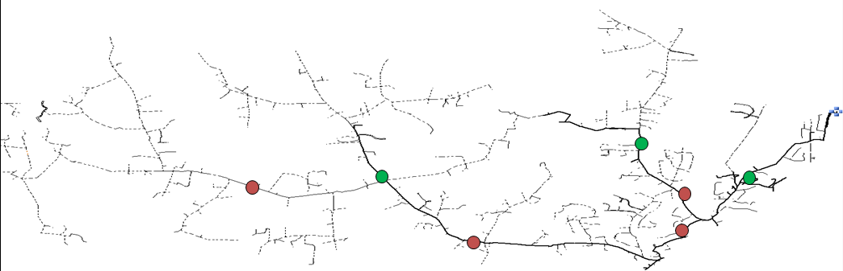

Figure 1 – Original CYME File Provided by Duke Energy

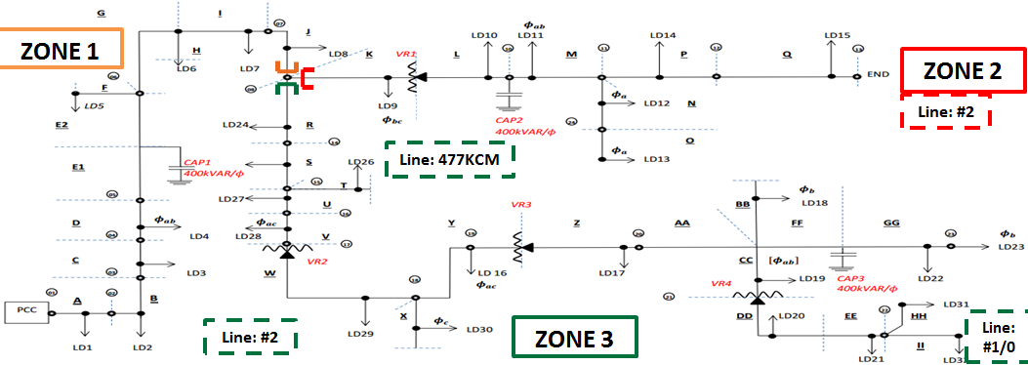

Figure 2 – Simplified Feeder

**Appendix A: Circuit Diagrams**

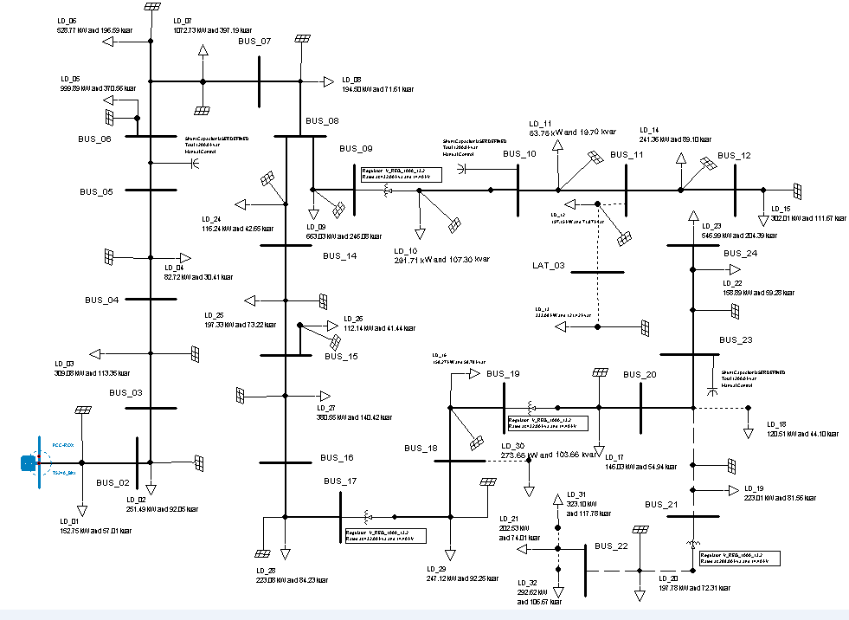

**Figure 3** – Simplified Feeder Modeled in CYME

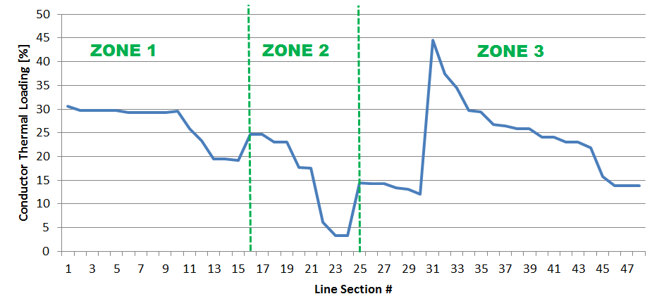

**Figure 4** – Relative Loading Condition for Test Case

**Appendix B: Simplified Feeder Parameters**

|  |  |  |  |  |
| --- | --- | --- | --- | --- |
| **LOAD NAME** | **(kVA)** | **(kVA)** | **(kVA)** | **CUSTOMERS** |
| **LD1** | **143** | **88** | **315** | 83 |
| **LD2** | **192.5** | **710.5** | **25** | 118 |
| **LD3** | **694** | **304** | **138** | 81 |
| **LD4** | **123** | **130** | **50** | 19 |
| **LD5** | **1132.5** | **1100** | **1382.5** | 12 |
| **LD6** | **439.8333** | **577.8333** | **884.3333** | 36 |
| **LD7** | **1360.333** | **1125.333** | **1398.333** | 73 |
| **LD8** | **128** | **452** | **131** | 53 |
| **LD9** | **0** | **1458** | **935** | 164 |
| **LD10** | **167** | **734** | **167** | 96 |
| **LD11** | **25** | **163** | **10** | 18 |
| **LD12** | **731** | **0** | **0** | 51 |
| **LD13** | **1235** | **0** | **0** | 0 |
| **LD14** | **378** | **250** | **250** | 13 |
| **LD15** | **348.6667** | **398.6667** | **348.6667** | 8 |
| **LD16** | **305** | **0** | **265** | 30 |
| **LD17** | **80** | **20** | **415** | 18 |
| **LD18** | **0** | **445** | **0** | 19 |
| **LD19** | **120** | **704** | **0** | 60 |
| **LD20** | **160** | **571** | **0** | 44 |
| **LD21** | **271** | **478** | **0** | 62 |
| **LD22** | **207.5** | **30** | **330.5** | 42 |
| **LD23** | **0** | **806** | **1146** | 122 |
| **LD24** | **176** | **201** | **50** | 33 |
| **LD25** | **188** | **229.5** | **294.5** | 61 |
| **LD26** | **214** | **62.5** | **130.7159** | 14 |
| **LD27** | **270** | **772** | **344** | 125 |
| **LD28** | **25** | **50** | **707** | 50 |
| **LD29** | **147.5** | **227** | **508.5** | 54 |
| **LD30** | **0** | **0** | **954** | 98 |
| **LD31** | **1198** | **0** | **0** | 76 |
| **LD32** | **1085** | **0** | **0** | 95 |
| **TOTAL CONN** | **11544.83** | **12087.33** | **11180.05** | **1828** |

Table I – Simplified Feeder Spot Load Connected kVA Summary

**Appendix B: Simplified Feeder Parameters**

Table II – Simplified Feeder Line Section Summary

|  |  |  |  |  |  |  |  |
| --- | --- | --- | --- | --- | --- | --- | --- |
| **Section Name** | **Length (ft)** | **App. L** | **Load Center** | **Length Remain** | **Phase Conductor** | **Neutral** | **Spacing** |
| **A** | 3194 | 0.5 | 1597 | 1597 | PEC_477KCMIL_AAC | PEC_#4AWG_CHD | PEC_PEC_23kV_Tria_3P |
| **B** | 307.6 | 0.5 | 153.8 | 153.8 | PEC_477KCMIL_AAC | PEC_#4AWG_CHD | PEC_PEC_23kV_Tria_3P |
| **C** | 3765.2 | 0.5 | 1882.59 | 1882.59 | PEC_477KCMIL_AAC | PEC_#1/0AWG_ACSR | PEC_PEC_23kV_Tria_3P |
| **D** | 968.8 | 0.4 | 387.52 | 581.28 | PEC_477KCMIL_AAC | PEC_#1/0AWG_ACSR | PEC_PEC_23kV_Tria_3P |
| **E_1** | 230 | - | - | - | PEC_477KCMIL_AAC | PEC_#1/0AWG_ACSR | PEC_PEC_23kV_Tria_3P |
| **E_2** | 102 | - | - | - | PEC_477KCMIL_AAC | PEC_#1/0AWG_ACSR | PEC_PEC_23kV_Tria_3P |
| **F** | 2246 | 0.5 | 1123 | 1123 | PEC_#1/0AWG_ACSR | PEC_#1/0AWG_ACSR | PEC_PEC_23kV_VERT_3P |
| **G** | 358 | - | - | - | PEC_477KCMIL_AAC | PEC_#1/0AWG_ACSR | PEC_PEC_23kV_Tria_3P |
| **H** | 938 | 0.7 | 656.6 | 281.4 | PEC_#4/0AWG_AAAC | PEC_#1/0AWG_AAAC | PEC_PEC_23kV_Tria_3P |
| **I** | 1770 | 0.5 | 885 | 885 | PEC_477KCMIL_AAC | PEC_#4AWG_CHD | PEC_PEC_23kV_VERT_3P |
| **J** | 1214 | 0.5 | 607 | 607 | PEC_477KCMIL_AAC | PEC_#1/0AWG_ACSR | PEC_PEC_23kV_VERT_3P |
| **K** | 3542 | 0.8 | 2833.6 | 708.4 | PEC_#2AWG_ACSR | PEC_#2AWG_ACSR | PEC_PEC_23kV_TRIA_3P |
| **L** | 2950 | 0.7 | 2065 | 885 | PEC_#2AWG_ACSR | PEC_#4AWG_CHD | PEC_PEC_23kV_VERT_3P |
| **M** | 1450 | 0.8 | 1160 | 290 | PEC_#1/0AWG_ACSR | PEC_#4AWG_CHD | PEC_PEC_23kV_TRIA_3P |
| **N** | 3965 | 0.8 | 3172 | 793 | PEC_#2AWG_ACSR | PEC_#2AWG_ACSR | PEC_PEC_23kV_TRIA_1P |
| **O** | 6381 | 0.9 | 5742.9 | 638.1 | PEC_#2AWG_ACSR | PEC_#2AWG_ACSR | PEC_PEC_23kV_TRIA_1P |
| **P** | 2433 | 0.8 | 1946.4 | 486.6 | PEC_#2AWG_ACSR | PEC_#2AWG_ACSR | PEC_PEC_23kV_TRIA_3P |
| **Q** | 3516 | 0.9 | 3164.4 | 351.6 | PEC_#2AWG_ACSR | PEC_#2AWG_ACSR | PEC_PEC_23kV_TRIA_3P |
| **R** | 1360 | 0.6 | 816 | 544 | PEC_477KCMIL_AAC | PEC_#1/0AWG_ACSR | PEC_PEC_23kV_TRIA_3P |
| **S** | 3304 | 0.5 | 1652 | 1652 | PEC_477KCMIL_AAC | PEC_#1/0AWG_ACSR | PEC_PEC_23kV_VERT_3P |
| **T** | 947 | 0.7 | 662.9 | 284.1 | PEC_477KCMIL_AAC | PEC_#2AWG_CHD | PEC_PEC_23kV_TRIA_3P |
| **U** | 3530 | 0.8 | 2824 | 706 | PEC_477KCMIL_AAC | PEC_#2AWG_ACSR | PEC_PEC_23kV_TRIA_3P |
| **V** | 824.44 | 0.5 | 412.22 | 412.22 | PEC_#4AWG_CHD | PEC_#2AWG_ACSR | PEC_PEC_23kV_TRIA_3P |
| **W** | 4519.2 | 0.5 | 2259.62 | 2259.62 | PEC_#2AWG_ACSR | PEC_#2AWG_ACSR | PEC_PEC_23kV_HORZ_3P |
| **X** | 14000 | 0.5 | 7000 | 7000 | PEC_#2AWG_ACSR | PEC_#2AWG_ACSR | PEC_PEC_23kV_TRIA_1P |
| **Y** | 3875 | 0.6 | 2325 | 1550 | PEC_#2AWG_ACSR | PEC_#2AWG_ACSR | PEC_PEC_23kV_HORZ_3P |
| **Z** | 2760 | 0.4 | 1104 | 1656 | PEC_#2AWG_ACSR | PEC_#2AWG_ACSR | PEC_PEC_23kV_HORZ_3P |
| **AA** | 810 | - | - | - | PEC_#2AWG_ACSR | PEC_#2AWG_ACSR | PEC_PEC_23kV_HORZ_3P |
| **BB** | 9084 | 0.7 | 6358.8 | 2725.2 | PEC_#6AWG_RD | PEC_#6AWG_RD | PEC_PEC_23kV_TRIA_1P |
| **CC** | 2625 | 0.9 | 2362.5 | 262.5 | PEC_#2AWG_ACSR | PEC_#4AWG_CHD | PEC_PEC_23kV_TRIA_2P |
| **DD** | 4815.1 | 0.5 | 2407.57 | 2407.57 | PEC_#2AWG_ACSR | PEC_#4AWG_CHD | PEC_PEC_23kV_HORZ_2P |
| **EE** | 11856 | 0.8 | 9484.66 | 2371.16 | PEC_#1/0AWG_AAAC | PEC_#1/0AWG_AAAC | PEC_PEC_23kV_TRIA_2P |
| **FF** | 419 | - | - | - | PEC_#2AWG_ACSR | PEC_#4AWG_CHD | PEC_PEC_23kV_HORZ_2P |
| **GG** | 3916 | 0.8 | 3132.8 | 783.2 | PEC_#2AWG_ACSR | PEC_#4AWG_CHD | PEC_PEC_23kV_HORZ_3P |
| **HH** | 10814 | 0.8 | 8651.58 | 2162.9 | PEC_#1/0AWG_AAAC | PEC_#1/0AWG_AAAC | PEC_PEC_23kV_TRIA_1P |
| **II** | 16996 | 0.8 | 13596.8 | 3399.2 | PEC_#1/0AWG_AAAC | PEC_#1/0AWG_AAAC | PEC_PEC_23kV_TRIA_1P |

**Appendix C: Comparison between Feeder Models**

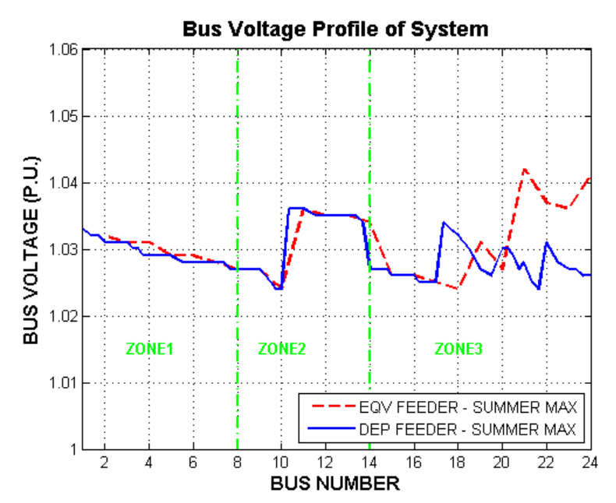

**Figure 1A** – Voltage Profile of the Two Systems

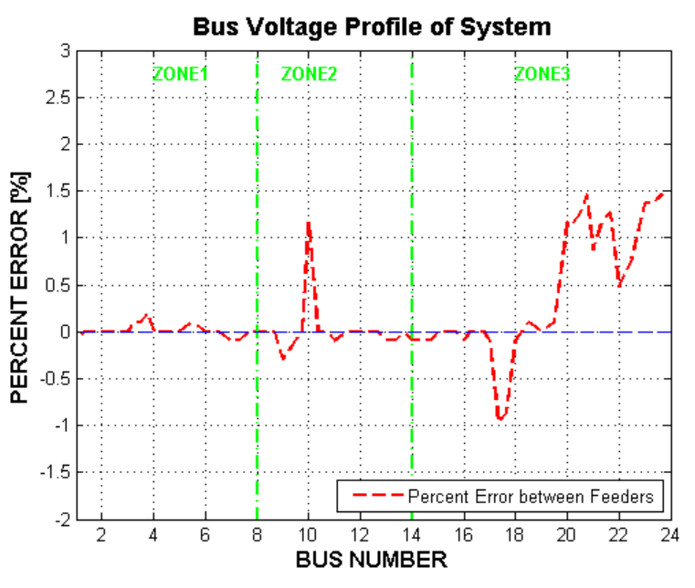

**Figure 1B** – Percent Error of Voltage Profile

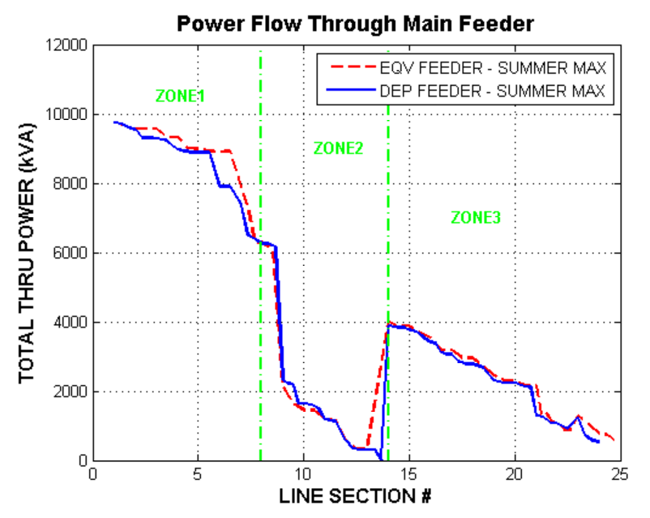

**Figure 2A** – Apparent Power Profile of the Two Systems

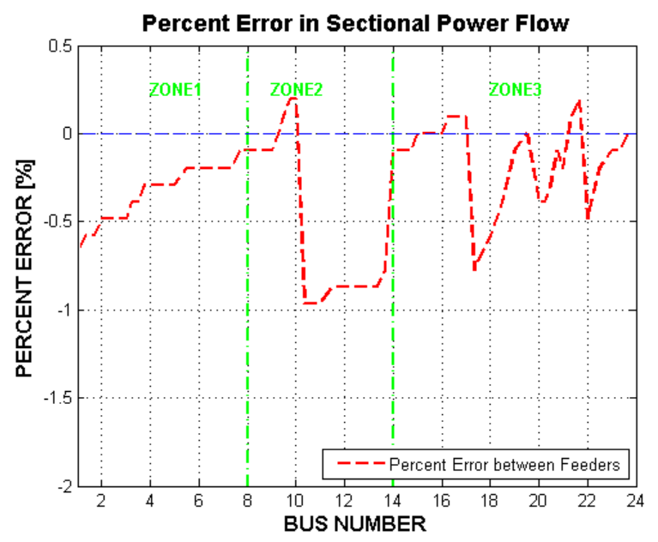

**Figure 2B** – Percent Error of Power Flow Profile

**Appendix D: Available Land Study**

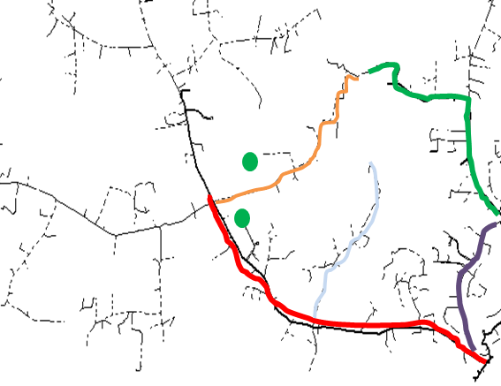

Figure 1 – Trace of Feeder Lines Referencing Original CYME File

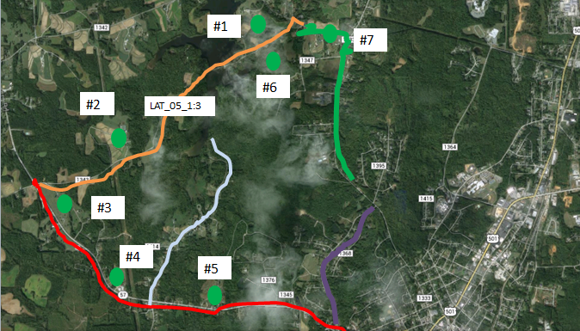

Figure 2 – Trace of Feeder Lines using Google Earth

**Appendix E: Individual Permissible PV-DG to Local Limitations**

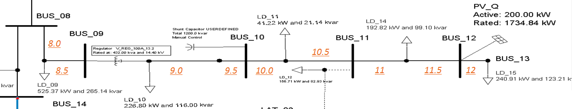

Figure 1 – Detailed Depiction of Zone 2

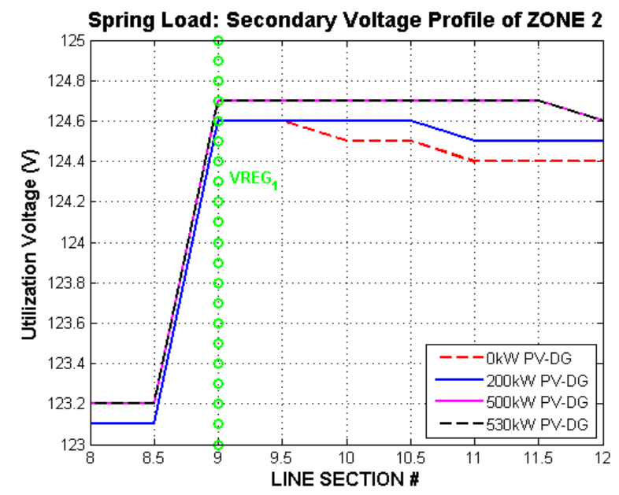

Figure 2 – Secondary Voltage Profile of Zone 2

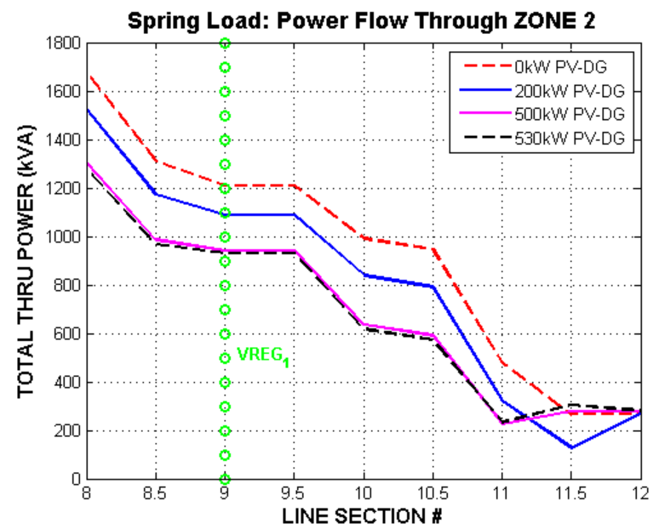

Figure 3 – Apparent Power Flow through Zone 2

**Appendix E: Individual Permissible PV-DG to Local Limitations**

**Table I** – Land Availability & Permissible PV-DG Results

|  |  |  |  |  |  |  |  |  |  |
| --- | --- | --- | --- | --- | --- | --- | --- | --- | --- |
| **Load Name** | **ft^2** | **Acres** | **MW** | **Permissible PV-DG (kW)** | **Conductor Type** | **# of Phases** | **Limit** | **%VD/kW** | **VR ZONE** |
| **LD15** | 6.00E+05 | 13.77 | 1.722 | **530** | #2 | 3 | VR Tap | 5.660E-04 | 1 |
| **LD16** | 7.00E+05 | 16.07 | 2.009 | **2008** | #2 | 3 | VR Tap | 2.490E-04 | 2 |
| **LD29** | 2.80E+05 | 6.43 | 0.803 | **803** | #2 | 3 | VR Tap | **-2.491E-04** | 2 |
| **LD30** | 1.00E+06 | 22.96 | 2.870 | **870** | #2 | 1 | VR Tap | 1.494E-03 | 2 |
| **LD17** | 1.25E+06 | 28.70 | 3.587 | **2015** | #2 | 3 | VR Tap | -5.955E-04 | 3 |
| **LD18** | 1.20E+06 | 27.43 | 3.429 | **436** | #6 | 1 | Capacity | 3.440E-03 | 3 |
| **LD19** | 1.95E+06 | 44.65 | 5.581 | **1340** | #2 | 2 | VR Tap | -5.224E-04 | 3 |
| **LD22** | 1.00E+06 | 22.96 | 2.870 | **2010** | #2 | 3 | VR Tap | -4.478E-04 | 3 |
| **LD23** | 3.00E+06 | 68.87 | 8.609 | **2015** | #2 | 3 | VR Tap | **-2.978E-04** | 3 |
| **LD20** | 7.75E+05 | 17.79 | 2.224 | **1250** | #2 | 2 | VR Tap | -8.000E-05 | 4 |
| **LD21** | 2.75E+06 | 63.13 | 7.891 | **1250** | #1/0 | 2 | VR Tap | 6.400E-04 | 4 |
| **LD31** | 1.00E+07 | 229.57 | 28.696 | **880** | #1/0 | 1 | Voltage | **3.409E-03** | 4 |
| **LD32** | 7.00E+06 | 160.70 | 20.087 | **840** | #1/0 | 1 | Voltage | 3.810E-03 | 4 |

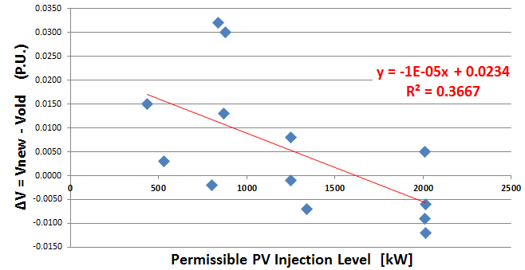

**Figure 4** – Relationship between Voltage deviation and Max KW

**Appendix F: PV Locational Scenario Results**

**Table I** – PV Impact Scenario Parameters

|  |  |  |  |  |  |  |  |
| --- | --- | --- | --- | --- | --- | --- | --- |
| **Load Name** | **S1 (kW)** | **S2 (kW)** | **S3 (kW)** | **S4 (kW)** | **S5 (kW)** | **Location** | **VR_ZONE** |
| LD15 | 530 | 530 | 530 | 530 | 530 | *End* | 1 |
| LD16 |  | 700 | 700 |  |  | *End* | 2 |
| LD29 | 803 |  |  | 400 |  | *Start* | 2 |
| LD30 |  |  |  |  |  | *Middle* | 2 |
| LD17 |  |  |  | 800 |  | *Start* | 3 |
| LD18 |  | 436 |  |  |  | *Middle* | 3 |
| LD19 |  |  |  |  |  | *End* | 3 |
| LD22 |  |  |  |  |  | *Middle* | 3 |
| LD23 | 1215 |  | 1250 |  | 2015 | *End* | 3 |
| LD20 |  |  |  | 500 |  | *Start* | 4 |
| LD21 |  |  |  |  |  | *Middle* | 4 |
| LD31 | 708 |  |  |  |  | *End* | 4 |
| LD32 |  | 840 | 640 |  | 700 | *End* | 4 |
| **Total kW** | **3256** | **2506** | **3120** | **2230** | **3245** |  |  |
| **System Penetration Level** | **43.12%** | **33.19%** | **41.32%** | **29.53%** | **42.97%** |  |  |

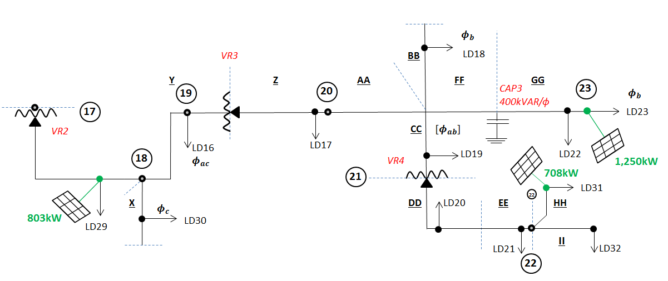**Figure 1** – A Simplified Depiction of Scenario 1 (S1) in Zone 3

**Appendix F: PV Locational Scenario Results**

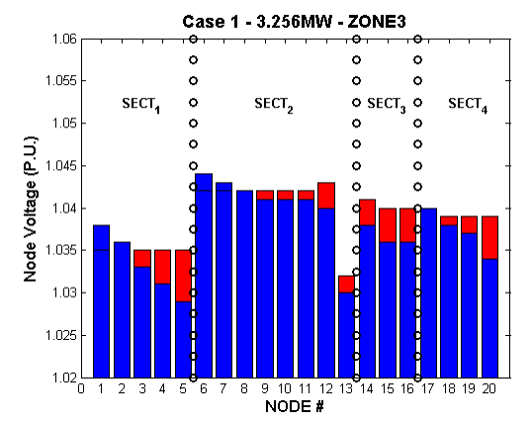 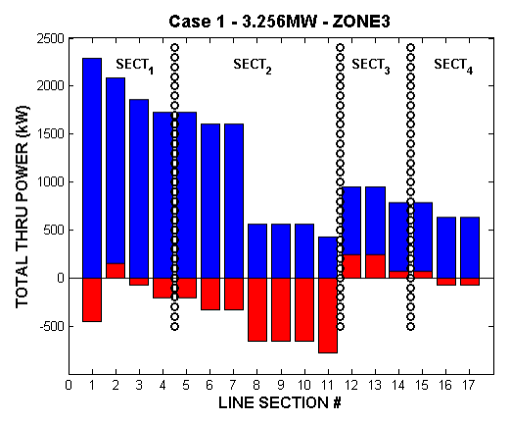

**Figure 2A** - S1’s Voltage Impact **Figure 2B** - S1’s Power Flow Impact

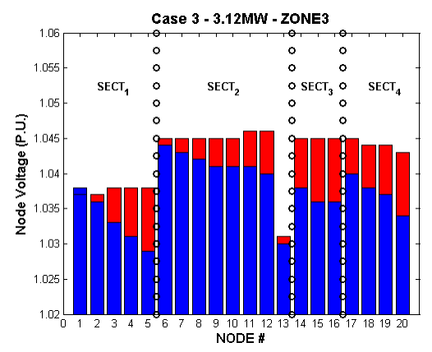 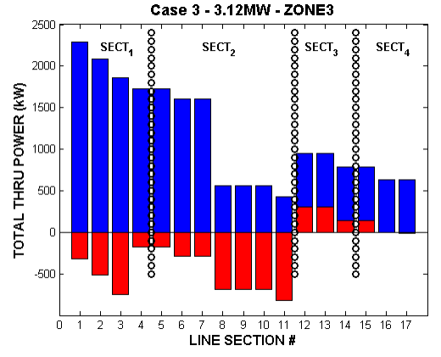

**Figure 3A** - S3’s Voltage Impact **Figure 3B** - S3’s Power Flow Impact

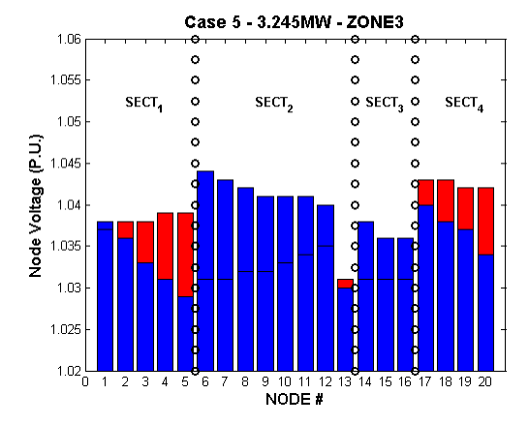 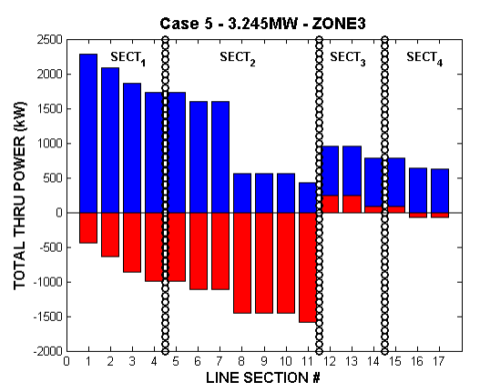

**Figure 4A** - S5’s Voltage Impact **Figure 4B** - S5’s Power Flow Impact

**Appendix G: 477KCMIL-Main PV Scenarios**

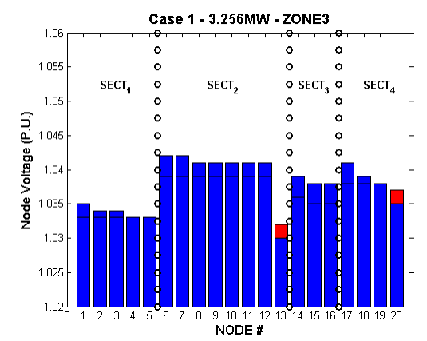

**Figure 1A** - S1 - Original System **Figure 1B** - S1 - Upgraded System

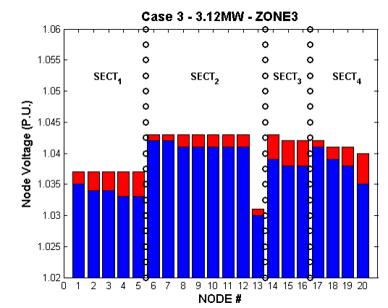

**Figure 2A** - S3 - Original System **Figure 2B** - S3 - Upgraded System

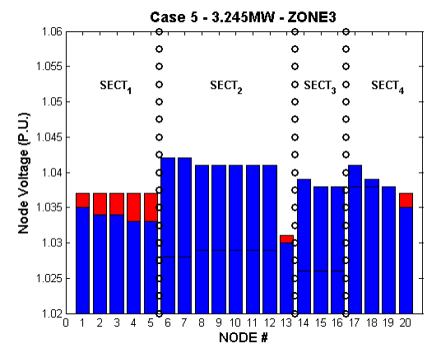

**Figure 3A**- S5 - Original System **Figure 3B** - S5 - Upgraded System

**Appendix H: Topology Reconfiguration Results**

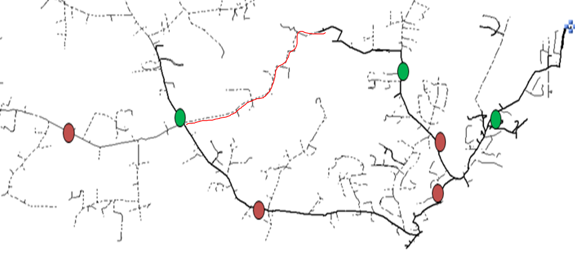

**Figure 1 -** Topology Reconfiguration highlighted in RED

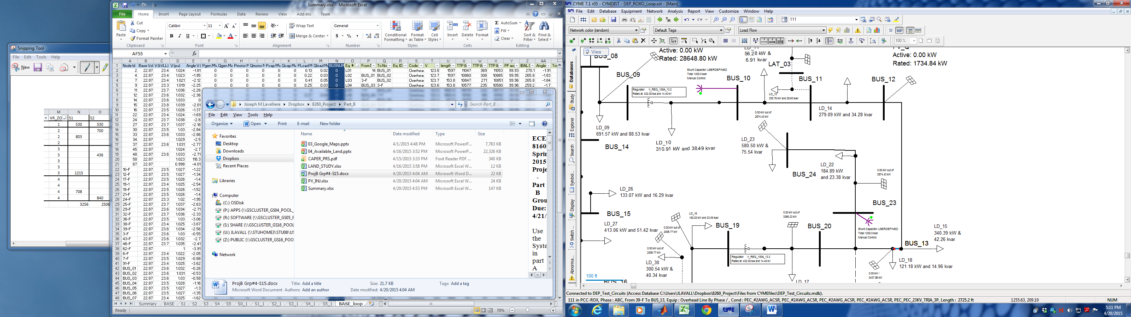

**Figure 2**- Topology Change in CYME (BUS 13 to LD 18)

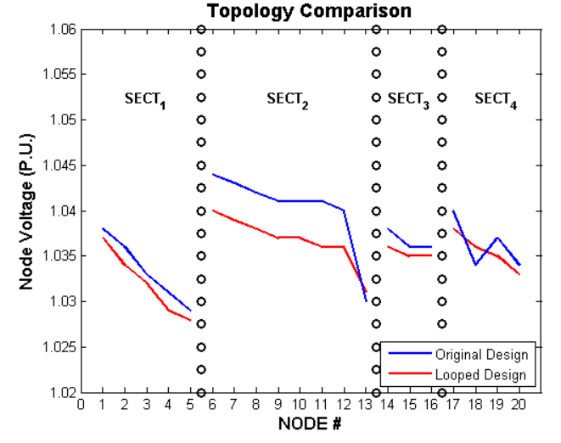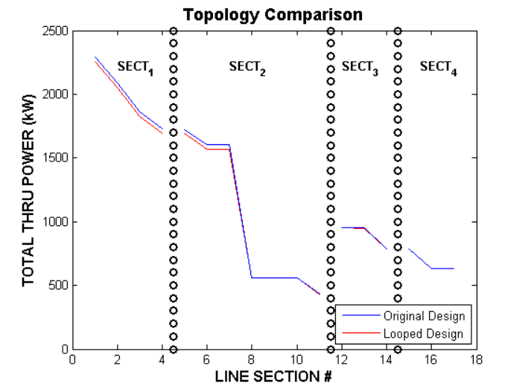

**Figure 3A** - Voltage Profile Comparison **Figure 3B** - Power Flow Comparison