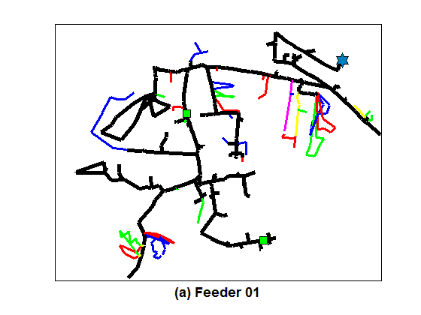

**Feeder 01:** Bellhaven, 12.47kV

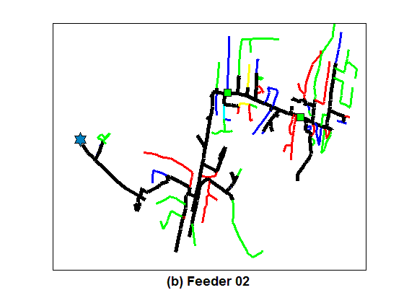

**Feeder 02:** Commonwealth, 12.47kV

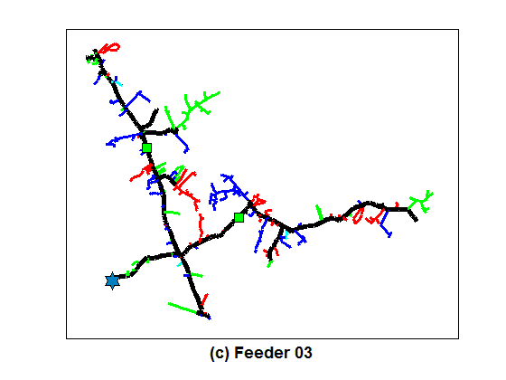

**Feeder 03:** Flay, 12.47kV

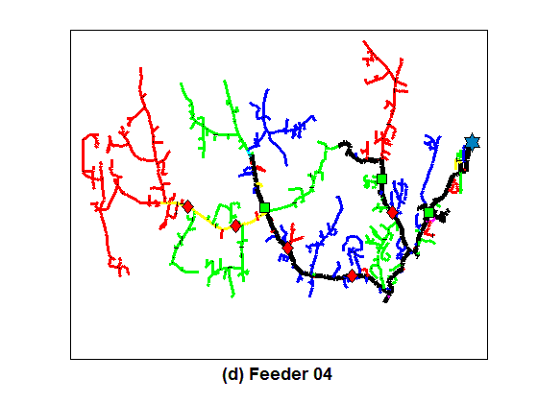

**Feeder 04:** Roxboro, 22.90kV

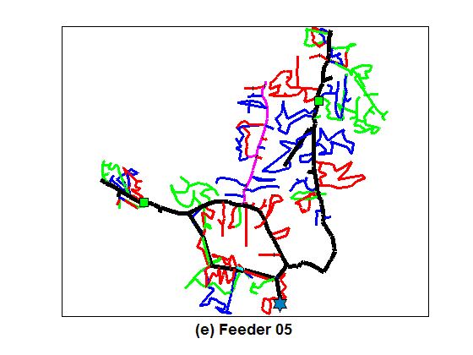

**Feeder 05:** Hollysprings, 22.90kV

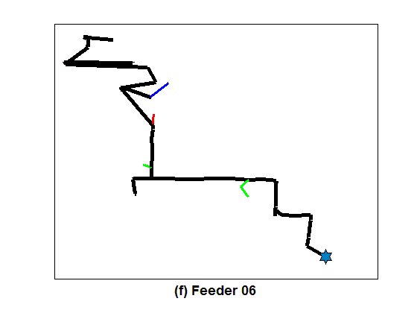

**Feeder 06:** E. Raleigh 12.47kV

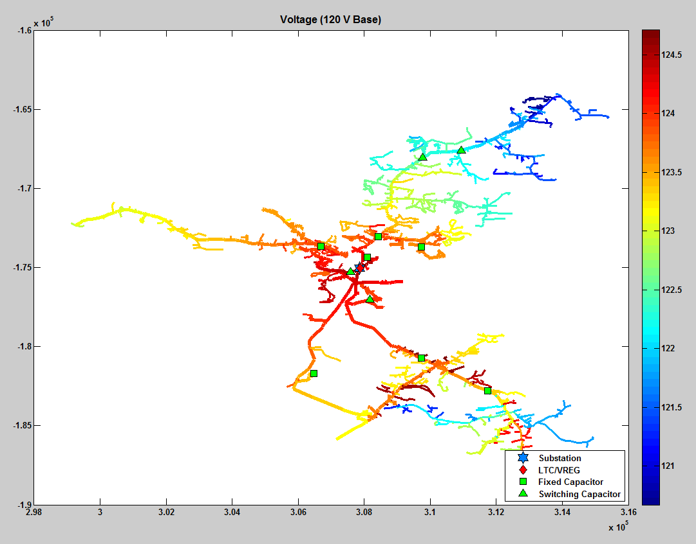

Substation 1: Mocksville Main 23.9kV