1.

On this occasion we will report the rp_16bit

**1.1** Running the code the coverage the file

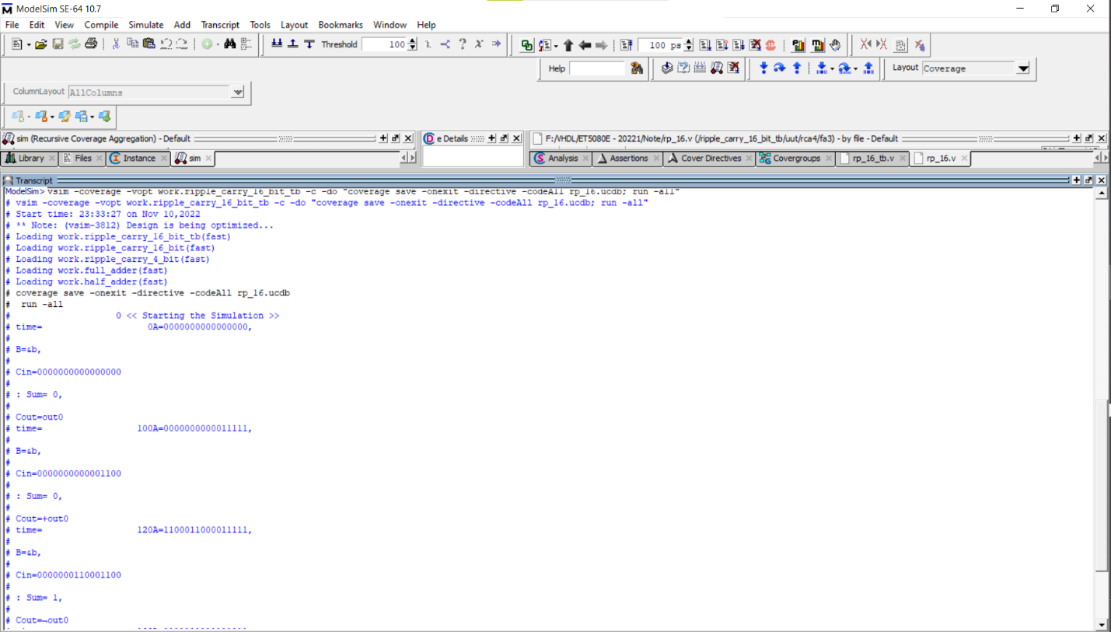

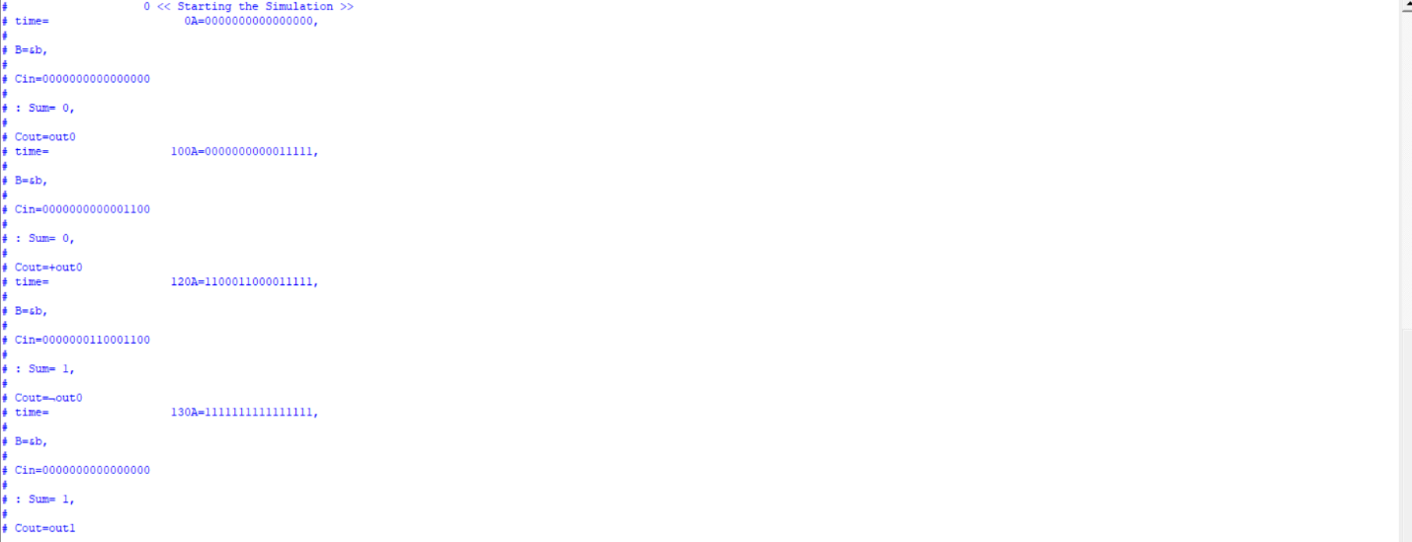

**1.2** Coverage the result into html file

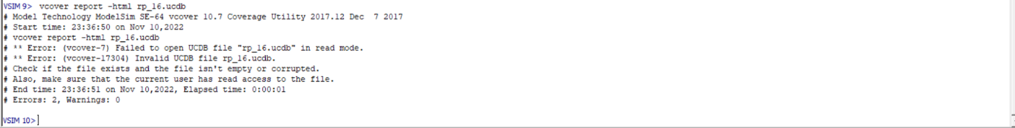

**1.3** Covhtreport into html file

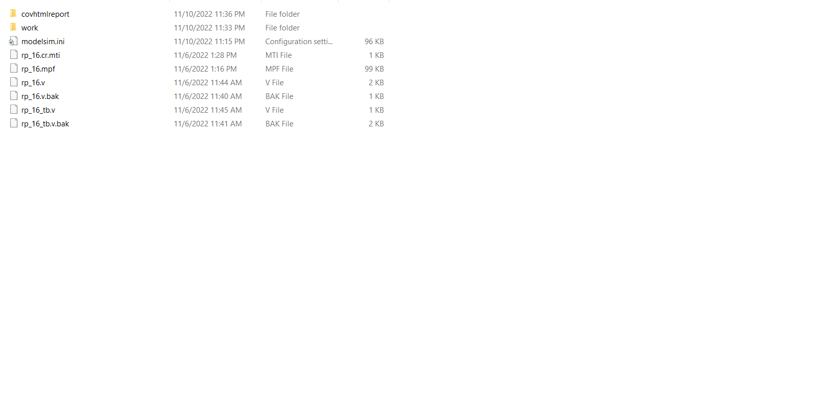

**1.4** Final report on the website

