**Verilog**

module encoder_7segment (

input [3:0] in ,

output reg [6:0] out

);

always @(in) begin

case (in)

4'b0000: begin

out = 7'b1111110;

end

4'b0001: begin

out = 7'b0110000;

end

4'b0010: begin

out = 7'b1101101;

end

4'b0011: begin

out = 7'b1111001;

end

4'b0100: begin

out = 7'b0110011;

end

4'b0101: begin

out = 7'b1011011;

end

4'b0110: begin

out = 7'b1011111;

end

4'b0111: begin

out = 7'b1110000;

end

4'b1000: begin

out = 7'b1111111;

end

4'b1001: begin

out = 7'b1111011;

end

default : begin

out = 7'b1111111;

end

endcase

end

endmodule : encoder_7segment

**Testbench**

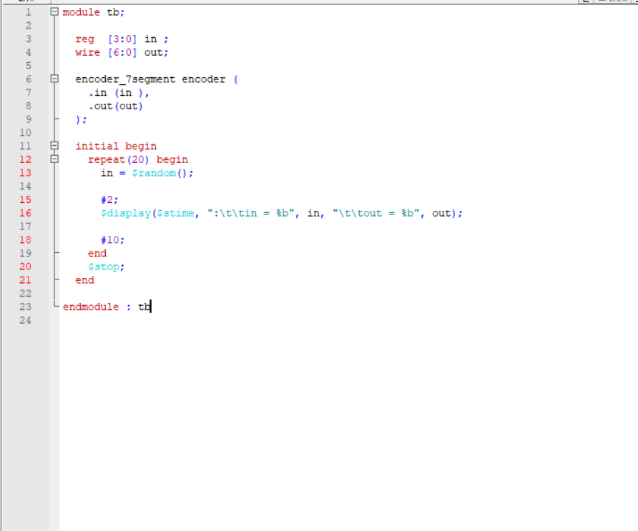

**Wave**

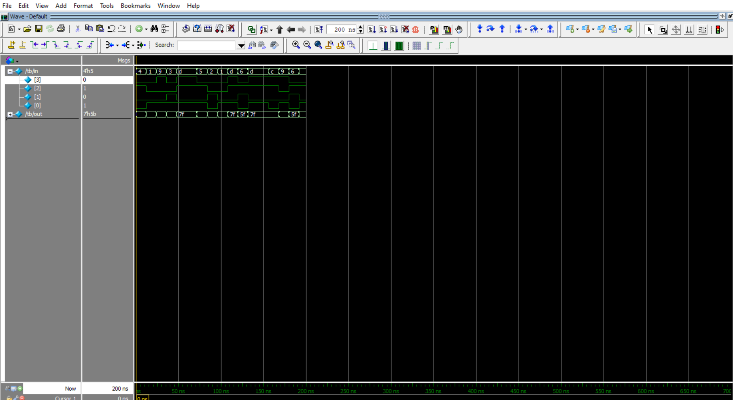

**Result**

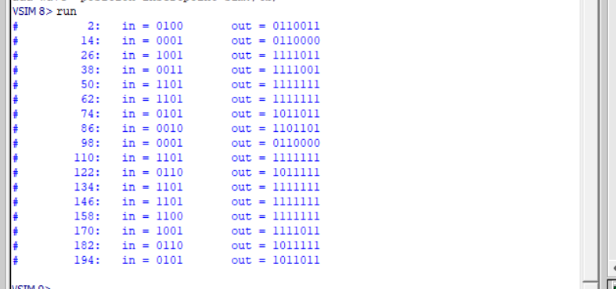

**Report**

