ASSIGNMENT-1

Creation of Table :-

CREATE TABLE Product_Master (

Product_No VARCHAR2(10),

Description VARCHAR2(50),

Profit_Percent NUMBER(5, 2),

Unit_Measure VARCHAR2(20),

Qty_On_Hand NUMBER,

Reorder_Lvl NUMBER,

Sell_Price NUMBER,

Cost_Price NUMBER

);

Inserting Data into the Table :-

INSERT INTO Product_Master VALUES ('P00001', 'T-SHIRT', 5, 'PIECE', 200, 50, 350, 250);

INSERT INTO Product_Master VALUES ('P0345', 'SHIRTS', 6, 'PIECE', 150, 50, 500, 350);

INSERT INTO Product_Master VALUES ('P06734', 'COTTON JEANS', 5, 'PIECE', 100, 20, 600, 450);

INSERT INTO Product_Master VALUES ('P07865', 'JEANS', 5, 'PIECE', 100, 20, 750, 500);

INSERT INTO Product_Master VALUES ('P07868', 'TROUSERS', 2, 'PIECE', 150, 50, 850, 550);

INSERT INTO Product_Master VALUES ('P07885', 'PULL OVERS', 2.5, 'PIECE', 80, 30, 700, 450);

INSERT INTO Product_Master VALUES ('P07965', 'DENIM SHIRTS', 4, 'PIECE', 100, 40, 350, 250);

INSERT INTO Product_Master VALUES ('P07975', 'LYCRA TOPS', 5, 'PIECE', 70, 30, 300, 175);

INSERT INTO Product_Master VALUES ('P08865', 'SKIRTS', 5, 'PIECE', 75, 30, 450, 300);

1. Show all details of the product master table.

SELECT * FROM Product_Master;

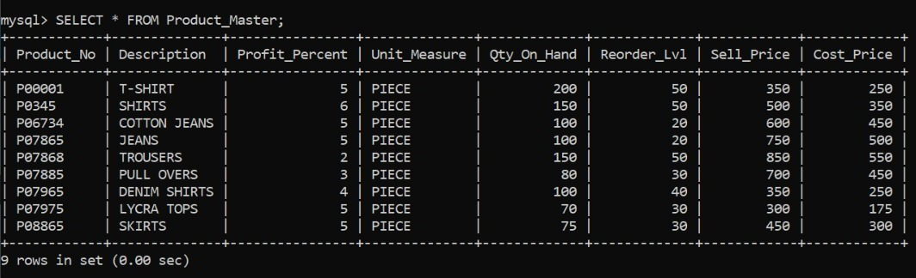

2. Show the product number of jeans.

SELECT Product_No FROM Product_Master WHERE Description LIKE '%JEANS%';

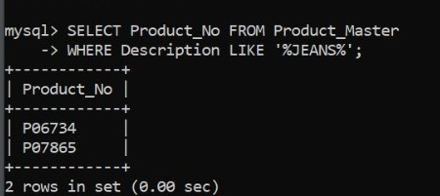

3. Show all details of the product where profit percent is 5.

SELECT * FROM Product_Master WHERE Profit_Percent=5;

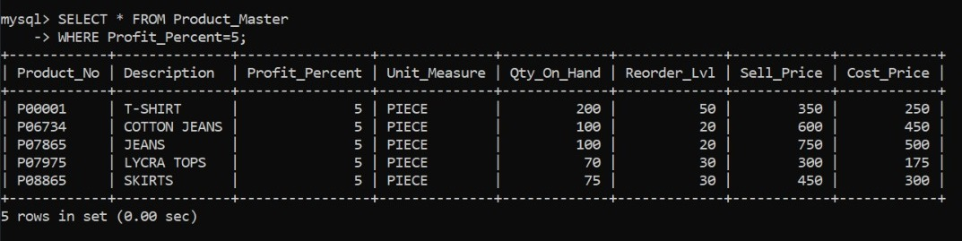

4. Show the details where the cost price is greater than 350.

SELECT * FROM Product_Master WHERE Cost_Price>350;

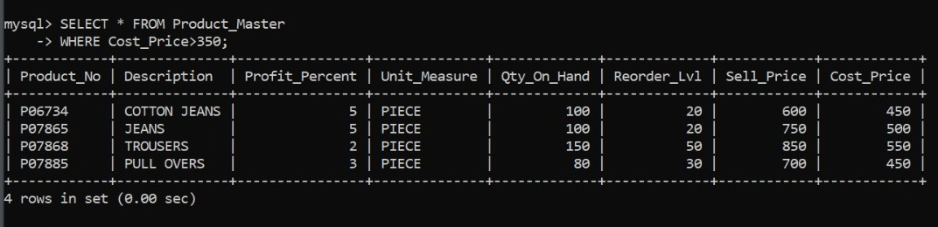

5. Show the sell price of DENIM SHIRTS.

SELECT Sell_Price FROM Product_Master WHERE Description='DENIM SHIRTS';

