TopoLink-CCI Benchmarking Manuscript-style Report
Formatted Word report with embedded figures and source-data links

Overall Progress
本报告整理 TopoLink-CCI benchmarking 的完整收口状态。主线从 PDC Synthetic Truth 和 false-positive controls 出发，说明方法在受控场景下的 ranking behavior，再引入 Breast WTA 主 benchmark、A100 supplement、bounded appendix 和 Cervical WTA cross-dataset generalization。
当前 PDC publication queue 为 0，A100 无 active rescue process。报告口径已升级为 expanded 18-method benchmark：9 个 full success、7 个 bounded success、2 个 reproducible failure cards、0 个 deferred candidate methods、0 个 pending/running。这里的 all_methods_accounted=true 表示所有提到的方法都有明确状态，不表示所有方法都成功。
FastCCC、SCILD、Copulacci 和 NicheNet 现在正式计入 expanded denominator，并且均已在 PDC 与 A100 完成终端化处理。FastCCC 和 SCILD 经 A100 retry 升级为 bounded subset result；Copulacci 和 NicheNet 保留 reproducible failure card，原因分别是 adapter workflow mapping blocker 与 R dependency/API audit blocker。
Key path: D:\GitHub\pyXenium\benchmarking\cci_2026_atera\results\publication_benchmark_24h_20260511
Key path: /cfs/klemming/scratch/h/hutaobo/pyxenium_cci_benchmark_2026-04
Key path: /data/taobo.hu/pyxenium_lr_benchmark_2026-04

Summary of Evaluated Methods
Dataset | Method | Status | Evidence tier | Phase | Rows | Hardware/source | Interpretation
Breast WTA | TopoLink-CCI | Full | Main | full common-db | 1,319,600 | PDC | Primary clean full-common result.
Breast WTA | CellPhoneDB | Full | Main | full common-db | reported in artifact | PDC | Reproducible non-spatial expression baseline.
Breast WTA | LARIS | Full | Main | full common-db | reported in artifact | PDC | Diffusion/spatial smoothing comparator.
Breast WTA | LIANA+ | Full | Main | full common-db | reported in artifact | PDC | Spatial bivariate/multi-method comparator.
Breast WTA | SpatialDM | Full | Main | full common-db | reported in artifact | PDC | Spatial co-expression/null comparator.
Breast WTA | stLearn | Full | Main | full common-db | reported in artifact | PDC/A100 | Spatial neighborhood permutation comparator.
Breast WTA | Squidpy | Full | Supplement | full common-db | 1,319,600 | A100 | Permutation-style ligrec supplement.
Breast WTA | CellChat | Full | Supplement | LR-only full | 31,592 | A100 | Pathway step disabled because of runtime bug.
Breast WTA | COMMOT | Full | Appendix | chunked full | 724,604 | A100/PDC | Transport/diffusion comparator; 16/16 chunks merged.
Breast WTA | Giotto | Bounded | Appendix | pilot50k | 1,151,351 | A100 | Full limited by R Matrix/TsparseMatrix 2^31-1 sparse index boundary.
Breast WTA | SpaTalk | Bounded | Appendix | smoke20k | 37,532 | A100 | 66/66 smoke chunks completed; pilot50k had no usable output.
Breast WTA | NICHES | Bounded | Appendix | pilot50k | 1,181,042 | A100 | Full stopped by memory safety gate.
Breast WTA | CellNEST | Bounded | Appendix | pilot50k | 157,553 | A100 | Bounded GPU/source workflow result.
Breast WTA | CellAgentChat | Bounded | Appendix | pilot50k | 1,143,543 | A100 | 16/16 pilot chunks succeeded; full resource exceeded.
Breast WTA | SCILD | Bounded | Bounded appendix | smoke3k common-db | 2,880 rows | A100 | Official source-backed ligand-diffusion bounded retry succeeded: 3000 cells x 20 CCI pairs, peak RSS about 18.9GB.
Breast WTA | FastCCC | Bounded | Appendix | smoke20k | 1,319,600 | A100 | A100 retry succeeded after PDC standardization failure; analytic non-spatial expression baseline.
Breast WTA | Copulacci | Failure card | Terminal card | env/API audit | reported in artifact | PDC/A100 | Official source imports, but no safe common-resource bounded adapter mapping.
Breast WTA | NicheNet | Failure card | Terminal card | env/API audit | reported in artifact | PDC/A100 | R dependency/API audit blocker; downstream support method, not direct spatial CCI ranker.
Cervical WTA | TopoLink-CCI | Full | Cross-dataset | full common-db | 2,404,971 | PDC | Top hit: DSC2-DSG3 in differentiating tumor cells.

Figure panel 1. Benchmark completion status
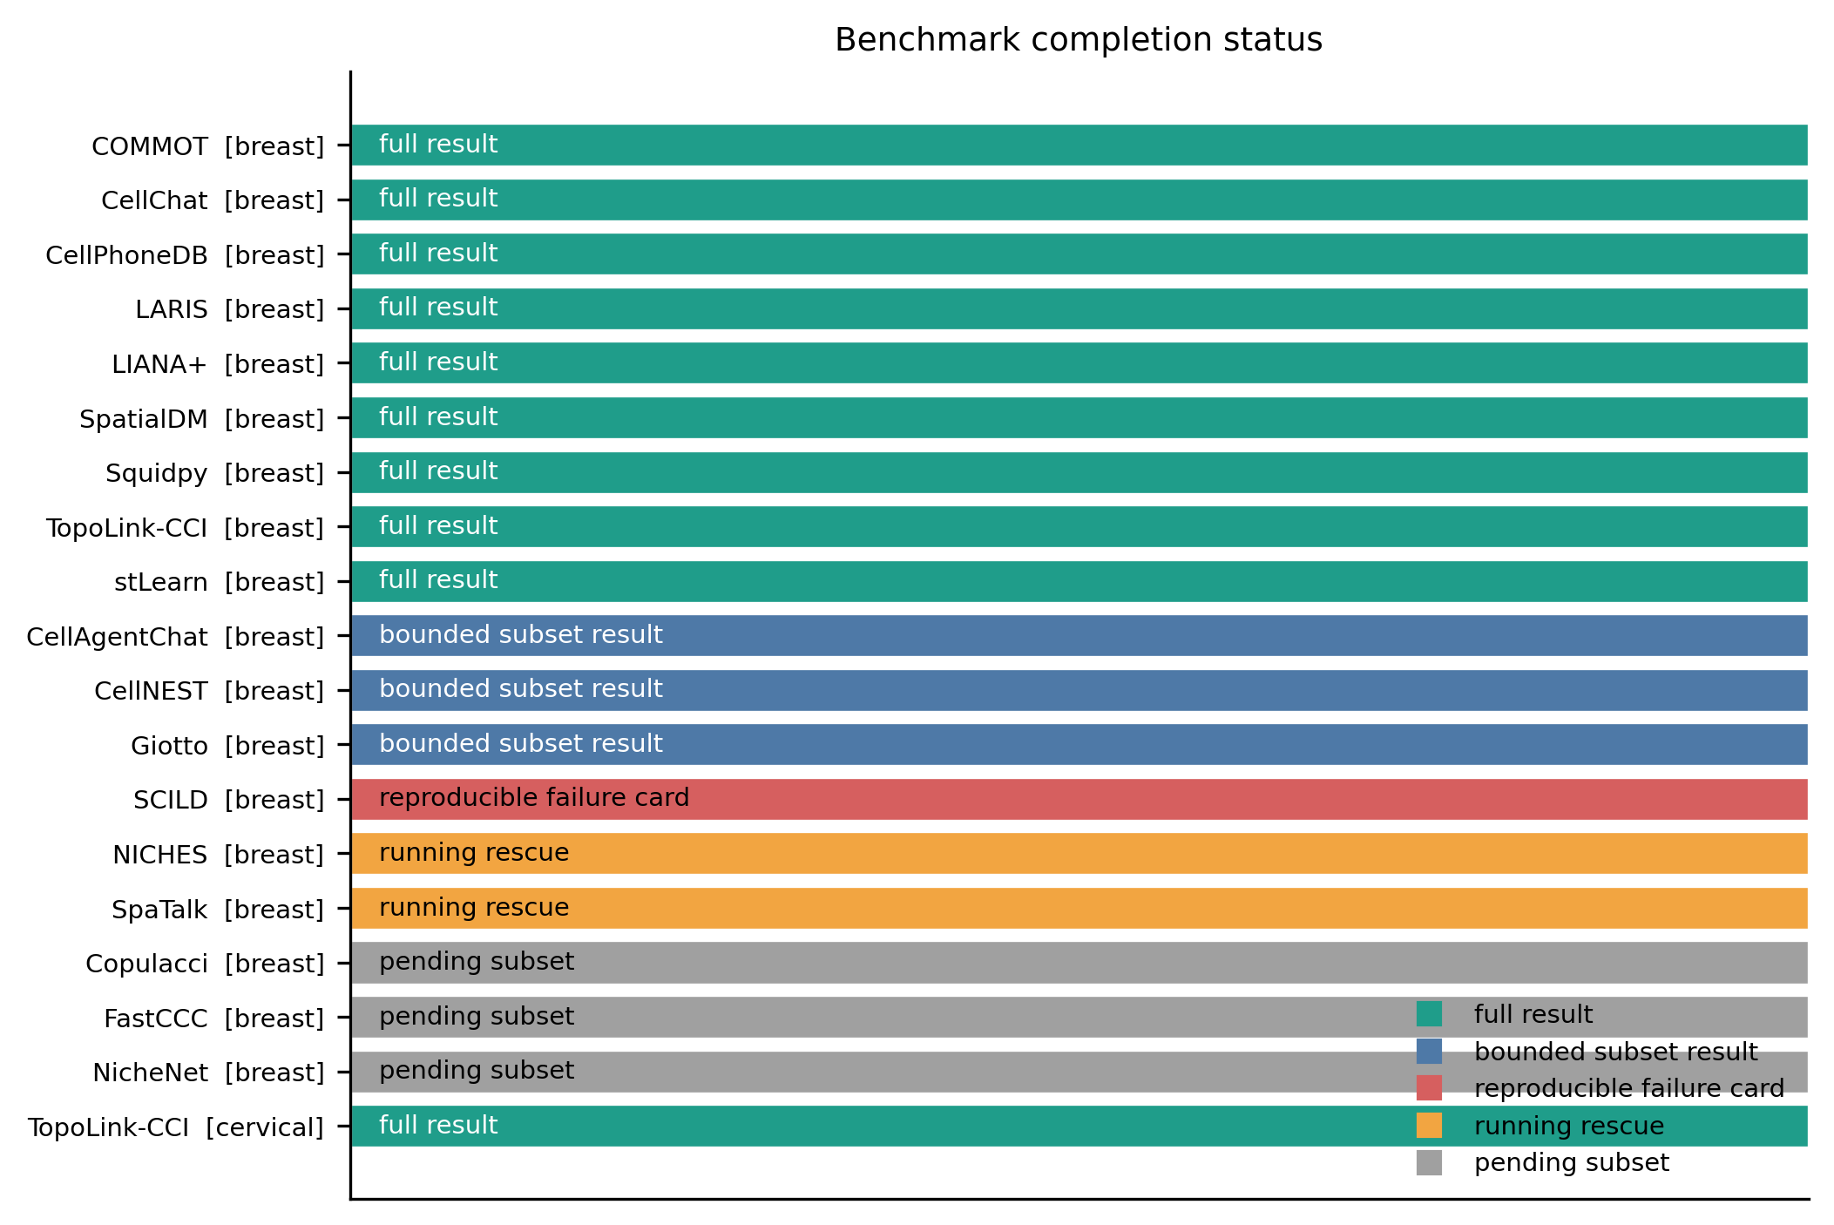
Overview of full, bounded, and reproducible failure-card method states.
Figure: D:\GitHub\pyXenium\benchmarking\cci_2026_atera\results\preview_completed_20260511\figures\fig1_completion_status.png
Source data: D:\GitHub\pyXenium\benchmarking\cci_2026_atera\results\preview_completed_20260511\source_data\fig1_completion_status.tsv

Validation & Controls
PDC Synthetic Truth 结果提供了真实 WTA benchmark 的前置可信度论证。完整 TopoLink-CCI 模型获得 AUROC 0.9919 和 AUPRC 0.8333。expression-only 为 AUROC 0.9839 / AUPRC 0.8333，contact-only 为 AUROC 0.9919 / AUPRC 0.8333，而 topology-anchor-only 虽然 AUROC 为 0.9839，但 AUPRC 降至 0.5833。
该结果说明 Topology Anchor 单独使用不足以稳定排序 positive CCI axes；完整模型通过 expression specificity 和 local contact 补充拓扑信息，提升 precision-recall ranking 的稳定性。

Figure panel 2. Synthetic Truth validation
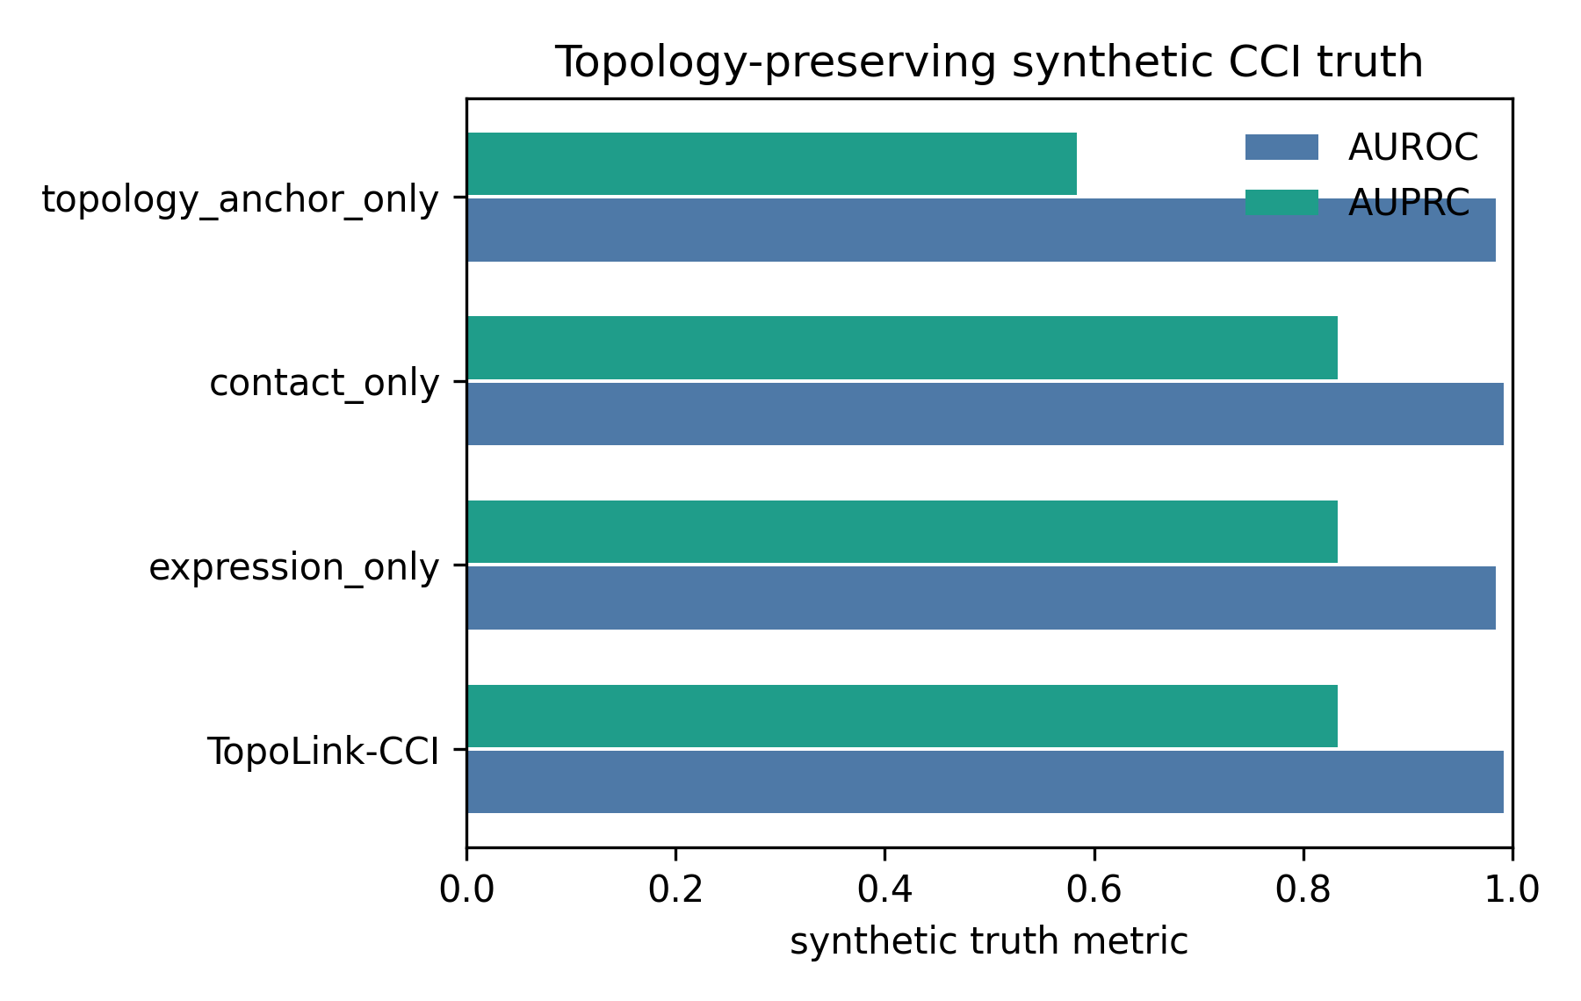
TopoLink-CCI achieves AUROC 0.9919 and AUPRC 0.8333; topology-anchor-only loses precision-recall stability.
Figure: D:\GitHub\pyXenium\benchmarking\cci_2026_atera\results\publication_benchmark_24h_20260511\pdc_collected\publication_benchmark_24h_20260511\synthetic_truth\figures\synthetic_truth_auroc_auprc.png
Source data: D:\GitHub\pyXenium\benchmarking\cci_2026_atera\results\publication_benchmark_24h_20260511\pdc_collected\publication_benchmark_24h_20260511\synthetic_truth\tables\synthetic_truth_metrics.tsv

Core Benchmarking Results

Breast WTA common-db main comparison
Breast WTA 是主实验数据集。TopoLink-CCI Breast full result 产生 1,319,600 rows，构成 biological interpretation、classic CCI axis selection、validation 和 cross-method consistency 的主要输入。
TopoLink-CCI Breast artifact: pdc_collected/pdc_20260426_1327/runs/full_common/pyxenium

Figure panel 3. Breast WTA TopoLink-CCI top axes
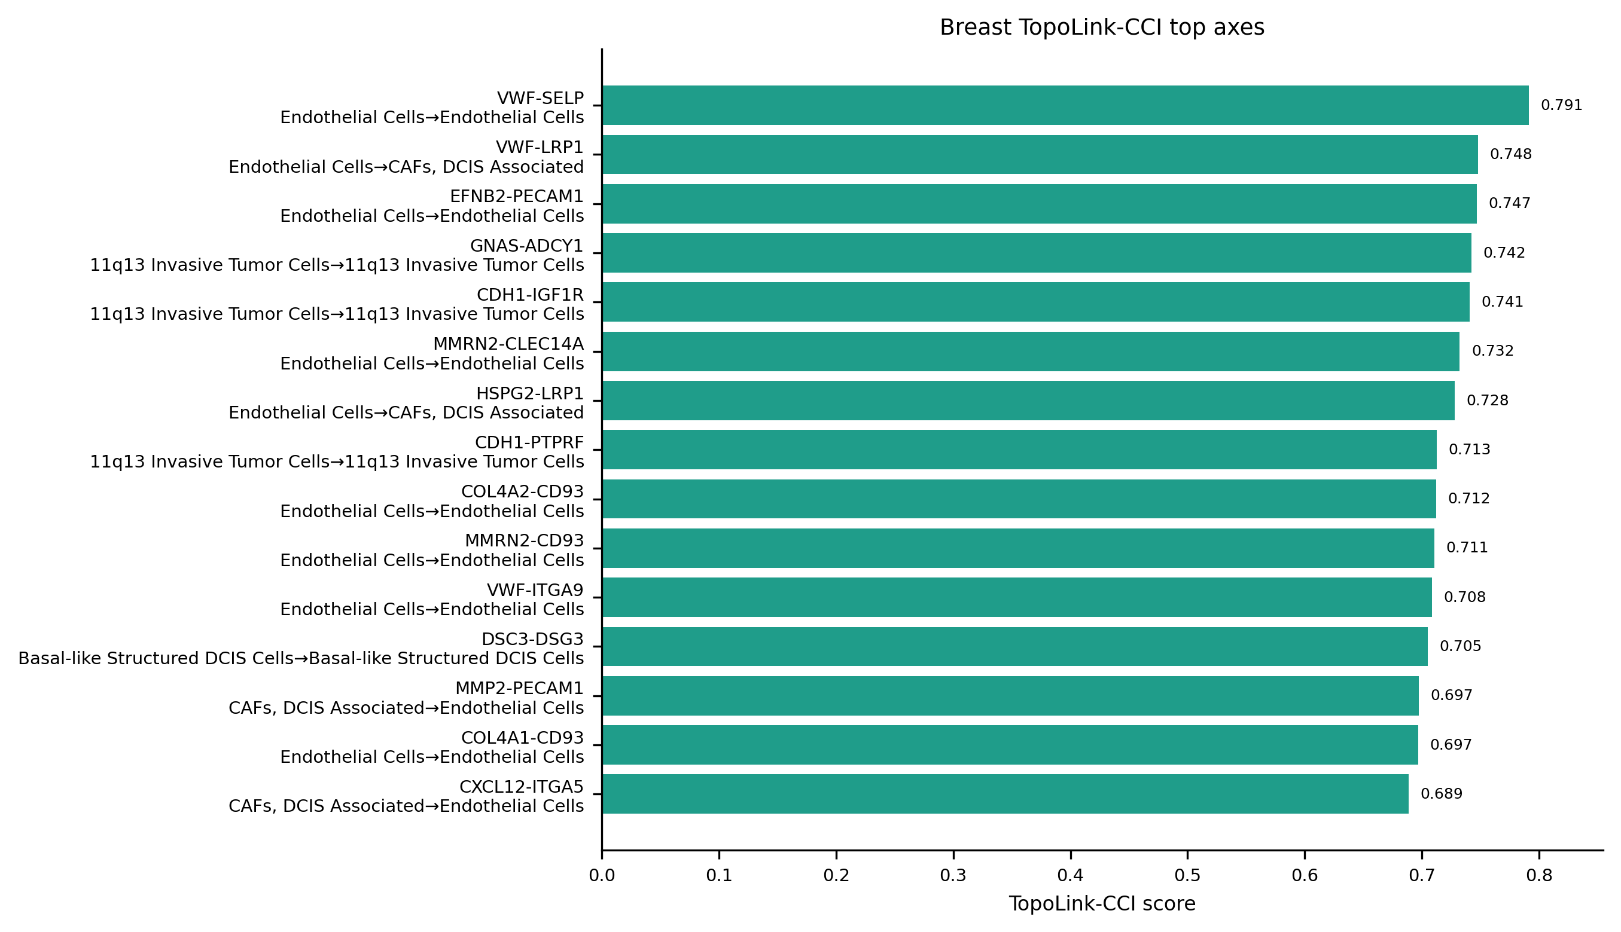
High-ranking Breast WTA axes emphasize vascular, stromal, immune and Notch-associated CCI themes.
Figure: D:\GitHub\pyXenium\benchmarking\cci_2026_atera\results\preview_completed_20260511\figures\fig3_breast_topolink_top_axes.png
Source data: D:\GitHub\pyXenium\benchmarking\cci_2026_atera\results\preview_completed_20260511\source_data\fig3_breast_topolink_top_axes.tsv

Figure panel 4. Canonical pair rank matrix
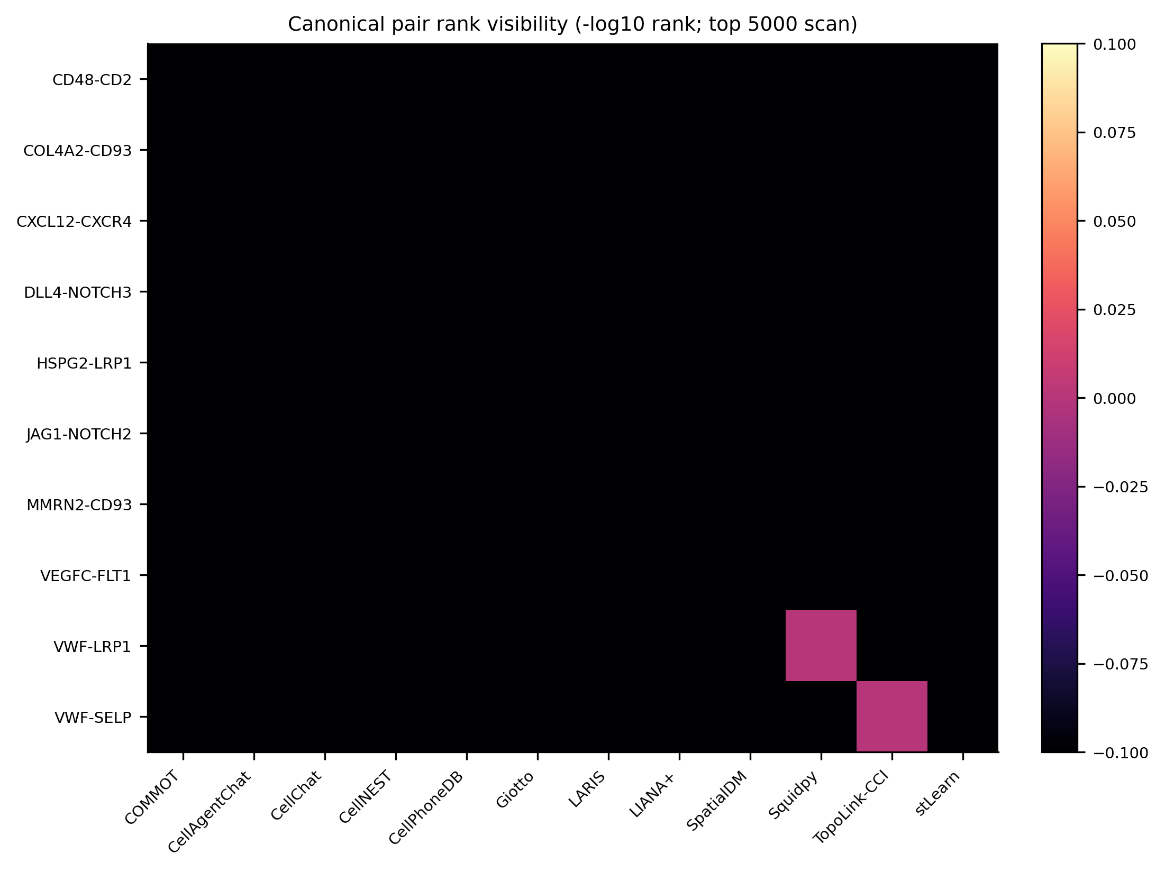
Canonical axis recovery is evaluated by within-method ranks rather than raw score comparison.
Figure: D:\GitHub\pyXenium\benchmarking\cci_2026_atera\results\cross_method_comparison_20260511\figures\fig6_canonical_pair_rank_heatmap.png
Source data: D:\GitHub\pyXenium\benchmarking\cci_2026_atera\results\cross_method_comparison_20260511\source_data\fig6_canonical_pair_rank_heatmap.tsv

A100 supplementary full and appendix runs
A100 supplement 提供 Squidpy full、CellChat LR-only full 和 COMMOT chunked result。bounded appendix 记录 Giotto、SpaTalk、NICHES、CellNEST 和 CellAgentChat 的 scalability/resource tradeoff。

Figure panel 5. Runtime and scalability
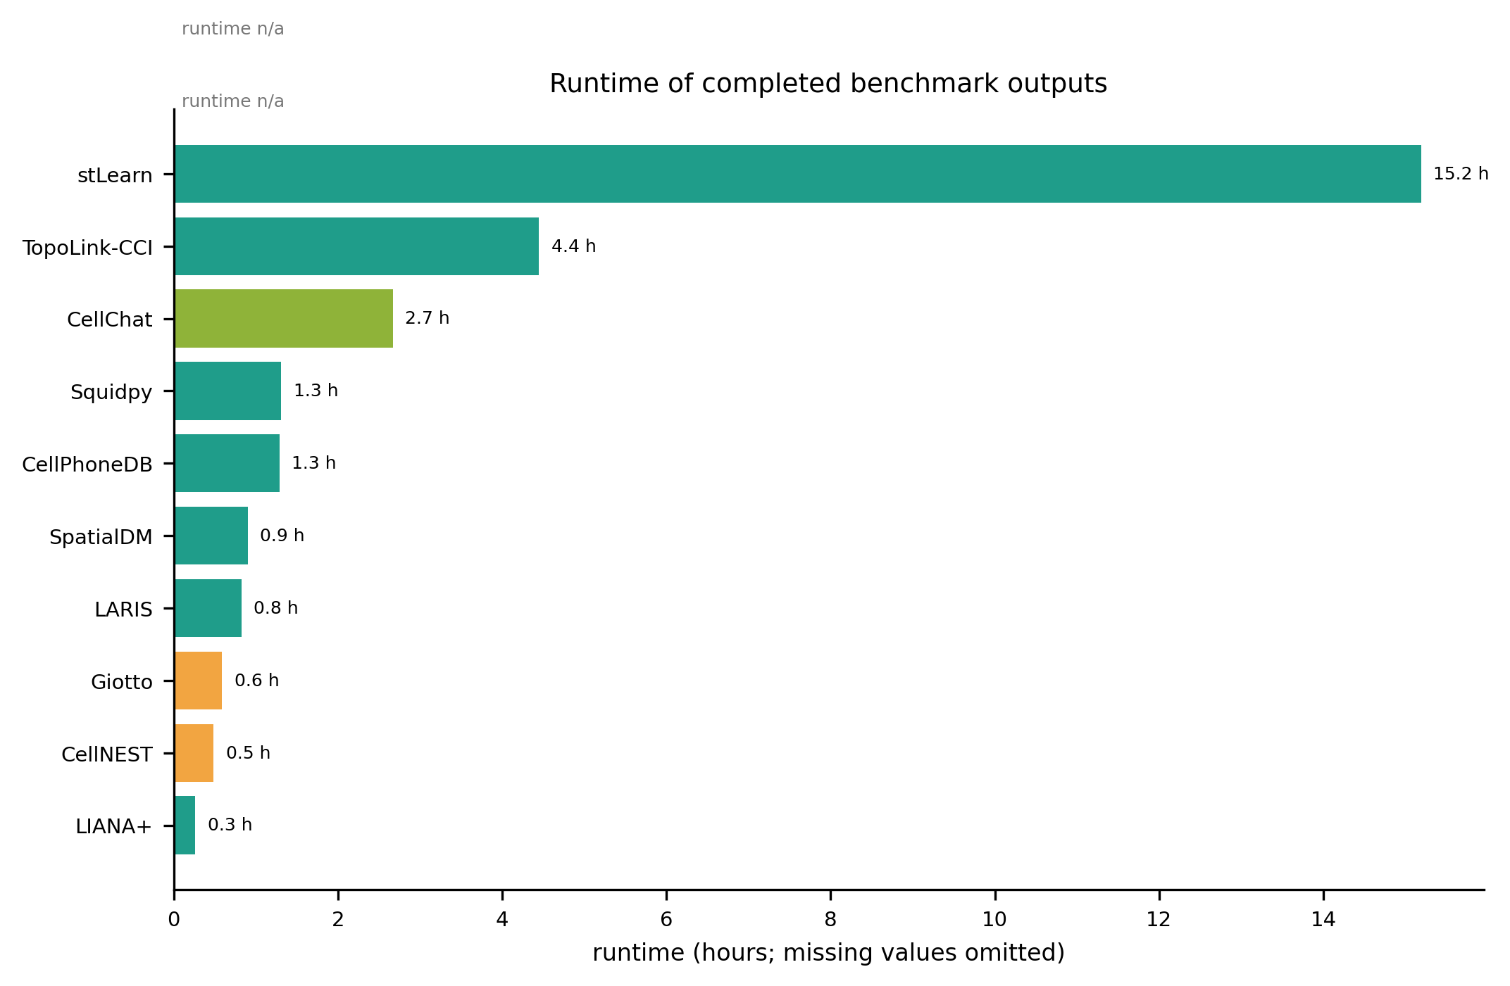
Engineering comparison across full and bounded runs.
Figure: D:\GitHub\pyXenium\benchmarking\cci_2026_atera\results\cross_method_comparison_20260511\figures\fig1_runtime_hours.png
Source data: D:\GitHub\pyXenium\benchmarking\cci_2026_atera\results\cross_method_comparison_20260511\source_data\fig1_runtime_hours.tsv

Figure panel 6. Top-100 pair Jaccard consistency
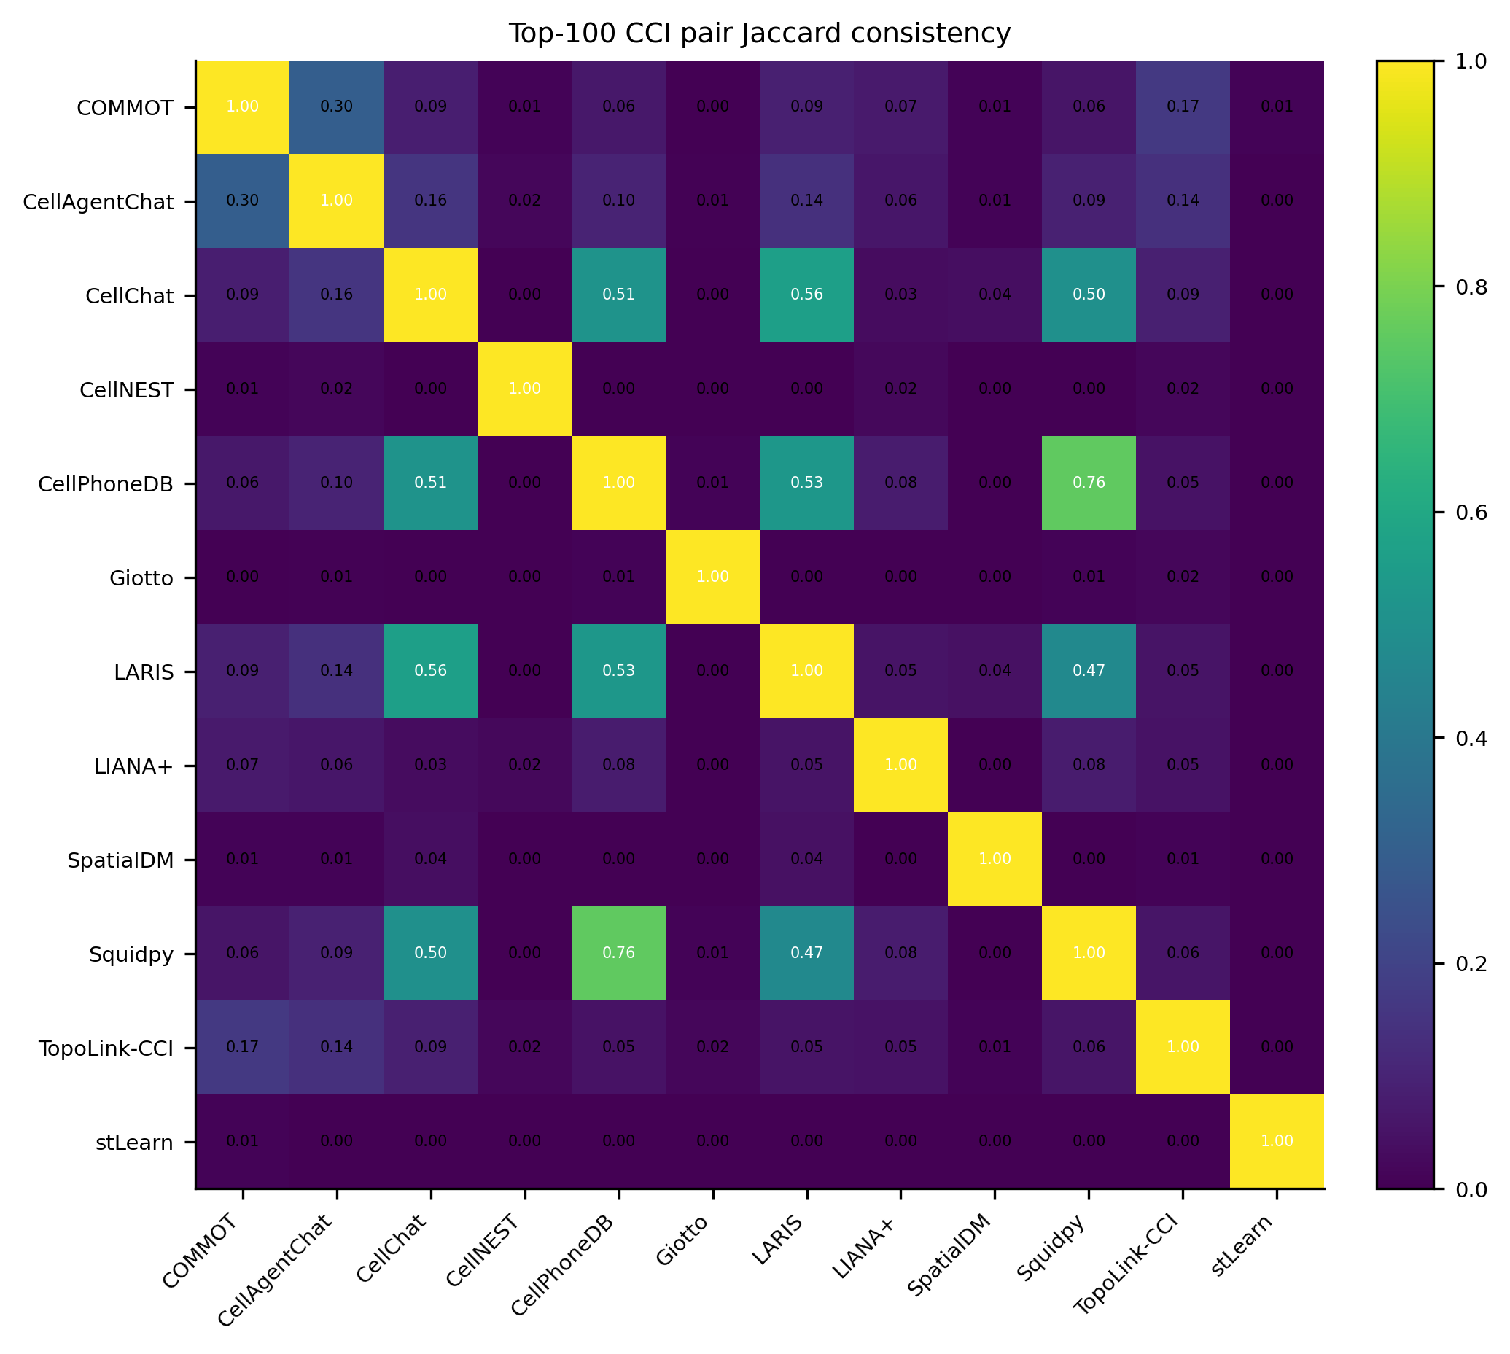
Cross-method consistency is summarized as overlap among top-ranked CCI axes.
Figure: D:\GitHub\pyXenium\benchmarking\cci_2026_atera\results\cross_method_comparison_20260511\figures\fig3_top100_pair_jaccard_heatmap.png
Source data: D:\GitHub\pyXenium\benchmarking\cci_2026_atera\results\cross_method_comparison_20260511\source_data\fig3_top100_pair_jaccard_heatmap.tsv

Cross-dataset generalization
Cervical WTA TopoLink-CCI full common-db run 生成 2,404,971 rows。其 top hit 为 DSC2-DSG3 / Differentiating Tumor Cells -> Differentiating Tumor Cells，与 Breast WTA 中 vascular/endothelial top axes 不同，支持 tissue-context-specific CCI prioritization。
Cervical artifact: /cfs/klemming/scratch/h/hutaobo/pyxenium_cci_benchmark_2026-04/datasets/atera_cervical_wta/runs/full_common/pyxenium/pyxenium_standardized.tsv

Figure panel 7. Breast versus Cervical generalization
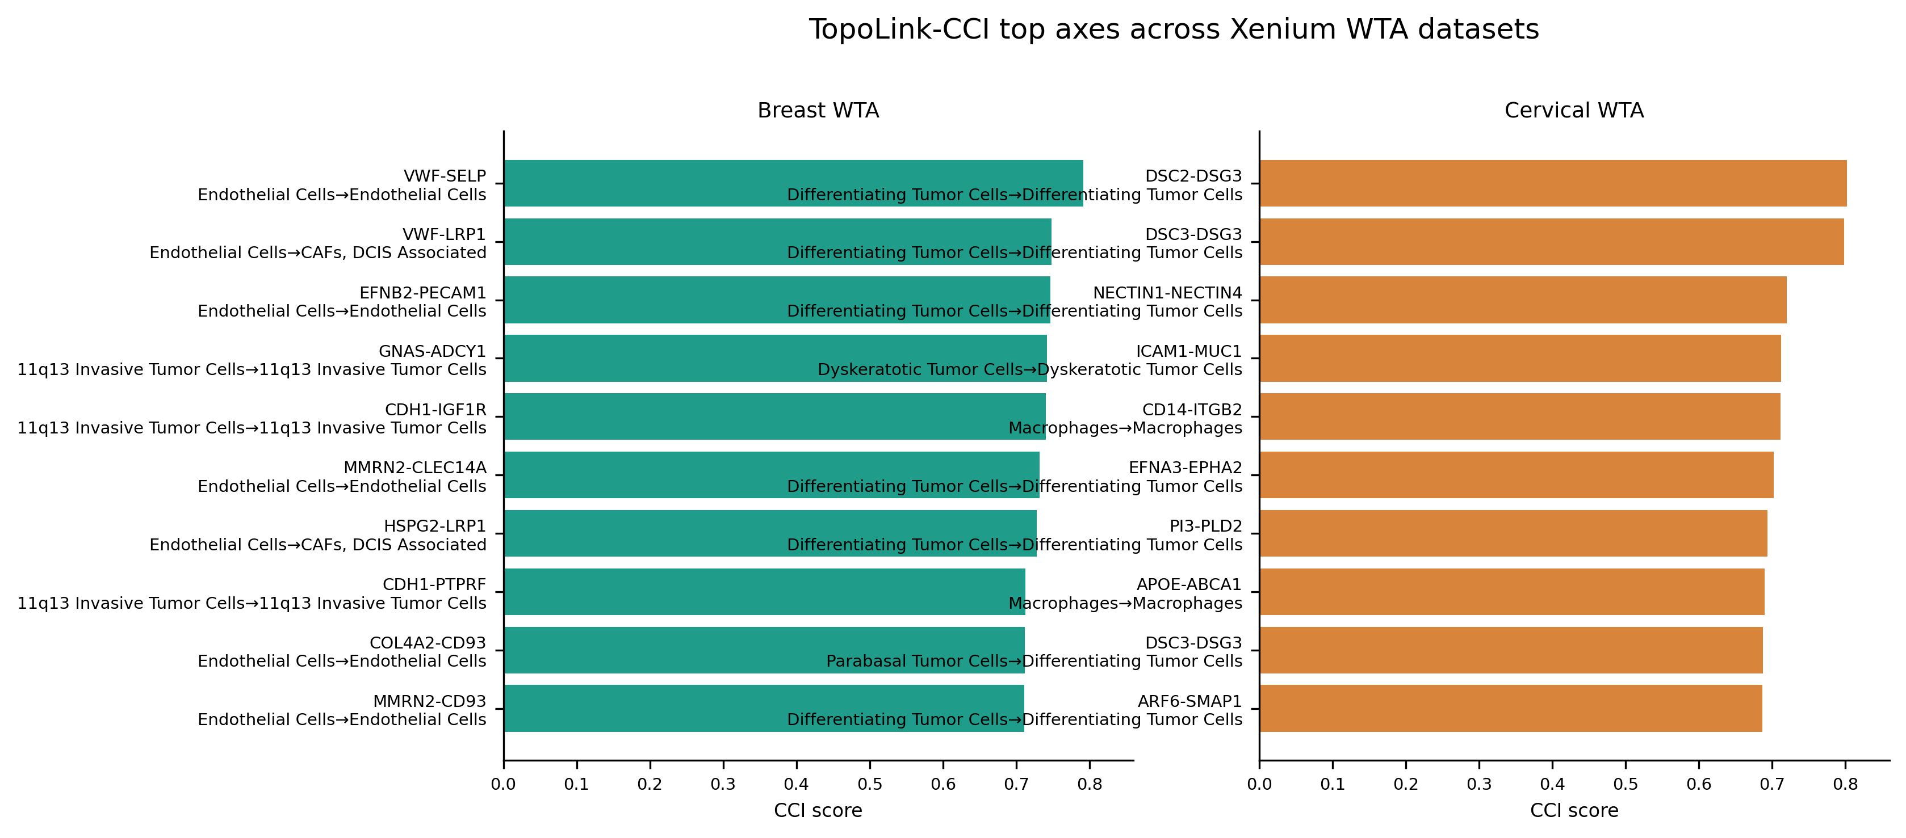
TopoLink-CCI recovers tissue-context-specific top axes across Breast and Cervical WTA datasets.
Figure: D:\GitHub\pyXenium\benchmarking\cci_2026_atera\results\preview_completed_20260511\figures\fig4_breast_cervical_topolink_comparison.png
Source data: D:\GitHub\pyXenium\benchmarking\cci_2026_atera\results\preview_completed_20260511\source_data\fig4_breast_cervical_topolink_comparison.tsv

Figure panel 8. Cervical WTA TopoLink-CCI top axes
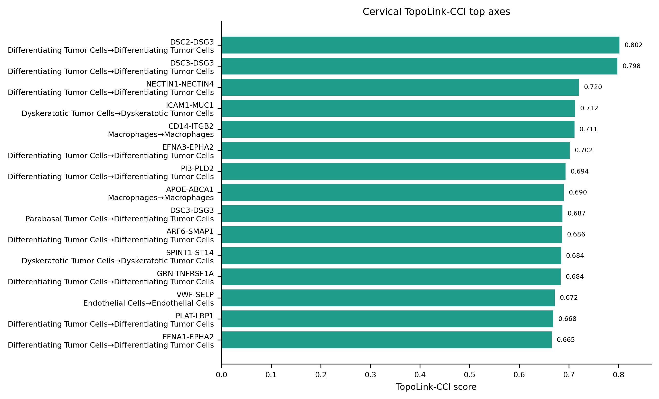
Cervical WTA full common-db result contains 2,404,971 rows and is led by DSC2-DSG3.
Figure: D:\GitHub\pyXenium\benchmarking\cci_2026_atera\results\preview_completed_20260511\figures\fig3b_cervical_topolink_top_axes.png
Source data: D:\GitHub\pyXenium\benchmarking\cci_2026_atera\results\preview_completed_20260511\source_data\fig3b_cervical_topolink_top_axes.tsv

Scope of Benchmark and Technical Limitations
本 benchmark 不把所有外部 CCI 方法强行推进到 whole-dataset full run，而是为每个方法保留 full result、bounded subset result 或 reproducible failure card。SpaTalk smoke20k 完成 66/66 chunks；NICHES pilot50k 完成 1,181,042 rows；Giotto pilot50k 完成 1,151,351 rows。这些结果说明真实方法链路可运行，同时也暴露了大规模 WTA 下的内存、sparse index 和 runtime scalability tradeoff。
SCILD 已在官方 source 被重新确认后通过 A100 专用 Python 3.11 环境升级为 bounded subset result：3000 cells × 20 CCI pairs，2,880 rows，峰值内存约 18.9GB。Copulacci 和 NicheNet 是 expanded 18-method benchmark 中仍保留的 reproducible failure cards；Copulacci 官方 source 可安装和 import，但没有可安全映射到 common-resource benchmark 的 native bounded workflow；NicheNet 在 PDC 和 A100 均受 R dependency/API audit 约束，并且其定位更接近 downstream receiver-response support，而不是直接 spatial CCI ranker。FastCCC 已通过 A100 retry 产生 20k bounded standardized output。

Figure panel 9. Result row counts
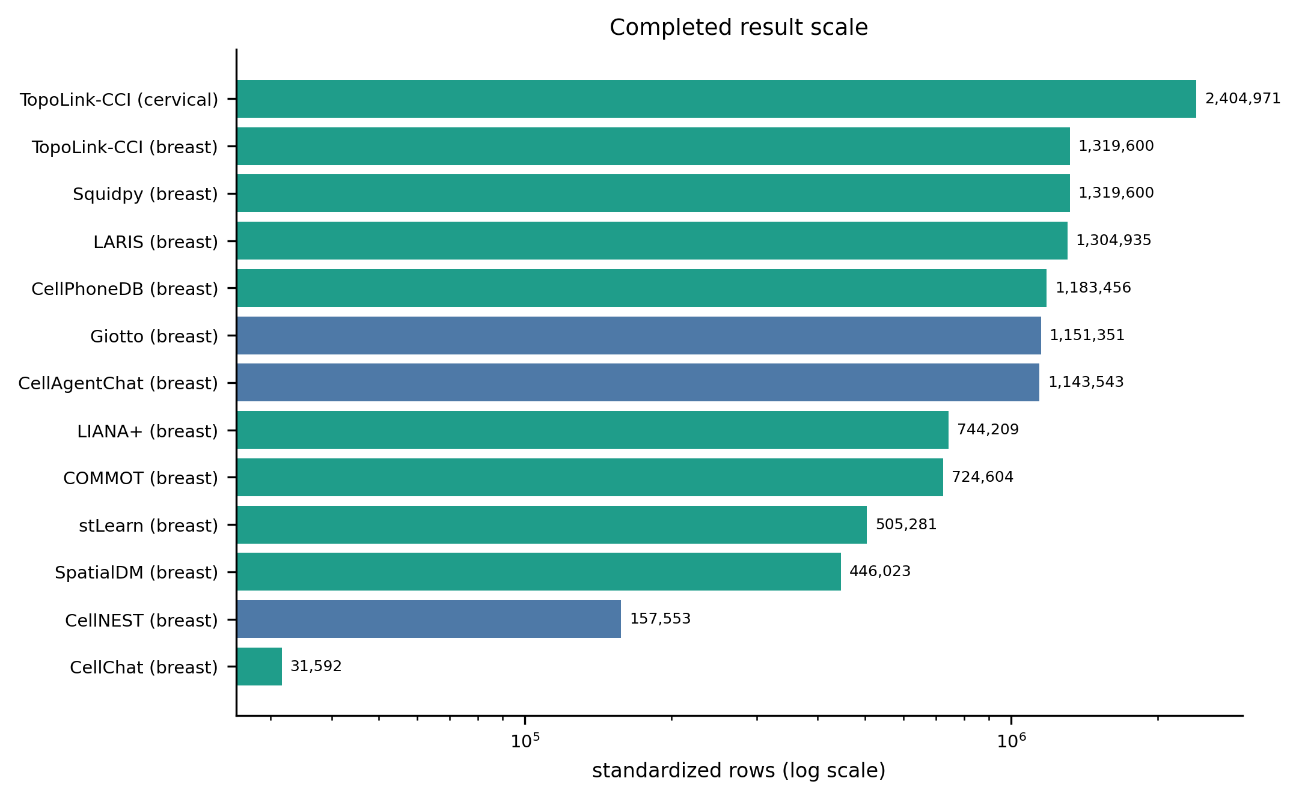
Full and bounded outputs differ in scale and should not be collapsed into a single evidence tier.
Figure: D:\GitHub\pyXenium\benchmarking\cci_2026_atera\results\preview_completed_20260511\figures\fig2_result_row_counts.png
Source data: D:\GitHub\pyXenium\benchmarking\cci_2026_atera\results\preview_completed_20260511\source_data\fig2_result_row_counts.tsv

Figure panel 10. Overlap with TopoLink-CCI
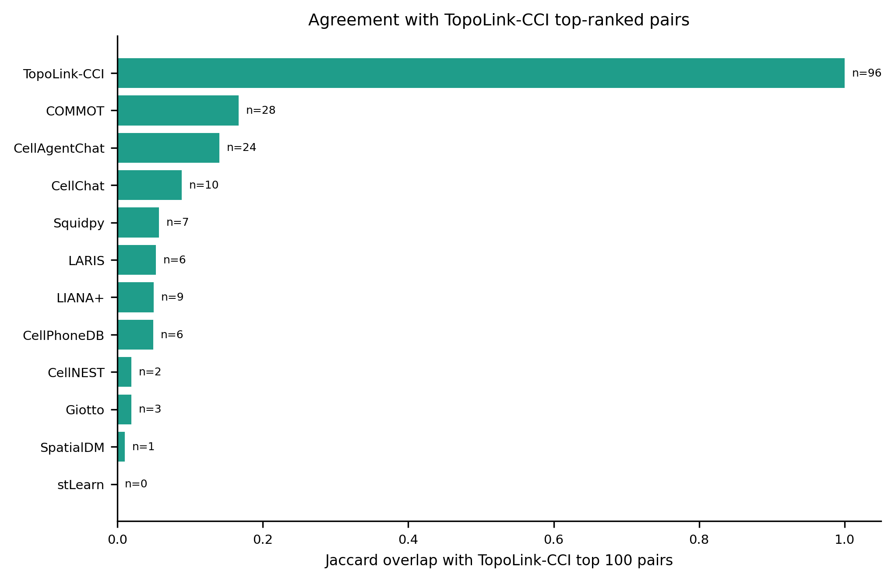
Overlap with TopoLink-CCI is interpreted as theme-level support, not absolute ground truth.
Figure: D:\GitHub\pyXenium\benchmarking\cci_2026_atera\results\cross_method_comparison_20260511\figures\fig5_overlap_with_topolink.png
Source data: D:\GitHub\pyXenium\benchmarking\cci_2026_atera\results\cross_method_comparison_20260511\source_data\fig5_overlap_with_topolink.tsv

Methodological Discussion
本 benchmark 不直接比较不同方法的 raw score，因为各方法的 score 定义不一致。评价体系采用 rank、canonical recovery、cross-method consistency、false-positive controls、Synthetic Truth 和 cross-dataset generalization。
F1 只用于 Synthetic Truth 或预定义 canonical truth set；ARI 不作为主指标，因为当前输出是 interaction-axis ranking，而不是统一 clustering assignment。
本研究建立的评估框架旨在为真实复杂组织切片中的 CCI 优先级排序提供可靠依据，而非单纯追求合成数据集上的指标拟合。
TopoLink-CCI 应被表述为 topology-guided spatial CCI hypothesis prioritization framework。所有结论均为 computational evidence，不应被解读为单靠 CCI_score 证明蛋白结合、因果通讯或功能效应。

Figure panel 11. Canonical recovery F1
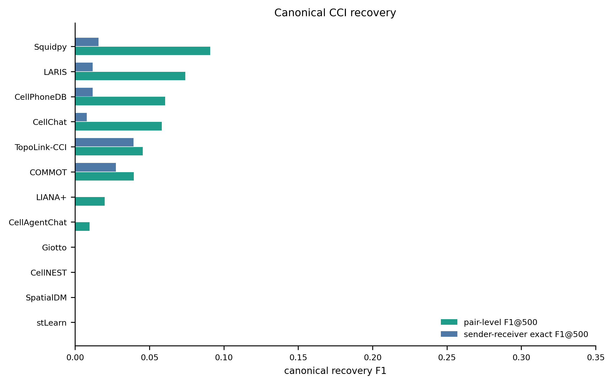
F1 is used only for predefined canonical truth sets, not global real-tissue CCI ranking.
Figure: D:\GitHub\pyXenium\benchmarking\cci_2026_atera\results\cross_method_comparison_20260511\figures\fig2_canonical_recovery_f1.png
Source data: D:\GitHub\pyXenium\benchmarking\cci_2026_atera\results\cross_method_comparison_20260511\source_data\fig2_canonical_recovery_f1.tsv

Figure panel 12. Exploratory ARI of top-k binary selections
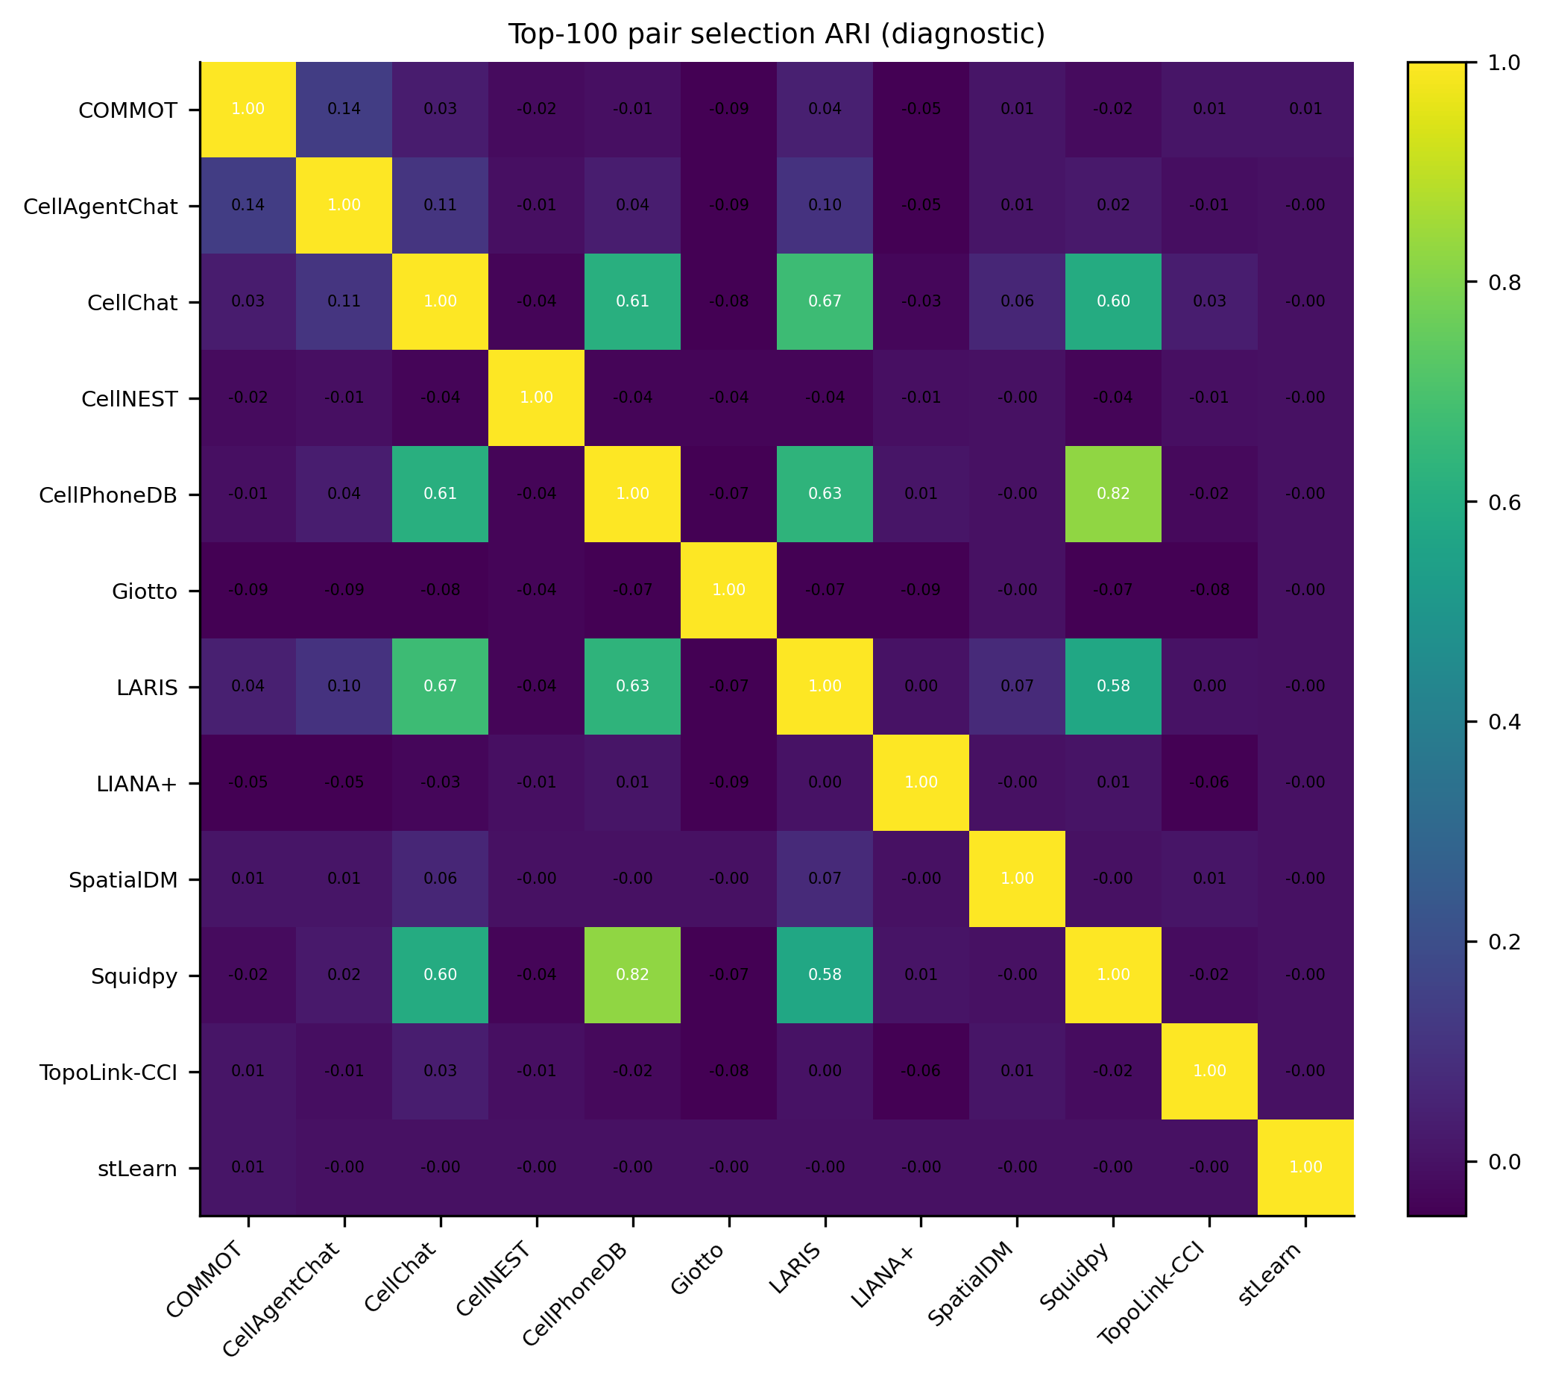
ARI is shown as an exploratory top-k selection similarity metric, not a main endpoint.
Figure: D:\GitHub\pyXenium\benchmarking\cci_2026_atera\results\cross_method_comparison_20260511\figures\fig4_top100_binary_selection_ari_heatmap.png
Source data: D:\GitHub\pyXenium\benchmarking\cci_2026_atera\results\cross_method_comparison_20260511\source_data\fig4_top100_binary_selection_ari_heatmap.tsv

