Topology-guided prioritization of spatial cell-cell interaction axes
Author list: [To be completed]
Affiliations: [To be completed]

Abstract
Spatial cell-cell interaction inference is confounded by co-expression, cell abundance and incomplete molecular resources. TopoLink-CCI integrates tissue topology, expression specificity and local contact, then challenges candidates with orthogonal controls. Across public 10x Genomics Atera Whole Transcriptome Assay (Atera WTA) FFPE breast and cervical cancer preview datasets, it scales to whole tissues and prioritizes computationally supported vascular, stromal, immune and tumor interaction hypotheses.
Spatial transcriptomics enables cell-cell interaction (CCI) inference in intact tissues, but whole-transcriptome imaging also expands false-positive risk. Candidate axes may rank highly because both genes are abundant, because cell groups are frequent, or because curated molecular resources include extracellular-matrix, adhesion, scavenger-receptor and shared activation-state relationships that are not classical secreted signaling. Spatial proximity improves plausibility but does not prove molecular exchange, receptor activation or causal communication.
TopoLink-CCI is a topology-guided CCI prioritization framework in pyXenium. In CCI-resource mode, each ligand, receptor, sender and receiver combination is scored using sender topology anchor, receiver topology anchor, structure bridge, sender expression, receiver expression and local contact. The prior-weighted geometric mean favors concordance across topology, expression and spatial contact, and every component is exported so users can diagnose topology-driven, expression-driven or contact-sensitive axes.
In a topology-preserving Synthetic Truth benchmark, the full model achieved AUROC 0.9919 and AUPRC 0.8333, whereas topology-anchor-only scoring retained high AUROC but dropped to AUPRC 0.5833. We analyzed the public 10x Genomics Preview Data: Atera In Situ Gene Expression, FFPE Human Breast Cancer dataset, generated using the pre-commercial Atera Whole Transcriptome Assay (Atera WTA) and Atera Onboard Analysis development workflow. TopoLink-CCI generated 1,319,600 common-resource hypotheses from 170,057 cells in this breast cancer tissue. The expanded benchmark terminalized 18 Breast WTA methods as nine full whole-dataset results and nine bounded subset results, with zero failure cards and zero deferred methods. Late-stage rescue runs converted FastCCC, SCILD, Copulacci and NicheNet into bounded appendix evidence, with NicheNet treated as downstream receiver-response support rather than a direct spatial ranker.
TopoLink-CCI prioritized interpretable axes spanning vascular activation, stromal matrix biology, immune adhesion, Notch signaling and tumor-intrinsic adhesion. The top Breast WTA axis, VWF-SELP from endothelial cells to endothelial cells, is best interpreted as an endothelial activation and vascular adhesion niche consistent with Weibel-Palade body biology, not as direct proof of protein release. Cross-dataset application to the corresponding public 10x Genomics Preview Data: Atera In Situ Gene Expression, FFPE Human Cervical Cancer dataset produced 2,404,971 hypotheses from 717,576 cells and a distinct top tumor-adhesion axis, DSC2-DSG3 in differentiating tumor cells. TopoLink-CCI therefore prioritizes topology-supported spatial CCI hypotheses while leaving biochemical mechanism and causality to orthogonal experimental validation.

Figures and figure legends
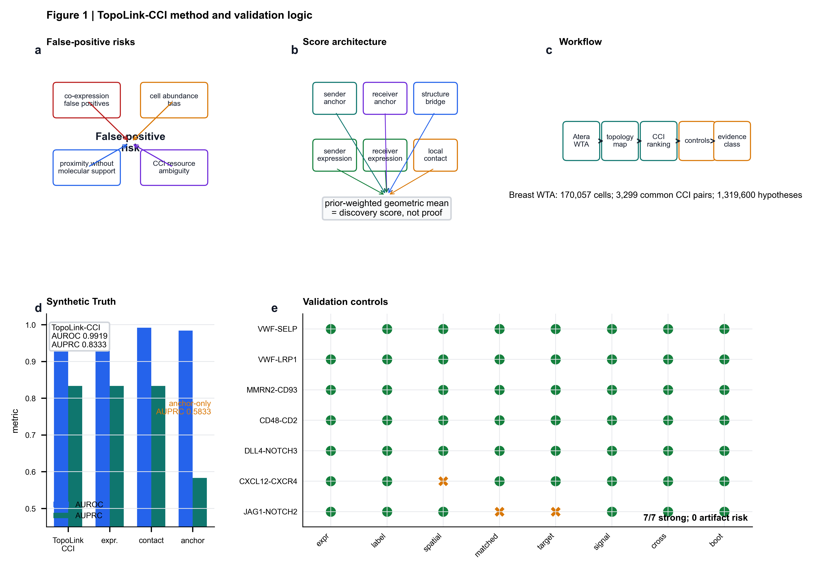
Figure 1 | TopoLink-CCI method and validation logic. a, Spatial CCI inference is vulnerable to co-expression, cell-abundance, proximity and resource-composition false positives. b, TopoLink-CCI scores each candidate using topology anchors, structure bridging, expression support and local contact. c, Workflow from Atera WTA preview datasets and pyXenium topology maps to ranked CCI axes and validation controls. d, Synthetic Truth evaluation shows AUROC 0.9919 and AUPRC 0.8333 for the full model, whereas topology-anchor-only scoring loses precision-recall performance. e, Orthogonal evidence matrix for seven interpretable breast cancer axes.

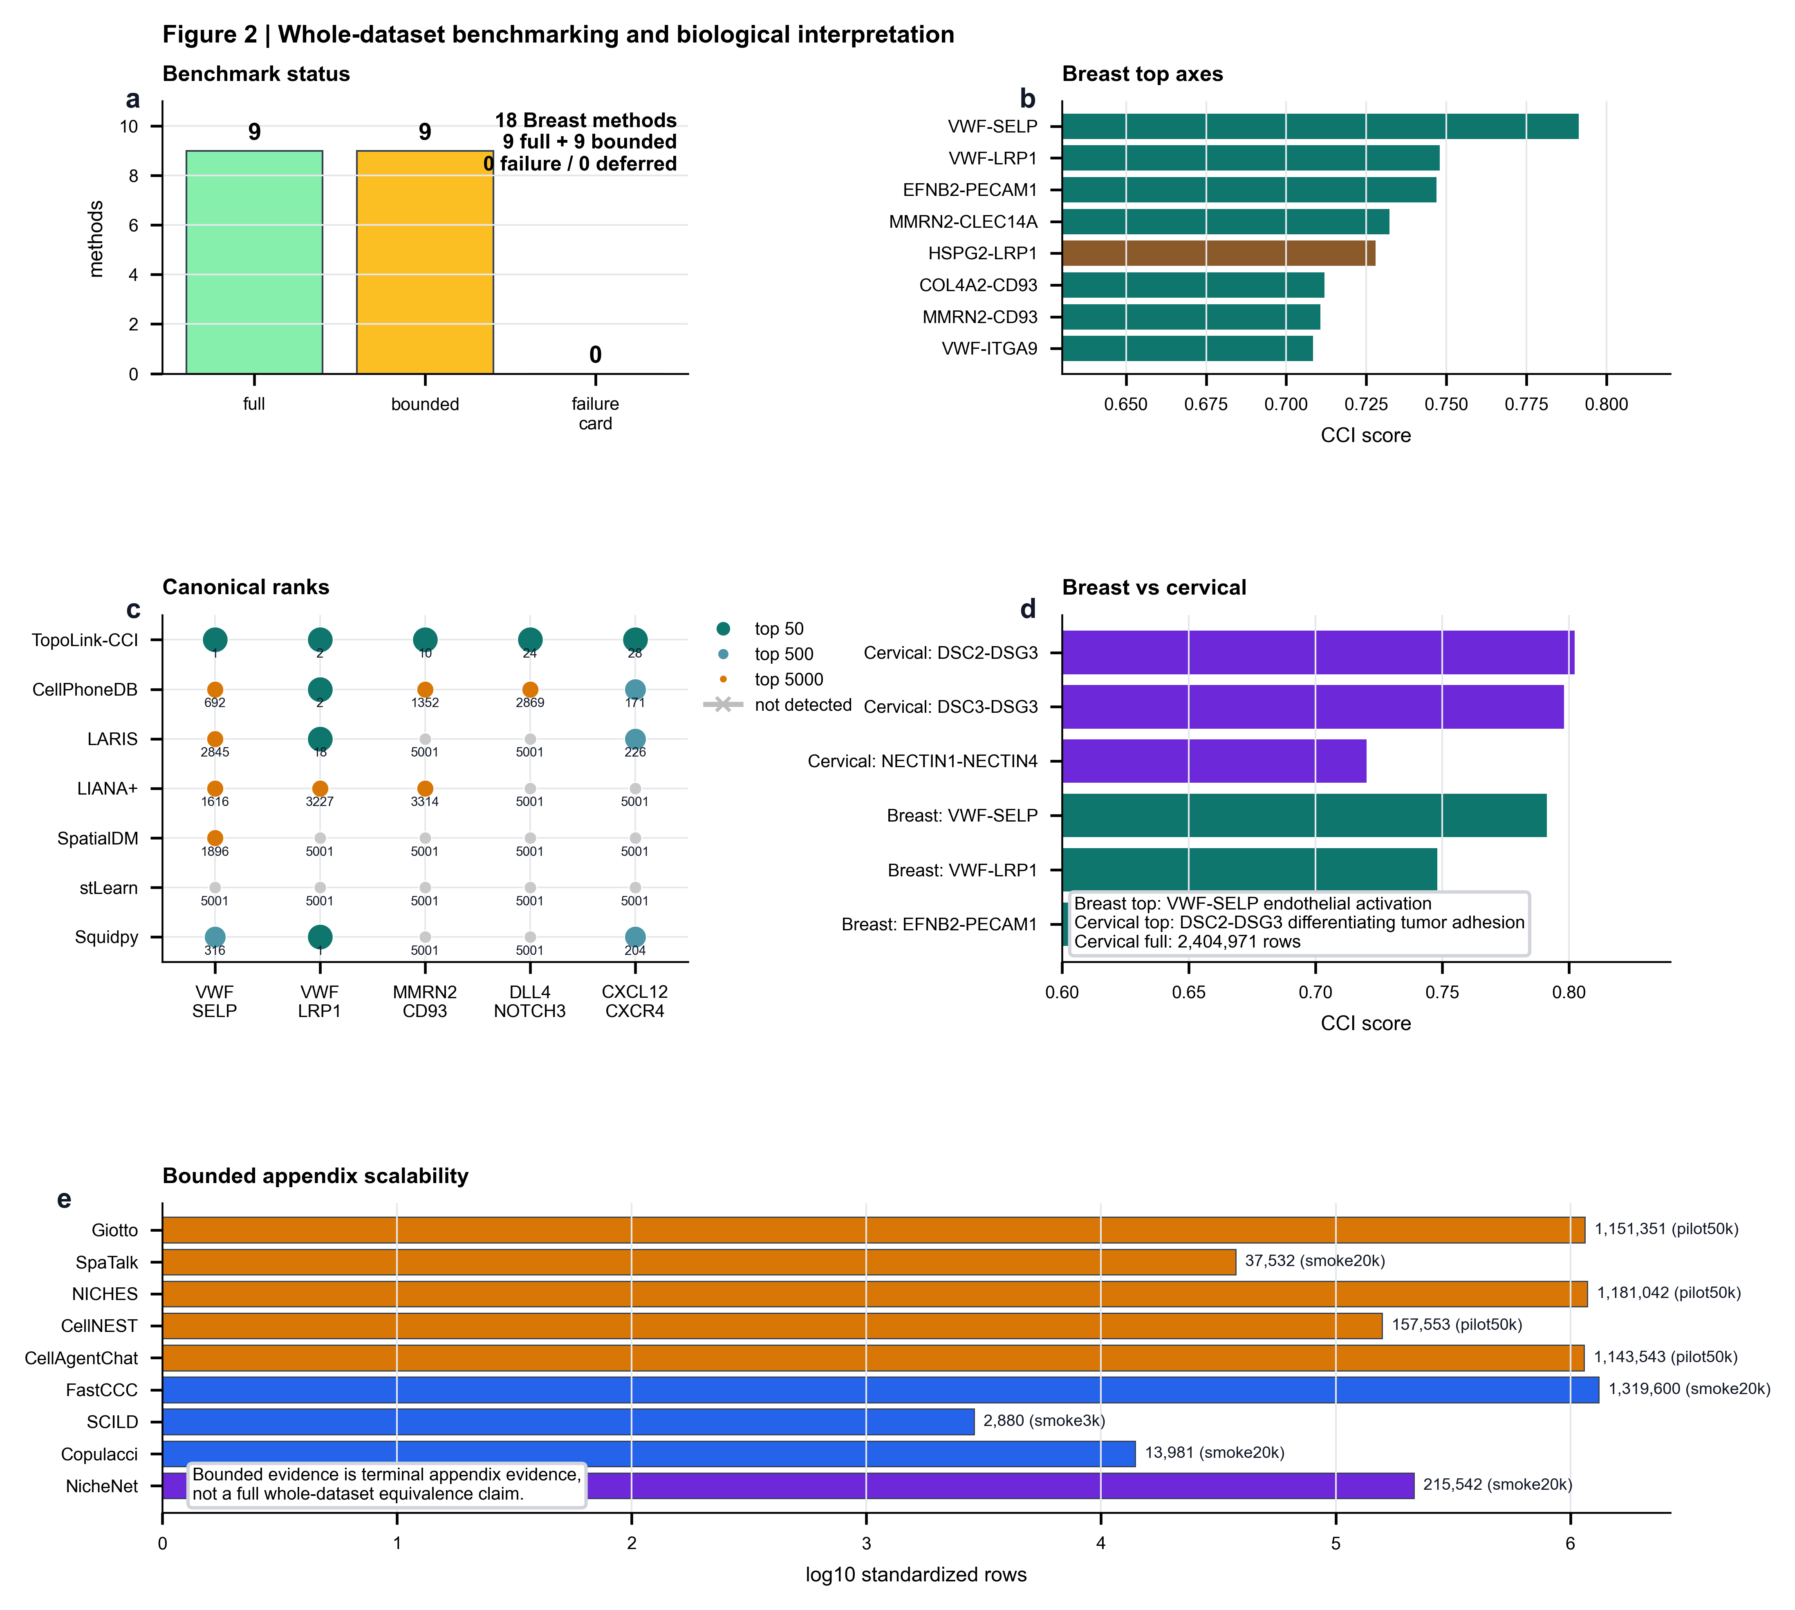
Figure 2 | Whole-dataset benchmarking and biological interpretation. a, The expanded Breast WTA benchmark terminalizes 18 methods as nine full and nine bounded results. b, Interpretable Breast WTA axes ranked by TopoLink-CCI score are led by VWF-SELP. c, Canonical recovery is compared by within-method rank rather than raw score. d, Breast and cervical WTA datasets yield tissue-context-specific top axes. e, Bounded appendix methods provide scalability-aware terminal evidence.

Online Methods

TopoLink-CCI score
TopoLink-CCI evaluates each candidate molecular interaction axis using six retained components: sender topology anchor, receiver topology anchor, structure bridge, sender expression, receiver expression and local contact. The discovery score is computed as a prior-weighted geometric mean of these components.

Benchmark tiers
Full results use whole-dataset common-resource outputs. Bounded results use documented cell-count, pair-count or method-specific scalability gates and are reported as appendix evidence. NicheNet is analyzed as downstream receiver-response support and is not presented as a direct spatial CCI ranker.

Validation controls
Synthetic Truth metrics use defined positive and negative axes. Real WTA interpretation uses rank, canonical recovery, cell-label permutation, spatial nulls, matched-gene controls, downstream support, cross-method consistency, component ablation and bootstrap stability.

Data availability
The manuscript uses public 10x Genomics Preview Data: Atera In Situ Gene Expression, FFPE Human Breast Cancer and FFPE Human Cervical Cancer datasets generated using Atera Whole Transcriptome Assay (Atera WTA): https://www.10xgenomics.com/cn/datasets/atera-wta-ffpe-human-breast-cancer and https://www.10xgenomics.com/cn/datasets/atera-wta-ffpe-human-cervical-cancer. Benchmark outputs are archived in the repository artifact manifests.

Code availability
TopoLink-CCI code and reproducible benchmark scripts are available in the pyXenium GitHub repository.

Acknowledgements
[To be completed]

Author contributions
[To be completed]

Competing interests
The authors declare no competing interests.

