PROOF OF CONCEPT
Operational Coordination Using
Microsoft Planner
Office of the District Attorney, Cobb Judicial Circuit
Primary Contact: AikWah Leow | Spring 2026

Event  Community Outreach & Legal Awareness | Tool Evaluated  Microsoft Planner (M365) | Status  Proof of Concept Complete

1. Overview
Sponsor | Office of the District Attorney, Cobb Judicial Circuit
Primary Contact | AikWah Leow
Goal | Evaluate an enterprise solution for managing and coordinating event-related tasks.
Selected Tool | Microsoft Planner (Microsoft 365)
Scope | Community Outreach & Legal Awareness Event — Spring 2026

2. Problem Statement
The Office of the District Attorney faces the following operational challenges when coordinating outreach events:

- Centralization: No single platform for tracking all event-related tasks across the team.
- Accountability: Difficulty assigning and monitoring individual responsibilities.
- Visibility: Limited real-time visibility into task progress and deadlines.
- Coordination: Communication gaps between staff members managing different workstreams.

3. Selected Solution: Microsoft Planner
Microsoft Planner was selected as the enterprise tool to prototype a centralized event coordination system. As part of the Microsoft 365 ecosystem already available to the DA Office, it requires no additional licensing and integrates seamlessly with Outlook, Teams, and SharePoint.

Why Microsoft Planner?

- Zero extra cost: Included in the existing Microsoft 365 subscription.
- Ease of use: No technical training required — intuitive drag-and-drop interface.
- M365 Integration: Direct integration with Outlook calendar, Teams channels, and SharePoint files.
- Mobile access: Available on iOS and Android via the Microsoft Planner app.
- Real-time updates: All team members see task status changes instantly.

4. Planner Structure
The Planner board was organized into six buckets representing the major workstreams of the event. Each bucket contains task cards with assignees, due dates, checklists, and priority labels.

Bucket | Example Tasks
1. Planning | - Define event goals and timeline  - Book venue at Cobb Civic Center  - Confirm DA Office participation and speakers
2. Flyer Creation | - Design outreach flyer (Canva / MS Designer)  - Get DA Office approval  - Print 200 copies and upload to SharePoint
3. Invitations & Outreach | - Draft invitation letter for community leaders  - Send Outlook email invitations to 150 contacts  - Track RSVPs in Excel on SharePoint
4. Staffing | - Recruit and confirm 10 volunteers  - Create staff schedule using MS Teams Shifts  - Conduct pre-event briefing via Teams meeting
5. Day-of Logistics | - Set up event space and registration table  - Distribute materials to attendees  - Collect feedback forms
6. Completed | - Archive completed tasks for record-keeping  - All finished items move here automatically

5. Features Demonstrated

Feature | How It Was Used
Task Assignments | Each task card was assigned to a specific team member, creating clear accountability.
Due Dates | Every task has a deadline; overdue tasks are flagged automatically in red.
Progress Tracking | Tasks move across buckets (Not Started → In Progress → Completed).
Checklists | Sub-tasks within each card ensure step-by-step completion of complex tasks.
Priority Labels | Color-coded labels (Urgent, High, Medium, Low) applied to each task.
File Attachments | Flyer drafts and invitation templates attached directly to task cards via SharePoint.
Charts View | Built-in charts show task completion rate and workload distribution per team member.
Teams Integration | Planner tab embedded in the event Teams channel for unified communication.

6. Planner Screenshots
6.1 Full Planner Board

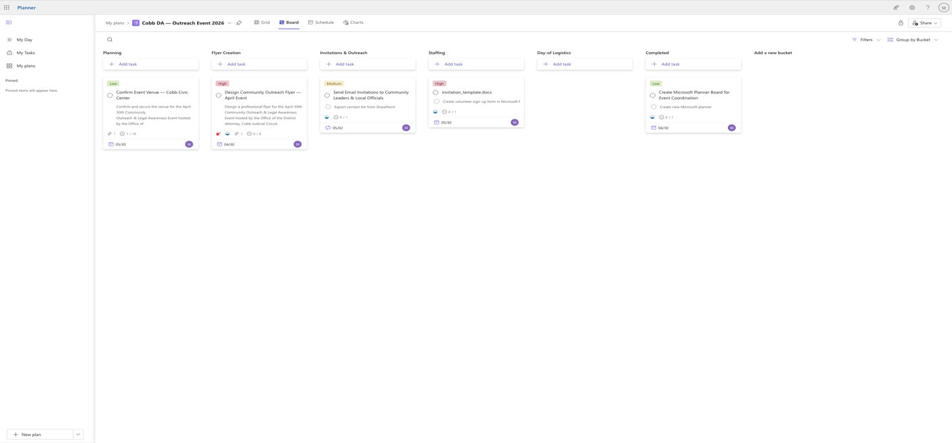

6.2 Task Detail View

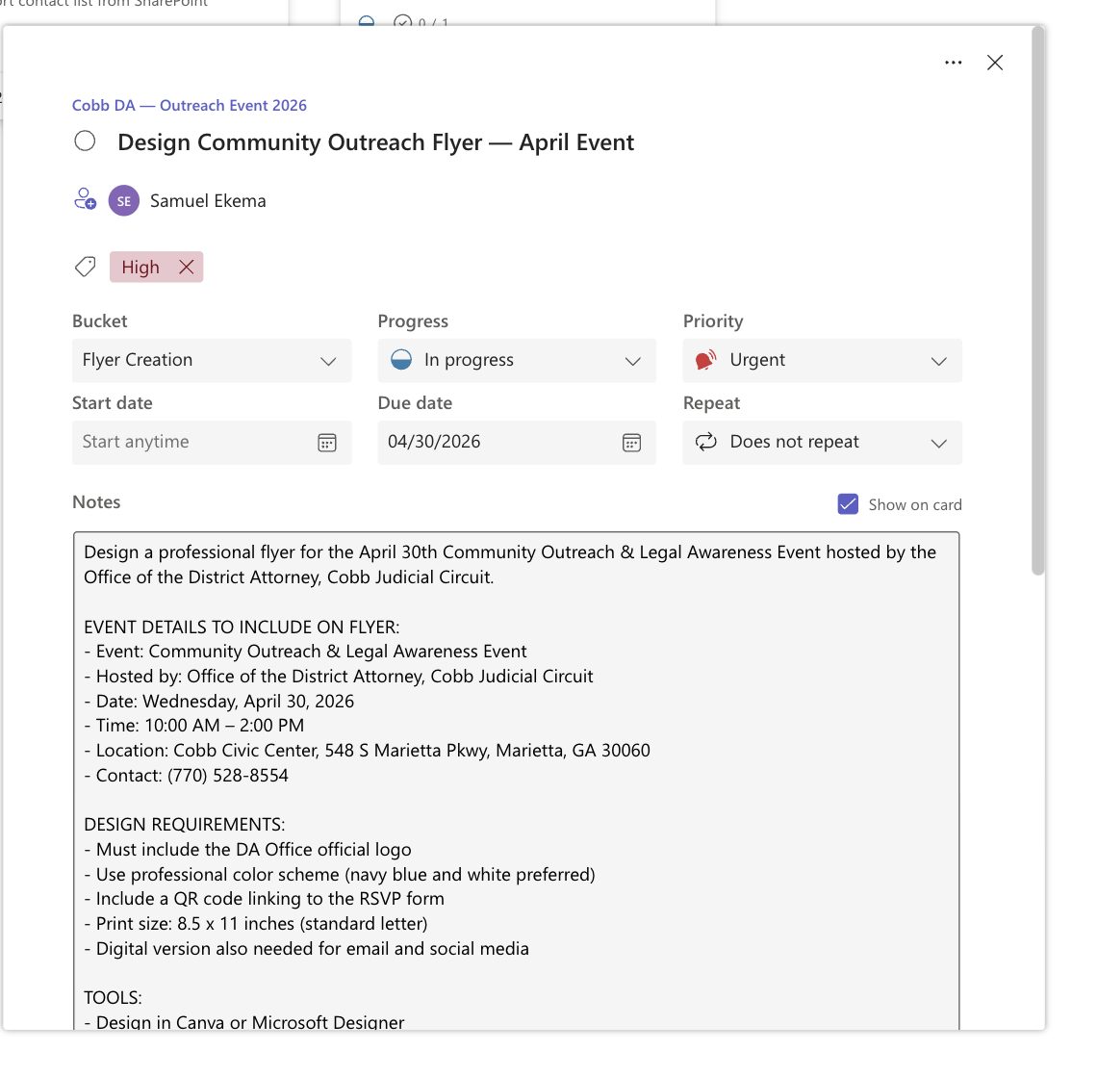

6.3 Progress & Charts

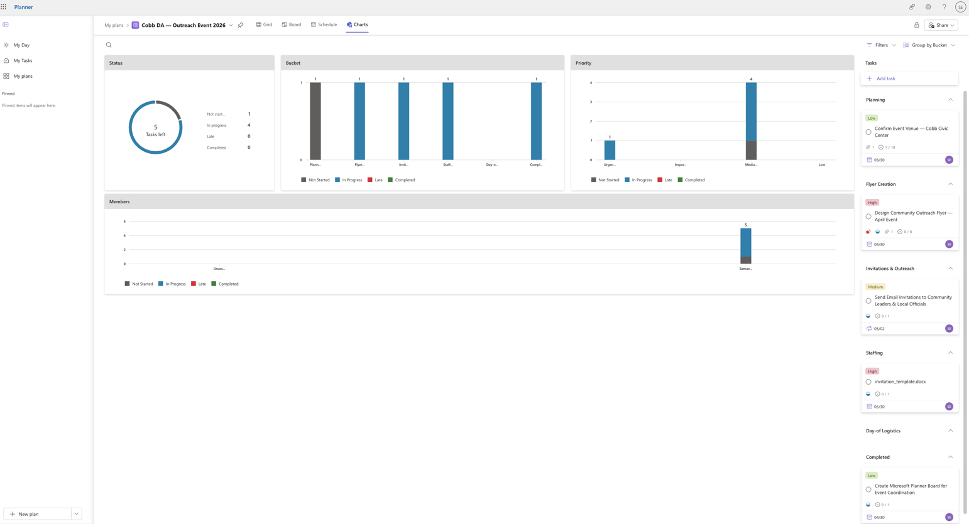

7. Evaluation
Advantages  - Included in Microsoft 365 — no additional cost  - Intuitive interface — minimal training needed  - Real-time collaboration across all team members  - Seamless integration with Outlook, Teams & SharePoint  - Mobile app available for on-the-go access  - Built-in charts for progress reporting | Limitations  - Limited automation compared to Jira or Asana  - No advanced reporting or custom dashboards  - Cannot set recurring tasks natively  - Task dependencies not supported  - External guest access requires additional setup

8. Conclusion
Microsoft Planner provides a simple, cost-effective solution for coordinating event-related tasks at the Office of the District Attorney, Cobb Judicial Circuit.
By centralizing task tracking, assigning clear ownership, and leveraging existing Microsoft 365 infrastructure, Planner directly addresses the coordination challenges identified in the problem statement. The proof of concept demonstrates that this tool can meaningfully improve team visibility and accountability for community outreach events.
Recommended next step: Pilot the full Planner board with the live event team and collect feedback from staff before a broader rollout.

35-Operational Coordination-Capstone Meeting

