Team 1
Masoud khelghati, adam hutcheson, samuel ekema, tyler higgins
Walkthrough documentation
Table of Contents
Introduction 2
Creating a Plan 3
Adding Members to a Plan 5
Adding a Bucket 6
Creating a Task 8
Configuring a Task & Task Details 12
Bucket 12
Progress 13
Priority 15
Start Date & Due Date 15
Repeat 16
Notes 17
Checklist 18
Labels 19
Navigating Planner Views 22
Board View 22
Grid View 23
Schedule View 24
Charts 25

Introduction
This document will be a walkthrough demonstration of Microsoft Planner. In it, you will find a detailed walkthrough with screenshots of the process of creating a plan in Planner, adding tasks, configuring tasks, adding assignees, and showing the various ways to view tasks in Planner. Through the walkthrough process, we will show how Planner can comfortably assist in assisting the Cobb Country Judicial Circuit District Attorney Communications and Community Engagement teams in effectively coordinating events and ensuring that tasks do not fall through the cracks.
In Microsoft Planner, each event would be separated into its own board which is called a “plan”. For the purpose of the walkthrough, an example plan will be created which showcases what a plan may look like for a real-world event. The various features of Microsoft Planner will be demonstrated with titled sections to help aid referencing this document.

Creating a Plan
Tasks in Planner are divided into plans, which are used to keep track of tasks for a specific event. Under each plan, you create tasks and manage them. In Planner, creating a plan is easy. On the bottom left side of the screen, there is a button that says “New Plan.” Click this to start creating a new plan. You will see an option to create a plan from scratch (“Basic”) or use a template.
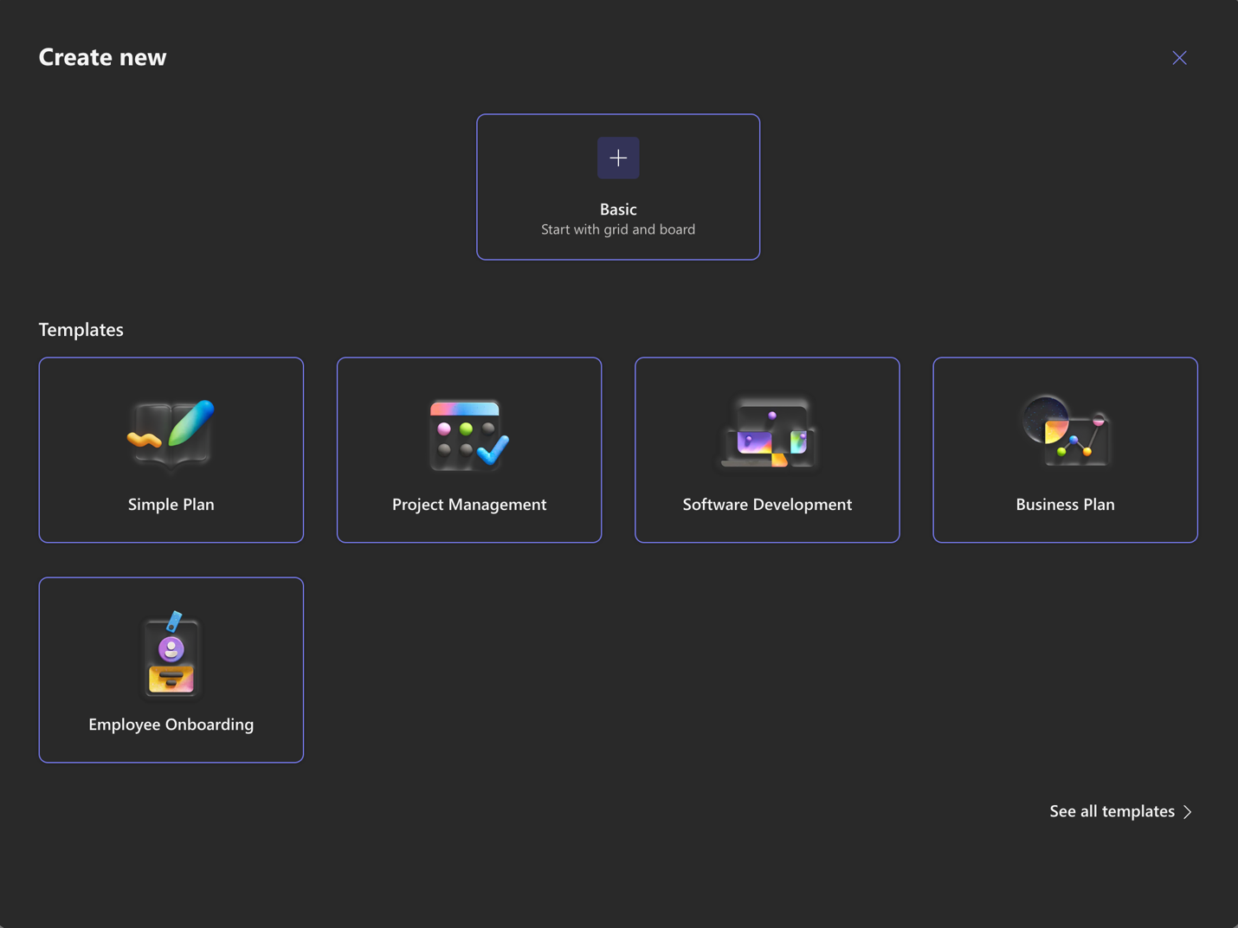
Screenshot 1: Menu that appears when pressing “New Plan”
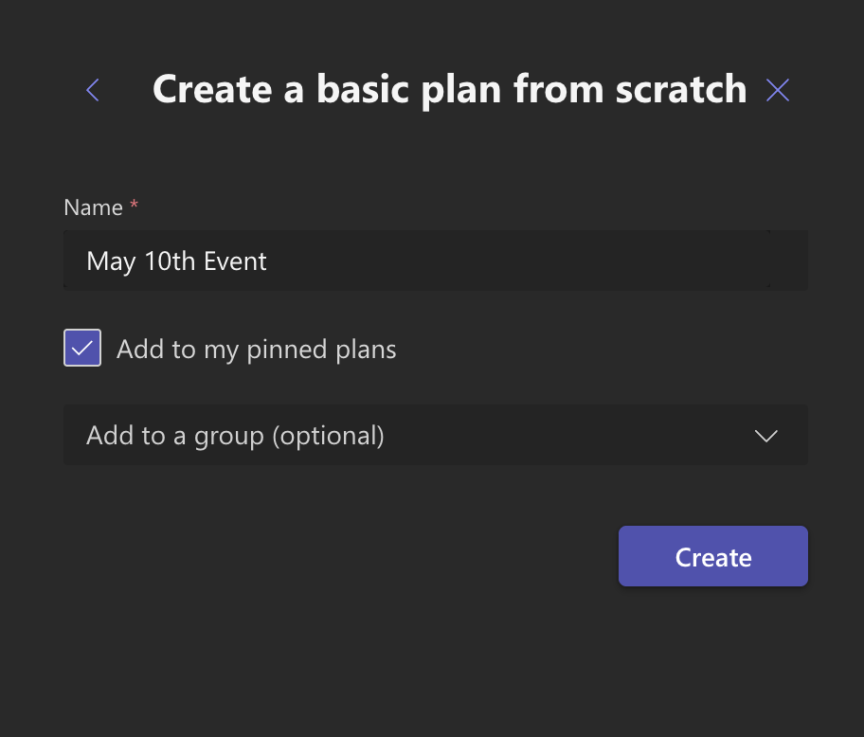
Screenshot 2: Menu that appears when creating a new plan either from scratch or from a template
When a plan is created from scratch or a template is chosen, you must choose a name for it. Additionally, it is possible to add it to your pinned plans. This is recommended almost always as it will make it easier to locate the plan quickly. Pinned plans always show up on the sidebar on the left.
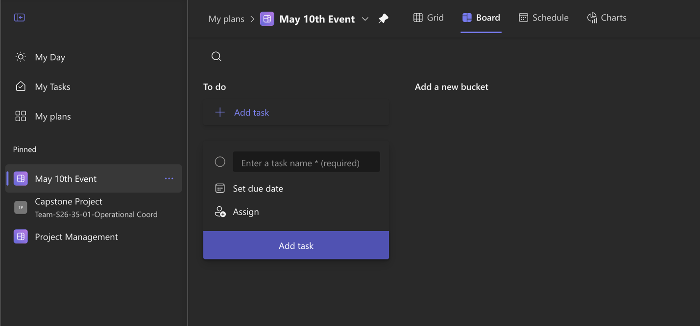
Screenshot 3: Sidebar shows pinned plans at all times, they would otherwise be located under “My plans”
You can also add all participants to the plan using a Teams group or add them later. When you have put the name and are satisfied with your other options, click “Create.”

Adding Members to a Plan
Members can be added to the plan either on creation of a plan or after. Plans in Planner are synced with Teams. You can add members to a Plan based on an existing Teams group and if a Team does not already exist, adding new members to the Plan will create a new Team automatically.
To add new members to an existing plan, click the “Share” button in the top right corner. A menu will appear with “Invite members” at the top. If you have not added any members yet, it will have a text box to enter a name for a new Teams group. If you click on the name, you can edit the group name, description, and set the privacy.
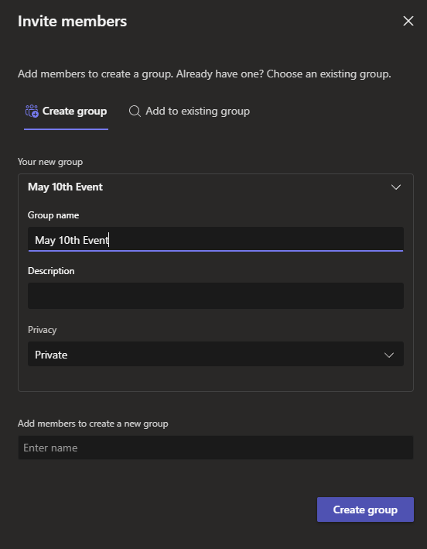
Screenshot 4: Menu for inviting new members to plan
Once the group has been configured, you can now add members. Click on the “Enter name” box underneath “Add members to create a new group.” When you do this, type the name of the person you want to add. The results will auto-complete based on the members in your organization. When you have found the person you want to add, click their name. You can repeat this as many times as you want in one session.
When you have added all the desired members, click “Invite.” They will be added to the plan. You can repeat this anytime and you do not have to recreate the Teams group.

Adding a Bucket
In Planner, tasks are categorized into groups called “Buckets.” In the default “board” view, these are organized into vertical columns with the bucket’s name at the top. For a plan created from scratch, there will be only one bucket: “To Do.” Buckets can be used to create categories in any way you want. One way buckets could be used is to set categories of tasks. In our example plan, we will create buckets using categories of tasks to be done, such as tasks for the venue, external promotion, and general event prep.
Creating a new bucket is simple and is clearly labeled in the app. Click on “Add a new bucket” beside the rightmost bucket to create a new bucket.
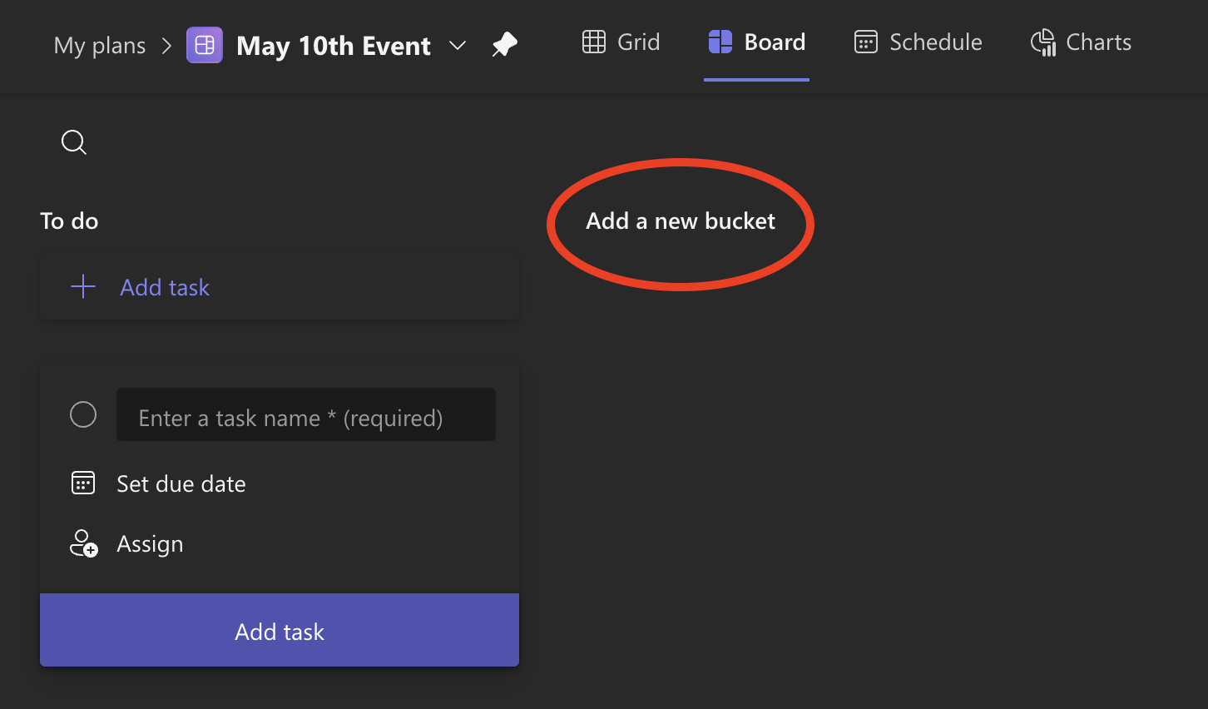
Screenshot 5: Press the “Add a new bucket” button which is circled to create a new bucket
When you click the button, a text box will appear where you put in the name of your bucket. Enter the name that you want for the bucket and click enter. You can change this name later.
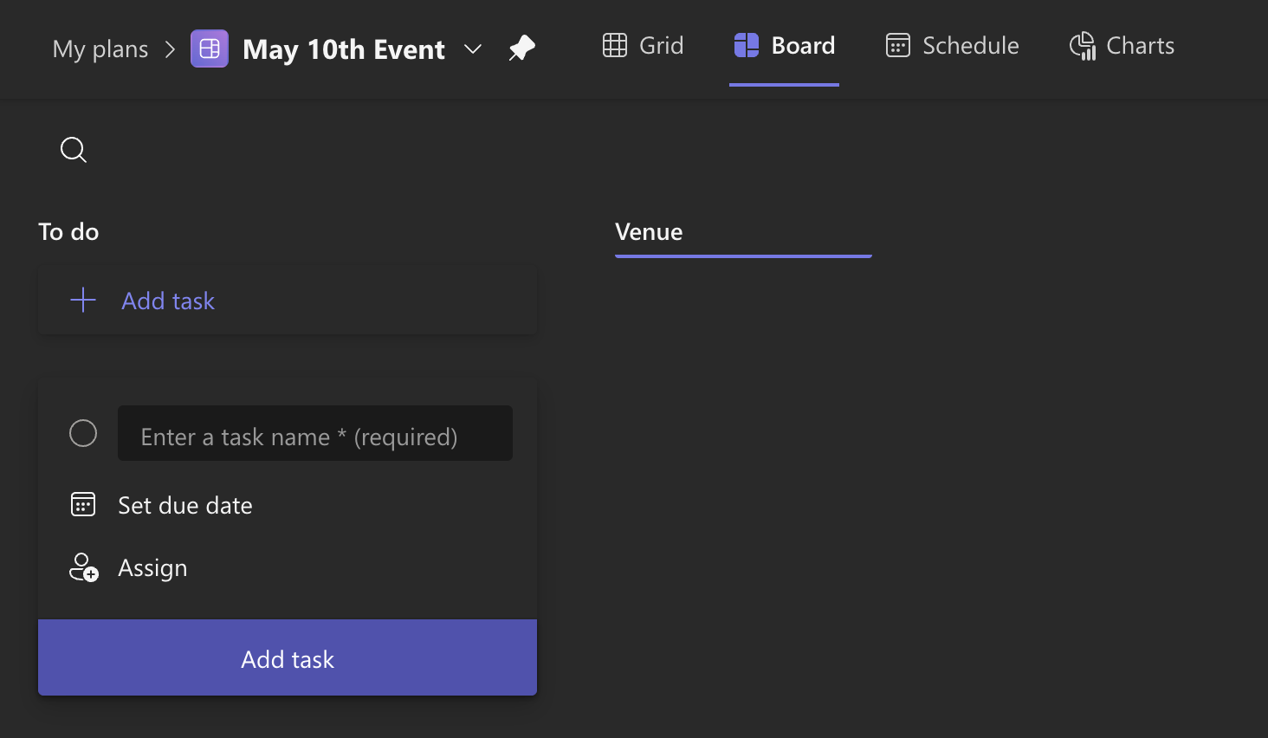
Screenshot 6: Name has been input, after pressing enter, the bucket will be created.
You can create up to 200 buckets in a plan. In our example, we put Venue, Promotion, and Event Prep as buckets.
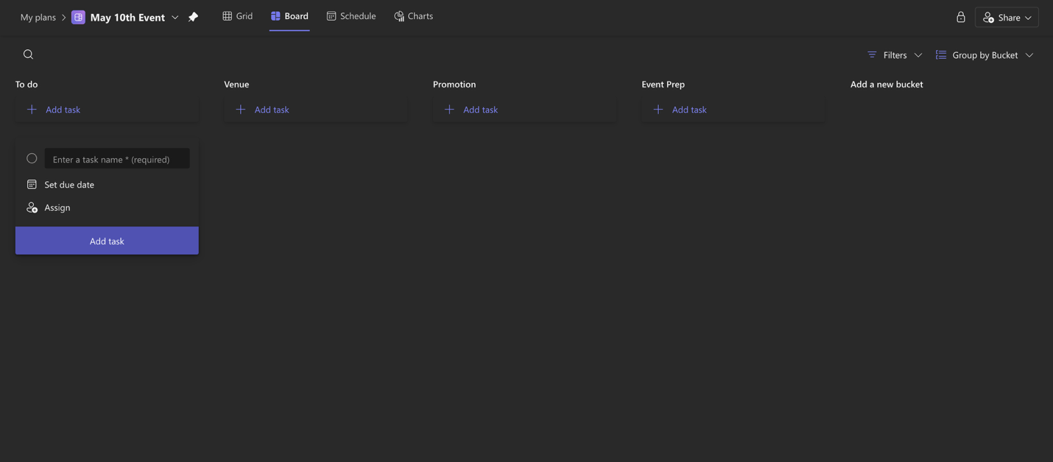
Screenshot 7: Buckets have been filled in

Creating a Task
Tasks are added under buckets. Under each bucket, there is an “Add task” button which will bring up a menu. To create a new task, start by pressing this button.
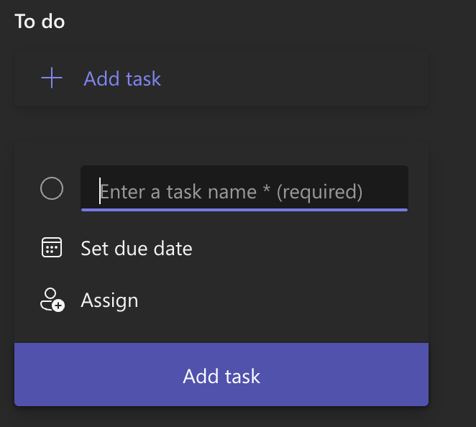
Screenshot 8: Showing the “Add task” button and menu that appears when pressing add task
The menu that appears has 3 fields to quickly fill out information: task name, due date, and member assignment. Task name is the only field that is required to create a task; a due date or member assignment is not required. In our example, we call this first task “Fill out plan for event.” After, if you want to set a due date, press the “set due date button” and a calendar will appear.
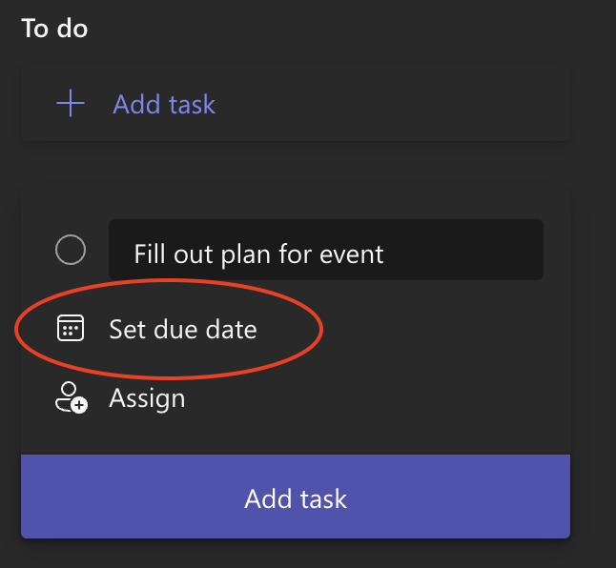
Screenshot 9: Press the “set due date” button circled to set a due date
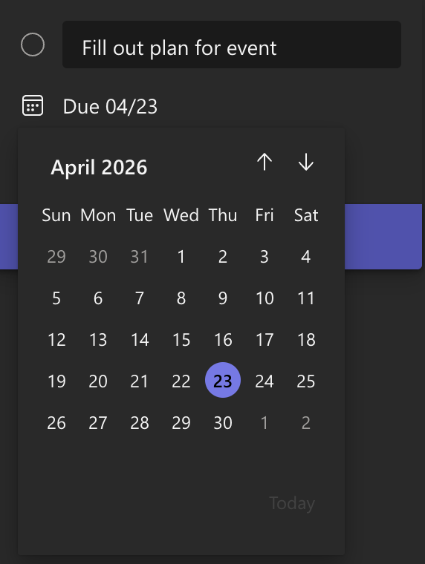
Screenshot 10: A calendar menu will appear which can be used to select the due date
When you click the date on the calendar, it will set this as the due date for the task. This can be changed later, and you can also add a starting date for a task, which will be explained under the “Task Details” section.
Under the same menu, you can assign one or multiple members to a task by clicking the “Assign” button. Click this button and you will see the current members of the plan or can type in the member’s name that you want to assign to the task.
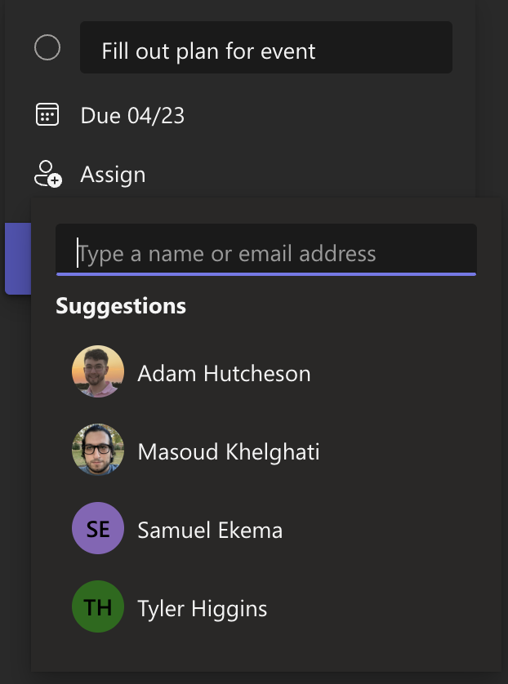
Screenshot 11: Members of the plan are shown, or the member’s name or email address can be used to search
Once the member is clicked, they are assigned to the task. Members can be assigned or unassigned to a task later.
When you are finished with everything on the task, click the “Add task” button. The task will appear in the plan under the bucket that you pressed “Add task” under.
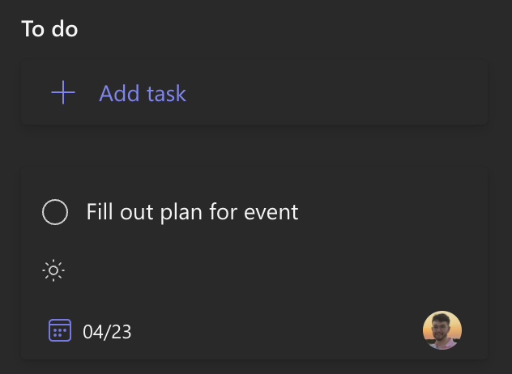
Screenshot 12: The task will appear and look like this under the bucket

Configuring a Task & Task Details
Configuring a task is mostly done in the “Task Details” menu. To open this menu, click on the task in the board by clicking in any blank area on the task or on the name of the task.
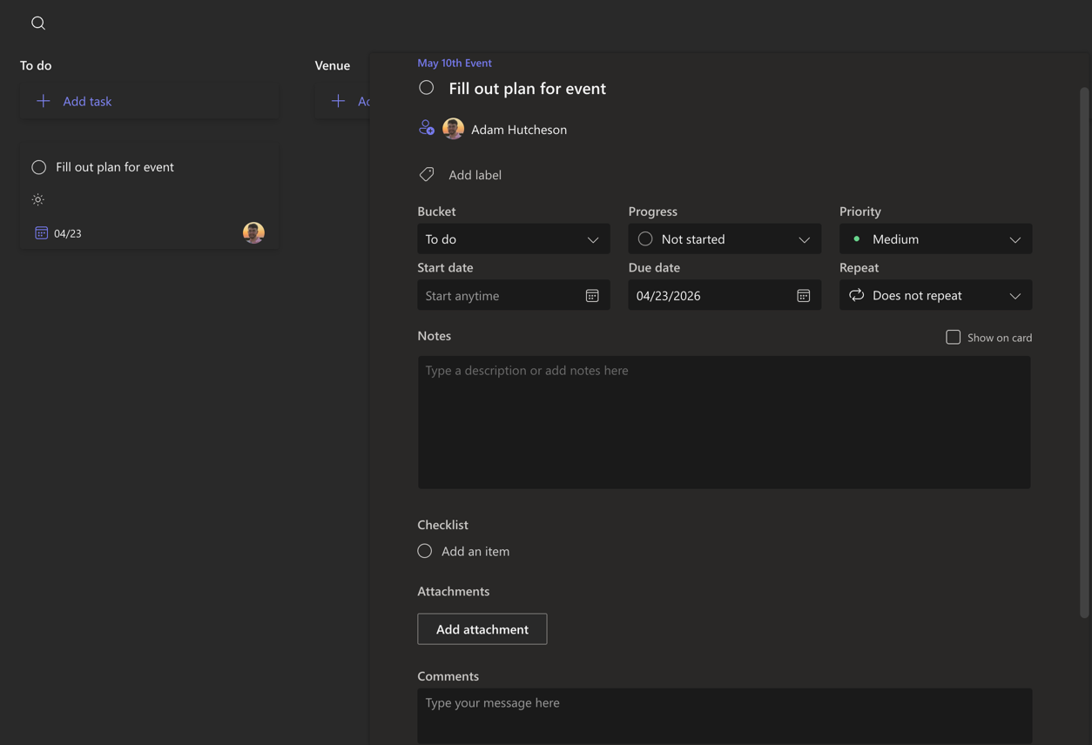
Screenshot 13: Task details menu after clicking inside the task
In this menu, you can adjust the bucket, set the progress of the task, set the task’s priority, the task start date or due date, set a repeating task, add a note, add a checklist, add attachments, and add comments.

Bucket
Under the Bucket field, you will see the task’s current bucket. Clicking the dropdown menu will show all the current buckets. If you want to change the bucket, click the bucket you wish to add it to, and it will add it automatically.
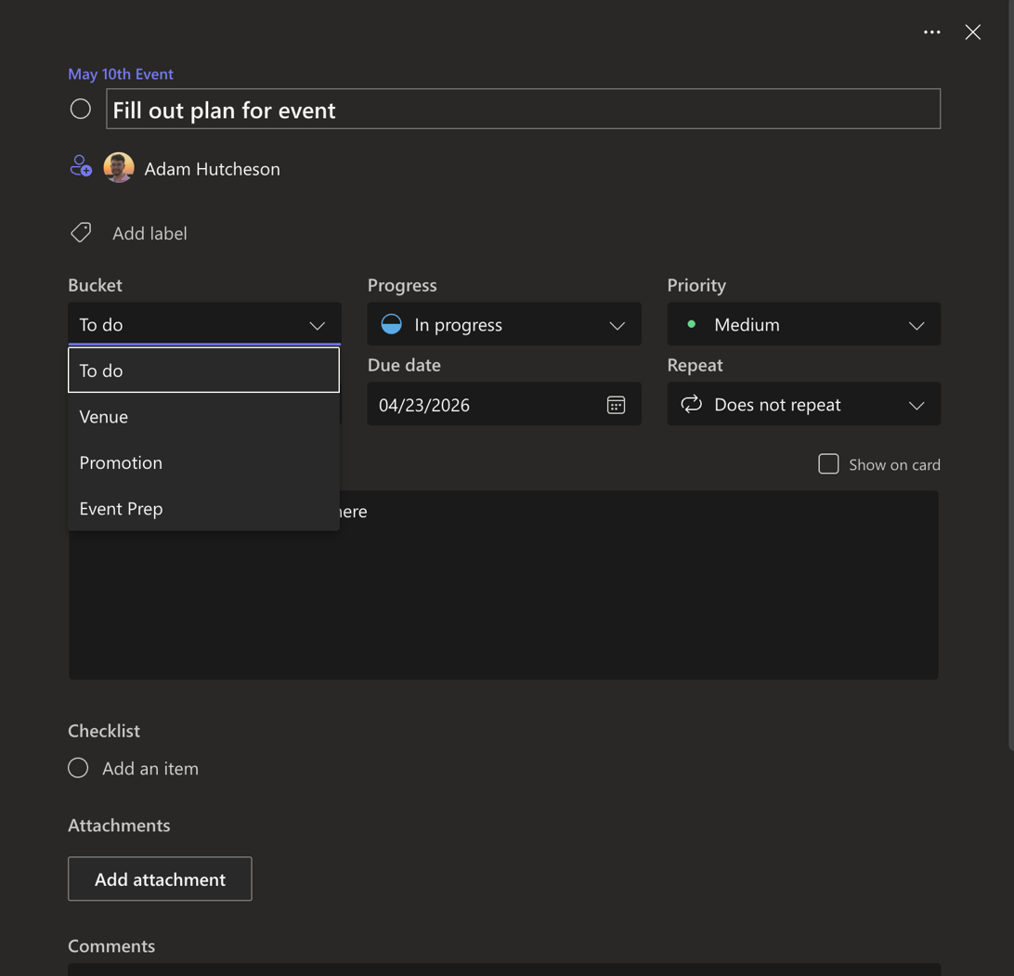
Screenshot 14: The bucket dropdown menu with all the current buckets

Progress
Under progress, you can view the current progress of the task and adjust it if desired. The dropdown menu will show the 3 progress states available in Planner: not started, in progress, and completed. A not started task will show an unfilled circle, in progress shows a half filled circle, and a completed task will show a filled circle with a check mark.

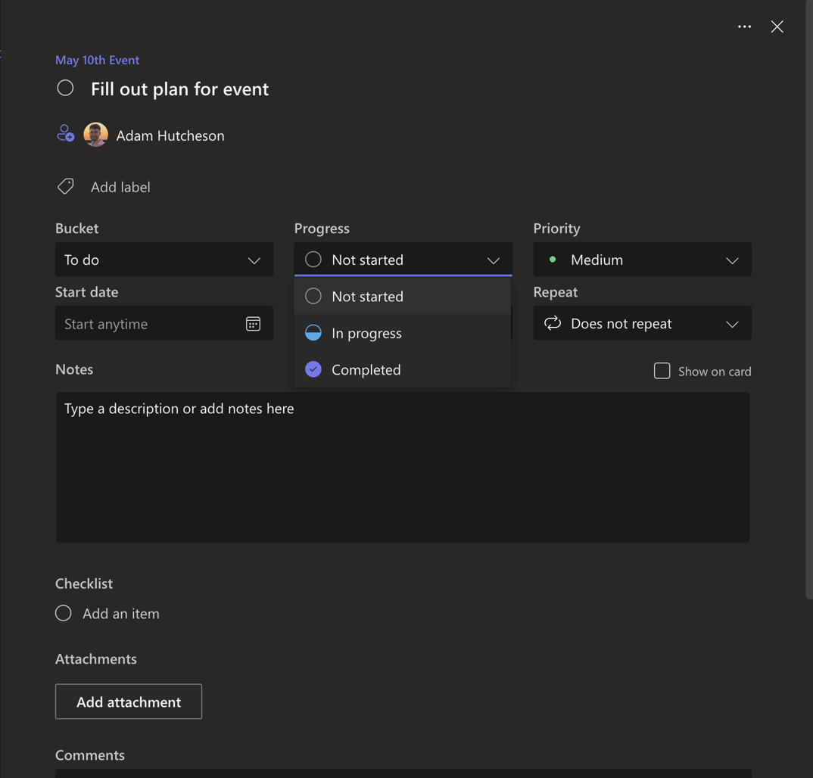
Screenshot 15: Dropdown menu for progress
A task can also quickly be set as complete under its task card by clicking the circle icon beside the task’s name.
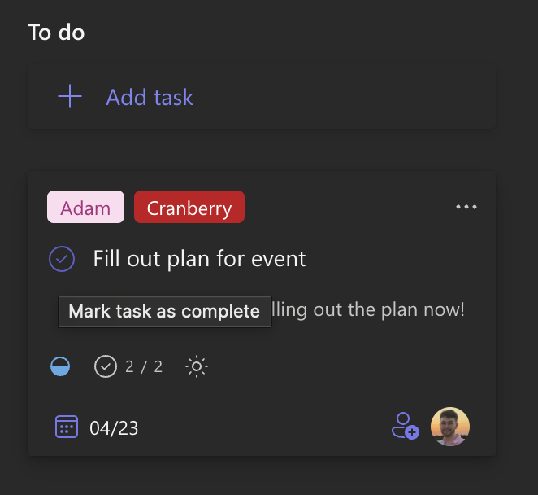
Screenshot 16: Press the circle button to quickly complete a task

Priority
Task priority is shown under priority and can be adjusted in the dropdown menu. There are four options: low, medium, important, and urgent. When you set the priority to low or medium, this will not show up on the task’s card on the board. For important priority, it will be shown on the card with an exclamation point, and urgent priority is shown with a bell.
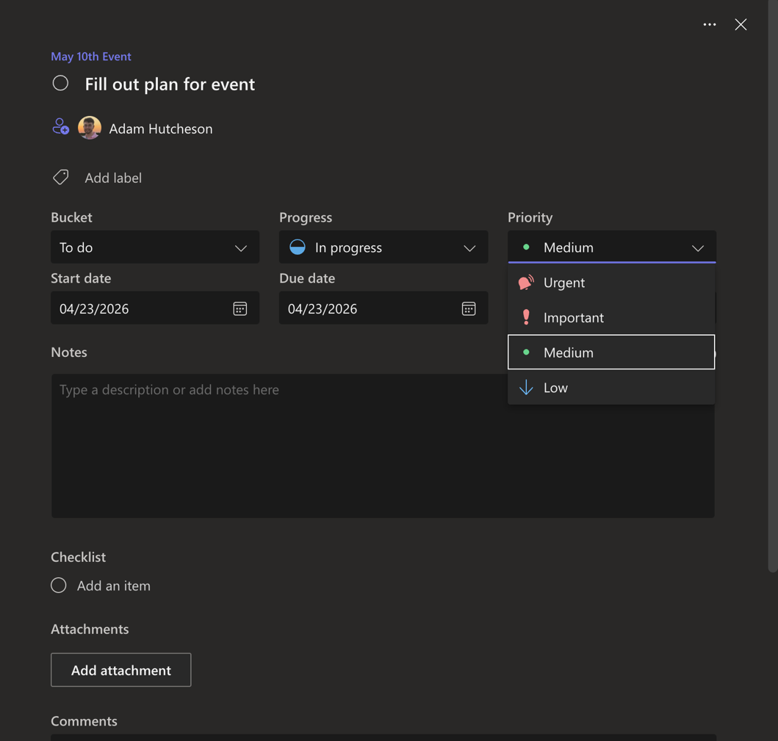
Screenshot 17: Priority dropdown menu

Start Date & Due Date
You can also set or adjust the start and due dates of a task. Clicking the date underneath the “Start Date” or “Due Date” label will open a calendar similar to the menu under the task creation menu. Clicking a date in the calendar will set the date, and a date can also be typed in manually and this must be done using leading zeroes for single digit dates (04/01/2026 must be used, 4/1/2026 will not be accepted).
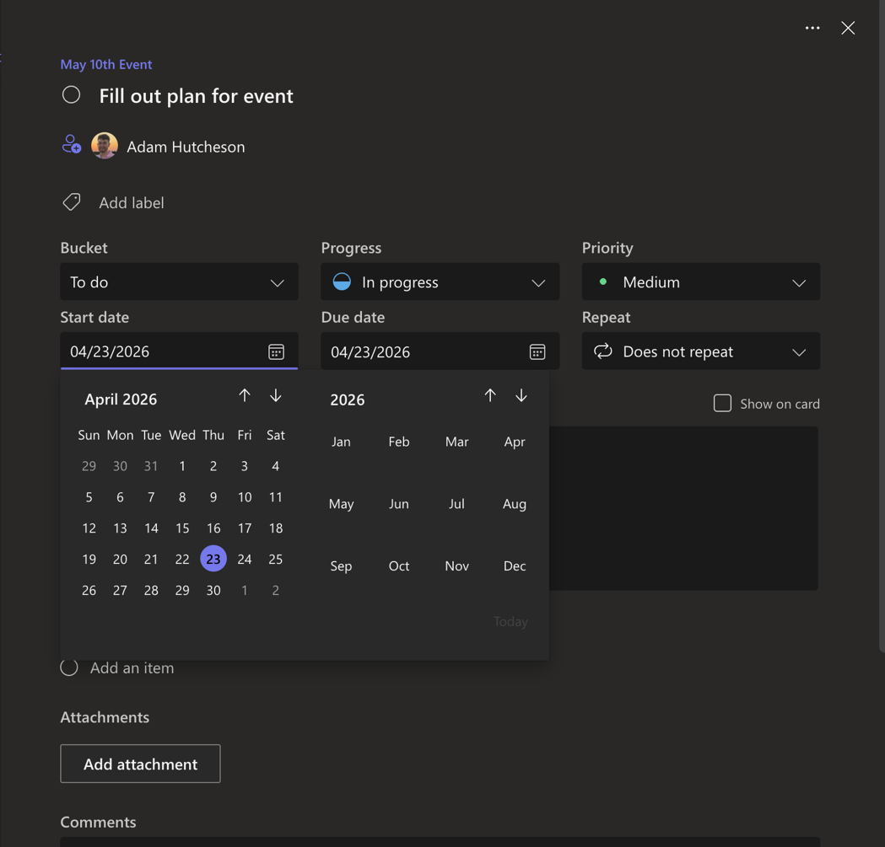
Screenshot 18: Calendar menu for setting dates

Repeat
Tasks can also be set to repeat on time intervals and will automatically be added to your calendar. For example, a task can be repeated daily, weekly, monthly, and you can even add a custom time interval.
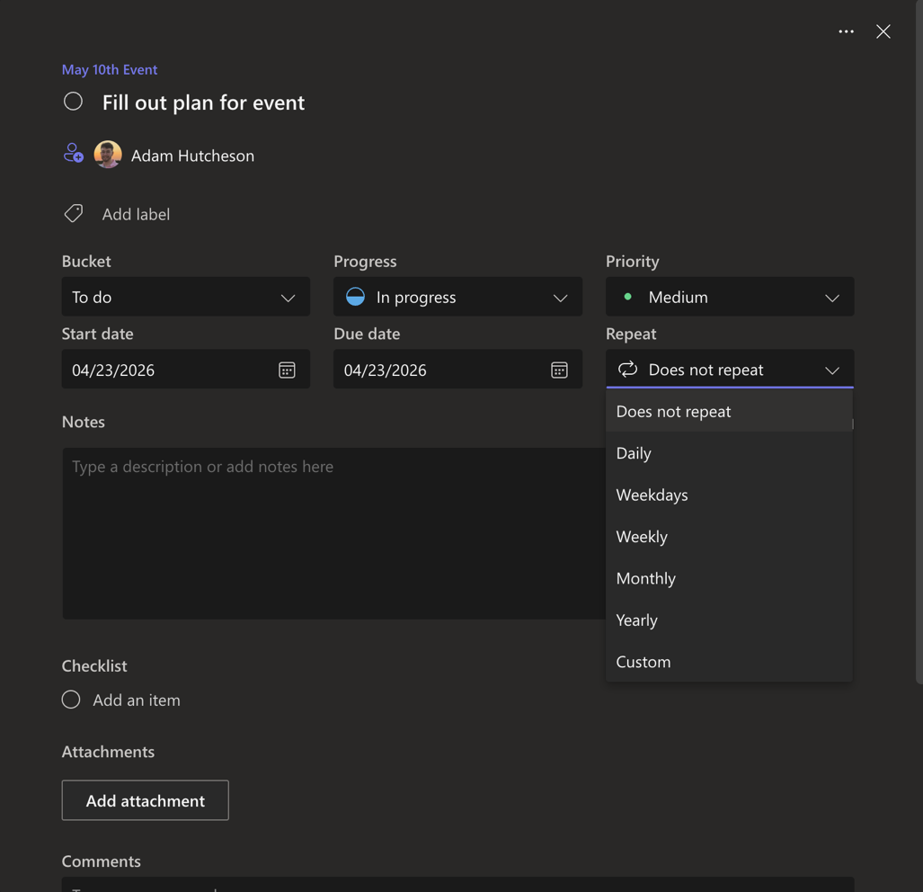
Screenshot 19: Showing repeat dropdown menu

Notes
Tasks can also have a note on them. You can type anything you want such as important information that is needed to complete the task. Optionally, this can appear on the task card itself by clicking the check button above the note, “Show on card.”
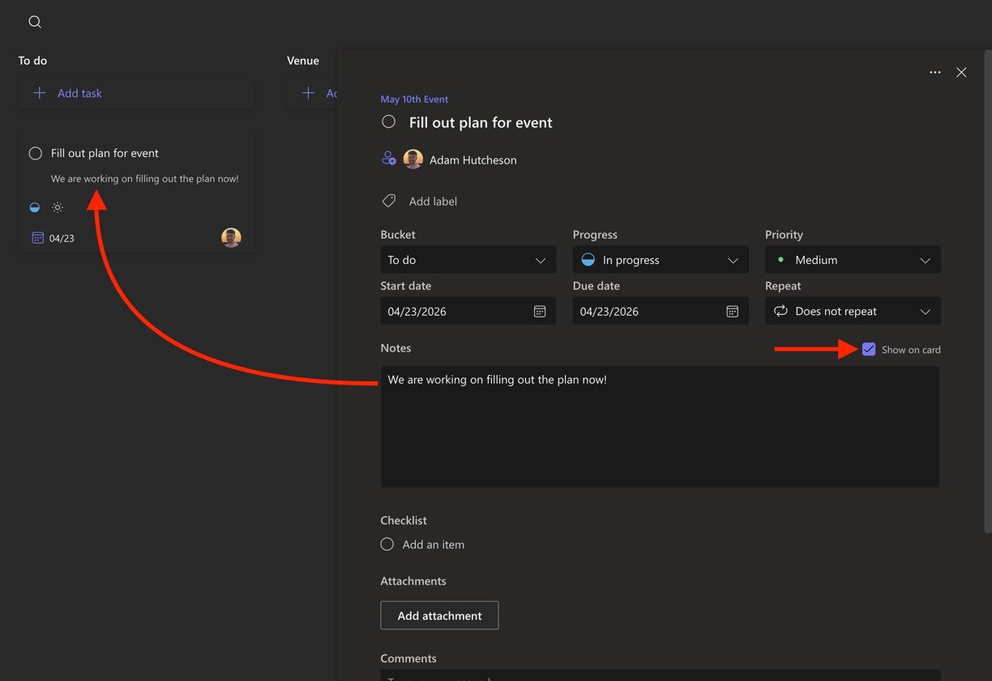
Screenshot 20: Showing notes, show on card button, and how the note appears on the task

Checklist
Subtasks can also be added to each task under the “checklist” section which can be used to add subtasks to better track progress under each task. By clicking “Add an item” and clicking enter, the subtask will be added. You can also optionally press the “Show on card” button to display these subtasks on the task’s card similarly to the notes, though the subtask progress will always be shown under the card regardless of whether or not the button is checked.
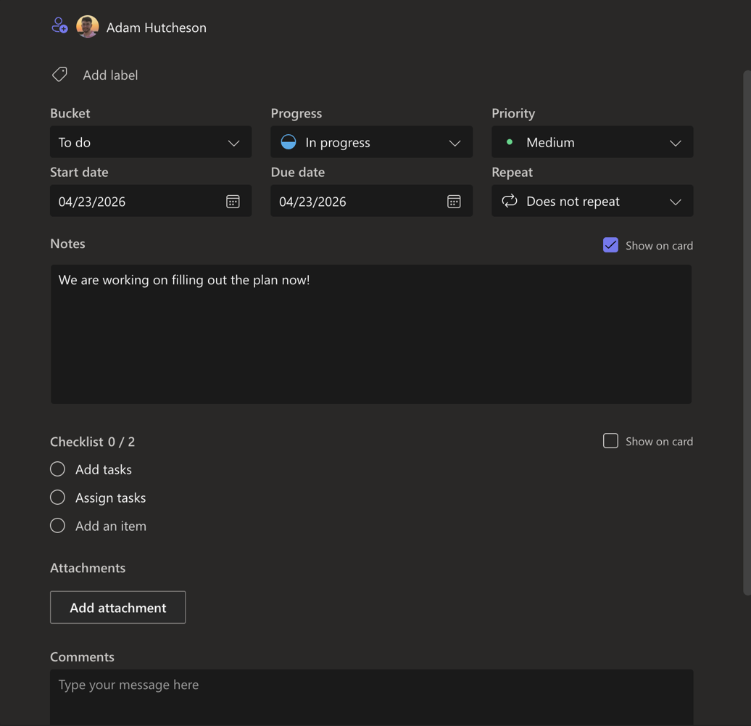
Screenshot 21: Tasks have been added to the checklist

Labels
Finally, a task can be assigned a label. This is done through the “Add label” button near the top of the card.
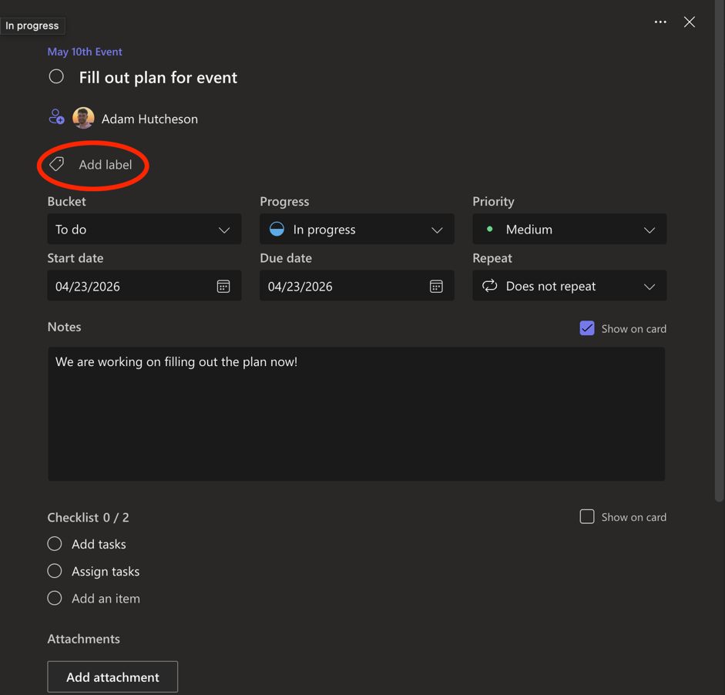
Screenshot 22: Add label button is circled. Press it to add a label
Pressing this button will open an “Add label” menu. Labels are already created as colors in the menu. You cannot create your own labels, though the labels can be edited. There are 25 labels under the menu with various colors. Clicking the pencil icon next to the label will allow you to change the name. Changing the name will adjust this for every task using that label automatically.

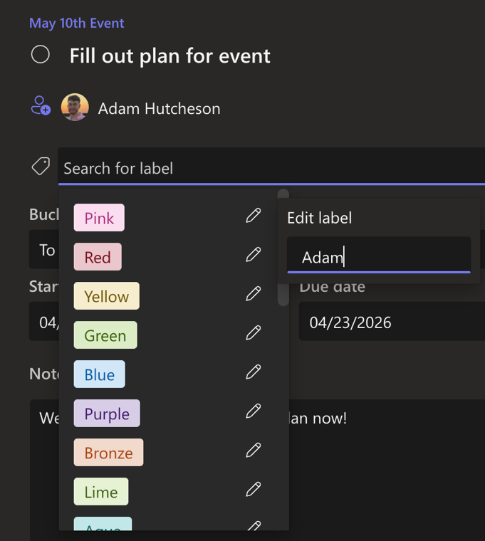
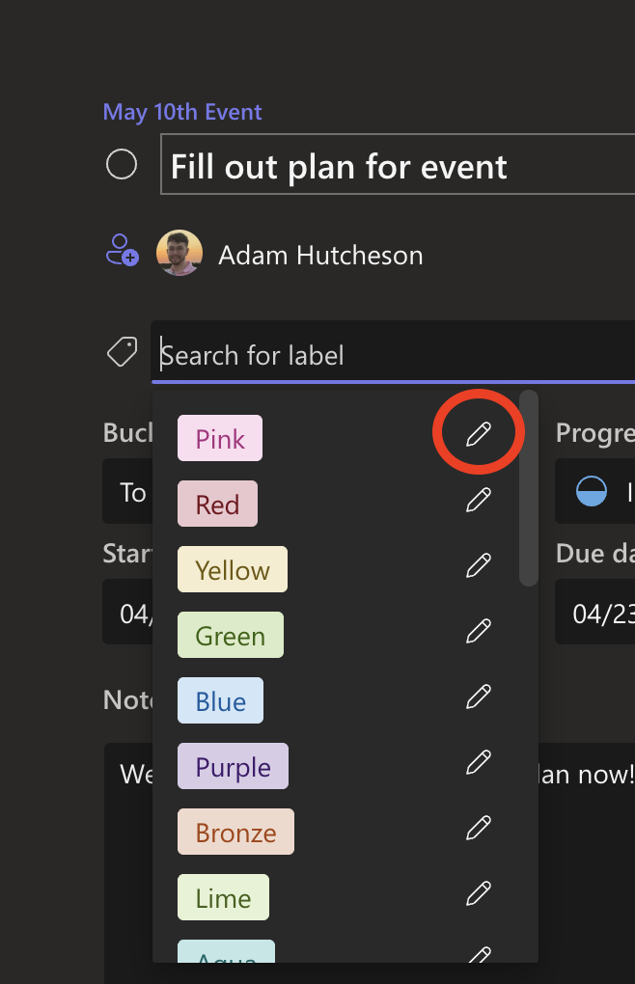
By clicking the label’s name in this dropdown menu, the label will be added to the card. You can add one or many labels. As stated in the presentations and prior documents, Planner does not have a way to explicitly assign primary owners to a task, but this could be done using labels, which we have shown in our document here. Labels could also be used for anything else that the team desires.
Screenshot 23: By entering the desired name and pressing enter, the label will be changed
Screenshot 24: Click the pencil to edit the name

Navigating Planner Views
Planner has several different views, which present information about the plan in different ways, and each one has its own uses. Changing the view can be done by clicking the corresponding button at the top of the plan: grid, board, schedule, or charts. Under each view, results can be filtered to only include the desired tasks. By clicking filters at the top, you can add one or more filters which will limit what is shown in the view.

Board View
The default view which is shown upon first entering the plan is called the “Board” view. This is good for general viewing of the plan, and it initially shows all the tasks as vertical columns using the plan’s buckets to organize tasks. It shows each task and its card, with information on the due date, assigned members, and any other information attached to the card.
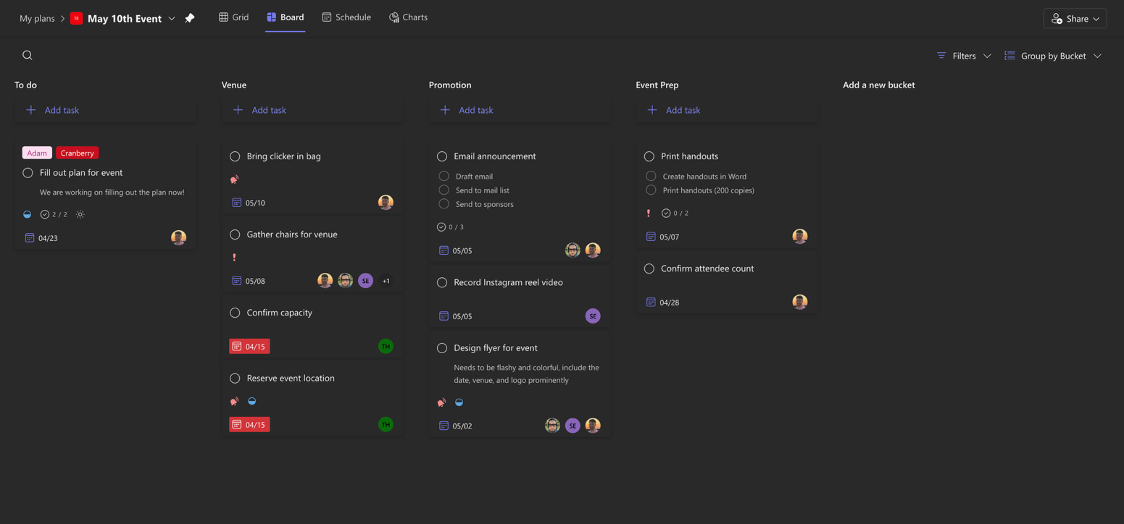
Screenshot 25: A completed board looks like this when grouped by buckets
Though it is initially grouped by buckets, this can be changed by clicking the “Group by Bucket” button in the top right. When you click this button, a dropdown menu will appear which allows you to change the grouping in the following categories: bucket, assigned to, progress, due date, labels, and priority. Clicking these options will change the columns to be the different options that it says. For example, “assigned to” will show the columns as each member of the plan, with their names at the top and all of their assigned tasks underneath. Unassigned tasks show up as a column on the left.
Inside each group, you can move a task from one group to another by simply dragging it from one group to the desired group.
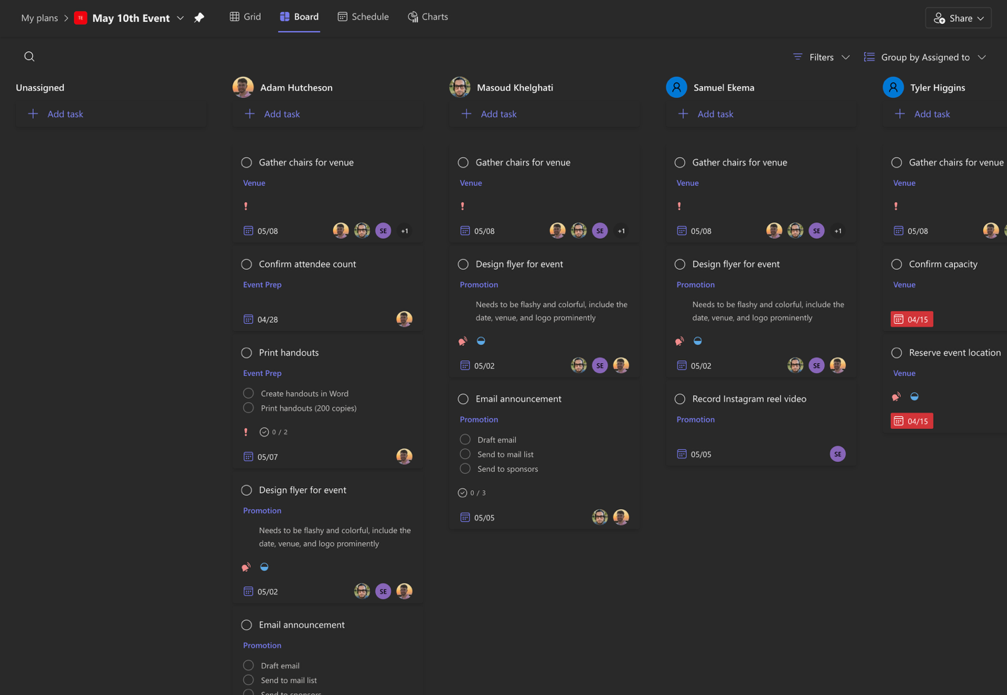
Screenshot 26: Board view when grouped by “Assigned to”

Grid View
The next view is the Grid view. This is a more compact version of the same information. It shows each point of information under a task as its own column, allowing you to sort the information by ascending or descending under each one. For example, tasks may go from closest due date at the top to the furthest due date at the bottom, and this can be changed to sort by bucket or progress as well. This can be great for getting information at a glance or quickly viewing what is upcoming, as well as the status of the project if needed.
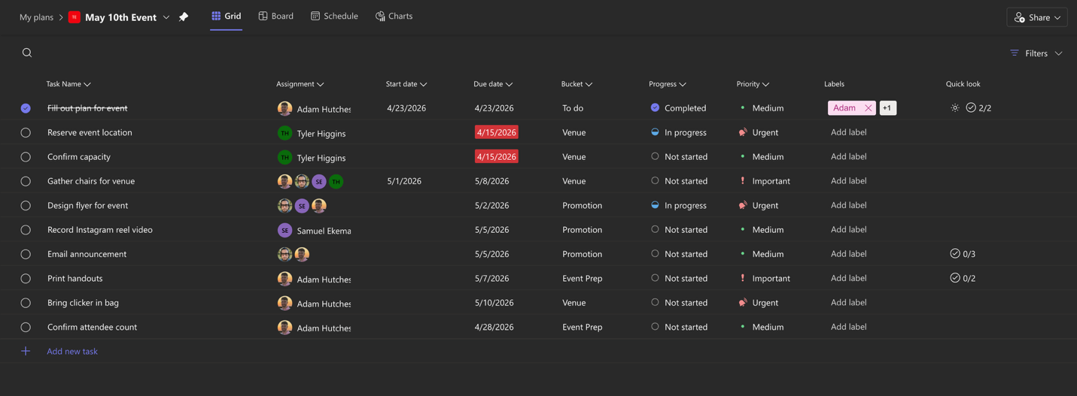
Screenshot 27: Grid view; the same information is present as the Board view

Schedule View
The next view is the Schedule view, which is a calendar view of all of the tasks. This shows each task inside the calendar based on its set dates. A task which has only its due date set will be placed on that date only, while a task with both a start and due date set will be shown for all days from the start to due date. Tasks that are unscheduled will not appear in the calendar itself, though they do appear in the top right under the “Unscheduled tasks” label, and the grouping of the sidebar can be adjusted similarly to the Board view.
Any task that is under “Unscheduled tasks” can be placed on the calendar by simply dragging it from “unscheduled tasks” onto the desired date on the calendar.
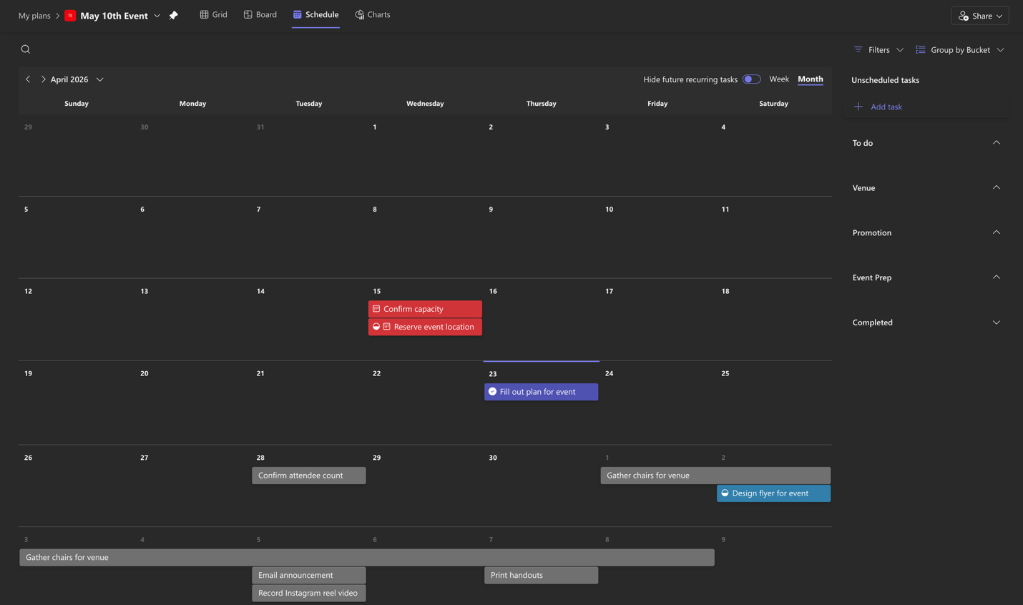
Screenshot 28: Schedule (calendar) view
As shown in Screenshot 28 above, the calendar view also has color coded progress when viewing a task. Red tasks indicate an overdue task, a dark blue task indicates a completed task, a light blue task indicates an in-progress task, and a grey task indicates a task that is not started.
The calendar can also be adjusted to show each week only or can stay in the default view which is the full month.

Charts
The final view in Microsoft Planner is the Charts view. This view shows the status of tasks in the project in various groupings. When initially opening the Charts view, you will see four groupings: Status, Bucket, Priority, and Members. There is also a sidebar with all tasks on the side similarly to the other views which functions as a mini Board view.
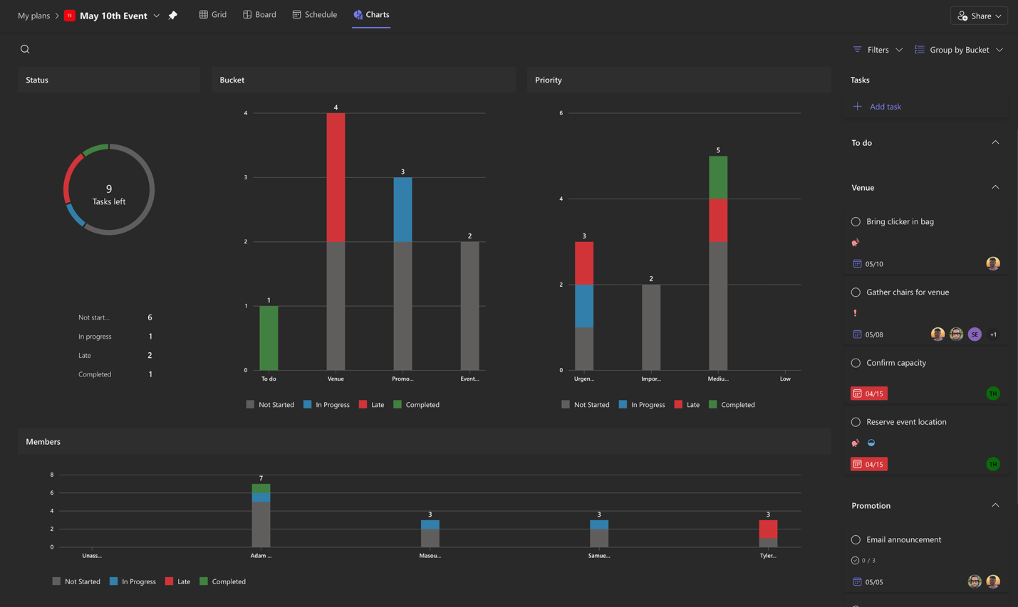
Screenshot 29: Charts view
The Status section shows an overall view of the status of every task in the plan with no groupings. In Screenshot 29, it shows our example plan as having 9 tasks uncompleted. 6 tasks have not been started (shown as the grey part of the circle), 1 task is in progress (the light blue), and 2 tasks are late (the red). Tasks that are completed (shown in green) are not included in the “tasks left” count as they have already been completed.
The Bucket grouping shows the same information but grouped by each bucket that has been added. The total tasks in each bucket is shown at the top of the graph line, and hovering over each colored portion of the graph will show the total number of tasks that are in the portion (for example, the “Venue” bucket shows 2 late tasks when hovering over the red).
The Priority grouping shows the same information but grouped by priority. Similarly to the Bucket grouping, hovering over a colored portion will show the number of tasks that are not started, in progress, etc., and also shows the total number in each priority at the top.
The Members grouping shows the same information but grouped by member. This works the same as all other groupings and it shows the status of all the tasks assigned to the member, with the total task number at the top and the number of tasks in each status being found by hovering over each colored portion of the bar.

