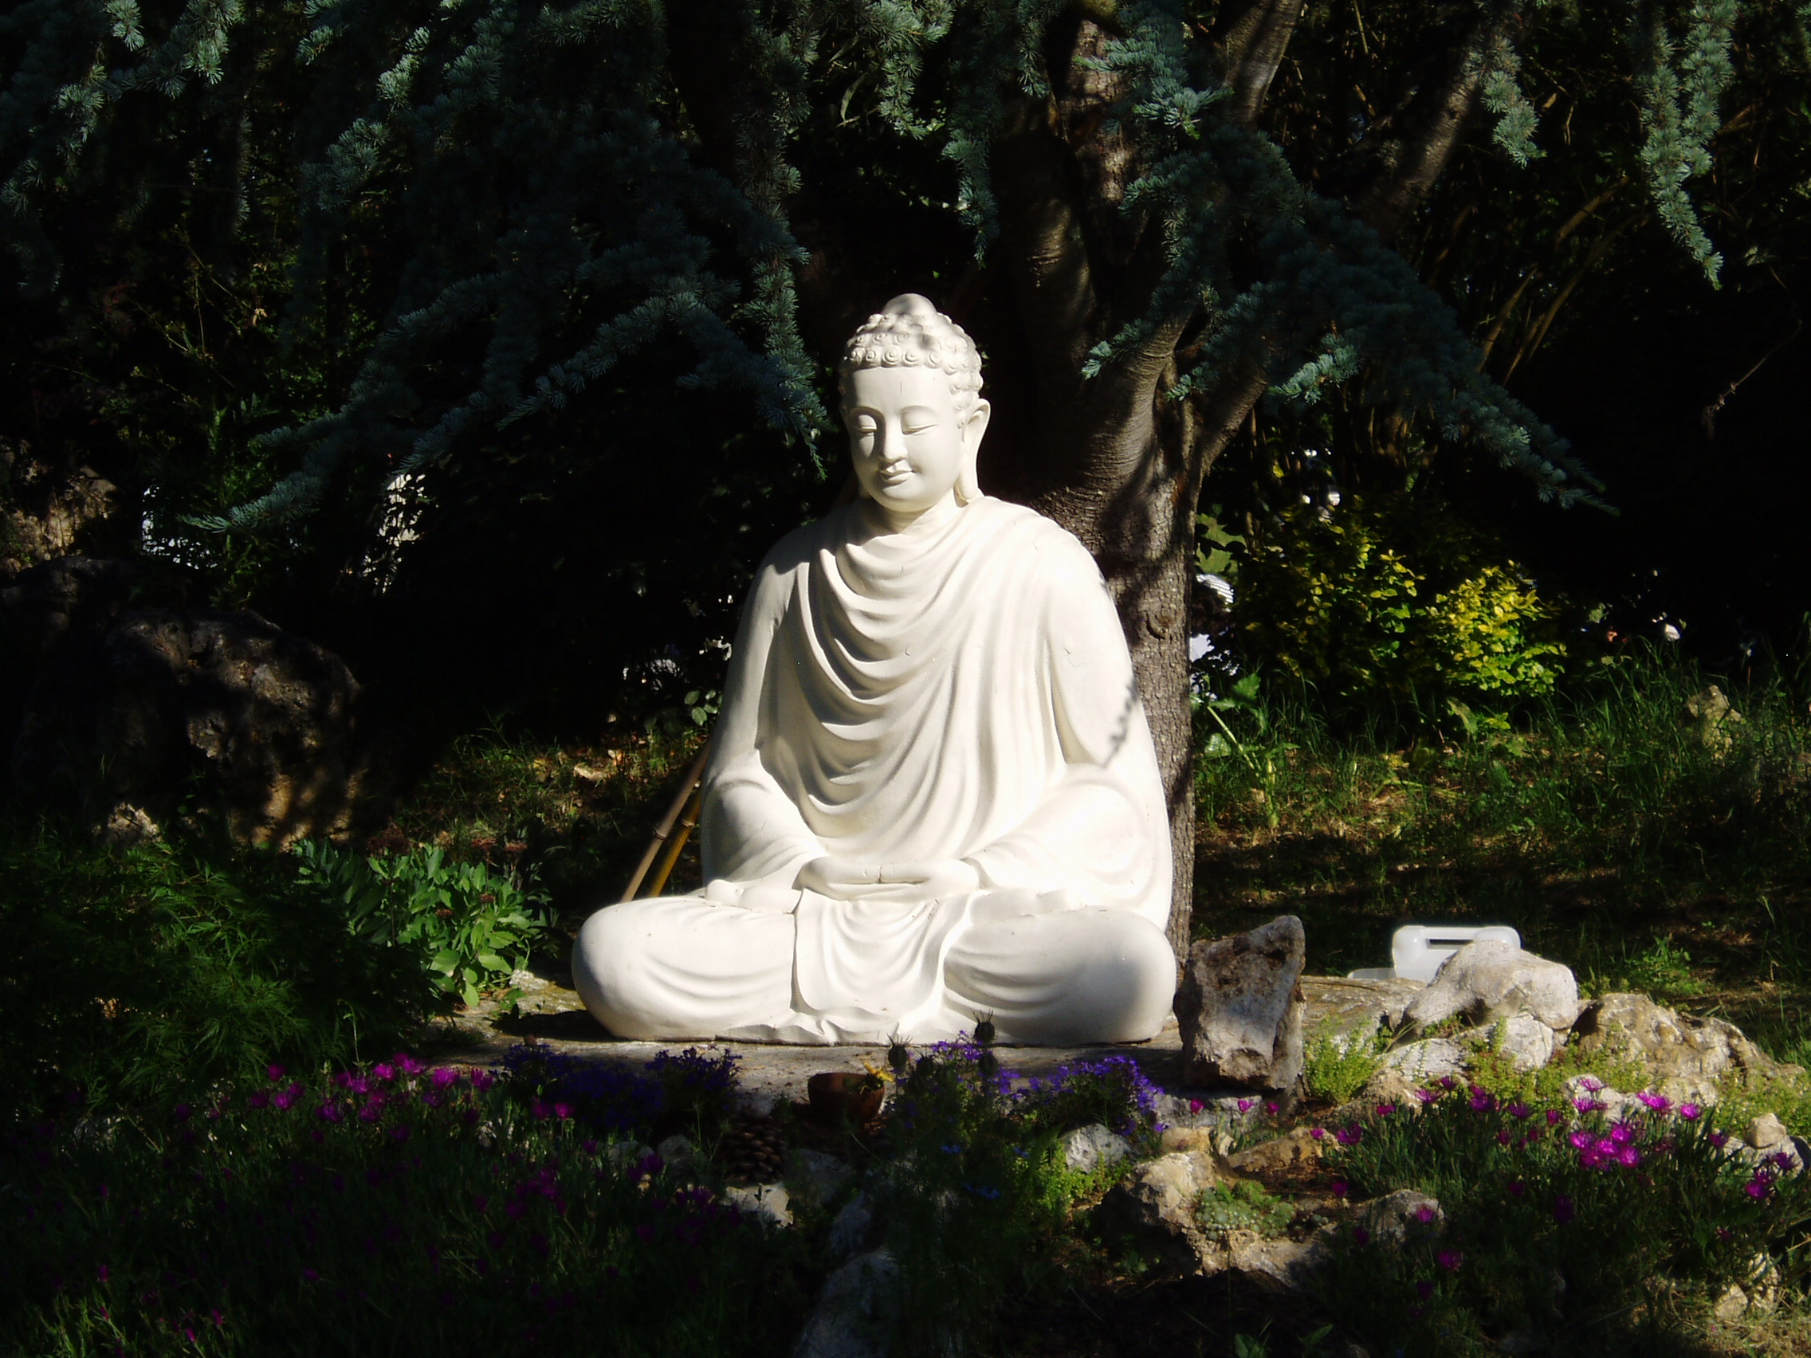

PLUMLINE
Online Sangha
In the tradition of Thich Nhat Hanh

Plumline is not a replacement for
face-to-face Sangha, but a viable
alternative for those who cannot
regularly attend traditional
Sangha.

The Plumline website is a support
center for those wishing to
establish, build and maintain an
online Sangha. A place to share
ideas and resources as online
Sangha develops.

"Without Sangha the
practitioner will quickly lose
their practice"
Thich Nhat Hanh

For more information:
http://plumline.org/
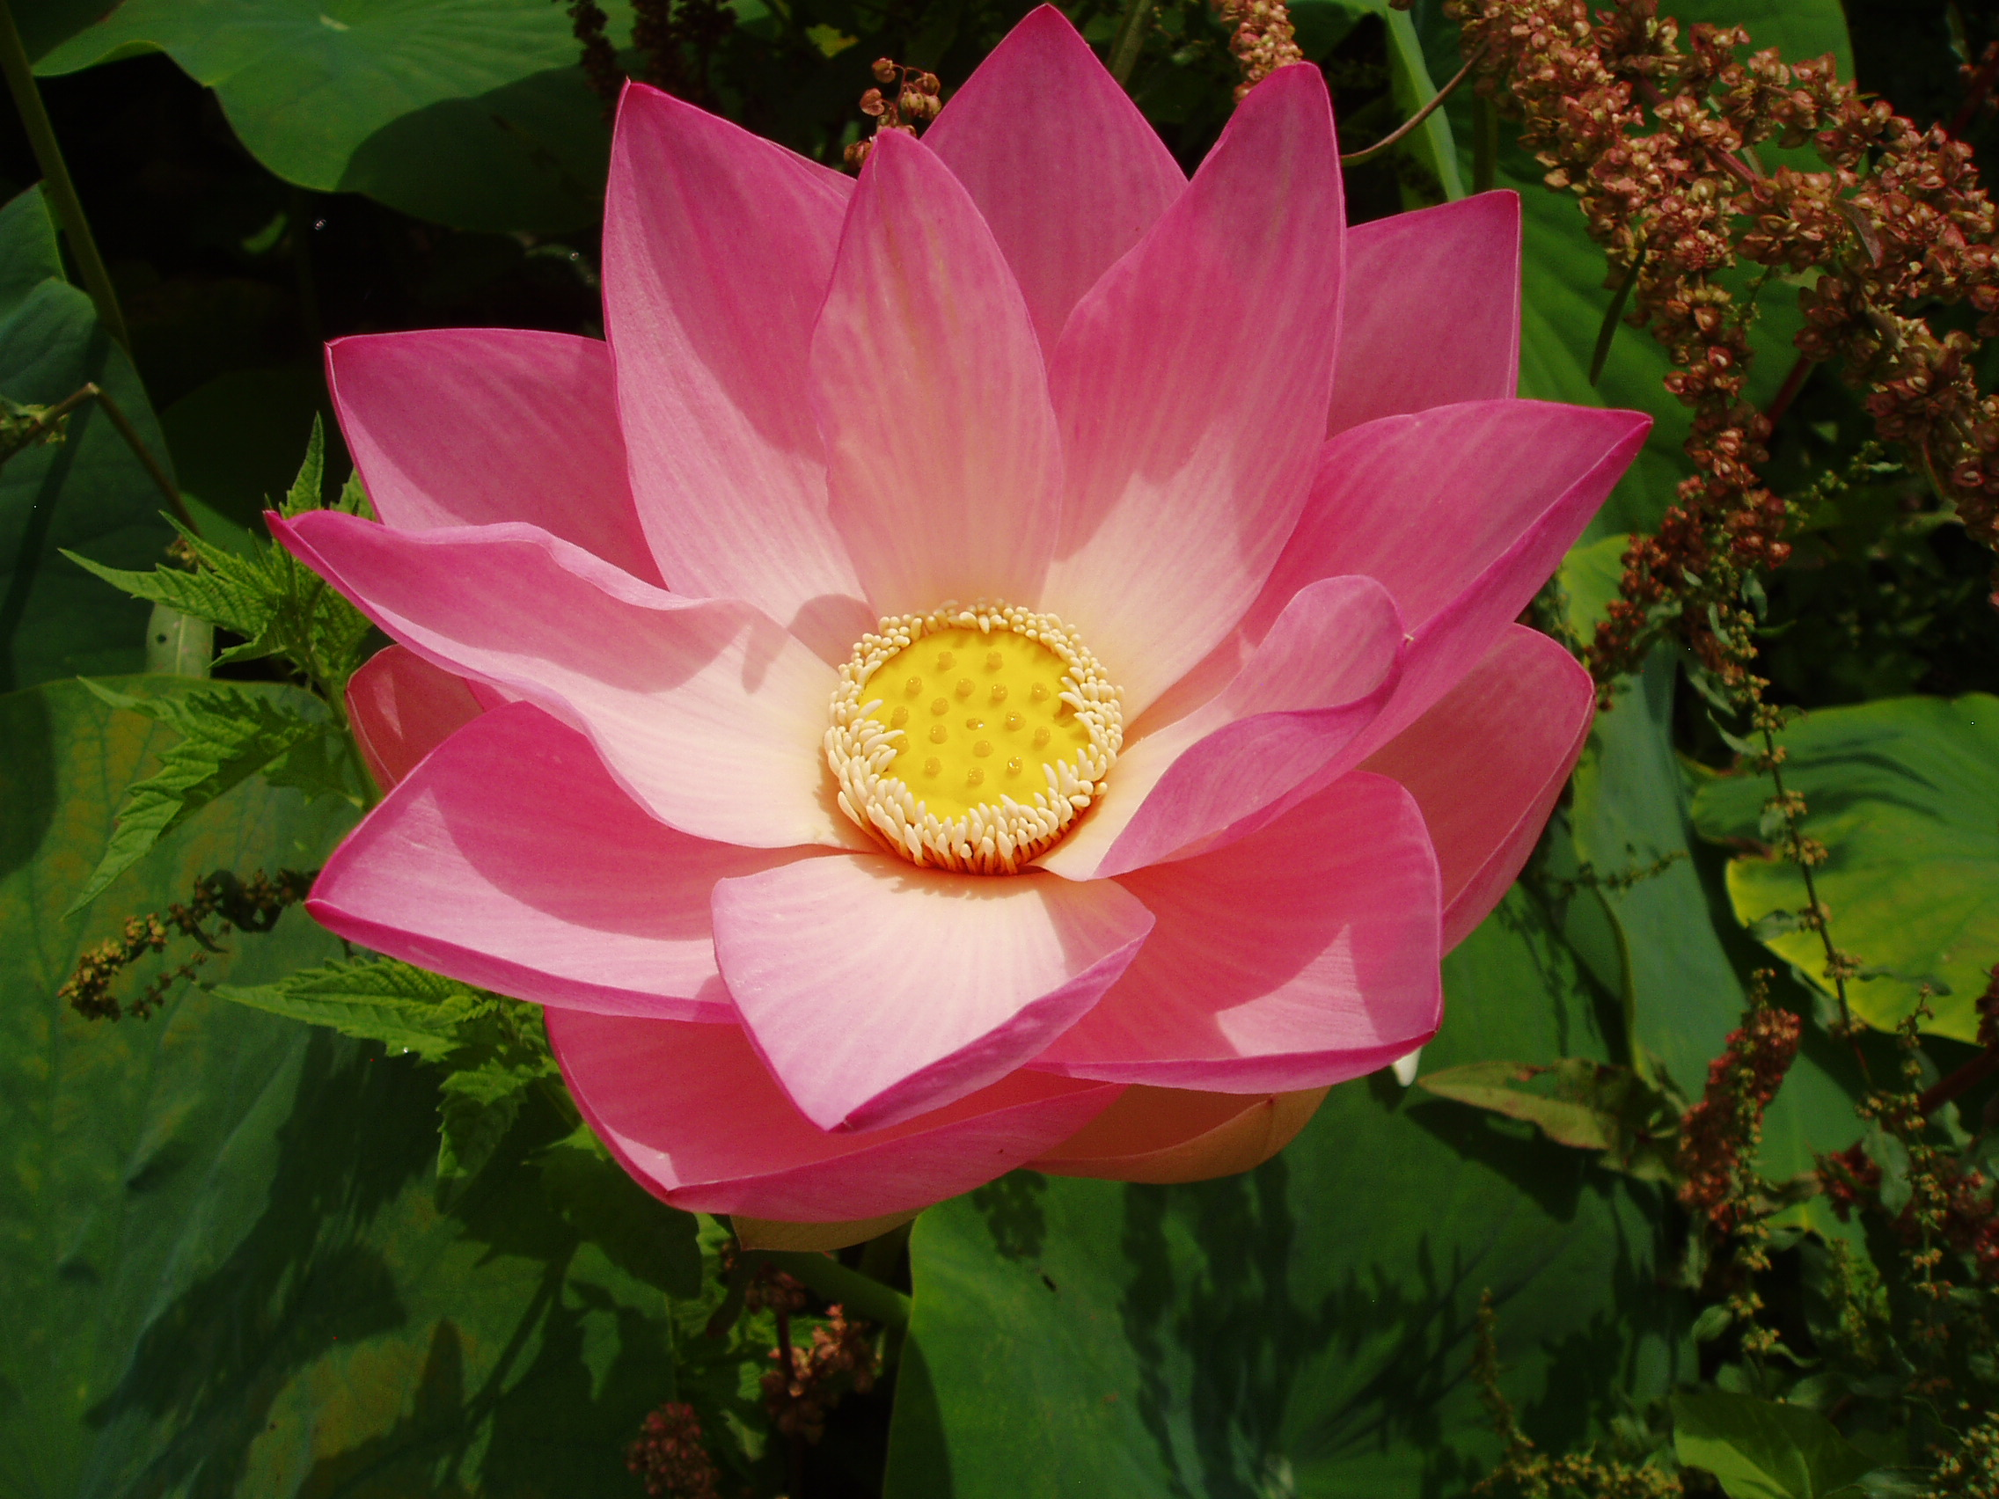

PLUMLINE
Online Sangha
In the tradition of Thich Nhat Hanh

Plumline is not a replacement for
face-to-face Sangha, but a viable
alternative for those who cannot
regularly attend traditional
Sangha.

The Plumline website is a support
center for those wishing to
establish, build and maintain an
online Sangha. A place to share
ideas and resources as online
Sangha develops.

"Without Sangha the
practitioner will quickly lose
their practice"
Thich Nhat Hanh

For more information:

http://plumline.org/

