Supplementary Material for

Evo2VED: a database of DNA large language model–derived scores for variant interpretation

Corresponding author:
Xiaopu Zhou <xiaopu.zhou@sickkids.ca>
Lucila Ohno-Machado <lucila.ohno-machado@yale.edu>

This Supplementary Material includes:

Supplementary Methods
Supplementary Figures S1–S16
Abbreviations
Software
References

Supplementary Methods

Evo2 Variant Scoring
Evo2 (1) variant scores were computed for 6,475,578 sites with rsID annotation (dbSNP build 156; dbsnp156) (2); and with minor allele frequency ≥ 5% in the gnomAD v4.1 European‑descent (non‑Finnish European) population (3, 4)., restricted to variants with a call rate > 80% in the gnomAD whole‑genome sequencing (WGS) dataset.
We applied two Evo2 model variants (Evo2-7B and Evo2-40B) and three reverse-complement (RC) scoring schemes (noRC, avgRC, and wtRC) to score both alleles of each variant. For each variant, positioned at the centre of a 2-kb window on the GRCh38 reference, the model's per-position conditional log-probabilities were obtained for reference and alternative sequences, and the position-wise effect was defined as in formula 1:
$δ_{i}=logpθ\left(s_{i}^{alt}|s_{<i}^{alt}\right)-logpθ\left(s_{i}^{ref}|s_{<i}^{ref}\right)$ (1)
Because Evo2 is a decoder-only (causal, left-to-right) model, the reference and alternative sequences are identical upstream of the variant, so only the variant position and downstream positions carry a non-zero effect on a given strand. The three schemes differ in how positions and strands are combined. noRC sums δᵢ over the forward strand only. avgRC averages the forward-strand and reverse-complement scores, recovering signal from both flanks of the variant.
In addition to the two scoring schemes introduced in the original Evo2 study, we implemented a third approach, weighted reverse-complement scoring (wtRC). wtRC weights each position by its proximity to the variant, since nearer positions carry the strongest variant-specific signal while distant positions are progressively diluted. Positions at distance dᵢ from the variant are assigned exponentially decaying weights that sum to one (see formula 2)
$w_{i}=\frac{exp\left(-d_{i}/τ\right)}{\sum_{j}{exp\left(-d_{j}/τ\right)}}$ (2)
Where $\sum_{i}{w_{i}}=1$ ,
and the per-strand weighted score $S =\sum_{i}{w_{i}δ_{i}}$ is computed on the forward strand ($S^{(f)}$) and the reverse complement ($S^{(r)}$), giving:
$∆_{wtRC}=S^{(f)}+S^{(r)}$ (3)
For each variant, the two models and three scoring schemes yielded six delta scores and 12 corresponding reference- and alternate-allele scores, resulting in 18 archived score columns in Evo2VED. Under each scoring scheme, a positive delta indicates that the model assigns a higher score to the alternate sequence than to the reference sequence, whereas a negative delta indicates the opposite. The sign reflects the direction of the model-based allelic score difference, not the direction of a molecular or phenotypic effect.

Statistical Analyses for Case Studies
For Figure 2A–B, Evo2 scores were compared with evolutionary conservation using Spearman correlation analyses in R. Six Evo2 delta-score models were evaluated: 7b_noRC, 7b_avgRC, 7b_weightRC, 40b_noRC, 40b_avgRC and 40b_weightRC. For each model, correlations were calculated between the absolute Evo2 delta score and phastCons100way (5) conservation score for Figure 2A, and between the raw Evo2 delta score and phyloP100way (6) conservation score for Figure 2B. Variants with non-finite Evo2 or conservation scores were excluded, and the remaining variants were grouped into five minor allele frequency tiers for Spearman correlation test.
For Figure 2C–D, associations between Evo2 scores and population genetic annotations were assessed using repeated MAF-stratified subsampling and Spearman correlation analysis. Variants were categorized as LCR or nonLCR based on Repeat_Family annotation and restricted to an LD-pruned set of HapMap3 variants present in the 1000 Genomes Phase 3 European reference population with MAF >5%. Variants were stratified into five allele-frequency bins. The Evo2_40B_AvgRC_Delta score was correlated with mean allele age (AgeMean_Jnt) (Figure 2C) (7) and singleton density score (SDS_Final) (Figure 2D) (8). For all variants combined, as well as for LCR and nonLCR subsets separately, 2,000 iterations of stratified subsampling were performed without replacement, with 80% of variants sampled from each allele-frequency bin in every iteration. Empirical 95% confidence intervals were estimated from the distribution of Spearman correlation coefficients across iterations.
For Figure 2E, variants overlapping repeat annotations were excluded, and the analysis was restricted to SNPs. The absolute 40b_avgRC_delta_score was used as the model-based allelic score magnitude. Variants were grouped by functional category, and each category was compared with the Intergenic reference group using two-sided Wilcoxon rank-sum tests in R (wilcox.test, exact = FALSE). For Figure 2F, repeat-overlapping variants were similarly excluded, and the analysis was restricted to non-intergenic SNPs. Variants were grouped by ExonicFunc.ensGene, and each exonic-function category was compared with the reference group (Others category) using the same Wilcoxon testing framework.
For Figure 2G–H, regional analyses were performed using chromosome- and allele-frequency-stratified subsampling. Variants overlapping target genomic regions were identified by intersecting variant coordinates with BED-formatted interval files using data.table::foverlaps. Figure 2G examined variants located within human accelerated regions (HARs) (9), whereas Figure 2H used the same analytical framework applied to an independent set of psychiatric-disorder-associated genomic regions derived from unpublished work. Only variants overlapping the specified regions were retained for analysis. Associations between allele age (AgeMean_Jnt) and raw 40b_avgRC_delta_score were evaluated across all regional variants and within each of five allele-frequency bins (AF_bin). To assess the robustness of these associations, 2,000 subsampling iterations were performed without replacement, sampling 80% of variants from each chromosome-by-allele-frequency-bin stratum in every iteration while retaining representation from all chromosomes. Spearman's rank correlation coefficient (ρ) was calculated for each subsampling iteration, and empirical 95% confidence intervals were estimated from the resulting distributions of correlation coefficients. Correlations were considered robust when the corresponding confidence interval excluded zero.
For Figure 3A–C, GWAS summary statistics were harmonized using a modified implementation of munge_sumstats.py that retained strand-ambiguous SNPs (A/T and G/C) when supported by the 1000 Genomes Project Phase 3 (10, 11) European reference panel. Stratified LD score regression (S-LDSC (12); LDSC v1.0.1 (13)) was performed using raw Evo2 score annotations and matched LD-score regression weights and allele-frequency files derived from the same reference population. Partitioned heritability analyses were conducted with overlapping annotations enabled (--overlap-annot). Regression coefficients and block-jackknife estimates were obtained using --print-coefficients and --print-delete-vals, respectively. Bonferroni correction was applied separately to the reported LDSC enrichment P values for each biobank dataset. Before correction, FinnGen records in the “NULL” and “symptoms” categories and MVP records in the “Biological Family”, “Other” and “Women's Health” categories were excluded. Results with adjusted LDSC enrichment P < 0.05 were flagged as significant. Only phenotype categories containing at least one flagged result were displayed. The stratified LD score regression framework is described by Finucane et al. (12).

Functional evidence for Evo2 scores
We evaluated the relationships between Evo2 scores and experimental measurements, molecular quantitative trait loci (QTLs), GWAS fine-mapping probabilities, and clinical variant annotations (Supplementary Figures S2–S16). The analyses used the six precomputed score configurations generated by Evo2-7B and Evo2-40B under noRC, avgRC, and wtRC scoring. For each configuration, the Evo2 score was defined as the alternative-allele minus reference-allele sequence score. Absolute scores were used to assess the magnitude of allelic sequence differences. These analyses assessed associations and model fit within the available matched variants.
Variant matching and functional annotations
Evidence records were matched to the precomputed Evo2VED scores using GRCh38 genomic coordinates and reference and alternative alleles. Analyses requiring functional annotations were restricted to variants with finite values for all six Evo2 configurations and the relevant covariates. Evolutionary conservation was represented by phastCons100way (5) and phyloP100way (6) scores. Candidate cis-regulatory element (cCRE) annotations were obtained from the ENCODE SCREEN Registry V4 (14) on GRCh38 and included promoter-like signatures (PLS), proximal and distal enhancer-like signatures (pELS and dELS), CA-CTCF, CA-H3K4me3, CA-TF, CA, and TF. Variants outside these annotations constituted the background. cCRE overlap indicators were used in the MPRA and QTL/fine-mapping analyses; ClinVar models used cCRE category, including background. Conservation annotations used the UCSC hg38 phastCons100way and phyloP100way tracks (5, 6). The eight GRCh38 cCRE category files came from SCREEN Registry V4, downloaded on 8 September 2026, with the expanded-registry publication cited as the resource reference (14).
For regression analyses, absolute Evo2 scores were transformed as ln(1 + |Evo2 score|) and represented by quadratic B-splines with three uniformly spaced knots. The spline basis contributed up to three degrees of freedom in addition to the model intercept. Continuous annotation covariates were represented using the same spline construction. Basis columns were standardized, and constant or redundant terms were excluded when determining the effective model rank. Each annotation-adjusted model was compared with its baseline model on the same variants. For QTL and GWAS fine-mapping analyses, the Evo2-only and all three adjusted comparisons used the same annotation-complete variant set within each gene, intron, protein assay, or fine-mapped signal. This requirement prevented differences in variant availability from being interpreted as an improvement in model fit.
Massively parallel reporter assay
Experimental evidence was evaluated using the massively parallel reporter assay (MPRA) dataset from Lee et al. (15). The continuous analysis included 12,986 matched variants and used the absolute allelic log2 fold change as the outcome without selection on its significance. For the binary analysis, variants with an assay false discovery rate (FDR) < 0.05 were classified as showing an allelic effect, whereas variants with nominal P > 0.1 were classified as negative; intermediate variants were excluded. This yielded 10,735 variants for the binary outcome. Complete conservation and cCRE annotations were available for 12,930 continuous-outcome variants and 10,692 binary-outcome variants. The source was the published Table S1 from Lee et al. (15), associated with GEO accession GSE244011, downloaded on 8 September 2026.
For each Evo2 configuration, we fitted a logistic regression for binary allelic-effect status and an ordinary least-squares regression for the continuous outcome. Evo2-only models contained an intercept and the Evo2 spline. We then added the Evo2 spline separately to conservation, cCRE, and joint conservation/cCRE baseline models; these MPRA baselines did not include MAF or transcription start site (TSS) distance. Model fit was summarized by Nagelkerke pseudo-R² for the binary outcome and ordinary R² for the continuous outcome. The incremental contribution was calculated as the difference between augmented-model and baseline-model fit, using the corresponding R² or pseudo-R² metric. Nagelkerke pseudo-R² was treated as a likelihood-based measure of fit rather than a proportion of explained variance. The pseudo-R² definition followed Nagelkerke (16).
Statistical significance was assessed by a joint Wald F test of the Evo2 spline coefficients using locus-cluster-robust covariance estimates with a finite-sample correction. Locus groups were constructed from 1-Mb genomic blocks, merging adjacent cross-boundary records when their separation was < 100 kb. The reference degrees of freedom were the number of tested coefficients and the number of locus groups minus one. Holm correction was applied separately within each outcome across six Evo2-only tests and across 18 incremental tests (six configurations × three baselines). The estimates in Supplementary Figure S2 were obtained from full-sample fits. Holm-adjusted tests used the sequential multiple-testing procedure (17).
Expression, splicing, and protein QTL evidence
Molecular evidence comprised GTEx cis-eQTLs for 36,233 annotation-covered genes across 50 tissues, GTEx cis-eQTL fine-mapping results for 35,420 genes across 50 tissues, eQTLGen blood cis-eQTLs for 14,262 genes, GTEx cis-sQTLs for 17,045 genes across 50 tissues, and cis-pQTLs for 1,930 UKB-PPP and 570 INTERVAL target genes (Supplementary Figures S3–S8). The GTEx fine-mapping source cohort contained 35,435 genes; 15 genes without an annotation-complete SNP did not contribute to the annotation-covered cohort. These coverage counts describe represented genes and are not the number of testable models in each figure cell.
GTEx cis-eQTL, cis-sQTL, and cis-eQTL fine-mapping data were obtained from Adult GTEx release v11 on GRCh38 (18), using the GTEx_Analysis_v11_eQTL, GTEx_Analysis_v11_sQTL, and GTEx_Analysis_v11_eQTL_SuSiE archives, respectively. The original GTEx resource publication (18) describes the project and earlier analyses; the v11 release documentation identifies the files used here. The 50 tissue-specific datasets had tissue-dependent sample sizes and were not treated as a single participant cohort. Blood cis-eQTL evidence was obtained from eQTLGen (19), whose meta-analysis included up to 31,684 individuals across 37 cohorts. We used the significant cis-eQTL file dated 11 December 2019 (source FDR < 0.05; downloaded 8 September 2026); the effective sample size differs among SNP–gene associations.
For UKB-PPP, we used the European-ancestry discovery summary statistics from Sun et al. (2023), comprising 34,557 participants from the randomly selected baseline cohort (20). The original discovery analysis measured 2,922 proteins; this participant count is distinct from the broader UKB-PPP proteomics cohort. INTERVAL pQTL summary statistics came from Sun et al. (2018), whose analysis included 3,301 participants after genetic quality control, in two subcohorts of 2,481 and 820 participants (21). These are the source-study participant counts, whereas the 1,930 and 570 target genes reported here describe the respective annotation-covered Evo2 intersections. The downloaded association sets retained the source-selection thresholds described below; participant counts were not used as variant-level regression denominators.
The outcome was the absolute association Z statistic for eQTL, sQTL, and pQTL analyses and the untransformed posterior inclusion probability (PIP) for GTEx cis-eQTL fine-mapping. Models were fitted separately for each gene–tissue pair, blood eQTL gene, intron–tissue pair, or protein assay, as appropriate. Absolute-Z analyses required at least 20 annotation-complete SNPs per gene or protein assay and at least 10 per intron. No additional minimum-SNP or PIP threshold was imposed for continuous-PIP models; groups without sufficient residual degrees of freedom, outcome variation, or identifiable predictor terms were recorded as unavailable. Eligibility for annotation-adjusted analyses was not conditional on a significant Evo2-only test. The available source association sets nevertheless retained their original ascertainment: the UKB-PPP and INTERVAL pQTL inputs were restricted to additive cis associations at P ≤ 10⁻⁵ and P < 10⁻⁵, respectively.
For each analysis unit, an Evo2-only spline regression was compared with an intercept-only model using an overall F test. To assess additional association information, we fitted three baseline models containing MAF and ln(1 + absolute TSS distance), together with conservation, cCRE annotations, or both. MAF was calculated as the smaller of the two allele frequencies in the corresponding input. Each baseline model was augmented with one Evo2 spline, and the improvement was tested using a nested-model F test with effective model ranks determining the numerator and residual degrees of freedom. R² and the increase in R² were calculated from residual sums of squares. These ordinary regression tests use a working independence assumption for variants; they do not remove the effects of local LD.
Benjamini–Hochberg (BH) correction was applied across valid analysis units within each tissue or dataset, Evo2 configuration, and model comparison. The correction unit was the gene for eQTL analyses, the intron for sQTL analyses, and the assay for pQTL analyses. Supplementary Figures S3–S8 display nominal P < 0.05. For sQTLs and pQTLs, passing introns and assays were subsequently mapped to distinct genes for display. This aggregation did not define a new gene-level FDR, and unions across tissues or configurations were not treated as independently corrected tests. The BH procedure followed Benjamini and Hochberg (22). Supplementary Tables S11–S16 additionally report nominal- and BH-threshold counts and percentages among testable genes. A testable gene has a valid gene-level test or at least one valid intron or assay test, as appropriate; percentages use the number of testable genes within the corresponding tissue or dataset, configuration, and comparison as the denominator. Reported P values test the Evo2 spline terms, not the original QTL associations.
GWAS fine-mapping evidence
GWAS fine-mapping records from the Open Targets Platform were matched to Evo2VED and analyzed using the original continuous PIP values. The matched collection comprised 17,557 GWAS analysis instances assigned to seven broad trait categories: protein-related measurements (1,842), metabolite-related measurements (6,155), imaging-derived phenotypes (3,259), diseases, symptoms, and clinical endpoints (2,551), other quantitative traits (1,529), other traits (347), and unclassified traits (1,874). The five categories presented in Supplementary Figures S9–S13 contained 1,840, 6,153, 3,256, 2,550, and 1,529 annotation-covered instances, respectively. A GWAS analysis instance was defined as a unique Open Targets study ID; it did not necessarily represent an independent participant cohort or phenotype. The input was Open Targets Platform release 26.06, released on 24 June 2026 (23); credible-set and study metadata were obtained from the release-specific public data files. Original study sample sizes and ancestry composition vary among instances, so no pooled participant count was assigned to this collection.
Models were fitted within each study–signal combination, retaining the fine-mapping method and LD-provenance confidence stratum supplied with the source results. The outcome was PIP on its original scale. Evo2-only and annotation-adjusted models followed the same spline and nested F-test framework described for the QTL analyses. The adjusted baselines contained gnomAD non-Finnish European MAF, ln(1 + distance to the nearest canonical TSS), and conservation, cCRE annotations, or both. The population MAF annotation was used as a common covariate because study-specific allele frequencies were not available for every signal member. The nearest canonical TSS was defined from the Open Targets annotation and was not interpreted as a confirmed target gene.
No additional filter on PIP, group size, or Evo2-only significance was applied; non-estimable models were excluded from the corresponding testable set. BH-adjusted P values were calculated across signals within each study, fine-mapping method, confidence stratum, Evo2 configuration, and model comparison. The figures show the number of instances with at least one signal reaching nominal P < 0.05, separately by method and LD provenance. These counts summarize signal-level associations; the within-study adjustment does not provide instance-level or trait-category-level FDR control. Associations with PIP were not interpreted as formal GWAS–QTL colocalization or evidence of experimental causality. Supplementary Tables S17–S21 also report BH-threshold counts and percentages among instances with at least one valid signal test in the corresponding method/LD stratum, configuration, and comparison. Reported P values test the Evo2 spline terms, not the original GWAS associations.
Clinical variant annotations and external predictions
ClinVar and the Evo Variant Effect Explorer (EVEE) were used to evaluate the relationship between Evo2 scores and clinical annotations and external predictions (Supplementary Figures S14–S16). Matching identified 72,965 ClinVar variants, including 69,332 single-nucleotide variants (SNVs), and 69,729 EVEE variants, including 67,291 SNVs. EVEE zero-based positions were converted to one-based positions before GRCh38 coordinate and allele matching. Matched counts included records that were not eligible for the subsequent binary analyses. ClinVar annotations were taken from the local GRCh38 snapshot dated 21 March 2026 (24). EVEE predictions were obtained from Zenodo record 19701997, version v1, published on 23 April 2026, using its five chromosome-balanced Parquet shards. The parent EVEE resource contains 4,252,870 variant records; the matched and eligible subsets used here are reported above and below.
For ClinVar, the analysis compared variants carrying the strict Benign annotation with the retained non-Benign group. The latter included likely benign, uncertain, conflicting, and other retained annotations and was not equated with pathogenicity. Of 61,775 eligible SNVs, 61,771 had complete annotations, comprising 59,412 Benign and 2,359 non-Benign variants. Logistic regression models used conservation splines, a nine-level cCRE category with background as reference, or both as baselines. Each of the six Evo2 splines was then added separately. MAF and TSS distance were not included in these ClinVar models. Incremental fit was summarized by the increase in Nagelkerke pseudo-R², and significance was evaluated with a nested likelihood-ratio test. BH correction was applied jointly across all 18 baseline–configuration comparisons (Supplementary Figure S15).
The EVEE (25) comparison retained 59,428 SNVs with pathogenic/likely pathogenic (P/LP) or benign/likely benign (B/LB) labels: eight P/LP and 59,420 B/LB variants. Signed and absolute Evo2 scores were evaluated separately using sensitivity, specificity, balanced accuracy, and the area under the receiver operating characteristic curve (AUROC). For each Evo2 configuration and score representation, the decision threshold maximized Youden’s J statistic (sensitivity + specificity − 1) in the evaluation sample. EVEE was evaluated at fixed thresholds of > 0.50, ≥ 0.80, and ≥ 0.95; these thresholds apply to a single continuous score and therefore share the same AUROC. The small number of positive variants, sample-optimized Evo2 thresholds, and unestablished independence from model training data limit interpretation of these comparisons as estimates of general predictive performance.
Sensitivity of LDSC results in score direction
To assess sensitivity to score direction, we compared LDSC (12, 13) models using signed Evo2 annotations with corresponding models using absolute Evo2 annotations for the same phenotype (Supplementary Figure S1). The paired results comprised 833 UKB, 2,464 FinnGen, and 1,470 MVP phenotype analyses. The MVP set included 1,244 binary phenotypes and 226 survey-based binary phenotypes with non-overlapping identifiers. These counts refer to available paired fits in the sensitivity analysis. We compared the annotation coefficient, its Z-score, and the observed-scale heritability estimate reported by each fitted model. The LDSC framework was as described above (12); the counts are paired phenotype-level model fits rather than participant sample sizes.
Rank correlations between paired estimates were assessed using Spearman’s rho, with 95% percentile confidence intervals from 2,000 paired bootstrap resamples of phenotypes within each cohort (26). BH correction was applied across the nine primary correlation tests (three metrics × three cohorts; Supplementary Table S9). Negative estimates and extreme observations were retained. Descriptive ordinary least-squares lines summarized the numerical relationship between paired estimates; pointwise 95% bootstrap confidence bands represented uncertainty in the fitted mean trend. They were distinct from the confidence intervals for Spearman correlation and from prediction intervals. These calculations assumed independent phenotype pairs for inference, although related phenotypes may violate this assumption. Rank correlations between signed and absolute results describe similarity in phenotype ordering, not numerical agreement or interchangeability of the estimates; they do not establish a functional or clinical meaning for score direction.

Data Visualization
Figures were generated using a combination of Python, R, and GraphPad Prism. The Graphical Abstract was designed with assistance from ChatGPT (GPT-5.5) and further optimized using Adobe Photoshop CS6. For Figure 2, conservation and allele-age comparisons (panels A–D), together with analyses of human accelerated regions and psychiatric disorder–associated regions (panels E–F), were plotted in GraphPad Prism; functional-category comparisons (panels G–H) were plotted using the ggplot2 R package. For Figure 3, trait-category plots of S-LDSC coefficient Z-scores (panels A–C) were generated using ggplot2, and bar plots of selected traits (panels D–F) were generated in GraphPad Prism. For Figure 4A–B, Manhattan plots were produced using the qqman R package, while regional association plots displaying GWAS signals and Evo2 scores were generated using LocusZoom (http://locuszoom.org/) (27, 28).
Within the Evo2VED web interface, interactive visualizations are rendered client-side using Plotly.js (v2.35.2). Region/Region-Set Analysis includes mean ± SEM stratification plots, model-concordance heatmaps, genomic score landscapes, subsample-correlation plots and functional-stratification plots. Trait Analysis provides S-LDSC coefficient Z-score histograms and category dot plots, with links to multi-track regional views that display GWAS association signals alongside Evo2 scores. Variant Analysis presents individual scores and their percentile ranks together with genomic annotations and available supporting evidence. The Guided Workflow connects these views for exploration from a selected GWAS study to regions and individual variants. Static, publication-quality versions of selected panels were generated using Matplotlib.
Supplementary Figures S1–S16 were generated in Python using Matplotlib from the corresponding analysis tables. For Supplementary Figure S2, horizontal bar plots displayed Evo2-only model fit and incremental fit for the binary and continuous MPRA outcomes, with separate panels for the annotation baselines. Blue and orange distinguished Evo2-7B and Evo2-40B, respectively, and asterisks indicated Holm-adjusted significance. For Supplementary Figures S3–S13, annotated heatmaps displayed the numbers of genes or GWAS analysis instances with nominal P < 0.05 for each Evo2 configuration and model comparison. A sequential blue palette represented counts, with numerical labels and color bars indicating the scale. Supplementary Figure S14 used horizontal bar plots to summarize the ClinVar and EVEE analysis cohorts. Supplementary Figure S15 used stacked horizontal bars to distinguish baseline Nagelkerke pseudo-R² from the increment after adding Evo2; conservation, cCRE, and joint baselines were arranged vertically in three panels, with BH-adjusted P values printed beside the bars. Supplementary Figure S16 used grouped bar plots to compare sensitivity, specificity, balanced accuracy, and AUROC across signed Evo2 scores, absolute Evo2 scores, and the EVEE thresholds. Supplementary Figure S1 used a three-by-three scatter-plot layout to compare signed and absolute LDSC estimates across UKB, FinnGen, and MVP. Matplotlib was cited according to its published software description (29).

Supplementary Figures
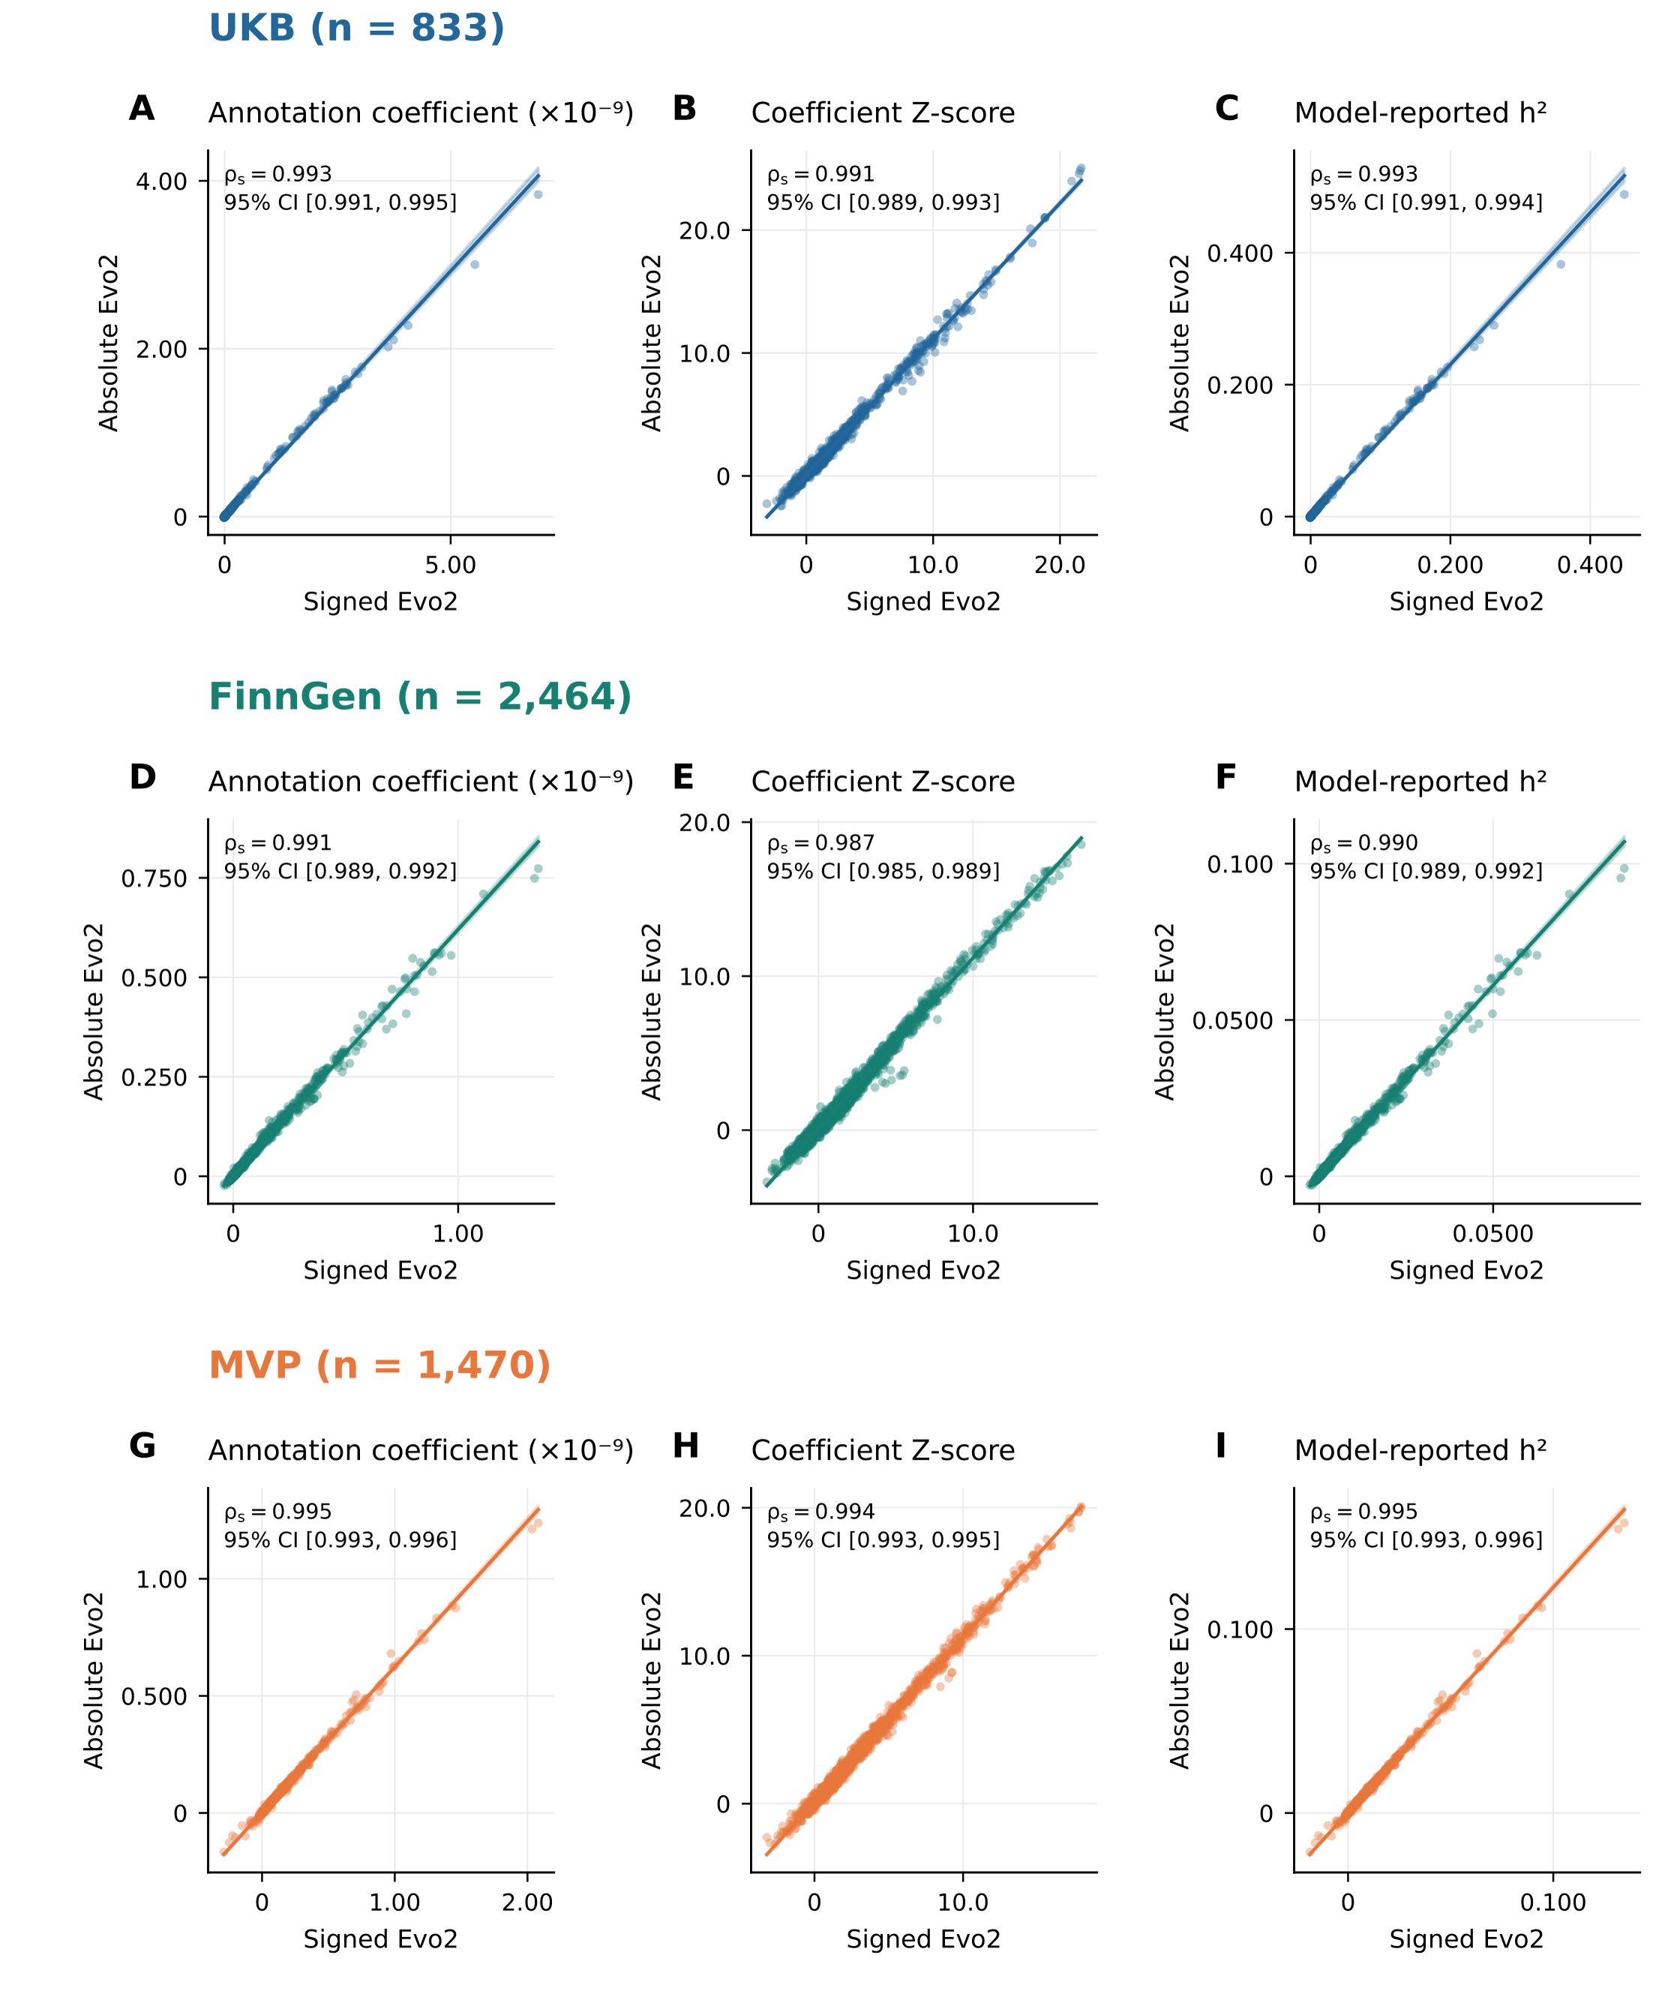
Supplementary Figure S1. Sensitivity of LDSC estimates to signed and absolute Evo2 annotations.
Each point represents paired LDSC estimates for one phenotype using signed Evo2 annotations (horizontal axis) and absolute Evo2 annotations (vertical axis). Rows show UKB (A–C; 833 phenotypes), FinnGen (D–F; 2,464), and MVP (G–I; 1,470). Columns show the annotation coefficient, coefficient Z-score, and model-reported observed-scale heritability (h²). Annotation coefficients are expressed in units of 10⁻⁹. Insets report Spearman’s rank correlation and its 95% percentile confidence interval from 2,000 paired phenotype bootstrap resamples. All nine correlations shown have two-sided asymptotic P < 10⁻³⁰⁰. Solid lines show descriptive ordinary least-squares fits, and shaded regions show pointwise 95% bootstrap confidence intervals for the mean trend. Negative and extreme estimates are retained. BH-adjusted P values across these nine tests are reported in Supplementary Table S9.
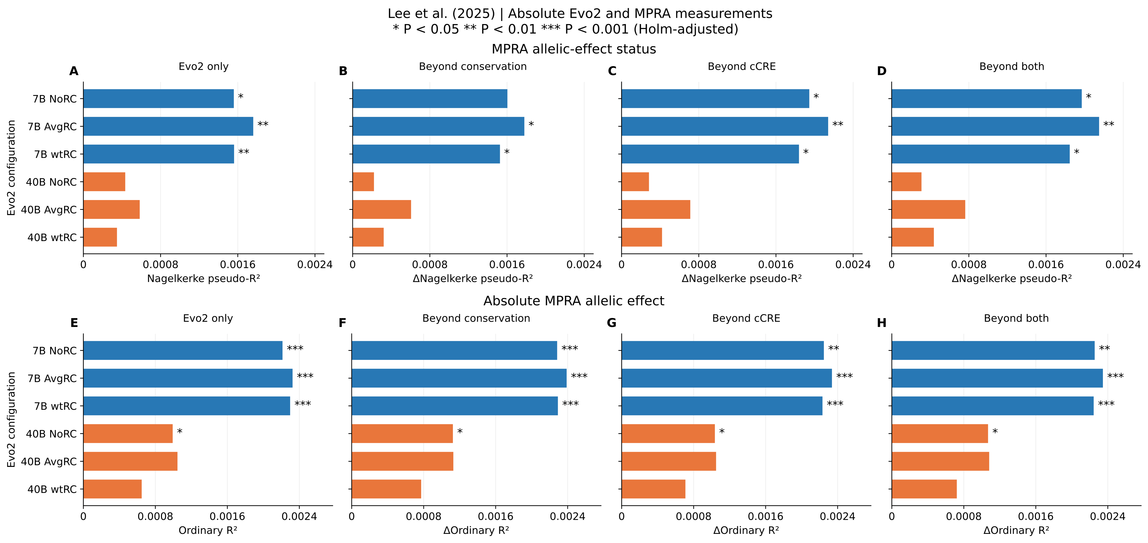
Supplementary Figure S2. Model fit for MPRA allelic effects using absolute Evo2 scores.
Panels A–D show model fit for binary allelic-effect status, and panels E–H show model fit for the absolute allelic log2 fold change in the Lee et al. (2025) MPRA dataset. The six configurations combine Evo2-7B or Evo2-40B with noRC, avgRC, or wtRC scoring. Blue and orange bars denote the 7B and 40B models, respectively. Evo2-only analyses include 10,735 variants for the binary outcome and 12,986 for the continuous outcome. Incremental analyses use 10,692 and 12,930 annotation-complete variants, respectively. The first column shows Evo2-only fit; subsequent columns show the increase after adding Evo2 to conservation, cCRE, or joint annotation baselines. Binary fit is measured by Nagelkerke pseudo-R² and continuous fit by ordinary R². Asterisks denote locus-cluster-robust joint Wald tests with Holm correction across six Evo2-only tests or 18 incremental tests per outcome: * P < 0.05, ** P < 0.01, and *** P < 0.001. Source: Lee et al. (2025), Table S1; GEO GSE244011 (15).
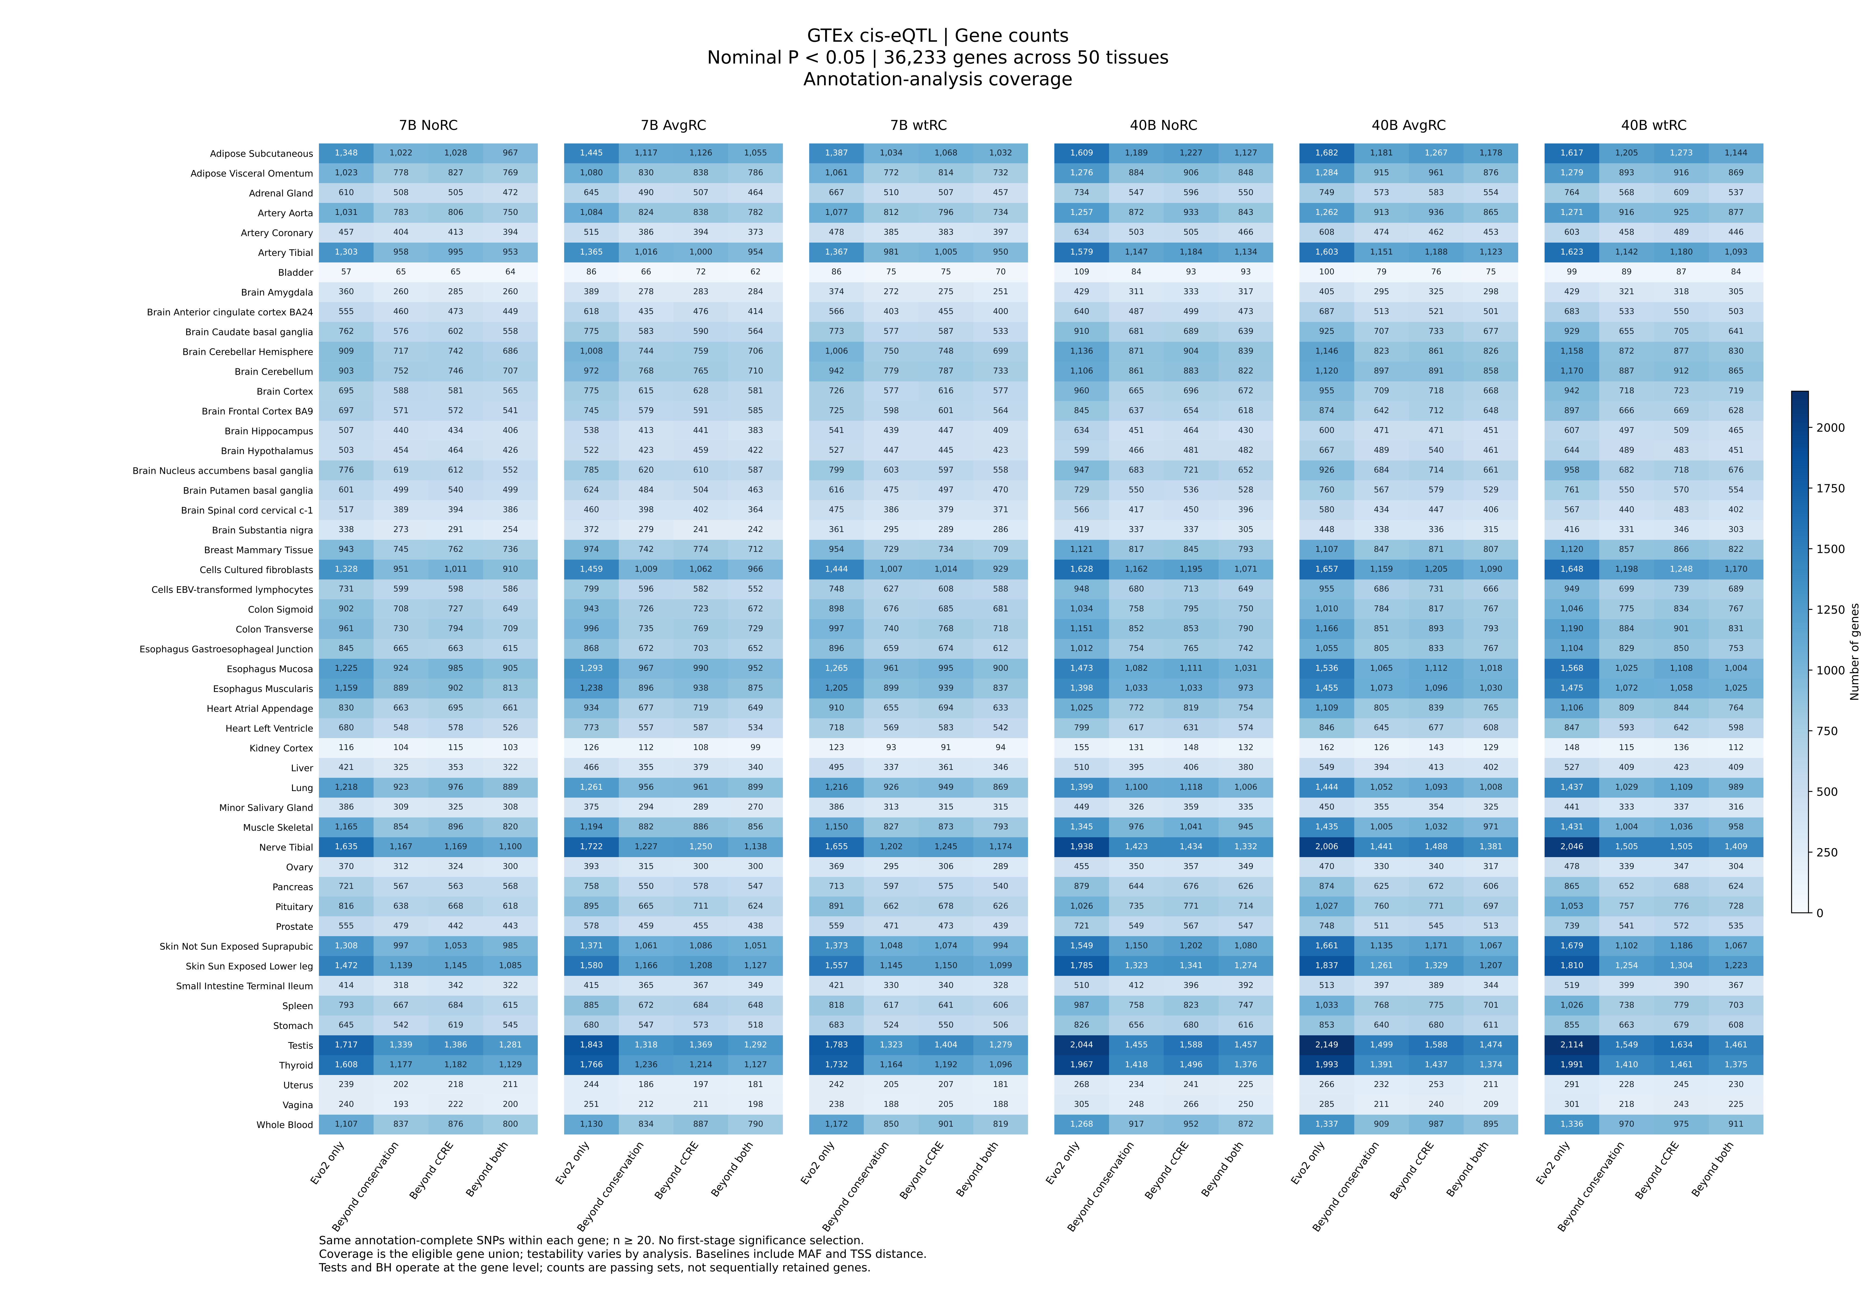
Supplementary Figure S3. Associations between absolute Evo2 scores and absolute cis-eQTL Z statistics in GTEx.
Heatmaps summarize nominal associations in 36,233 genes across 50 tissues. The six configurations combine Evo2-7B or Evo2-40B with noRC, avgRC, or wtRC scoring. The outcome is the absolute association Z statistic. Each cell reports the number of distinct genes at nominal P < 0.05 for the indicated configuration and model comparison. “Evo2 only” denotes the overall spline F test; “Beyond conservation”, “Beyond cCRE”, and “Beyond both” denote nested F tests for the added Evo2 spline, conditional on MAF, TSS distance, and the indicated annotations. Comparisons use the same annotation-complete SNPs within each analysis unit, without selection on Evo2-only significance. Blue intensity represents the count on the displayed scale. Source: GTEx v11 cis-eQTL release (18). Nominal P values refer to tests of the Evo2 spline terms. Supplementary Table S11 additionally reports BH-threshold counts and percentages among testable genes.
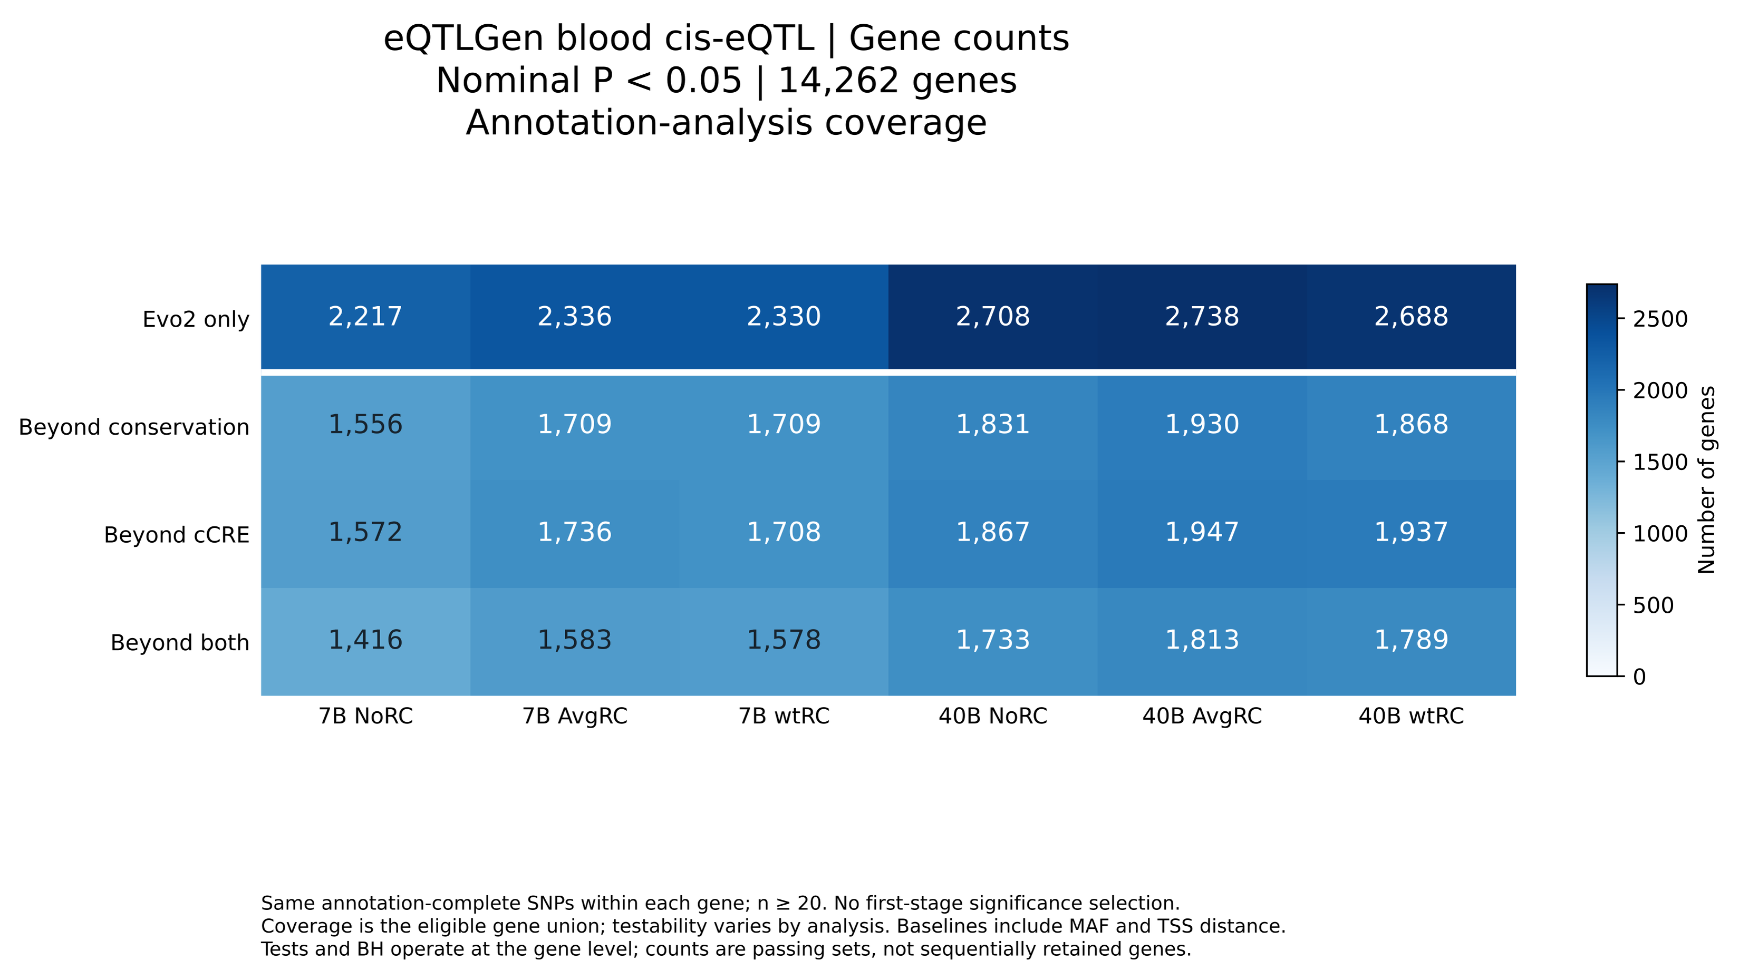
Supplementary Figure S4. Associations between absolute Evo2 scores and absolute blood cis-eQTL Z statistics in eQTLGen.
Heatmaps summarize nominal associations in 14,262 genes. The six configurations combine Evo2-7B or Evo2-40B with noRC, avgRC, or wtRC scoring. The outcome is the absolute association Z statistic. Each cell reports the number of distinct genes at nominal P < 0.05 for the indicated configuration and model comparison. “Evo2 only” denotes the overall spline F test; “Beyond conservation”, “Beyond cCRE”, and “Beyond both” denote nested F tests for the added Evo2 spline, conditional on MAF, TSS distance, and the indicated annotations. Comparisons use the same annotation-complete SNPs within each analysis unit, without selection on Evo2-only significance. Blue intensity represents the count on the displayed scale. Source: eQTLGen, up to 31,684 participants across 37 cohorts; significant cis-eQTL release dated 11 December 2019 (19). Nominal P values refer to tests of the Evo2 spline terms. Supplementary Table S12 additionally reports BH-threshold counts and percentages among testable genes.
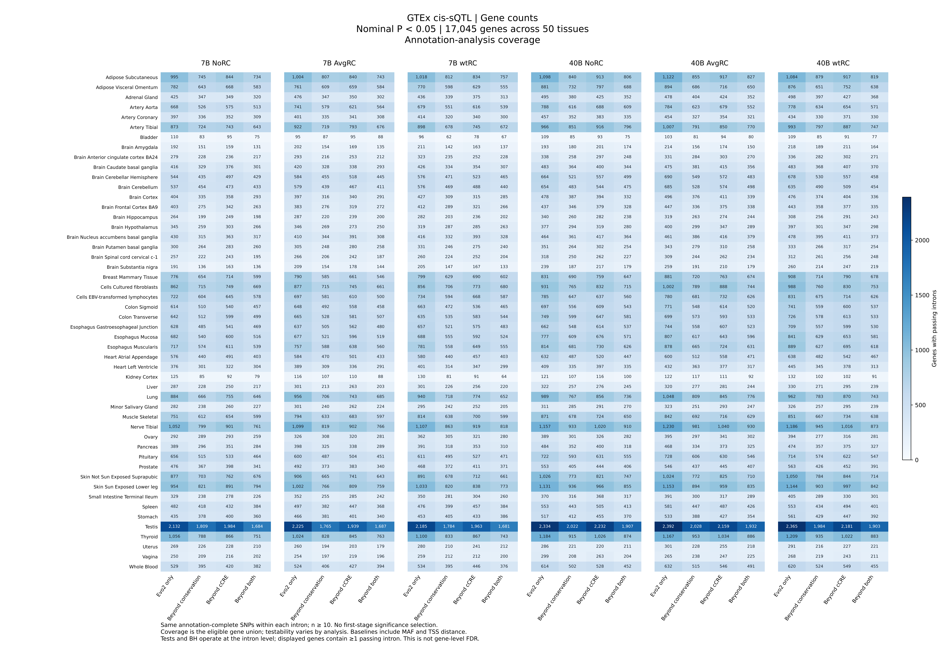
Supplementary Figure S5. Associations between absolute Evo2 scores and absolute cis-sQTL Z statistics in GTEx.
Heatmaps summarize nominal associations in 17,045 genes across 50 tissues. The six configurations combine Evo2-7B or Evo2-40B with noRC, avgRC, or wtRC scoring. The outcome is the absolute association Z statistic. Each cell reports the number of distinct genes with at least one passing intron at nominal P < 0.05 for the indicated configuration and model comparison. “Evo2 only” denotes the overall spline F test; “Beyond conservation”, “Beyond cCRE”, and “Beyond both” denote nested F tests for the added Evo2 spline, conditional on MAF, TSS distance, and the indicated annotations. Comparisons use the same annotation-complete SNPs within each analysis unit, without selection on Evo2-only significance. Blue intensity represents the count on the displayed scale. Source: GTEx v11 cis-sQTL release (18). Nominal P values refer to tests of the Evo2 spline terms. Supplementary Table S13 additionally reports BH-threshold counts and percentages among testable genes.
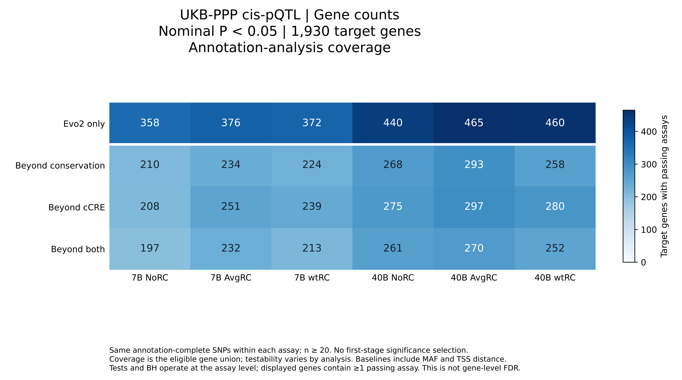
Supplementary Figure S6. Associations between absolute Evo2 scores and absolute cis-pQTL Z statistics in UKB-PPP.
Heatmaps summarize nominal associations in 1,930 target genes. The six configurations combine Evo2-7B or Evo2-40B with noRC, avgRC, or wtRC scoring. The outcome is the absolute association Z statistic. Each cell reports the number of distinct genes with at least one passing protein assay at nominal P < 0.05 for the indicated configuration and model comparison. “Evo2 only” denotes the overall spline F test; “Beyond conservation”, “Beyond cCRE”, and “Beyond both” denote nested F tests for the added Evo2 spline, conditional on MAF, TSS distance, and the indicated annotations. Comparisons use the same annotation-complete SNPs within each analysis unit, without selection on Evo2-only significance. Blue intensity represents the count on the displayed scale. Source: UKB-PPP European-ancestry discovery cohort, 34,557 participants (Sun et al., 2023) (20). The 1,930 target genes represent the annotation-covered intersection used here. Nominal P values refer to tests of the Evo2 spline terms. Supplementary Table S14 additionally reports BH-threshold counts and percentages among testable genes.
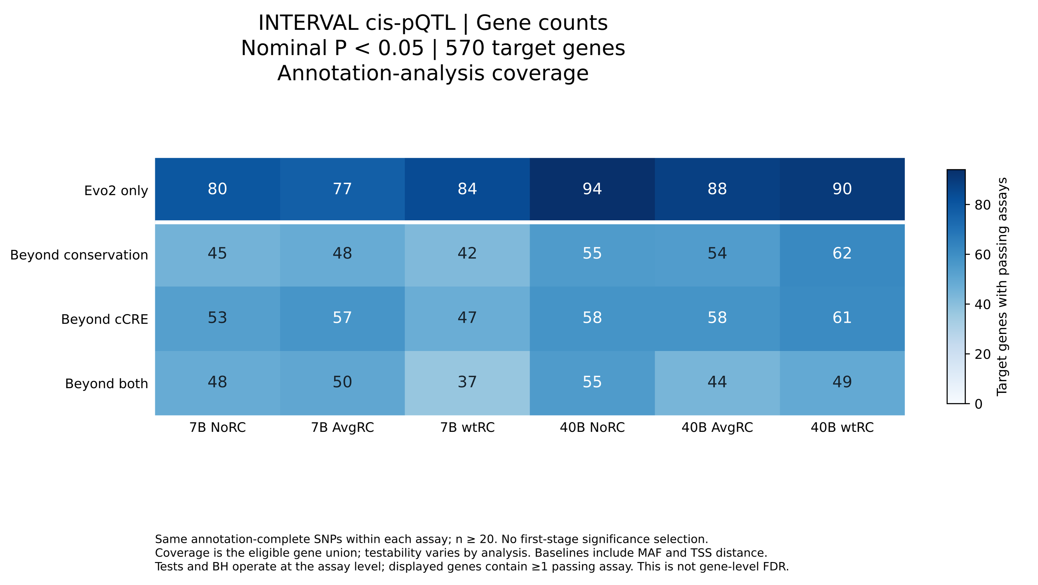
Supplementary Figure S7. Associations between absolute Evo2 scores and absolute cis-pQTL Z statistics in INTERVAL.
Heatmaps summarize nominal associations in 570 target genes. The six configurations combine Evo2-7B or Evo2-40B with noRC, avgRC, or wtRC scoring. The outcome is the absolute association Z statistic. Each cell reports the number of distinct genes with at least one passing protein assay at nominal P < 0.05 for the indicated configuration and model comparison. “Evo2 only” denotes the overall spline F test; “Beyond conservation”, “Beyond cCRE”, and “Beyond both” denote nested F tests for the added Evo2 spline, conditional on MAF, TSS distance, and the indicated annotations. Comparisons use the same annotation-complete SNPs within each analysis unit, without selection on Evo2-only significance. Blue intensity represents the count on the displayed scale. Source: INTERVAL original pQTL analysis, 3,301 participants after genetic quality control (Sun et al., 2018) (21). The 570 target genes represent the annotation-covered intersection used here. Nominal P values refer to tests of the Evo2 spline terms. Supplementary Table S15 additionally reports BH-threshold counts and percentages among testable genes.
Supplementary Figure S8. Associations between absolute Evo2 scores and cis-eQTL fine-mapping PIPs in GTEx.
Heatmaps summarize nominal associations in 35,420 genes across 50 tissues. The six configurations combine Evo2-7B or Evo2-40B with noRC, avgRC, or wtRC scoring. The outcome is the untransformed posterior inclusion probability (PIP). Each cell reports the number of distinct genes at nominal P < 0.05 for the indicated configuration and model comparison. “Evo2 only” denotes the overall spline F test; “Beyond conservation”, “Beyond cCRE”, and “Beyond both” denote nested F tests for the added Evo2 spline, conditional on MAF, TSS distance, and the indicated annotations. Comparisons use the same annotation-complete SNPs within each analysis unit, without selection on Evo2-only significance. Blue intensity represents the count on the displayed scale. Source: GTEx v11 cis-eQTL SuSiE fine-mapping release (18). Nominal P values refer to tests of the Evo2 spline terms. Supplementary Table S16 additionally reports BH-threshold counts and percentages among testable genes.

Supplementary Figure S9. Associations between absolute Evo2 scores and GWAS fine-mapping PIPs for protein-related measurements in Open Targets.
Heatmaps summarize Open Targets fine-mapping results for 1,842 matched instances, of which 1,840 have annotation-covered variants. The six configurations combine Evo2-7B or Evo2-40B with noRC, avgRC, or wtRC scoring. Panels distinguish fine-mapping methods and LD provenance. Each cell reports the number of instances with at least one signal reaching nominal P < 0.05. The outcome is continuous posterior inclusion probability (PIP). “Evo2 only” denotes the overall spline F test; the three “Beyond” comparisons test the added Evo2 spline after adjustment for MAF, nearest canonical TSS distance, and conservation, cCRE annotations, or both. All comparisons use the same annotation-complete variants within each signal. Blue intensity represents counts on the displayed scale. Source: Open Targets Platform release 26.06 (23). An instance is a unique Open Targets study ID. Nominal P values refer to tests of the Evo2 spline terms; corresponding Supplementary Table S17 additionally reports BH-threshold counts and percentages among testable instances.
Supplementary Figure S10. Associations between absolute Evo2 scores and GWAS fine-mapping PIPs for metabolite-related measurements in Open Targets.
Heatmaps summarize Open Targets fine-mapping results for 6,155 matched instances, of which 6,153 have annotation-covered variants. The six configurations combine Evo2-7B or Evo2-40B with noRC, avgRC, or wtRC scoring. Panels distinguish fine-mapping methods and LD provenance. Each cell reports the number of instances with at least one signal reaching nominal P < 0.05. The outcome is continuous posterior inclusion probability (PIP). “Evo2 only” denotes the overall spline F test; the three “Beyond” comparisons test the added Evo2 spline after adjustment for MAF, nearest canonical TSS distance, and conservation, cCRE annotations, or both. All comparisons use the same annotation-complete variants within each signal. Blue intensity represents counts on the displayed scale. Source: Open Targets Platform release 26.06 (23). An instance is a unique Open Targets study ID. Nominal P values refer to tests of the Evo2 spline terms; corresponding Supplementary Table S18 additionally reports BH-threshold counts and percentages among testable instances.
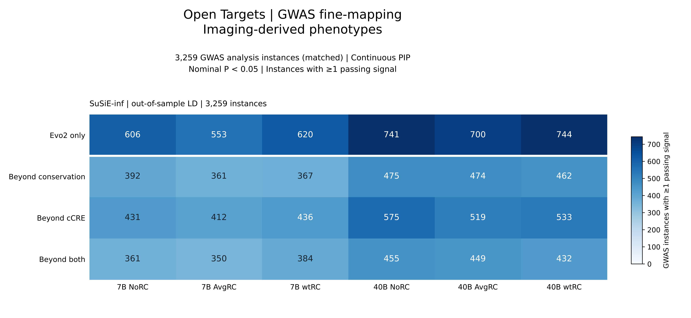
Supplementary Figure S11. Associations between absolute Evo2 scores and GWAS fine-mapping PIPs for imaging-derived phenotypes in Open Targets.
Heatmaps summarize Open Targets fine-mapping results for 3,259 matched instances, of which 3,256 have annotation-covered variants. The six configurations combine Evo2-7B or Evo2-40B with noRC, avgRC, or wtRC scoring. Panels distinguish fine-mapping methods and LD provenance. Each cell reports the number of instances with at least one signal reaching nominal P < 0.05. The outcome is continuous posterior inclusion probability (PIP). “Evo2 only” denotes the overall spline F test; the three “Beyond” comparisons test the added Evo2 spline after adjustment for MAF, nearest canonical TSS distance, and conservation, cCRE annotations, or both. All comparisons use the same annotation-complete variants within each signal. Blue intensity represents counts on the displayed scale. Source: Open Targets Platform release 26.06 (23). An instance is a unique Open Targets study ID. Nominal P values refer to tests of the Evo2 spline terms; corresponding Supplementary Table S19 additionally reports BH-threshold counts and percentages among testable instances.
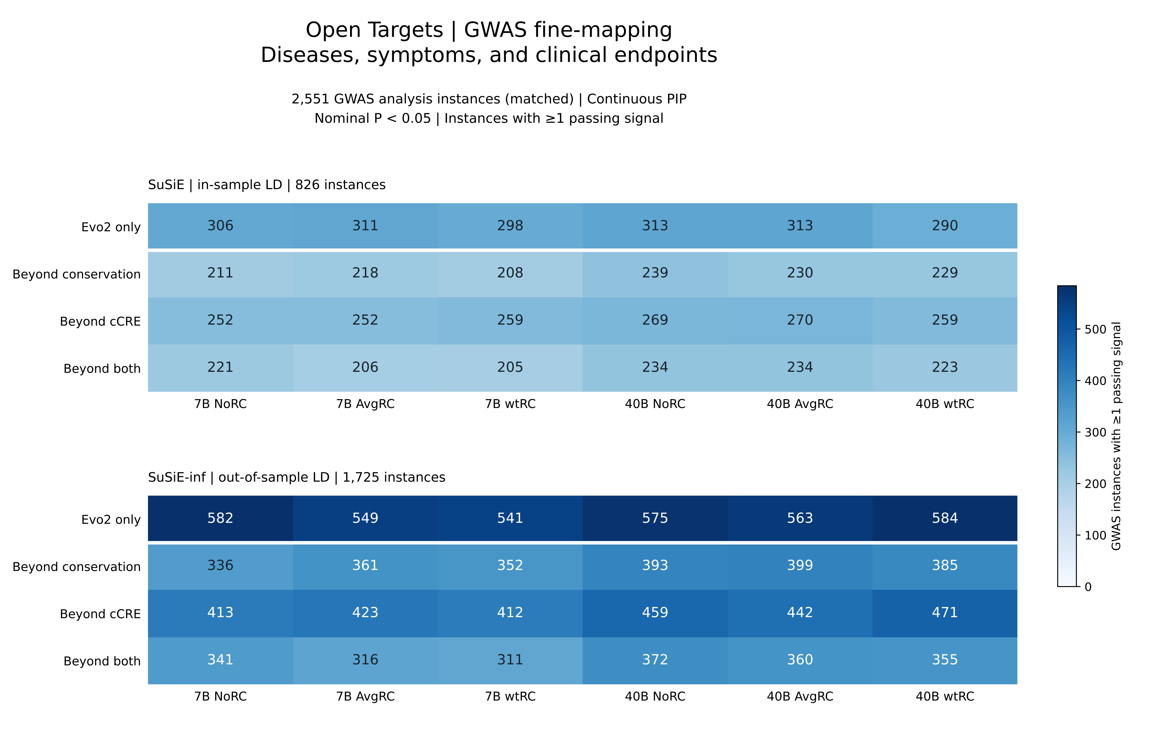
Supplementary Figure S12. Associations between absolute Evo2 scores and GWAS fine-mapping PIPs for diseases, symptoms, and clinical endpoints in Open Targets.
Heatmaps summarize Open Targets fine-mapping results for 2,551 matched instances, of which 2,550 have annotation-covered variants. The six configurations combine Evo2-7B or Evo2-40B with noRC, avgRC, or wtRC scoring. Panels distinguish fine-mapping methods and LD provenance. Each cell reports the number of instances with at least one signal reaching nominal P < 0.05. The outcome is continuous posterior inclusion probability (PIP). “Evo2 only” denotes the overall spline F test; the three “Beyond” comparisons test the added Evo2 spline after adjustment for MAF, nearest canonical TSS distance, and conservation, cCRE annotations, or both. All comparisons use the same annotation-complete variants within each signal. Blue intensity represents counts on the displayed scale. Source: Open Targets Platform release 26.06 (23). An instance is a unique Open Targets study ID. Nominal P values refer to tests of the Evo2 spline terms; corresponding Supplementary Table S20 additionally reports BH-threshold counts and percentages among testable instances.
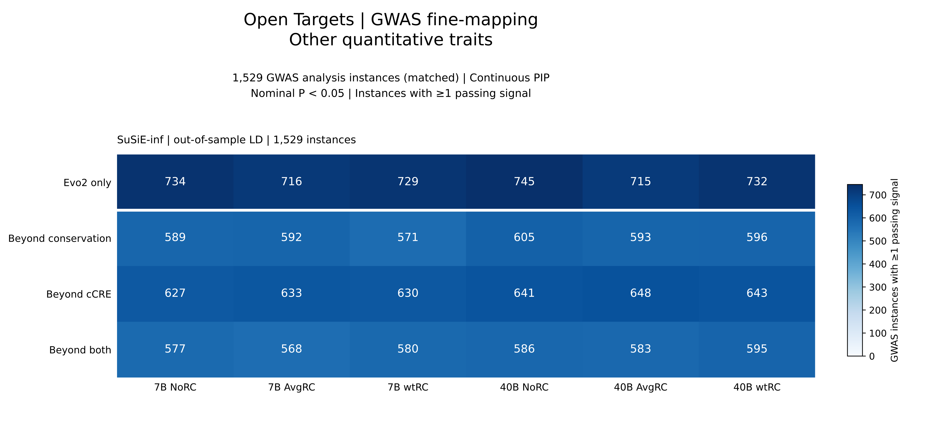
Supplementary Figure S13. Associations between absolute Evo2 scores and GWAS fine-mapping PIPs for other quantitative traits in Open Targets.
Heatmaps summarize Open Targets fine-mapping results for 1,529 matched instances, of which 1,529 have annotation-covered variants. The six configurations combine Evo2-7B or Evo2-40B with noRC, avgRC, or wtRC scoring. Panels distinguish fine-mapping methods and LD provenance. Each cell reports the number of instances with at least one signal reaching nominal P < 0.05. The outcome is continuous posterior inclusion probability (PIP). “Evo2 only” denotes the overall spline F test; the three “Beyond” comparisons test the added Evo2 spline after adjustment for MAF, nearest canonical TSS distance, and conservation, cCRE annotations, or both. All comparisons use the same annotation-complete variants within each signal. Blue intensity represents counts on the displayed scale. Source: Open Targets Platform release 26.06 (23). An instance is a unique Open Targets study ID. Nominal P values refer to tests of the Evo2 spline terms; corresponding Supplementary Table S21 additionally reports BH-threshold counts and percentages among testable instances.
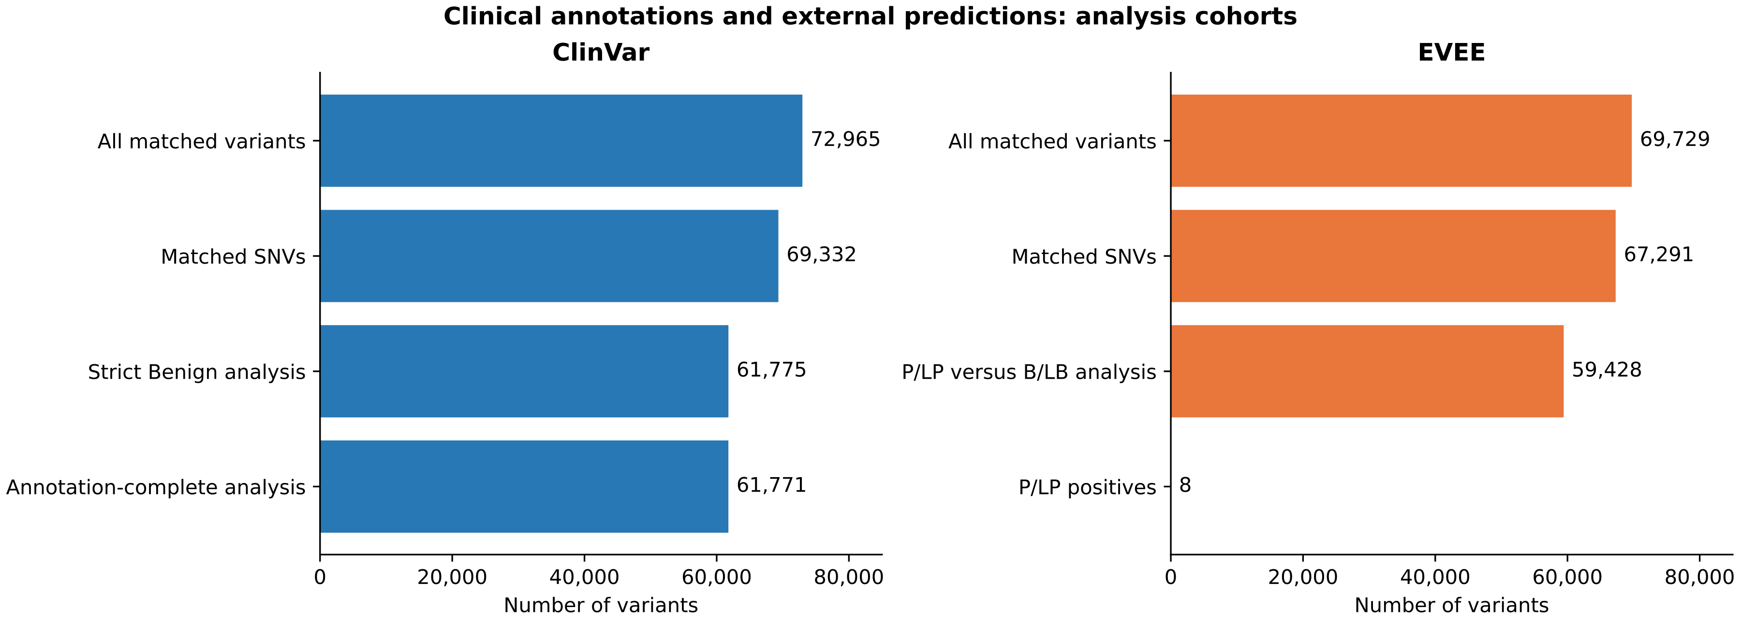
Supplementary Figure S14. Variant matching and analysis cohorts for ClinVar and EVEE.
Bars show the numbers of variants retained at successive analysis stages. ClinVar includes 72,965 matched variants, 69,332 matched SNVs, 61,775 SNVs eligible for the strict Benign comparison, and 61,771 annotation-complete SNVs. EVEE includes 69,729 matched variants, 67,291 matched SNVs, and 59,428 SNVs with P/LP or B/LB labels, including eight P/LP variants. Blue and orange denote ClinVar and EVEE, respectively. Counts represent nested subsets and should not be added. ClinVar evaluates strict Benign versus non-Benign annotations, whereas EVEE evaluates P/LP versus B/LB; the two comparisons use different outcome definitions. Sources: ClinVar snapshot dated 21 March 2026 and EVEE Zenodo version v1 (24, 25).
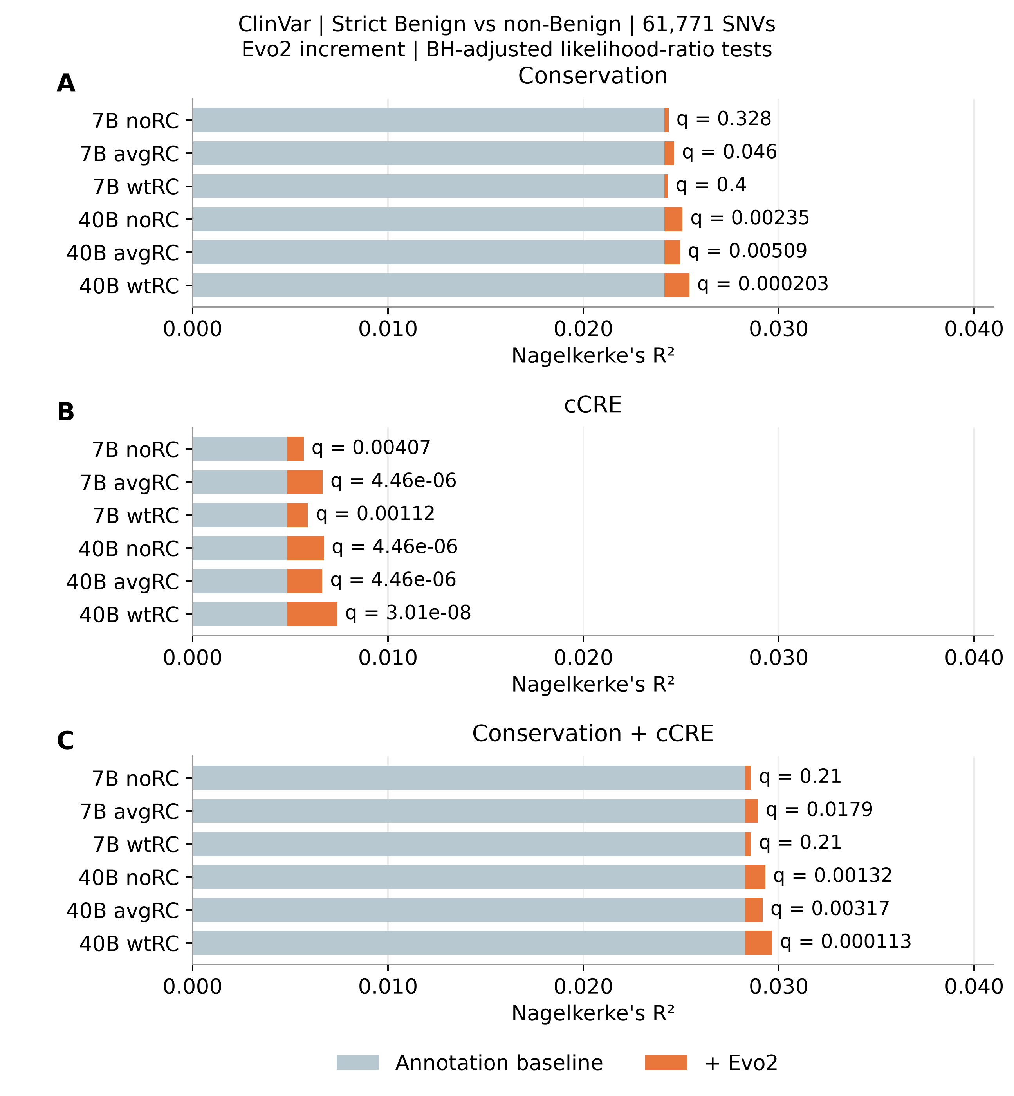
Supplementary Figure S15. Incremental model fit from absolute Evo2 scores for strict Benign versus non-Benign ClinVar labels.
The six configurations combine Evo2-7B or Evo2-40B with noRC, avgRC, or wtRC scoring. Logistic regressions use the same 61,771 annotation-complete SNVs, including 59,412 strict Benign and 2,359 non-Benign variants. Panels A–C show conservation, cCRE, and joint annotation baselines, respectively, from top to bottom. Gray-blue bars indicate baseline Nagelkerke pseudo-R², and orange segments indicate the increase after adding the Evo2 spline. Conservation is represented by phastCons100way and phyloP100way splines; cCRE is represented by a nine-level category including background. Labels report BH-adjusted P values from nested likelihood-ratio tests across all 18 comparisons. The non-Benign group includes several clinical annotation classes and is not synonymous with pathogenicity. The increments describe additional fit within this sample. Source: ClinVar snapshot dated 21 March 2026 (24).
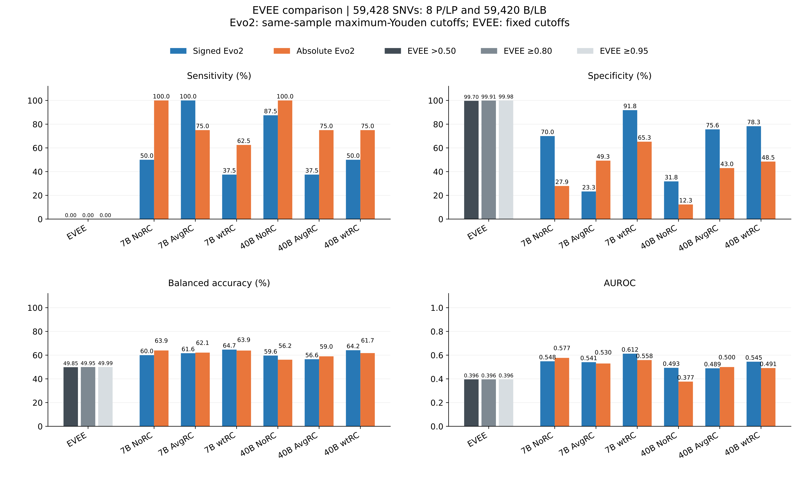
Supplementary Figure S16. Discrimination of P/LP versus B/LB variants using Evo2 scores and EVEE predictions.
The six configurations combine Evo2-7B or Evo2-40B with noRC, avgRC, or wtRC scoring. The comparison includes 59,428 SNVs with eight pathogenic/likely pathogenic (P/LP) and 59,420 benign/likely benign (B/LB) labels. Panels show sensitivity, specificity, balanced accuracy, and AUROC. Blue and orange bars denote signed and absolute Evo2 scores, respectively; gray bars denote EVEE at > 0.50, ≥ 0.80, and ≥ 0.95. Evo2 decision thresholds maximize Youden’s J in this sample, whereas EVEE thresholds are fixed. The three EVEE AUROC values describe the same continuous score. All three EVEE thresholds identify 0/8 P/LP variants, with 178, 54, and 14 false positives, respectively. Source: EVEE Zenodo version v1 (25).

Abbreviations
AI: Artificial intelligence
ANNOVAR: Variant annotation software
API: Application programming interface
AUROC: Area under the receiver operating characteristic curve
avgRC: Average reverse-complement scoring
B/LB: Benign or likely benign
BED: Browser Extensible Data format
BH: Benjamini–Hochberg
CA: Chromatin accessible only
CA-CTCF: Chromatin accessible with CTCF
CA-H3K4me3: Chromatin accessible with H3K4me3
CA-TF: Chromatin accessible with transcription factor binding
cCRE: Candidate cis-regulatory element
CSV: Comma-separated values
CTCF: CCCTC-binding factor
dbGaP: Database of Genotypes and Phenotypes
dbSNP: Database of Single Nucleotide Polymorphisms
dELS: Distal enhancer-like signature
DNA: Deoxyribonucleic acid
ENCODE: Encyclopedia of DNA Elements
eQTL: Expression quantitative trait locus
EVEE: Evo Variant Effect Explorer
Evo2: Evolutionary DNA foundation model version 2
Evo2-40B: Evo2 40-billion-parameter model
Evo2-7B: Evo2 7-billion-parameter model
Evo2VED: Evo2 Variant Effect Database
FDR: False discovery rate
FTS5: Full-text search version 5
GEVA: Genealogical Estimation of Variant Age
gnomAD: Genome Aggregation Database
GRCh38: Genome Reference Consortium Human Build 38
GTEx: Genotype-Tissue Expression
GWAS: Genome-wide association study
H3K4me3: Histone H3 lysine 4 trimethylation
HAR: Human accelerated region
JSON: JavaScript Object Notation
kb: Kilobase
LCR: Low-complexity region
LD: Linkage disequilibrium
LDSC: Linkage disequilibrium score regression
LLM: Large language model
M-CAP: Mendelian Clinically Applicable Pathogenicity score
MAF: Minor allele frequency
Mb: Megabase
MPRA: Massively parallel reporter assay
MVP: Million Veteran Program
NA: Not available (no testable units in the heatmaps)
noRC: No reverse-complement scoring
P/LP: Pathogenic or likely pathogenic
pELS: Proximal enhancer-like signature
PIP: Posterior inclusion probability
PLS: Promoter-like signature
PMID: PubMed identifier
pQTL: Protein quantitative trait locus
QTL: Quantitative trait locus
RC: Reverse complement
rsID: Reference SNP identifier
S-LDSC: Stratified LD score regression
S2F: Sequence-to-function model
SCREEN: Search Candidate Regulatory Elements by ENCODE
SDS: Singleton Density Score
SEM: Standard error of the mean
SNP: Single-nucleotide polymorphism
SNV: Single-nucleotide variant
SQL: Structured Query Language
SQLite: Lightweight relational database engine
sQTL: Splicing quantitative trait locus
TF: Transcription factor; TF-only cCRE category
TSS: Transcription start site
UCSC: University of California, Santa Cruz
UKB: UK Biobank
UKB-PPP: UK Biobank Pharma Proteomics Project
WGS: Whole-genome sequencing
wtRC: Weighted reverse-complement scoring

Software
Software / tool | Usage | Website / repository
Evo2 | Generated reference- and alternative-allele sequence likelihoods and allele-difference (delta) scores for the common-variant dataset using the Evo2-7B and Evo2-40B genomic foundation models. | https://github.com/arcinstitute/evo2
ANNOVAR  (table_annovar.pl) | Assigned gene-based functional categories, exonic consequences, and additional annotations to the scored variants using Ensembl gene definitions. | https://annovar.openbioinformatics.org/
Docker | Containerized the Evo2VED application and its runtime dependencies to support reproducible building and deployment of the web resource. | https://www.docker.com/
Python | Provided the application runtime, data processing, and statistical computations; also ran the scripts used to prepare and plot Supplementary Figures S1–S16. | https://www.python.org/
Datasette | Served the SQLite database as an interactive table browser, read-only SQL endpoint, JSON API, and extensible web application through a custom plugin. | https://datasette.io/
SQLite | Stored the precomputed variant scores, annotations, region sets, GWAS metadata, and associations in a read-only relational database with indexed and full-text search. | https://www.sqlite.org/
Plotly.js | Rendered all interactive client-side visualizations in Evo2VED, including stratification plots, heatmaps, score landscapes, histograms, dot plots, and multi-track locus views. | https://github.com/plotly/plotly.js
NumPy | Supported numerical array operations, summary calculations, and paired resampling calculations used for the LDSC sensitivity plots. | https://numpy.org/
SciPy | Provided hypothesis tests and rank-based correlations, including Spearman correlations summarized in Supplementary Figure S1. | https://scipy.org/
R | Performed the case-study statistical analyses, including Spearman correlations, MAF-stratified resampling, and Wilcoxon rank-sum tests. | https://www.r-project.org/
LDSC / stratified LD score regression | Performed LD score regression and compared model estimates obtained using signed and absolute Evo2 annotations. | https://github.com/bulik/ldsc
GraphPad Prism | Generated publication-quality dot plots for Figures 2A-D, 2G-H and bar plots for Figures 3D-F. | https://www.graphpad.com/scientific-software/prism/
ChatGPT  (GPT-5.5) | Assisted with the initial design of the graphical abstract; the output was subsequently reviewed and optimized by the authors. | https://chatgpt.com/
Adobe Photoshop CS6 | Performed final manual optimization and graphical editing of the graphical abstract. | https://www.adobe.com/products/photoshop.html
ggplot2  (R package) | Generated static dot plots for Figures 2E-F and Figures 3A-C. | https://ggplot2.tidyverse.org/
qqman  (R package) | Generated Manhattan plots for Figures 4A-B. | https://github.com/stephenturner/qqman
LocusZoom | Generated regional association plots integrating GWAS signals with Evo2 variant scores. | https://locuszoom.org/
Matplotlib | Generated Supplementary Figures S1–S16: MPRA model-fit bars; QTL and fine-mapping heatmaps; clinical cohort, incremental-fit, and performance bars; and LDSC scatter plots with fitted lines and confidence bands. Arranged the ClinVar baselines vertically in Figure S15 and exported figure files for document assembly. | https://matplotlib.org/
Hugging Face Spaces | Hosted and deployed the publicly accessible containerized Evo2VED web application. | https://huggingface.co/docs/hub/en/spaces

REFERENCES
1. Brixi,G., Durrant,M.G., Ku,J., et al. (2026) Genome modelling and design across all domains of life with Evo 2. Nature, 652, 1349–1361.
2. Phan,L., Zhang,H., Wang,Q., et al. (2025) The evolution of dbSNP: 25 years of impact in genomic research. Nucleic Acids Res., 53, D925–D931.
3. Karczewski,K.J., Francioli,L.C., Tiao,G., et al. (2020) The mutational constraint spectrum quantified from variation in 141,456 humans. Nature, 581, 434–443.
4. Guez,J., Goodrich,J.K., Moldovan,M.A., et al. (2026) Integrating 730,947 exome sequences with clinical literature improves gene discovery. 10.64898/2026.03.23.26349081.
5. Siepel,A., Bejerano,G., Pedersen,J.S., et al. (2005) Evolutionarily conserved elements in vertebrate, insect, worm, and yeast genomes. Genome Res., 15, 1034–1050.
6. Pollard,K.S., Hubisz,M.J., Rosenbloom,K.R., et al. (2010) Detection of nonneutral substitution rates on mammalian phylogenies. Genome Res., 20, 110–121.
7. Albers,P.K. and McVean,G. (2020) Dating genomic variants and shared ancestry in population-scale sequencing data. PLOS Biol., 18, e3000586.
8. Field,Y., Boyle,E.A., Telis,N., et al. (2016) Detection of human adaptation during the past 2000 years. Science, 354, 760–764.
9. Doan,R.N., Bae,B.-I., Cubelos,B., et al. (2016) Mutations in Human Accelerated Regions Disrupt Cognition and Social Behavior. Cell, 167, 341-354.e12.
10. The 1000 Genomes Project Consortium, Corresponding authors, Auton,A., et al. (2015) A global reference for human genetic variation. Nature, 526, 68–74.
11. Sudmant,P.H., Rausch,T., Gardner,E.J., et al. (2015) An integrated map of structural variation in 2,504 human genomes. Nature, 526, 75–81.
12. ReproGen Consortium, Schizophrenia Working Group of the Psychiatric Genomics Consortium, The RACI Consortium, et al. (2015) Partitioning heritability by functional annotation using genome-wide association summary statistics. Nat. Genet., 47, 1228–1235.
13. Schizophrenia Working Group of the Psychiatric Genomics Consortium, Bulik-Sullivan,B.K., Loh,P.-R., et al. (2015) LD Score regression distinguishes confounding from polygenicity in genome-wide association studies. Nat. Genet., 47, 291–295.
14. Moore,J.E., Pratt,H.E., Fan,K., et al. (2026) An expanded registry of candidate cis-regulatory elements. Nature, 10.1038/s41586-025-09909-9.
15. Lee,S., McAfee,J.C., Lee,J., et al. (2025) Massively parallel reporter assay investigates shared genetic variants of eight psychiatric disorders. Cell, 188, 1409-1424.e21.
16. Nagelkerke,N.J.D. (1991) A note on a general definition of the coefficient of determination. Biometrika, 78, 691–692.
17. Holm,S. (1979) A Simple Sequentially Rejective Multiple Test Procedure. Scand. J. Stat., 6, 75–70.
18. The GTEx Consortium, Aguet,F., Anand,S., et al. (2020) The GTEx Consortium atlas of genetic regulatory effects across human tissues. Science, 369, 1318–1330.
19. Võsa,U., Claringbould,A., Westra,H.-J., et al. (2021) Large-scale cis- and trans-eQTL analyses identify thousands of genetic loci and polygenic scores that regulate blood gene expression. Nat. Genet., 53, 1300–1310.
20. Sun,B.B., Chiou,J., Traylor,M., et al. (2023) Plasma proteomic associations with genetics and health in the UK Biobank. Nature, 622, 329–338.
21. Sun,B.B., Maranville,J.C., Peters,J.E., et al. (2018) Genomic atlas of the human plasma proteome. Nature, 558, 73–79.
22. Benjamini,Y. and Hochberg,Y. (1995) Controlling the False Discovery Rate: A Practical and Powerful Approach to Multiple Testing. J. R. Stat. Soc. Ser. B Stat. Methodol., 57, 289–300.
23. Buniello,A., Suveges,D., Cruz-Castillo,C., et al. (2025) Open Targets Platform: facilitating therapeutic hypotheses building in drug discovery. Nucleic Acids Res., 53, D1467–D1475.
24. Landrum,M.J., Lee,J.M., Benson,M., et al. (2018) ClinVar: improving access to variant interpretations and supporting evidence. Nucleic Acids Res., 46, D1062–D1067.
25. Pearce,M.T., Dooms,T., Yamamoto,R., et al. (2026) Interpretable variant effect prediction from genomic foundation model representations. 10.64898/2026.04.10.717844.
26. Efron,B. and Tibshirani,R. (1993) An introduction to the bootstrap Chapman & Hall, New York.
27. Boughton,A.P., Welch,R.P., Flickinger,M., et al. (2021) LocusZoom.js: interactive and embeddable visualization of genetic association study results. Bioinformatics, 37, 3017–3018.
28. Pruim,R.J., Welch,R.P., Sanna,S., et al. (2010) LocusZoom: regional visualization of genome-wide association scan results. Bioinformatics, 26, 2336–2337.
29. Hunter,J.D. (2007) Matplotlib: A 2D Graphics Environment. Comput. Sci. Eng., 9, 90–95.

